Assignment#4 Volume Randering

20131329 신선우 (전기전자컴퓨터공학부/학생)

**1. Introduction**

This assignment is making Volume Rendering and ray casting to get MIP and AlphaBlending.

1. Find Box intersection with ray casting

2. MIP(Maximum Intensity Projection)

3. Alpha Blending

**2. Method**

1) Ray casting.

The find intersection point was most difficult.

The some kinds of horror image was generated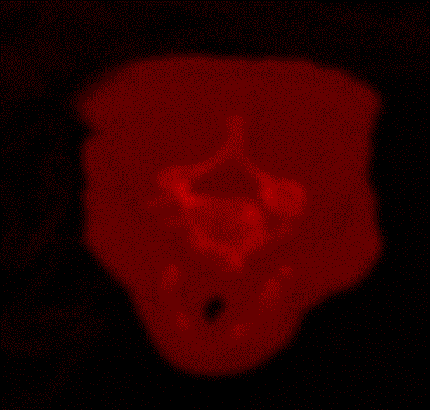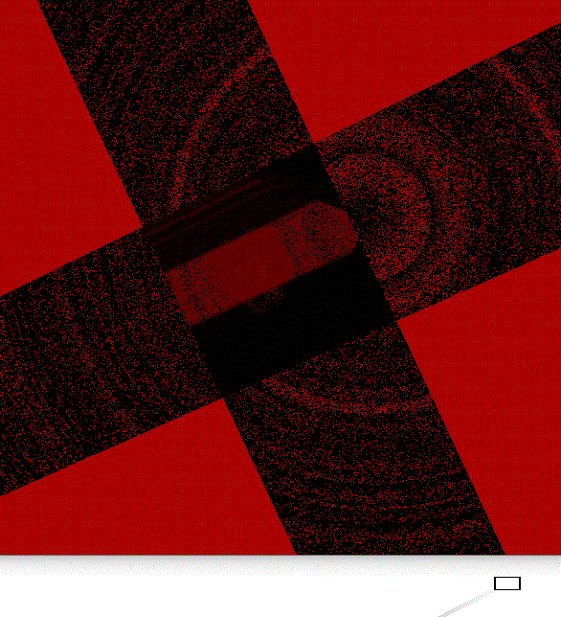

- result of error point

I try to figure how to generate the right position.

This one is I found the equation.

Actually, I referenced an algorithm AABB, OBB on a website I will write as a reference.

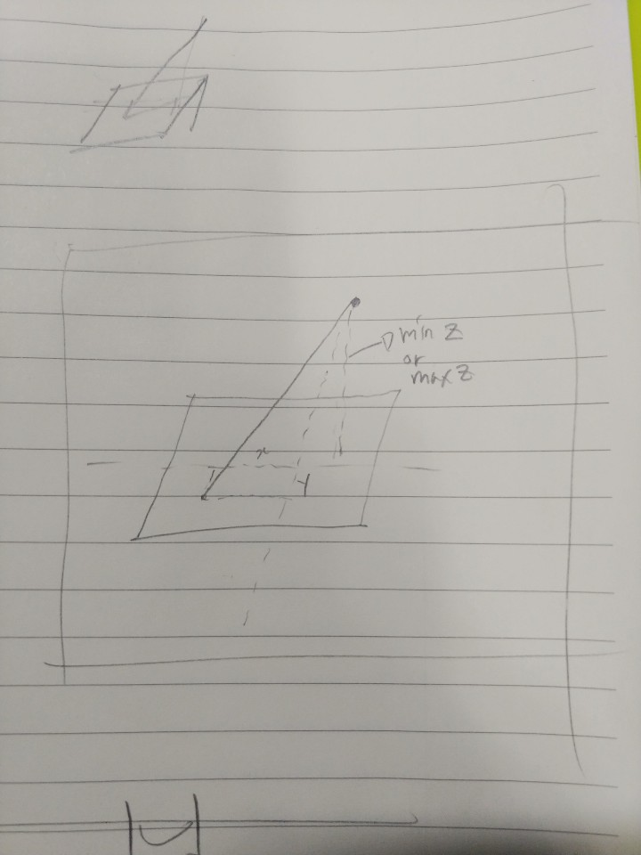

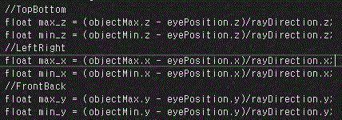

This is the length of ‘eyePosition’ to Box’s faces.

For example, let’s figure top face and bottom face.

1. Find z length of the ray.

2. multiply the length and ‘rayDirection.x’ is x coordinate Also, the way of calculating y coordinate is the same way.



3. the formula is (eyePosition + max_z*rayDirection).x and .y . z is objectMax.z

4. Compare with objectMax.x, objectMin.x, objectMax.y, objectMin.y

5. if success then it is the near face or far face. And count +1.

6. Then check this with min_z same way

7. repeat for x and y.

2) MIP(Maximum Intensity Projection)

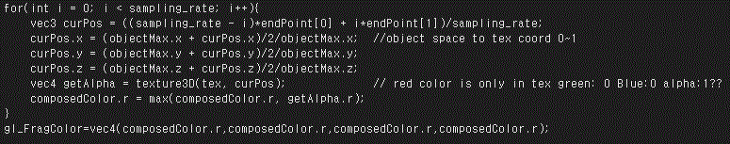

I divide the position as sampling rate.

The inside of box is middle of two endpoint. And converted as texture coordinate 0 ~ 1.

And the get value at tex.

The problem of tex is only stored r value. This problem occurred all model to red shape.

3)Alpha blend

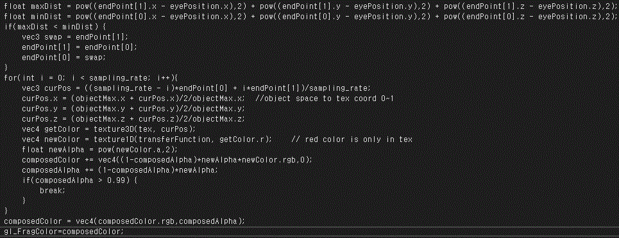

The alphablend code has an issue of distance flipped.

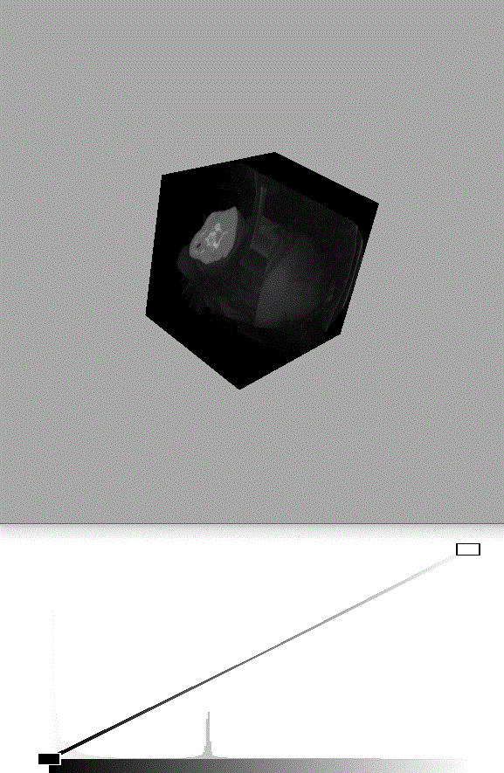

So I added distance measure comparing. If max min is flipped then swap two values. Which is MaxDist and MinDist part.

Alpha blending equation.

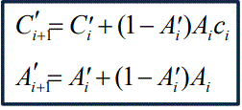

From PPT slide.

**3. Result**

MIP image1

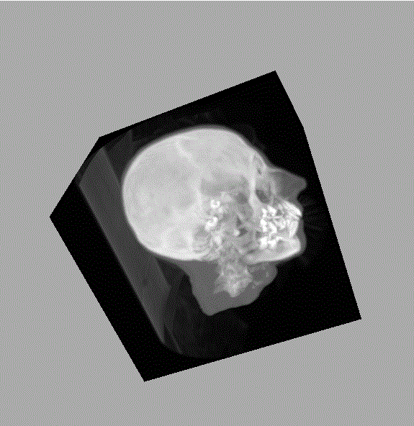

MIP image2

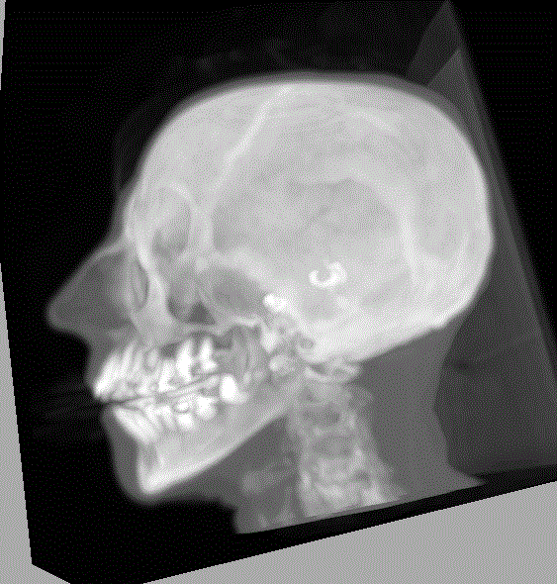

Alpha blending image1

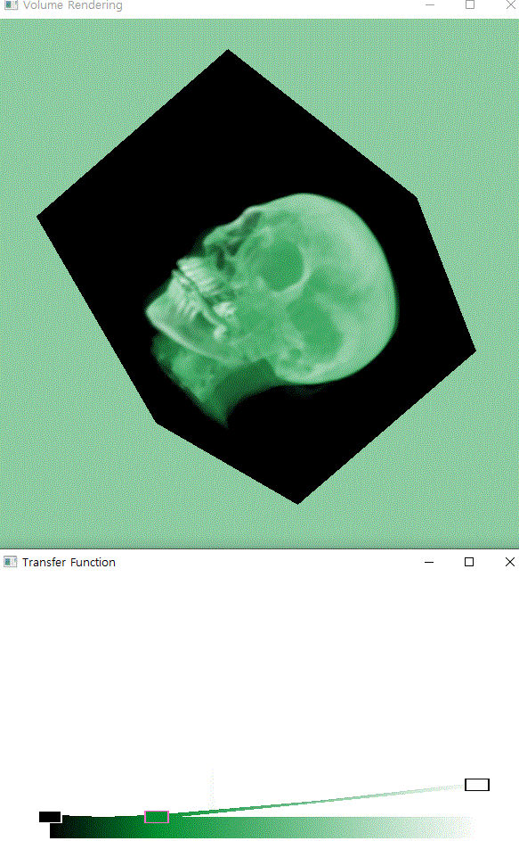

Alpha blending image2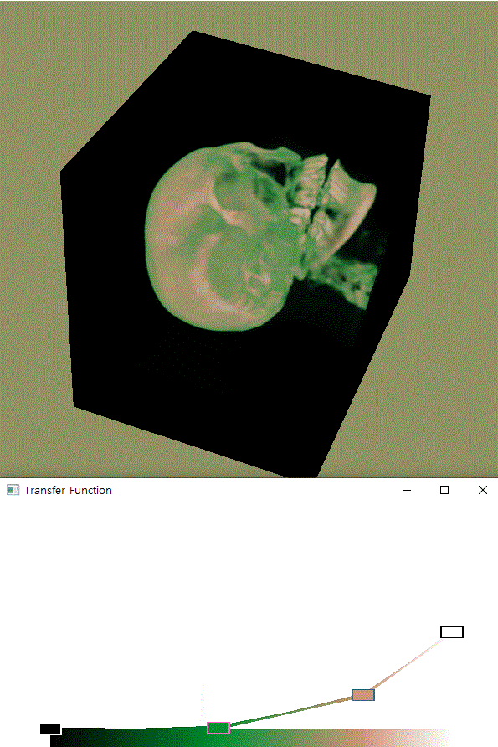

**4. Conclusion**

Calculating ray direction was a hard job in this assignment.

But the MIP and AlphaBlending was easy then intersection calculation.

I think the portion of grade has to be change. 50 to intersection rest to MIP and AlphaBlending.

The total work was so difficult for me but it was a great experience.

**5. reference**

<https://www.scratchapixel.com/lessons/3d-basic-rendering/minimal-ray-tracer-rendering-simple-shapes/ray-box-intersection?url=3d-basic-rendering/minimal-ray-tracer-rendering-simple-shapes/ray-box-intersection>