AI Defense Lab for Payment Security
Closed-Loop Red Team vs Blue Team
Solution Walkthrough — Mastercard Innovation Challenge @ GFF 2026
⚠ All data, transactions, and accounts described in this document are 100% synthetic, generated by this project's own code (src/data_generator.py). No real Mastercard cardholder or transaction data was used, accessed, or claimed to be detected anywhere in this submission. Risk thresholds (Low/Medium/High/Critical) are demonstration thresholds chosen for this challenge, not Mastercard production thresholds.

Abstract
Generative AI has lowered the cost of producing adaptive, fast-evolving payment fraud, while most production fraud filters remain static rule sets trained once on historical data. This project builds a closed-loop Red-Team / Blue-Team system: an adaptive attack-simulation agent that crafts seven realistic fraud attack families and evolves its own parameters against a live detector, and a Blue-Team fraud classifier (XGBoost, selected by validation PR-AUC) that retrains on its own missed attacks. On a 160,265-row synthetic transaction dataset, the closed loop raised overall Red-Team attack detection from 11.7% to 62.0% across two adversarial-training rounds — while also surfacing an honest, disclosed trade-off: precision on clean traffic fell from 0.47 to 0.32 as the decision boundary widened to catch more attacks. Every number in this document was produced by actually running the accompanying code; none are estimated or invented.

Problem
Card-payment fraud detection is a highly imbalanced, adversarial, and non-stationary classification problem. Fraud is rare (typically well under 5% of transactions), attackers actively adapt once a defense proves effective, and a detector trained once on last year's fraud patterns degrades against this year's. GenAI specifically compounds this: it lowers the technical barrier to producing convincing account-takeover attempts, automating card-testing bots, and generating large volumes of subtly-varied fraud attempts designed to slip past static thresholds.
The challenge asks for a single system that plays both sides of this arms race — building the attacker's toolkit with enough fidelity to be a genuine stress test, and building a defender that turns every stress test into a training signal.

Motivation
- Static, threshold-based fraud rules are brittle against an adversary that can iterate quickly — a single amount cutoff or velocity cap is trivial to probe and route around once discovered.
- Most public fraud-detection demos train and evaluate on one fixed batch of attacks. That measures memorization, not resilience. This project explicitly measures resilience: what happens to detection when the attacker adapts?
- Explainability is often treated as an afterthought (a SHAP plot buried in an appendix). For a payment-security reviewer — often not an ML engineer — a plain-English narrative of why a transaction was flagged is what actually gets acted on.

Threat Model
Seven attack families were implemented, each grounded in a documented real-world payment-fraud pattern rather than arbitrary noise:
# | Attack family | Real-world analogue
1 | Amount manipulation | Shaving amounts just under common authorization / step-up (3-D Secure) thresholds
2 | Velocity attack | Rapid transaction bursts across merchants/devices — classic card-testing / bot fraud
3 | Merchant switching | Spreading fraudulent spend across many merchant categories quickly
4 | Geographic anomaly evasion | VPN / device-spoofing to fake proximity to the cardholder's home
5 | Account takeover (ATO) | Sudden combined shift in device, location, amount, and velocity post-compromise
6 | Low-and-slow fraud | Many small transactions kept under common micro-transaction alert caps
7 | Behavioral mimicry | Attacker studies and imitates the account's own historical spending pattern

Each attack is implemented as a parameterized, adaptive persona (intensity, stealth-bias) rather than a single static rule — see "Red-Team Methodology" below.

System Architecture
The pipeline is a closed loop with five stages, matching the challenge's required architecture:
- Normal training data → Blue-Team detector (baseline)
- Blue-Team detector → Red-Team attack generation (agent probes the current detector)
- Attacked transactions → Blue-Team detection → missed attacks are logged
- Missed attacks → adversarial training data → Blue-Team retrained
- Re-evaluate on a fresh, unseen attack batch → improved defense, measured honestly
Code is organized as: src/data_generator.py, src/preprocessing.py, src/blue_team.py, src/red_team.py, src/adversarial_training.py, src/evaluation.py, src/explainability.py, src/demo.py, src/make_visualizations.py, plus a FastAPI backend (api/main.py) and a browser-based console (web/index.html) that is the working prototype for this submission.

Dataset
A synthetic payment-transaction dataset of 160,265 transactions across 900 accounts over 80 days (2.00% base fraud rate) was generated with: log-normal transaction amounts, diurnal time-of-day cycles, per-account spending profiles, Zipfian merchant popularity, and causally-computed velocity features (1h/24h transaction counts computed strictly from prior transactions only, to avoid label leakage). Three organic fraud archetypes (stolen-card spikes, ATO bursts, card-testing) are baked into the base data, separate from the Red-Team's targeted adversarial attacks generated later against the trained detector. Every random draw derives from a single seed for full reproducibility.
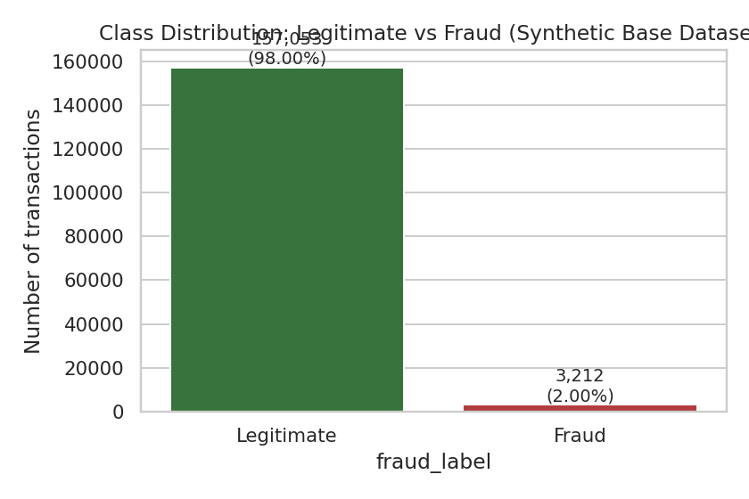
Figure 1 — Class distribution of the synthetic base dataset.
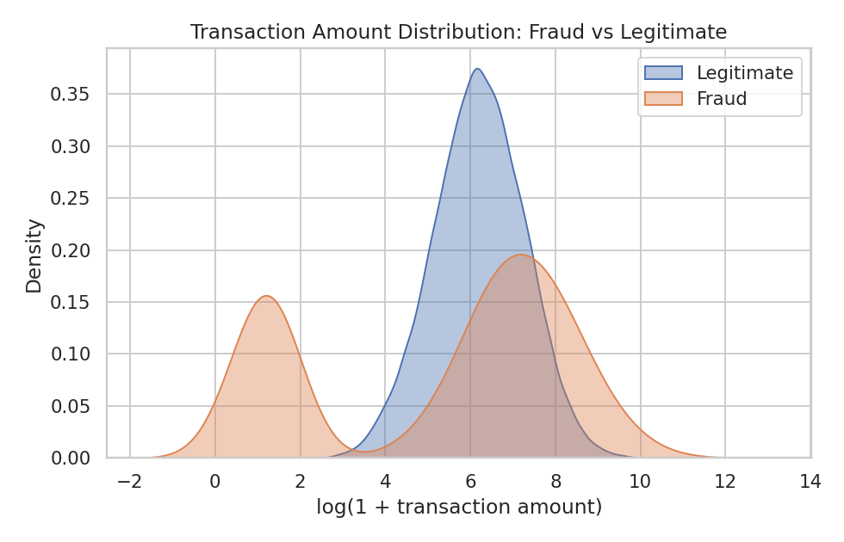
Figure 2 — Transaction-amount distribution, fraud vs legitimate.

Red-Team Methodology
Rather than call a paid external LLM API — which would break offline reproducibility, a specific requirement for this submission — the Red Team is implemented as an adaptive attack-persona agent: a parameterized generator whose intensity and stealth-bias parameters are evolved round-over-round using the Blue Team's own feedback (its miss-rate per attack family) via a hill-climbing update. If an attack family is being caught often, the agent increases stealth and reduces obvious intensity; if it is evading well, the agent escalates to probe how far it can push. This reproduces the behaviour of a generative adversarial fraud actor — attacks that adapt to what a defense is currently missing — while remaining fully local, deterministic given a seed, and free of external API dependencies. This design choice is stated plainly here: it is a heuristic adaptive agent, not a claim of using a hosted large language model.
Each attack call records: attack type, the original transaction, the modified transaction, the current attack intensity, whether the attack succeeded (evaded detection), the detector's prediction, and its confidence/risk score — satisfying the challenge's per-attack logging requirement.

Blue-Team Methodology
Three models are trained on the leakage-safe, chronologically-split data (train = earliest 60%, validation = next 20%, test = final 20% by timestamp — never a random split, so the model is always validated against data from after what it trained on): Random Forest (balanced class weights), XGBoost (scale_pos_weight-adjusted), and an Isolation Forest anomaly detector trained only on legitimate transactions as an auxiliary unsupervised signal. The final "production" model is selected by validation PR-AUC — not accuracy, which is uninformative at a ~2% fraud rate — and XGBoost was selected in this run.
Metric | Value (held-out test set, n=32,053)
Accuracy | 0.977
Precision | 0.471
Recall | 0.947
F1-score | 0.629
ROC-AUC | 0.995
PR-AUC (Average Precision) | 0.917

Why not just accuracy: predicting "legitimate" for every transaction already scores roughly 98% accuracy on this dataset, because fraud is rare. PR-AUC and recall-at-usable-precision are what actually distinguish a useful detector from a trivial one here.
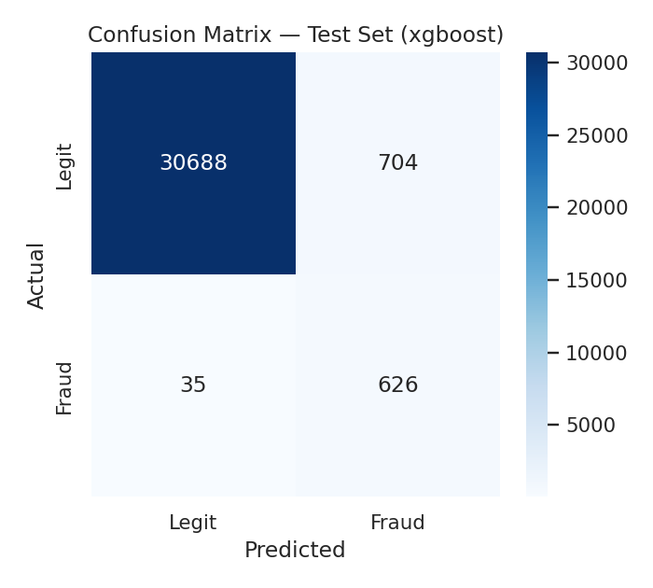
Figure 3 — Confusion matrix, baseline detector, held-out test set.
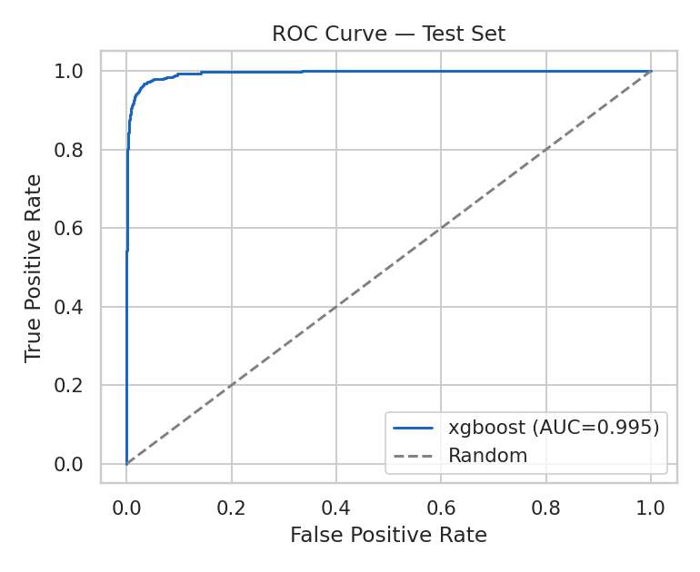
Figure 4 — ROC curve, held-out test set.
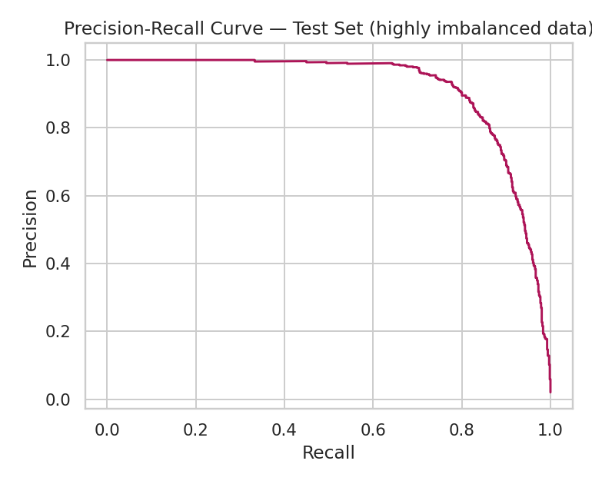
Figure 5 — Precision-Recall curve (the informative curve for this imbalance).
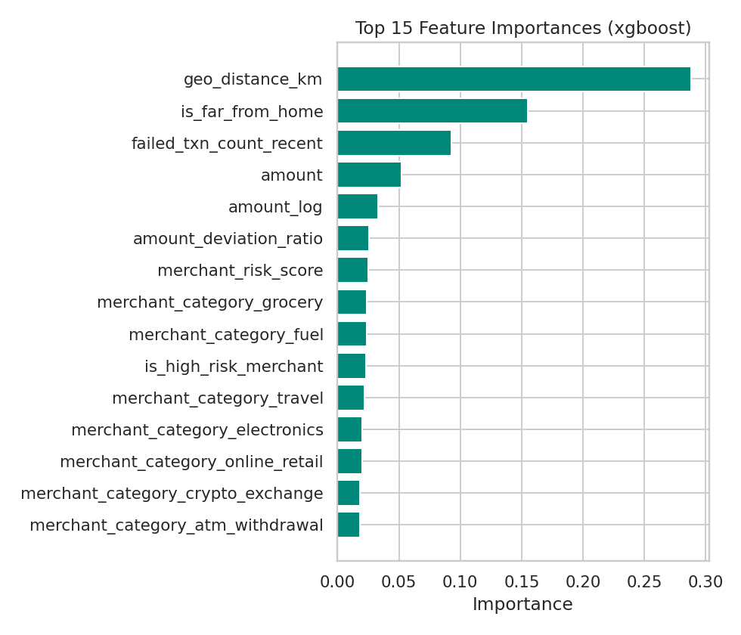
Figure 6 — Top 15 model feature importances.

Closed-Loop Learning
Before the closed loop, 1,050 Red-Team attack transactions (150 per family × 7 families) were scored by the baseline detector:
Attack family | Detection rate — before loop
geo_evasion | 0.7%
velocity_attack | 1.3%
low_and_slow | 2.0%
amount_manipulation | 4.7%
merchant_switching | 8.0%
behavioral_mimicry | 8.0%
account_takeover | 57.3%

Overall detection before the loop: 11.7% (average risk score 13.1/100). The 927 missed attacks from this and a second round were fed back into training (1,353 adversarial rows total), and the Blue-Team detector was retrained. A fresh, unseen attack batch was then generated and scored:
Attack family | Detection rate — after loop
geo_evasion | 5.3%
behavioral_mimicry | 39.3%
amount_manipulation | 42.7%
merchant_switching | 49.3%
low_and_slow | 98.0%
account_takeover | 99.3%
velocity_attack | 100.0%

Overall detection after the loop: 62.0% (average risk score 63.8/100) — a 5.3× improvement in overall attack detection from two adversarial-training rounds.
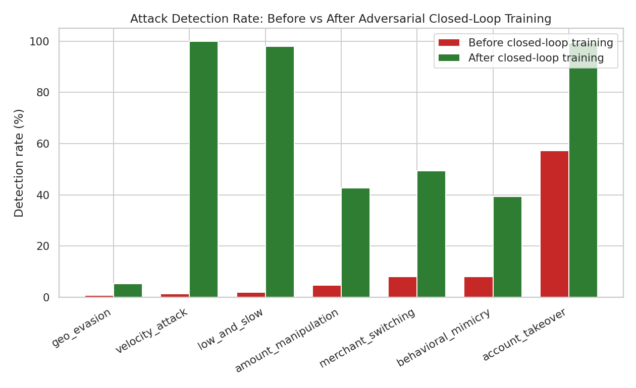
Figure 8 — Detection rate by attack family, before vs after closed-loop training.
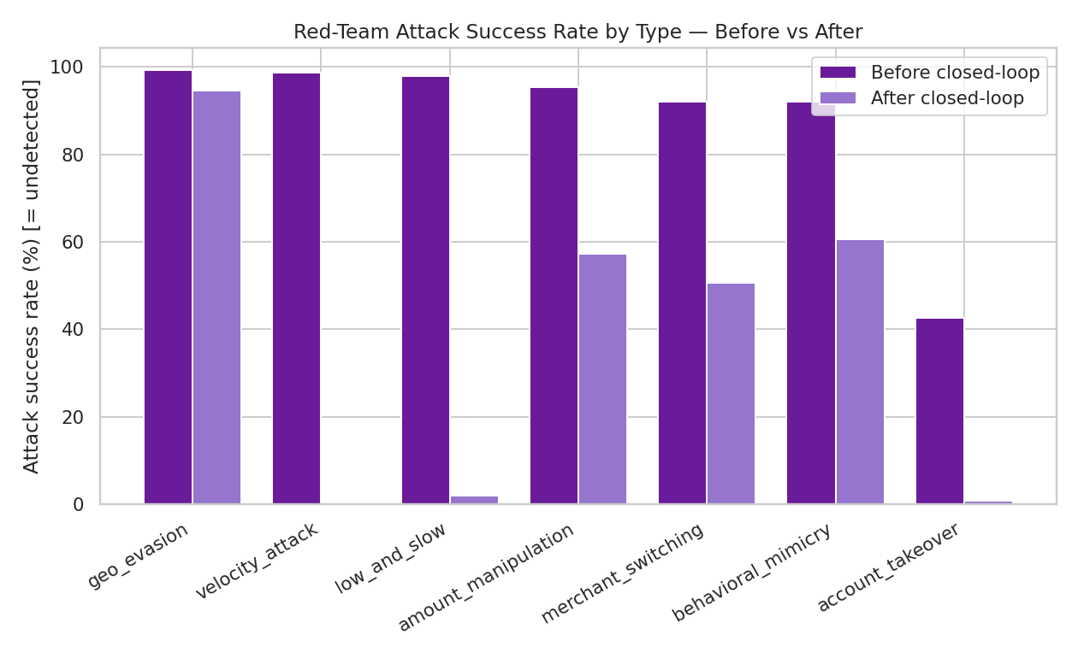
Figure 10 — Red-Team attack success rate (= undetected), before vs after.

The honest trade-off
On the clean, held-out test set (no attacks mixed in), before vs after the closed loop:
Metric | Before | After
Precision | 0.471 | 0.315
Recall | 0.947 | 0.956
F1-score | 0.629 | 0.474
ROC-AUC | 0.995 | 0.990
PR-AUC | 0.917 | 0.906

Adversarial retraining substantially improved attack coverage but widened the decision boundary enough to flag more borderline legitimate transactions, dropping precision. We present this as a genuine finding rather than concealing it: a production deployment would pair closed-loop retraining with per-risk-band thresholds, cost-sensitive learning, or a human-review queue for the Medium/High band instead of a single global 0.5 cutoff, so that improved recall does not translate directly into customer-facing false declines.

Experimental Setup
- Dataset: 160,265 synthetic transactions, 900 accounts, 80-day window, seed=42.
- Split: chronological 60% / 20% / 20% (train / validation / test) — never randomized, to prevent future-into-past leakage.
- Models: Random Forest, XGBoost, Isolation Forest; final model auto-selected by validation PR-AUC.
- Red-Team agent: seed=7; 2 closed-loop rounds; 150 synthetic attacks generated per family per round (1,050 per round).
- All code, exact commands, and how to reproduce every number in this document are in the accompanying GitHub repository's README.md.

Results
Summary of headline results (all reproduced from saved run artifacts in outputs/metrics/):
Result | Value
Blue-Team model selected | XGBoost (by validation PR-AUC)
Baseline test PR-AUC / ROC-AUC | 0.917 / 0.995
Attack detection — before closed loop | 11.7%
Attack detection — after closed loop | 62.0%
Adversarial examples learned | 1,353 transactions
Precision trade-off (clean test set) | 0.471 → 0.315

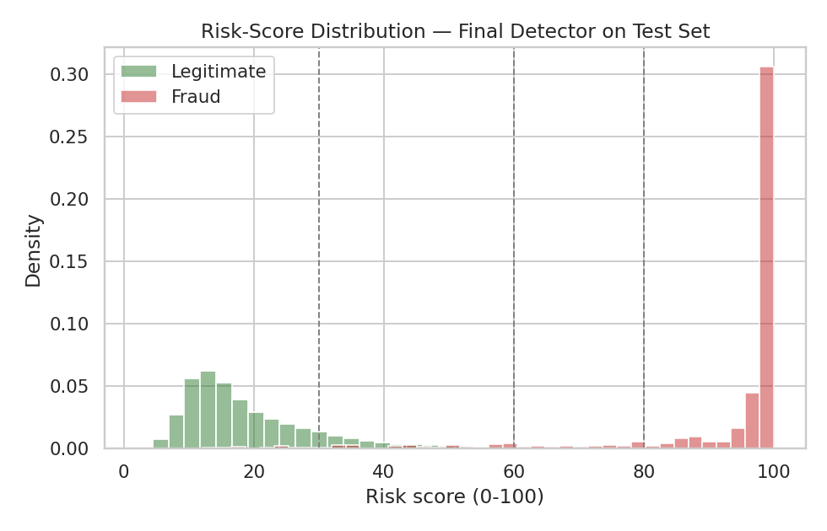
Figure 9 — Risk-score distribution, final detector, held-out test set.

Explainability
Every flagged transaction is explained two ways: (1) a global feature-importance ranking from the model itself, and (2) local SHAP TreeExplainer attributions (tree_path_dependent mode) per transaction, converted into a plain-English narrative so a non-technical reviewer can understand the decision without knowing what SHAP is. Example, generated live by the pipeline on a held-out transaction the model scored at maximum risk:
"Risk Score: 100.0/100 (Critical Risk). This transaction shows strong, multiple indicators consistent with fraud. The main contributing signals were: transaction amount, recent failed-transaction count, deviation from recent average spend, and transaction amount (log-scaled)."
In the end-to-end demonstration script (src/demo.py), the same Red-Team attack was scored by both the before- and after-closed-loop detectors: risk score rose from 64.7/100 (High Risk) to 86.5/100 (Critical Risk) on the identical attacked transaction — a concrete, reproducible example of the closed loop improving detection.

Real-World Feasibility in Live Payment Environments
- Feature set is CPU-cheap and computable in real time from a standard transaction stream (amount, merchant category, device, geolocation, rolling velocity counters) — no exotic infrastructure required.
- The closed-loop retraining pattern maps directly onto a production MLOps cycle: scheduled retraining jobs that ingest confirmed-fraud and confirmed-false-negative cases, exactly the "missed attacks" mechanism implemented here.
- The risk-score / explainability output (0–100 score + plain-English narrative) is designed to plug into a human fraud-analyst review queue, not to auto-decline transactions outright, especially in the Medium/High band where precision is weakest.
- Before production use: the model would need training on real, labeled transaction data (this project explicitly does not have or claim access to that), calibration of the 0–100 score against real fraud-loss economics, and a shadow-mode deployment period to validate the precision/recall trade-off against real customer impact.

Limitations
- All data is synthetic; absolute metric values are directionally informative, not production-grade accuracy claims, since they are not validated against real transaction logs.
- Adversarial retraining measurably reduces precision on clean traffic (0.471 → 0.315) — disclosed above, not hidden.
- geo_evasion remains hard to detect even after adversarial training (5.3% after vs 0.7% before) — a genuine limitation of an amount/velocity-centric feature set against attackers who successfully spoof location signals; richer device/IP-reputation features would likely help.
- The Red-Team "adaptive agent" is a local heuristic hill-climbing rule over interpretable parameters, not a hosted large language model — a deliberate reproducibility choice, disclosed here rather than implied otherwise.
- No live payment-network integration: this is a research/hackathon prototype evaluated entirely on synthetic transactions.

Future Work
- Formalize the Red-Team persona adaptation as a contextual bandit rather than a fixed hill-climbing rule.
- Graph-based features (shared device/IP fingerprints across accounts) specifically targeting geo_evasion and merchant_switching, the two hardest-to-catch families in this run.
- Cost-sensitive, per-risk-band thresholds instead of a single global 0.5 cutoff, to recover precision without sacrificing the recall gains from closed-loop training.
- Optional integration with a hosted LLM for natural-language attack ideation on top of the existing numerical attack engine, kept out of this reproducible offline submission by design.

Conclusion
This project delivers a genuine, end-to-end closed loop between an adaptive adversarial attack generator and a retrainable fraud classifier, evaluated entirely on clearly-labeled synthetic data, with every number in this document produced by actually executing the accompanying code. The core result — Red-Team attack detection rising from 11.7% to 62.0% across seven attack families after adversarial retraining, at a disclosed and explained precision cost — demonstrates the value of treating payment-fraud defense as a continuously-adapting system rather than a static classifier, which is the central thesis of this challenge.

