# **Tasks**

**Objective Questions**

**Objective Question 1  
  
What is the total no. of tables present in the data?**

**Guidelines:** Count the total distinct tables in the dataset to understand the base structure for analysis.

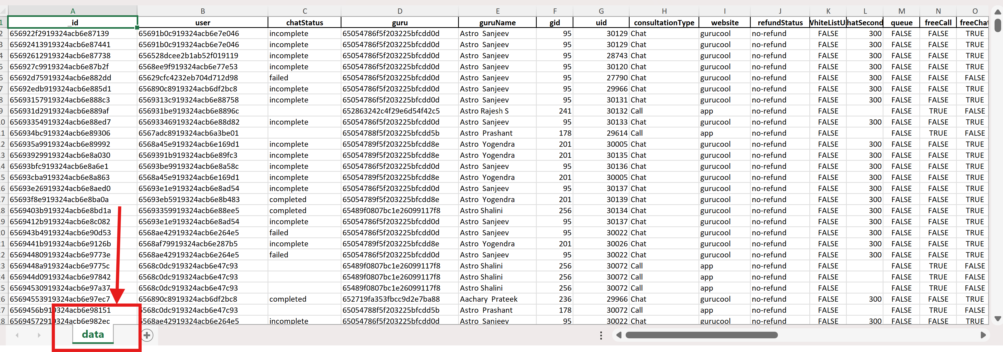**Visualization:** *(showing Table)*

**Observation:**  
The dataset contains only **1 table** named *“data”*. This indicates that all records are consolidated in a single source, simplifying integration but requiring careful cleaning for accurate results.

**Objective Question 2**

**What is the total no. of attributes present in the data?**

**Guidelines:** Count the total number of columns (features/fields) present in the table to measure dataset richness.

**Visualization:** *(showing Attribute Count)*

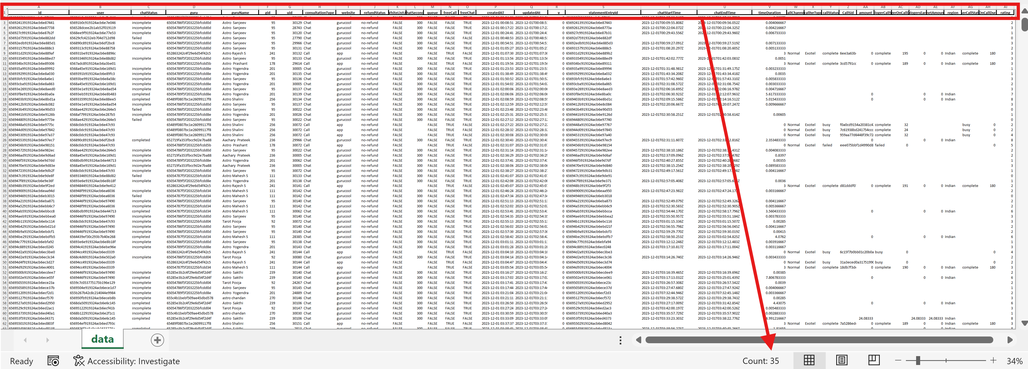

**Observation:**  
The dataset contains **35 attributes**. This wide attribute set provides sufficient detail for multidimensional analysis (e.g., operational, financial, customer metrics). However, some fields may not be equally relevant, requiring preprocessing before use.

**Objective Question 3**

**The data consists of some inconsistent and missing values so ensure that the data used for further analysis is cleaned.**

**Guidelines:** Apply a structured cleaning process including removal of irrelevant fields, standardization of text fields, and imputation of missing values.

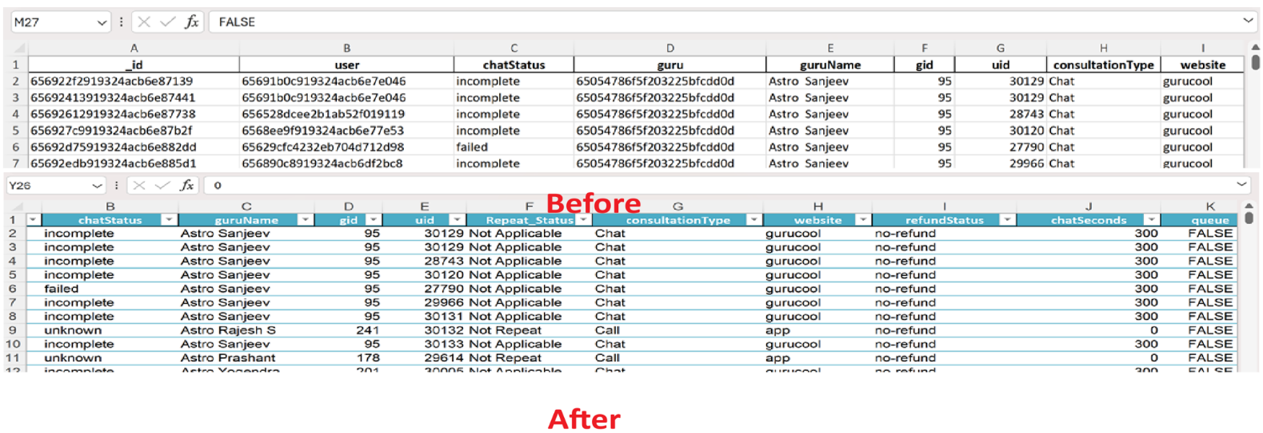**Visualization:** *(Before vs After cleaning table)*

**Observation:**

* **Columns Removed:** Non-essential fields like *user, guru, updatedAt, statementEntryId, chatStartTime, chatEndTime, timeDuration, CallSid* were excluded.
* **Standardization:** The *guruName* column was normalized using the formula =PROPER(TRIM(D2)).
* **Missing Values Treatment:**
  + Numeric blanks were replaced with 0.
  + Categorical blanks were replaced with placeholders (*Not Applicable, Unknown*).

**Final Outcome:** The dataset is now **clean, consistent, and reliable** for summarization, visualization, and advanced analysis.

**Objective Question 4**

**What is the change in daily call volume day by day and also find the average daily call volume?**

**Guidelines:** Analyze daily call volume trends using line charts and calculate average calls per day to understand fluctuations and plan staffing.

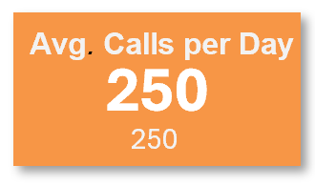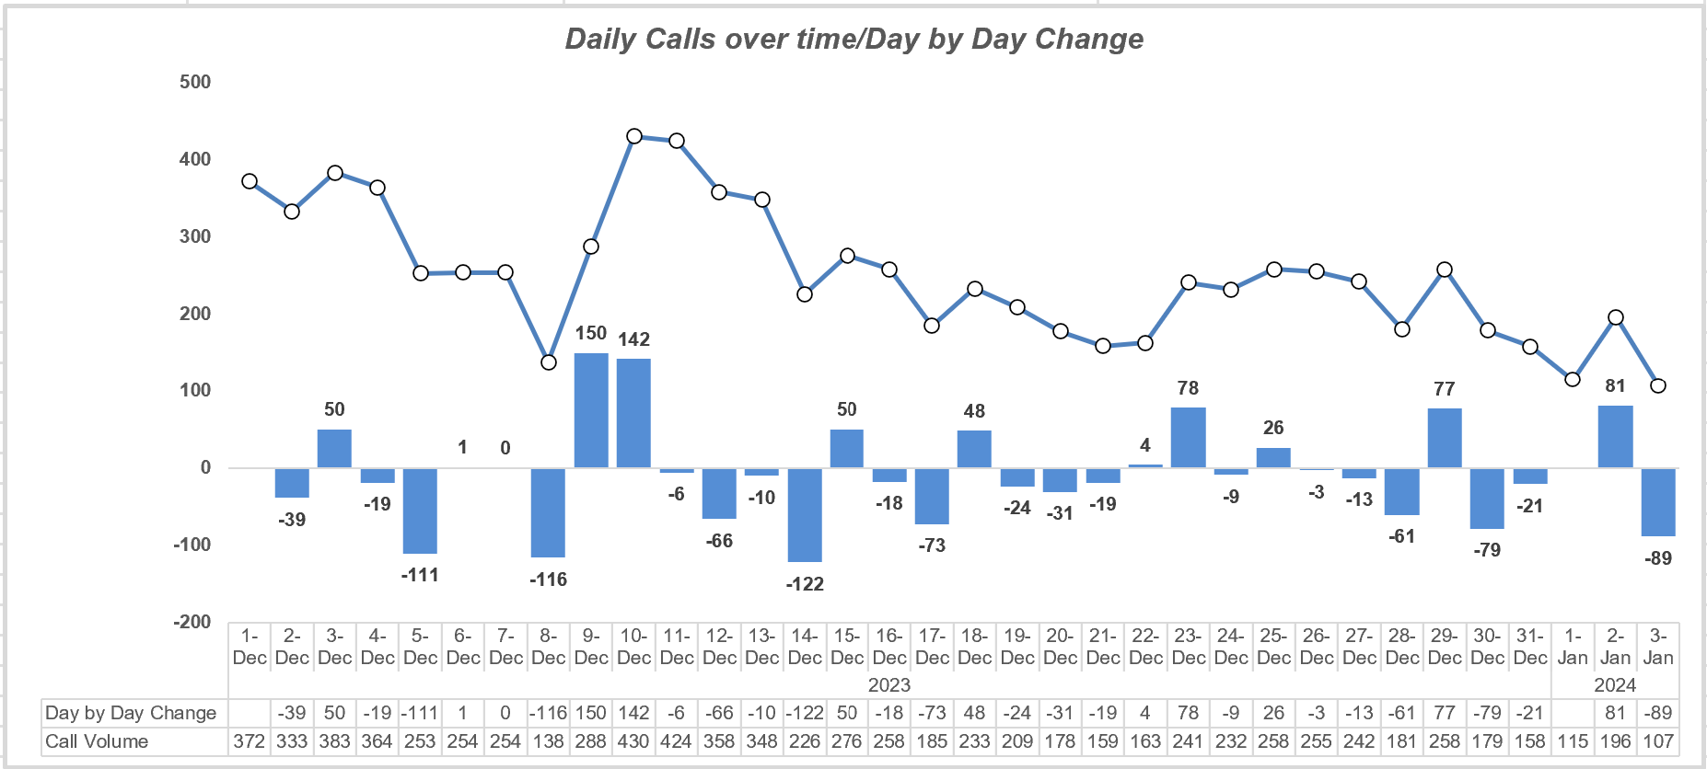**Visualization:** *(Line chart showing Daily Calls over time + KPI card for Average Calls per Day)*

**Observation:**

* The call volume changes significantly from day to day.
* Big drops occurred (–122 on 14-Dec, –116 on 8-Dec), while spikes happened (+150 on 9-Dec, +142 on 10-Dec).
* On average, the call center handles **250 calls/day**.

**Insight:** Call demand is unstable, requiring **flexible staffing**. More agents should be scheduled on peak days, with adjustments on low-demand days.

**Objective Question 5**

**Which months experienced the highest and lowest call volumes?**

**Guidelines:** Compare total call counts across months to identify peak and low demand periods.

**Visualization:** *(Bar chart with Months vs. Total Calls)*

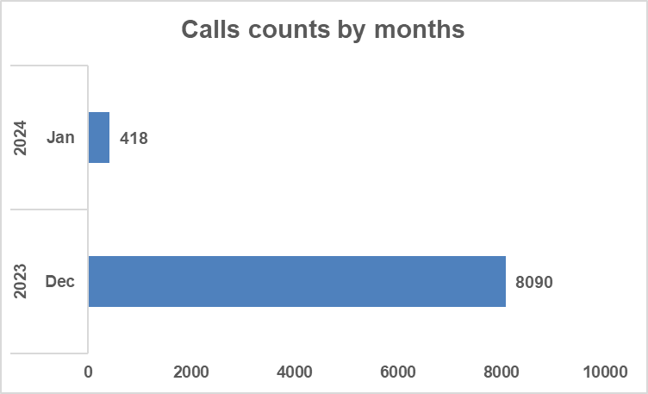

**Observation:**

* **Highest:** December 2023 with **8,090 calls**.
* **Lowest:** January 2024 with **418 calls**.

**Insight:** December is a **high-demand period** requiring more resources, while January is a **low-demand month**, highlighting seasonal variation in customer demand.

**Objective Question 6**

**What is the total operational cost for that month?**

**Guidelines:** Sum monthly costs and align with call volume to assess cost efficiency.

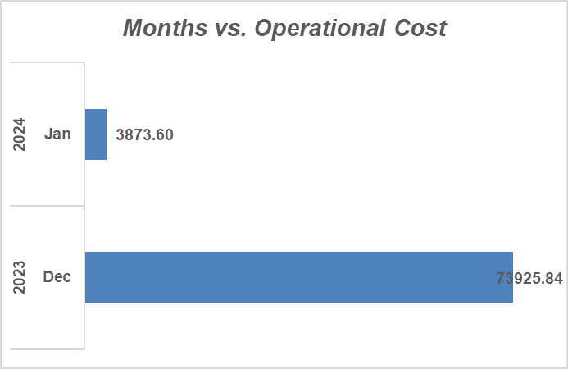**Visualization:** *(Bar chart of Months vs. Operational Cost)*

**Observation:**

* December 2023: **₹73,925.84** (highest cost, aligned with peak calls).
* January 2024: **₹3,873.60** (lowest cost, aligned with fewer calls).
* Total for both months: **₹77,799.44**.

**Insight:** Costs scale directly with call volume. High-volume months significantly drive operational expenses.

**Objective Question 7**

**What is the average number of calls handled per agent per day?**

**Guidelines:** Divide total calls by (number of agents × number of days) to calculate workload distribution.

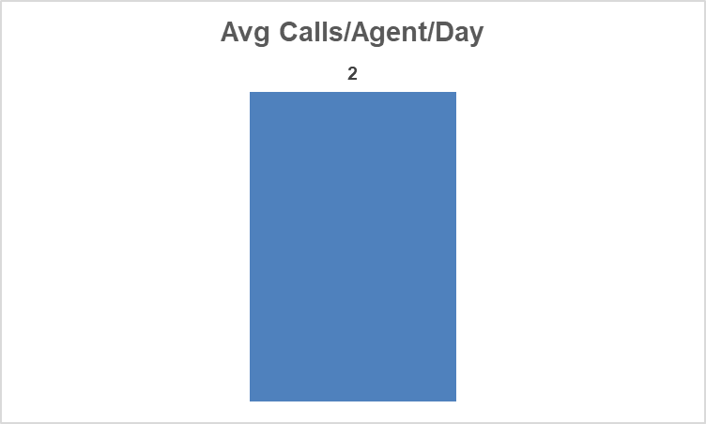**Visualization:** *(simple bar showing Avg. Calls/Agent/Day)*

**Observation:**  
On average, each agent handled **2 calls per day**.

**Insight:** Low utilization suggests overstaffing or inefficiencies in workload allocation.

**Objective Question 8**

**How many repeat callers are there, and what percentage of total calls do they represent?**

**Guidelines:** Count repeat callers and calculate their share of total calls.

**Approach:**

* Dataset filtered on **consultationType = Call**.
* For each unique **User ID (uid):**
  + **First call - Initial Contact.**
  + **Subsequent calls - Repeat Calls.**
* A **pivot table** was used to calculate the number of calls per uid, and then repeat calls were derived by ignoring the first call.

**Logic and Formula Used:**

* Repeat Callers **User with >1 Call** = 1277
* Percentage of Calls Represented by Repeat Callers = 57.35%

**=SUM(BU11:BU1287)**

**=(Repeat Calls/Total Calls)*100**





**Insight for Management:**

* Over **half of all Call-type consultations (57.35%)** come from repeat callers.
* High repeat caller rate indicates:
  + **Low First Call Resolution (FCR).**
  + Customers are calling multiple times for the same/related issues.
  + Increased operational costs and uneven agent workload.

**Objective Question 9**

**What are the total sales generated by the call centre for each product category?**

**Guidelines:** Aggregate sales by category to assess revenue contribution.

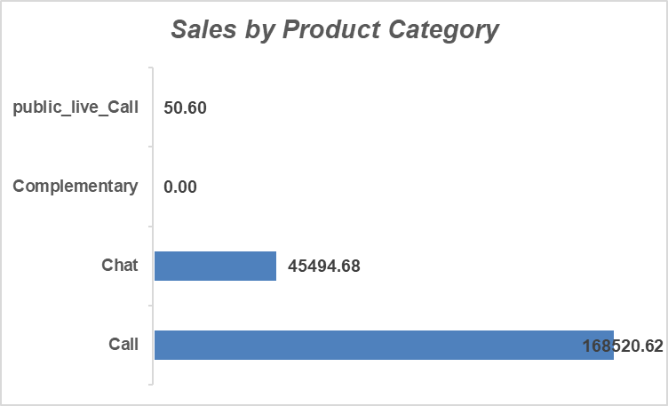**Visualization:** *(Bar chart chart showing Sales by Product Category)*

**Observation:**

* Calls: **~79% of sales** (dominant contributor).
* Chats: **~21% of sales**.
* Public Live Call & Complementary: negligible.

**Insight:** Revenue is **heavily dependent on Call consultations**, requiring diversification to reduce risk.

**Objective Question 10**

**How many calls were made for each user ID and guru ID?**

**Guidelines:** Count calls grouped by User ID and Guru ID.

**Visualization:** *(Pivot summary table or Column chart: User vs Guru Calls*

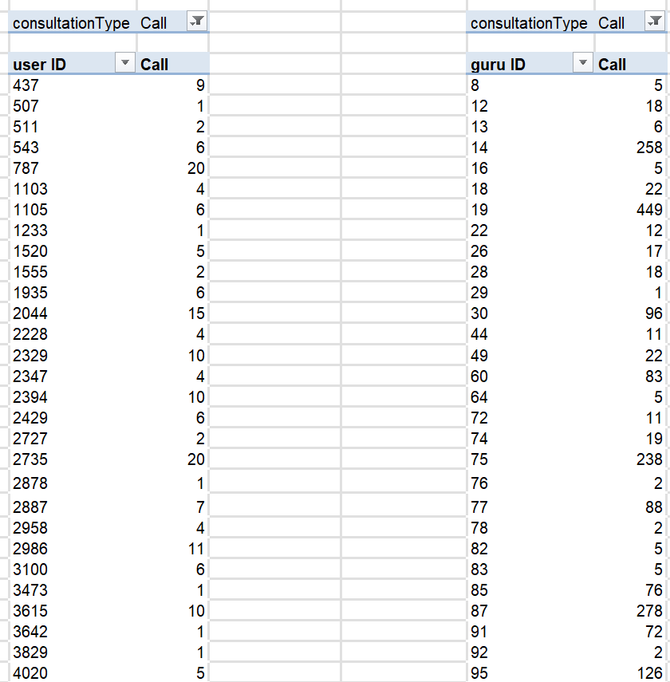

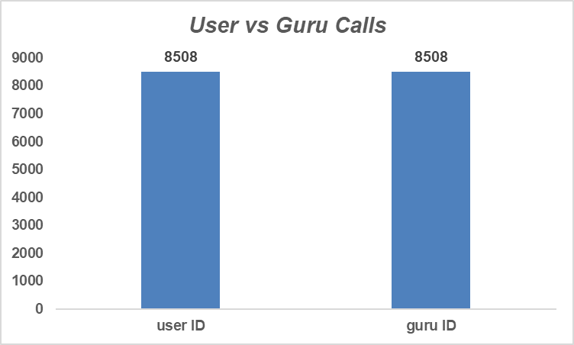

**Observation:**

* Total: **8,508 calls** for both User IDs and Guru IDs.
* Breakdowns identify:
  + High-frequency users (loyal customers).
  + Top-engaged gurus (high workload).

**Insight:** This segmentation supports **retention strategies** and **workload balancing**.

**Objective Question 11**

**What is the correlation between call duration and customer satisfaction?**

**Guidelines:** Use correlation function (=CORREL(duration, rating)) to check relationship.

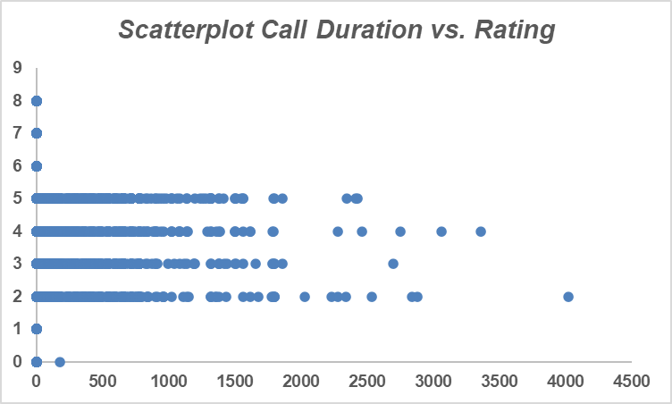**Visualization:** *(Scatterplot Call Duration vs. Rating)*



**Observation:**

* Correlation: **0.055 (near zero)**.
* Longer calls ≠ higher satisfaction.

**Insight:** **Quality of interaction** (clarity, empathy, resolution) drives satisfaction more than duration.

**Objective Question 12**

**Which guru has the highest and lowest customer satisfaction scores?**

**Guidelines:** Aggregate average ratings by Guru and identify top/bottom performers.

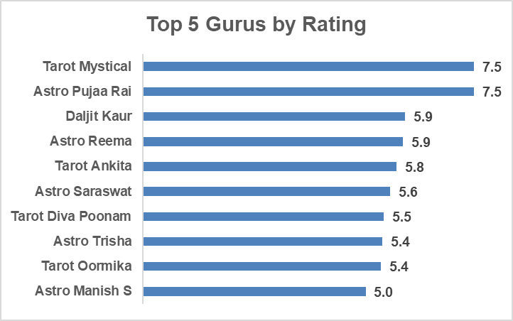**Visualization:** *(Bar chart — Top 10 vs. Bottom 10 Gurus by Rating)*

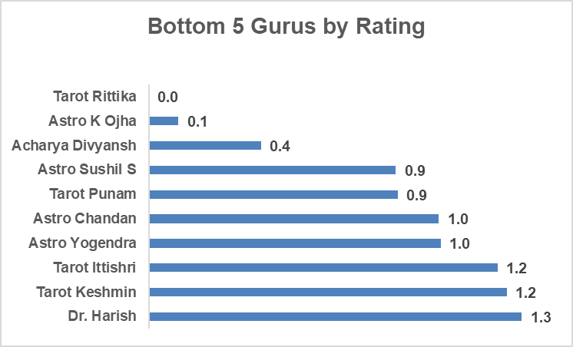

**Observation:**

* **Highest:** Multiple gurus with **7.5** rating.
* **Lowest:** Some gurus with **0.0** rating.

**Insight:** Wide variation highlights a need for **training low performers** while leveraging best practices from top gurus.

**Objective Question 13**

**What is the average customer satisfaction score by month?**

**Guidelines:** Group average ratings by month to assess trends.

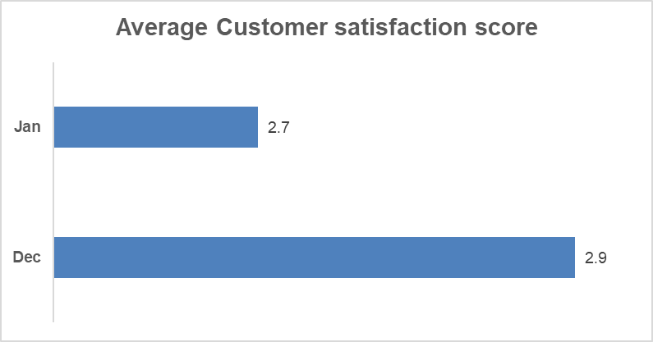**Visualization:** *(Column chart: Months vs. Avg. CSAT)*

**Observation:**

* December: **2.9**
* January: **2.7**

**Insight:** Scores remain **consistently low (<3)** - urgent need to improve service quality.

**Objective Question 14**

**How many categorical columns are there in the data?**

**Guidelines:** Identify and count columns that contain categorical (non-numeric) data.

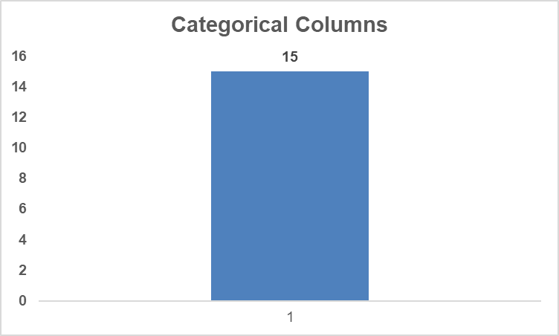**Visualization:** *(Categorical Count)*

**Observation:**

After analyzing the dataset, I found **15 categorical columns**. These are fields that represent categories or qualitative data rather than continuous numeric values.  
**Columns Identified:** chatStatus, consultationType, website, refundStatus, isWhiteListUser, queue, freeCall, freeChat, callChannel, callIvrType, callStatus, astrologerCallStatus, region, userCallStatus, rating.

**Subjective Questions**

**Subjective Question 1**

**Should the investment be used to hire more agents, improve training programs, or upgrade call center technology?**

**Guidelines:** To evaluate whether AstroSage should hire more agents, improve training programs, or upgrade call center technology, I analyzed the dataset using pivot tables, averages, and call/rating distributions. The findings and recommendations are below:

**Hiring More Agents:**

* Avg calls per agent per day = **2** (8508 calls ÷ 148 gurus ÷ 34 days).
* Top 10 Gurus handled **>10,000 calls combined**, bottom 10 Gurus handled only **24 calls**.

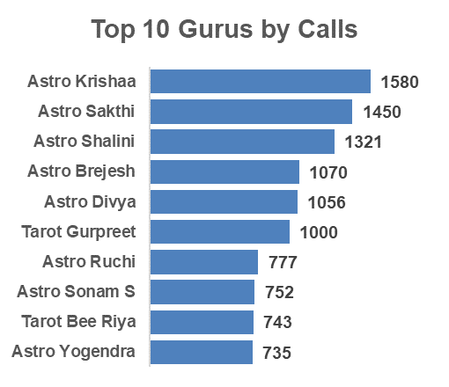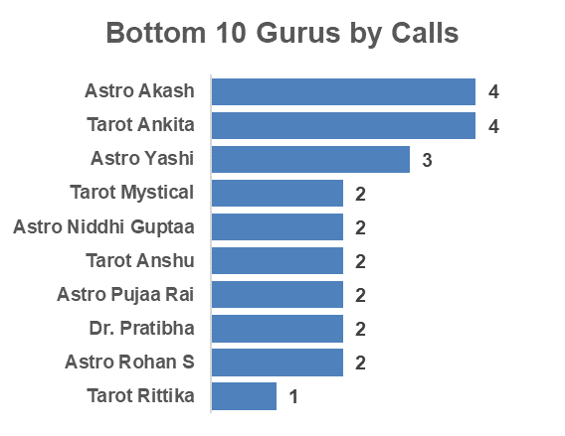

* Large **workload imbalance** + underutilization.

**Insight:**

* Current team is not overworked; the issue is **uneven distribution of calls**, not shortage of manpower.

**Recommendation:**

* Do not hire more agents immediately.
* Focus on **load balancing through smart call routing**.
* Hire only if future demand rises and top performers remain overloaded.

**Improving Training Programs:**

* Avg ratings range from **7.5 (top gurus)** to **below 1.0 (bottom gurus)**.

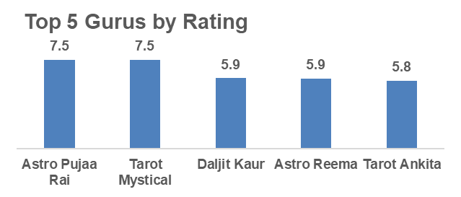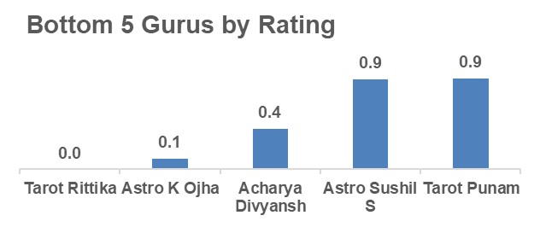

* Some Gurus take **longer call durations but still get poor ratings**.
* Some Gurus like **Astro Aishwarya (417 sec)** & **Astro Anju (387 sec)** take very long calls but their ratings are only **3.3–3.6** - indicates inefficiency.
* On the other hand, **Tarot Srishti (145 sec, rating 4.9)** and **Astro Lakshmi (69 sec, rating 4.1)** handle **shorter calls** but deliver **much higher ratings**.
* Top-rated Gurus resolve faster **with higher CSAT**.

**Insight:**

* Service quality gaps are due to **skill and efficiency differences**.
* High-performing Gurus provide a **benchmark for training content**.

**Recommendation:**

* Develop **structured training modules** based on top-performer practices.
* Regular coaching for low performers.
* Use performance dashboards (rating + avg call duration) to track improvement.

**Upgrading Call Center Technology:**

* **34% of calls failed or went unanswered** (13.9% failed + 20.3% no answer).
* 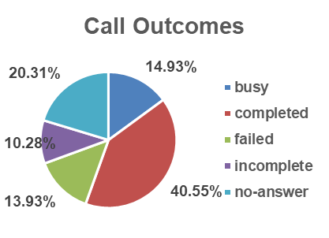**Call Outcomes (8,508 total):** 40.5% completed, **59.5% failed/busy/no-answer/incomplete**.
* 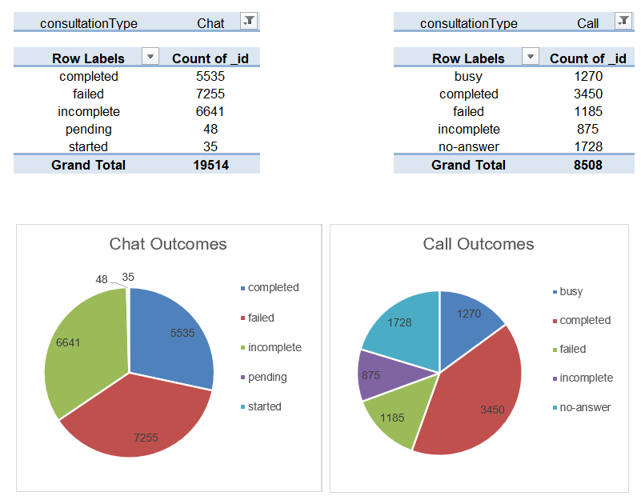**Chat Outcomes (19,514 total):** Only 28% completed, **71% failed/incomplete**.
* High **drop & failure rates** across both channels - indicates **tech inefficiency**
* Current tech not supporting efficient call handling.

**Insight:**

* Technology inefficiencies are directly causing **lost calls, customer frustration, and repeat calls**.

**Recommendation:**

* Invest in **CRM system** with smart routing.
* Improve IVR & callback systems to reduce failed/no-answer calls.
* Enable **real-time monitoring dashboards** for supervisors.

**Final Priority Order**

1. **Upgrade Technology (High Priority)** – fixes call drop issues.
2. **Improve Training (Medium Priority)** – reduces quality gap & repeat calls.
3. **Hire More Agents (Low Priority)** – not required until demand increases.

**Analytical Tools Used:**

* PivotTable/Pie chart (Calls by Status, Avg. Rating by Guru).
* Bar Chart (Guru Rating comparison).
* COUNT & AVERAGE functions to summarize efficiency.

**Subjective Question 2**

**What are the potential risks of each investment option (hiring, training, technology upgrades), and how can they be mitigated?**

**Guidelines:** Identify risks for hiring, training, and tech upgrades. Use spreadsheet functions (COUNT, AVERAGE) and visualizations (line/bar charts) to quantify impact.

**Insights & Risks:**

* **Hiring Agents:**
  + *Risk:* Increased salary/benefit costs; rushed hiring may dilute service quality.
  + *Mitigation:* Adopt phased hiring, competency-based recruitment, and align hiring with peak demand.
* **Training Programs:**
  + *Risk:* ROI uncertainty if training doesn’t lead to improved metrics; resistance from experienced agents.
  + *Mitigation:* Benchmark against top performers, use mentorship, and link incentives to adoption.
* **Technology Upgrades:**
  + *Risk:* High upfront cost, adoption resistance, and temporary disruption.
  + *Mitigation:* Pilot rollout, ensure user-friendly tools, provide onboarding and post-go-live support.

**Recommendations:**

* A **hybrid approach** works best: selective hiring for peak load, continuous training for quality improvement, and gradual adoption of scalable technology.



**Analytical Tools Used:**

* PivotTable (Calls by Hour/Day - hiring needs).
* AVERAGE() - training impact comparison.
* Line Chart - resolution rate before/after tech upgrades.

**Subjective Question 3**

**How does AstroSage's call center performance compare to AstroGuru's average call volume, customer satisfaction, and agent performance? Will you use any aggregation function or visualization?**

**Guidelines:** Use internal metrics first (call volume, CSAT, agent ratings) via PivotTables and visualizations. If competitor data becomes available, extend to benchmarking.

**Insights:**

* AstroGuru data not available - no direct benchmarking possible.
* Internally, AstroSage shows fluctuating call volumes, moderate utilization, and wide variation in agent performance.

**Recommendations:**

* Continue tracking internal metrics (volume, CSAT, ratings).
* Prepare baseline KPIs for future comparison when AstroGuru data is accessible.
* Use insights to **strengthen weak areas** before external benchmarking.

**Analytical Tools Used:**

* PivotTable (COUNT calls, AVERAGE ratings).
* Bar/Line Charts (agent performance, call volume trends).

**Subjective Question 4**

**How can the call center improve its handling of peak call periods to ensure high customer satisfaction?**

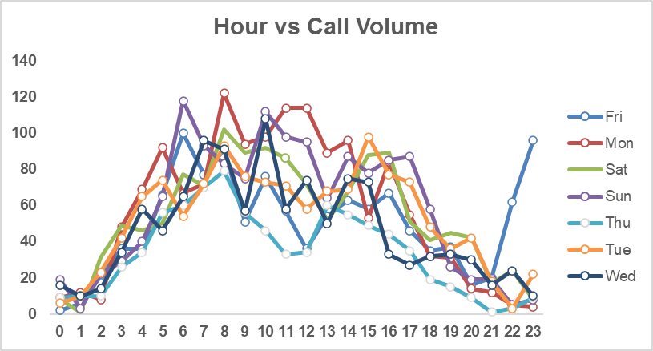**Guidelines:** Analyze call distribution by time/day to identify peak hours. Recommend operational and technology strategies.

**Insights:**Peak demand occurs **8 AM – 12 PM**, with the sharpest surge on **Monday mornings (122 calls at 8 AM)**.

* Consistent congestion during these periods risks customer dissatisfaction if unmanaged.

**Recommendations:**

1. **Dynamic Staffing:** Increase agent availability during 8 AM – 12 PM and weekends.
2. **Call Routing Optimization:** Deploy smart routing for even workload distribution.
3. **Self-Service Enhancements:** Strengthen IVR and chatbot responses for basic queries.
4. **Real-Time Monitoring:** Use live dashboards to track queues and reassign idle agents.

**Tools Used:**

* PivotTable + COUNT - to aggregate hourly/daily volumes.
* Heatmap (Conditional Formatting) - to highlight peak congestion hours.
* Line Chart - to visualize daily call trends.

**Subjective Question 5**

**Based on historical data, what strategic initiatives should be prioritized to improve efficiency and customer satisfaction?**

**Guidelines:** Examine call completion, repeat callers, and ratings distribution to identify inefficiencies.

**Insights:**

* **Call Completion Rate:** Only 40.56% completed successfully; remainder failed, busy, incomplete, or no-answer.



* **Repeat Callers:** 57% repeat calls - indicates low first-call resolution (FCR).

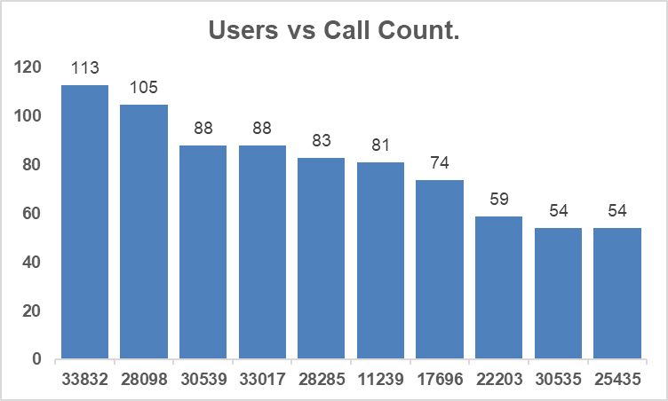

* 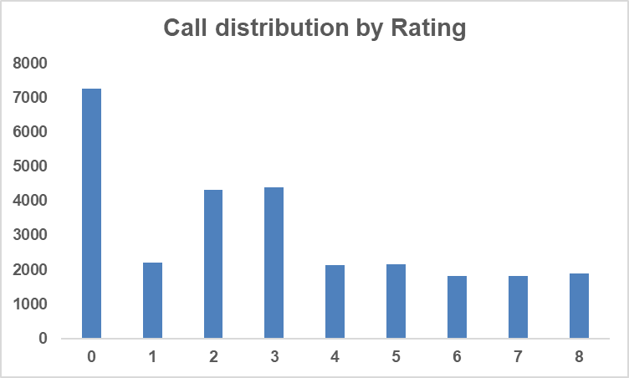**Customer Ratings:** Majority (57%) fall between 0–3; only ~20% rated 6–8.
* **Performance Gap:** Top gurus (7.5 rating) vs. bottom (0.0 rating) show quality inconsistency.

**Recommendations:**

1. **Fix Call Handling Inefficiencies:** Reduce failed/busy/no-answer calls via better routing & availability.
2. **Targeted Training:** Use top gurus’ methods as benchmarks for structured training.
3. **Customer Retention Focus:** Resolve root causes of repeat calls; add call-back feature.
4. **Performance Monitoring & Incentives:** Link agent KPIs to customer satisfaction and FCR.

**Tools Used:**

* PivotTable + COUNT - call outcome breakdown.
* Pie Chart - visualize call completion vs failure.
* Bar Chart - guru rating comparison.
* Conditional Formatting - highlight top vs bottom performers.

**Subjective Question 6**

**What are the key factors contributing to high customer satisfaction scores, and how can these be leveraged to improve overall performance?**

**Guidelines:** Correlate call outcomes, guru quality, and rating distribution to satisfaction levels.

**Insights:**

* High satisfaction (~20% rating 6–8) aligns with:
  + 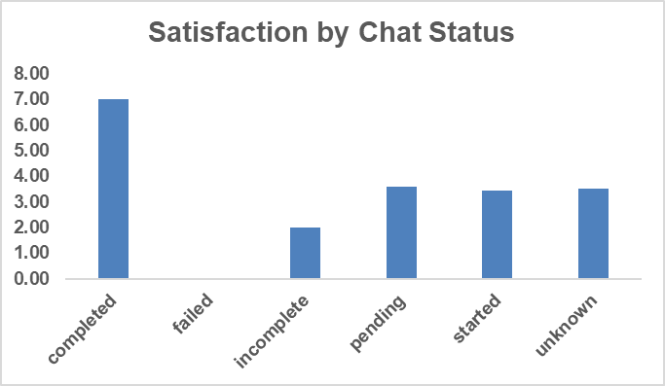**Completed Calls/Chat** - far more likely to earn higher ratings.
  + **Guru Expertise** - Tarot Mystical & Astro Pooja Rai consistently scored 7.5.
  + **Low Call Friction** - fewer dropped/busy calls linked with better feedback.
* 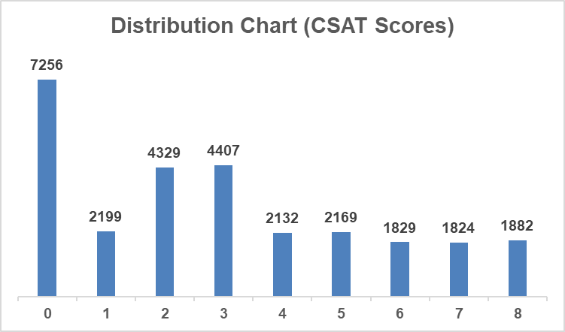Dissatisfaction peaks at Score 0 (7,256 cases, ~26%).

**Recommendations:**

* Replicate **best practices** of high-rated gurus in training modules.
* Increase **completion rates** via improved routing/load balancing.
* Develop **skill enhancement programs** in empathy & communication.
* Collect feedback from high scorers (6–8) to codify successful behaviors.

**Tools Used:**

* Cross-tab/PivotTable - Call Status vs. Rating correlation.
* Bar Chart - Satisfaction distribution (0–8).

**Subjective Question 7**

**How should the call center balance the workload among agents to ensure optimal performance and avoid burnout?**

**Guidelines:** Evaluate consultation counts per astrologer; identify imbalance patterns.

**Insights:**

* **Astro Krishaa:** handled 1,580 consultations - overburdened.
* **Bottom 10 Gurus:** only 1–4 consultations - underutilized.

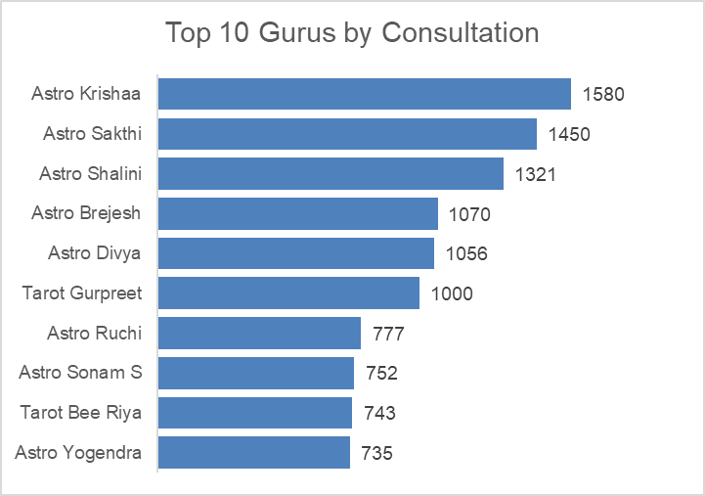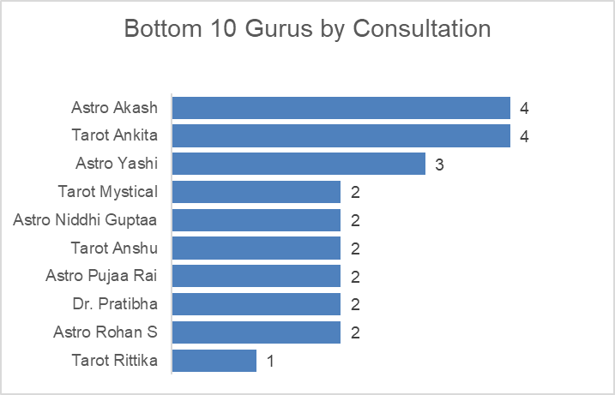

* Wide disparity risks burnout for top performers and disengagement for low performers.

**Recommendations:**

1. **Load Distribution:** Set average consultations as benchmark and reassign excess load to underutilized gurus.
2. **Skill-Based Routing:** Route complex cases to top gurus, simple ones to mid/low workload gurus.
3. **Shift Scheduling:** Align top astrologers’ shifts with peak hours.
4. **Training:** Spread best practices from top gurus to others.

**Tools Used:**

* PivotTable (Guru vs Consultations).
* AVERAGE & STDEV - to measure workload balance.
* Bar/Histogram - show workload disparity.

**Subjective Question 8**

**What new technologies or tools could be implemented to enhance call center operations and customer service?**

**Recommendations:**

1. **CRM System** - centralize customer history, reduce handling time, and ensure continuity.
2. **AI-Powered Call Routing** - balance workload, improve FCR, enhance customer trust.
3. **Speech Analytics** - detect sentiment, flag poor-quality calls, replicate best practices.
4. **Chatbots** - handle FAQs, booking, and repetitive queries to reduce wait times.

**Business Outcomes:**

* Efficiency - reduced AHT, balanced workload.
* Customer Experience - higher CSAT and loyalty.
* Productivity - prevent burnout, improve agent quality.
* Scalability - handle higher call volumes without proportional costs.

**Subjective Question 9**

**What metrics should be included in the final dashboard to comprehensively view call center performance and guide investment decisions?**

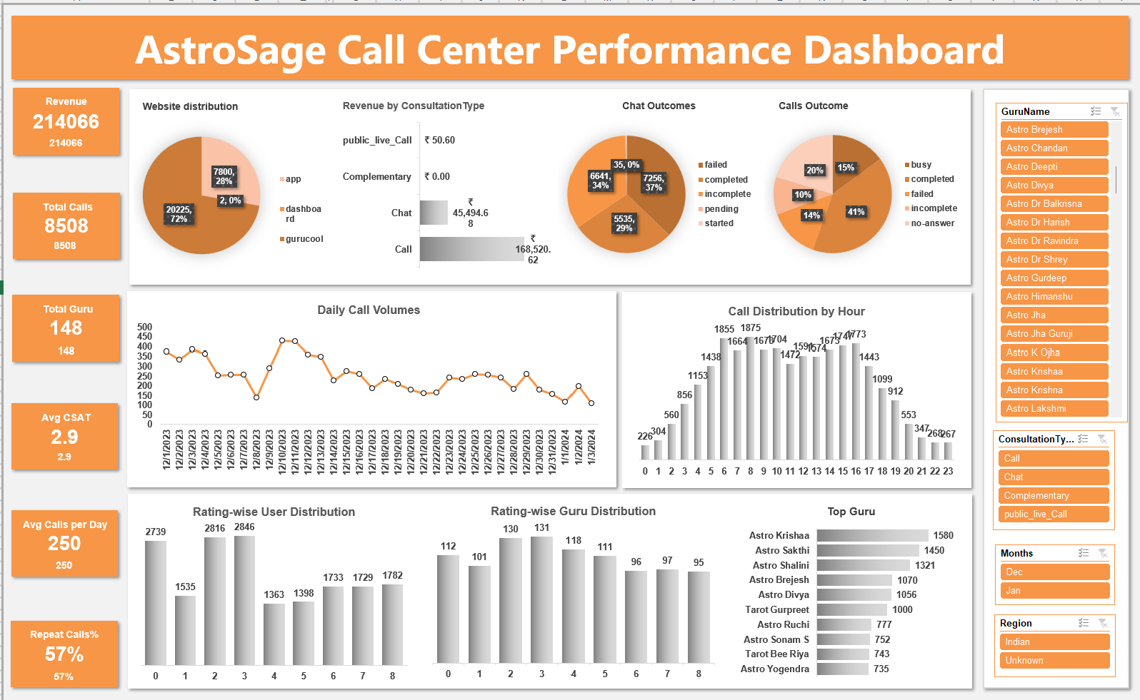**Guidelines:** Include financial, customer, operational, and workforce metrics.

**1. Financial Metrics**

* **Total Revenue:** Shows overall business performance and helps assess ROI of agents and services.
* **Revenue by Consultation Type (Chat, Call, Complementary, Public Live Call):** Identifies which services are most profitable and should be prioritized for investment.
* **Revenue per Call/Chat:** Evaluates profitability per interaction to guide pricing and efficiency decisions.

**2. Customer Experience Metrics**

* **Average CSAT (Customer Satisfaction Score):** Reflects service quality and customer happiness. Low CSAT highlights training or tech gaps.
* **Repeat Caller %:** Indicates how many issues remain unresolved in first contact. A high repeat % (e.g., 57%) shows poor first-call resolution and hints at training or tech improvements needed.
* **Retention Rate (if tracked):** Measures how many customers return, indicating long-term satisfaction.

**3. Operational Efficiency Metrics**

* **Total Consultations (Calls + Chats):** Shows workload handled by the center.
* **Average Calls per Agent per Day:** Helps measure utilization. Current avg (~2/day per agent) highlights underutilization and poor routing.
* **Call/Chat Outcome Distribution (Completed vs Failed/No-Answer/Incomplete):** Critical for identifying inefficiencies. (Example: 41% call completion vs 59% failures - investment in CRM/IVR upgrades is justified.)
* **First Call Resolution (FCR) Rate:** Percentage of issues resolved in the first attempt, directly linked to repeat calls and CSAT.

**4. Workforce & Quality Metrics**

* **Top/Bottom Guru Performance (Calls handled, Avg Rating):** Highlights workload imbalance and quality variation. Supports decisions on training vs hiring.
* **Average Call Duration per Guru:** Identifies inefficiency (long calls + low ratings) and best practices (short calls + high ratings).
* **Training Impact (Pre vs Post-training performance, Avg CSAT improvement):** Shows whether training investments are effective.
* **Incentive Effectiveness (Revenue per Incentivized Agent):** Helps decide if incentive schemes improve productivity or satisfaction.

**5. Interactive Dashboard Features**

* **Slicers:** (Month, Guru Name, Consultation Type, Region) - Allow drill-downs for management to identify trends and problem areas quickly.
* **Visuals:** Pie charts (distribution), Line charts (daily volumes), Bar charts (top gurus, ratings), Scatter plots (efficiency vs quality).

**Recommendation:**

The dashboard should **integrate all four categories** to provide a **360° view of performance**. This ensures that investment decisions are **data-driven** — for example, whether to spend on technology upgrades, training, or additional agents.

**Subjective Question 10**

**How would you allocate a ₹1 crore investment to optimize efficiency, enhance satisfaction, and boost profitability?**

**Guidelines:**

* Analyze historical data on call outcomes, repeat callers, agent utilization, and satisfaction scores to identify key bottlenecks.
* Use percentage allocation to distribute investment among technology, training, incentives, and hiring based on severity of issues and potential ROI.
* Define KPIs to measure the impact of each investment stream.
* Use visual tools (pivot tables, bar/pie charts) to illustrate decision rationale.

**Analysis & Insights**

* **Operational Inefficiencies:** 59% calls not completed (busy, failed, no-answer).
* **Workload Utilization:** 148 agents but avg. only 2 calls/day - underutilization + imbalance.
* **Customer Dissatisfaction:** Avg. CSAT <3/8 and 57% repeat calls - unresolved queries.
* **Top vs Low Performers:** Big gap in guru ratings - quality inconsistency.

**Recommended Allocation:**

* **Technology Upgrade:** ₹40L (40%) - CRM, platform stabilization, reduce failed calls.
* **Training & Development:** ₹35L (35%) - Guru Excellence Program for skill enhancement.
* **Performance Incentives:** ₹15L (15%) - bonuses tied to CSAT & FCR improvements.
* **Phased Hiring:** ₹10L (10%) - selective scaling once efficiency gains are realized.

**Dashboard KPIs to Track ROI:**

* Financial: Revenue, Operational Cost.
* Quality: Avg CSAT Score.
* Volume: Total Consultations, Repeat Calls %.
* Efficiency: Avg Calls per Agent per Day.

**Executive Recommendation:**  
Invest first in **technology and training**, as these address root causes of inefficiencies and low satisfaction. Hold hiring until these investments demonstrate measurable improvements. Incentives help in boosting performance early, while technology and training build sustainable growth and customer loyalty.