**Lab 7: Design of a Traffic Light Controller**

**Demonstration of traffic light controller**

Upper inter section of cross road of the TLLC board is given in following figure. In this figure1,2,3,4 are the 4 lanes. R1,Y1,G1 are the red , yellow and green lights of the lane 1. PA6,PA7,PB0 are the ports for R1,Y1,G1 correspondingly.

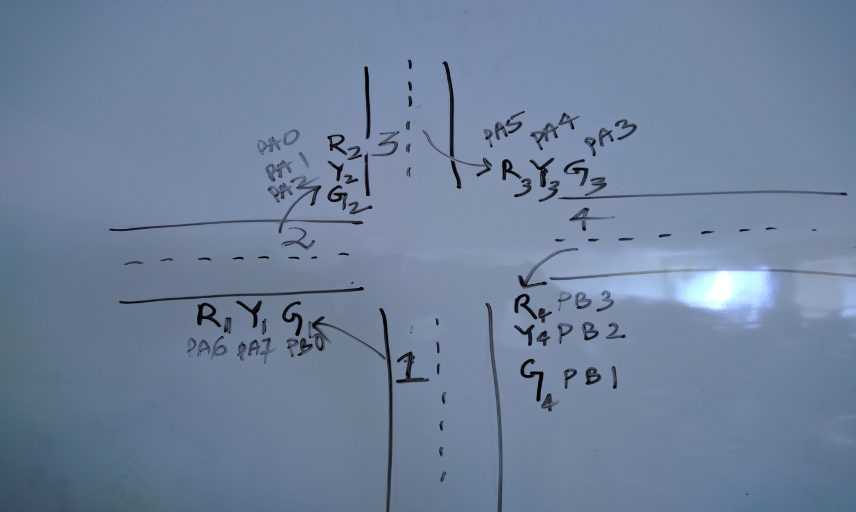

The following table describes the different states of the ON lights at the intersection, their corresponding ports and the value of A,B,C required to glow the LEDs for the specific ports.

DELAY2 is the delay between green to yellow or red to yellow. (5 seconds delay)

DELAY1 is the delay between yellow to green or yellow to red. (1 second delay)

|  |  |  |  |  |  |  |
| --- | --- | --- | --- | --- | --- | --- |
| STEP NO | ON LIGHT | CORR PORT BIT | VALUE OF A | VALUE OF B | VALUE OF C | DELAY |
| 1 | G1 R4 R2 R3 | PB0 PB3 PA0 PA5 | 21 | 09 | 00 | DELAY2 |
| 2 | Y1 R4 Y2 R3 |  |  |  |  | DELAY1 |
| 3 | R1 R4 G2 R3 |  |  |  |  | DELAY2 |
| 4 | R1 R4 Y2 Y3 |  |  |  |  | DELAY1 |
| 5 | R1 R4 R2 G3 |  |  |  |  | DELAY2 |
| 6 | R1 Y4 R2 Y3 |  |  |  |  | DELAY1 |
| 7 | R1 G4 R2 R3 |  |  |  |  | DELAY2 |
| 8 | Y1 Y4 R2 R3 |  |  |  |  | DELAY1 |

Sample code for the state of ON light described in step 1 of the above table :

MOV AL,80

MOV DX,8006

OUT DX,AL

MOV AL,**21**

MOV DX,8000

OUT DX,AL

MOV AL,**09**

MOV DX,8002

OUT DX,AL

MOV AL,**00**

MOV DX,8004

OUT DX,AL

DELAY 2(5 seconds delay)

**NB: Above mentioned 8 steps is a single round. This round will be repeated continuously.**

**Assignment**

1**:** Implement a program for traffic light control as explained above in the TLLC board for both intersections of cross road. There are 24 LEDs whose function is associated with a color.

2. Write a program to flash all red lights for 5 seconds, all yellow lights for 1 second and all green for 2 seconds in continuously

Submission:

**(Hardcopy submission in the Lab: 14th September)**