Angrybird

Brief description: A Qt program of game of angrybird, written by c++, applied box2D(physical engine tools).

How to play: Execute the program, you will start with a start window that u can choose to start the game or exit the game. Press play then enter a game view. There have several birds on the screen. Just put the mouse on the bird over the sling and press left mouse button then pull without release mouse button (attention!!do not let the bird touch the ground wile moving.) aimig the target then release the mouse button, the bird will emit. Once emit the bird you can press right button to use extra function of each different bird. An if the bird hit the pig, score will increase till the birds are use out. Game will automaticlally jump out to end view. You then can choose to restart or terminate the game. Also, you can reset the game by pressing the reset button anytime during the game.

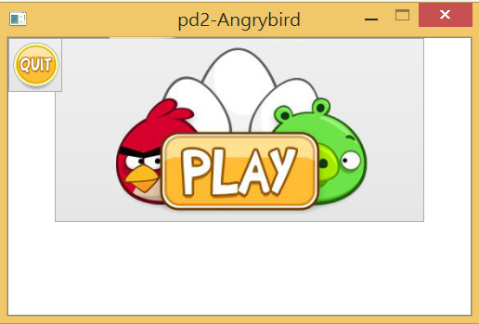

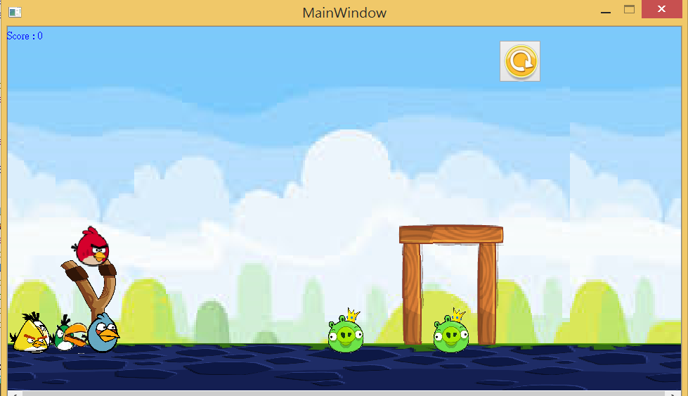

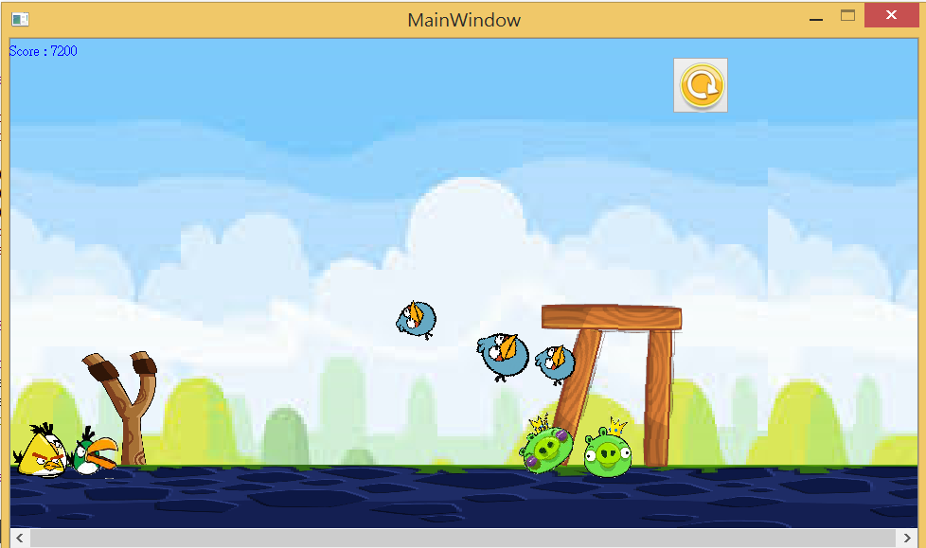

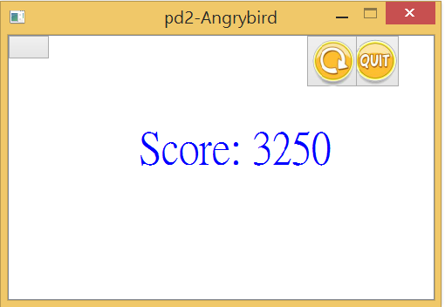

Structure:A Mainwindow is where the project all object be created and inferected in the field. Which handle mouseevent. GameItem is the bass class of birds, enemy(pigs), wood bricks end etc. Inherite from GameItem, each class has it own version of function designed by polymorphism technique. By the way, start and end windows are independent view from Mainwindow to deal with the menu. Contactlistener is used to detect collisions and response to them using box2D library.

UMl diagram: