

**A Study of Paper: Dengue Epidemic in Jamshedpur-Tata Main Hospital (TMH) Experience**

**Project Report for IS4250 Healthcare Analytics**

Submitted to: Prof [Chan Wai Mun, Raymond](mailto:discwmr@nus.edu.sg?subject=IVLE:)

Submitted by: IS4250 Group 22

Liu Han A0091705H

Qin Tian A0105694B

Piyush Varanjani A0105178H

Table of Contents

1.Introduction 3

2.Data 4

2.1 Problems of Interest 4

2.1.1 Symptoms vs Severity of Dengue 5

2.1.2 Symptoms vs Death Rate 5

3.Analysis 5

3.1 Background Information 5

3.2 Descriptive Statistics 8

3.3 Symptoms vs Severe Dengue 10

3.4 Symptoms vs Death 11

4.Discussion 11

5.Limitations 13

6.Conclusion 13

# 1.Introduction

Dengue is a mosquito-borne tropical disease caused by the dengue virus[1] and is spread by several species of mosquito of the Aedes type. Symptoms of dengue vary from just mild febrile illness to life threatening diseases.

Nowadays, dengue is the most rapidly spreading mosquito-borne viral disease in the world and currently there is no vaccine for it. Singapore, as it is a tropical city, also suffers a lot from this disease. However, there have been few case reports on the clinical and laboratory data in patients with dengue from the eastern part of the subcontinent.

In order to learn more about dengue, our team picks this paper – “Dengue Epidemic in Jamshedpur-Tata Main Hospital (TMH) Experience” from Journal of Tropical Diseases & Public Health. Below is the abstract of the paper:

**Aim:** This study was aimed to evaluate the clinical profile and laboratory data of patients admitted in TMH, Jamshedpur in order to understand better the clinical pattern and severity of the disease and to identify the factors associated with bad outcome.

**Method:** A retrospective study of the case records of confirmed dengue fever cases admitted to the medical wards of TMH, Jamshedpur (Jharkhand), from September to December 2013 was done. The data analyzed included demographic profile, clinical presentation, biochemical parameters, hematological profile, treatment strategy and clinical outcomes.

Our team view this paper as a valuable one since it is one of a few papers aiming to identify issues related to dengue with solid data. It contributes a lot to the field of health. First of all, it provides public with first-hand laboratory data with dengue disease. Secondly, it identifies the dengue symptoms related with severe dengue as well as death, which will be elaborated in later part. Last but not least, it provides a broader insight into dengue disease.

Therefore, our team decides to analyze this paper and try to replicate several experiment plots based on the related data.

# 2.Data

The original dataset includes 431 cases of dengue disease in TMH. The data includes dozens of variables such as age, gender, location, symptoms and so on. Our team could not find the original dataset online. We emailed the authors but did not get response from the research team. Therefore, our team decides to simulate the dataset so as to replicate experiments plots based on that.

## 2.1 Problems of Interest

The key point our team is interested in is what information we can get from the various dengue symptoms, or in other words, what we can tell from different symptoms of different customers.

### 2.1.1 Symptoms vs Severity of Dengue

As mentioned above, there are various types of symptoms, which can vary from just mild febrile illness to life threatening diseases. It is extremely hard for people to tell how severe the situation could be if the relationship between symptoms and severity of dengue remains unclear. Thus, one focus of the study is to identify the symptoms that are more related to severe dengue so as to provide necessary precautionary measures for patients with these symptoms.

### 2.1.2 Symptoms vs Death Rate

Moreover, the research team wants to move forward and identify the symptoms that are more related to deaths. In this stage, the research team also considers the syndromes.

# 3.Analysis

## 3.1 Background Information

To understand better, the epidemic nature of Dengue, WHO released a report which mentioned that an estimated 50 million dengue infections occur annually (Figure *XX*) and approximately 2.5 billion people live in dengue endemic countries.

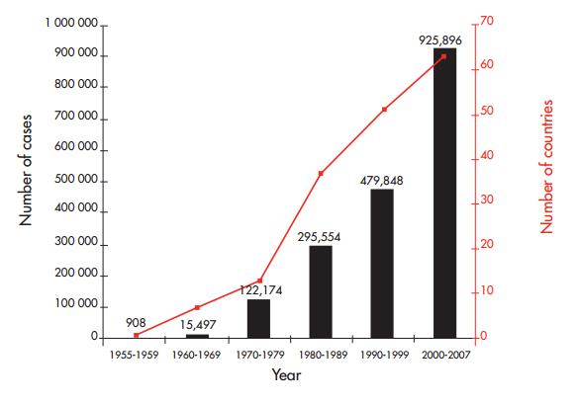Fig 1: Average annual number of dengue fever (DF) and dengue hemorrhagic fever (DHF) cases reported to WHO, and of countries reporting dengue, 1955–2007

All patients with severe dengue should be admitted to a hospital with access to intensive care facilities and blood transfusion

Infection by any of the four dengue serotypes may be asymptomatic or lead to classic dengue fever (DF) or more severe forms of the disease, hemorrhagic fever (DHF) and dengue shock syndrome (DSS)1.

Currently there are two ways suggested by the WHO for the classification of dengue virus infection, one was introduced in 1997 (Fig. 2) and the other was introduced recently in 2009.

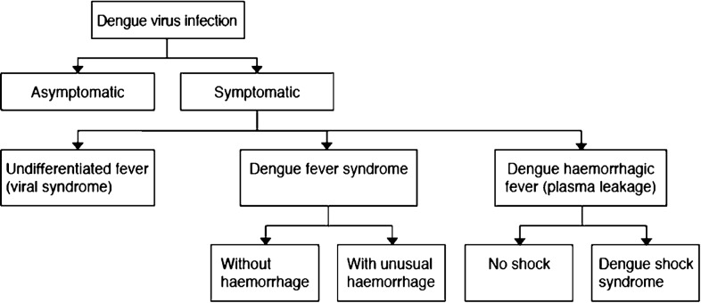

Fig 2. The 1997 revised dengue case classification

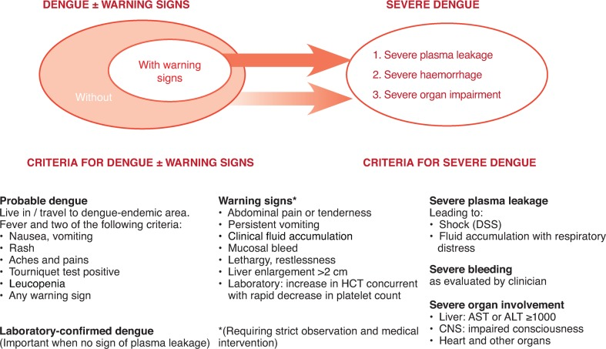

Fig 3. The 2009 revised dengue case classification

Symptomatic dengue virus infections were grouped into three categories: undifferentiated fever, dengue fever (DF) and dengue hemorrhagic fever (DHF). DHF was further classified into four severity grades, with grades III and IV being defined as dengue shock syndrome (DSS)2.

## 3.2 Descriptive Statistics

Results were broken down and introduced as mean ± standard deviation (SD) for continuous variables. For qualitative variables, frequency and percentage were given. Chi square test was used to compare categorical variables and a value of ≤ 0.05 was taken as significant. This approach is appropriate because the sampling method was simple random sampling, and the variables under study are categorical. Random sampling helps to derive meaningful estimates of population parameter such as standard deviation hence it is apt to use. A univariate analysis was done to study the association of the risk factors with disease severity. To remove the effect of confounding factors, a multivariate analysis was done.

Of the total of 431 admitted cases, 257 (59.6 %) were males and 174 (39.4%) were females. The male to female ratio was 1.48:1. Their age ranged from 4 months to 82 years with the average being 26.5 years (SD 14.53). While 242 patients (56.15%) were in the age range of 12 to 30 years, 57 patients (13.22%) were in the pediatric age group (≤ 12 yrs.) and only 3 patients (0.7%) were beyond sixth decade of life.

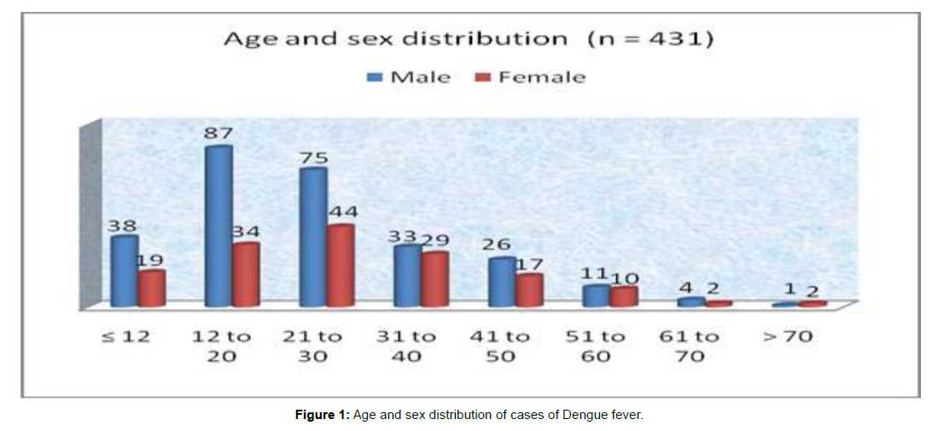

Fig 4: Age and Sex Distribution of cases of dengue fever

Using the WHO criteria of 1997 for classification of dengue severity, out of 431 cases, only 5 patients (1.2%) were classified as dengue shock syndrome (DSS), 16 patients (3.7%) as dengue hemorrhagic fever (DHF), 357 patients (83.3%) had classical dengue fever while the remaining 53 (12.3%) were unclassifiable.

Of these, 6 patients (1.39%) had dengue fever with shock, 46 patients (10.67%) had dengue fever with hemorrhage and 1 patient (0.23%) had dengue fever with acute pancreatitis. The researchers focused on data quality than quantity. One of the KPI in the analysis was the length of stay of the patient. The mean length of hospital stay in the survived group was 4.2 days (SD 1.1).

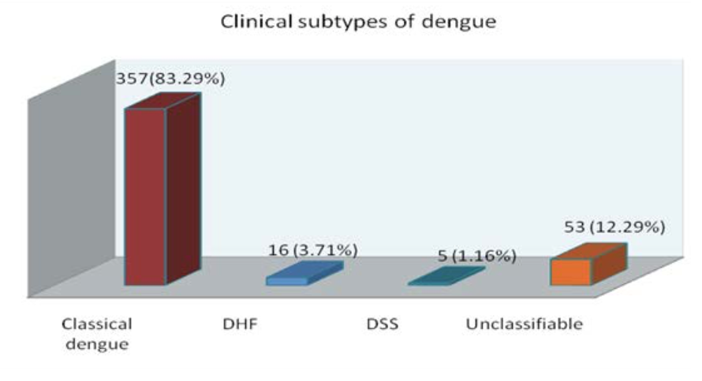

Fig 5: The Clinical Subtype of Dengue Fever

Dengue has a wide spectrum of clinical presentations, from the data analysis it was found that fever was the most common presentation and was found in 350 (81%) of the patients. Mean duration of fever prior to admission was 3.3 days (SD 1.1). 100 patients (23%) had fever > 102°F during the hospital stay.

Vomiting was the most common gastrointestinal symptom described by 201 patients (46.6%) followed by abdominal pain in 66 patients (15.3%), diarrhea in 54 patients (12.5%), gastrointestinal bleed in 54 patients (12.5%) and abdominal distension in 5 patients (1.2%).

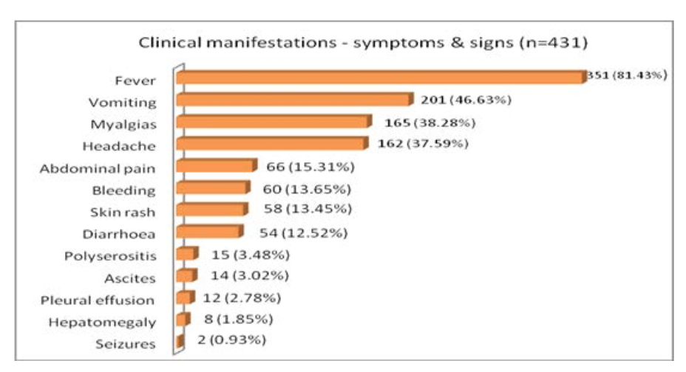

Fig 6: Clinical Manifestations

## 3.3 Symptoms vs Severe Dengue

Based on the basic analysis achieved above, the team then perform chi square test with R to identify what symptoms are highly related to severe dengue. Blow is the result:

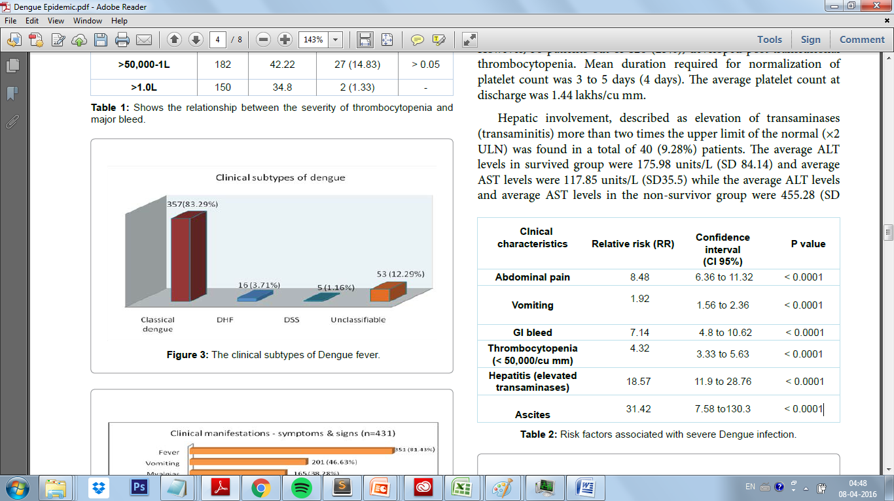

Fig 7: Risk factors associated with severe Dengue infection.

These 6 symptoms turned out to suggest high chance of severe dengue infection. For example, the relative risk (RR), for vomiting here, signifies that "Those who had dengue had 1.92 times the risk of being subjected to vomiting than compared to those who did not have the exposure of dengue."

## 3.4 Symptoms vs Death

Moreover, the team also use chi square test to identify the symptoms that are most related to death. Below is the result:

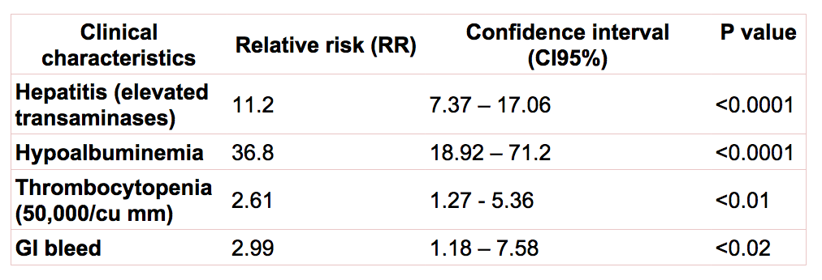

Fig 8: Risk factors associated with death in severe Dengue infection

These 4 symptoms turned out to suggest high chance of death. For example, the relative risk (RR), for Hypoalbuminemia here, signifies that “Those who had Hypoalbuminemia had 36.8 times the risk of being subjected to vomiting than compared to those who did not have the exposure of dengue.”

# 4.Discussion

Dengue fever is an infectious disease because there are no specific markers capable of early diagnosis of the disease is endemic in the region difficult from other viruses distinguished. Because of it can with the serious consequence evolution, even is the one fatal disease, this research objective is to attempt to determine the index analysis of definable order of severity clinical and data of laboratory. Our research indicates the classics (CD) form of the disease (96.7%) superiority. These cases during the monsoon (September - December) occurrence. In our research, the eruption of DF and DHF reported in the post-monsoon season that and continues the winter to be taken bad (August to November). The frequency of the case in male dominance of life second and third ten years is highest. In this research, the features seen in the order of frequency were the fever (81%), the vomits (47%), the omodynia (38%), the headache (38%), the abdominal pain (15%), the hemorrhagic displays (14%), skin rash (13.5%), diarrhea (12.5%), ascites (3%), multi-serositises (3.5%), chest cavity fluid (2.8%) and liver tumescent (1.9%).

Exanthema is a prominent clinical symptom, and 3% from 53% reported in a series of severe dengue cases. In our series, it was considered in 13.5% of patients. Myalgia were observed in 38.3% of patients.

Gastrointestinal tract (GIT) was reported as through Ahmed, in the research bleeding (61%) most common the spot. In our research, gastrointestinal bleeding was seen in 13% of cases. Hemorrhage of digestive tract secondary to the capillaries damage, causing the permeability to increase (especially when blood platelet function reduces) or actual destruction and partial hemorrhage. In a research, common hemorrhage performance to bleed GIT (22%) and ecchymosis (18%). In our research pointed out that bleeds other spots are the skin, nose and subconjunctival space.

Pointed out in our research that the most consistent hematological abnormality is the thrombocytopenia for in other research discoveries.

We realized 42(14%) patients to have the serious bleeding manifestation with the thrombocytopenia sickness, does not have the sign of blood plasma leakage. Such manifestations also have been reported that was marked as the unusual hemorrhage dengue fever in other series and these situations.

The liver is one of the dengue fever virus target organs. The liver cell of dengue fever virus induction, the oxygen deficit, the shock or the related liver disease damage were supposed as regarding transaminase the pathogenesis mechanism of occurrence. In our research, hepatic dysfunction was noted in 40 (9.28%) patients including all 16(100%) patients of DHF and 4 (80%) patients of DSS.

Dengue will cause a lot of complications, considering importance issue, we will discuss here one by one.

# 5.Limitations

In our research, we have following limitations:

1. On the data collection, because the study has not include the patients who have visited outpatient department. The data is from a single hospital and it may lead the result not accurate.
2. Laboratory testing and imaging studies may have been biased by clinician selection based on personal recognition of clinical dengue severity.
3. The use of dengue IgM ELISA and card test for NS1ag only for diagnosis due to non-availability of nucleic acid based tests in our hospital.
4. We did not determine the serotype of the virus.

# 6.Conclusion

Dengue infections are a huge burden on healthcare systems; their range is from mild to self-limiting disease to severe fatal illness. It can be diversified, and multi-system manifestations can be recognized. Nonspecific manifestations are highlighted due to the importance of laboratory tests and a high degree of suspicion of the illness to reduce morbidity and mortality. The majority of the cases have the self-resolving process with the disease. The presence of vomiting, abdominal pain, the absence of white blood cells to reduce disease, gastrointestinal bleeding, elevated liver enzymes, thrombocytopenia and ascites are signs of more severe dengue infection, therefore, be considered to be the outcome of the disease, the adverse prognostic indicator. When platelet count is <50,000/cu mm, bleeding manifestations relate to the severity of thrombocytopenia. Hypoalbuminemia and transaminases are very strongly correlated with increased mortality (P<0.0001). The high mortality rate index of suspicion, strict monitoring, and proper fluid resuscitation.

References:

1. Whitehorn J, Simmons CP. The pathogenesis of dengue. Vaccine. 2011;29:7221–8.
2. WHO. Dengue haemorrhagic fever: diagnosis, treatment, prevention and control,

2nd ed. Geneva, World Health Organization, 1997

1. Wikipedia: Dengue fever

   https://en.wikipedia.org/wiki/Dengue_fever