**Bank Loan Analysis**

Agenda: To gain a thorough understanding of our lending operations and track loan performance, I designed a grid view report segmented by 'Loan Status.' This report provides valuable insights into key metrics such as 'Total Loan Applications,' 'Total Funded Amount,' 'Total Amount Repaid,' 'Month-to-Date (MTD) Funded Amount,' 'MTD Amount Repaid,' 'Average Interest Rate,' and 'Average Debt-to-Income (DTI) Ratio.' By delivering these metrics, this report enables data-driven decision-making and helps assess the overall health of our loan portfolio.

SQL Commands:

Sql Query to Fetch the data

KPI’S

Total Loan Application:

. Select COUNT(id ) As Total_Loan_Application from "Bank_Loan_Data "

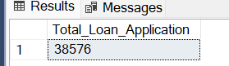

MTD Loan Applications (Month To Date )

. Select COUNT(id ) As MTD_Total_Loan_Application from "Bank_Loan_Data "

Where MONTH(issue_date) = 12 And YEAR (issue_date) =2021

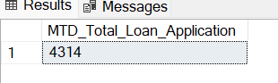

Previous month loan Application :

. Select COUNT(id ) As PMTD_Total_Loan_Application from "Bank_Loan_Data "

Where MONTH(issue_date) = 11 And YEAR (issue_date) =2021

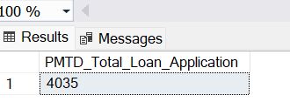



Total Funded Amount:

. Select SUM (loan_amount) As Total_funded_Amount from "Bank_Loan_Data ";

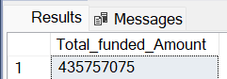

Total Funded Amount MTD(Month To date ):

Select SUM (loan_amount) As MTD_Total_funded_Amount from "Bank_Loan_Data "

Where MONTH (issue_date) = 12 And YEAR (issue_date) = 2021;

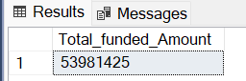

Total Funded Amount PMTD( Previous Month To date ):

Select SUM (loan_amount) As PMTD_Total_funded_Amount from "Bank_Loan_Data "

Where MONTH (issue_date) = 11 And YEAR (issue_date) = 2021;

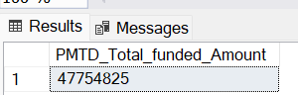

Total Amount Received:

Select SUM (total_payment) As Total_Amount_Recive From "Bank_Loan_Data ";

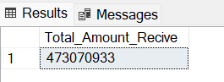

Total Amount received month To Date :

. Select SUM (total_payment) As MTD_Total_Amount_Recive From "Bank_Loan_Data "

Where MONTH(issue_date) = 12 And year (issue_date) = 2021;

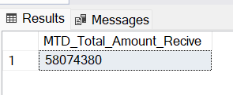

Total Amount received Previous month To Date:

Select SUM (total_payment) As PMTD_Total_Amount_Recive From "Bank_Loan_Data "

Where MONTH(issue_date) = 11 And year (issue_date) = 2021;

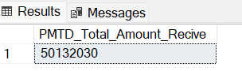

Average interest rate :

Select Round( AVG (int_Rate),4) *100 As Avg_intrest_rate From "Bank_Loan_Data";

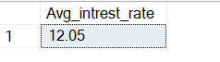

Average interest rate Month to date:

Select Round( AVG (int_Rate),4) *100 As MTD_Avg_intrest_rate From "Bank_Loan_Data"

Where MONTH (issue_date) =12 And Year (issue_date) = 2021;

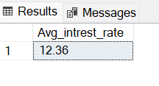

Average interest rate Previous Month to date:

.Select Round( AVG (int_Rate),4) *100 As PMTD_Avg_intrest_rate From "Bank_Loan_Data"

Where MONTH (issue_date) =11 And Year (issue_date) = 2021;

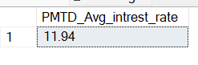

Average DTI :

. Select Round (AVG (dti) ,4 ) *100 As Average_MTD_DTI from "Bank_Loan_Data";



Average DTI _Month To date (MTD) :

. Select Round (AVG (dti) ,4 ) *100 As Average_MTD_DTI from "Bank_Loan_Data"

Where MONTH (issue_date) =12 And YEAR (issue_date) =2021;



Average DTI _previous_Month To date (PMTD) :

Select Round (AVG (dti) ,4 ) *100 As Average_PMTD_DTI from "Bank_Loan_Data"

Where MONTH (issue_date) =11 And YEAR (issue_date) =2021;

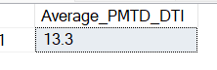

Good_Loan_Precentage:

. Select (COUNT (CASE WHEN loan_status = 'Fully Paid' OR loan_status = 'Current' THEN id END)*100)

/COUNT(id) As Good_loan_Percentage

From "Bank_Loan_Data "

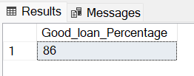

Good Loan Application :

. Select COUNT (id) AS Good_Loan_Application from Bank_Loan_Data

WHERE loan_status = 'Fully Paid' OR loan_status = 'Current';



Good Loan Funded Amount:

. Select Sum (loan_amount) AS Good_Loan_Funded_Amount from Bank_Loan_Data

WHERE loan_status = 'Fully Paid' OR loan_status = 'Current';

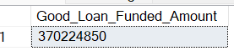

Good Loan Total Received Amount :

. Select Sum (total_payment) AS Good_Loan_Total_Payment_Recived from Bank_Loan_Data

WHERE loan_status = 'Fully Paid' OR loan_status = 'Current';

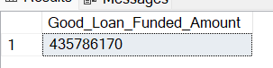

Bad Loan Percentage:

. Select (COUNT (CASE WHEN loan_status = 'Charged off' THEN id END)*100)

/COUNT(id) As Bad_loan_Percentage

From "Bank_Loan_Data "

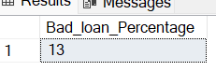

Bad Loan Application:

. Select COUNT ((id) )As Bad_Loan_Application from "Bank_Loan_Data"

WHERE loan_status ='charged off'

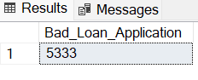

Bad Loan Funded Amount:

. Select Sum ((loan_amount) )As Bad_Loan_Funded_Amount from "Bank_Loan_Data"

WHERE loan_status ='charged off'

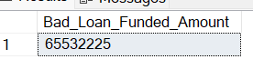

Total Amount Received from Bad Loan:

. Select Sum ((total_payment) )As Bad_Loan_Recived_Amount from "Bank_Loan_Data"

WHERE loan_status ='charged off'

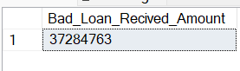

Loan Status:

SELECT

loan_status,

COUNT(id) AS LoanCount,

SUM(total_payment) AS Total_Amount_Received,

SUM(loan_amount) AS Total_Funded_Amount,

AVG(int_rate * 100) AS Interest_Rate,

AVG(dti * 100) AS DTI

FROM

bank_loan_data

GROUP BY

loan_status

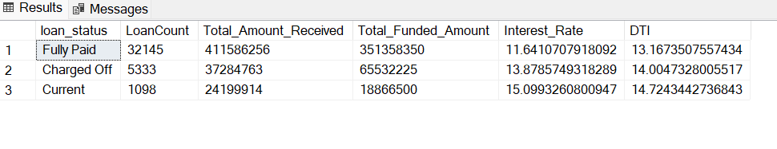

Sum of payment Received on current Month (December)

SELECT

loan_status,

SUM(total_payment) AS MTD_Total_Amount_Received,

SUM(loan_amount) AS MTD_Total_Funded_Amount

FROM bank_loan_data

WHERE MONTH(issue_date) = 12

GROUP BY loan_status

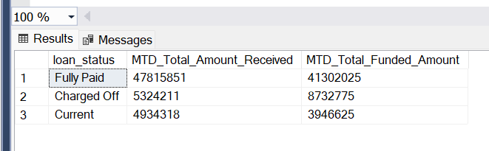

Bank loan report on monthly basis:

. SELECT

MONTH(issue_date) AS Month_Name,

DATENAME(MONTH, issue_date) AS Month_name,

COUNT(id) AS Total_Loan_Applications,

SUM(loan_amount) AS Total_Funded_Amount,

SUM(total_payment) AS Total_Amount_Received

FROM bank_loan_data

GROUP BY MONTH(issue_date), DATENAME(MONTH, issue_date)

ORDER BY MONTH(issue_date)

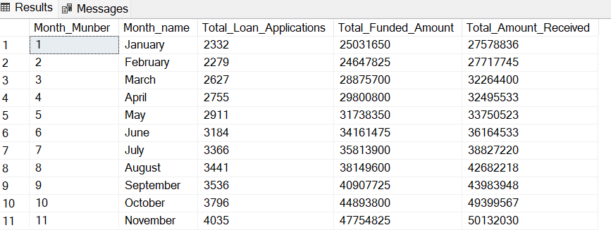

Bank Loan Report on address basis

. SELECT

address_state AS State,

COUNT(id) AS Total_Loan_Applications,

SUM(loan_amount) AS Total_Funded_Amount,

SUM(total_payment) AS Total_Amount_Received

FROM bank_loan_data

GROUP BY address_state

ORDER BY address_state

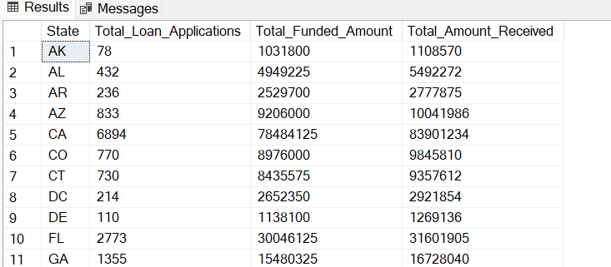

Bank Loan Report on Term basis

. SELECT

term AS Term,

COUNT(id) AS Total_Loan_Applications,

SUM(loan_amount) AS Total_Funded_Amount,

SUM(total_payment) AS Total_Amount_Received

FROM bank_loan_data

GROUP BY term

ORDER BY term

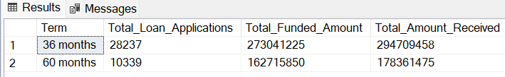

Employee Length :

SELECT

emp_length AS Employee_Length,

COUNT(id) AS Total_Loan_Applications,

SUM(loan_amount) AS Total_Funded_Amount,

SUM(total_payment) AS Total_Amount_Received

FROM bank_loan_data

GROUP BY emp_length

ORDER BY emp_length

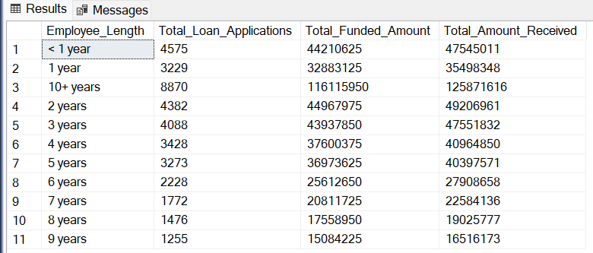

Purpose:

SELECT

purpose AS PURPOSE,

COUNT(id) AS Total_Loan_Applications,

SUM(loan_amount) AS Total_Funded_Amount,

SUM(total_payment) AS Total_Amount_Received

FROM bank_loan_data

GROUP BY purpose

ORDER BY COUNT(id) DESC

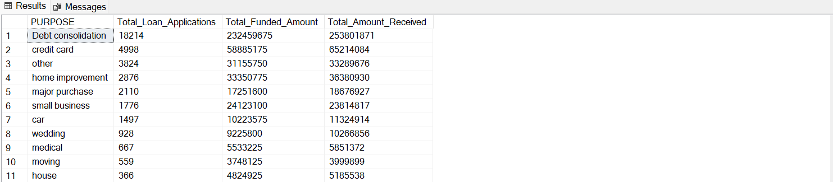

Home Ownership:

SELECT

home_ownership AS Home_Ownership,

COUNT(id) AS Total_Loan_Applications,

SUM(loan_amount) AS Total_Funded_Amount,

SUM(total_payment) AS Total_Amount_Received

FROM bank_loan_data

GROUP BY home_ownership

ORDER BY COUNT (id) DESC

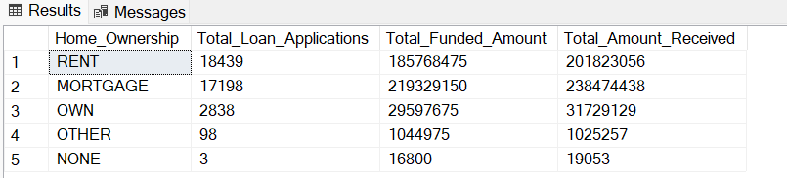

Technical insight: The main goal of the Details Dashboard is to offer an intuitive and comprehensive interface for accessing essential loan data. It acts as a centralized platform for users to obtain in-depth insights into our loan portfolio, borrower profiles, and loan performance.