Group Member List
Chen Tsz Yan (Team Coordinator) 24074387d
Chan Man Pan 25133703d
Wong Kin Chung 24065065D
Tang Wing Yan 24076001D
Mok Pan Yu 22112435D
DSAI4205 – Big Data Analytics
Group Project Report
Table of Contents
1. EDA 2
1.1 Dataset Overview 2
1.2 Dataset Distribution 3
1.3 Data Quality 3
1.4 Review Length 4
1.5 Data Splitting 5
1.6 Evaluation Matrix 5
2. Data Cleaning 6
2.1 Dataset and granularity 6
2.2 Data Quality Assessment 6
2.3 Missing Values and Invalid Entries 7
2.4 Duplicate Handling 7
2.5 Outlier Handling 8
2.6 Standardization and Variable Transformation 8

1. EDA

1.1 Dataset Overview
The Movie Reviews dataset contains 511 records and 4 columns, which includes 3 input attributes (PhraseId, SentenceId, and Phrase) and 1 target variable (Sentiment).
PhraseId and SentenceId columns are identifiers, and they would be excluded from the model’s input features as they don’t provide any useful information for the model to do prediction.
The Phrase contains the textual content of each movie review.
The Sentiment represents the corresponding sentiment classification label, ranging from 0 (negative) to 4 (positive).
The Phrase serves as the primary input feature, while Sentiment serves as the target variable.

1.2 Dataset Distribution
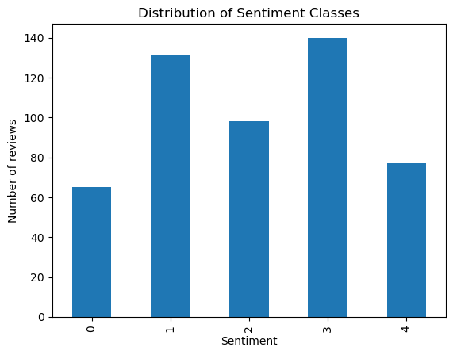(Figure 1.1 Class Distribution)

The dataset exhibits moderate class imbalance. As illustrated in Figure 1, classes 3 and 1 contain more samples than the other classes, while class 0 has the fewest samples. This imbalance may cause the model to be biased towards predicting the majority classes. Hence, we might need to implement data augmentation or class weight for each class.

1.3 Data Quality
There is no missing value and duplicates in the given dataset.

1.4 Review Length
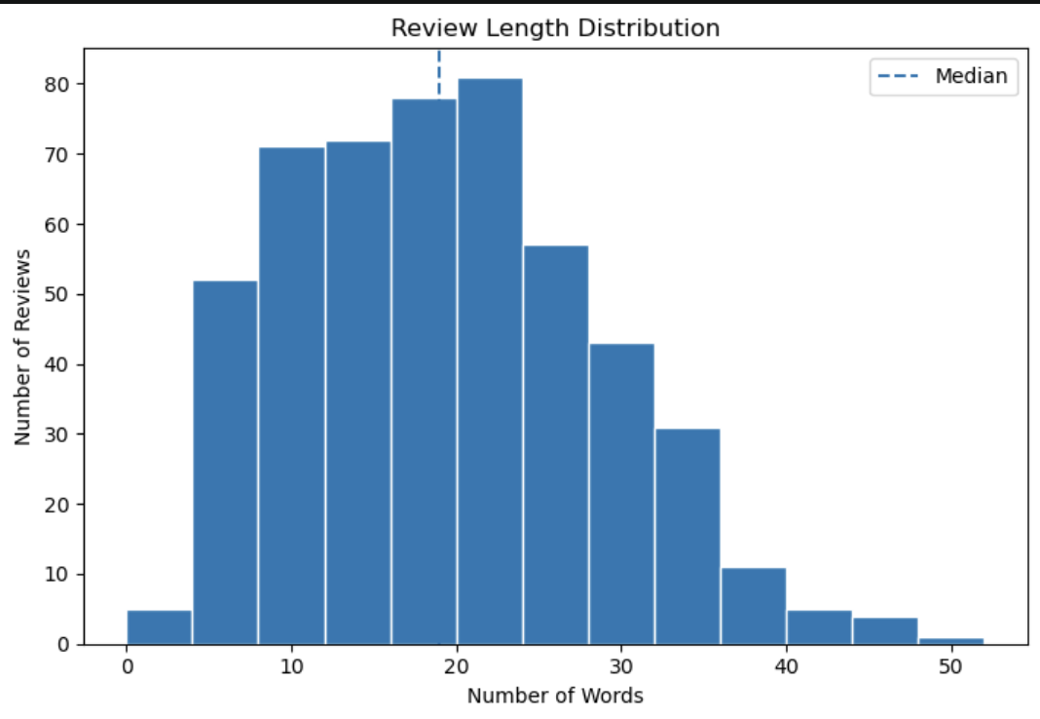
(Figure 1.2 Review Length Distribution)
Figure 1.2 illustrates the distribution of review lengths, measured by the number of words in each review.
The average review length is 18.92 words, with a median of 19 words. The shortest review contains only 2 words, while the longest contains 50 words. The similarity between the mean and median suggests that the distribution is relatively balanced around its central value, although some variation in review length exists. Overall, the dataset primarily consists of relatively short movie reviews. This finding is useful for determining an appropriate maximum sequence length during text tokenization, which can help reduce unnecessary padding and computational overhead when training models.

1.5 Data Splitting
Stratified Split can preserve the same proportion of each class in both subsets.

1.6 Evaluation Matrix
Accuracy and Macro F1-score

2. Data Cleaning
Data cleaning was performed to improve data quality, standardize the textual representation, and prepare the dataset for sentiment classification. The original training and test split was preserved throughout the process. The cleaned outputs are cleaned_train.csv and cleaned_test.csv.

2.1 Dataset and granularity
The movie review dataset contains 511 training records and 341 test records, giving 852 records in total. Each row represents one review phrase identified by PhraseId and associated with a sentence through SentenceId.
Sentiment is an ordered five-class variable
Value | Label
0 | Negative
1 | Somewhat negative
2 | Neutral
3 | Somewhat positive
4 | Positive
The original four columns were retained: PhraseId, SentenceId, Phrase, and Sentiment. Additional columns were created for modelling, traceability, and quality analysis.

2.2 Data Quality Assessment
The dataset was examined for missing values, invalid sentiment labels, duplicate records, empty text, parser artifacts, unusual phrase lengths, and overlap between the training and test sets.

Table 2.1: Data quality findings
Check | Training | Test
Records | 511 | 341
Missing required fields | 0 | 0
Exact duplicate rows | 0 | 0
Duplicate text after normalization | 0 | 0
Invalid sentiment labels | 0 | 0
Empty text after normalization | 0 | 0
Records containing parser-punctuation artifacts | 15 | 17
Character-length outliers | 0 | 1
Identifiers overlapping between splits | 0 | 0
The main hidden data-quality issue was the presence of Penn Treebank punctuation tokens such as -LRB- and -RRB-. These tokens represent parentheses and appeared in 32 records across the two splits. They were converted to readable punctuation before the general punctuation-removal step. Targeted repairs were also applied to parser-separated abbreviations such as -LRB- N -RRB- o matter.

2.3 Missing Values and Invalid Entries
All required fields were checked for missing values. No missing PhraseId, SentenceId, Phrase, or Sentiment values were found, so imputation or row deletion was unnecessary.
Sentiment values were also validated against the permitted range of 0 to 4. No invalid labels were identified, and the labels were not added, removed, or collapsed during cleaning. HTML entities were checked where applicable, but no HTML-related entries required decoding.
No records were removed because all 852 records passed the final validation checks.

2.4 Duplicate Handling
Duplicate detection was performed at three levels:
- Exact duplicate rows within each split.
- Duplicate phrases after case, punctuation, whitespace, and contraction normalization.
- Duplicate normalized phrases across the training and test sets.
No exact or normalized duplicates were detected. There were also no overlapping PhraseId or SentenceId values between the training and test datasets. The original split was therefore preserved without removing records or introducing cross-split data leakage.

2.5 Outlier Handling
Phrase length was measured using the original character count, and the interquartile-range method was used as a diagnostic for unusually long text.
One test record exceeded the split-specific upper length threshold. It had a character length of 259, compared with an upper threshold of approximately 247. The record was retained and identified using LengthOutlier=True because it contained valid, coherent review text rather than an invalid value or data-entry error.
Removing the record would unnecessarily alter the test distribution. For text data, extreme length is not automatically equivalent to an invalid observation, so it was treated as a review flag rather than grounds for deletion.

2.6 Standardization and Variable Transformation
The following cleaning operations were applied:
- Validated required identifiers, phrase text, and sentiment labels.
- Repaired Penn Treebank punctuation artifacts.
- Normalized Unicode characters, quotation marks, and dashes.
- Trimmed and collapsed repeated whitespace.
- Converted text to lowercase.
- Expanded common contractions, including parser-separated forms such as is n't.
- Replaced punctuation with spaces.
- Tokenized the normalized text using an alphanumeric pattern.
- Applied Porter stemming to create a separate stemmed representation.
- Calculated token and character counts and flagged length outliers.
- Rechecked missing values, labels, empty documents, duplicates, and train/test overlap.
Stop words and negations were intentionally retained. Words such as not, never, and but carry important sentiment information, and removing them could reverse or weaken the meaning of a review.
The cleaning process produced the following additional variables:
Variable | Purpose
Phrase | Original review text retained for traceability
CleanText | Lowercased and normalized text for BERT, GloVe, or Word2Vec
StemmedText | Porter-stemmed text for the TF-IDF baseline
Sentiment | Integer target label from 0 to 4
SentimentLabel | Human-readable description of the target label
TokenCount | Number of normalized tokens
CharCount | Original phrase character count
LengthOutlier | IQR diagnostic flag; the record remains valid
Split | Identifies training or test membership

2.7 Documentation of Changes
All cleaning operations were documented so that modifications can be traced from the original review phrases to the cleaned data. The original phrase text and identifiers were retained, and the training and test records remained in their original splits.
Table 2.2 Summary of cleaning changes
Cleaning Stage | Training rows affected | Test rows affected | Outcome
Missing-value and label validation | 0 | 0 | All required fields and labels were valid
Parser-punctuation repair | 15 | 17 | Parser tokens were converted or repaired
Whitespace normalization | 0 | 0 | No irregular whitespace required correction
Case and Unicode normalization | 493 | 335 | Text was converted to a consistent lowercase form
Contraction expansion | 172 | 115 | Contractions were converted to expanded forms
Punctuation removal | 506 | 339 | Punctuation was replaced with spaces
Tokenization and Porter stemming | 500 | 336 | At least one token changed in the stemmed representation
Length-outlier review | 0 | 1 | The valid long record was flagged and retained

Table 2.3 Before and after record counts
Split | Records before cleaning | Records after cleaning | Records removed
Training | 511 | 511 | 0
Test | 341 | 341 | 0
Total | 852 | 852 | 0

3. Data Modeling
To develop a decision support system for text classification, data modeling is a crucial stage to construct and train candidate models, as well as to evaluate and compare their performances systematically. The model performance is evaluated using standard classification metrics such as accuracy, precision, recall and F1-score.

3.1 Baseline model with TF-IDF
For baseline feature extraction, we build a logistic regression model using TF-IDF (Term Frequency-Inverse Document Frequency). The cleaned data for training is then processed and assembled with TF-IDF vectorizer and logistic regressor through a pipeline, with StemmedText being the feature (x) and Sentiment as the label.
After model training and testing, the evaluation results are presented as below:
Label | Precision | Recall | F1-score | Support
Negative | 0.000 | 0.000 | 0.000 | 42
Somewhat negative | 0.338 | 0.506 | 0.405 | 89
Neutral | 0.176 | 0.045 | 0.071 | 67
Somewhat positive | 0.317 | 0.620 | 0.419 | 92
Positive | 0.700 | 0.137 | 0.230 | 51
Accuracy | 0.328 |  |  | 341
The accuracy of the baseline model is poor, with only 32.8% of texts classified correctly. Most of the predictions are concentrated on the middle classes, with texts labelled either as “somewhat negative” (class 1) or “somewhat positive” (class 3). Both of them have relatively higher recall rates of 50.6% and 62.0% and higher F1-scores with 40.5% and 41.9%.
In contrast, “negative” (class 0) and “positive” (class 4) have poor performance,
The model never predicts the “negative” label

