**Create a Database with Tables having the following data : (Name the columns as per your understanding of the data)**

**employeeData**

(1, 'Madhuri', 'Sripada', 100000, '19-02-01 09.00.00', 'HR'),

(2, 'Haritha', 'Verma', 80000, '19-01-10 09.00.00','Admin'),

(3, 'Vimal', 'Rao', 300000, '19-03-10 09.00.00','HR'),

(4, 'Amrita', 'Prasad', 500000, '19-03-10 09.00.00', 'Admin'),

(5, 'Vidhi', 'Agarwal', 500000, '19-02-11 09.00.00','Admin'),

(6, 'Nitya', 'Prasad', 200000, '19-02-11 09.00.00','Account'),

(7, 'Sravan', 'Kumar', 75000, '19-04-20 09.00.00','Account'),

(8, 'Girish', 'Varma', 90000, '19-04-11 09.00.00','Admin');

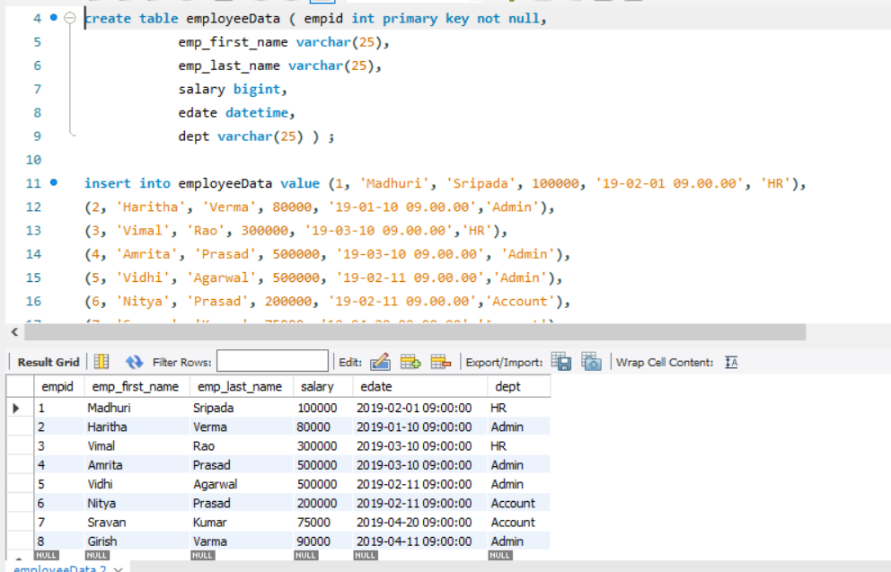

**incentivesData**

(1, 8000, '19-06-15'),

(2, 10000, '19-05-11'),

(3, 45000, '19-05-20'),

(1, 9500, '19-06-20'),

(2, 3500, '19-06-11');

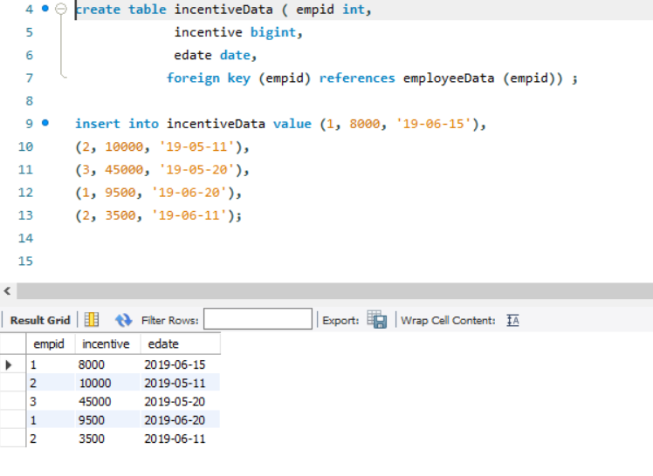

**jobRoles**

(1, 'Manager', '2019-02-01 00:00:00'),

(2,'Executive', '2019-06-01 00:00:00'),

(8,'Executive', '2019-06-01 00:00:00'),

(5,'Manager', '2019-06-01 00:00:00'),

(4,'Asst. Manager', '2019-06-01 00:00:00'),

(7, 'Executive', '2019-06-01 00:00:00'),

(6,'Team Lead', '2019-06-01 00:00:00'),

(3,'Team Lead', '2019-06-01 00:00:00');

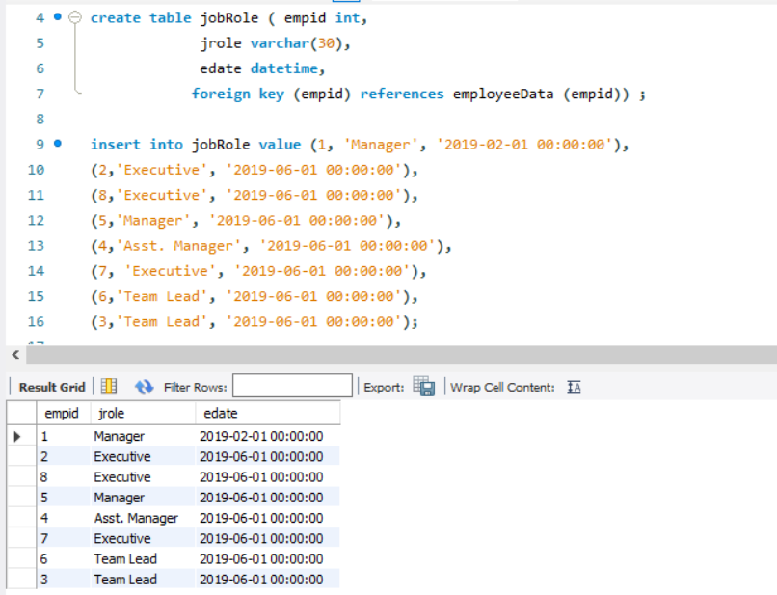

1. Display last name as employee_last_name.

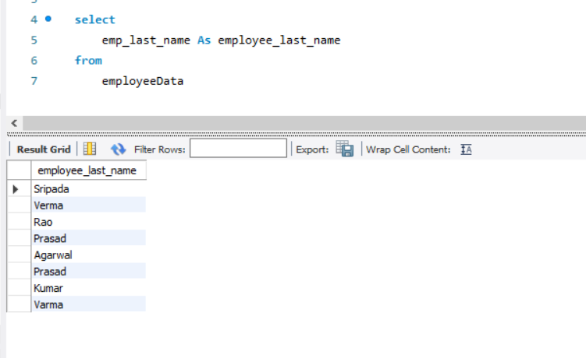

1. Display fname and lname as employee_fullname.

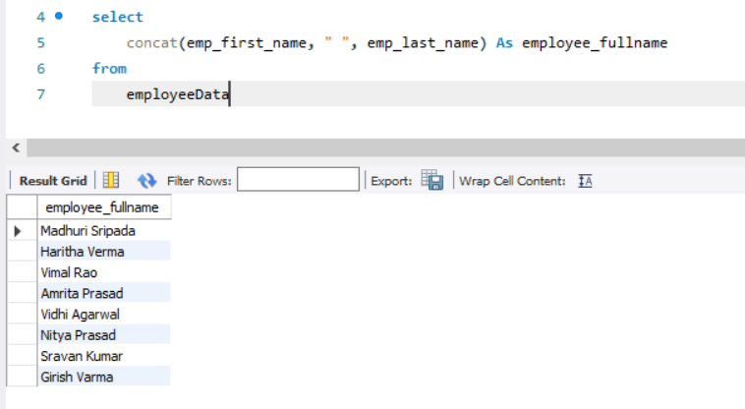

1. Display fname, lname in upper case.

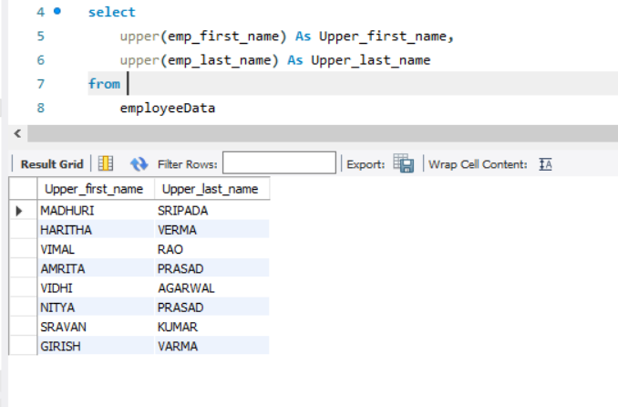

1. Display unique dept from emp table.

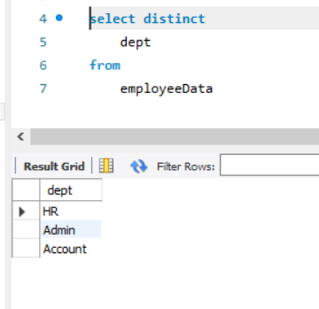

1. Display emp fname in asc order.

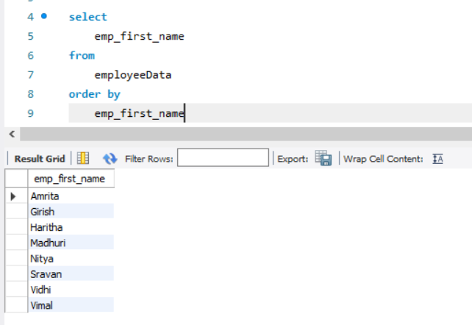

1. Print details of employees 'amrita' and 'nitya'.

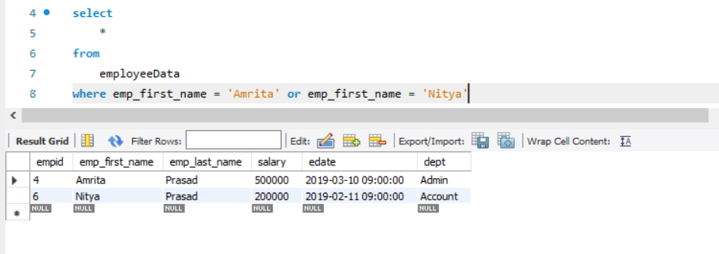

1. Details of emps except 'girish' and 'sravan'.

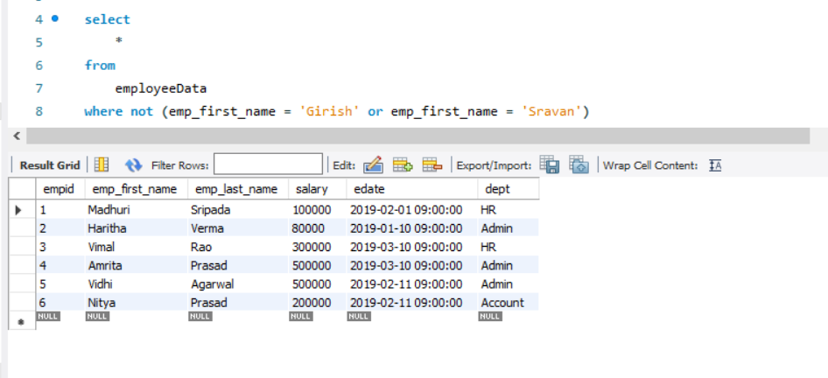

1. Display emps from hr dept.

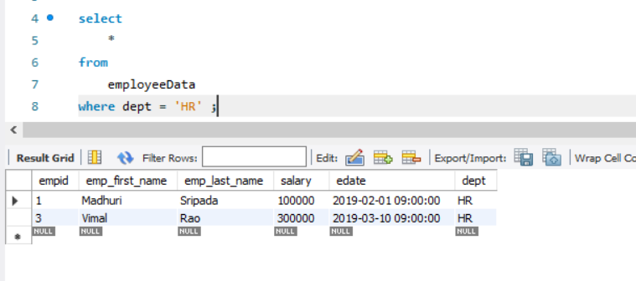

1. Details of emps whose name starts with 'A'.

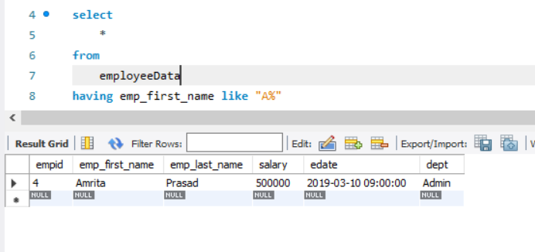

1. Details of emps whose name contains 'A'.

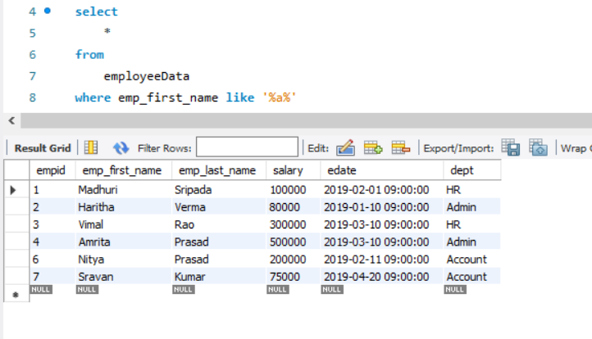

1. emp details of salaries who are earning between 2.5 - 5 lacs.

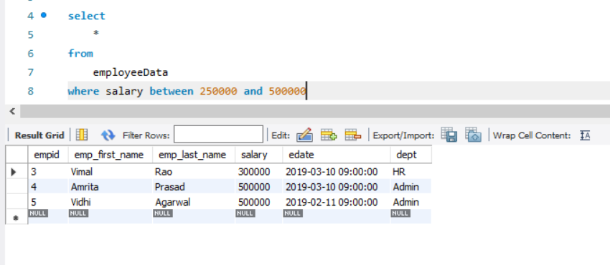

1. Write a query to display employee fullname who are earning above 70,000 and below 2 lacs.

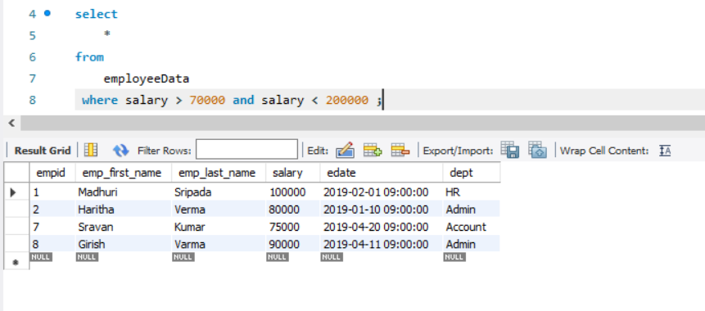

1. Write a query to display dept name and number of employees in dept.

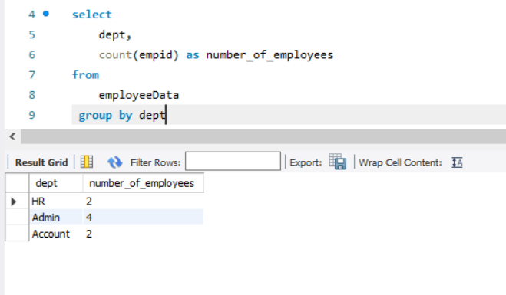

1. Display employees who are managers.

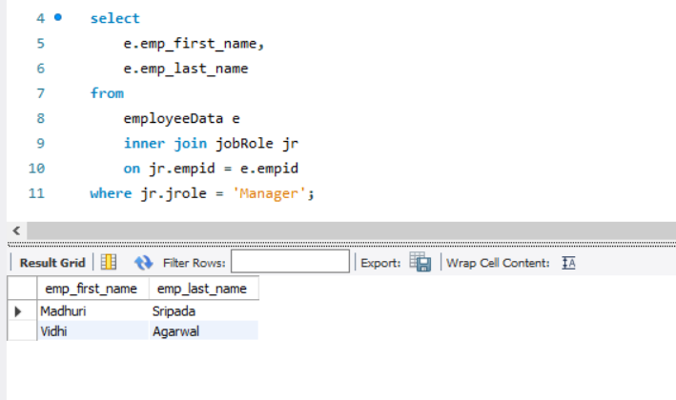

1. Print details of employees who got incentives.

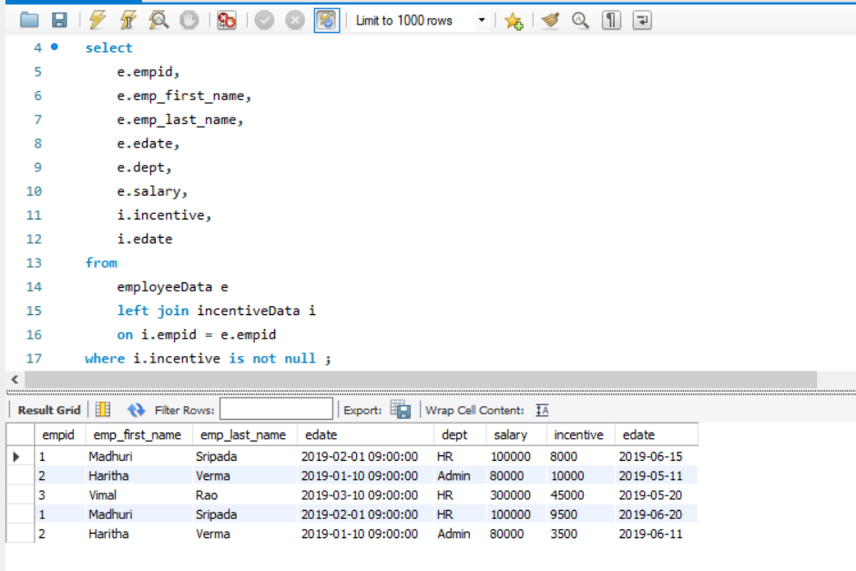

1. Display max salary from each dept (department wise max salary).

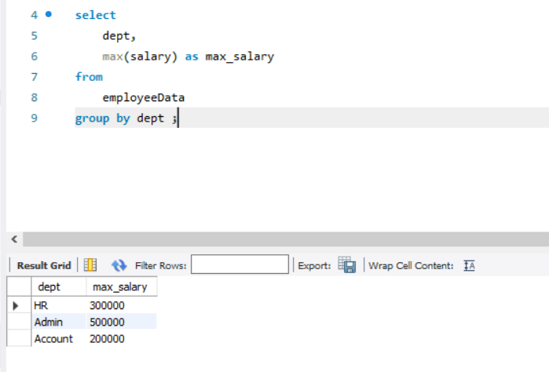

1. Print emp name, dept name and bonus amount who got highest bonus.

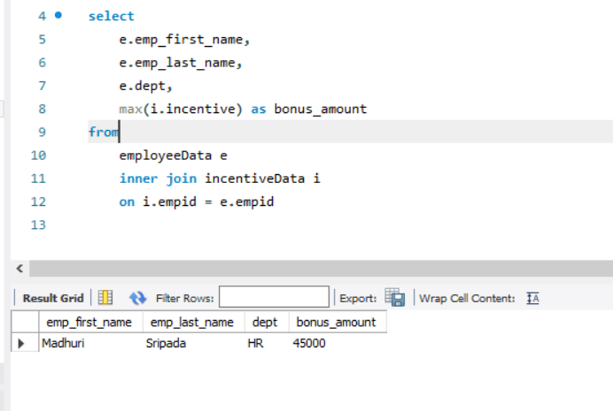

1. Display details of emp who is earing max salary.

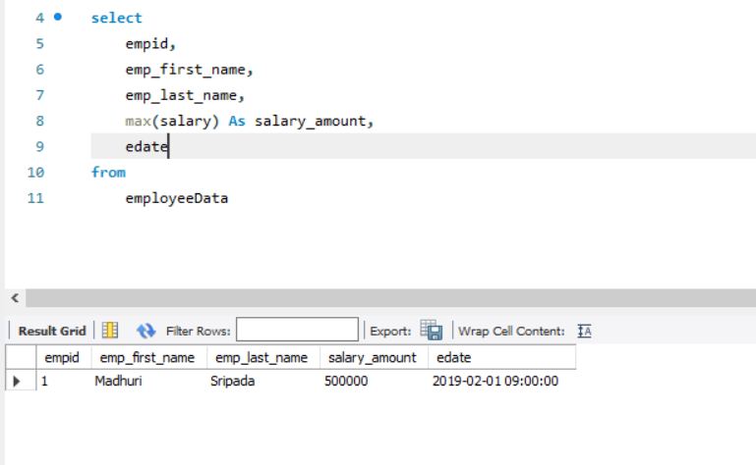

1. Print emp last name , dept , salary of employees who is earing max salary in each department.

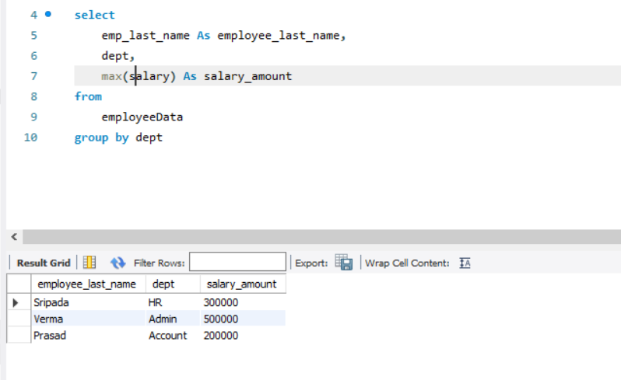

1. Print emp details who is earning lowest salary.

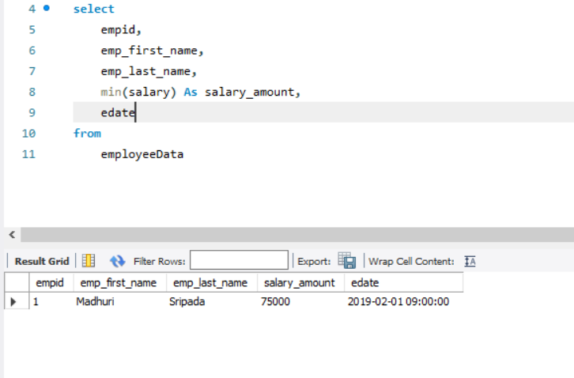

1. Print the emp last name, job role and effective date for each employee.

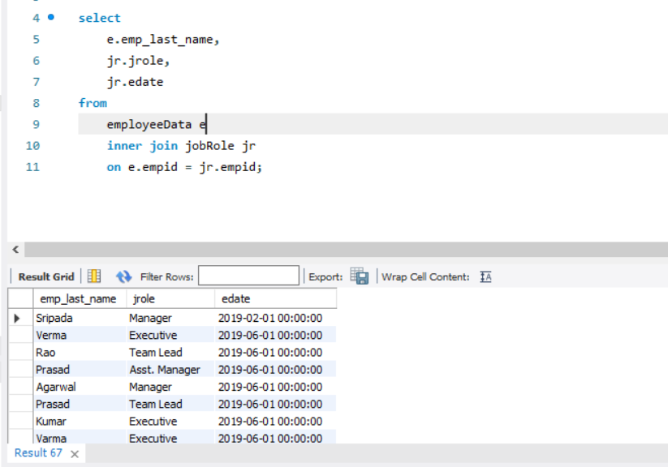

1. Print emp lastname.

