Create table customers (custId int primary key not null, custName varchar(10), city varchar(10) );

Insert below data:

(1,"Rupa", "Hyderabad");

(2, "Sudha", "Hyderabad");

(3, "Vinay", "Chennai");

(4, "Sruthi", "Vijayawada");

(5, "Madhu", "Chennai");

(6, "Gita", "Hyderabad");

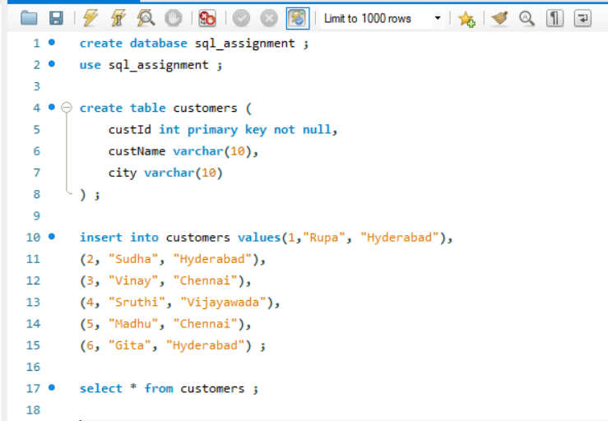

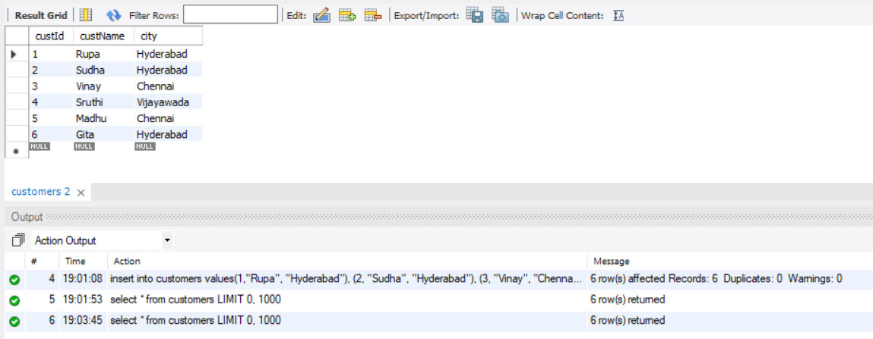

Create table orders (oid int primary key not null, cId int , odate date, foreign key (cId) references customers (custId ));

Insert data like this:

(22,3,'2018-07-15');

(23,1,'2018-07-16');

(24,1,'2018-07-17');

(25,2,'2018-07-19');

(26,4,'2018-07-20');

(27,5,'2018-07-20');

(28,5,'2018-07-12');

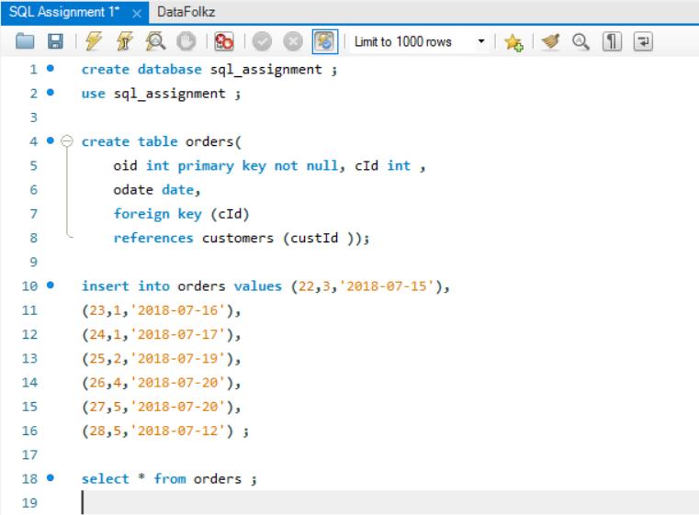

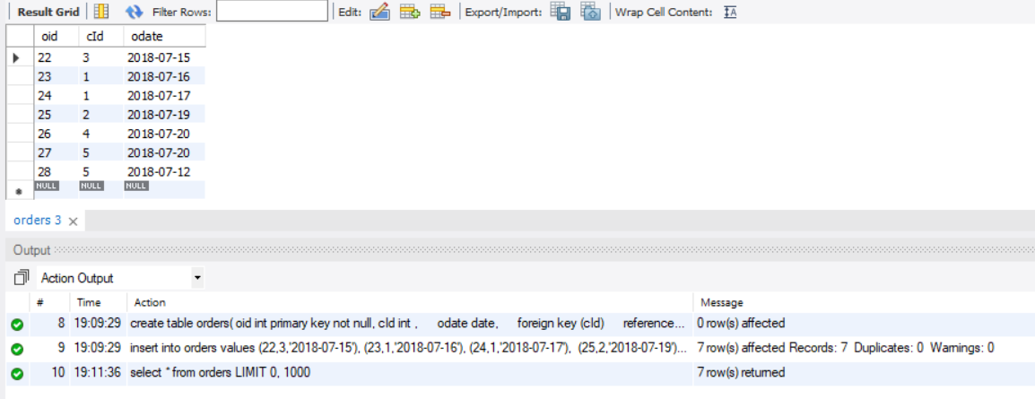

1. Select all the customers who have placed orders.

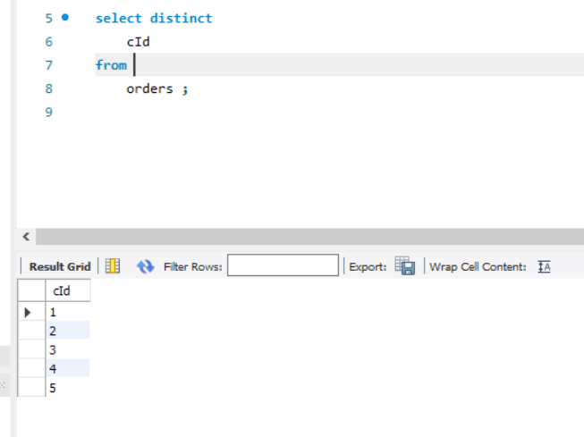

1. Display num of orders placed by each customer.

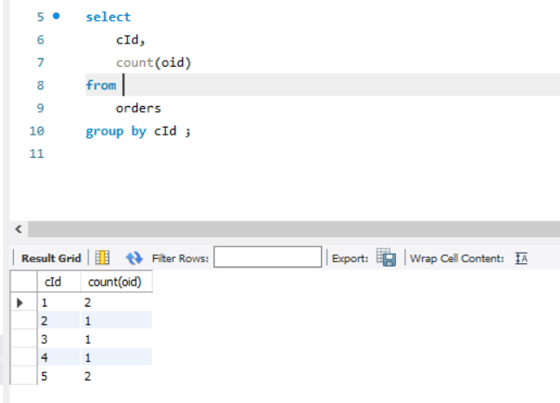

1. Select all the customers who have placed more than 1 order

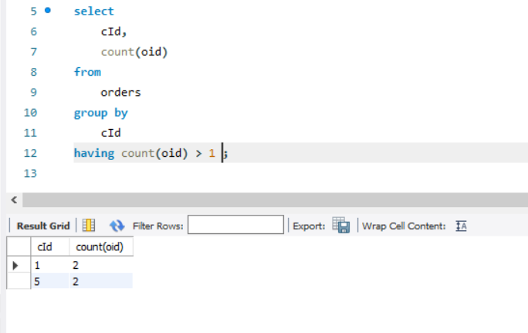

1. Select all the customers who did not place any order

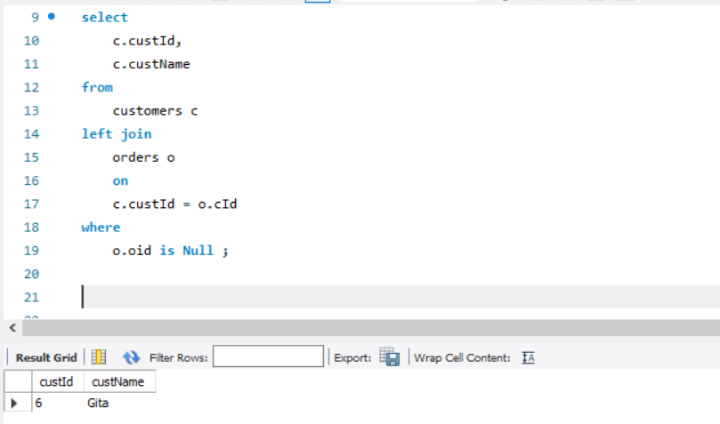

1. Display customer names who have made a purchase on July 20th

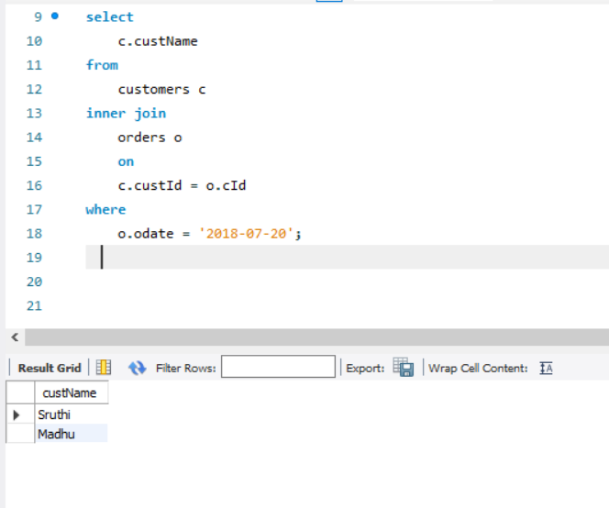

1. Select all the customers who made purchases after July 12th and before July 18th

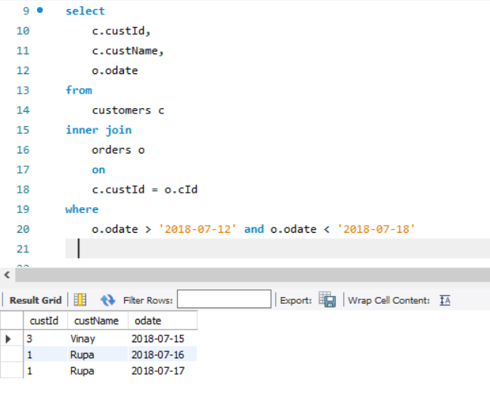

1. Select all the customer who did not purchase on these days - 12th and 18th.

