**Name: Yang Sun, Andrew ID: yksun**

**Q2:**

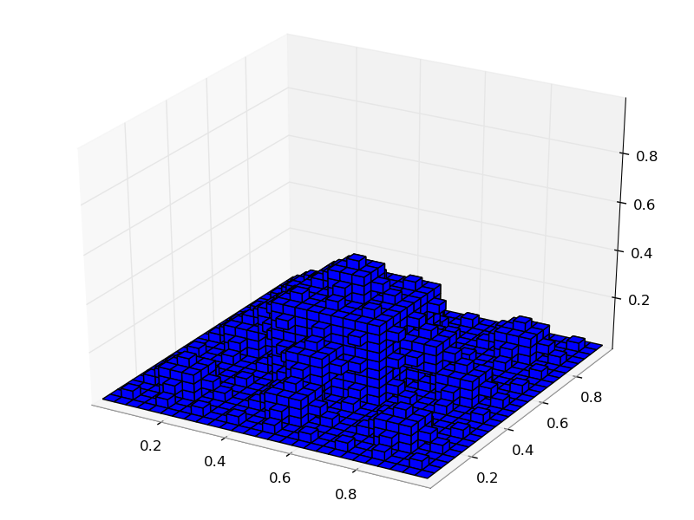

Figure 1: image of the fractal K3

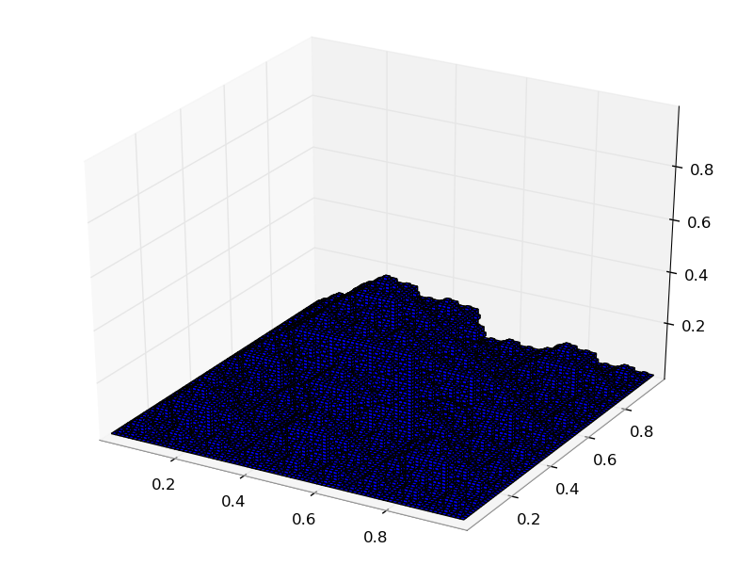

Figure 2: image of the fractal K4

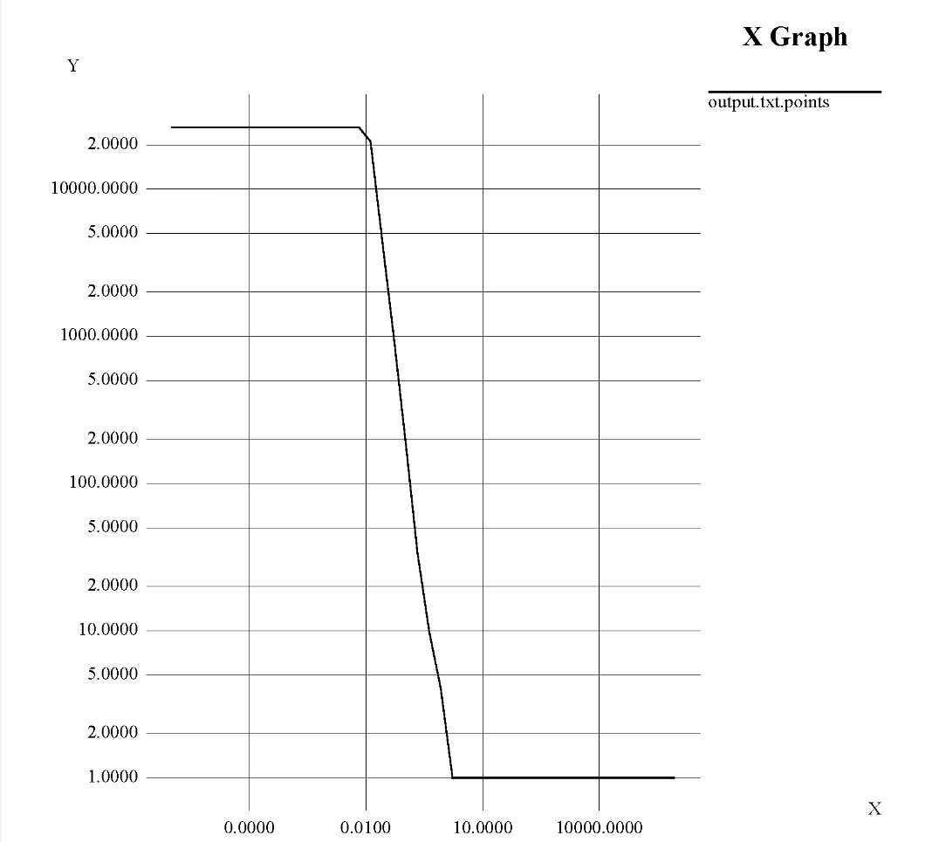

Figure 3: Hausdorff plot for K4

Hausdorff fractal dimension of K4: 2.07995

**Q3:**

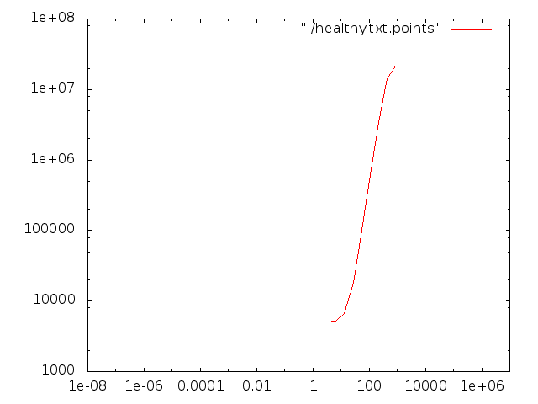

Figure 4:

Correlation plot of dataset H

Correlation Integral: 2.52976

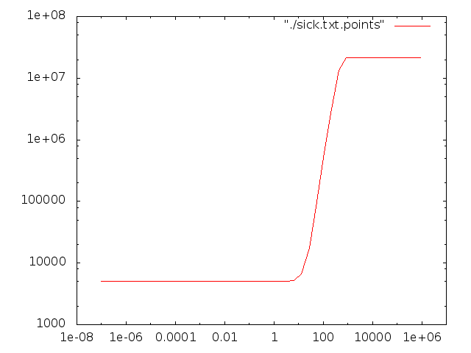

Figure 5:

Correlation plot of dataset S

Correlation Integral: 2.51242

1. **Is dataset H uniformly distributed in 4D space?**

No. Dataset H is uniform distribution only if correlation integral is 4.

1. **Is dataset S uniformly distributed in 4D space?**

No. Dataset S is uniform distribution only if correlation integral is 4.

**Are H and S separable?** No.

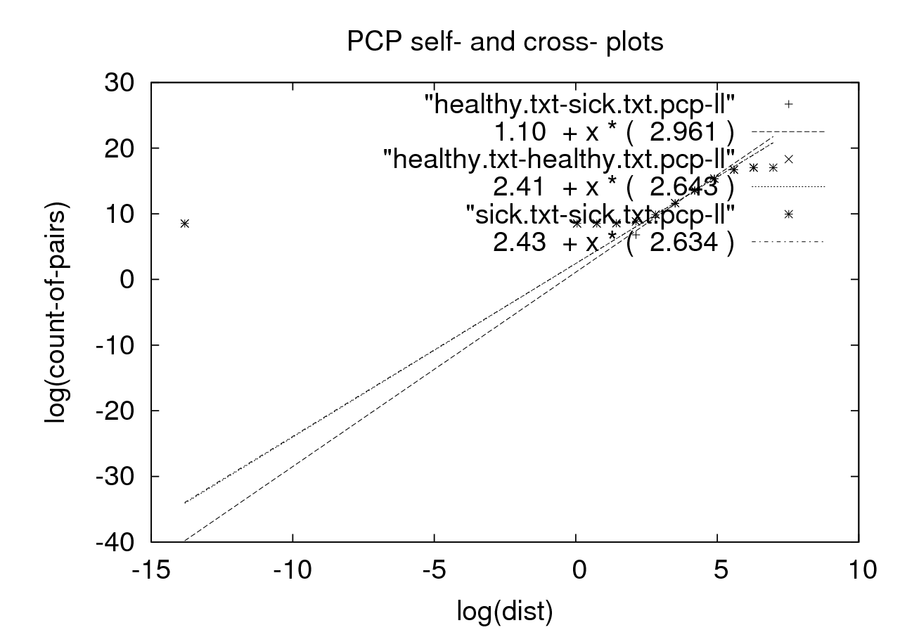

Figure 6:

PCP self- and cross- plots between healthy and sick dataset

**Justification:**

**Tool used:** BOPS plot

Through the BOPS plot in Figure 6, we can see that self- plots of healthy and sick dataset are overlapped and can’t be visually separated (should have three lines in the graph, two self- plots are overlapped and the other is cross- plot). In addition, as we can see from the plot of 3D projection of the 4D patient dataset in the handout, sick and healthy points are already impossible to separate. Under this circumstance, given that the correlation dimension of both data sets is no greater than 3 and almost identical, it is not even possible to separate them in 4D plot.

**Q4:**

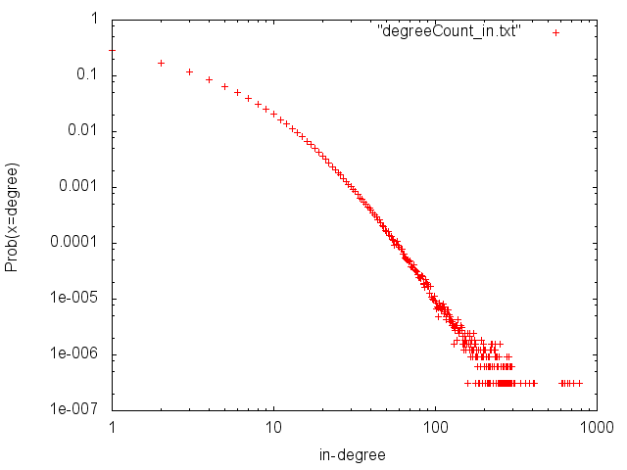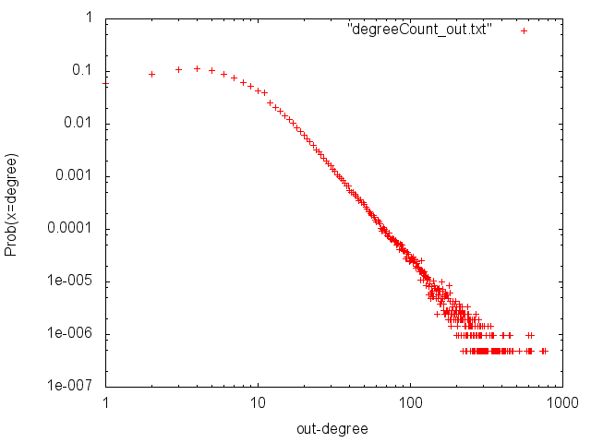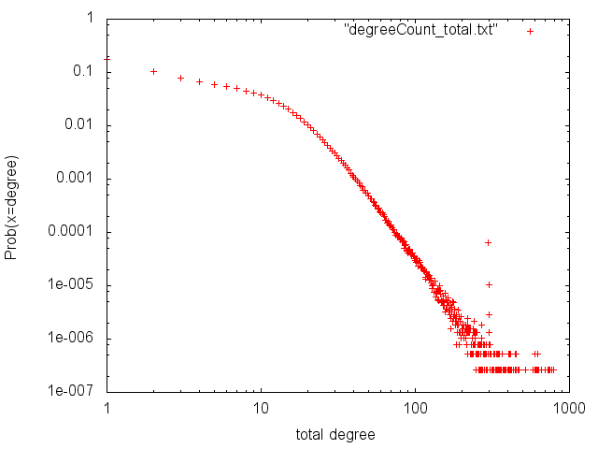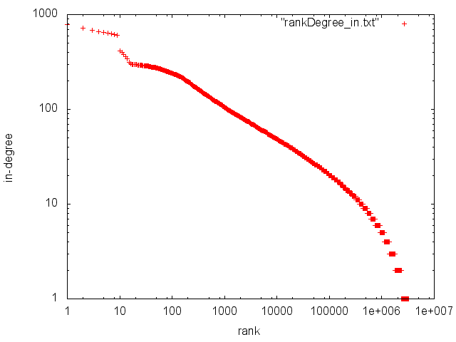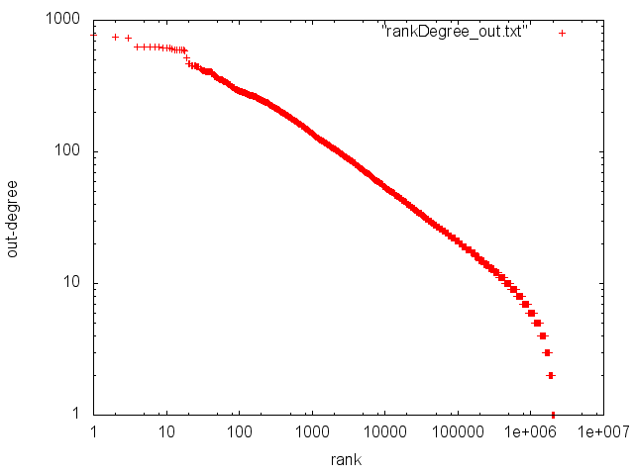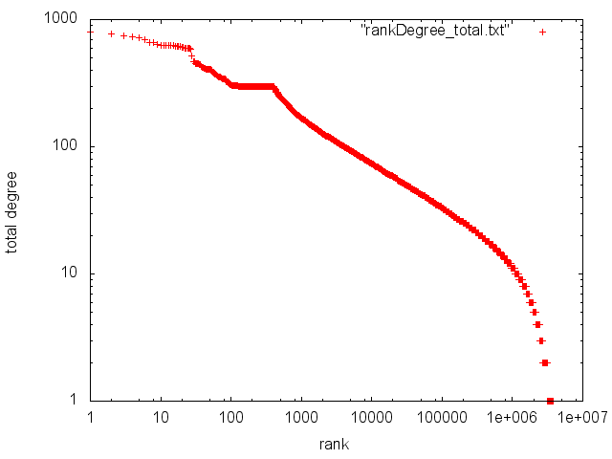

Figure 8: PDF plot for out-degree

Figure 7: PDF plot for in-degree

Figure 9: PDF plot for total-degree

Figure 10: Zipf plot for in-degree

Figure 11: Zipf plot for out-degree

Figure 12: Zipf plot for total-degree

**Estimation for the size K:** 300

**Justification:**

Because as we can see in the Zipf plot for total-degree, there is a plateau at ranks 100-through-400, which could be due to a clique of size 300.