Deliverables
SC2006 Team SCE3-04
Deliverable | Page range
Complete Use Case diagram | 2
Use Case descriptions (UC-01–UC-08) | 3–10
Class diagram of entity classes | 11–15
Key boundary and control classes | 16–18
Initial Dialog Map | 19–22

1 Use Case — Complete Use Case Diagram
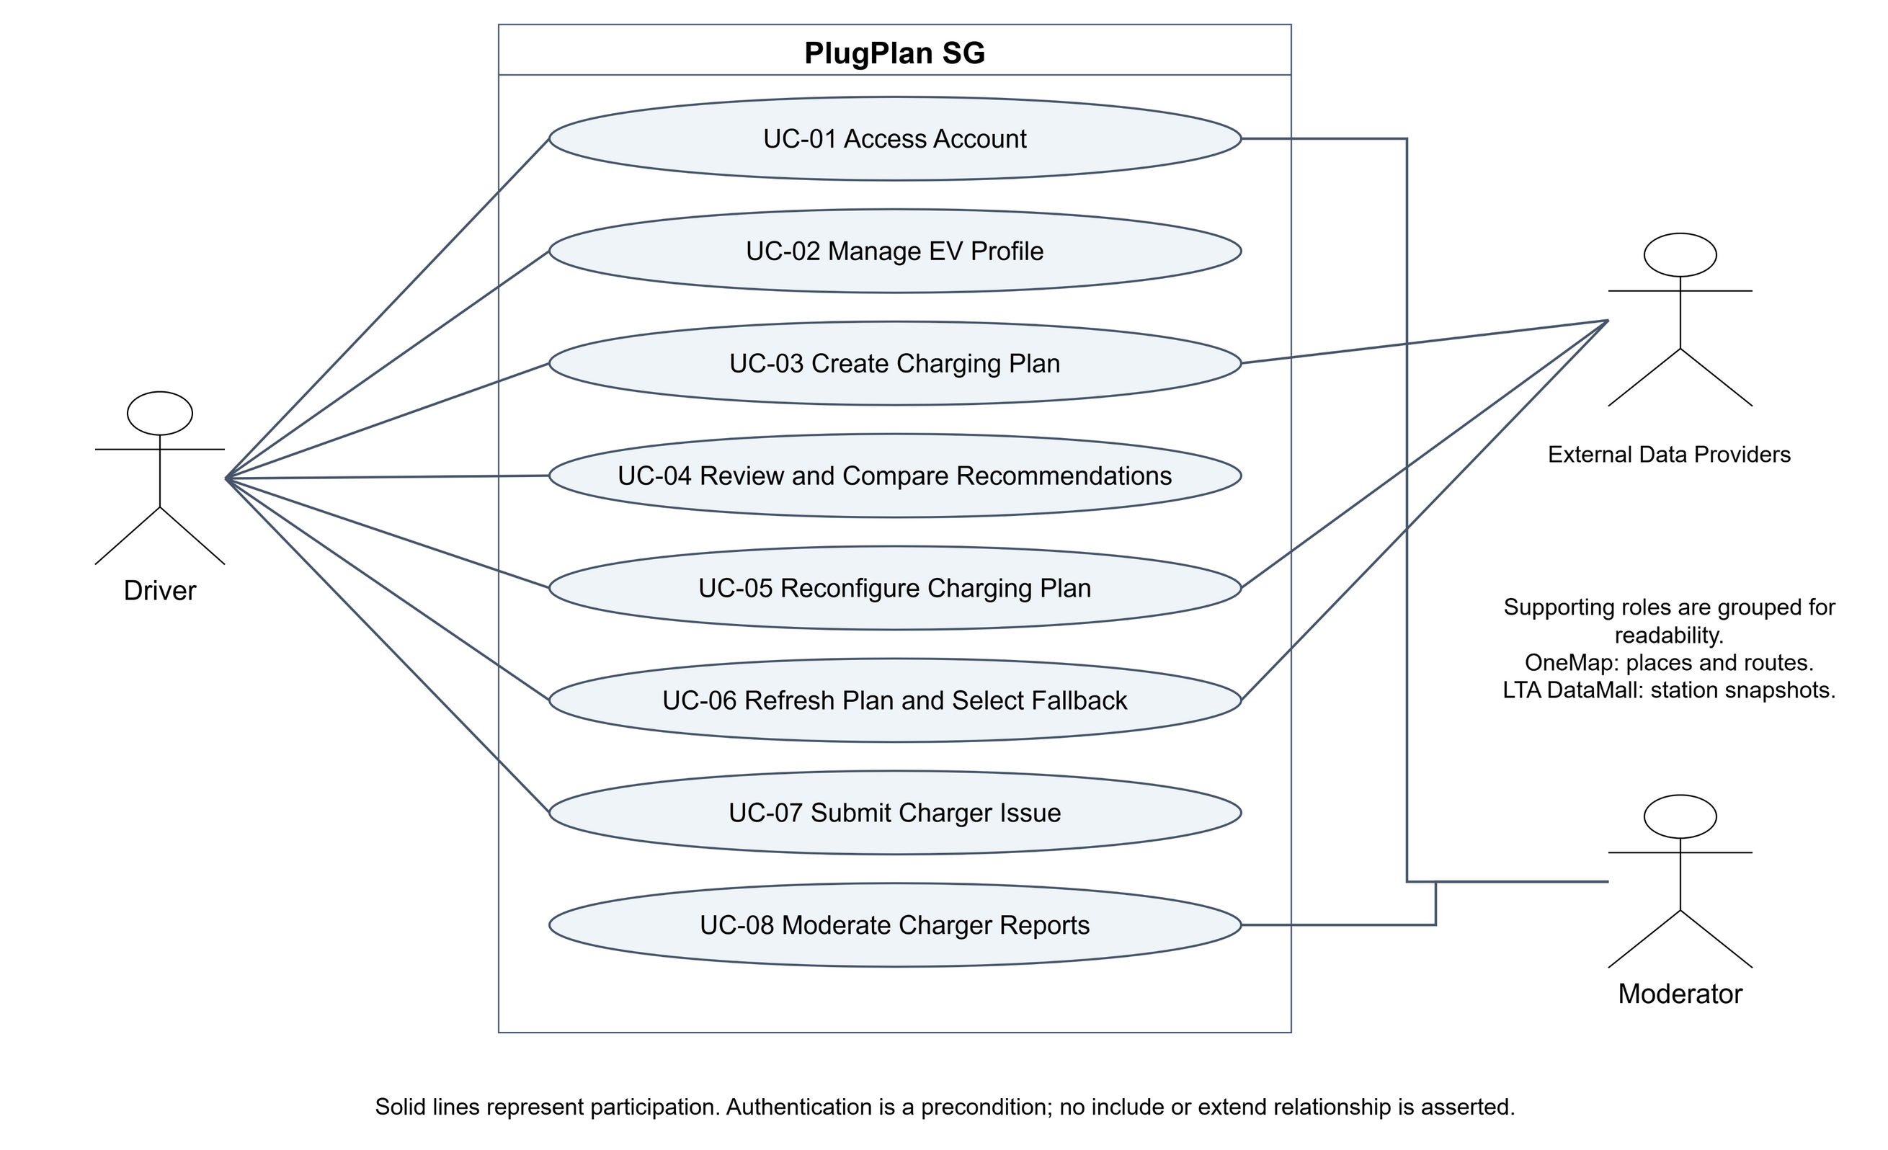
All eight use cases. External Data Providers groups OneMap and LTA DataMall as supporting roles; provider participation includes reconfiguration when route/data work is needed.

UC-01 Access Account
A new Driver registers, or an existing Driver or Moderator signs in and reaches the role-appropriate workspace.
Field | Specification
Primary and supporting actors | Driver or Moderator
Priority and frequency | High; At the start of an authenticated session
Traceability | FR-01, FR-02; D-00

Preconditions
- The user can access the PlugPlan SG web application.
- For sign-in, an active account exists.

Postconditions
- An authenticated session contains the user's role.
- The user is directed to the appropriate Driver or Moderator workspace.

Normal flow of events
1. The user opens the account access screen.
2. The user enters an email address and password.
3. The system validates the credentials.
4. The system creates an authenticated session containing the user's role.
5. The system displays the role-appropriate workspace.

Alternative flows
- UC-01.AC.1 - A new Driver selects Create a Driver account, enters a unique email and compliant password, and the system creates the account before continuing at step 4.
- UC-01.AC.2 - A signed-in user ends the session; the system invalidates the session and returns to the access screen.

Exceptions
- UC-01.EX.1 - If credentials are invalid, the system displays a generic error and does not reveal whether the email exists.
- UC-01.EX.2 - If the account is inactive, the system denies access and provides a support instruction.

Special requirements and assumptions
NFR-05 and NFR-06 apply.
Moderator accounts are provisioned by the team; public registration creates Driver accounts only.

UC-02 Manage EV Profile
The Driver records validated vehicle and planning assumptions used by subsequent charging plans.
Field | Specification
Primary and supporting actors | Driver
Priority and frequency | High; Initial setup and occasional updates
Traceability | FR-03, FR-04; D-01

Preconditions
- The Driver is authenticated.

Postconditions
- The valid EV Profile is stored.
- Existing Plan Versions retain their original assumptions.

Normal flow of events
1. The Driver opens Vehicle Profile and Preferences.
2. The system displays the current values or an empty form.
3. The Driver enters vehicle capacity, consumption, plug types, charging limits, reserve, and planning preferences.
4. The Driver selects Save Profile.
5. The system validates the values and stores the profile.
6. The system confirms that the profile was saved.

Alternative flows
- UC-02.AC.1 - The Driver edits an existing profile; future Plan Versions use the new values.
- UC-02.AC.2 - The Driver deletes the profile after confirming the destructive action.

Exceptions
- UC-02.EX.1 - Missing or out-of-range values are rejected with field-specific messages.
- UC-02.EX.2 - If storage fails, the system keeps the entered values and displays a retry instruction.

Special requirements and assumptions
Values must show units and must be described as planning assumptions.
The MVP permits at most one EV Profile per Driver; a valid profile is required before planning. Zero profiles is the state before creation or after deletion.

UC-03 Create Charging Plan
The Driver submits journey inputs and receives a saved Plan Version containing ranked, explained charging recommendations.
Field | Specification
Primary and supporting actors | Driver; supporting actors: OneMap and LTA DataMall
Priority and frequency | High; Several times per week per active Driver
Traceability | FR-05 to FR-19; D-02, D-03; FR-24 refinement

Preconditions
- The Driver is authenticated.
- A valid EV Profile exists.

Postconditions
- A new Charging Plan and Plan Version are stored.
- Feasible recommendations or an explicit no-feasible-option result is displayed.

Normal flow of events
1. The Driver enters origin, destination, current SOC, departure time, maximum charging duration, maximum detour, and target choice.
2. The system resolves the places and obtains route distance and duration from OneMap.
3. The system obtains the latest usable station and connector snapshot through the LTA DataMall adapter.
4. The system calculates reachability, compatibility, arrival SOC, target SOC, required energy, charging time, cost, and dwell fit.
5. The system excludes infeasible candidates and ranks the remaining candidates using the selected fixed strategy.
6. After the algorithm generates ranked suggestions, the system removes stations with an active Moderator faulty mark, takes up to three surviving recommendations, and stores and displays the Plan Version with explanations, timestamps, and data-state labels.

Alternative flows
- UC-03.AC.1 - The Driver selects a valid manual target; the system uses it while continuing to show the automatic target.
- UC-03.AC.2 - The Driver already has enough energy; the system offers continuation without a charging stop.
- UC-03.AC.3 - No candidate is feasible; the system explains the reasons and offers editable inputs.
- UC-03.AC.4 - If filtering leaves one option, show that option and disable comparison; if none remain, explain that no eligible option remains. Fill a shortlist from the next-ranked unmarked candidates when available.

Exceptions
- UC-03.EX.1 - An ambiguous place requires Driver selection before route calculation.
- UC-03.EX.2 - If no usable route is available, the system preserves the inputs and displays an explicit failure.
- UC-03.EX.3 - If live charging data fails, the system may use a labeled cached or Demo Fixture snapshot.

Special requirements and assumptions
NFR-01 to NFR-04 apply. A result is an estimate, not a reservation or guarantee.
Reserve is 20%, charging efficiency is 90%, and targets above 80% show a taper warning.

UC-04 Review and Compare Recommendations
The Driver inspects recommendation evidence and compares two or three alternatives using a consistent metric order.
Field | Specification
Primary and supporting actors | Driver
Priority and frequency | High; After each successful plan calculation
Traceability | FR-18 to FR-20; D-03, D-04

Preconditions
- The Driver is authenticated and owns the displayed plan.
- A Plan Version exists; at least two eligible recommendations are required for the comparison branch.

Postconditions
- The Driver understands the trade-offs and may select one recommendation.

Normal flow of events
1. The system displays ranked recommendation cards and the selected strategy.
2. The Driver reviews availability, detour, arrival SOC, target SOC, required energy, time, cost, freshness, issues, and explanation.
3. The Driver selects two or three recommendations for comparison.
4. The system displays the selected recommendations side by side using the same metric order.
5. The Driver reviews scoring factors, missing data, and exclusions.
6. The Driver selects a preferred recommendation or returns without selecting one.

Alternative flows
- UC-04.AC.1 - The Driver changes the fixed ranking strategy through UC-05; a new Plan Version explains the changed order.
- UC-04.AC.2 - A price is missing; the system displays Price unavailable and does not label that option cheapest.

Exceptions
- UC-04.EX.1 - If fewer than two feasible choices remain, comparison is unavailable and the system explains why.

Special requirements and assumptions
Official data, PlugPlan estimates, and community reports must be visually distinguished.
A maximum of three options can be compared at once.

UC-05 Reconfigure Charging Plan
The Driver changes a plan input or strategy and receives a new immutable Plan Version.
Field | Specification
Primary and supporting actors | Driver
Priority and frequency | High; As needed before selecting a charger
Traceability | FR-05, FR-14, FR-18, FR-21; D-04; FR-24 refinement

Preconditions
- An existing Charging Plan has at least one Plan Version.
- The Driver is authenticated and owns the plan.

Postconditions
- A new Plan Version is stored.
- The previous Plan Version remains unchanged and accessible.

Normal flow of events
1. The Driver opens Compare and Reconfigure for an existing plan.
2. The system displays current timing, dwell, reserve, target, detour, and strategy values.
3. The Driver changes one or more values.
4. The Driver selects Recalculate.
5. The system repeats feasibility and ranking using the new values, then filters stations with active Moderator faulty marks before forming the new shortlist.
6. The system stores and displays the new Plan Version with an explanation of material ranking changes.

Alternative flows
- UC-05.AC.1 - The Driver resets the pending changes and keeps the current Plan Version.
- UC-05.AC.2 - A previously feasible option becomes infeasible and is labeled accordingly.

Exceptions
- UC-05.EX.1 - If route refresh fails, the previous Plan Version remains visible and no partial version is stored.
- UC-05.EX.2 - Leaving with unsaved changes requires confirmation.

Special requirements and assumptions
Plan Version immutability supports traceability.
Reconfiguration is user-initiated; continuous background recalculation is outside scope.

UC-06 Refresh Plan and Select Fallback
The Driver manually requests newer data and reviews a fallback when the selected connector is no longer feasible.
Field | Specification
Primary and supporting actors | Driver; supporting actors: OneMap and LTA DataMall
Priority and frequency | High; Immediately before travel or after a visible data-age warning
Traceability | FR-07 to FR-19, FR-22, FR-23; D-03, D-04; FR-24 refinement

Preconditions
- A saved Plan Version exists.
- The Driver is authenticated.
- The saved plan belongs to the authenticated Driver.

Postconditions
- A refresh result is stored as a new Plan Version.
- The prior selection remains or a fallback result is clearly presented.

Normal flow of events
1. The Driver selects Refresh Data on a saved plan.
2. The system requests the latest usable route and charging snapshot through its backend adapters.
3. The system recalculates feasibility and ranking using existing inputs, then filters stations with active Moderator faulty marks before forming the refreshed shortlist.
4. The system compares the refreshed result with the previous Plan Version.
5. If the selected connector is unsuitable or its station is marked faulty, the system explains the change and identifies the next-ranked feasible, unmarked option.
6. The Driver keeps the original selection when still feasible, selects the fallback, or edits the plan.

Alternative flows
- UC-06.AC.1 - The original selection remains feasible; the system confirms that no fallback is required.
- UC-06.AC.2 - No feasible fallback exists; the system provides reasons and editable inputs.
- UC-06.AC.3 - Only cached or stale data is available; the system labels the state and age.

Exceptions
- UC-06.EX.1 - If no usable snapshot is available, the system displays a failure and keeps the previous Plan Version unchanged.

Special requirements and assumptions
Refresh is manual. The system must not promise automatic alerts or guaranteed availability.
The latest usable snapshot can be live, cached, stale, or a clearly labeled Demo Fixture.

UC-07 Submit Charger Issue
The Driver submits a categorized, expiring community report associated with a station or connector.
Field | Specification
Primary and supporting actors | Driver
Priority and frequency | Medium; Occasionally after observing a site problem
Traceability | FR-24; D-05

Preconditions
- The Driver is authenticated.
- A Charging Station or Connector is selected.

Postconditions
- A Pending Issue Report is stored with an expiry time.
- The Driver receives a report reference.
- The report is available in the Moderator review workspace; the Driver receives a Pending acknowledgement. Submission alone does not exclude a station.

Normal flow of events
1. The Driver selects Report an Issue for a station or connector.
2. The system pre-fills the station and connector context.
3. The Driver selects a category, enters a note, and optionally adds an image.
4. The system validates the input and checks for a similar active report.
5. The Driver confirms submission.
6. The system stores a Pending report, sets its expiry, and displays the reference.

Alternative flows
- UC-07.AC.1 - A similar report exists; the Driver views it instead of submitting a duplicate.
- UC-07.AC.2 - The Driver opens the operator's official reporting channel for repair or enforcement.

Exceptions
- UC-07.EX.1 - An invalid or oversized image is rejected without discarding other inputs.
- UC-07.EX.2 - If the submission rate limit is exceeded, the system displays when another report may be submitted.

Special requirements and assumptions
Images must include a privacy reminder. Community reports must not look like official status. Moderator-confirmed faulty status is made useful to other Drivers by excluding that station after suggestion generation and before display, through UC-03, UC-05 and UC-06. No new public report feed is required.
Default report expiry is 24 hours unless moderated earlier.

UC-08 Moderate Charger Reports
A Moderator reviews community evidence and records a justified report-lifecycle decision.
Field | Specification
Primary and supporting actors | Moderator
Priority and frequency | Medium; Daily during the prototype demonstration period
Traceability | FR-02, FR-25; D-06; FR-24 refinement

Preconditions
- The Moderator is authenticated.
- At least one Issue Report exists.

Postconditions
- A valid Moderation Decision is appended to the audit history.
- The Issue Report status reflects the decision.
- A verified fault can mark its station faulty; the mark is used by subsequent generation, recalculation and manual refresh.

Normal flow of events
1. The Moderator opens the restricted report queue and selects a report.
2. The system displays the report, evidence, related reports, current official connector status, and audit history.
3. The Moderator reviews the provenance and enters a decision reason.
4. The Moderator selects Verify, Reject, Merge, Resolve, or Expire.
5. The system requests confirmation for destructive or consolidating actions.
6. The system records the actor, action, reason, timestamp and resulting status; verification of a fault activates the station faulty mark, while resolution or expiry removes that report as support for the mark.

Alternative flows
- UC-08.AC.1 - Evidence is inconclusive; the Moderator keeps the report Pending.
- UC-08.AC.2 - An official status supersedes the report; the Moderator resolves it with that reason.
- UC-08.AC.3 - The Moderator selects a valid target report and merges a duplicate.

Exceptions
- UC-08.EX.1 - If another Moderator changed the report, the system rejects the stale update and requests a refresh.
- UC-08.EX.2 - A missing decision reason prevents submission.

Special requirements and assumptions
NFR-06 applies to every moderation operation.
No appeal workflow is included in the MVP. A non-fault report does not create a faulty mark. A station stays marked while at least one verified, unexpired fault report supports it; a merge preserves the valid target report and does not create duplicate support. Pending, rejected, resolved and expired reports do not cause exclusion.

2 Class diagram of entity classes — Ownership
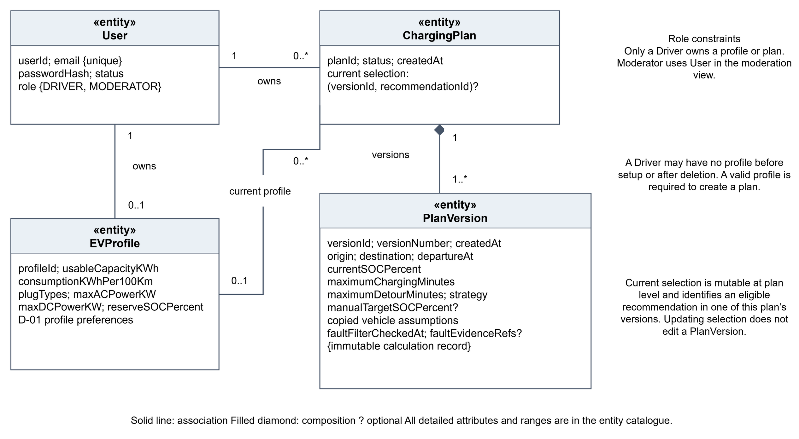
Driver ownership, optional current profile, version composition and mutable version-qualified selection.

2 Class diagram of entity classes — Calculation
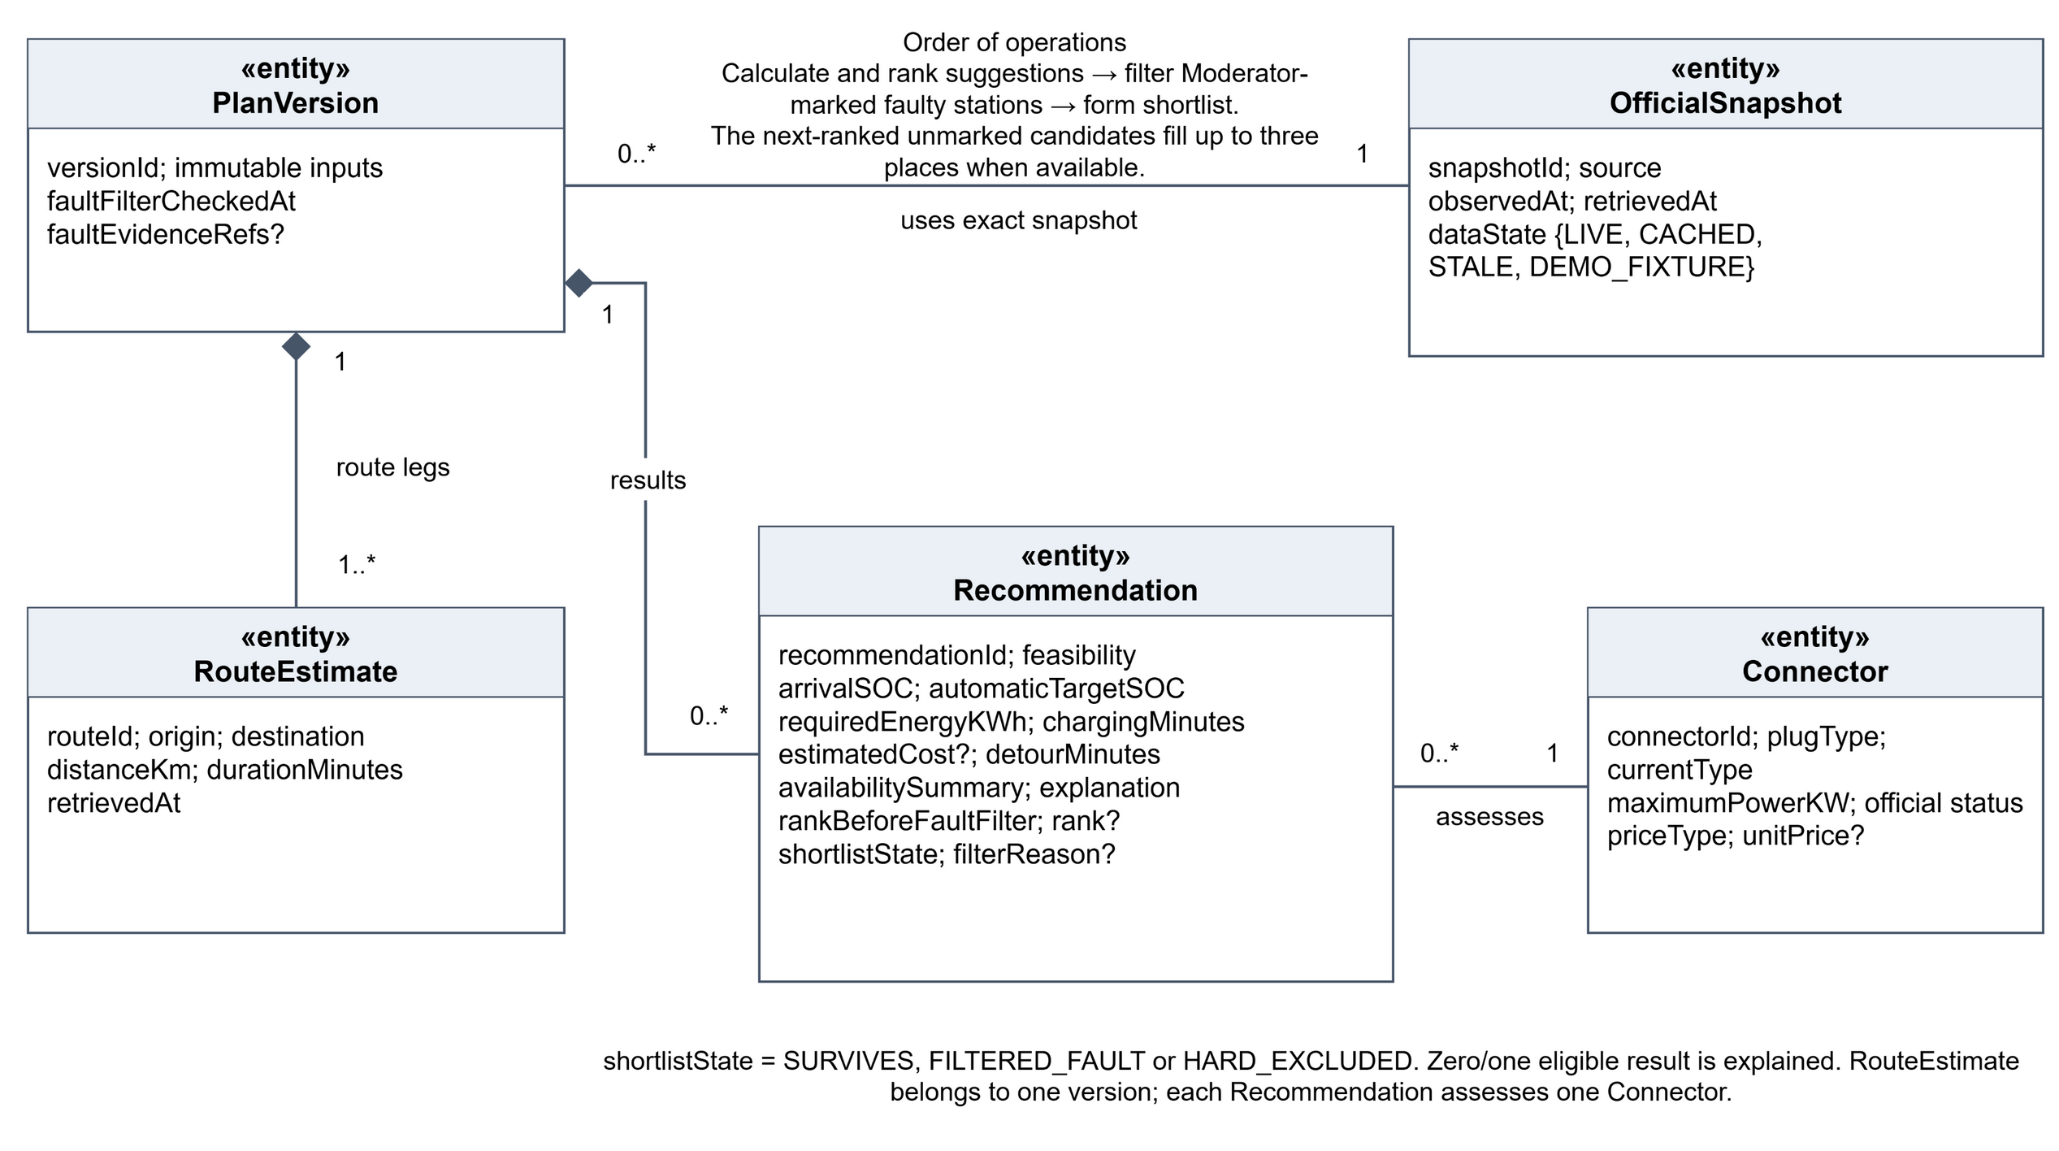
Immutable calculation results, exact provider evidence, route legs and connector assessments. Repeated classes are the same entities across views.

2 Class diagram of entity classes — Moderation
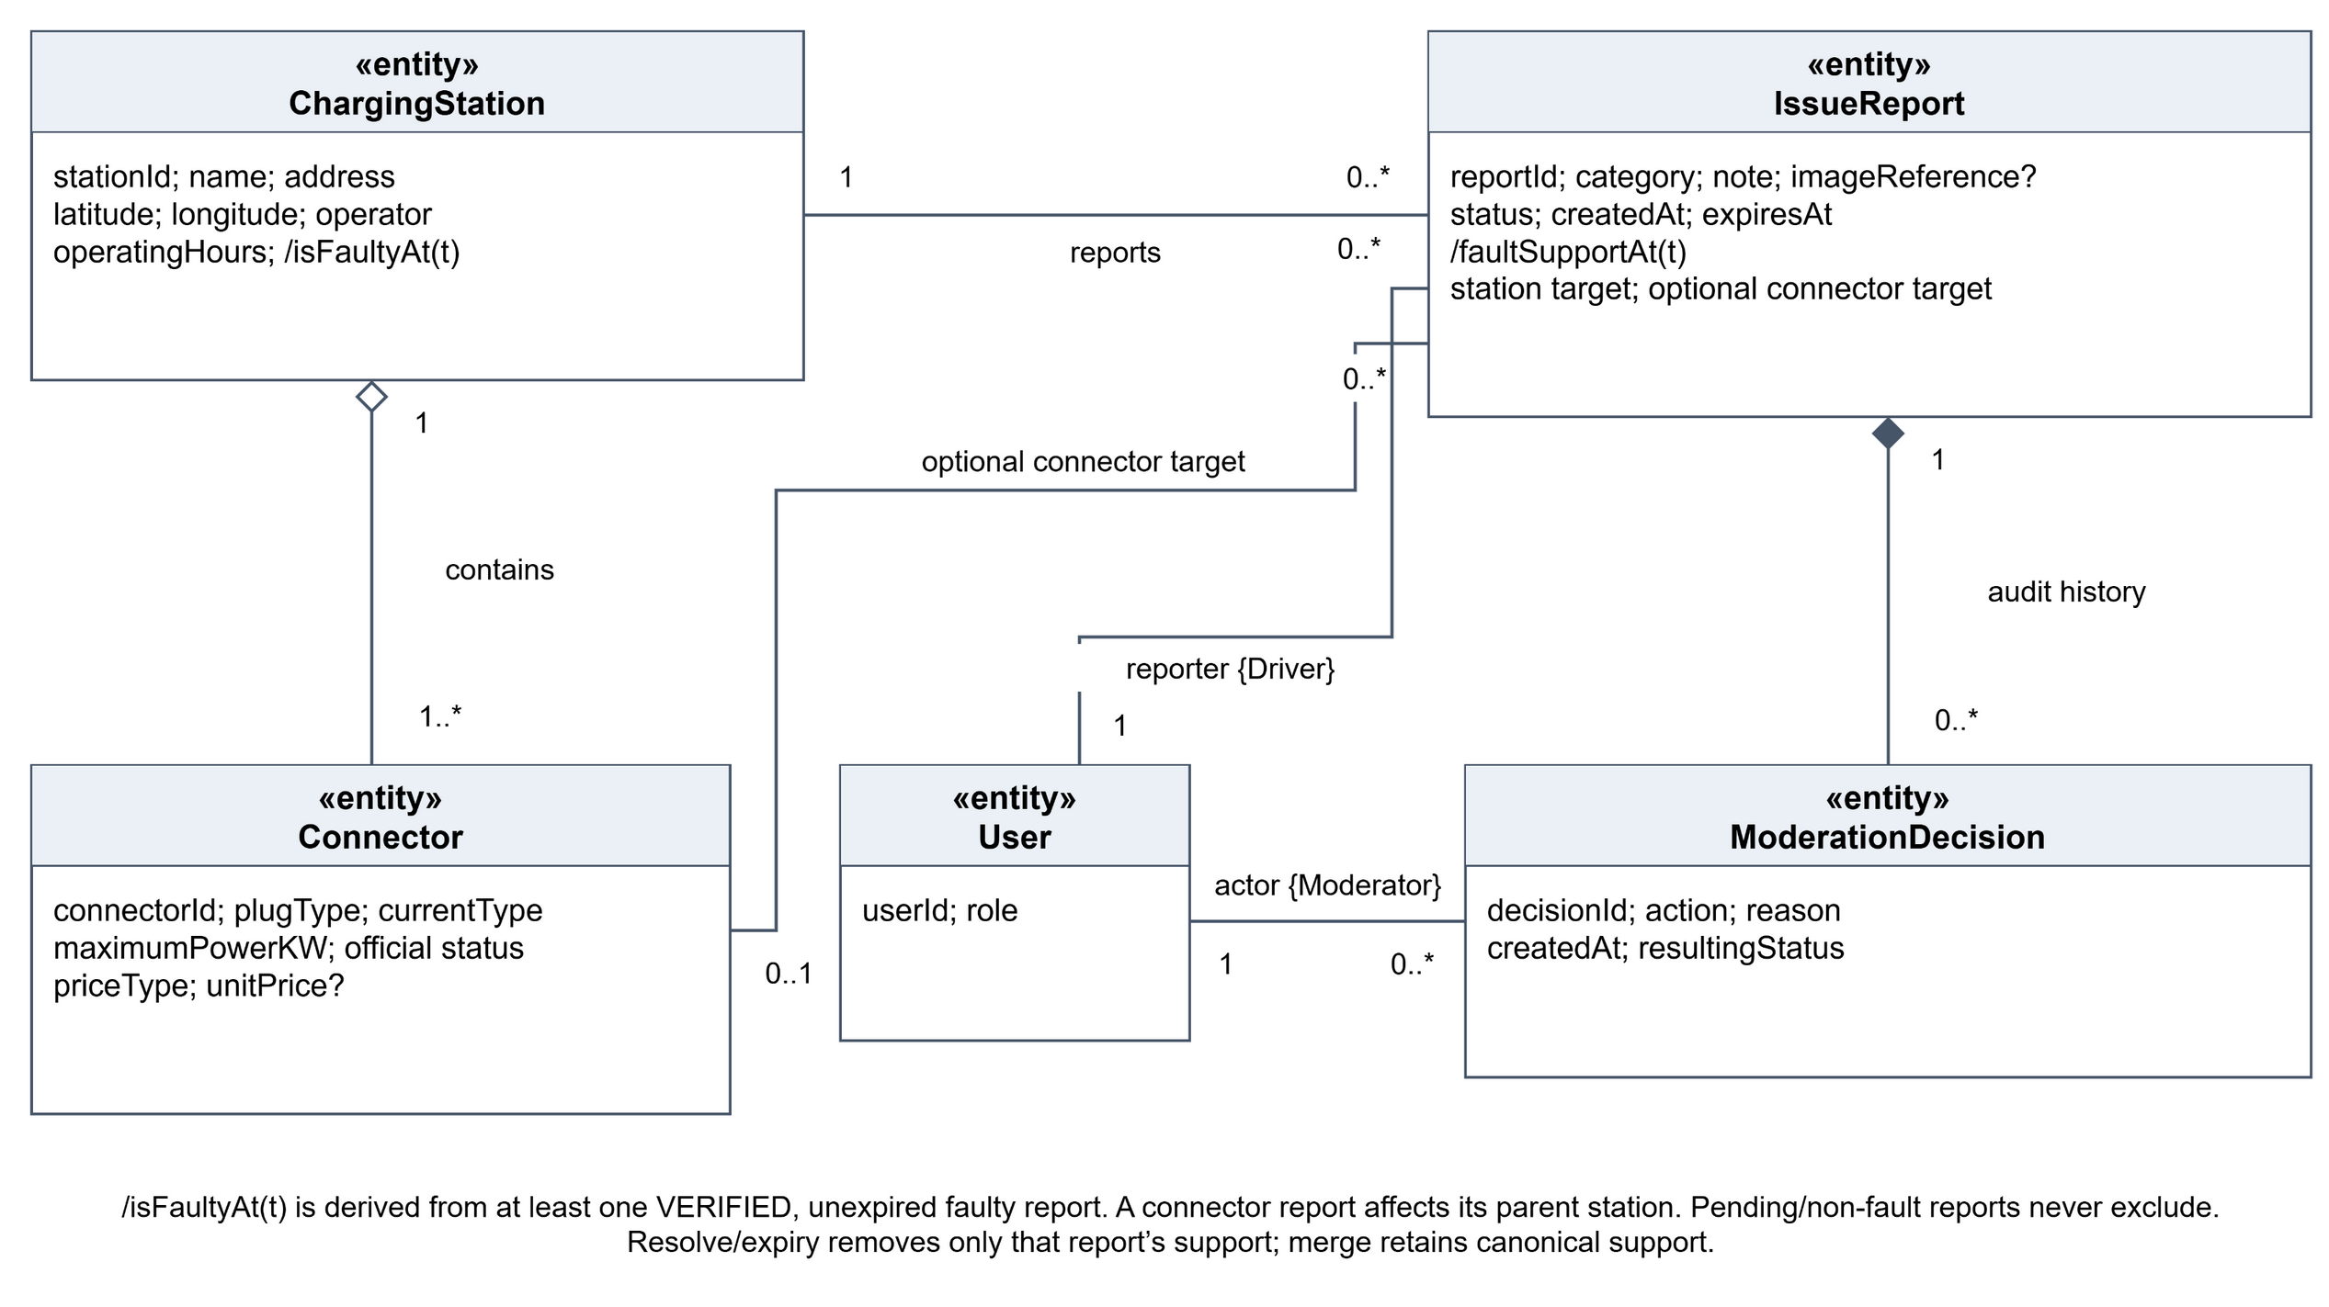
Physical inventory, issue targets and audit history. The station faulty mark is derived from existing report/decision evidence.

2 Class diagram of entity classes
The following attributes are the labels for the class diagram. ? means optional and / means derived. Existing ranges come from Lab 1; the profile preference values are also shown in D-01.
Class (stereotype) | Key attributes and constraints
User (<<entity>>) | userId; unique email; passwordHash; role {DRIVER, MODERATOR}; status. Only a Driver owns planning/report data; only a Moderator creates decisions.
EVProfile (<<entity>>) | profileId; vehicleName?; usableCapacityKWh [10,250]; consumptionKWhPer100Km [5,50]; one or more plugTypes; maxACPowerKW [1,50]; maxDCPowerKW [1,400]; reserveSOCPercent [5,40]; D-01 preferences defaultMaximumDetourMinutes?, minimumChargerPowerKW?, maximumWalkingDistanceM?.
ChargingPlan (<<entity>>) | planId; status; createdAt; current selection (versionId, recommendationId)? if a Driver selects a charger. Persistent Driver-owned record containing versions; selection is a mutable plan-level reference, not part of an immutable version.
PlanVersion (<<entity>>) | versionId; versionNumber; origin; destination; currentSOCPercent [0,100]; departureAt; maximumChargingMinutes [5,720]; maximumDetourMinutes [0,120]; strategy; manualTargetSOCPercent?; createdAt; faultFilterCheckedAt; faultEvidenceRefs?. Stores a copy of vehicle assumptions used by the calculation.
ChargingStation (<<entity>>) | stationId; name; address; latitude; longitude; operator; operatingHours; /isFaultyAt(t). The derived mark is true when verified/unexpired faulty support exists.
Connector (<<entity>>) | connectorId; plugType; currentType {AC, DC}; maximumPowerKW; official status; priceType; unitPrice?. Belongs to exactly one station; official status is distinct from the derived faulty mark.
OfficialSnapshot (<<entity>>) | snapshotId; source; observedAt; retrievedAt; dataState {LIVE, CACHED, STALE, DEMO_FIXTURE}. Timestamped provider evidence used by a version.
RouteEstimate (<<entity>>) | routeId; origin; destination; distanceKm; durationMinutes; retrievedAt. OneMap result used for route energy, detour, and destination energy.
Recommendation (<<entity>>) | recommendationId; feasibility; arrivalSOC; automaticTargetSOC; requiredEnergyKWh; chargingMinutes; estimatedCost?; detourMinutes; availabilitySummary; rankBeforeFaultFilter; rank?; shortlistState {SURVIVES, FILTERED_FAULT, HARD_EXCLUDED}; filterReason?; explanation. Only surviving eligible recommendations are displayed or selected.
IssueReport (<<entity>>) | reportId; category {BLOCKED_BAY, SUSPECTED_FAULTY_CONNECTOR, INCORRECT_LOCATION, ACCESS_PROBLEM}; note; imageReference?; status {PENDING, VERIFIED, REJECTED, MERGED, RESOLVED, EXPIRED}; createdAt; expiresAt; /faultSupportAt(t). Always identifies one station and may identify one connector.
ModerationDecision (<<entity>>) | decisionId; action {VERIFY, REJECT, MERGE, RESOLVE, EXPIRE}; reason; createdAt; resultingStatus. Append-only audit event by one Moderator for one report.

RankingStrategy is a value/enumeration selected by each version: FASTEST, CHEAPEST, AVAILABILITY_FIRST, MINIMUM_DETOUR, or BALANCED. PriceType supports per-kWh or per-hour; missing or unsupported price is Price unavailable, never zero. ChargingPlan.status retains the Lab 1 plan lifecycle without adding a new status model.

Associations and multiplicities
Use composition (◆) for version-owned calculation data and aggregation (◇) for the station/connector grouping.
Association | Multiplicity and meaning
User — EVProfile | User 1 to Profile 0..1; Profile to User 1. At most one profile per Driver; a Moderator has zero.
User — ChargingPlan | User 1 to Plans 0..*; Plan to owner 1.
ChargingPlan — EVProfile | Plan to current profile 0..1; Profile to Plans 0..*. Historical versions use copied assumptions, so deletion does not rewrite history.
ChargingPlan ◆— PlanVersion | Plan 1 to Versions 1..*; Version to Plan 1. Every recalculation/refresh appends a version.
ChargingPlan — current selection | Plan to selection 0..1; selection refers to one version and one recommendation and may change without mutating the version.
PlanVersion — OfficialSnapshot | Version 1 to Snapshot 1; Snapshot to Versions 0..*.
PlanVersion ◆— RouteEstimate | Version 1 to Routes 1..*; Route to Version 1.
PlanVersion ◆— Recommendation | Version 1 to Recommendations 0..*; Recommendation to Version 1. Zero is the explicit no-option result.
ChargingStation ◇— Connector | Station 1 to Connectors 1..*; Connector to Station 1.
Recommendation — Connector | Recommendation 0..* to Connector 1.
ChargingStation — IssueReport | Station 1 to Reports 0..*; Report to Station 1.
Connector — IssueReport | Report to Connector 0..1; Connector to Reports 0..*. Connector-target fault support resolves to the parent station.
User — IssueReport | Driver 1 to Reports 0..*; Report to reporter 1.
IssueReport ◆— ModerationDecision | Report 1 to Decisions 0..*; Decision to Report 1.
User — ModerationDecision | Moderator 1 to Decisions 0..*; Decision to Moderator 1.
PlanVersion — RankingStrategy | Version to selected strategy 1.

Calculation relationships
PlanVersion supplies the journey and copied profile assumptions to FeasibilityControl; it uses RouteEstimate, Connector, and OfficialSnapshot to create Recommendation objects. Effective power is the lower of connector power and the applicable vehicle AC/DC limit. The automatic target and manual-target rules, reachability, compatibility, operating hours, detour, dwell fit, cost, ranking factors, timestamps, and estimate warnings remain those specified in Lab 1. The model does not introduce a new calculation formula.

3 Key boundary and control classes
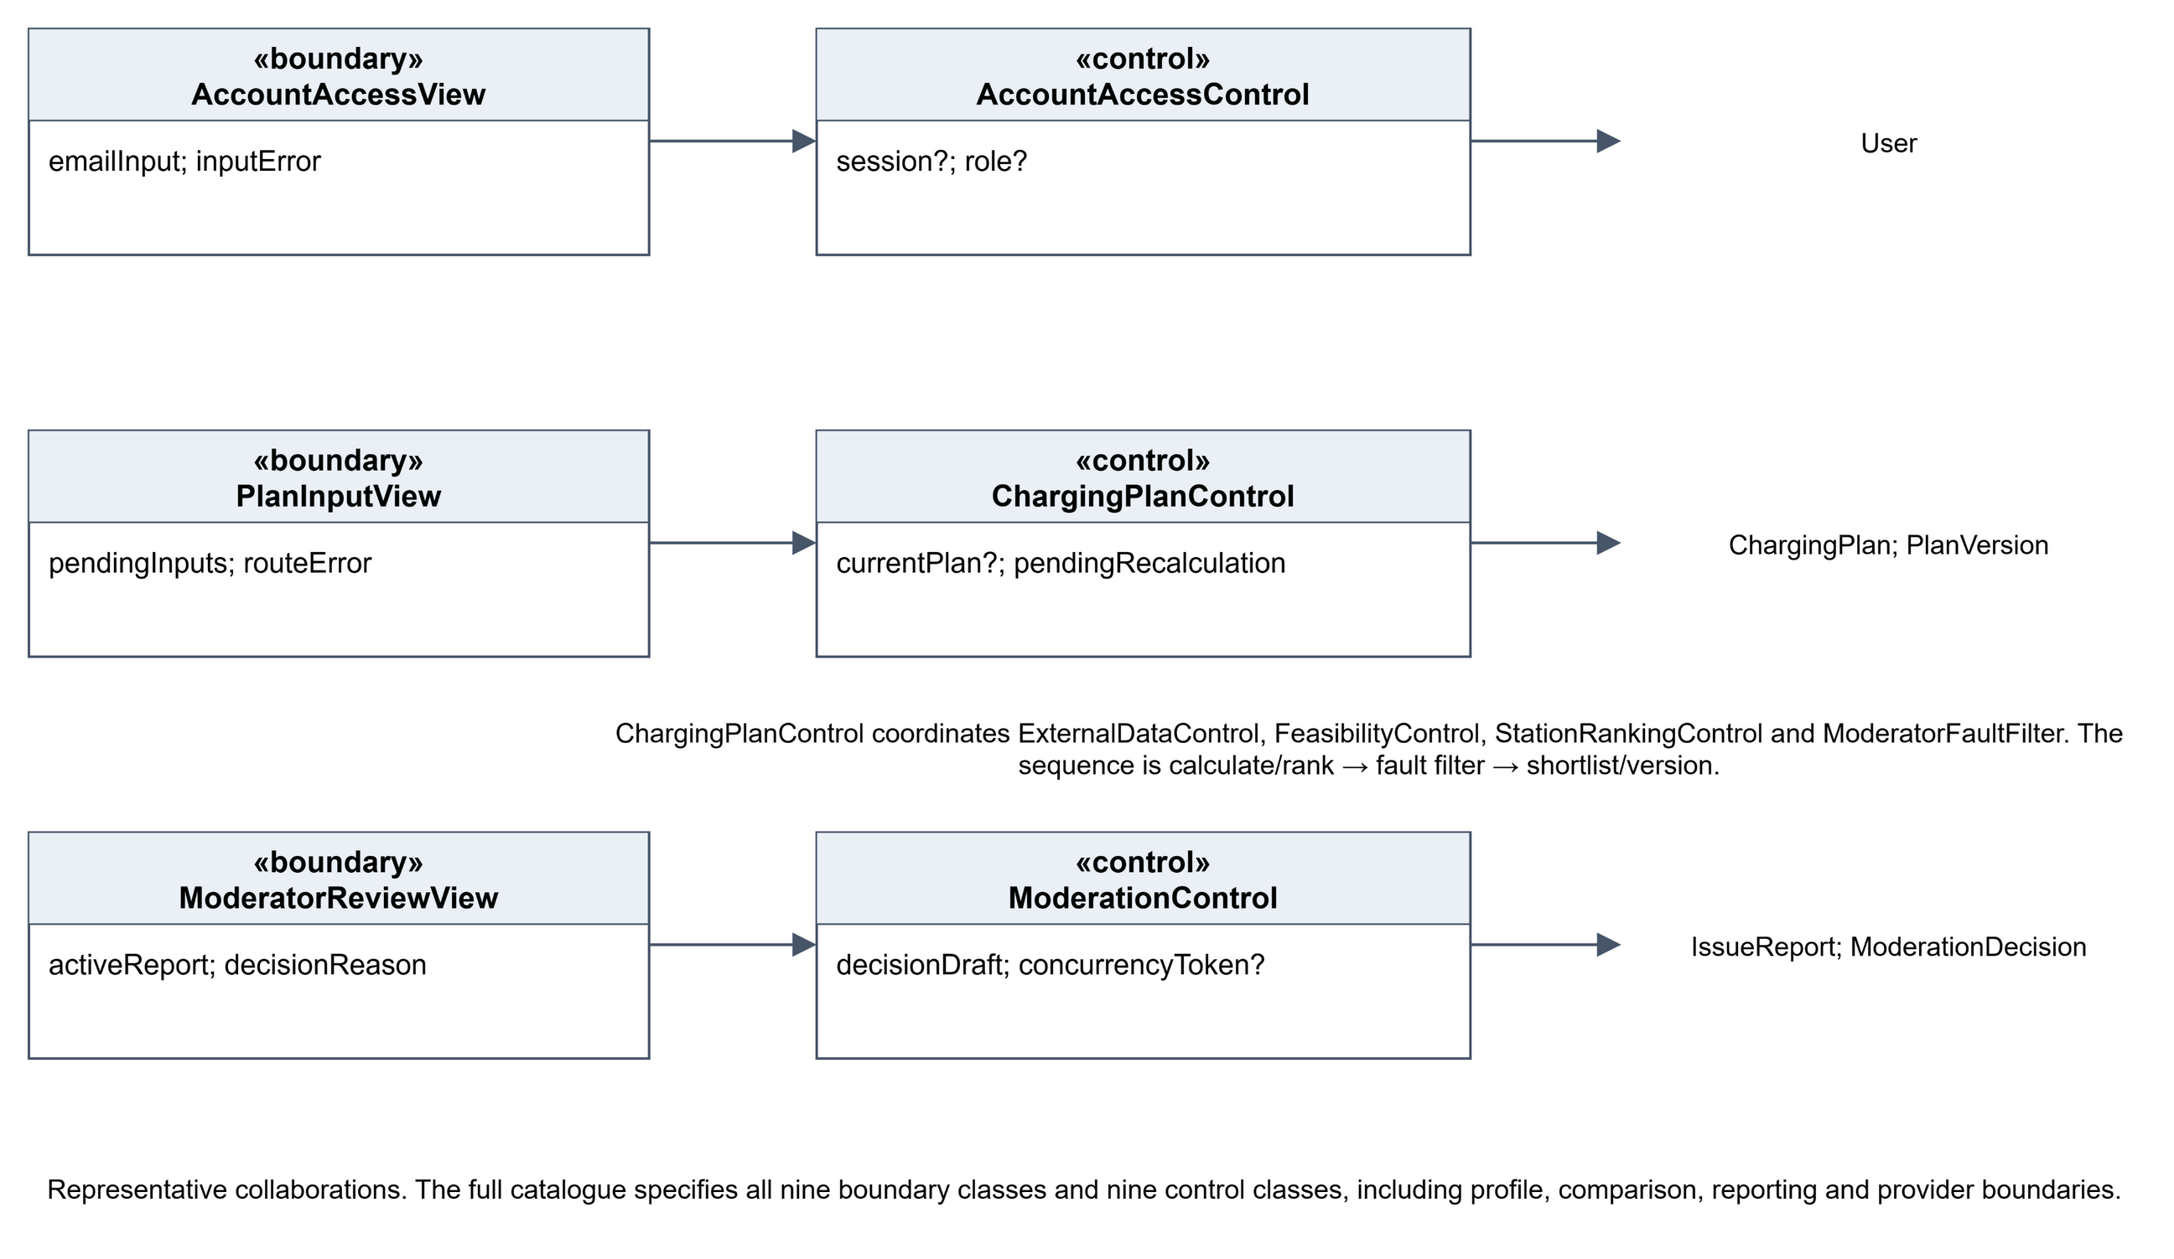
Representative boundary–control–entity collaborations. The complete object and attribute catalogue follows the diagrams.

3 Key boundary and control classes

Boundary classes
Class (<<boundary>>) | Key boundary state/attributes | Responsibility | Frame
AccountAccessView | emailInput; passwordInput; registrationMode; inputError; sessionRoute | Sign-in, Driver registration, generic error, role-aware routing | D-00
VehicleProfileView | profileForm; validationErrors; saveState; deleteConfirmation | One profile, units/assumptions, validation, save/delete | D-01
PlanInputView | pendingInputs; targetMode; placeResolutionState; routeError; transient draftState | Journey, SOC, departure, dwell, detour, target, draft/cancel/find | D-02, M-01
RecommendationView | displayedRecommendations; dataState; excludedReasons; selectedStrategy; refreshState | Cards, route, explanations, freshness/data state, exclusions, edit/refresh | D-03, M-02
CompareReconfigureView | comparisonSet[2..3]?; whatIfInputs; unsavedChanges; recalculationState | Two/three-option comparison and what-if/recalculate controls | D-04
IssueReportView | stationContext; connectorContext?; category; note; imageState; submissionState | Station/connector context, category, note, image, duplicate/validation/success | D-05
ModeratorReviewView | queueFilter; activeReport; evidence; decisionReason; auditHistory; concurrencyState | Restricted queue, evidence, official status, audit, decision controls | D-06
OneMapBoundary | placeQuery; resolvedPlace?; routeResult?; providerError? | Place resolution and route result/error boundary | Plan flows
LTASnapshotBoundary | snapshot?; observedAt; retrievedAt; dataState; providerError? | Station/connector snapshot, timestamps, data-state boundary | Plan flows

M-01 and M-02 are responsive presentations of D-02 and D-03, not separate use cases or domain entities.

Control classes
Class (<<control>>) | Maintained analysis state/attributes | Responsibilities | Trace
AccountAccessControl | session?; attemptState; role? | Registration, sign-in, session role, sign-out, generic errors | UC-01; FR-01–02
EVProfileControl | loadedProfile?; validationResult; saveState | Load/validate/create/update/delete profile; protect copied version assumptions | UC-02; FR-03–04
ChargingPlanControl | currentPlan?; currentVersion?; pendingRecalculation?; currentSelection? | Validate inputs, create plan/version, coordinate recalc/refresh, preserve versions and selection/fallback | UC-03, UC-05, UC-06; FR-05, FR-21–23
ExternalDataControl | placeState; routeResults; usableSnapshot?; dataState; providerFailure? | OneMap place/routes, latest usable LTA snapshot, cached/stale/demo state, visible provider failure | UC-03, UC-06; FR-06–07
FeasibilityControl | candidateResults; exclusionReasons; calculationWarnings | Reachability, plug/hours/detour, SOC/energy/time/dwell/cost rules | UC-03–06; FR-08–17
StationRankingControl | strategy; factorValues; rankedSuggestions; rankingExplanation | Fixed strategy factors, ranking, explanations, next-ranked alternatives | UC-03–06; FR-18–20, FR-23
ModeratorFaultFilter | checkTime; activeSupportRefs; filteredCandidates; survivors | Evaluate report/decision support after ranking, mark candidates FILTERED_FAULT, record evidence and form survivors | UC-03/05/06 plus UC-07/08 refinement; FR-24 refinement
IssueReportControl | reportDraft; duplicateMatch?; expiry; submissionState | Validate/create expiring Pending report, duplicate check, queue availability and acknowledgement | UC-07; FR-24
ModerationControl | queue; activeReport; decisionDraft; auditHistory; concurrencyToken? | Moderator authorization, queue/evidence/history, reason/concurrency checks, append decisions and status | UC-08; FR-25

The main coordination dependencies are ChargingPlanControl -> ExternalDataControl, FeasibilityControl, StationRankingControl, ModeratorFaultFilter and ModeratorFaultFilter -> Recommendation, ChargingStation, IssueReport, ModerationDecision, PlanVersion. IssueReportControl uses IssueReport/ChargingStation/Connector/User; ModerationControl uses IssueReport/ModerationDecision/ChargingStation/User.

4 Initial Dialog Map — Driver Journey
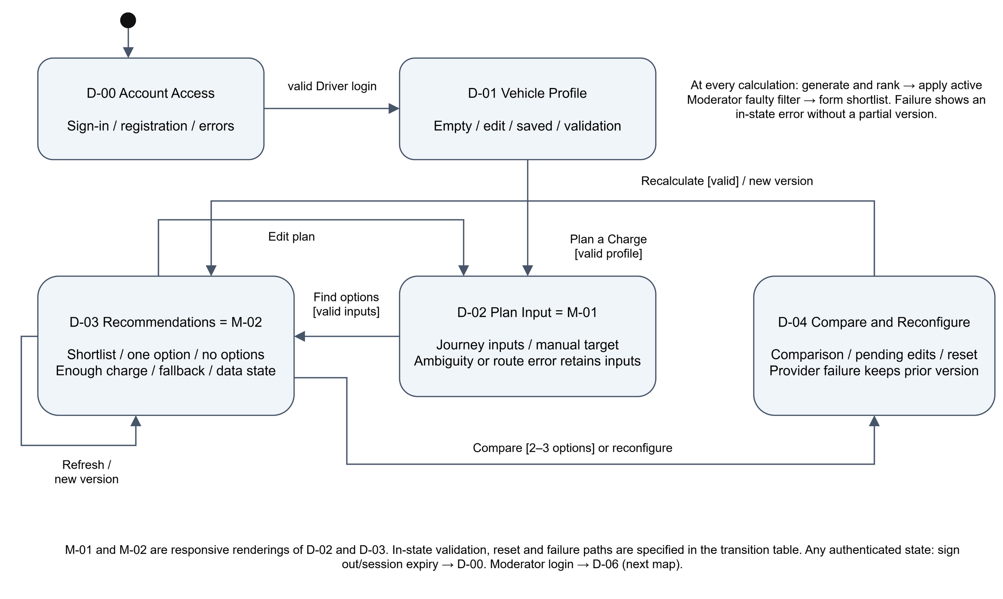
Nodes are UI states. M-01 and M-02 share the logical states of D-02 and D-03; validation and manual refresh are UI state transitions.

4 Initial Dialog Map — Reporting and Moderation
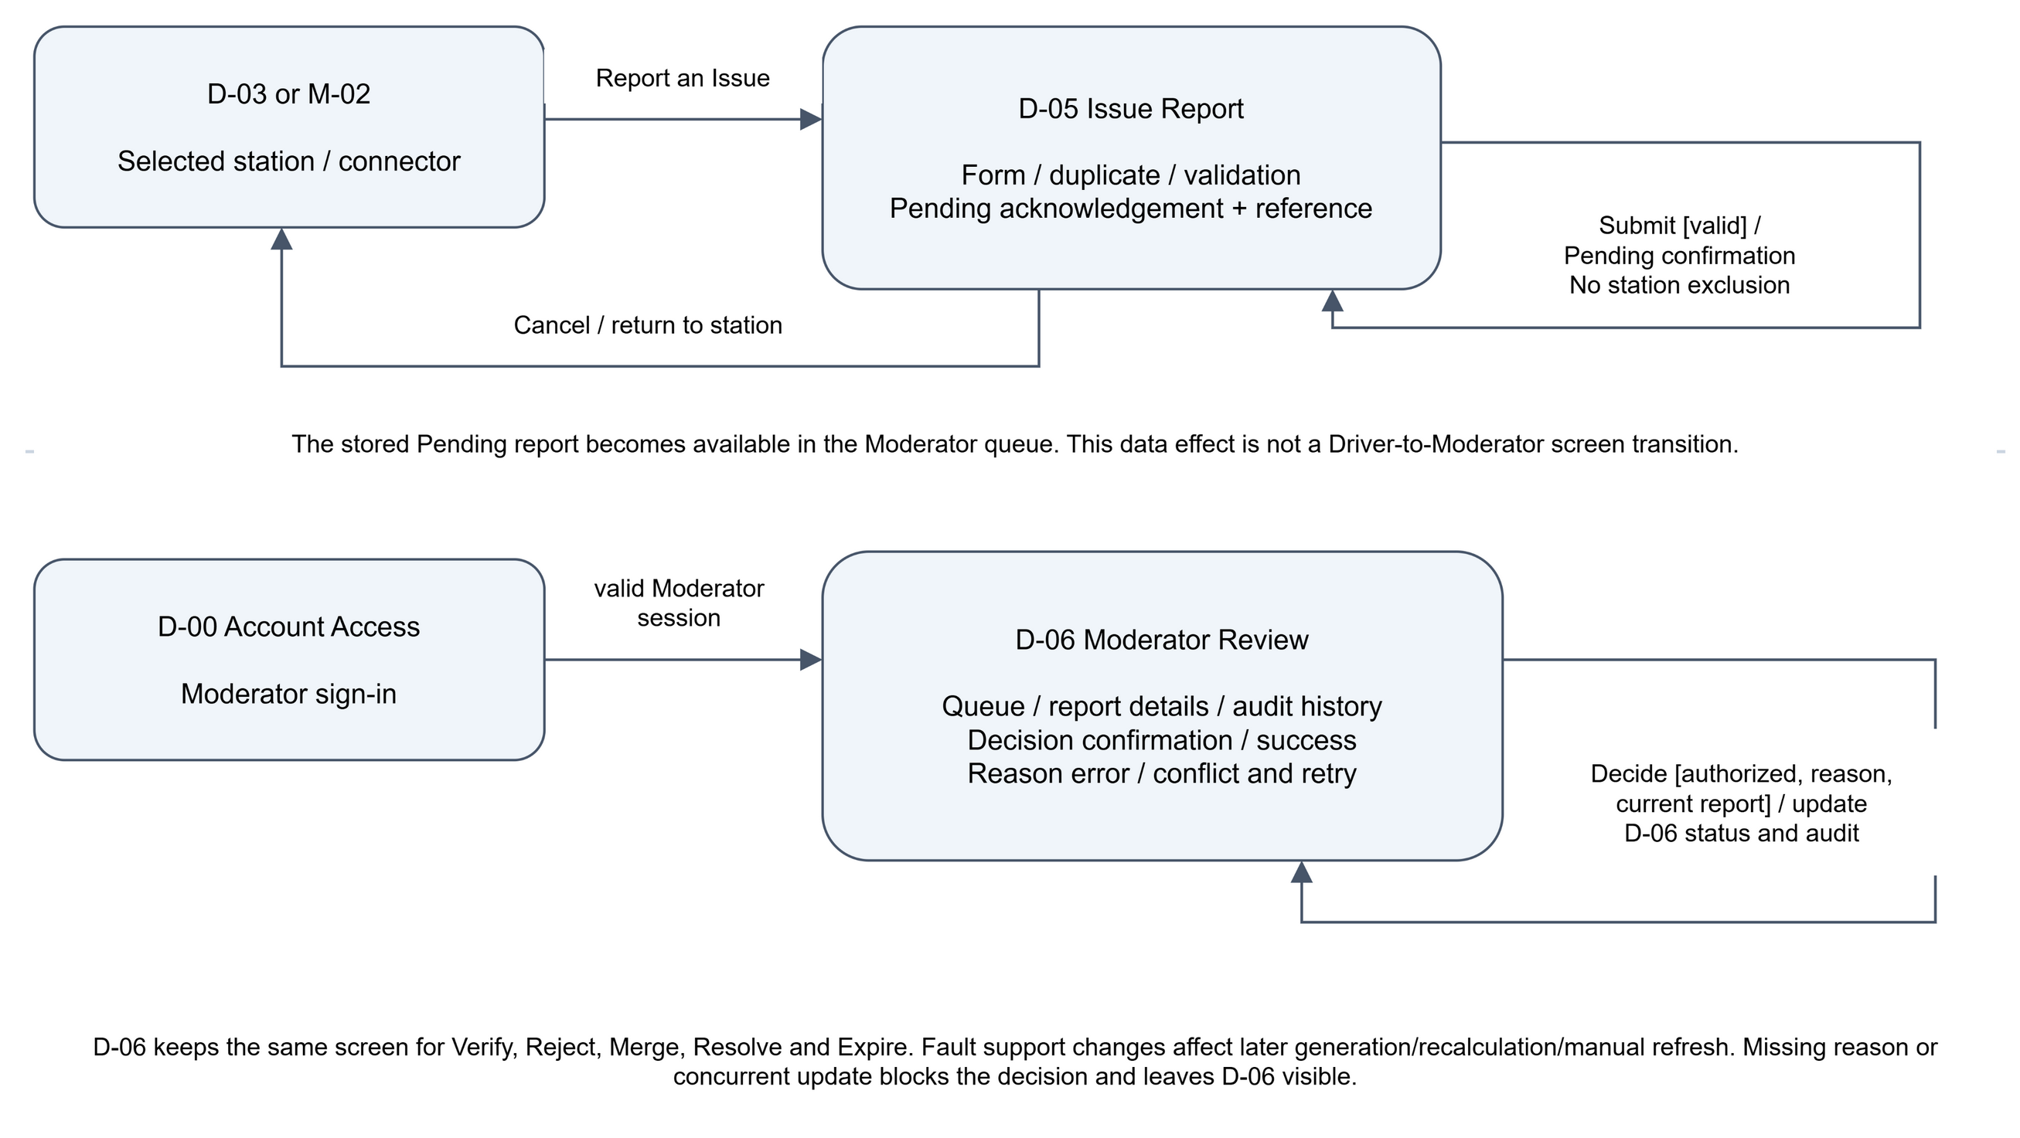
Driver and Moderator journeys are separated by role. Report lifecycle changes appear as variants of the report/review UI, not as screen transfers between users.

4 Initial Dialog Map

Logical UI states
State | Frame(s) | Entry and in-state variants
S0 Account Access | D-00 | No session; sign-in, Driver registration, generic invalid-credentials and inactive-account states.
S1 Vehicle Profile | D-01 | Authenticated Driver; empty/current profile, validation, saved confirmation, delete/empty state.
S2 Plan Input | D-02; M-01 | Valid profile; normal, automatic/manual target, transient draft controls, ambiguous place, invalid input, route-error-with-inputs-preserved.
S3 Recommendations | D-03; M-02 | Ranked cards; live/cached/stale/demo, estimate warning, enough charge, no options, one survivor/comparison disabled, fallback, fault-filtered exclusion.
S4 Compare & Reconfigure | D-04 | Comparison, missing price/stale option, pending what-if, reset, new-version notice, provider error.
S5 Report Charger Issue | D-05 | Context/category/note/image, privacy reminder, duplicate, image validation, Pending success/reference, cancel.
S6 Moderator Report Review | D-06 | Queue tabs, evidence/official status/related reports/audit, reason, five actions, missing reason, concurrent update.

The D-02 Save as Draft control is retained as a UI affordance from Lab 1. In this analysis model it is a transient input state, not a new persistent Draft entity or additional functional requirement; unsaved origin/destination values are not retained after the UI is abandoned.

Transitions
Same-state edges are intentional UI state changes and may be shown as loops or annotations in the state machine.
From | Trigger and guard | To / outcome
S0 | Register Driver or valid Driver sign-in | S1 or S2 with Driver session; UC-01, FR-01–02
S0 | Valid Moderator sign-in | S6 with restricted Moderator session; UC-01
S0 | Invalid/inactive account | S0 with generic error/support instruction; UC-01 exceptions
Any | Sign out | S0; session invalidated
S1 | Save valid profile / invalid profile / confirm delete | S1 saved / S1 field errors / S1 empty; UC-02
S1 | Plan a Charge with valid profile | S2 (D-02 or M-01); UC-02 → UC-03
S2 | Choose manual target, transient draft, ambiguous place, invalid input, route failure | S2 with corresponding state; UC-03 alternatives/exceptions
S2 | Valid journey and provider results; calculate, rank, then fault-filter | S3 (D-03 or M-02), new Plan Version; UC-03, FR-05–19, FR-24 refinement
M-01 | Find options with valid input | M-02 using the same calculation guard; UC-03
S3 | Edit Plan | S2; UC-05
S3 | Compare two/three eligible cards | S4; UC-04, FR-20
S3 | Strategy/reconfigure action | S4 or new-version calculation; UC-04.AC.1, UC-05
S3 | Manual Refresh with usable snapshot | S3, new version, original or next-ranked unmarked fallback; UC-06, FR-22–23, FR-24 refinement
S3 | No usable snapshot / enough charge / zero or one survivor | S3 explicit failure / continuation / no-option or comparison-disabled state
M-02 | Edit or Refresh | M-01 or M-02; same S2/S3 rules as desktop
S3 | Report station/connector issue | S5 with pre-filled context; UC-07
S4 | Change values / Reset / Recalculate | S4 pending / S4 current values / S3 new immutable version; UC-05, FR-21, FR-24 refinement
S4 | Unsaved exit or provider failure | S4 confirmation / previous version unchanged; UC-05 exceptions
S5 | Submit valid / duplicate / invalid image or rate limit / cancel | S5 Pending reference / S5 existing-report choice / S5 validation / prior S3; UC-07, FR-24
S6 | Select report | S6 with evidence, official status, related reports, audit; UC-08
S6 | Verify faulty with reason | S6; append decision and activate station support for future generation/recalc/refresh
S6 | Reject, resolve, expire, or merge with reason | S6; append decision and update lifecycle/support according to the rules above
S6 | Missing reason or concurrent update | S6 blocked action / S6 refresh-required state; UC-08 exceptions

