Online EDA Automation

Wireframe Document

## Login Screen

First screen is the login screen which help user to login/signup or change password if needed.

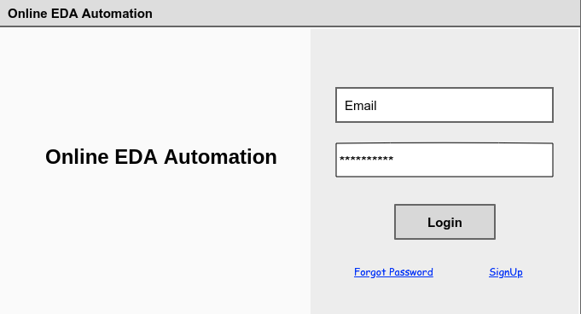

If the user is not signed up the user can signup using the signup button.

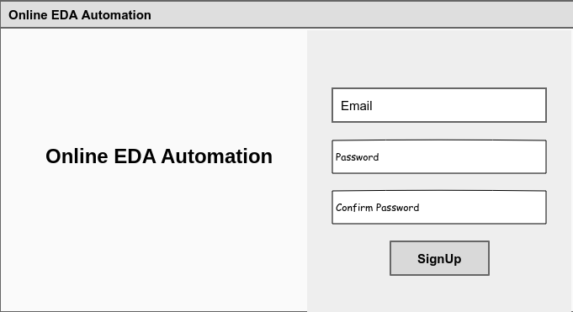

Once the user is signed up user can login using the login page.

## Home Page

After successful login user will see the home page of the application

Once the user is logged in they will see options to select the dataset and also the type of the dataset i.e, csv, json, xml etc

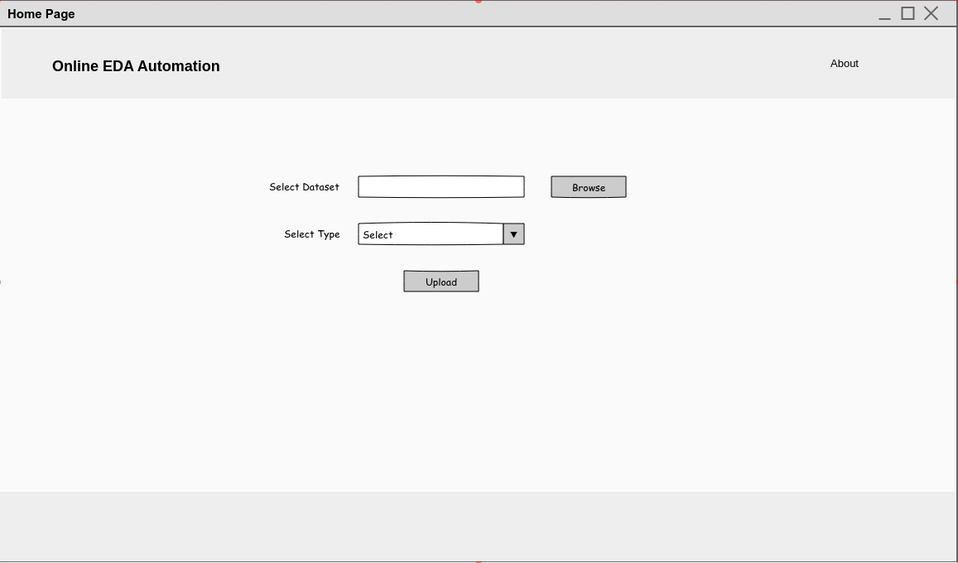

Once the user uploads the dataset it will take the user to the new page with the prebuild EDA steps

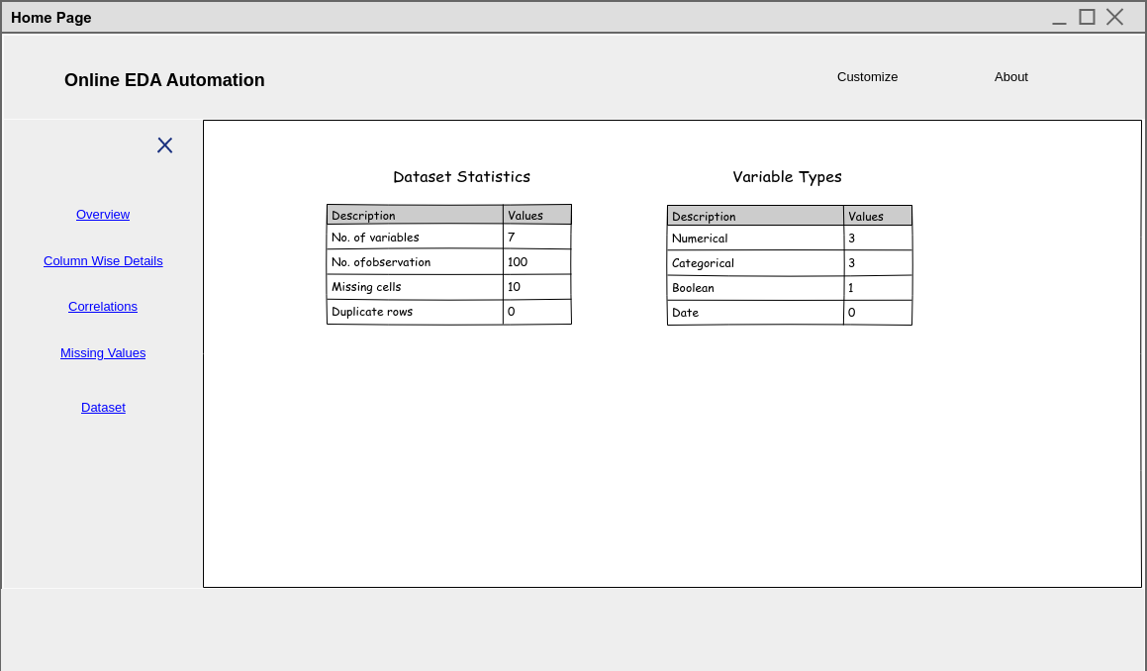

The Overview page will give the dataset stats and variable types

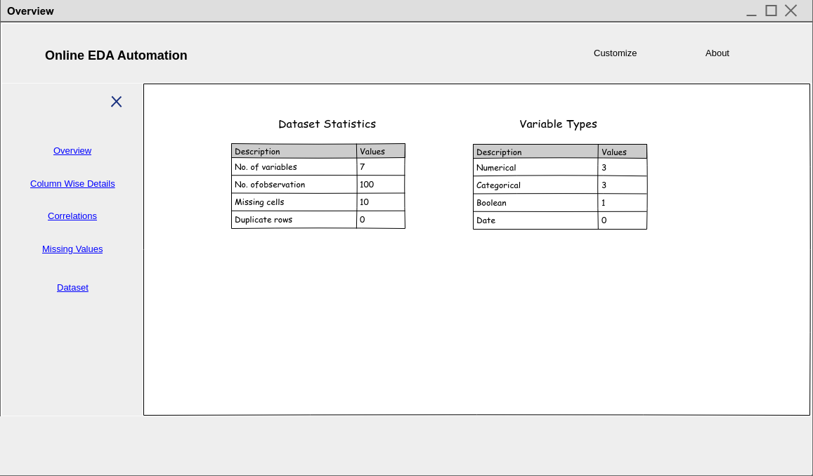

The column wise details gives the details of the columns such as data types, column variable information with dedicated statistics.

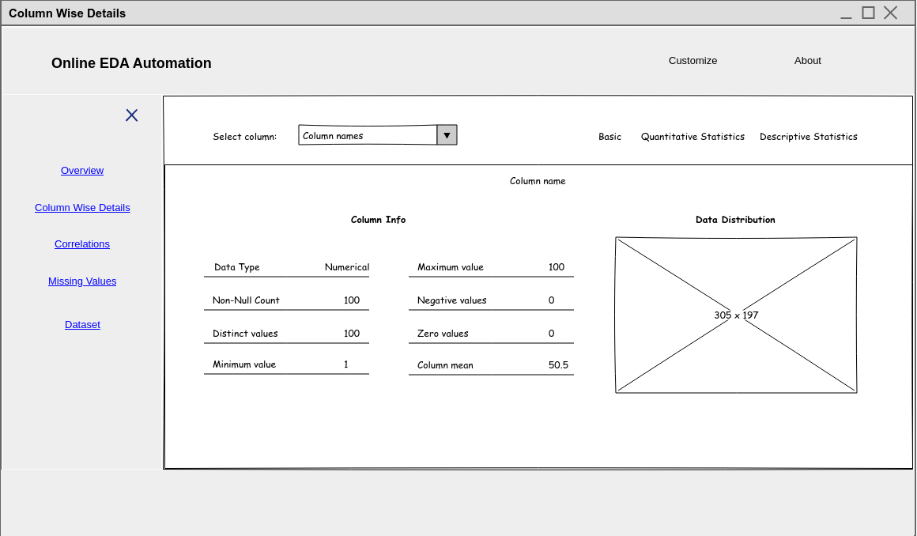

The column wise details shows three navigation

* Basic
* Quantitative Statistics
* Descriptive Statistics

Basic shows the column information with data distribution

Quantitative Statistics shows information of the quantiles

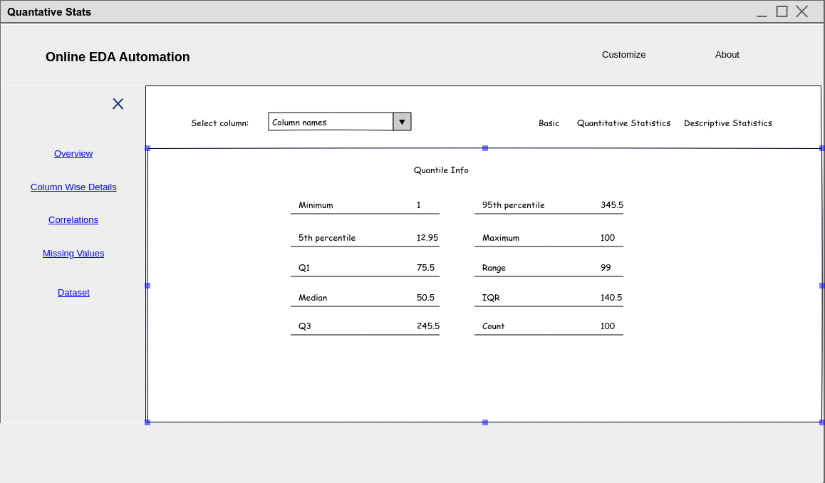

Descriptive Statistics shows the information standard deviation, skewness,mean ,median absolute deviation etc.

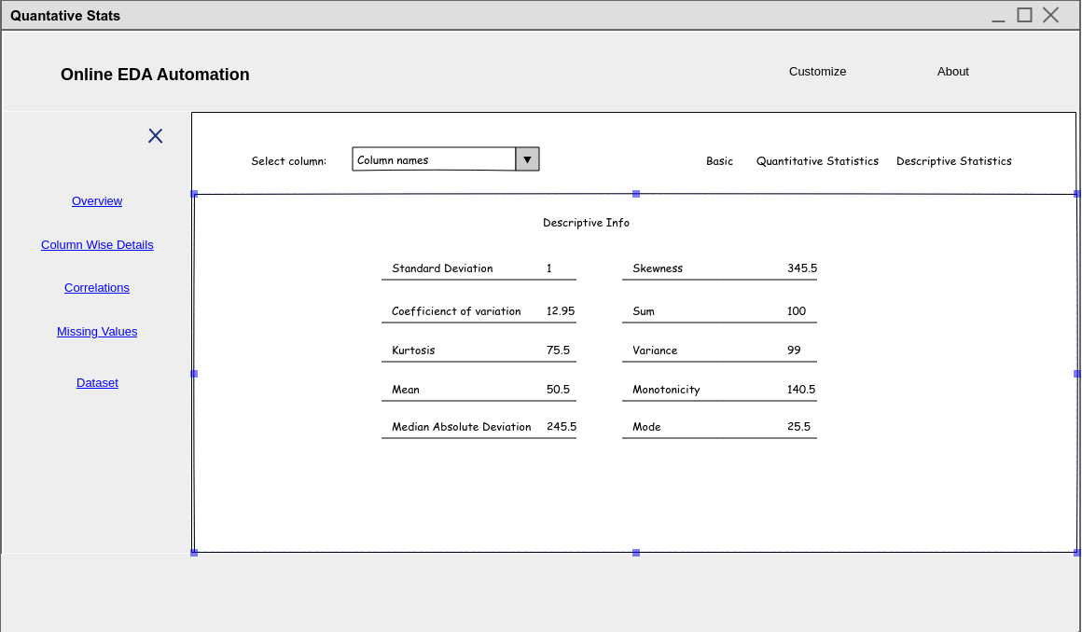

The correlation link will display the different correlations in the dataset like Pearson’s correlation, Spearman’s correlation etc.

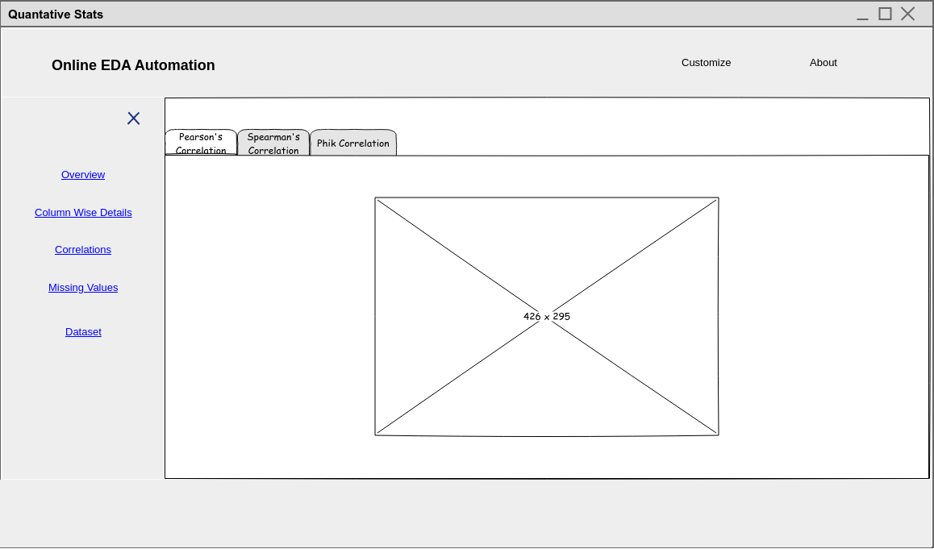

The Missing values link will show the nullity matrix which lets you quickly visually pick out patterns in data completion.

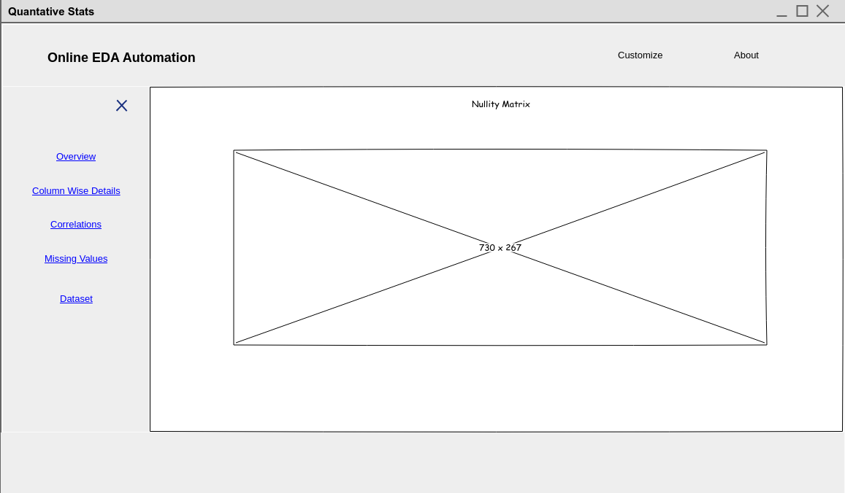

Now the last dataset link will give us the dataset in a tabular format.

