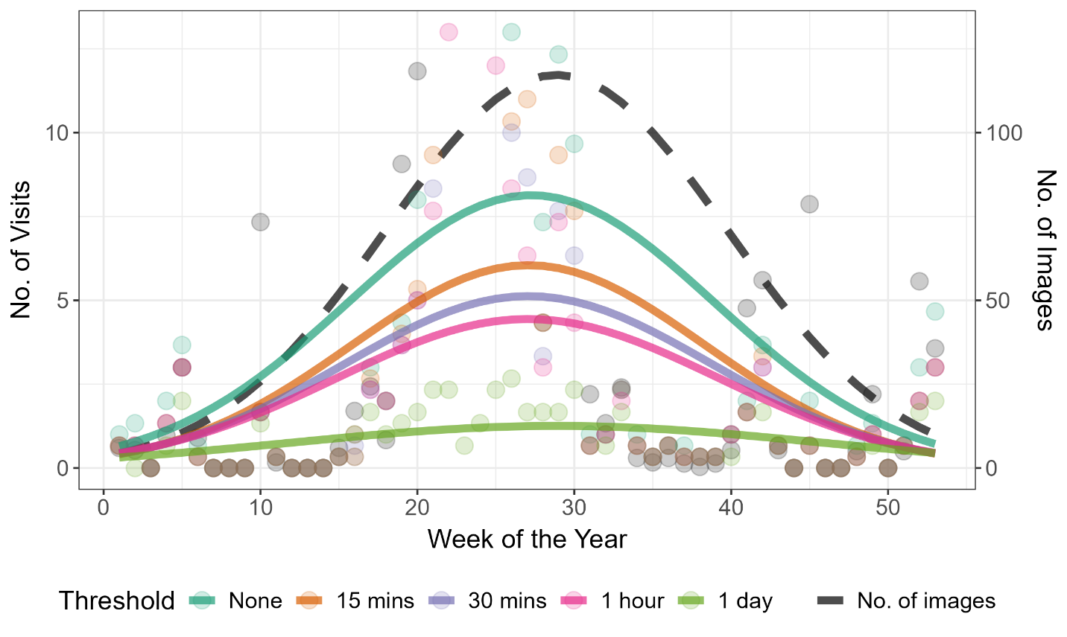

**Figure 1**. Weekly predicted number of visits over a year, using the Chain Rule Interval combination method across different time thresholds (None, 15 mins, 30 mins, 1 hour, and 1 day). The “No. of Image” category represents the raw total number of images collected by camera trap per week. Predicted visits were generated as the average values from 2020 to 2022 using negative binomial count models, incorporating week, week squared, and year as predictor variables.

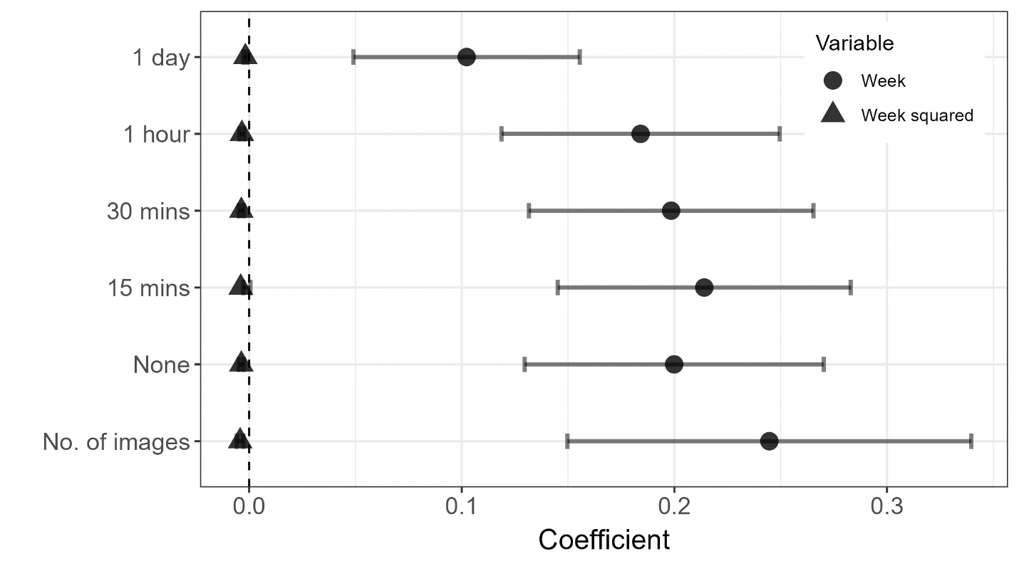

**Figure 2:** Coefficients and 95% confidence intervals of the negative binomial count models representing the number of visits by moose to a mineral lick, relative to the time of year. Models were constructed using both linear and non-linear terms for week and year (not shown) with camera trap data processed through the Chain Rule Interval method across different time thresholds (None, 15 mins, 30 mins, 1 hour, and 1 day).