Project title
Acoustic Monitoring for Migratory Birds in Lithuania – Land of the Storks

Project summary
National Geographic grant number | EC-KOR-53792R-18
National Geographic program officer | Nate Hall (nhall@ngs.org)
Principle investigator | Yi-Chin (Sunny) Tseng (sunnyyctseng@gmail.com) – University of Northern British Columbia, Canada; independent researcher
Local collaborator(s) | Tomas Pikūnas (tomas.pikunas@saugoma.lt) – Žuvintas Biosphere Reserve  Modestas Bružas (modestas.bruzas@nerija.lt) – Curonian Spit National Park
Project timeline | - Plan for fieldwork: 2025 Jan - April  - Data collection: 2025 May – July  - Data summary and draft report: 2025 Aug – Dec  - Final project deliveries: 2026 spring

Background and Relevance
Lithuania is a particularly watered region with more than 3,000 lakes, mostly in the northeast. The landscape is dominated by meadows, dense forests, and fertile arable lands¹. With the highest elevation less than 300m, Lithuania is home to a terrestrial biome “temperate broadleaf and mixed forests”, according to the WWF classification², or “temperate-boreal forests and woodlands”, according to IUCN³. The mixed forest occupies around one-third of the country’s territory⁴, with the dominant tree species being pine, birch and spruce. In contrast, the freshwater biomes includes rivers and streams, lakes, and wetlands, which cover around 7.9% of the country’s territory, although most of the wetlands having been lost due to drainage and human activity between 1960 to 1980.
Protected areas, of all protection levels, occupy 17% of the total area of Lithuania. There are five National Parks, including Curonian Spit National Park, the one with the most diversity of bird communities. There are also six Strict Nature Reserves, including Zuvintas Biosphere Reserve, which is an important breeding ground and migration halt for waterbirds.
Many birds fly through Lithuania as part of the Baltic Flyway, one of the world's most important migratory routes, bounded by East Atlantic Flyway and Black Sea Mediterranean Flyway⁵. The avifauna of Lithuania include a total of 387 species (bird list obtained from Lithuanian Ornithological Society, LOD⁶; v2024 April), including thirteen globally endangered specie such as Ferruginous Duck (Aythya nyroca), White-tailed Eagle (Haliaeetus albicilla), Corncrake (Crex crex), Great Snipe (Gallinago media) and Aquatic Warbler (Acrocephalus paludicola). Named in 1973, the White Stork (Ciconia ciconia) is the national bird of Lithuania, symbolising harmonious coexistence of humans and nature. The bird spring migration in Lithuania starts as early as March/April, bringing huge concentration of geese, swans, ducks and other waterfowls. The breeding season in May/June provide the most species observed (150 ~ 200 species). Most passerine (aka. songbirds) arrive at end of May⁷.
Although being rich in bird diversity, only few publicly available resources are available regarding to the Lithuanian bird sound documentation:
- Website of Žuvintas Biosphere Reserve (link) – a collection of bird sounds from lakeshore, forest, and meadows.
- A CD recorded by Vidmantas Blažys (link) – a collection of bird sounds in the Novaraistis region.
- A Youtube video channel Asvidea (link) – a comprehensive which includes 400 bird sounds – however, the recordings are likely from other countries instead of collected in Lithuania locally.
- Xeno Canto (link) – a worldwide bird sound library, including recordings shared by citizen scientists for about 140 bird species across Lithuania (accessed on Jan.2024).
Documenting single bird species vocalization is crucial in understanding the behaviour and sound variation, while a long-term soundscape monitoring, by autonomous recording units (ARUs), is also important in understanding the interaction between the species and the environment. A very recent study inventories passive acoustic monitoring (PAM) datasets targeting biodiversity globally, indicating that very few, if any, effort has been made for passive acoustic monitoring in Lithuania⁸ (see the interactive map).

Objectives and contributions
In this project, I am going to conduct fieldwork in Žuvintas Biosphere Reserve and Curonian Spit National Park to document the Lithuania’s bird diversity. The objectives of this study are to 1) set up autonomous recording units (ARUs) for large scale passive monitoring for soundscape and 2) collect species-specific vocalization for bird species in Lithuania. The ultimate goal is to explore the sounds of the ecosystem in Lithuania and enhance the documentary of the local birds. All collected data will be publicly available upon completion of the project, as part of the worldwide soundscape project (link), and Xeno-Canto sound library (link).

Methodology
Study area
The Curonian Spit National Park, located between the Baltic Sea and the Curonian Lagoon, has the highest diversity of bird species in Lithuania. This park is renowned for its sand dunes and proximity to Ventės Ragas Ornithological Station, Lithuania's largest bird banding station, which is instrumental in monitoring avian migration. The Žuvintas Biosphere Reserve, located in southern, is one of the country's most critical breeding grounds and migratory stopovers for waterbirds. As the largest wetland area in Lithuania, the reserve encompasses a lake that serves as a habitat for more than 120 bird species. In total, the biosphere reserve supports over 240 bird species, underscoring its ecological significance⁹ (Fig. 1).
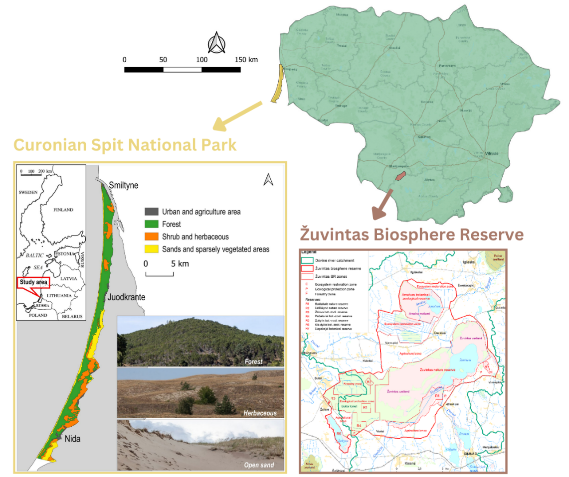
Fig. 1. Study area in Lithuania, showing both Curonian Spit National Park¹⁰ and Žuvintas Biosphere Reserve¹¹.
Recording equipment
Passive Acoustic Monitoring – Autonomous recording units (ARUs) will be deployed for passive acoustic monitoring, programmed to record continuously for 24 hours during May – July 2025. Each ARU will follow a schedule of 1 minute of recording followed by 4 minutes off, resulting in 288 minutes (approximately 5 hours) of audio recordings per day. A minimum of 10 ARUs (e.g., AudioMoths, Song Meters, or equivalent models) will be installed at each site to ensure adequate spatial coverage.
Active Recording – Targeted recordings of individual bird species will be conducted by Sunny Tseng using a Telinga Pro parabolic microphone and a Tascam MKHIII audio recorder. The parabolic microphone is ideal for isolating and capturing clean, species-specific vocalizations. Active recording will take place during dawn hours, when birds are most vocally active, and will involve walking within the study area to track and record individual birds.
Audio interpretation
The soundscape data collected by the ARUs will be analyzed using BirdNET, a machine learning algorithm designed to identify bird species based on their vocalizations. This analysis will generate a comprehensive local species list and provide insights into the activity patterns of various bird groups, including songbirds and owls. The processed data will also be contributed to the global soundscape project, supporting broader research and conservation initiatives.
Species-specific audio recordings will be manually processed using Audacity to isolate and clean target bird vocalizations. These curated recordings will then be shared publicly on Xeno-Canto, contributing to an open-access repository of avian sound data.

Fieldwork Plans for Summer 2025
May
- May 2–4: Arrival in Vilnius, Lithuania. Settle in and gather necessary field supplies (e.g., batteries, food, etc.).
- May 5: Travel from Vilnius to Žuvintas Biosphere Reserve; meet with local collaborators.
- May 6–8: Conduct fieldwork in Žuvintas Biosphere Reserve.
- May 9: Travel from Žuvintas Biosphere Reserve to Curonian Spit National Park; meet with local collaborators.
- May 10–14: Conduct fieldwork in Curonian Spit National Park.
- May 15: Return from Curonian Spit National Park to Vilnius.
June
- June 9–13 (second week): Local collaborators will assist with swapping ARU SD cards and replacing ARU batteries.
July
- Late July: Return to Lithuania and the field sites to retrieve ARUs and finalize data collection.

Note:
- This schedule is flexible and to be finalized with local partners
- Communicate with local partners to see if there is anything that this project could contribute back to the local (e.g., data sharing, report writing, interaction with the local…)

Reference
1. Lithuania Land Use: Total Area | Economic Indicators | CEIC. https://www.ceicdata.com/en/lithuania/environmental-land-use-oecd-member-annual/land-use-total-area.
2. Dinerstein, E. et al. An Ecoregion-Based Approach to Protecting Half the Terrestrial Realm. Bioscience 67, 534–545 (2017).
3. Global Ecosystem Typology. https://global-ecosystems.org/.
4. Wayback Machine. https://web.archive.org/web/20210623222205/http:/files.gamta.lt/aaa/pranesimai/Lietuvos_gamtine_aplinka_bukle_procesai_ir_raida.pdf (2021).
5. Flyway conservation | Flyways Initiative. https://flyway.waddensea-worldheritage.org/flyway-conservation.
6. birdlife.lt - Mes dirbame paukščiams ir žmonėms. https://birdlife.lt/sarasas.
7. Birds, Birding Trips and Birdwatching Tours in lithuania - Fat Birder. https://fatbirder.com/world-birding/europe/lithuania/.
8. Darras, K. F. et al. Worldwide soundscape ecology patterns across realms. 2024.04.10.588860 Preprint at https://doi.org/10.1101/2024.04.10.588860 (2024).
9. Commemorative coin. https://www.lb.lt/en/flyers/zuvintas-biosphere-reserve.
10. Šimanauskienė, R. et al. Curonian Spit Coastal Dunes Landscape: Climate Driven Change Calls for the Management Optimization. Land 11, 877 (2022).
11. (PDF) INTEGRATED DOVINE RIVER BASIN MANAGEMENT PLAN: LITHUANIAN CASE STUDY. ResearchGate https://www.researchgate.net/publication/242184204_INTEGRATED_DOVINE_RIVER_BASIN_MANAGEMENT_PLAN_LITHUANIAN_CASE_STUDY.

