i

**Grassland Birds in Ontario**

### Balancing Agriculture and Conservation

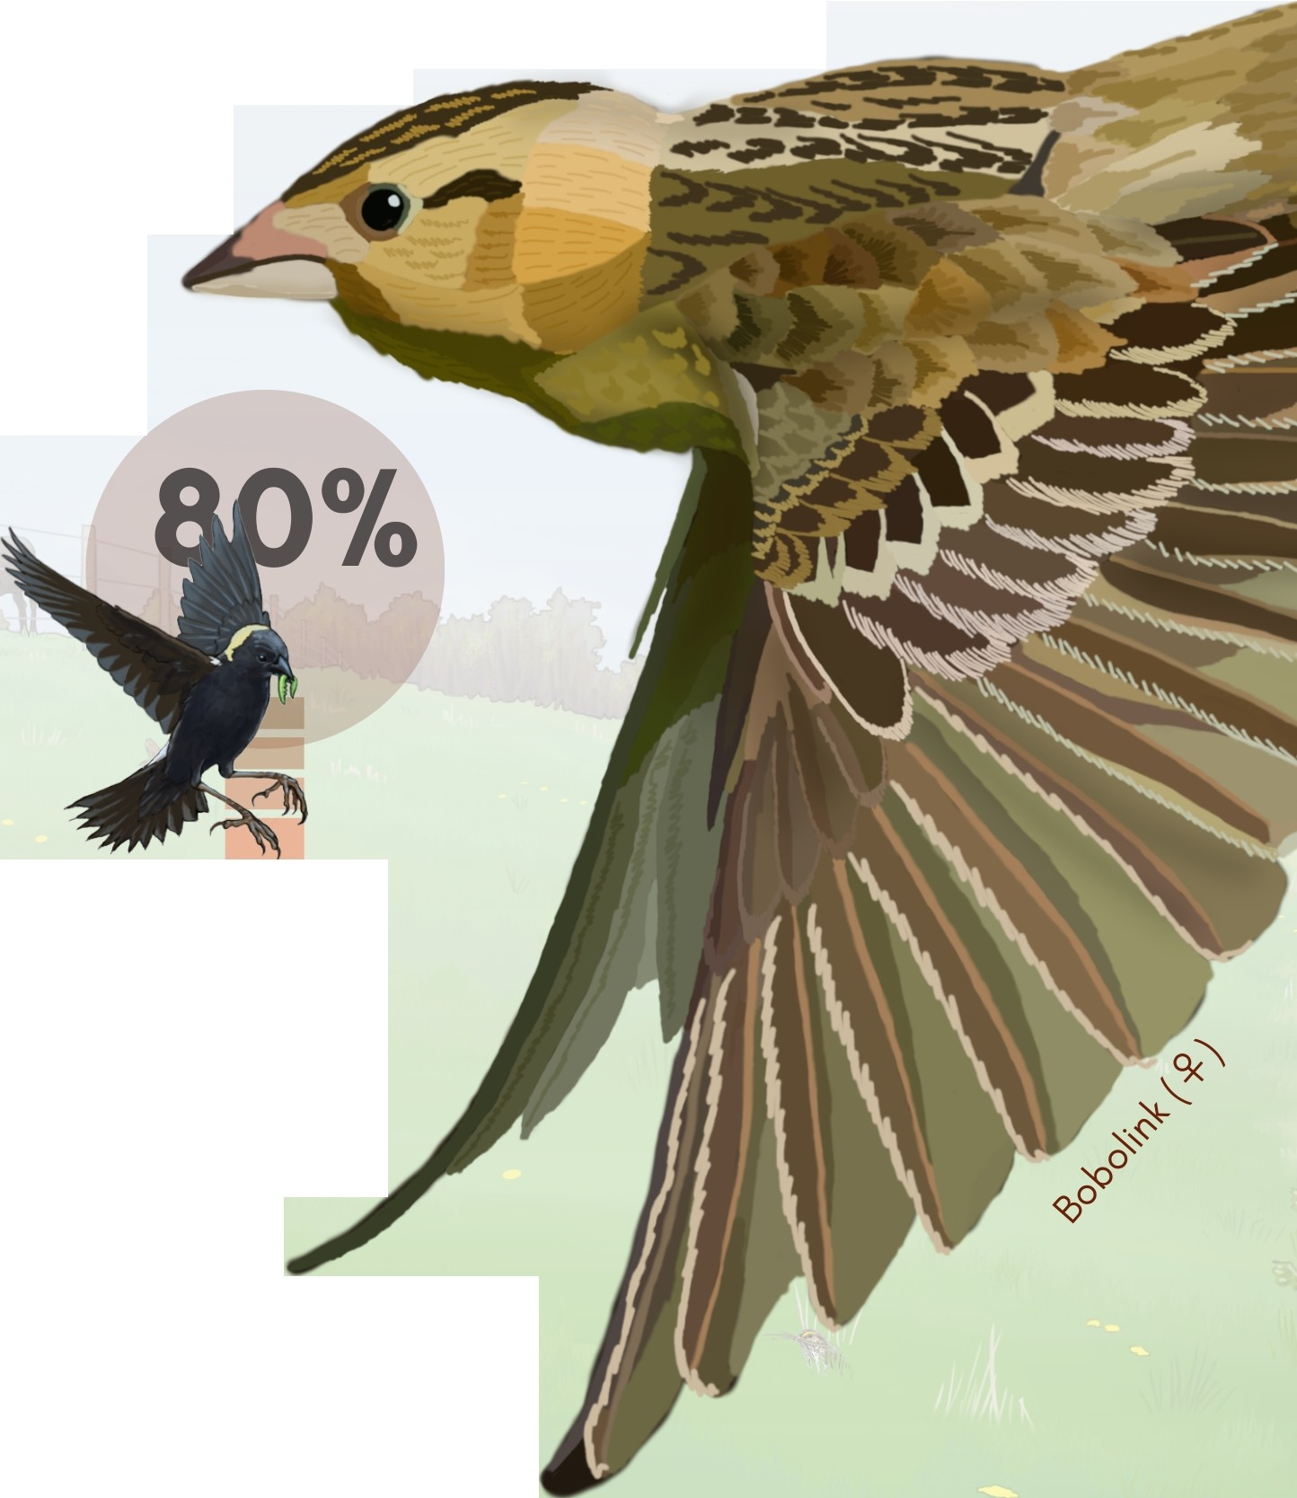Bird species that nest exclusively in grassland are an important part of Ontario's biodiversity. These migratory

species nest in Canada and the USA, and winter in the south. The majority of grassland bird nesting habitat in Ontario occurs in grass

-dominated hayfields and pastures on farms.

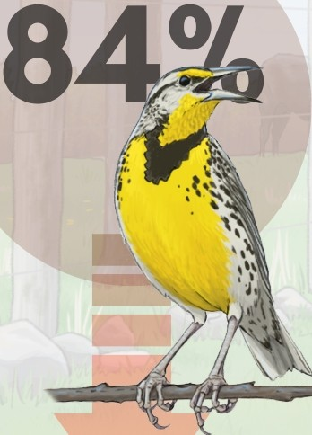 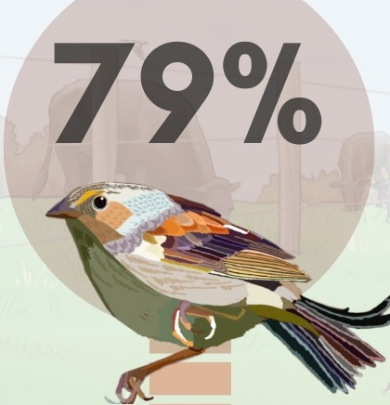

Eastern meadowlark

l 'Yeare n :)

Grasshopper sparrow

-:ip"''"''u ,.;Oncern

Bobolink (d")

r rea ;n-e )

Over the past 50 years, the number of grassland birds across North America has decreased by 53%. All three species above are

listed as at risk in Ontario and Canada. Because grassland birds build their nests directly on the ground, nests are vulnerable to trampling by livestock, destruction by farm machinery, and exposure to predators after heavy grazing and hay harvesting.

Bl,o

### Suitable habitat:

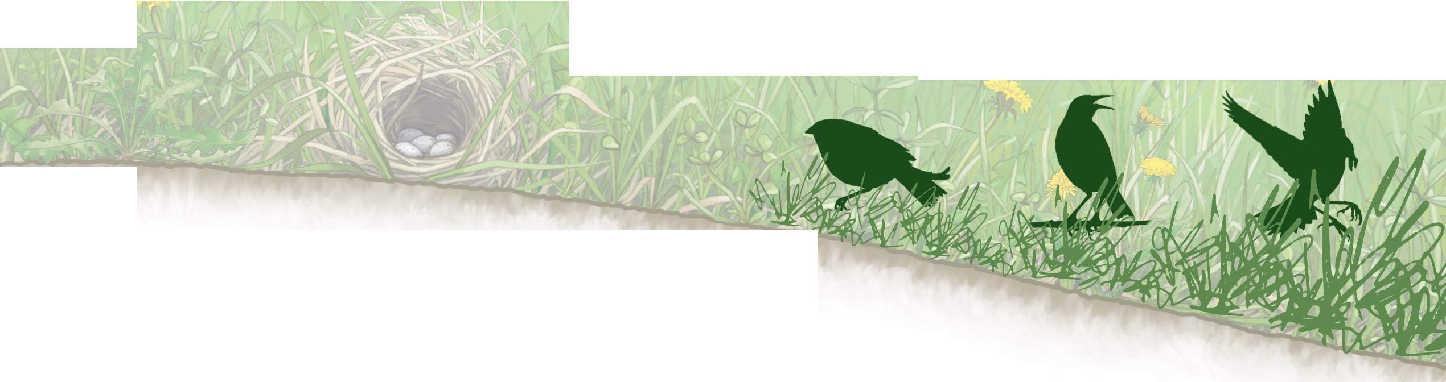Medium to large grass-dominated fields with few shrubs, adjacent to open areas. Vegetation preference varies by species. Bobolinks typically nest in grasslands with tall, dense vegetation; whereas grasshopper sparrows prefer shorter and sparser vegetation. All three species sometimes nest in the same field.

low --- vegetation height & density --- high

Bird Ecology & Illustration by Emily S. Damstra & Sunny Tseng

Conservation Ontario Design by Sunny Tseng

**Conservation on farms**

Farmers who manage agricultural grassland are integral to grassland bird conservation. The actions below aim to balance farm management with providing grassland bird species at risk time and space to raise young in some actively-farmed areas. Targeting areas with the most nesting birds (or most suitable habitat) for conservation actions will have the greatest positive impact.

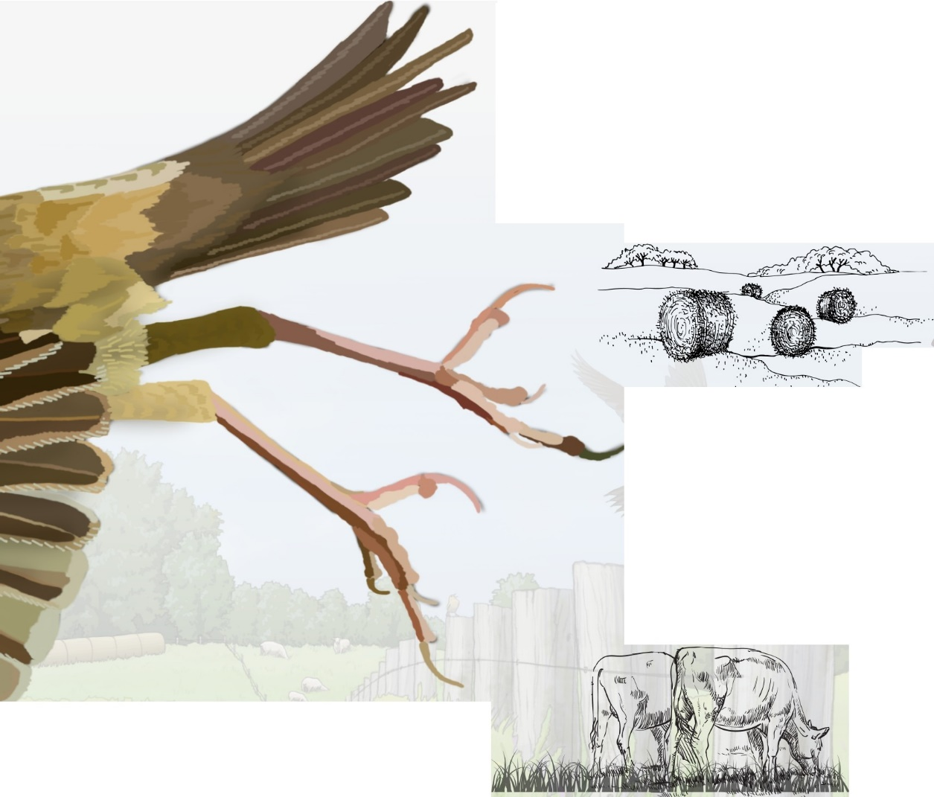

# Hayfields

Delay haying until **mid-July** or later

## Alternatives:

* Delay as long as possible, even early July is better than mid-June
* Cut perimeters first, delay interior cut
* Cut fields with high bird abundance last
* Cut large fields last

## Alternatives:

**Pastures**

Create a nesting refuge in 1 or more paddocks: delay grazing until **mid-July** or later

* Delay as long as possible (even early July provides some birds a chance to raise young)
* Light spring grazing from late May to the beginning of June, then rest paddock until mid-July (bobolink will stay and renest if enough vegetation remains}
* Lengthen rest period between grazing to at least 40 days (if vegetation is short after grazing, bobolink will disperse, but eastern meadowlark and grasshopper sparrow will stay and renest).
* Reduce grazing pressure during peak nesting in fields with high bird abundance
  + **peak nesting** •

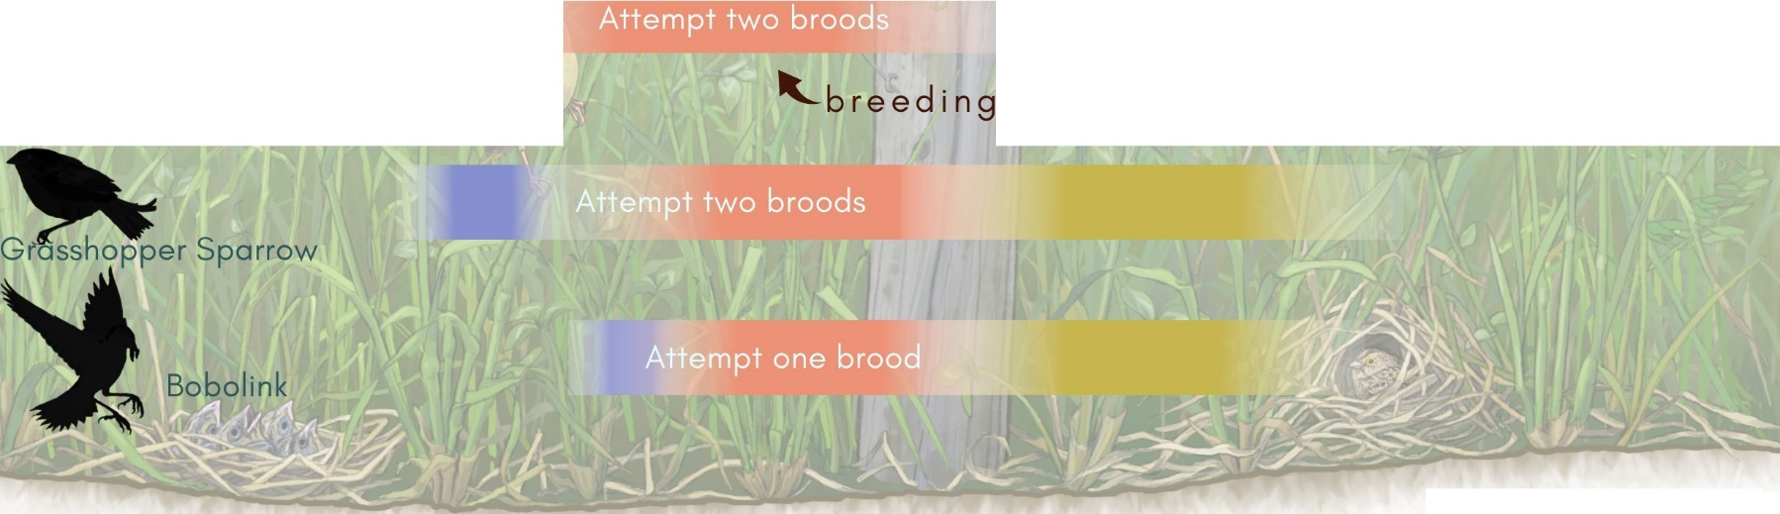

***s***

Eastern meadowlark '- post-breeding migration

©{2024}BECO

grassland bi rds.c