# i

**Grassland Birds in Ontario**

### Balancing Agriculture and Conservation

**About grassland birds:**

##### Bird species that nest exclusively in grassland are an important part of Ontario's biodiversity. These migratory species

nest in Canada and the USA, and winter in the south. The majority of grassland bird nesting habitat in Ontario occurs in grass-dominated hayfields

and pastures on farms.

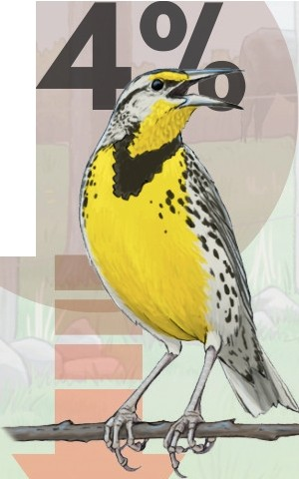**8 *79%***

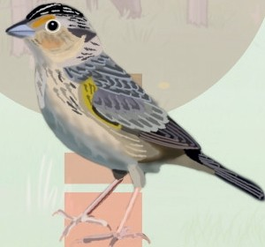

Eastern meadowlark

ll 'l'ea _nedj

Grasshopper sparrow

.:>p 1_;1u concern

Bobolink (d")

r'l'E•a en:J

Over the past 50 years, the number of grassland birds across North America has decreased by 53%. AlI three species above are listed as at risk in Ontario and Canada. Because grassland birds build their nests directly on the ground, nests are vulnerable to trampling

by livestock, destruction by farm machinery, and exposure to predators after heavy grazing and hay harvesting.

**Suitable habitat:**

Medium to large grass-dominated fields with few shrubs, adjacent to open areas. Vegetation preferences vary by species. Bobolinks typically nest in grasslands with tall, dense vegetation; whereas, grasshopper sparrows prefer shorter and sparser vegetation. All three species sometimes nest in the same field.



Fact sheet designed by Sunny Tseng Illustration by Emily S. Damstra & Sunny Tseng

Bird Ecology &

**Blo**

Conservation Ontario

This project was undertaken with the financial support of the Government of Canada. Ce project a ete realise avec l'appui financier du gouvernement du Canada.

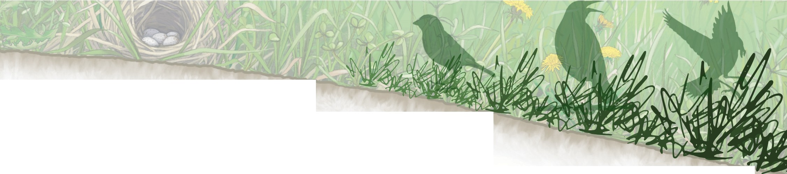Rosenberg, K. V., A. M. Dokter, P. J. Blancher, J. R. Sauer, A. C. Smith, P.A. Smith, J.C. Stanton, A. Panjabi, L. Helft, M. Parr, and P. P. Marra. 2019. Decline of the North American avifauna. Science 366:120-124.

Smith, A. C., M-A. R. Hudson, V. I. Aponte, W. B. English, and C. M. Francis. 2023. North American Breeding Bird Survey - Canadian Trends Website, Data-version 2021. Environment and Climate Change Canada, Gatineau, Canada.

**Conservation on farms**

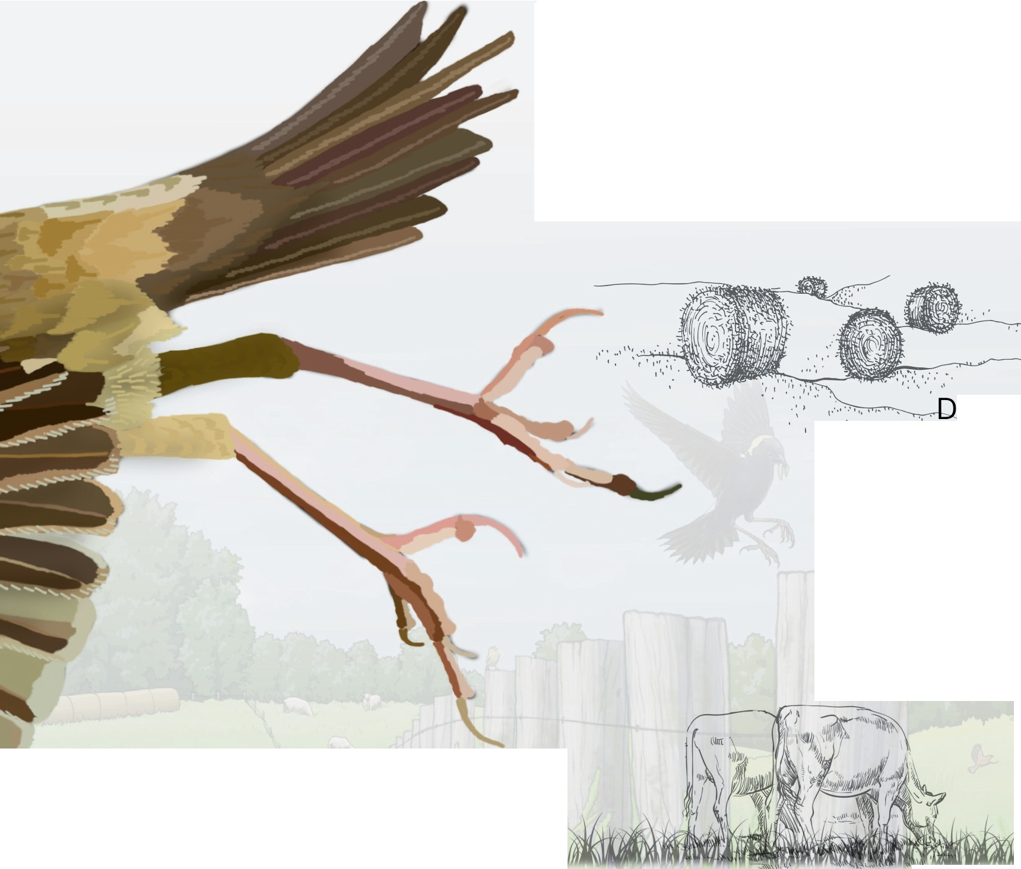Farmers who manage agricultural grassland are integral to grassland bird conservation. The actions below aim to balance farm management with providing grassland bird species at risk time and space to raise young in some actively-farmed areas.Targeting areas with the most nesting birds (or most suitable habitat) for conservation

actions will have the greatest positive impact.

**Hayfields**

elay haying until **mid-July** or later

* ', I , . , /

#### Alt'Errn' o t i ves:

* Delay as long as possible (even early July is better than mid-June)
* Cut perimeters first, delay interior cut
* Cut fields with high bird abundance last
* Cut large fields last

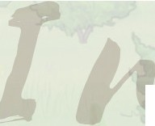,ml

## f'astu res

#### Alternatives:

Create a nesting refuge: delay grazing until **mid-July** or later

* Delay as long as possible (even early July provides some birds a chance to raise young)
* Light spring grazing from late May to the beginning of June, then rest paddock until mid-July (bobolink will stay and renest if enough vegetation remains)
* Lengthen rest period between grazing to at least 40 days (if vegetation is short after grazing, bobolink will disperse, but eastern meadowlark and grasshopper sparrow will stay and renest)
* Reduce grazing pressure during peak nesting in fields with high bird abundance



E aste d a wl a rk

a ssh pper sparrow

'j

Bobolink

.

# .

arrival post-breeding migration

Bobolink and eastern meadowlark breeding territories frequently contain more than 1 nesting female, whereas grasshopper sparrows pair with only 1 mate.

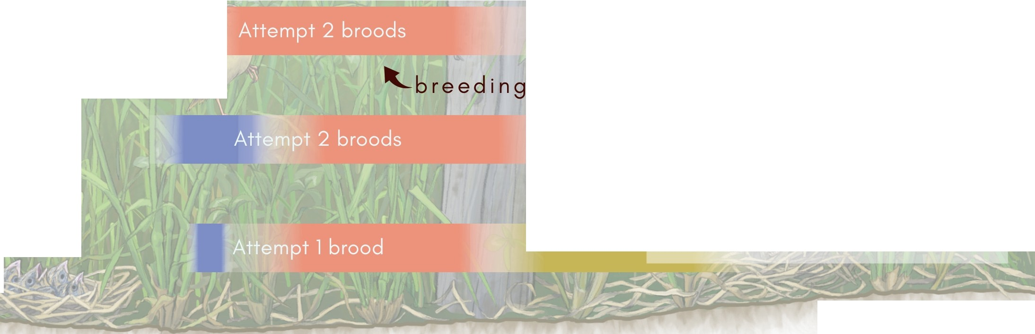

©{2024 }BECO

beco-birds.org gra ssla nd b i rd s.c