**Can Thinning Operations be used as a form of Ungulate-Adapted Forest Management? A Mini-Review and Primer**

**Roy V. Rea, UNBC**

Variability and complexity describe both habitat use by moose and habitats used by moose. Moose habitat requirements vary, among other things, with season and by sex and age class of moose. Use of both disturbed and natural forests by moose have been documented by researchers and what appears to be most recorded is high use of aquatic and edge habitats but also mixed, uneven-aged forest and – at certain times of the year – primary, uncut forests.

Like most species, moose require an abundant supply of food and cover. Moose diets are variable and not completely understood but staples such as willow, birch, aspen, subalpine fir, fireweed and aquatic macrophytes appear to top the list in BC. Cover required by moose is both security cover that allows moose to remain undetected and thermal cover that allows them to stay cooler in summer and warmer in winter and can also act as a means of snow interception to minimize snow accumulations on the forest floor and energy required by moose to travel (Mastenbrook and Cumming 1989, Welsh et al. 1980, Courtois et al. 2002). Small openings created by timber harvesting can aid in the production of browse used by moose (Leblond et al. 2015) but moose that characteristically forage close to cover and along edges make little use of large openings that would expose them to the elements and potential predators (Ontario Ministry of Natural Resources 1988). We’ve all seen moose in the middle of clearcuts but that is because they are easy to see there.

With some growing attention in the forest industry now being directed at commercial thinning operations of 30–60-year-old stands to meet fiber demands, questions have started being asked about the value of thinned stands for moose, especially in areas where moose populations have declined. Some research investigating the impacts of commercial and pre-commercial thinning on moose has been conducted, but much remains unknown. Over the last year, I have reviewed the literature on the subject and now summarize a portion of my findings here that might act as a primer for more discussions around the value of thinned stands for moose.

The value of thinnined stands for moose appear to vary by many things including site productivity, the age and composition of the stand, the season of harvest, what is taken and what is left behind (both in terms of quality and quantity of food and cover; Cassing et al. 2006, Ara et al. 2022), and the configuration of what remains. Because moose require an interspersion of food and cover (Dussault et al. 2005), thinning operations that target closed-in stands with poor forage quantity and or quality, appear to benefit moose due to a response by deciduous plants to an opening of the stand. Stand management objectives that target fiber extraction but also create stand characteristics that benefit moose, have been termed Ungulate-Adapted Forest Management by some authors (Edenius et al. 2014).

Thinning operations must create openings that are large enough to produce browse but also leave strips or pockets of unharvested timber that are thick enough to provide sufficient thermal, snow interception and security cover if all the seasonal needs of moose are to be met. As a result, the width or size of both cut and uncut areas of the stand will be, among other things, site- and tree density-dependent. For example, in one study, snow drift and piling from large openings filled in uncut areas making them difficult for moose to use in late winter (Todesco et al. 1985). Authors suggest that the size of the openings and the composition and density of what is left behind must be considered in light of the prevailing winds and the slope and aspect on which the harvesting is conducted. Stands with less ability to intercept snow are less likely to be used by cows with calves that could struggle in deep drifts (Thompson and Vucelich 1981), making stands that do not intercept snow of low year-round value to moose.

What gets left behind should be useful to moose and operationally feasible to create but should include tree and shrub screening along openings so that moose are less visible to hunters and predators. Trails and openings should be curved to reduce sight lines and the amount of potential windthrow. Where conifers that are used by moose (such as cedar, Douglas fir, and true firs) are being thinned, topped and delimbed on site, harvesting in winter could provide easily accessible conifer browse in the winter of harvest (St. Louis et al. 2000). Harvesting in winter also creates a stronger response in deciduous resprouting in spring than when timber is removed at other times of year. Where operationally feasible, minimizing damage in harvest areas to already-established sapling-stage browse trees and shrubs leaves more food for moose. Research has shown an increase in the forage quality of trees and shrubs left uncut in harvested areas following the removal of competing trees (Thompson 1988). Use by moose occurs immediately in the years following thinning (McLaren et al 2000), but long term use likely depends on many factors and requires study.

All efforts to rehabilitate roads and eliminate herbicide use should be made in any form of ungulate- adapted forest management planning and operations.

Following a thorough review of the literature, I have more questions than answers concerning the usefulness of thinned forest stands for moose. Questions left unanswered revolve around the optimal age, structure, and composition of stands to target, optimal width of the cut and uncut strips/areas, the length of time that thinned stands are useful to moose, the usefulness of thinned stands for moose relative to other treatments or no treatments at all, the impact of thinning on biodiversity and ecosystem function or on specific species, such as caribou. Thinning means different things to different managers, so specifying the type of thinning in question and its potential impacts to moose will narrow the scope of what is being considered and the types of questions that must be answered. As with most research, seeking answers to a few questions leads to many others being formulated. Some research forests such as the John Prince Research Forest are working to answer questions around the use of thinned stands by moose. Landowners and licensees may also help to answer some of these questions and may qualify for reduced stumpage as they seek answers to addressing large scale disturbances through thinning for fiber and wildlife values (Pavel et al. 2021).

The importance of using local rights holder and stakeholder knowledge and knowledge from forest planners, wildlife managers, loggers, naturalists, guide-outfitters, and others about how to manage stands in various regions under varying site conditions for both fiber and moose is imperative.

If you have any questions, comments, or suggestions about how to use thinning as a way to increase moose habitat value or if you know of documented impacts of such treatments on post-harvest habitat use by moose, please feel free to contact me at roy.rea@unbc.ca

**Summary of Management Considerations**

Thinning can be used to increase fiber production, while maintaining non-timber forest values such as wildlife habitat (Pavel et al. 2021). For thinning to be of benefit to moose:

* Openings/strips must be large enough to create a browse response, oriented relative to prevailing winds to reduce blow down, snow drifting and piling, and to reduce visibility for predators and hunters.
* Unharvested retention areas must be vast and thick enough to provide security/thermal/snow interception cover
* Harvesting should be conducted in winter to stimulate resprouting response from deciduous stumps and root stocks and to provide harvest slash as browse
* Retaining unmerchantable sapling size browse trees and shrubs in harvested areas should be attempted.
* Where thinning has been done, all roads should be rehabilitated and the use of herbicides left unconsidered.
* Both short- and long-term monitoring of tree and moose response to treatment is critical.

**Acknowledgement**

This review was funded by the McLeod Lake Mackenzie Community Forest Project Funding Program.

**References**

Ara, M., Felton, A.M., Holmström, E., Petersson, L., Berglund, M., Johansson, U. and Nilsson, U., 2022. Pre-commercial thinning in Norway spruce-birch mixed stands can provide abundant forage for ungulates without losing volume production. *Forest Ecology and Management*, *520*, p.120364.

Cassing, G., Greenberg, L.A. and Mikusiñski, G., 2006. Moose (Alces alces) browsing in young forest stands in central Sweden: a multiscale perspective. *Scandinavian Journal of Forest Research*, *21*(3), pp.221-230.

Courtois, R., Dussault, C., Potvin, F. and Daigle, G., 2002. Habitat selection by moose (Alces alces) in clear-cut landscapes. *Alces: A Journal Devoted to the Biology and Management of Moose*, *38*, pp.177-192.

Dussault, C., Ouellet, J.P., Courtois, R., Huot, J., Breton, L. and Jolicoeur, H., 2005. Linking moose habitat selection to limiting factors. *Ecography*, *28*(5), pp.619-628.

Edenius, L., Roberge, J.M., Månsson, J. and Ericsson, G., 2014. Ungulate-adapted forest management: effects of slash treatment at harvest on forage availability and use. *European journal of forest research*, *133*, pp.191-198.

Leblond, M., Dussault, C. and St-Laurent, M.H., 2015. Low-density spruce plantations increase foraging by moose in a northeastern temperate forest. *Forest Ecology and Management*, *347*, pp.228-236.

Mastenbrook, B. and Cumming, H., 1989. Use of residual strips of timber by moose within cutovers in northwestern Ontario. *Alces: A Journal Devoted to the Biology and Management of Moose*, *25*, pp.146-155.

McLaren, B.E., Mahoney, S.P., Porter, T.S. and Oosenbrug, S.M., 2000. Spatial and temporal patterns of use by moose of pre-commercially thinned, naturally-regenerating stands of balsam fir in central Newfoundland. *Forest Ecology and Management*, *133*(3), pp.179-196.

Ontario Ministry of Natural Resources. 1988. Timber management guidelines for the provision of moose habitat. 33p.

Pavel, M., Byrne, K., Gaudreau, J.P., Meek, P. and Belyea, D., 2021. *Operational Manual for Commercial Thinning in British Columbia* (No. 93). Technical Report: TR.

St-Louis, A., Ouellet, J.P., Crête, M., Maltais, J. and Huot, J., 2000. Effects of partial cutting in winter on white-tailed deer. *Canadian Journal of Forest Research*, *30*(4), pp.655-661.

Todesco, C.J., Cumming, H.G. and McNicol, J.G., 1985. Winter moose utilization of alternate strip cuts and clearcuts in northwestern Ontario: Preliminary results. *Alces: A Journal Devoted to the Biology and Management of Moose*, *21*, pp.447-474.

Thompson, I.D., 1988. Moose damage to pre-commercially thinned balsam fir stands in Newfoundland. *Alces: A Journal Devoted to the Biology and Management of Moose*, *24*, pp.56-61.

Thompson, I.D. and Vukelich, M.F., 1981. Use of logged habitats in winter by moose cows with calves in northeastern Ontario. *Canadian Journal of Zoology*, *59*(11), pp.2103-2114.

Welsh, D.A., Morrison, K.P., Oswald, K. and Thomas, E.R., 1980. Winter utilization of habitat by moose in relation to forest harvesting. *Alces: A Journal Devoted to the Biology and Management of Moose*, *16*, pp.398-428.

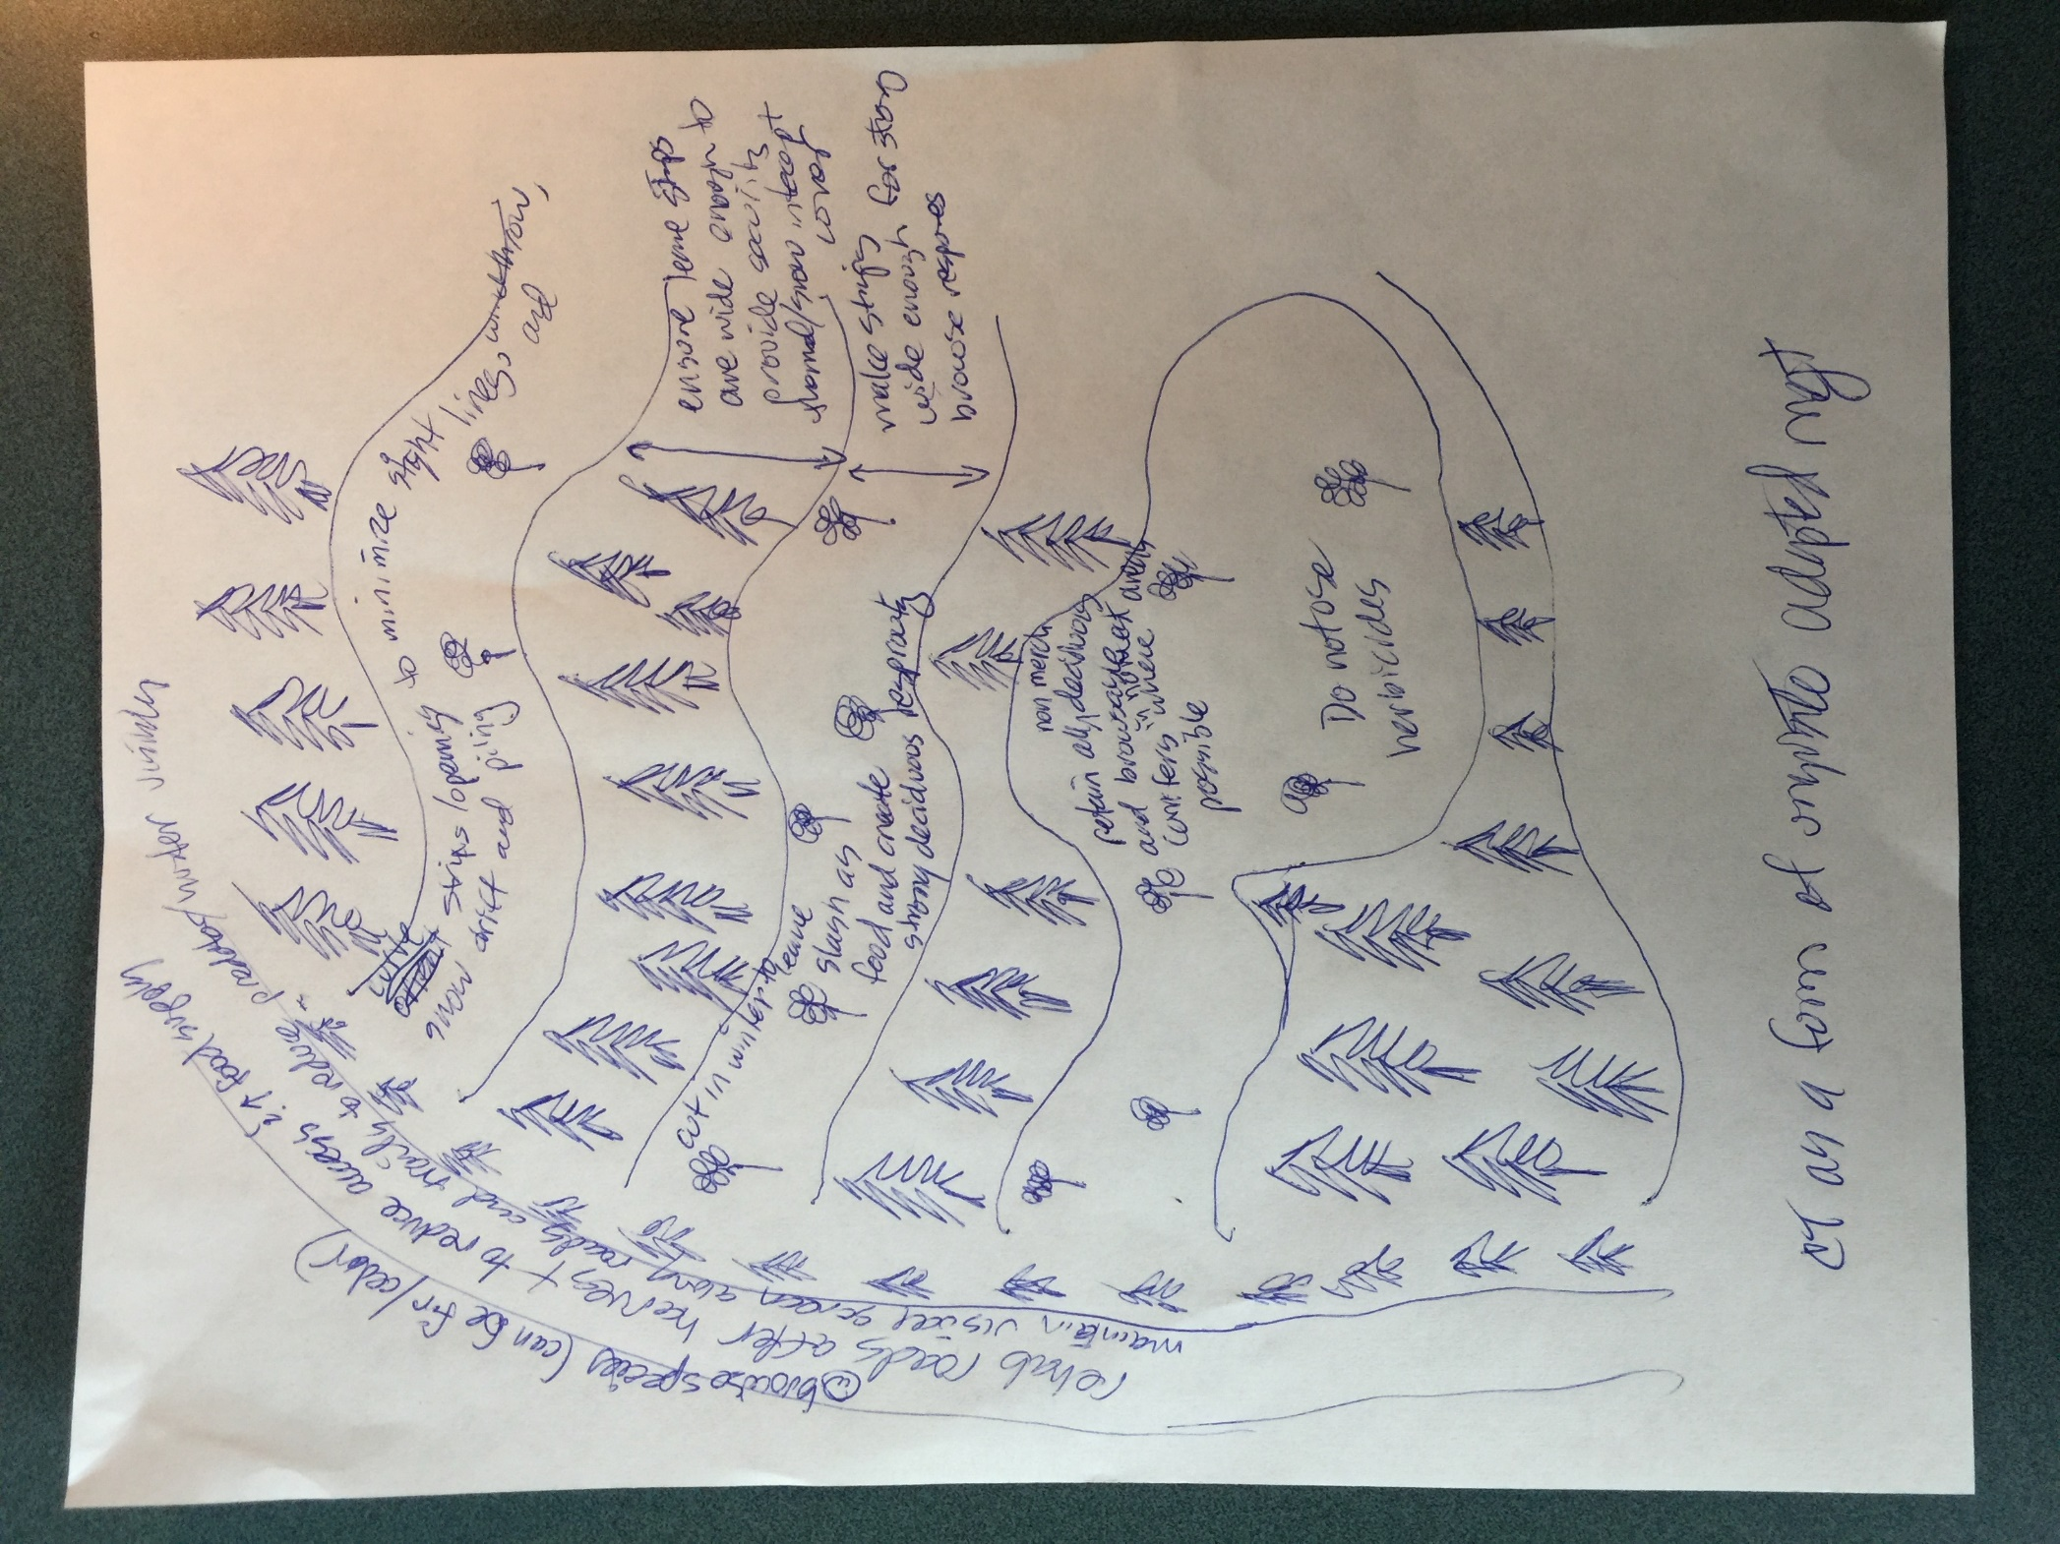

**Figure 1.** I am wondering if I can work with BC Forest Professional to have a professional diagram made up that reflects this visual summary of the article.