# Key messages for AOS conference poster

Title

* Broad-scaled Bird Biodiversity Assessment with Autonomous Recording Units

Introduction

* Advances in the hardware and software have made large-scale acoustic monitoring of bird biodiversity possible. We deployed a large-scale project to investigate the advantages and challenges of using acoustic monitoring in bird biodiversity monitoring.

Methods

* Location: John Prince Research Forest in central British Columbia, Canada
* Tool: Autonomous recording units (ARUs) with 66 units deployed in 3 years (2020, 2021, and 2022 summer). We used BirdNET as the sound classifier with human validation.

Results

* Systematical deploy of ~ 50 ARUs with ~2500 ARU days would be sufficient effort in surveying bird composition in the JPRF area, which is around 16,000 hectares in interior BC.
* There are 120 species detected in the JPRF area, with ARU detecting similar number of species (96) to human observers (93).
* ARUs were better at picking up rare but vocal species (i.e., crane, owls, woodpeckers), but didn’t detect rare non-vocal species (i.e., collared dove, peregrine falcon) that have been documented in the area. Other species that vocalize or engage in auditory signals infrequently (i.e., bittern, ruffed grouse, calliope hummingbird) were also not detected frequently on ARUs, despite being relatively common in the region.
* Species known in the region that would be infrequently encountered in the forest sites where ARUs were placed (i.e., grebe, ducks) were also not well accounted for in ARU recordings.
* Bird richness is higher in sites with lower canopy height, shorter distance to water, and older forest age (>80 yr).

Conclusion

* ARUs, combined with advanced sound classifier, is an (time, cost, labor) efficient method to survey bird community in JPRF area, across broad spatiotemporal scale. Subsequent analysis can inform important forest features for bird biodiversity.

# Methods

Bird data

ARU data were collected from 2020, 2021, and 2022 between April to July, with consistent time schedule 4 am to 7 am, 1 min on, 4 min off. There were in total 66 ARU set up across the JPRF forest station. The number of functioning ARUs varies given the time needed to set up ARUs in sites, and ARU failures (batteries dead, unites taken down by wild animals). ARU data were analyzed by BirdNET-Lite version, with parameters set (lon, lat, week). Verification of the ARU species list was done by three steps: (1) listening to at least 1 – 5 recordings for each species with confidence score higher than 0.85, (2) reviewing the species distribution range from the breeding bird atlas in the Prince George area, and from eBird species occurrence report, and (3) use of local expert opinions. Only species that were verified through these three standard as occurring within the region and/or having been seen in the John Prince Research Forest were classified as ”confirmed species”. ARU species were re-categorized by the Cornell lab of Ornithology clement species.

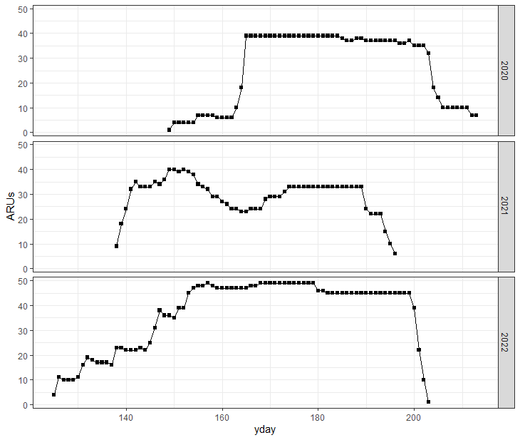

eBird hotspot was set up in 2022 summer, with field observers working across the JPRF area and reporting species. Data were derived on 2023 July 6th, making it a one year observer effort. Most observations were done during summer while some checklists were reported during winter. All the species were categorized based on the Cornell Lab of Ornithology clement categorization. eBird species were re-categorized by the Cornell lab of Ornithology clement species.

Forest attribute data (lidar and ground survey)

Species accumulation curve

We compare the biodiversity of each of the site using the estimated richness. To do this, we used sampling – unit-based accumulation curve (rarefraction curve) to balance the survey effort. The number of species detected by the ARU is a function of the amount of effort – the longer the ARU is active the more species detected. All the observed richness will underestimate true richness. We used iNext to extrapolate species richness. See if your camera project has sufficient survey effort to capture the species within the area of interest. To do this we can compute a species accumulation curves across the site as a whole. Species accumulation curves plot the increase in species richness as we add survey units. If the curve plateaus (flattens), then that suggests you have sampled the majority of the species in your survey area.

# Result

Comparison between ARU and eBird detection

There are 96 species (80%) detected by ARU (Table 1), 93 species (78%) detected by eBird observers. In total, there are 120 species from 15 orders get detected in JPRF area collectively by both methods. ARU detected all the species of kingfisher, owl, cranes, woodpeckers, and loons, and detected most (87%) of the passerines, shorebirds (75%), and eagles and hawks (71%).

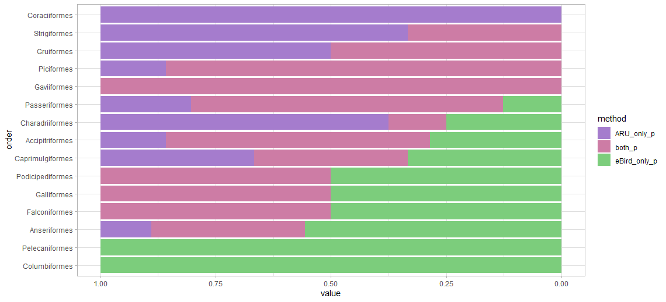

We used rarefaction curve across all the sites to show the sufficient ARU effort (ARU surveying days and number of sites) in sampling the bird species in the JPRF area. To achieve 90% of the detection, we have to at least have XYZ ARU sites and XYZ total ARU surveying days. The curve in the surveying days flatten earlier than the sites, which represents that we are sufficient in the surveying duration.

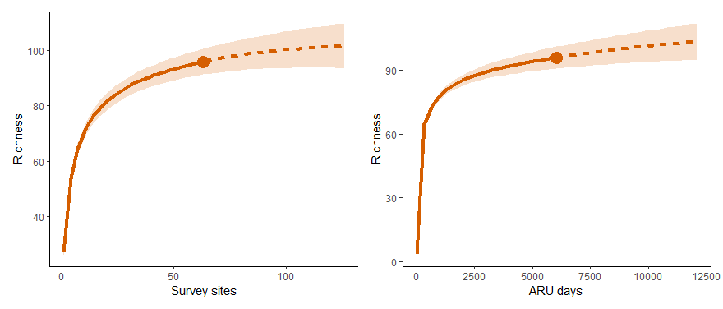

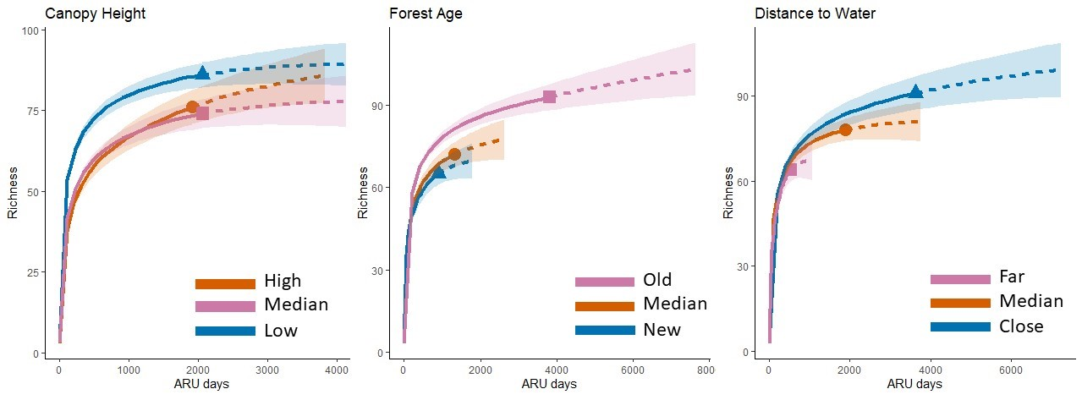

# Discussion

In general, we got 120 species detected in the JPRF area. Systematic ARU deployment detected more species (96 species) than unsystematic human observers (93 species), especially for passerines, and rare but vocal species (i.e., crane, owls, woodpeckers). Birds that get missed by ARUs are the ones that is rare (i.e., collared dove, peregrine falcon), or species not making sound frequently (i.e., bittern, ruffed grouse, calliope hummingbird), or far away from deployment sites (i.e., grebe, ducks).

The project has sufficient survey effort (# of ARUs and the ARU days) to capture the species within the area of interest. This is supported by the species accumulation curves across sites as a whole, which shows plateaus (flattens).

Separating the sites according to the site attributes, we found the bird richness is higher when the canopy height is lower, closer to water, and older forest age (>80 yr).

|  |  |  |  |  |  |
| --- | --- | --- | --- | --- | --- |
| order | family | common_name | scientific name | ARU | eBird |
| Accipitriformes | Accipitridae (Hawks, Eagles, and Kites) | Bald Eagle | Haliaeetus leucocephalus | Y | Y |
| Broad-winged Hawk | Buteo platypterus | Y | Y |
| Northern Goshawk | Accipiter gentilis | Y | Y |
| Sharp-shinned Hawk | Accipiter striatus | Y | N |
| Northern Harrier | Circus hudsonius | N | Y |
| Red-tailed Hawk | Buteo jamaicensis | N | Y |
| Pandionidae (Osprey) | Osprey | Pandion haliaetus | Y | Y |
| Anseriformes | Anatidae (Ducks, Geese, and Waterfowl) | American Wigeon | Mareca americana | Y | N |
| Canada Goose | Branta canadensis | Y | Y |
| Ring-necked Duck | Aythya collaris | Y | Y |
| Trumpeter Swan | Cygnus buccinator | Y | Y |
| Mallard | Anas platyrhynchos | N | Y |
| Bufflehead | Bucephala albeola | N | Y |
| Common Goldeneye | Bucephala clangula | N | Y |
| Barrow's Goldeneye | Bucephala islandica | N | Y |
| Common Merganser | Mergus merganser | N | Y |
| Caprimulgiformes | Caprimulgidae (Nightjars and Allies) | Common Nighthawk | Chordeiles minor | Y | N |
| Trochilidae (Hummingbirds) | Rufous Hummingbird | Selasphorus rufus | Y | Y |
| Calliope Hummingbird | Selasphorus calliope | N | Y |
| Charadriiformes | Laridae (Gulls, Terns, and Skimmers) | Bonaparte's Gull | Chroicocephalus philadelphia | Y | N |
| Glaucous-winged Gull | Larus glaucescens | Y | N |
| Scolopacidae (Sandpipers and Allies) | American Woodcock | Scolopax minor | Y | N |
| Greater Yellowlegs | Tringa melanoleuca | Y | N |
| Solitary Sandpiper | Tringa solitaria | Y | N |
| Wilson's Snipe | Gallinago delicata | Y | Y |
| Whimbrel | Numenius phaeopus | N | Y |
| Spotted Sandpiper | Actitis macularius | N | Y |
| Columbiformes | Columbidae (Pigeons and Doves) | Eurasian Collared-Dove | Streptopelia decaocto | N | Y |
| Coraciiformes | Alcedinidae (Kingfishers) | Belted Kingfisher | Megaceryle alcyon | Y | N |
| Falconiformes | Falconidae (Falcons and Caracaras) | Merlin | Falco columbarius | Y | Y |
| Peregrine Falcon | Falco peregrinus | N | Y |
| Galliformes | Phasianidae (Pheasants, Grouse, and Allies) | Spruce Grouse | Canachites canadensis | Y | Y |
| Ruffed Grouse | Bonasa umbellus | N | Y |
| Gaviiformes | Gaviidae (Loons) | Common Loon | Gavia immer | Y | Y |
| Gruiformes | Gruidae (Cranes) | Sandhill Crane | Antigone canadensis | Y | Y |
| Rallidae (Rails, Gallinules, and Coots) | Sora | Porzana carolina | Y | N |
| Passeriformes | Bombycillidae (Waxwings) | Bohemian Waxwing | Bombycilla garrulus | Y | N |
| Cedar Waxwing | Bombycilla cedrorum | Y | Y |
| Cardinalidae (Cardinals and Allies) | Western Tanager | Piranga ludoviciana | Y | Y |
| Certhiidae (Treecreepers) | Brown Creeper | Certhia americana | Y | Y |
| Corvidae (Crows, Jays, and Magpies) | American Crow | Corvus brachyrhynchos | Y | Y |
| Canada Jay | Perisoreus canadensis | Y | Y |
| Common Raven | Corvus corax | Y | Y |
| Steller's Jay | Cyanocitta stelleri | N | Y |
| Black-billed Magpie | Pica hudsonia | N | Y |
| Fringillidae (Finches, Euphonias, and Allies) | Cassin's Finch | Haemorhous cassinii | Y | N |
| Evening Grosbeak | Coccothraustes vespertinus | Y | Y |
| Pine Grosbeak | Pinicola enucleator | Y | Y |
| Pine Siskin | Spinus pinus | Y | Y |
| Purple Finch | Haemorhous purpureus | Y | Y |
| Red Crossbill | Loxia curvirostra | Y | Y |
| White-winged Crossbill | Loxia leucoptera | Y | Y |
| House Finch | Haemorhous mexicanus | N | Y |
| Hirundinidae (Swallows) | Tree Swallow | Tachycineta bicolor | Y | Y |
| Violet-green Swallow | Tachycineta thalassina | N | Y |
| Barn Swallow | Hirundo rustica | N | Y |
| Icteridae (Troupials and Allies) | Red-winged Blackbird | Agelaius phoeniceus | Y | Y |
| Rusty Blackbird | Euphagus carolinus | Y | N |
| Yellow-headed Blackbird | Xanthocephalus xanthocephalus | N | Y |
| Brown-headed Cowbird | Molothrus ater | N | Y |
| Paridae (Tits, Chickadees, and Titmice) | Black-capped Chickadee | Poecile atricapillus | Y | Y |
| Boreal Chickadee | Poecile hudsonicus | Y | Y |
| Chestnut-backed Chickadee | Poecile rufescens | Y | N |
| Mountain Chickadee | Poecile gambeli | Y | N |
| Parulidae (New World Warblers) | American Redstart | Setophaga ruticilla | Y | Y |
| Blackpoll Warbler | Setophaga striata | Y | N |
| Common Yellowthroat | Geothlypis trichas | Y | Y |
| MacGillivray's Warbler | Geothlypis tolmiei | Y | Y |
| Magnolia Warbler | Setophaga magnolia | Y | Y |
| Northern Waterthrush | Parkesia noveboracensis | Y | Y |
| Orange-crowned Warbler | Leiothlypis celata | Y | Y |
| Ovenbird | Seiurus aurocapilla | Y | N |
| Tennessee Warbler | Leiothlypis peregrina | Y | Y |
| Townsend's Warbler | Setophaga townsendi | Y | Y |
| Wilson's Warbler | Cardellina pusilla | Y | Y |
| Yellow Warbler | Setophaga petechia | Y | N |
| Yellow-rumped Warbler | Setophaga coronata | Y | Y |
| Passerellidae (New World Sparrows) | Chipping Sparrow | Spizella passerina | Y | Y |
| Dark-eyed Junco | Junco hyemalis | Y | Y |
| Fox Sparrow | Passerella iliaca | Y | N |
| Lincoln's Sparrow | Melospiza lincolnii | Y | Y |
| Song Sparrow | Melospiza melodia | Y | Y |
| White-crowned Sparrow | Zonotrichia leucophrys | Y | Y |
| White-throated Sparrow | Zonotrichia albicollis | Y | Y |
| Regulidae (Kinglets) | Golden-crowned Kinglet | Regulus satrapa | Y | Y |
| Ruby-crowned Kinglet | Corthylio calendula | Y | Y |
| Sittidae (Nuthatches) | Red-breasted Nuthatch | Sitta canadensis | Y | Y |
| Sturnidae (Starlings) | European Starling | Sturnus vulgaris | Y | N |
| Troglodytidae (Wrens) | Pacific Wren | Troglodytes pacificus | Y | Y |
| Marsh Wren | Cistothorus palustris | N | Y |
| Turdidae (Thrushes and Allies) | American Robin | Turdus migratorius | Y | Y |
| Hermit Thrush | Catharus guttatus | Y | N |
| Swainson's Thrush | Catharus ustulatus | Y | Y |
| Townsend's Solitaire | Myadestes townsendi | Y | Y |
| Varied Thrush | Ixoreus naevius | Y | Y |
| Tyrannidae (Tyrant Flycatchers) | Alder Flycatcher | Empidonax alnorum | Y | Y |
| Dusky Flycatcher | Empidonax oberholseri | Y | Y |
| Eastern Kingbird | Tyrannus tyrannus | Y | N |
| Hammond's Flycatcher | Empidonax hammondii | Y | Y |
| Least Flycatcher | Empidonax minimus | Y | N |
| Olive-sided Flycatcher | Contopus cooperi | Y | Y |
| Pacific-slope Flycatcher | Empidonax difficilis | Y | Y |
| Western Wood-Pewee | Contopus sordidulus | Y | Y |
| Yellow-bellied Flycatcher | Empidonax flaviventris | Y | N |
| Vireonidae (Vireos, Shrike-Babblers, and Erpornis) | Cassin's Vireo | Vireo cassinii | Y | Y |
| Warbling Vireo | Vireo gilvus | Y | Y |
| Red-eyed Vireo | Vireo olivaceus | N | Y |
| Pelecaniformes | Ardeidae (Herons, Egrets, and Bitterns) | American Bittern | Botaurus lentiginosus | N | Y |
| Piciformes | Picidae (Woodpeckers) | American Three-toed Woodpecker | Picoides dorsalis | Y | Y |
| Black-backed Woodpecker | Picoides arcticus | Y | Y |
| Hairy Woodpecker | Dryobates villosus | Y | Y |
| Northern Flicker | Colaptes auratus | Y | Y |
| Pileated Woodpecker | Dryocopus pileatus | Y | Y |
| Red-breasted Sapsucker | Sphyrapicus ruber | Y | Y |
| Yellow-bellied Sapsucker | Sphyrapicus varius | Y | N |
| Podicipediformes | Podicipedidae (Grebes) | Red-necked Grebe | Podiceps grisegena | Y | Y |
| Horned Grebe | Podiceps auritus | N | Y |
| Strigiformes | Strigidae (Owls) | Barred Owl | Strix varia | Y | Y |
| Great Horned Owl | Bubo virginianus | Y | N |
| Northern Saw-whet Owl | Aegolius acadicus | Y | N |