Integrating passive acoustic monitoring and LiDAR for breeding bird habitat modelling in a working forest
Sunny Tseng^{1*}, Dexter P. Hodder² and Ken A. Otter¹
¹Natural Resources & Environmental Studies, University of Northern British Columbia, Prince George, British Columbia, Canada
²John Prince Research Forest, Fort. St. James, British Columbia, Canada
*Corresponding author E-mail: stseng@unbc.ca

Target journal:
- Remote Sensing in Ecology and Conservation: scope is explicitly at the intersection of remote sensing, ecology, and conservation. UNBC library has signed a discount agreement with Wiley publisher.
- Ecological Applications: integration of monitoring tools and management applications. UNBC library has signed a discount agreement with Wiley publisher.

Abstract
Accurately identifying bird species richness hotspots is essential for guiding conservation and forest management decisions; however, traditional ground-based surveys are often limited in spatial and temporal coverage. Here, we integrated passive acoustic monitoring and LiDAR-derived habitat covariates to model breeding bird richness (composed by a total of 40 target species) within the John Prince Research Forest, a 16,000 ha managed working forest in central British Columbia, Canada. Acoustic data were collected from 59 sites over three breeding seasons using autonomous recording units (ARUs) to inform site-level richness, which is then compared to 17 LiDAR covariates that calculated from a 100-m buffer around each site. Our results revealed species assemblages corresponding to habitat preferences, including mature coniferous forest, mixed or generalist habitats, and early successional openings. Among LiDAR-derived metrics, proximity to streams, wetlands, and lake edges was the strongest predictor of site-level richness, whereas vertical canopy structure was less influential, likely reflecting the homogeneous forest-associated guilds sampled. We also highlight the substantial effort required for species-specific validation of automated detections and discuss the potential use of universal thresholds for broad-scale surveys. This study demonstrates the complementary value of PAM and LiDAR for quantifying biodiversity in working forests and provides practical guidance for integrating acoustic monitoring into conservation and management strategies.
Introduction
Understanding the hotspots of bird species richness is crucial for identifying preferred habitats and guiding conservation priorities (Francis and Currie 2003; Hawkins et al. 2003). Traditionally, estimates of richness rely on ground-based bird surveys that provide direct observations of species presence. To extend beyond surveyed locations, models have been developed to predict bird richness using habitat covariates, thereby linking biodiversity patterns to environmental drivers and supporting conservation and management decisions (Rahbek et al. 2006). In working forests, such models are particularly valuable for identifying priority areas for conservation, informing harvest planning, and evaluating the ecological impacts of forest management strategies (e.g., Maes et al., 2005).
Obtaining accurate and comprehensive data on bird richness, however, remains challenging. Ground-based surveys are labor-intensive, time-consuming, and often limited in spatial and temporal coverage, making it difficult to monitor large or remote areas effectively. Moreover, habitat covariates derived from conventional remote sensing methods, such as satellite imagery or aerial photography, generally emphasize horizontal landscape features. However, vertical habitat structure - such as canopy height, foliage density, and understory complexity - plays a critical role in shaping bird communities (Culbert et al. 2013). These vertical attributes are hard to capture with traditional remote sensing products, limiting the ecological relevance of bird–habitat models (Gottschalk et al. 2005).
Passive acoustic monitoring has emerged as a powerful and scalable tool for biodiversity assessment (Ross et al. 2023; Sugai et al. 2019). Autonomous recording units (ARUs) can collect continuous or repeated audio data over large spatial and temporal scales with relatively low human effort (Sugai et al. 2019). This approach enables detection of vocalizing bird species even in remote or difficult-to-access areas, thereby greatly expanding survey coverage. Numerous studies have demonstrated the effectiveness of acoustic monitoring for estimating species presence (e.g., Picciulin et al. 2019), vocal activity patterns (e.g., Pérez-Granados et al. 2021), density (Pérez-Granados and Traba 2021), and community composition (e.g., Mattmüller et al. 2022).
Light Detection and Ranging (LiDAR) technology provides a complementary perspective by offering detailed three-dimensional information on vegetation structure (Vierling et al. 2008). Unlike conventional remote sensing, LiDAR captures both horizontal and vertical habitat attributes, making it particularly well-suited for studying bird–habitat relationships (Bradbury et al. 2005; Tattoni et al. 2012). Previous research has demonstrated the utility of LiDAR-derived metrics in modeling bird diversity and habitat suitability across diverse ecosystems (Bakx et al. 2019). However, the integration of LiDAR with passive acoustic monitoring remains relatively unexplored, despite its potential to improve our understanding of the structural drivers of bird richness.
In this study, we integrate passive acoustic monitoring and LiDAR remote sensing to model breeding bird richness within the John Prince Research Forest, a managed working forest in central British Columbia, Canada. Acoustic data were collected using autonomous recording units (ARUs) during three breeding seasons. LiDAR data provided structural habitat covariates characterizing vertical and horizontal forest complexity. Our objectives were to: (1) compile a comprehensive species list and estimate asymptotic site-level breeding bird richness; (2) identify groups of species with similar habitat-use patterns; and (3) evaluate the association between LiDAR-derived habitat covariates and bird asymptotic richness.

Methods

Study area and acoustic recording sites
The study was conducted in the John Prince Research Forest (~16,000 hectares in area), located in central British Columbia, Canada, within the dry sub-boreal spruce biogeoclimatic zone (Fig. 1A). Audio data were collected from 2020 to 2022 throughout the breeding season (early May to late July) between daily dawn chorus (4 am to 7am), using Audio Moth ARUs (Hill et al. 2019). ARUs were set to record for 1 minute, followed by 4 minutes pause, throughout the three hours recording period, resulting in 36 one-minute recordings per day per site. Each ARU was placed at least two kilometers apart to minimize spatial correlation. Variability in the number of active ARUs at each site/date (Fig. 1B) occurred due to setup logistics (e.g., accessibility of sites during early season) and field/equipment challenges (e.g., battery depletion, firmware issues, disturbances by wildlife). We excluded data from sites which had less than 15 days of ARU data to avoid potential bias due to low surveying effort. This resulted in data from 59 sites, with each site having an average of 106 ARU days across three years, ranging from 32 to 182 ARU days.

Acoustic data processing and target species
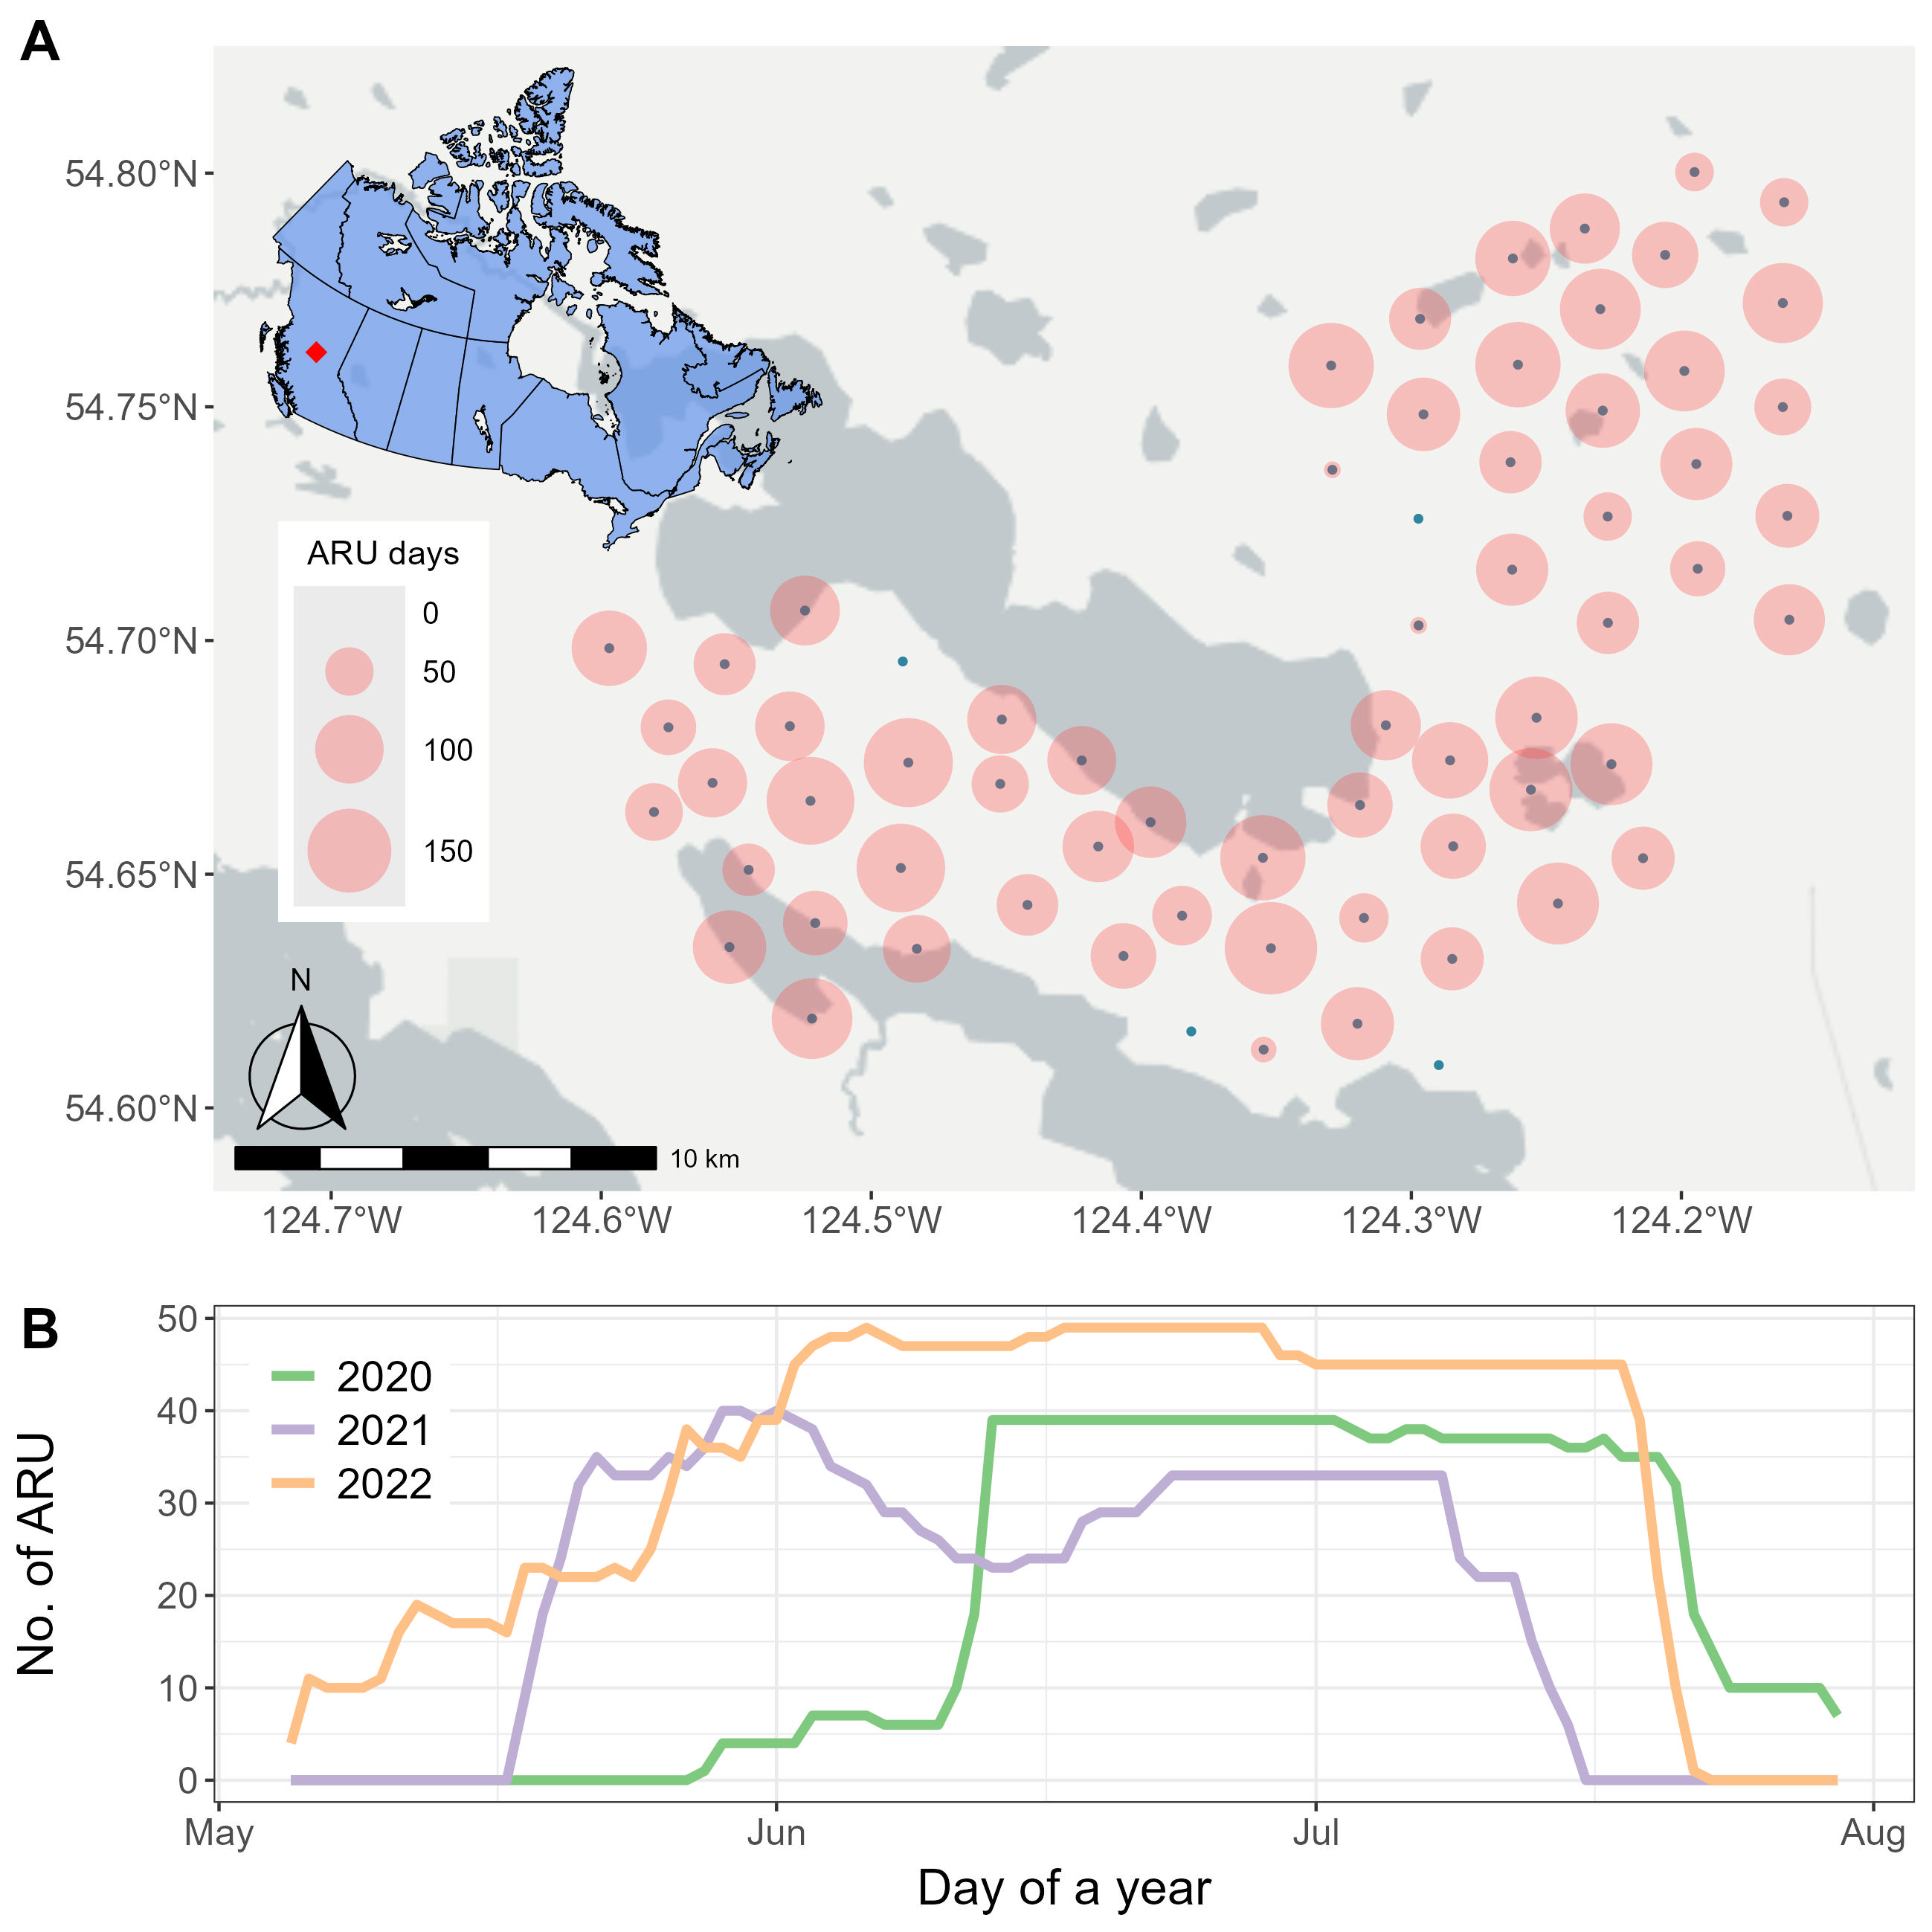
Fig. 1. Spatiotemporal distribution of surveying effort. (A) ARU locations (central solid dots, with ARU days depicted in the size of the halo around the dot) during the surveying seasons and (B) yearly number of ARUs across the surveying period.
We analyzed collected acoustic data with the BirdNET Analyzer v2.4 model (BirdNET Team 2025), using the parameters listed in Table 1. The entire dataset, comprising 1.5 terabytes of audio, required approximately 72 consecutive hours of processing. An overall bird community list was generated in four steps: (1) BirdNET detections were initially filtered using a confidence threshold of 0.8. For each detected category, five recording segments with the highest confidence scores were manually reviewed. Sound categories with at least one confirmed vocalization were retained, resulting in 136 sound categories. (2) Non-bird categories, such as Car Engine, Red Squirrel, Wood Frog, and Slender Meadow Katydid, were removed, reducing the list to 129 sound categories. (3) Species not listed in the British Columbia Breeding Bird Atlas (Davidson et al. 2015), which documents species recorded in the Prince George area since 2008, were excluded, leaving 123 species. (4) Species detected at fewer than two sites or on fewer than two days in June (i.e., main breeding season) were excluded, resulting in a final list of 122 species (Supplementary Table A). The overall species list included a diverse range of bird taxa such as raptors, waterfowl, warblers, sparrows, flycatchers, woodpeckers, owls, and other families.
We further refined this overall species list to a target clade of passerine species that have confirmed breeding records in the study region, and which are known to be vocally active during the dawn chorus period. These criteria were used to avoid detection bias given that recordings were scheduled during the dawn chorus of the breeding season. We then assessed individual species-specific BirdNET confidence thresholds for the 40 species, following the methods of Tseng et al. (2025), to ensure the precision of detections. To do this, we used stratified sampling to select 360 recording segments in which BirdNET had detected each of the target species, with 20 segments drawn from each 0.05 detection confidence interval bin (ranging from 0.1 to 1.0). Each segment was then manually reviewed, by both listening to audio and viewing spectrograms in comparison with known exemplars of the species, to classify detections as true or false positives. For each species, a threshold BirdNET detection confidence threshold was set that achieved a minimum precision of 0.95, indicating that at least 95% of the retained detections were true positives (see Tseng et al. 2025 for the full workflow). These thresholds were set individually for each of the final list of 40 passerines target species included (Table 2).
Table 1. BirdNET algorithms arguments, with default values and the values used in this study.
Argument | Default value | Used value
i | none | --
o | none | --
lat | -1 | same as default
lon | -1 | same as default
week | -1 | same as default
slist | none | same as default
sensitivity | 1.0 | same as default
min_conf | 0.1 | same as default
overlap | 0 | same as default
rtype | table | r
threads | 1 | 4
batchsize | 1 | 4
locale | en | same as default
sf_thresh | 0.03 | same as default
classifier | none | same as default
fmin | 0 | same as default
fmax | 15000 | same as default
output_file | none | --
skip_existing_results | FALSE | TRUE

Table 2. The 40 breeding dawn chorus passerines selected as target species. For each species, the table reports the total number of BirdNET detections and the number of sites where the species was detected. These values were calculated after applying species-specific BirdNET confidence thresholds that achieved 95% precision, and after excluding sites with fewer than 15 ARU recording days.
Common name | Scientific name | Threshold (95%) | No. detections | No. sites
Swainson's Thrush | Catharus ustulatus | 0.10 | 327234 | 59
Hammond's Flycatcher | Empidonax hammondii | 0.10 | 140580 | 59
Yellow-rumped Warbler | Setophaga coronata | 0.10 | 110942 | 59
Warbling Vireo | Vireo gilvus | 0.10 | 86199 | 59
Golden-crowned Kinglet | Regulus satrapa | 0.10 | 84229 | 59
Magnolia Warbler | Setophaga magnolia | 0.10 | 74066 | 59
Dark-eyed Junco | Junco hyemalis | 0.10 | 48329 | 59
Western Tanager | Piranga ludoviciana | 0.10 | 39421 | 59
American Robin | Turdus migratorius | 0.10 | 37644 | 59
MacGillivray's Warbler | Geothlypis tolmiei | 0.10 | 30276 | 59
Orange-crowned Warbler | Leiothlypis celata | 0.10 | 11907 | 59
Pine Siskin | Spinus pinus | 0.10 | 6399 | 59
Northern Waterthrush | Parkesia noveboracensis | 0.10 | 145743 | 58
American Redstart | Setophaga ruticilla | 0.10 | 74866 | 58
White-throated Sparrow | Zonotrichia albicollis | 0.10 | 42408 | 58
Pacific Wren | Troglodytes pacificus | 0.10 | 60245 | 57
Red-breasted Nuthatch | Sitta canadensis | 0.21 | 15373 | 57
Tennessee Warbler | Leiothlypis peregrina | 0.10 | 36095 | 56
Ruby-crowned Kinglet | Corthylio calendula | 0.10 | 13718 | 56
Least Flycatcher | Empidonax minimus | 0.16 | 36919 | 55
Chipping Sparrow | Spizella passerina | 0.10 | 5162 | 54
Cedar Waxwing | Bombycilla cedrorum | 0.36 | 1994 | 53
Olive-sided Flycatcher | Contopus cooperi | 0.31 | 9201 | 52
Common Raven | Corvus corax | 0.10 | 4668 | 52
Varied Thrush | Ixoreus naevius | 0.61 | 6693 | 51
Townsend's Warbler | Setophaga townsendi | 0.24 | 3039 | 51
Boreal Chickadee | Poecile hudsonicus | 0.20 | 2918 | 51
Western Wood-Pewee | Contopus sordidulus | 0.10 | 10992 | 50
Dusky Flycatcher | Empidonax oberholseri | 0.26 | 3495 | 49
Alder Flycatcher | Empidonax alnorum | 0.10 | 21031 | 48
Common Yellowthroat | Geothlypis trichas | 0.10 | 4153 | 46
Western Flycatcher | Empidonax difficilis | 0.41 | 1306 | 37
Hermit Thrush | Catharus guttatus | 0.79 | 3301 | 36
Wilson's Warbler | Cardellina pusilla | 0.46 | 603 | 35
Black-capped Chickadee | Poecile atricapillus | 0.26 | 606 | 32
American Crow | Corvus brachyrhynchos | 0.10 | 1477 | 30
Song Sparrow | Melospiza melodia | 0.10 | 3390 | 23
Red-winged Blackbird | Agelaius phoeniceus | 0.10 | 204 | 23
Yellow Warbler | Setophaga petechia | 0.40 | 394 | 21
Blackpoll Warbler | Setophaga striata | 0.85 | 51 | 10

Asymptotic richness detected by ARUs
We calculated the number of days on which each of the 40 target species was detected at each of the 59 sites (Fig. 2). To characterize similarities in site use among species, we applied k-means clustering to group species with comparable detection patterns across sites. Prior to clustering, we applied data normalization by dividing the number of species ARU days by the total number of ARU days per site, thereby accounting for variation in sampling effort. To determine the optimal number of clusters, we evaluated two approaches: the total within-cluster sum of squares (“elbow method”) using the factoextra::fviz_nbclust() function (Kassambara 2017), and the gap statistic using the cluster::clusGap() and factoextra::fviz_gap_stat() functions (Kassambara 2017). Final clustering was performed using the kmeans() function in R (Lemenkova 2019).
Direct comparisons of observed species richness across sites (i.e., the number of coloured cells in each column of Fig. 2) can be misleading, as survey effort (i.e., number of ARU days) varied among sites. To account for this variation, we used asymptotic richness estimates as a standardized measure of site-level diversity (Chao et al. 2014). We calculated asymptotic richness using the iNEXT (iNterpolation and EXTrapolation) R package (Hsieh et al. 2016), which implements diversity estimation based on Hill numbers. Specifically, we used the iNEXT::ChaoRichness() function with incidence data to estimate asymptotic richness and its associated standard errors.

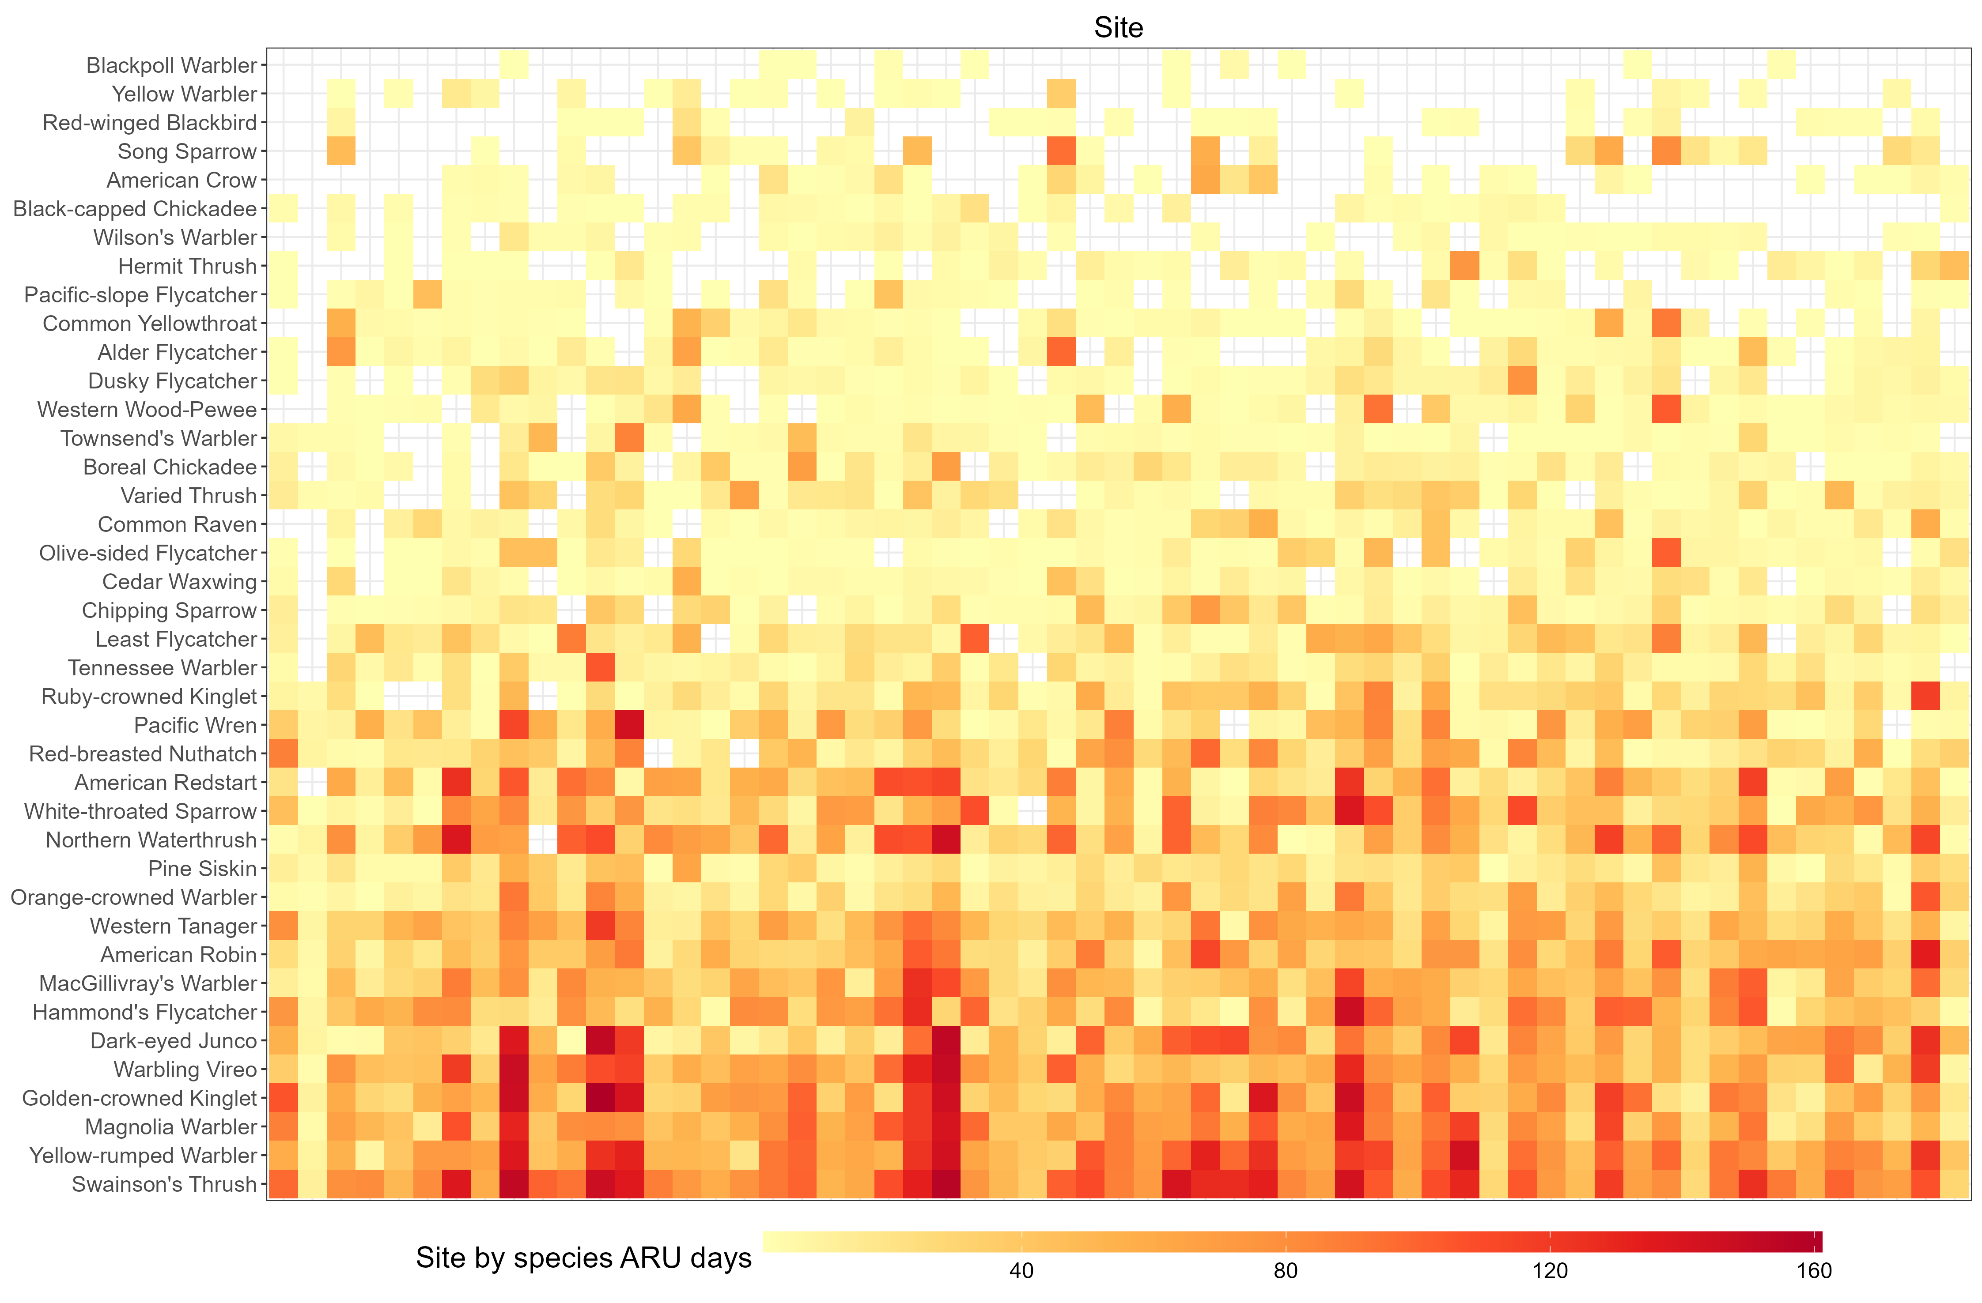
Fig. 2. Number of days each species was detected at each site using ARUs. Species in the lower part of the graph, such as American Robin, Dark-eyed Junco, and Golden-crowned Kinglet, were detected across most sites and likely represent generalists. In contrast, species toward the top of the graph, including Yellow Warbler and Red-winged Blackbird, were detected at fewer sites, potentially reflecting more specific habitat preferences.

LiDAR habitat covariates and model selection
LiDAR data were collected in 2015 during the leaf-off season, with a point density of XYZ. As all sites in the study had not undergone significant disturbance since 2015, the LiDAR should reflect the same relative habitat composition/shifts to allow the use to compare with the audio data. We applied an area-based approach to rasterize the point clouds at a spatial resolution of 10 meters. For modeling purposes, we aggregated habitat covariates within a 100-meter radius around each ARU site to represent the area a bird might be using when detected (Pérez-Granados 2025). A total of 17 LiDAR-derived variables were considered as candidate covariates (Table 3). These covariates were classified following the framework outlined in Bakx et al. (2018), which highlights canopy structure and total vegetation metrics as the most commonly associated with bird species richness (see Fig. 4 in Bakx et al. 2019).
To reduce multicollinearity and ensure model stability, we calculated pairwise correlations among the covariates and removed those with correlations greater than 0.8 (cite). Furthermore, we computed variance inflation factors (VIFs) for the remaining variables and excluded any with VIFs exceeding 5 (cite). This pre-selection ensured that only relatively independent covariates were included in the subsequent model selection. We employed an information-theoretical approach for model selection and inference. Specifically, we fitted models using all possible linear combinations of the LiDAR covariates. Model averaging was then performed to assess variable importance. This analysis was conducted using the MuMIn R package (Bartoń 2025), specifically the MuMIn::dredge() function, with the full model being a linear regression model.

Table 3. LiDAR-derived habitat covariates used in the analysis, including measures of canopy structure, vegetation density, and ground features.
Type | Name | Definition
Topography/  Ground | dem | Average elevation
Topography/  Ground | slope | Average slope
Topography/  Ground | aspect | Average aspect
Topography/  Ground | d_lid_rip_wet_str_le | Distance to LiDAR stream, wetland (polygon), lake edge
Topography/  Ground | d_vri_polyedge | Distance to VRI polygon stand edge
Canopy | cc1_3 | Average crown closure between 1 – 3 m
Canopy | cc3_10 | Average crown closure between 3 – 10 m
Canopy | cc10 | Average crown closure above 10m
Canopy | chm | Average canopy height
Canopy | vdi_95 | Vertical distribution if intercepted canopy elements ranging from 0 and 1 using 95% height
Total vegetation | less_10 | Proportion of polygon with forest age less than 10 years
Total vegetation | age_80 | Proportion of polygon with forest age greater than 80 years
Total vegetation | prop_decid | Proportion of deciduous tree counts for all trees having DBH > 10cm
Total vegetation | decid_dens | Number of deciduous trees per unit area
Total vegetation | conf_dens | Number of conifer trees per unit area
Total vegetation | tree_dens | Number of total trees per unit area
Total vegetation | ba_dens | Sum of basal area of all trees per unit area

Result

Asymptotic richness estimates
The estimated asymptotic richness for each site ranged from 19.49 to 48.79 species. Regardless of the number of ARU days acquired for a site, the number of species detected was close to reaching a plateau (e.g. approaching the asymptotic species richness estimate) at the conducted sampling effort level (Fig. 3). This is evident as the solid accumulation line (actual sampled effort) in many sites had already reached close to the asymptote level projected through extrapolation (dashed lines). The mean difference between estimated asymptotic richness and observed richness was 3.0 species for low effort, 4.6 species for medium effort, and 2.8 species for high effort (Supplementary Table B).
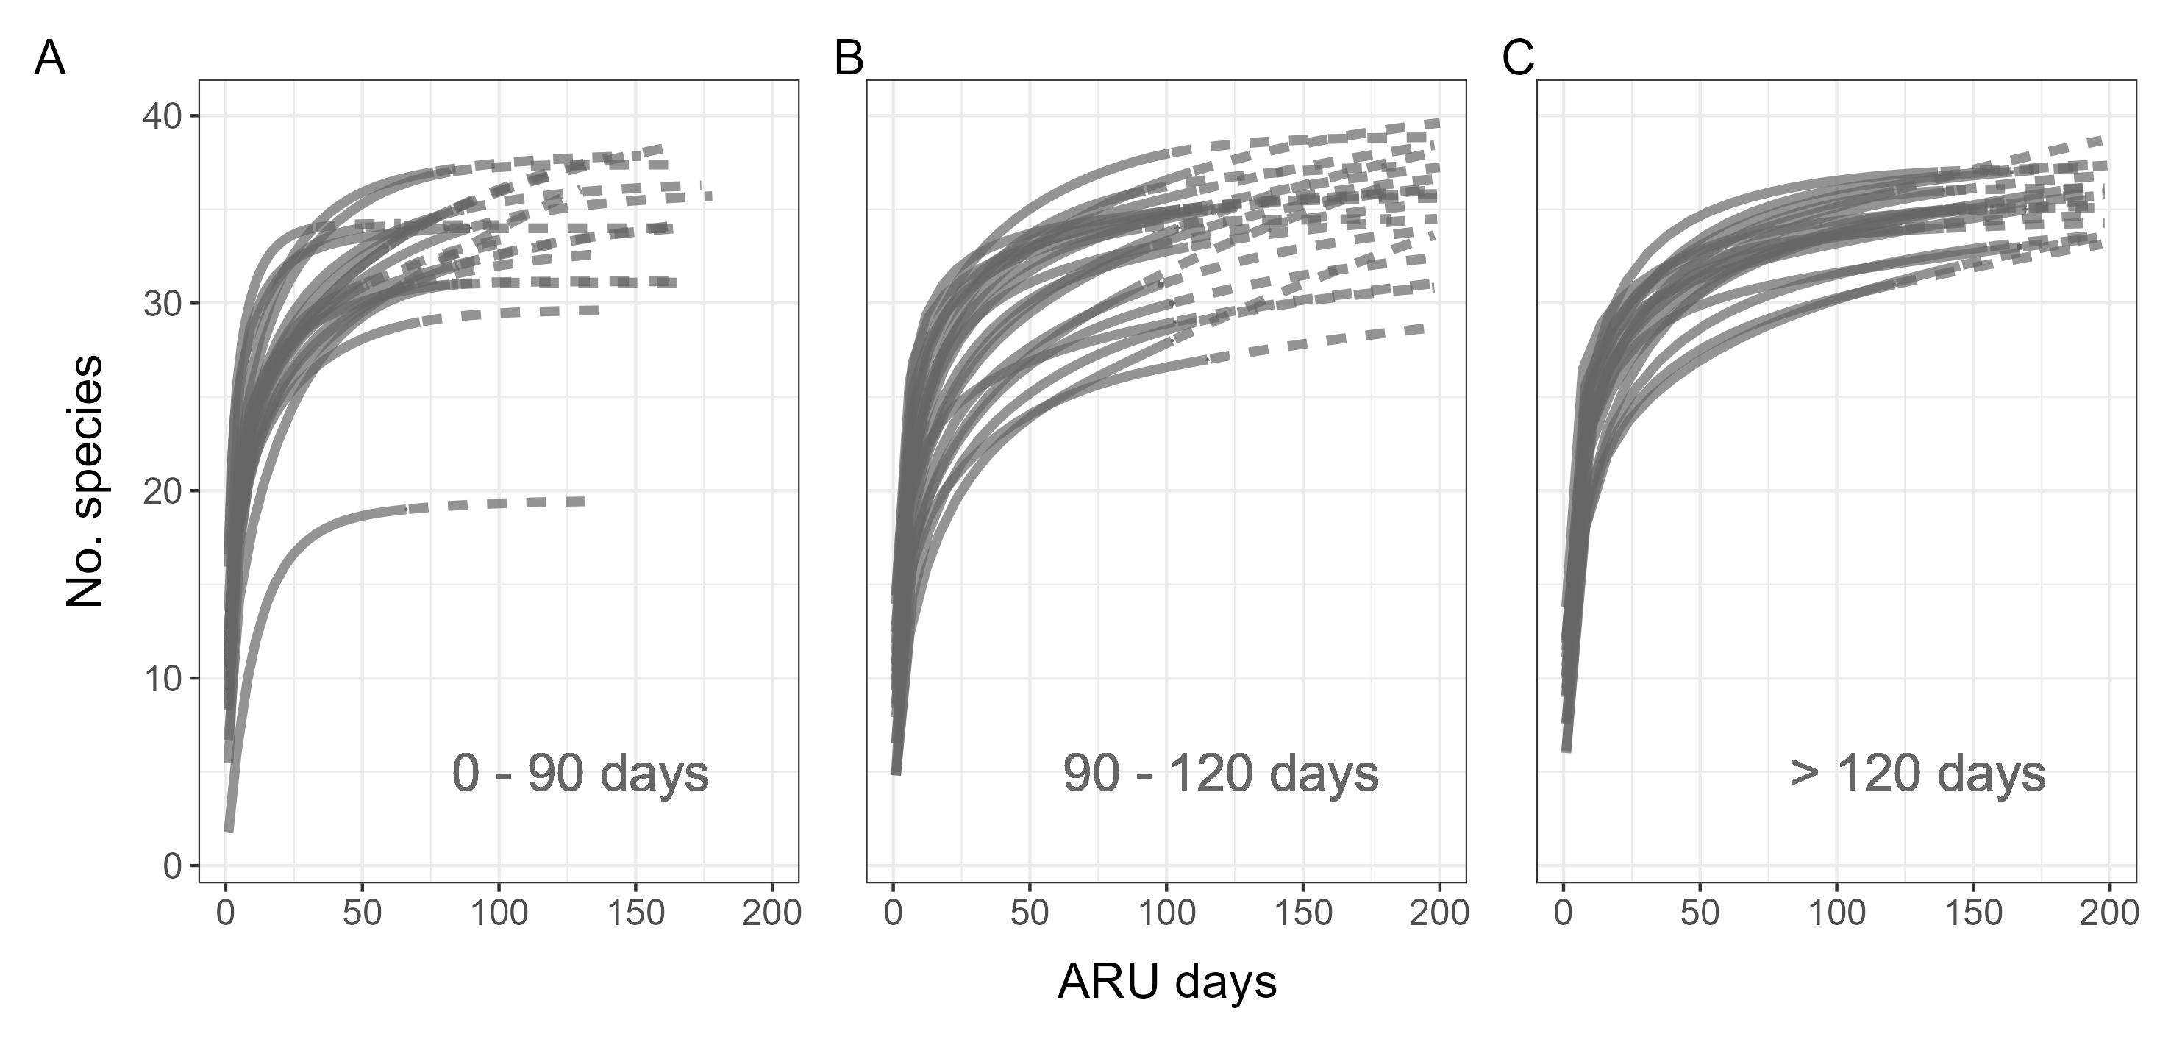
Fig. 3. Rarefaction curves for sites with different survey efforts: (A) ARU days fewer than 90, (B) ARU days between 90 and 120, and (C) ARU days greater than 120. Each semi-transparent line represents the curve for an individual site. The solid parts of the curve are interpolation of collected data while the dashed parts are extrapolation. If the solid line is already approaching the asymptote, it indicates that current sampling effort is sufficient in surveying richness.

LiDAR covariate pre-selection
Pairwise correlation analysis among the 17 LiDAR-derived covariates revealed several instances of high collinearity (|r| > 0.8; Fig. 4A). Specifically, many canopy structure covariates (Fig. 4A green highlight) and total vegetation covariates (Fig. 4A yellow highlight) were strongly correlated. To address this, we retained only the variables that were most interpretable and widely used in ecological studies, reducing the number of covariates from 17 to 10 (Fig. 4B). All retained variables had variance inflation factor (VIF) values below 5, indicating the absence of multicollinearity (Fig. 4C; bolded variables in Table 3). Because aspect is a circular variable, we further decomposed it into its sine and cosine components, resulting in a total of 11 LiDAR covariates used in the subsequent model selection.
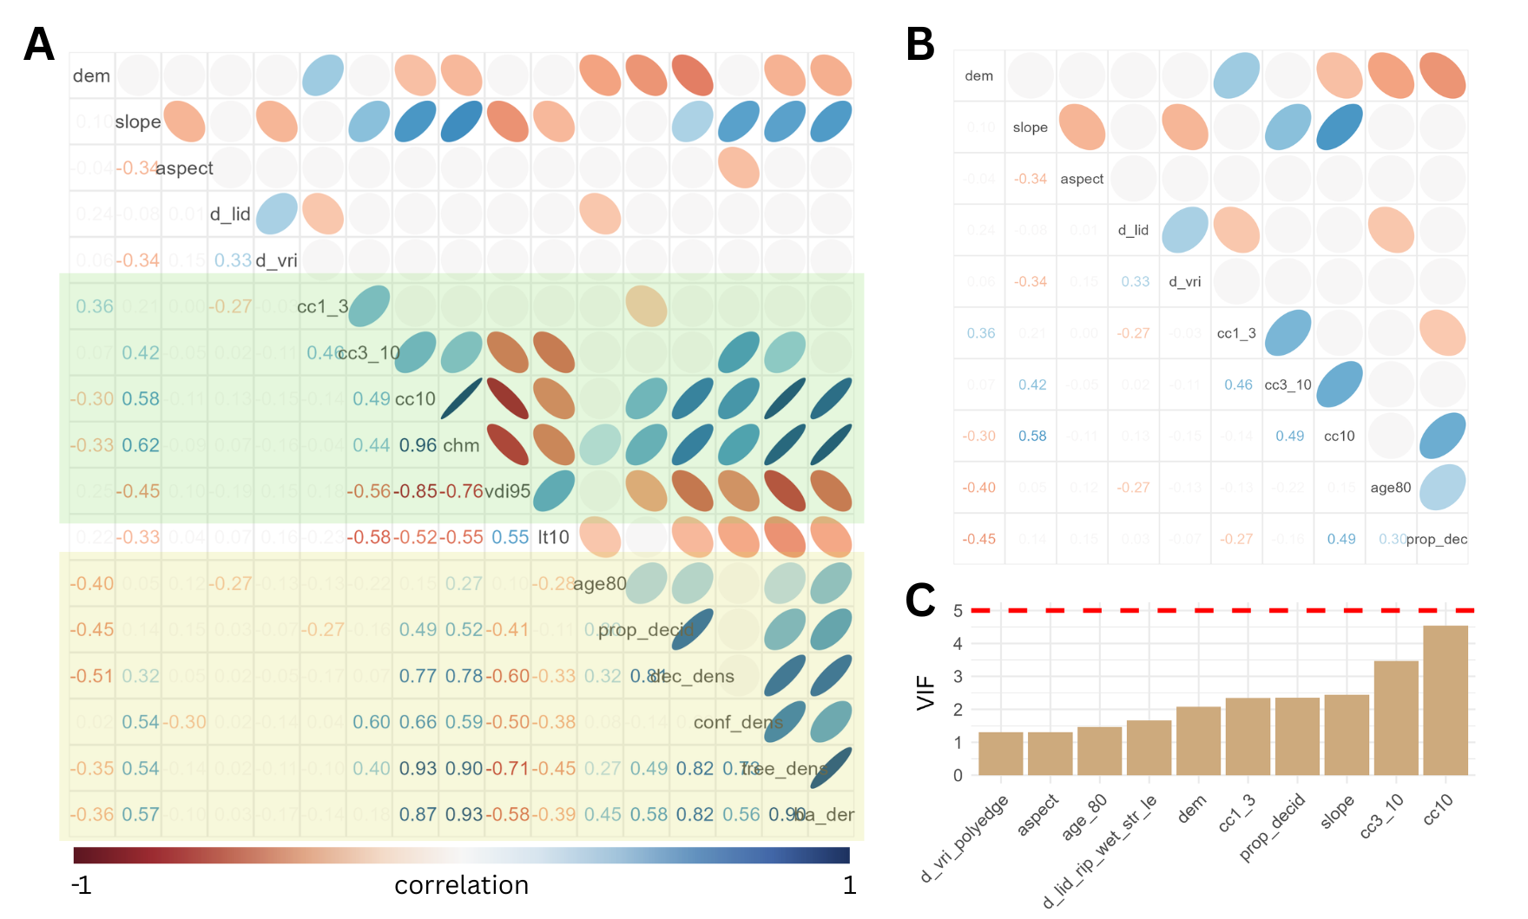
Fig. 4.

Predictive power for richness
Among all the LiDAR covariates, none of the covariate showed up to be significant in explaining the general asymptotic richness (Fig. 5A), which could be due to the variation of habitat preference in our species list, thus balanced out the effect of certain habitat preference. Thus, we further grouped the species based on the species by site distribution (Fig. 2) using k-means clustering (Fig. 6). Species within the same cluster exhibited similar distribution patterns across the study sites, which likely imply rough shared habitat preferences or frequent co-occurrenc for particular sub groups within the guild (Billerman et al. 2025).
Repeating the same method, we tried to see whether there is LiDAR covariates that would associated with the richness of each of the groups.
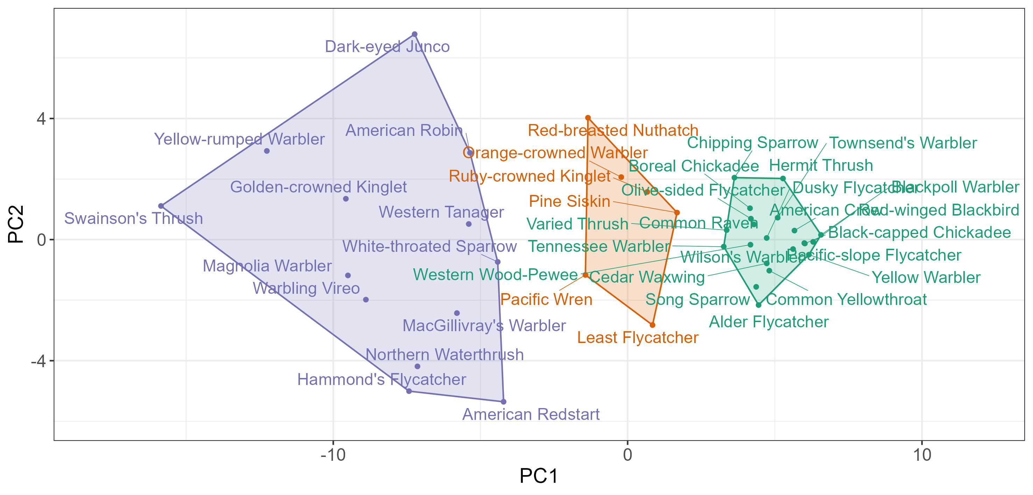
Fig. 6. K-means clustering of target species based on site-use patterns, visualized in principal component space. Species within the same cluster exhibit similar distributions across study sites.

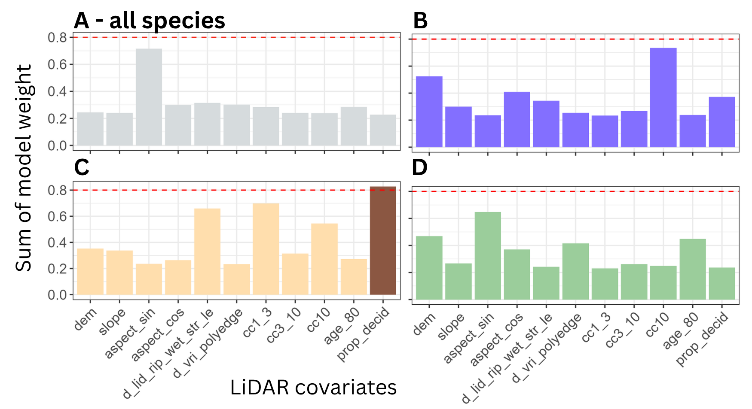
Fig. 5.

Discussion
Our large-scale acoustic survey provided a comprehensive bird community species list for the John Prince Research Forest in central British Columbia (Supplementary Table A). By examining species/site-presence relationships, we were able to distinguish generalists from specialists (Fig. 2) and identify species that tend to co-occur is similar habitat (Fig. 3). These groupings highlight potential habitat guilds within the breeding songbird species and demonstrate the value of passive acoustic monitoring for capturing broad-scale patterns of breeding songbird communities. When paired with LiDAR-derived environmental covariates, we found that proximity to streams, wetlands, and lake edges was the strongest habitat covariate predicting site-level asymptotic richness (Fig. 5), emphasizing the importance of riparian and wetland habitats for breeding songbirds in managed forest landscapes.
Contrary to expectations from previous studies that identified canopy covariates as key drivers of bird richness (Bakx et al. 2019), the LiDAR covariates related to vertical canopy structure were not statistically significant in our averaged models. Average crown closure between 1–3 m (cc1_3) ranked third among all 17 covariates, while crown closure above 10 m (cc10) ranked seventh, but neither was significant (Fig. 5). This discrepancy may reflect the composition of our focal species, the 40 dawn-chorus songbird species, were primarily forest-associated, in contrast to broader multi-guild analyses that include waterfowl, raptors, game birds, etc. Our findings suggest that within relatively homogeneous forest guilds, the proximity to riparian features may exert stronger influences on richness than canopy attributes alone.
Expanding analyses to include the full community species list would provide broader ecological insight but presents practical challenges. Validation of BirdNET detections requires substantial manual effort to establish species-specific thresholds (Tseng et al. 2025; Wood and Kahl 2024). Based on our workflow (see Methods), validating 360 song segments per species required approximately 4–8 hours, depending on factors such as vocal repertoire overlap (e.g., Varied Thrush vs. White-throated Sparrow, Alder Flycatcher vs. Hammond’s Flycatcher), frequency characteristics (e.g., high pitched songs of Brown Creeper and Golden-crowned Kinglet), and call length (e.g., short calls of warblers). Scaling this process to 122 species would equate to roughly 100 person-days of effort. These resource constraints highlight a trade-off between methodological rigor and ecological breadth when applying automated classifiers in community-level analyses.
One potential alternative is the use of universal threshold approaches (Tseng et al. 2025), which apply standardized BirdNET confidence threshold across species and aggregate results over longer temporal windows. One recent study has suggested that this strategy can yield community-level estimates comparable to expert validation while minimizing manual effort in validation (Fairbairn et al. 2025). However, such approaches bypass species-specific error assessment, and their outputs must therefore be interpreted with caution. Without explicit quantification of precision or detection probability, universal thresholds may be most appropriate for coarse-resolution analyses where presence–absence data are aggregated at broad spatial or temporal scales (Fairbairn et al. 2025).
A further challenge lies in incorporating uncertainty from asymptotic richness estimates into habitat models. We used single point estimates of richness, but iNEXT-derived confidence limits (Table 4) varied widely among sites and were asymmetrically distributed, complicating traditional bootstrapping approaches. Bayesian frameworks may offer a more flexible solution for propagating uncertainty into biodiversity models, enabling more robust inference about habitat–richness relationships (van de Schoot et al. 2021).
Finally, our findings underscore the importance of developing clear guidelines for the use of ARU-derived data in ecological modeling. Rarefaction and asymptotic richness estimators provide defensible ways to account for survey effort, but they remain subject to limitations such as controlling of estimator variance and manual efforts in validating the detection. Complementary approaches, including occupancy models or detection-rate metrics at appropriate temporal resolutions, may strengthen inferences about habitat use. Establishing standardized protocols will be critical to ensure consistent application of passive acoustic monitoring data in large scale biodiversity monitoring and forest management. In working landscapes, where balancing conservation with resource use is crucial, such protocols could support more reliable integration of biodiversity indicators into management planning.

Literature cited
Bakx, Tristan R. M., Zsófia Koma, Arie C. Seijmonsbergen, and W. Daniel Kissling. 2019. “Use and Categorization of Light Detection and Ranging Vegetation Metrics in Avian Diversity and Species Distribution Research.” Diversity and Distributions 25 (7): 1045–59. https://doi.org/10.1111/ddi.12915.
Bartoń, Kamil. 2025. MuMIn: Multi-Model Inference. V. 1.48.11. Released April 1. https://cran.r-project.org/web/packages/MuMIn/index.html.
Billerman, S. M., B. K. Keeney, G. M. Kirwan, F. Medrano, N. D. Sly, and M. G. Smith. 2025. Birds of the World. Cornell Laboratory of Ornithology. https://doi.org/10.2173/bow.
BirdNET Team. (2021) 2025. BirdNET-Analyzer. Python. September 22, released. https://github.com/birdnet-team/BirdNET-Analyzer.
Bradbury, Richard B., Ross A. Hill, David C. Mason, et al. 2005. “Modelling Relationships between Birds and Vegetation Structure Using Airborne LiDAR Data: A Review with Case Studies from Agricultural and Woodland Environments.” Ibis 147 (3): 443–52. https://doi.org/10.1111/j.1474-919x.2005.00438.x.
Chao, Anne, Nicholas J. Gotelli, T. C. Hsieh, et al. 2014. “Rarefaction and Extrapolation with Hill Numbers: A Framework for Sampling and Estimation in Species Diversity Studies.” Ecological Monographs 84 (1): 45–67. https://doi.org/10.1890/13-0133.1.
Culbert, Patrick D., Volker C. Radeloff, Curtis H. Flather, Josef M. Kellndorfer, Chadwick D. Rittenhouse, and Anna M. Pidgeon. 2013. “The Influence of Vertical and Horizontal Habitat Structure on Nationwide Patterns of Avian Biodiversity.” The Auk 130 (4): 656–65. https://doi.org/10.1525/auk.2013.13007.
Davidson, P.J.A., R.J. Cannings, A.R. Couturier, D. Lepage, and C.M. Di Corrado. 2015. “The Atlas of the Breeding Birds of British Columbia, 2008-2012.” https://www.birdatlas.bc.ca/.
Fairbairn, Andrew J., Josija-Simeon Burmeister, Wolfgang W. Weisser, and Sebastian T. Meyer. 2025. “BirdNET Can Be as Good as Experts for Acoustic Bird Monitoring in a European City.” PLOS ONE 20 (9): e0330836. https://doi.org/10.1371/journal.pone.0330836.
Francis, Anthony P., and David J. Currie. 2003. “A Globally Consistent Richness‐Climate Relationship for Angiosperms.” The American Naturalist 161 (4): 523–36. https://doi.org/10.1086/368223.
Gottschalk, T. K., F. Huettmann, and M. Ehlers. 2005. “Review Article: Thirty Years of Analysing and Modelling Avian Habitat Relationships Using Satellite Imagery Data: A Review.” International Journal of Remote Sensing 26 (12): 2631–56. https://doi.org/10.1080/01431160512331338041.
Hawkins, Bradford A., Richard Field, Howard V. Cornell, et al. 2003. “Energy, Water, and Broad-Scale Geographic Patterns of Species Richness.” Ecology 84 (12): 3105–17. https://doi.org/10.1890/03-8006.
Hill, Andrew P., Peter Prince, Jake L. Snaddon, C. Patrick Doncaster, and Alex Rogers. 2019. “AudioMoth: A Low-Cost Acoustic Device for Monitoring Biodiversity and the Environment.” HardwareX 6 (October): e00073. https://doi.org/10.1016/j.ohx.2019.e00073.
Hsieh, T. C., K. H. Ma, and Anne Chao. 2016. “iNEXT: An R Package for Rarefaction and Extrapolation of Species Diversity (Hill Numbers).” Methods in Ecology and Evolution 7 (12): 1451–56. https://doi.org/10.1111/2041-210X.12613.
Kassambara, Alboukadel. 2017. Practical Guide to Principal Component Methods in R: PCA, M (CA), FAMD, MFA, HCPC, Factoextra. Vol. 2. Statistical tools for high-throughput data analysis.
Lemenkova, Polina. 2019. “K-Means Clustering in R Libraries {cluster} and {factoextra} for Grouping Oceanographic Data.” International Journal of Informatics and Applied Mathematics 2 (1): 1–26.
Maes, Dirk, Dirk Bauwens, Luc De Bruyn, et al. 2005. “Species Richness Coincidence: Conservation Strategies Based on Predictive Modelling.” Biodiversity & Conservation 14 (6): 1345–64. https://doi.org/10.1007/s10531-004-9662-x.
Mattmüller, Ramona M., Karolin Thomisch, Ilse Van Opzeeland, Kristin L. Laidre, and Malene Simon. 2022. “Passive Acoustic Monitoring Reveals Year-Round Marine Mammal Community Composition off Tasiilaq, Southeast Greenlanda).” The Journal of the Acoustical Society of America 151 (2): 1380–92. https://doi.org/10.1121/10.0009429.
Pérez-Granados, Cristian. 2025. “Birdnet Confidence Scores Decrease with Bird Distance from the Recorder: Revisiting Pérez-Granados (2023).” Ardeola 72 (2): 149–59. https://doi.org/10.13157/arla.72.2.2025.fo1.
Pérez-Granados, Cristian, Karl-L. Schuchmann, and Marinez I. Marques. 2021. “Vocal Activity of the Ferruginous Pygmy-Owl (Glaucidium Brasilianum) Is Strongly Correlated with Moon Phase and Nocturnal Temperature.” Ethology Ecology & Evolution 33 (1): 62–72. https://doi.org/10.1080/03949370.2020.1820582.
Pérez-Granados, Cristian, and Juan Traba. 2021. “Estimating Bird Density Using Passive Acoustic Monitoring: A Review of Methods and Suggestions for Further Research.” Ibis 163 (3): 765–83. https://doi.org/10.1111/ibi.12944.
Picciulin, Marta, Loïc Kéver, Eric Parmentier, and Marta Bolgan. 2019. “Listening to the Unseen: Passive Acoustic Monitoring Reveals the Presence of a Cryptic Fish Species.” Aquatic Conservation: Marine and Freshwater Ecosystems 29 (2): 202–10. https://doi.org/10.1002/aqc.2973.
Rahbek, Carsten, Nicholas J Gotelli, Robert K Colwell, Gary L Entsminger, Thiago Fernando L.V.B Rangel, and Gary R Graves. 2006. “Predicting Continental-Scale Patterns of Bird Species Richness with Spatially Explicit Models.” Proceedings of the Royal Society B: Biological Sciences 274 (1607): 165–74. https://doi.org/10.1098/rspb.2006.3700.
Ross, Samuel R. P.-J., Darren P. O’Connell, Jessica L. Deichmann, et al. 2023. “Passive Acoustic Monitoring Provides a Fresh Perspective on Fundamental Ecological Questions.” Functional Ecology 37 (4): 959–75. https://doi.org/10.1111/1365-2435.14275.
Schoot, Rens van de, Sarah Depaoli, Ruth King, et al. 2021. “Bayesian Statistics and Modelling.” Nature Reviews Methods Primers 1 (1): 1. https://doi.org/10.1038/s43586-020-00001-2.
Sugai, Larissa Sayuri Moreira, Thiago Sanna Freire Silva, José Wagner Ribeiro Jr, and Diego Llusia. 2019. “Terrestrial Passive Acoustic Monitoring: Review and Perspectives.” BioScience 69 (1): 15–25. https://doi.org/10.1093/biosci/biy147.
Tattoni, Clara, Franco Rizzolli, and Paolo Pedrini. 2012. “Can LiDAR Data Improve Bird Habitat Suitability Models?” Ecological Modelling, 7th European Conference on Ecological Modelling (ECEM), vol. 245 (October): 103–10. https://doi.org/10.1016/j.ecolmodel.2012.03.020.
Tseng, Sunny, Dexter P. Hodder, and Ken A. Otter. 2025. “Setting BirdNET Confidence Thresholds: Species-Specific vs. Universal Approaches.” Journal of Ornithology, ahead of print, February 25. https://doi.org/10.1007/s10336-025-02260-w.
Vierling, Kerri T, Lee A Vierling, William A Gould, Sebastian Martinuzzi, and Rick M Clawges. 2008. “Lidar: Shedding New Light on Habitat Characterization and Modeling.” Frontiers in Ecology and the Environment 6 (2): 90–98. https://doi.org/10.1890/070001.
Wood, Connor M., and Stefan Kahl. 2024. “Guidelines for Appropriate Use of BirdNET Scores and Other Detector Outputs.” Journal of Ornithology 165 (3): 777–82. https://doi.org/10.1007/s10336-024-02144-5.

Supplementary
Table A. The full list of 122 species detected by ARUs at the study site. For each species, the table includes the total number of detections by BirdNET and the number of sites where the species was detected. The values were calculated before applying species-specific threshold, and before dropping any unused sites in the analysis. The species represent a diverse range of taxa, including raptors, waterfowl, warblers, sparrows, flycatchers, woodpeckers, owls, and other families.

Family | Scientific name | Common name | No. detections | No. sites
Accipitridae  (Hawks, Eagles, and Kites) | Astur atricapillus | American Goshawk | 4713 | 54
Accipitridae  (Hawks, Eagles, and Kites) | Buteo jamaicensis | Red-tailed Hawk | 296 | 50
Accipitridae  (Hawks, Eagles, and Kites) | Buteo platypterus | Broad-winged Hawk | 3302 | 57
Accipitridae  (Hawks, Eagles, and Kites) | Haliaeetus leucocephalus | Bald Eagle | 398 | 30
Accipitridae  (Hawks, Eagles, and Kites) | Accipiter striatus | Sharp-shinned Hawk | 116 | 38
Pandionidae  (Osprey) | Pandion haliaetus | Osprey | 238 | 39
Anatida  (Ducks, Geese, and Waterfowl) | Anas platyrhynchos | Mallard | 478 | 40
Anatida  (Ducks, Geese, and Waterfowl) | Branta canadensis | Canada Goose | 788 | 39
Anatida  (Ducks, Geese, and Waterfowl) | Mergus merganser | Common Merganser | 866 | 32
Anatida  (Ducks, Geese, and Waterfowl) | Bucephala clangula | Common Goldeneye | 82 | 21
Anatida  (Ducks, Geese, and Waterfowl) | Anas crecca | Green-winged Teal | 124 | 25
Anatida  (Ducks, Geese, and Waterfowl) | Lophodytes cucullatus | Hooded Merganser | 75 | 13
Anatida  (Ducks, Geese, and Waterfowl) | Bucephala islandica | Barrow's Goldeneye | 19 | 7
Anatida  (Ducks, Geese, and Waterfowl) | Cygnus buccinator | Trumpeter Swan | 97 | 18
Anatida  (Ducks, Geese, and Waterfowl) | Spatula discors | Blue-winged Teal | 24 | 7
Anatida  (Ducks, Geese, and Waterfowl) | Mareca americana | American Wigeon | 23 | 4
Anatida  (Ducks, Geese, and Waterfowl) | Aythya collaris | Ring-necked Duck | 144 | 14
Trochilidae  (Hummingbirds) | Selasphorus rufus | Rufous Hummingbird | 177 | 24
Caprimulgidae (Nightjars and Allies) | Chordeiles minor | Common Nighthawk | 469 | 45
Laridae  (Gulls, Terns, and Skimmers) | Chroicocephalus philadelphia | Bonaparte's Gull | 31 | 6
Scolopacidae  (Sandpipers and Allies) | Actitis macularius | Spotted Sandpiper | 297 | 33
Scolopacidae  (Sandpipers and Allies) | Gallinago delicata | Wilson's Snipe | 11401 | 37
Scolopacidae  (Sandpipers and Allies) | Tringa solitaria | Solitary Sandpiper | 94 | 23
Scolopacidae  (Sandpipers and Allies) | Tringa melanoleuca | Greater Yellowlegs | 994 | 48
Alcedinidae  (Kingfishers) | Megaceryle alcyon | Belted Kingfisher | 462 | 51
Falconidae  (Falcons and Caracaras) | Falco sparverius | American Kestrel | 143 | 42
Falconidae  (Falcons and Caracaras) | Falco columbarius | Merlin | 528 | 32
Phasianidae  (Pheasants, Grouse, and Allies) | Canachites canadensis | Spruce Grouse | 15906 | 58
Phasianidae  (Pheasants, Grouse, and Allies) | Bonasa umbellus | Ruffed Grouse | 1000 | 49
Phasianidae  (Pheasants, Grouse, and Allies) | Lagopus lagopus | Willow Ptarmigan | 62 | 23
Gaviidae  (Loons) | Gavia immer | Common Loon | 5530 | 57
Gruidae  (Cranes) | Antigone canadensis | Sandhill Crane | 535 | 35
Rallidae  (Rails, Gallinules, and Coots) | Porzana carolina | Sora | 3448 | 17
Bombycillidae  (Waxwings) | Bombycilla cedrorum | Cedar Waxwing | 5771 | 59
Bombycillidae  (Waxwings) | Bombycilla garrulus | Bohemian Waxwing | 151 | 40
Cardinalidae  (Cardinals and Allies) | Piranga ludoviciana | Western Tanager | 39616 | 61
Cardinalidae  (Cardinals and Allies) | Pheucticus ludovicianus | Rose-breasted Grosbeak | 3278 | 59
Certhiidae  (Treecreepers) | Certhia americana | Brown Creeper | 15142 | 61
Cinclidae  (Dippers) | Cinclus mexicanus | American Dipper | 1364 | 27
Corvidae  (Crows, Jays, and Magpies) | Perisoreus canadensis | Canada Jay | 634 | 55
Corvidae  (Crows, Jays, and Magpies) | Corvus corax | Common Raven | 4672 | 54
Corvidae  (Crows, Jays, and Magpies) | Corvus brachyrhynchos | American Crow | 1477 | 30
Fringillidae  (Finches, Euphonias, and Allies) | Pinicola enucleator | Pine Grosbeak | 1139 | 61
Fringillidae  (Finches, Euphonias, and Allies) | Spinus pinus | Pine Siskin | 6400 | 60
Fringillidae  (Finches, Euphonias, and Allies) | Loxia leucoptera | White-winged Crossbill | 6125 | 60
Fringillidae  (Finches, Euphonias, and Allies) | Coccothraustes vespertinus | Evening Grosbeak | 552 | 58
Fringillidae  (Finches, Euphonias, and Allies) | Haemorhous purpureus | Purple Finch | 10420 | 62
Fringillidae  (Finches, Euphonias, and Allies) | Leucosticte tephrocotis | Gray-crowned Rosy-Finch | 1210 | 51
Fringillidae  (Finches, Euphonias, and Allies) | Haemorhous mexicanus | House Finch | 4431 | 59
Fringillidae  (Finches, Euphonias, and Allies) | Loxia curvirostra | Red Crossbill | 165 | 45
Hirundinidae  (Swallows) | Tachycineta thalassina | Violet-green Swallow | 485 | 39
Hirundinidae  (Swallows) | Tachycineta bicolor | Tree Swallow | 1094 | 27
Icteridae  (Troupials and Allies) | Agelaius phoeniceus | Red-winged Blackbird | 204 | 23
Icteridae  (Troupials and Allies) | Molothrus ater | Brown-headed Cowbird | 87 | 28
Icteridae  (Troupials and Allies) | Euphagus carolinus | Rusty Blackbird | 1395 | 36
Motacillidae  (Wagtails and Pipits) | Anthus rubescens | American Pipit | 4368 | 58
Paridae  (Tits, Chickadees, and Titmice) | Poecile hudsonicus | Boreal Chickadee | 4430 | 57
Paridae  (Tits, Chickadees, and Titmice) | Poecile gambeli | Mountain Chickadee | 12994 | 61
Paridae  (Tits, Chickadees, and Titmice) | Poecile atricapillus | Black-capped Chickadee | 1615 | 54
Parulidae  (New World Warblers) | Setophaga magnolia | Magnolia Warbler | 74084 | 62
Parulidae  (New World Warblers) | Setophaga coronata | Yellow-rumped Warbler | 111092 | 62
Parulidae  (New World Warblers) | Setophaga townsendi | Townsend's Warbler | 7361 | 61
Parulidae  (New World Warblers) | Setophaga striata | Blackpoll Warbler | 4619 | 61
Parulidae  (New World Warblers) | Geothlypis tolmiei | MacGillivray's Warbler | 30304 | 61
Parulidae  (New World Warblers) | Leiothlypis peregrina | Tennessee Warbler | 36766 | 58
Parulidae  (New World Warblers) | Setophaga ruticilla | American Redstart | 74872 | 59
Parulidae  (New World Warblers) | Seiurus aurocapilla | Ovenbird | 5286 | 59
Parulidae  (New World Warblers) | Cardellina pusilla | Wilson's Warbler | 4738 | 60
Parulidae  (New World Warblers) | Leiothlypis celata | Orange-crowned Warbler | 11951 | 60
Parulidae  (New World Warblers) | Parkesia noveboracensis | Northern Waterthrush | 146613 | 60
Parulidae  (New World Warblers) | Setophaga petechia | Yellow Warbler | 3407 | 42
Parulidae  (New World Warblers) | Geothlypis trichas | Common Yellowthroat | 4153 | 46
Passerellidae  (New World Sparrows) | Spizella passerina | Chipping Sparrow | 5162 | 54
Passerellidae  (New World Sparrows) | Zonotrichia albicollis | White-throated Sparrow | 42421 | 60
Passerellidae  (New World Sparrows) | Zonotrichia leucophrys | White-crowned Sparrow | 69534 | 62
Passerellidae  (New World Sparrows) | Junco hyemalis | Dark-eyed Junco | 48344 | 62
Passerellidae  (New World Sparrows) | Passerella iliaca | Fox Sparrow | 2861 | 60
Passerellidae  (New World Sparrows) | Melospiza lincolnii | Lincoln's Sparrow | 19790 | 59
Passerellidae  (New World Sparrows) | Melospiza melodia | Song Sparrow | 3390 | 23
Passerellidae  (New World Sparrows) | Spizella pallida | Clay-colored Sparrow | 228 | 39
Passerellidae  (New World Sparrows) | Melospiza georgiana | Swamp Sparrow | 1846 | 56
Passerellidae  (New World Sparrows) | Zonotrichia atricapilla | Golden-crowned Sparrow | 140 | 35
Passerellidae  (New World Sparrows) | Pooecetes gramineus | Vesper Sparrow | 456 | 32
Regulidae  (Kinglets) | Regulus satrapa | Golden-crowned Kinglet | 84683 | 61
Regulidae  (Kinglets) | Corthylio calendula | Ruby-crowned Kinglet | 13918 | 59
Sittidae  (Nuthatches) | Sitta canadensis | Red-breasted Nuthatch | 23207 | 61
Troglodytidae  (Wrens) | Troglodytes pacificus | Pacific Wren | 60989 | 59
Turdidae  (Thrushes and Allies) | Catharus ustulatus | Swainson's Thrush | 327431 | 62
Turdidae  (Thrushes and Allies) | Ixoreus naevius | Varied Thrush | 32529 | 61
Turdidae  (Thrushes and Allies) | Catharus guttatus | Hermit Thrush | 52026 | 61
Turdidae  (Thrushes and Allies) | Turdus migratorius | American Robin | 37737 | 62
Turdidae  (Thrushes and Allies) | Myadestes townsendi | Townsend's Solitaire | 787 | 55
Turdidae  (Thrushes and Allies) | Sialia currucoides | Mountain Bluebird | 1238 | 54
Tyrannidae  (Tyrant Flycatchers) | Empidonax difficilis | Western Flycatcher | 12474 | 62
Tyrannidae  (Tyrant Flycatchers) | Empidonax hammondii | Hammond's Flycatcher | 141949 | 62
Tyrannidae  (Tyrant Flycatchers) | Empidonax minimus | Least Flycatcher | 44654 | 58
Tyrannidae  (Tyrant Flycatchers) | Empidonax oberholseri | Dusky Flycatcher | 9356 | 58
Tyrannidae  (Tyrant Flycatchers) | Contopus cooperi | Olive-sided Flycatcher | 17061 | 61
Tyrannidae  (Tyrant Flycatchers) | Empidonax flaviventris | Yellow-bellied Flycatcher | 5815 | 61
Tyrannidae  (Tyrant Flycatchers) | Empidonax alnorum | Alder Flycatcher | 21412 | 49
Tyrannidae  (Tyrant Flycatchers) | Tyrannus tyrannus | Eastern Kingbird | 48 | 26
Tyrannidae  (Tyrant Flycatchers) | Contopus sordidulus | Western Wood-Pewee | 10992 | 50
Vireonidae  (Vireos, Shrike-Babblers, and Erpornis) | Vireo gilvus | Warbling Vireo | 87002 | 62
Vireonidae  (Vireos, Shrike-Babblers, and Erpornis) | Vireo cassinii | Cassin's Vireo | 6188 | 55
Vireonidae  (Vireos, Shrike-Babblers, and Erpornis) | Vireo olivaceus | Red-eyed Vireo | 600 | 35
Ardeidae  (Herons, Egrets, and Bitterns) | Botaurus lentiginosus | American Bittern | 359 | 34
Picidae  (Woodpeckers) | Sphyrapicus varius | Yellow-bellied Sapsucker | 5261 | 57
Picidae  (Woodpeckers) | Sphyrapicus nuchalis | Red-naped Sapsucker | 5182 | 57
Picidae  (Woodpeckers) | Picoides arcticus | Black-backed Woodpecker | 2928 | 60
Picidae  (Woodpeckers) | Picoides dorsalis | American Three-toed Woodpecker | 6417 | 62
Picidae  (Woodpeckers) | Dryobates villosus | Hairy Woodpecker | 1589 | 54
Picidae  (Woodpeckers) | Dryocopus pileatus | Pileated Woodpecker | 1910 | 56
Picidae  (Woodpeckers) | Dryobates pubescens | Downy Woodpecker | 331 | 49
Picidae  (Woodpeckers) | Colaptes auratus | Northern Flicker | 950 | 43
Podicipedidae  (Grebes) | Podiceps grisegena | Red-necked Grebe | 26 | 8
Strigidae  (Owls) | Strix varia | Barred Owl | 498 | 43
Strigidae  (Owls) | Bubo virginianus | Great Horned Owl | 4902 | 57
Strigidae  (Owls) | Asio otus | Long-eared Owl | 294 | 40
Strigidae  (Owls) | Strix nebulosa | Great Gray Owl | 419 | 36
Strigidae  (Owls) | Aegolius acadicus | Northern Saw-whet Owl | 2223 | 54
Strigidae  (Owls) | Glaucidium gnoma | Northern Pygmy-Owl | 876 | 48
Strigidae  (Owls) | Aegolius funereus | Boreal Owl | 5826 | 44

Table B. Estimated asymptotic richness for each site. "ARU days" refers to the number of days the ARU operated at a given site, while "species ARU days" indicates the accumulated number of days a species was detected, summed across multiple species. LCL and UCL are the lower and upper boundary of the estimated asymptotic richness at 95% confidence level.
Site | ARU days | Species ARU days | Observed richness | Asymptotic richness | No. of species added | LCL | UCL
N_15 | 32 | 510 | 34 | 34.24 | + 0.24 | 34.01 | 38.62
N_25 | 50 | 463 | 31 | 35.41 | + 4.41 | 31.48 | 71.14
N_11 | 50 | 831 | 34 | 34.16 | + 0.16 | 34.01 | 37.49
14_29 | 52 | 606 | 31 | 34.92 | + 3.92 | 31.55 | 59.22
14_05 | 59 | 628 | 33 | 38.90 | + 5.9 | 34.05 | 66.10
N_19 | 65 | 641 | 31 | 48.72 | + 17.72 | 33.49 | 157.04
14_02 | 66 | 115 | 19 | 19.49 | + 0.49 | 19.03 | 27.34
N_23 | 69 | 571 | 31 | 33.22 | + 2.22 | 31.26 | 49.80
14_17 | 70 | 753 | 34 | 39.91 | + 5.91 | 35.05 | 67.18
14_42 | 71 | 775 | 29 | 29.66 | + 0.66 | 29.06 | 36.72
14_23 | 76 | 863 | 37 | 37.99 | + 0.99 | 37.09 | 47.94
14_16 | 81 | 1100 | 34 | 34.00 | + 0 | 34.00 | 35.61
N_05 | 82 | 862 | 31 | 31.16 | + 0.16 | 31.01 | 34.50
14_03 | 82 | 990 | 37 | 37.40 | + 0.4 | 37.03 | 42.26
N_08 | 83 | 453 | 32 | 36.45 | + 4.45 | 32.49 | 72.45
N_10 | 83 | 1034 | 35 | 41.17 | + 6.17 | 35.96 | 74.68
14_35 | 85 | 570 | 31 | 31.10 | + 0.1 | 31.00 | 33.52
14_41 | 85 | 959 | 32 | 34.63 | + 2.63 | 32.37 | 50.67
N_22 | 87 | 926 | 35 | 36.48 | + 1.48 | 35.17 | 47.76
14_08 | 89 | 746 | 34 | 35.98 | + 1.98 | 34.27 | 48.23
14_30 | 91 | 453 | 31 | 43.12 | + 12.12 | 33.18 | 98.45
14_34 | 91 | 1134 | 34 | 34.49 | + 0.49 | 34.04 | 40.19
14_21 | 92 | 870 | 36 | 37.48 | + 1.48 | 36.17 | 48.77
N_16 | 94 | 1012 | 33 | 37.45 | + 4.45 | 33.49 | 73.51
14_15 | 98 | 641 | 31 | 35.12 | + 4.12 | 31.67 | 56.54
14_19 | 101 | 1145 | 38 | 38.89 | + 0.89 | 38.10 | 46.30
14_04 | 102 | 492 | 28 | 48.79 | + 20.79 | 33.02 | 114.06
14_18 | 102 | 807 | 30 | 33.96 | + 3.96 | 30.55 | 58.46
14_10 | 103 | 865 | 29 | 33.46 | + 4.46 | 29.49 | 69.54
14_11 | 104 | 1077 | 34 | 42.91 | + 8.91 | 35.51 | 86.79
14_31 | 105 | 1247 | 35 | 35.66 | + 0.66 | 35.06 | 42.75
N_14 | 105 | 1515 | 35 | 35.99 | + 0.99 | 35.07 | 49.30
N_21 | 108 | 1068 | 33 | 35.23 | + 2.23 | 33.26 | 51.88
14_20 | 109 | 1015 | 35 | 38.96 | + 3.96 | 35.55 | 63.48
14_24 | 109 | 1166 | 37 | 41.13 | + 4.13 | 37.67 | 62.56
N_18 | 111 | 533 | 29 | 31.64 | + 2.64 | 29.37 | 47.72
N_09 | 111 | 1421 | 36 | 41.95 | + 5.95 | 36.92 | 74.61
14_28 | 114 | 985 | 34 | 37.10 | + 3.1 | 34.50 | 53.15
14_06 | 115 | 748 | 27 | 31.46 | + 4.46 | 27.49 | 67.58
N_04 | 115 | 1654 | 35 | 36.98 | + 1.98 | 35.18 | 56.95
N_12 | 118 | 1645 | 35 | 39.46 | + 4.46 | 35.49 | 75.59
14_01 | 121 | 915 | 31 | 38.93 | + 7.93 | 31.98 | 95.30
N_06 | 121 | 1665 | 36 | 45.92 | + 9.92 | 37.85 | 89.05
14_33 | 124 | 1115 | 34 | 34.99 | + 0.99 | 34.09 | 44.99
N_24 | 137 | 1642 | 37 | 37.25 | + 0.25 | 37.01 | 41.71
N_13 | 139 | 834 | 35 | 36.49 | + 1.49 | 35.17 | 47.81
14_07 | 139 | 1404 | 36 | 36.12 | + 0.12 | 36.01 | 38.91
N_17 | 139 | 1597 | 34 | 34.50 | + 0.5 | 34.03 | 42.39
14_37 | 143 | 1300 | 36 | 37.49 | + 1.49 | 36.17 | 48.81
14_40 | 143 | 1455 | 35 | 35.08 | + 0.08 | 35.00 | 37.26
14_39 | 145 | 888 | 32 | 38.21 | + 6.21 | 32.97 | 71.87
14_38 | 147 | 1393 | 35 | 36.49 | + 1.49 | 35.17 | 47.81
N_07 | 155 | 1180 | 33 | 34.49 | + 1.49 | 33.17 | 45.82
14_25 | 155 | 1841 | 37 | 37.99 | + 0.99 | 37.07 | 51.35
N_01 | 155 | 1893 | 35 | 35.50 | + 0.5 | 35.03 | 43.40
14_09 | 164 | 1990 | 37 | 37.99 | + 0.99 | 37.09 | 48.01
14_14 | 167 | 1668 | 33 | 37.47 | + 4.47 | 33.49 | 73.68
14_13 | 169 | 1877 | 35 | 42.95 | + 7.95 | 35.98 | 99.45
14_26 | 182 | 1934 | 36 | 39.98 | + 3.98 | 36.55 | 64.58

