Integrating passive acoustic monitoring and LiDAR for breeding bird habitat modelling in a working forest

Abstract
Accurately modelling bird species richness is essential for guiding conservation and forest management decisions; however, traditional ground-based surveys are often limited in spatial and temporal coverage. Here, we integrated passive acoustic monitoring and LiDAR-derived habitat covariates to model breeding songbird richness (composed of 40 target species) within the John Prince Research Forest, a 16,000 ha managed working forest in central British Columbia, Canada. Acoustic data were collected from 59 sites over three breeding seasons using autonomous recording units (ARUs) to inform site-level richness, which was then compared to 17 LiDAR covariates calculated using a 100-m buffer around each site. Our results showed that none of the LiDAR covariates strongly predicted richness of breeding songbirds, and only one covariate, the proportion of deciduous trees, showed a weak positive association for a species sub-group. Vertical canopy structure and other commonly used LiDAR metrics had limited explanatory power, likely reflecting the heterogeneous habitat preferences among breeding songbirds and the generally similar richness across sites. Overall, this study demonstrates the potential of integrating PAM and LiDAR to quantify biodiversity in working forests and highlights the importance of standardized approaches for large-scale acoustic monitoring.

Introduction
Identifying bird species richness and its association with habitat is crucial for guiding conservation priorities for different species (Francis and Currie 2003; Hawkins et al. 2003). Traditionally, estimates of richness relied on ground-based bird surveys that provided direct observations of species presence. To extend beyond surveyed locations, models have been developed to predict bird richness using habitat covariates, thereby linking biodiversity patterns to environmental drivers and supporting conservation and management decisions (Rahbek et al. 2006). In working forests, such models are particularly valuable for identifying priority areas for conservation, informing harvest planning, and evaluating the ecological impacts of forest management strategies (e.g., Maes et al., 2005).
Obtaining accurate and comprehensive data on bird richness, however, remains challenging. Ground-based surveys, such as point counts and transects, are labor-intensive, time-consuming, and often limited in spatial and temporal coverage, making it difficult to monitor large or remote areas effectively. Moreover, habitat covariates derived from conventional remote sensing methods, such as satellite imagery or aerial photography, generally emphasize horizontal landscape features. However, vertical habitat structure, such as canopy height, foliage density, and understory complexity, plays a critical role in shaping bird communities (Culbert et al. 2013). These vertical attributes are hard to capture with traditional remote sensing products, limiting the ecological relevance of bird–habitat models (Gottschalk et al. 2005).
Passive acoustic monitoring has emerged as a powerful and scalable tool for biodiversity assessment (Ross et al. 2023; Sugai et al. 2019). Autonomous recording units (ARUs) can collect continuous or repeated audio data over large spatial and temporal scales with relatively low human effort (Sugai et al. 2019). This approach enables detection of vocalizing bird species even in remote or difficult-to-access areas, thereby greatly expanding survey coverage. Numerous studies have demonstrated the effectiveness of acoustic monitoring for estimating species presence (e.g., Picciulin et al. 2019), vocal activity patterns (e.g., Pérez-Granados et al. 2021), density (Pérez-Granados and Traba 2021), and community composition (e.g., Mattmüller et al. 2022).
Light Detection and Ranging (LiDAR) technology provides a complementary perspective by offering detailed three-dimensional information on vegetation structure (Vierling et al. 2008). Unlike conventional remote sensing, LiDAR captures both horizontal and vertical habitat attributes, making it particularly well-suited for studying bird–habitat relationships (Bradbury et al. 2005; Tattoni et al. 2012). Previous research has demonstrated the utility of LiDAR-derived metrics in modeling bird diversity and habitat suitability across diverse ecosystems (Bakx et al. 2019). However, the integration of LiDAR with passive acoustic monitoring remains relatively unexplored, despite its potential to improve our understanding of the structural drivers of bird species richness.
In this study, we integrate passive acoustic monitoring and LiDAR remote sensing to model breeding bird richness within the John Prince Research Forest, a managed working forest in central British Columbia, Canada. Acoustic data were collected using autonomous recording units (ARUs) during three breeding seasons. LiDAR data provided structural habitat covariates characterizing vertical and horizontal forest complexity. Our objectives were to: (1) compile a comprehensive species list and estimate asymptotic site-level breeding bird richness, and (2) evaluate the associations between LiDAR-derived habitat covariates and bird asymptotic richness.

Methods

Study area and acoustic recording sites
The study was conducted in the John Prince Research Forest (~16,000 hectares in area), located in central British Columbia, Canada, within the dry sub-boreal spruce biogeoclimatic zone (Fig. 1A). Audio data were collected from 2020 to 2022 throughout the breeding season (early May to late July) between daily dawn chorus (4 am to 7am), using Audio Moth ARUs (Hill et al. 2019). ARUs were set to record for 1 minute, followed by 4 minutes pause, throughout the three hours recording period, resulting in 36 one-minute recordings per day per site. Each ARU was placed at least two kilometers apart to minimize spatial correlation. Variability in the number of active ARUs at each site/date (Fig. 1B) occurred due to setup logistics (e.g., accessibility of sites during early season) and field/equipment challenges (e.g., battery depletion, firmware issues, disturbances by wildlife). We excluded data from sites which had less than 15 days of ARU data to avoid potential bias due to low surveying effort. This resulted in data from 59 sites, with each site having an average of 106 ARU days across three years, ranging from 32 to 182 ARU days.

Acoustic data processing and target species
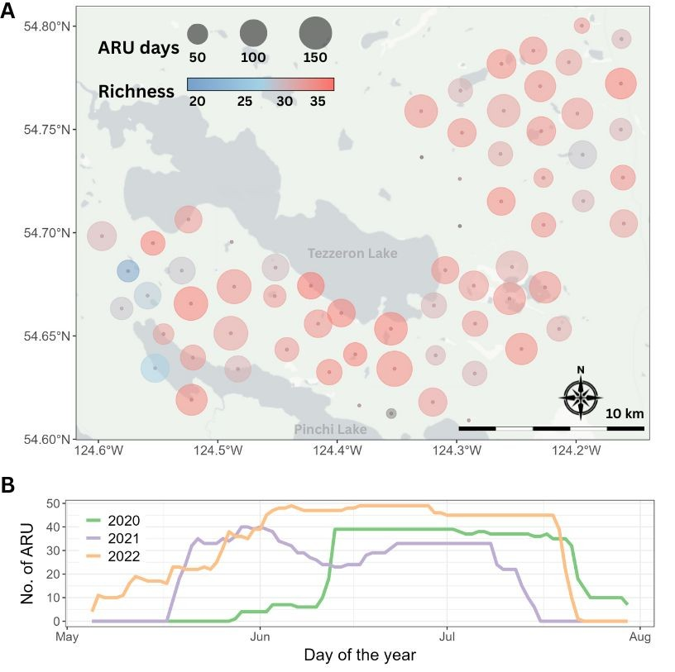
Fig. 1. Spatiotemporal distribution of survey effort for data collected in the John Prince Research Forest, British Columbia, Canada. (A) Spatial distribution of the 66 monitoring sites; solid central dots indicate the locations of autonomous recording units (ARUs), and circle size represents the number of days sampled during the survey period. (B) Annual number of active ARUs across the survey period, showing a gradual increase during deployment and a decline as units were retrieved.
We analyzed collected acoustic data with the BirdNET Analyzer v2.4 model (BirdNET Team 2025), using the parameters listed in Table 1. The entire dataset, comprising 1.5 terabytes of audio, required approximately 72 consecutive hours of processing. An overall bird community list was generated in four steps: (1) BirdNET detections were initially filtered using a confidence threshold of 0.8. For each detected category, five recording segments with the highest confidence scores were manually reviewed. Sound categories with at least one confirmed vocalization were retained, resulting in 136 sound categories. (2) Non-bird categories, such as Car Engine, Red Squirrel, Wood Frog, and Slender Meadow Katydid, were removed, reducing the list to 129 sound categories. (3) Species not listed in the British Columbia Breeding Bird Atlas (Davidson et al. 2015), which documents species recorded in the Prince George area since 2008, were excluded, leaving 123 species. (4) Species detected at fewer than two sites or on fewer than two days in June (i.e., main breeding season) were excluded, resulting in a final list of 122 species (Supplementary Table A). The overall species list included a diverse range of bird taxa such as raptors, waterfowl, warblers, sparrows, flycatchers, woodpeckers, owls, and other families.
We further refined this overall species list to a target guild of passerine species that have confirmed breeding records in the study region, and which are known to be vocally active during the dawn chorus period. These criteria were used to avoid detection bias given that recordings were scheduled during the dawn chorus of the breeding season. We then assessed individual species-specific BirdNET confidence thresholds for the 40 species, following the methods of Tseng et al. (2025), to ensure the precision of detections. To do this, we used stratified sampling to select 360 recording segments in which BirdNET had detected each of the target species, with 20 segments drawn from each 0.05 detection confidence interval bin (ranging from 0.1 to 1.0). Each segment was then manually reviewed, by both listening to audio and viewing spectrograms in comparison with known exemplars of the species, to classify detections as true or false positives. For each species, a BirdNET confidence threshold was set that achieved a precision of 0.95, indicating that at least 95% of the retained detections were true positives (see Tseng et al. 2025 for the full workflow). These thresholds were set individually for each of the final list of 40 passerines target species included (Table 2).
Table 1. BirdNET algorithm arguments with default values and the values used in this study.
Argument | Default value | Used value
i | none | --
o | none | --
lat | -1 | same as default
lon | -1 | same as default
week | -1 | same as default
slist | none | same as default
sensitivity | 1.0 | same as default
min_conf | 0.1 | same as default
overlap | 0 | same as default
rtype | table | r
threads | 1 | 4
batchsize | 1 | 4
locale | en | same as default
sf_thresh | 0.03 | same as default
classifier | none | same as default
fmin | 0 | same as default
fmax | 15000 | same as default
output_file | none | --
skip_existing_results | FALSE | TRUE

Table 2. The 40 breeding passerine species detected during the dawn chorus and selected as target species in this study. Detections were obtained from three years of songbird breeding-season data collected from 66 sites at the John Prince Research Forest. For each species, the table reports the total number of BirdNET detections and the number of sites where the species was detected. Values were calculated after applying species-specific BirdNET confidence thresholds achieving 95% precision and excluding sites with fewer than 15 ARU recording days.
Common name | Scientific name | Threshold (95%) | No. detections | No. sites
Swainson's Thrush | Catharus ustulatus | 0.10 | 327234 | 59
Hammond's Flycatcher | Empidonax hammondii | 0.10 | 140580 | 59
Yellow-rumped Warbler | Setophaga coronata | 0.10 | 110942 | 59
Warbling Vireo | Vireo gilvus | 0.10 | 86199 | 59
Golden-crowned Kinglet | Regulus satrapa | 0.10 | 84229 | 59
Magnolia Warbler | Setophaga magnolia | 0.10 | 74066 | 59
Dark-eyed Junco | Junco hyemalis | 0.10 | 48329 | 59
Western Tanager | Piranga ludoviciana | 0.10 | 39421 | 59
American Robin | Turdus migratorius | 0.10 | 37644 | 59
MacGillivray's Warbler | Geothlypis tolmiei | 0.10 | 30276 | 59
Orange-crowned Warbler | Leiothlypis celata | 0.10 | 11907 | 59
Pine Siskin | Spinus pinus | 0.10 | 6399 | 59
Northern Waterthrush | Parkesia noveboracensis | 0.10 | 145743 | 58
American Redstart | Setophaga ruticilla | 0.10 | 74866 | 58
White-throated Sparrow | Zonotrichia albicollis | 0.10 | 42408 | 58
Pacific Wren | Troglodytes pacificus | 0.10 | 60245 | 57
Red-breasted Nuthatch | Sitta canadensis | 0.21 | 15373 | 57
Tennessee Warbler | Leiothlypis peregrina | 0.10 | 36095 | 56
Ruby-crowned Kinglet | Corthylio calendula | 0.10 | 13718 | 56
Least Flycatcher | Empidonax minimus | 0.16 | 36919 | 55
Chipping Sparrow | Spizella passerina | 0.10 | 5162 | 54
Cedar Waxwing | Bombycilla cedrorum | 0.36 | 1994 | 53
Olive-sided Flycatcher | Contopus cooperi | 0.31 | 9201 | 52
Common Raven | Corvus corax | 0.10 | 4668 | 52
Varied Thrush | Ixoreus naevius | 0.61 | 6693 | 51
Townsend's Warbler | Setophaga townsendi | 0.24 | 3039 | 51
Boreal Chickadee | Poecile hudsonicus | 0.20 | 2918 | 51
Western Wood-Pewee | Contopus sordidulus | 0.10 | 10992 | 50
Dusky Flycatcher | Empidonax oberholseri | 0.26 | 3495 | 49
Alder Flycatcher | Empidonax alnorum | 0.10 | 21031 | 48
Common Yellowthroat | Geothlypis trichas | 0.10 | 4153 | 46
Western Flycatcher | Empidonax difficilis | 0.41 | 1306 | 37
Hermit Thrush | Catharus guttatus | 0.79 | 3301 | 36
Wilson's Warbler | Cardellina pusilla | 0.46 | 603 | 35
Black-capped Chickadee | Poecile atricapillus | 0.26 | 606 | 32
American Crow | Corvus brachyrhynchos | 0.10 | 1477 | 30
Song Sparrow | Melospiza melodia | 0.10 | 3390 | 23
Red-winged Blackbird | Agelaius phoeniceus | 0.10 | 204 | 23
Yellow Warbler | Setophaga petechia | 0.40 | 394 | 21
Blackpoll Warbler | Setophaga striata | 0.85 | 51 | 10

Asymptotic richness detected by ARUs
We calculated the number of days on which each of the 40 target species was detected at each of the 59 sites (Fig. 2). To characterize similarities in site use among species, we applied k-means clustering to group species with comparable detection patterns across sites. Prior to clustering, we applied data normalization by dividing the number of species ARU days by the total number of ARU days per site, thereby accounting for variation in sampling effort. To determine the optimal number of clusters, we evaluated two approaches: the total within-cluster sum of squares (“elbow method”) using the factoextra::fviz_nbclust() function (Kassambara 2017), and the gap statistic using the cluster::clusGap() and factoextra::fviz_gap_stat() functions (Kassambara 2017). Final clustering was performed using the kmeans() function in R (Lemenkova 2019).
Direct comparisons of observed species richness across sites (i.e., the number of coloured cells in each column of Fig. 2) can be misleading, as survey effort (i.e., number of ARU days) varied among sites. To account for this variation, we used asymptotic richness estimates as a standardized measure of site-level diversity (Chao et al. 2014). We calculated asymptotic richness using the iNEXT (iNterpolation and EXTrapolation) R package (Hsieh et al. 2016), which implements diversity estimation based on Hill numbers. Specifically, we used the iNEXT::ChaoRichness() function with incidence data to estimate asymptotic richness and its associated standard errors.

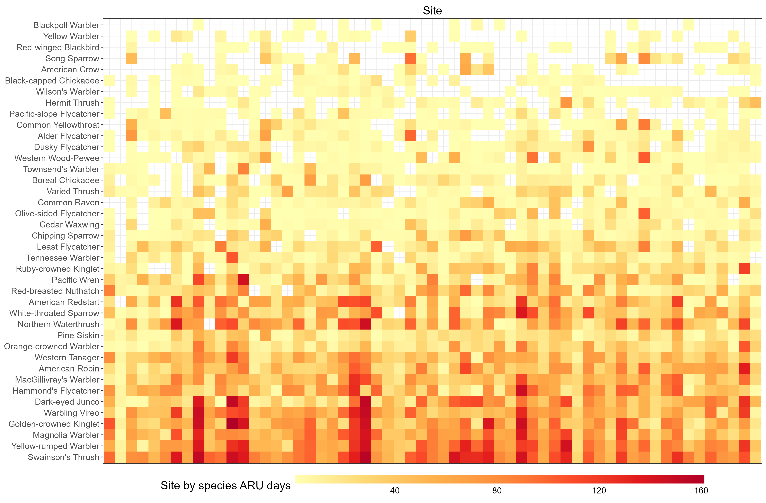
Fig. 2. Number of days each species was detected at each site using ARUs. Species in the lower part of the graph, such as American Robin, Dark-eyed Junco, and Golden-crowned Kinglet, were detected across most sites and likely represent generalists. In contrast, species toward the top of the graph, including Yellow Warbler and Red-winged Blackbird, were detected at fewer sites, potentially reflecting more specific habitat preferences.

LiDAR covariates and model selection
LiDAR data were collected in 2015 during the leaf-off season. As all sites in the study had not undergone significant disturbance since 2015, the LiDAR covariates reflect similar relative habitat composition/shifts to allow for comparison with the audio data collected in year 2020 to 2022. We applied an area-based approach to rasterize the point clouds at a spatial resolution of 10 meters. For modeling purposes, we aggregated habitat covariates within a 100-meter radius around each ARU site to represent the area a bird might be using when detected (Pérez-Granados 2025). A total of 17 LiDAR-derived variables were considered as candidate covariates (Table 3). These covariates were classified following the framework outlined in Bakx et al. (2018), which highlights canopy structure and total vegetation metrics as the most commonly associated with bird species richness (see Fig. 4 in Bakx et al. 2019).
To reduce multicollinearity and ensure model stability, we calculated pairwise correlations among the covariates and removed those with correlations greater than 0.8. Furthermore, we computed variance inflation factors (VIFs) to ensure all the covariates having a VIF less than 5. This pre-selection ensured that only relatively independent covariates were included in the subsequent model selection. We then used an information-theoretical approach for model selection. Specifically, we fitted models using all possible linear combinations of the LiDAR covariates, calculating Akaike weights to quantify the relative support for each model. For each covariate, we then computed the sum of model weights by summing the weights across all models in which the covariate appeared. Covariates with high sum of weights (> 0.8) consistently appeared in the best-supported models, representing a high variable importance. This analysis was conducted using the MuMIn::dredge() function (Bartoń 2025), with the full model specified as a linear regression.
Table 3. LiDAR-derived habitat covariates used in the analysis, including measures of canopy structure, vegetation density, and ground features. Covariates retained after the correlation and multicollinearity screening are shown in bold (see Results section for details).
Type | Name | Definition
Topography/  Ground | dem | Average elevation
Topography/  Ground | slope | Average slope
Topography/  Ground | aspect | Average aspect
Topography/  Ground | d_lid_rip_wet_str_le | Distance to LiDAR stream, wetland (polygon), lake edge
Topography/  Ground | d_vri_polyedge | Distance to VRI polygon stand edge
Canopy | cc1_3 | Average crown closure between 1 – 3 m
Canopy | cc3_10 | Average crown closure between 3 – 10 m
Canopy | cc10 | Average crown closure above 10m
Canopy | chm | Average canopy height
Canopy | vdi_95 | Vertical distribution if intercepted canopy elements ranging from 0 and 1 using 95% height
Total vegetation | less_10 | Proportion of polygon with forest age less than 10 years
Total vegetation | age_80 | Proportion of polygon with forest age greater than 80 years
Total vegetation | prop_decid | Proportion of deciduous tree counts for all trees having DBH > 10cm
Total vegetation | decid_dens | Number of deciduous trees per unit area
Total vegetation | conf_dens | Number of conifer trees per unit area
Total vegetation | tree_dens | Number of total trees per unit area
Total vegetation | ba_dens | Sum of basal area of all trees per unit area

Results

Asymptotic richness estimates
Estimated asymptotic species richness across sites ranged from 29.7 to 48.8 species. Regardless of the number of autonomous recording unit (ARU) sampling days per site, observed richness was, on average, within the 91% of the asymptotic richness (Fig. 3). Specifically, the mean difference between estimated asymptotic and observed species richness was 3.0 species for low-effort sites (i.e., 1 – 90 ARU days), 4.6 species for medium-effort sites (i.e., 90 – 120 ARU days), and 2.8 species for high-effort sites (i.e., > 120 ARU days). See Supplementary Table B for the estimated asymptotic richness and associated estimation uncertainty.
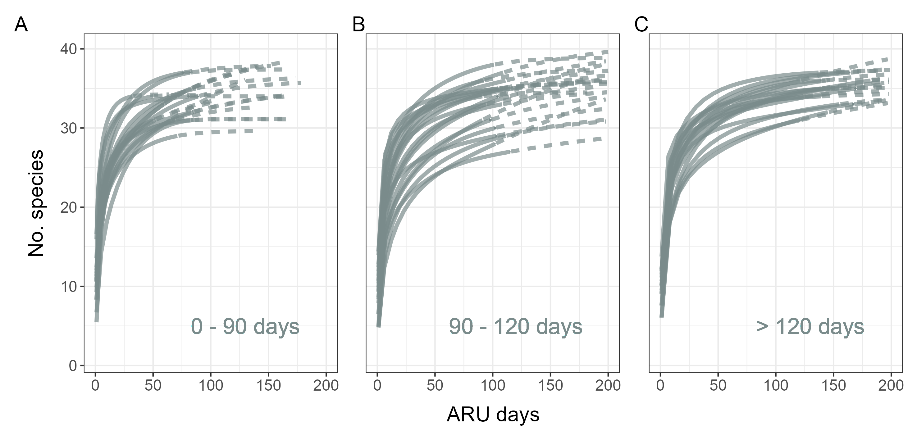
Fig. 3. Rarefaction curves for sites with different survey efforts (i.e., ARU days): (A) fewer than 90 days, (B) between 90 and 120 days, and (C) greater than 120 days. Each semi-transparent line represents the curve for an individual site. The solid parts of the curve are interpolation of collected data while the dashed parts are extrapolation. If the solid line is already approaching the asymptote, it indicates that current sampling effort is sufficient in surveying richness.

LiDAR covariate pre-selection
Pairwise correlations between the 17 LiDAR-derived covariates revealed several instances of high collinearity (|r| > 0.8; Fig. 4A). Specifically, several covariates representing canopy structure (Fig. 4A green highlight) and total vegetation (Fig. 4A yellow highlight) were strongly correlated. To reduce effects of multicollinearity among variables, we retained only the variables that were most interpretable and widely used in ecological studies, reducing the number of covariates from 17 to 10 (Fig. 4B). All retained variables had variance inflation factor (VIF) values below 5, indicating low levels of multicollinearity among variables (Fig. 4C; bolded variables in Table 3). Because aspect is a circular variable, we further decomposed it into its sine and cosine components, resulting in a total of 11 LiDAR covariates used in the subsequent model selection.
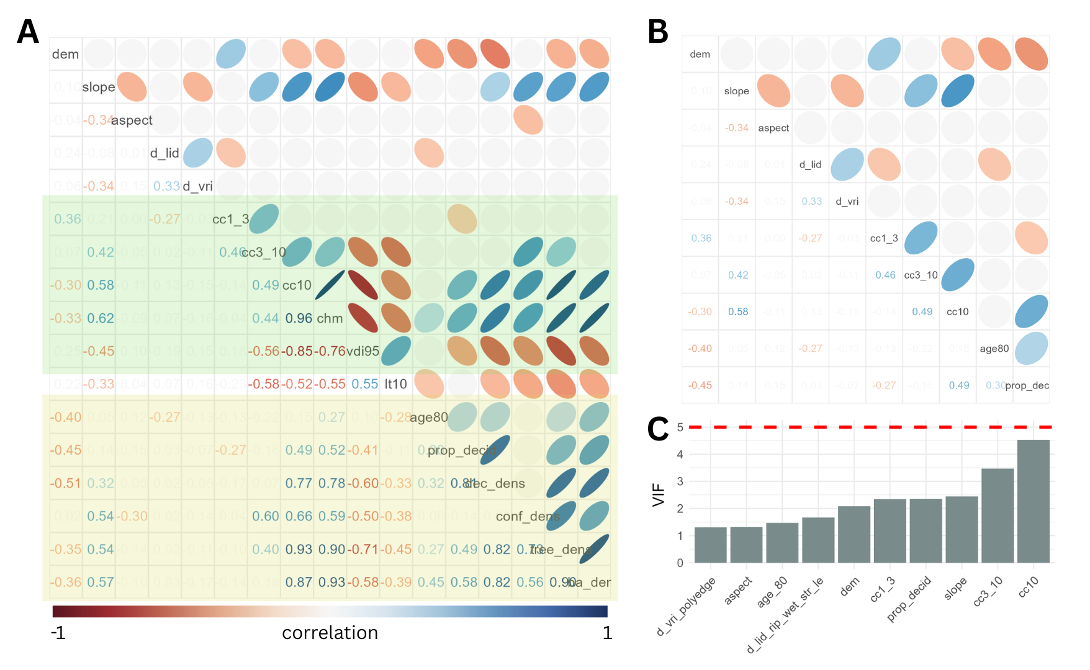
Fig. 4. Pre-selection of LiDAR covariates. (A) Correlation plot of the original set of 17 covariates. (B) Correlation plot of covariates retained after removing highly correlated variables (|r| > 0.8). (C) Final check showing that the variance inflation factors (VIF) for all variables were < 5.

Asymptotic richness model with LiDAR covariates
Among the 11 pre-selected LiDAR covariates, none had a sum of model weights exceeding 0.8 when predicting richness of all species combined (Fig. 5A). To account for the potential heterogeneity across all species, we grouped species based on their site-level occurrence patterns (Fig. 2) using k-means clustering (Fig. 6). This analysis identified three clusters comprising 13 (purple), 6 (orange), and 21 (green) species, respectively. Species within the same cluster exhibited similar distribution patterns across study sites, suggesting shared habitat associations or frequent co-occurrence.
All pre-selected LiDAR covariates had model weights lower than 0.8 for the purple (Fig. 5B) and green (Fig. 5D) groups. Even the covariates with the highest model weights, average crown closure above 10 m for the purple group and aspect for the green group, showed non-significant relationships with asymptotic richness (Figs. 7A, 7C). For the orange group, the proportion of deciduous trees (prop_decid) had a model weight greater than 0.8 (Fig. 5C) and showed a positive relationship with asymptotic richness (Fig. 7B). However, the association was weak (p = 0.04).

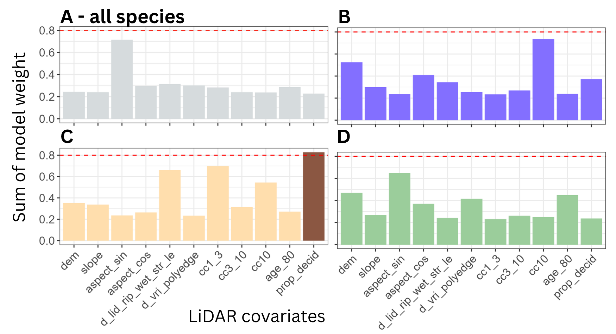
Fig. 5. Sum of model weights for each LiDAR covariate across different species groups: (A) full species list (40 species of breeding songbirds), (B) purple group (13 species), (C) orange group (6 species), and (D) green group (21 species). The red line indicates a sum of model weights of 0.8, a commonly used threshold for identifying influential covariates.
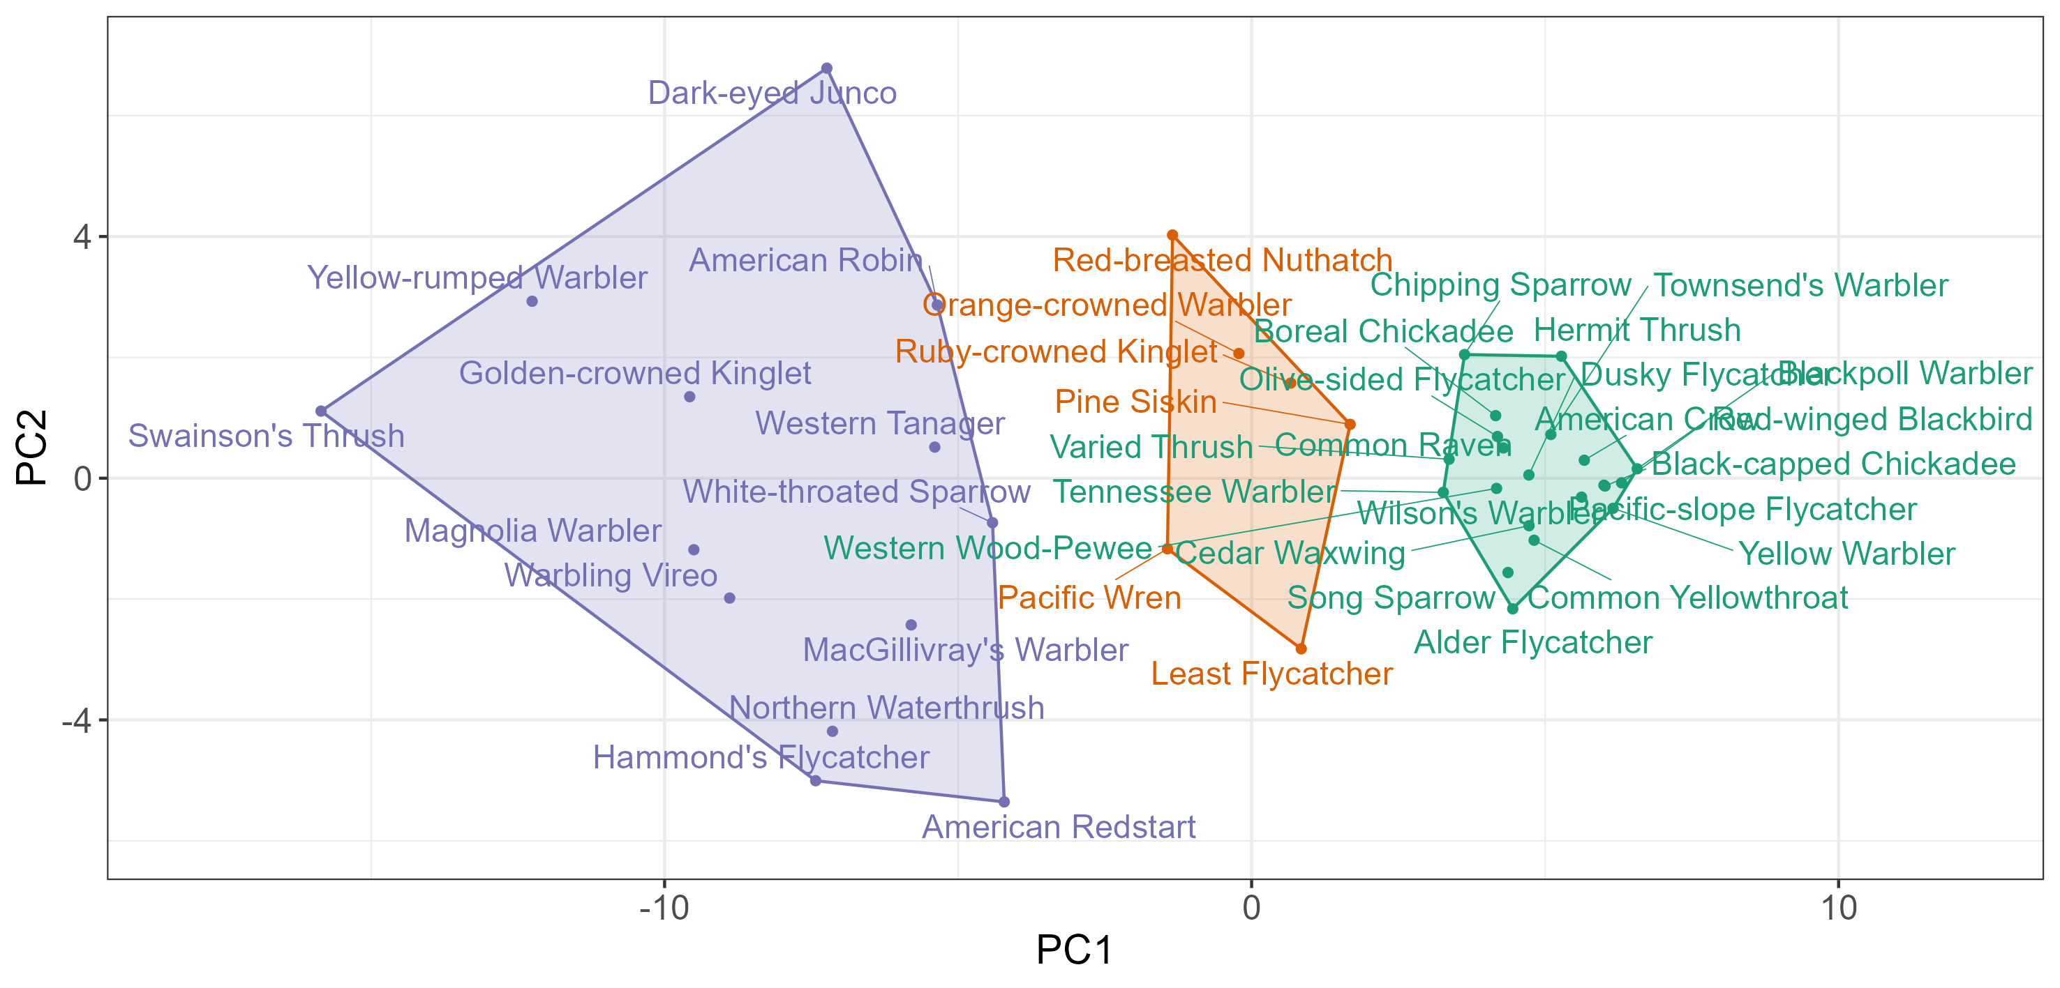
Fig. 6. K-means clustering of target species based on site-use patterns, visualized in principal component space. Species within the same cluster show similar distributions across study sites. The purple group includes 13 species, the orange group 6 species, and the green group 21 species.

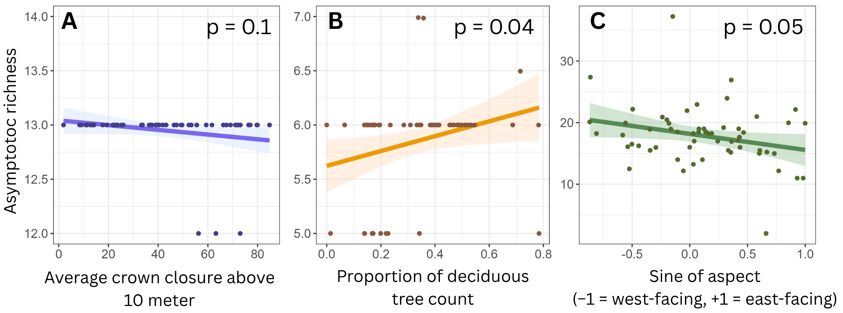
Fig. 7. Simple linear regression of the most influential LiDAR covariate for each species group in explaining asymptotic richness: (A) purple group – average crown closure above 10 m, (B) orange group – proportion of deciduous trees, and (C) green group – aspect. Note that even the most influential covariates showed weak or no association with richness within each group.

Discussion
Our results showed that none of the LiDAR covariates effectively predicted songbird asymptotic richness (Fig. 5). The lack of strong covariate importance likely reflects differences in habitat preferences among species, which reduced the overall signal when analyzed together. When species were grouped based on similarities in habitat use, only one covariate, the proportion of deciduous trees, showed a weak positive association with richness for a single species group (Fig. 7). Rarefaction analyses indicated that surveying effort across study sites was generally sufficient, as observed richness closely approached estimated asymptotic richness (Fig. 3). This suggests that the number of ARU days at each site provided an adequate sampling of the local breeding songbird richness, which included 40 species in total. Overall, our large-scale acoustic survey provided a general assessment of the breeding bird community within the John Prince Research Forest in central British Columbia (Supplementary Table A).
Contrary to expectations from previous studies that identified canopy covariates as key drivers of bird richness (Bakx et al. 2019), LiDAR variables related to vertical canopy structure, such as average crown closure at different heights, showed limited explanatory power for asymptotic richness across all species. This discrepancy may reflect the composition of our focal community: the 40 species of dawn-chorus songbirds occupy various habitat types, which may have blurred any clear habitat association in the overall model. When analyzed by species groups, none of the covariates strongly predicted richness, as species richness was relatively similar across sites. Specifically, the 13 species in the purple group (Fig. 6) occurred at nearly all sites (Fig. 7A), and the 6 species in the orange group (Fig. 6) were also widespread across sites (Fig. 7B), resulting in low variation in asymptotic richness across sites. Overall, the weak relationships between asymptotic richness and LiDAR covariates likely reflect both heterogeneous habitat preferences among target species and the generally uniform species richness across sites.
Expanding analyses to include the full community species list could provide broader ecological insight, but presents several practical challenges. First, validating BirdNET detections requires substantial manual effort to establish species-specific thresholds (Tseng et al. 2025; Wood and Kahl 2024). Based on our workflow (see Methods), validating 360 song segments per species took approximately 4–8 hours, depending on factors such as vocal repertoire overlap (e.g., Varied Thrush vs. White-throated Sparrow; Alder Flycatcher vs. Hammond’s Flycatcher), frequency characteristics (e.g., the high-pitched songs of Brown Creeper and Golden-crowned Kinglet), and call length (e.g., short warbler calls). Scaling this process to 122 species would require roughly 100 person-days of effort. Second, even when focusing only on breeding songbirds, our results showed that LiDAR covariates were generally non-significant due to heterogeneous habitat preferences among species. Expanding the analysis to the full species list would probably further obscure any trends, requiring more complex models to disentangle covariate associations.
One potential approach to reduce the validation effort and enable richness analyses across all species is the use of universal thresholds (Tseng et al. 2025), which apply a standardized BirdNET confidence threshold across species and aggregate results over longer temporal windows. Recent studies suggest that this strategy can yield community-level estimates comparable to expert validation while minimizing manual effort (Fairbairn et al. 2025). However, universal thresholds bypass species-specific error assessment, and their outputs should therefore be interpreted with caution. Without explicit quantification of precision or detection probability, such thresholds may be most appropriate for coarse-resolution analyses, where presence–absence data are aggregated over broad spatial or temporal scales (Fairbairn et al. 2025).
In conclusion, our findings showed none of the LiDAR covariate was strongly associated with the breeding songbird richness, resulting from the breeding songbirds in the study area exhibit varied habitat associations, and breeding songbird richness was generally similar across sites. Strategies such as universal thresholds could help facilitate broader community-level analyses, but they must be applied carefully due to the lack of species-specific error assessment. Future research could expand beyond richness to include other biodiversity metrics, such as evenness and abundance, though deriving these metrics from ARU data should be approached with caution. As acoustic monitoring becomes increasingly widespread for large-scale biodiversity assessments, the development of clear guidelines for using ARU-derived data is highly recommended. Such guidelines could include standardized procedures for generating species lists (as in our Methods), estimating richness across sites (e.g., using asymptotic richness), and deriving relative abundance for single or multiple species. Implementing these standardized practices will help ensure that acoustic monitoring can reliably inform biodiversity conservation and forest management decisions.

Literature cited
Bakx, Tristan R. M., Zsófia Koma, Arie C. Seijmonsbergen, and W. Daniel Kissling. 2019. “Use and Categorization of Light Detection and Ranging Vegetation Metrics in Avian Diversity and Species Distribution Research.” Diversity and Distributions 25 (7): 1045–59. https://doi.org/10.1111/ddi.12915.
Bartoń, Kamil. 2025. MuMIn: Multi-Model Inference. V. 1.48.11. Released April 1. https://cran.r-project.org/web/packages/MuMIn/index.html.
Billerman, S. M., B. K. Keeney, G. M. Kirwan, F. Medrano, N. D. Sly, and M. G. Smith. 2025. Birds of the World. Cornell Laboratory of Ornithology. https://doi.org/10.2173/bow.
BirdNET Team. (2021) 2025. BirdNET-Analyzer. Python. September 22, released. https://github.com/birdnet-team/BirdNET-Analyzer.
Bradbury, Richard B., Ross A. Hill, David C. Mason, et al. 2005. “Modelling Relationships between Birds and Vegetation Structure Using Airborne LiDAR Data: A Review with Case Studies from Agricultural and Woodland Environments.” Ibis 147 (3): 443–52. https://doi.org/10.1111/j.1474-919x.2005.00438.x.
Chao, Anne, Nicholas J. Gotelli, T. C. Hsieh, et al. 2014. “Rarefaction and Extrapolation with Hill Numbers: A Framework for Sampling and Estimation in Species Diversity Studies.” Ecological Monographs 84 (1): 45–67. https://doi.org/10.1890/13-0133.1.
Culbert, Patrick D., Volker C. Radeloff, Curtis H. Flather, Josef M. Kellndorfer, Chadwick D. Rittenhouse, and Anna M. Pidgeon. 2013. “The Influence of Vertical and Horizontal Habitat Structure on Nationwide Patterns of Avian Biodiversity.” The Auk 130 (4): 656–65. https://doi.org/10.1525/auk.2013.13007.
Davidson, P.J.A., R.J. Cannings, A.R. Couturier, D. Lepage, and C.M. Di Corrado. 2015. “The Atlas of the Breeding Birds of British Columbia, 2008-2012.” https://www.birdatlas.bc.ca/.
Fairbairn, Andrew J., Josija-Simeon Burmeister, Wolfgang W. Weisser, and Sebastian T. Meyer. 2025. “BirdNET Can Be as Good as Experts for Acoustic Bird Monitoring in a European City.” PLOS ONE 20 (9): e0330836. https://doi.org/10.1371/journal.pone.0330836.
Francis, Anthony P., and David J. Currie. 2003. “A Globally Consistent Richness‐Climate Relationship for Angiosperms.” The American Naturalist 161 (4): 523–36. https://doi.org/10.1086/368223.
Gottschalk, T. K., F. Huettmann, and M. Ehlers. 2005. “Review Article: Thirty Years of Analysing and Modelling Avian Habitat Relationships Using Satellite Imagery Data: A Review.” International Journal of Remote Sensing 26 (12): 2631–56. https://doi.org/10.1080/01431160512331338041.
Hawkins, Bradford A., Richard Field, Howard V. Cornell, et al. 2003. “Energy, Water, and Broad-Scale Geographic Patterns of Species Richness.” Ecology 84 (12): 3105–17. https://doi.org/10.1890/03-8006.
Hill, Andrew P., Peter Prince, Jake L. Snaddon, C. Patrick Doncaster, and Alex Rogers. 2019. “AudioMoth: A Low-Cost Acoustic Device for Monitoring Biodiversity and the Environment.” HardwareX 6 (October): e00073. https://doi.org/10.1016/j.ohx.2019.e00073.
Hsieh, T. C., K. H. Ma, and Anne Chao. 2016. “iNEXT: An R Package for Rarefaction and Extrapolation of Species Diversity (Hill Numbers).” Methods in Ecology and Evolution 7 (12): 1451–56. https://doi.org/10.1111/2041-210X.12613.
Kassambara, Alboukadel. 2017. Practical Guide to Principal Component Methods in R: PCA, M (CA), FAMD, MFA, HCPC, Factoextra. Vol. 2. Statistical tools for high-throughput data analysis.
Lemenkova, Polina. 2019. “K-Means Clustering in R Libraries {cluster} and {factoextra} for Grouping Oceanographic Data.” International Journal of Informatics and Applied Mathematics 2 (1): 1–26.
Maes, Dirk, Dirk Bauwens, Luc De Bruyn, et al. 2005. “Species Richness Coincidence: Conservation Strategies Based on Predictive Modelling.” Biodiversity & Conservation 14 (6): 1345–64. https://doi.org/10.1007/s10531-004-9662-x.
Mattmüller, Ramona M., Karolin Thomisch, Ilse Van Opzeeland, Kristin L. Laidre, and Malene Simon. 2022. “Passive Acoustic Monitoring Reveals Year-Round Marine Mammal Community Composition off Tasiilaq, Southeast Greenlanda).” The Journal of the Acoustical Society of America 151 (2): 1380–92. https://doi.org/10.1121/10.0009429.
Pérez-Granados, Cristian. 2025. “Birdnet Confidence Scores Decrease with Bird Distance from the Recorder: Revisiting Pérez-Granados (2023).” Ardeola 72 (2): 149–59. https://doi.org/10.13157/arla.72.2.2025.fo1.
Pérez-Granados, Cristian, Karl-L. Schuchmann, and Marinez I. Marques. 2021. “Vocal Activity of the Ferruginous Pygmy-Owl (Glaucidium Brasilianum) Is Strongly Correlated with Moon Phase and Nocturnal Temperature.” Ethology Ecology & Evolution 33 (1): 62–72. https://doi.org/10.1080/03949370.2020.1820582.
Pérez-Granados, Cristian, and Juan Traba. 2021. “Estimating Bird Density Using Passive Acoustic Monitoring: A Review of Methods and Suggestions for Further Research.” Ibis 163 (3): 765–83. https://doi.org/10.1111/ibi.12944.
Picciulin, Marta, Loïc Kéver, Eric Parmentier, and Marta Bolgan. 2019. “Listening to the Unseen: Passive Acoustic Monitoring Reveals the Presence of a Cryptic Fish Species.” Aquatic Conservation: Marine and Freshwater Ecosystems 29 (2): 202–10. https://doi.org/10.1002/aqc.2973.
Rahbek, Carsten, Nicholas J Gotelli, Robert K Colwell, Gary L Entsminger, Thiago Fernando L.V.B Rangel, and Gary R Graves. 2006. “Predicting Continental-Scale Patterns of Bird Species Richness with Spatially Explicit Models.” Proceedings of the Royal Society B: Biological Sciences 274 (1607): 165–74. https://doi.org/10.1098/rspb.2006.3700.
Ross, Samuel R. P.-J., Darren P. O’Connell, Jessica L. Deichmann, et al. 2023. “Passive Acoustic Monitoring Provides a Fresh Perspective on Fundamental Ecological Questions.” Functional Ecology 37 (4): 959–75. https://doi.org/10.1111/1365-2435.14275.
Schoot, Rens van de, Sarah Depaoli, Ruth King, et al. 2021. “Bayesian Statistics and Modelling.” Nature Reviews Methods Primers 1 (1): 1. https://doi.org/10.1038/s43586-020-00001-2.
Sugai, Larissa Sayuri Moreira, Thiago Sanna Freire Silva, José Wagner Ribeiro Jr, and Diego Llusia. 2019. “Terrestrial Passive Acoustic Monitoring: Review and Perspectives.” BioScience 69 (1): 15–25. https://doi.org/10.1093/biosci/biy147.
Tattoni, Clara, Franco Rizzolli, and Paolo Pedrini. 2012. “Can LiDAR Data Improve Bird Habitat Suitability Models?” Ecological Modelling, 7th European Conference on Ecological Modelling (ECEM), vol. 245 (October): 103–10. https://doi.org/10.1016/j.ecolmodel.2012.03.020.
Tseng, Sunny, Dexter P. Hodder, and Ken A. Otter. 2025. “Setting BirdNET Confidence Thresholds: Species-Specific vs. Universal Approaches.” Journal of Ornithology, ahead of print, February 25. https://doi.org/10.1007/s10336-025-02260-w.
Vierling, Kerri T, Lee A Vierling, William A Gould, Sebastian Martinuzzi, and Rick M Clawges. 2008. “Lidar: Shedding New Light on Habitat Characterization and Modeling.” Frontiers in Ecology and the Environment 6 (2): 90–98. https://doi.org/10.1890/070001.
Wood, Connor M., and Stefan Kahl. 2024. “Guidelines for Appropriate Use of BirdNET Scores and Other Detector Outputs.” Journal of Ornithology 165 (3): 777–82. https://doi.org/10.1007/s10336-024-02144-5.

Supplementary Materials
Table A. The full list of 122 bird species detected from 66 sites at the John Prince Research Forest during the three years monitoring of songbird breeding season. For each species, the table includes the total number of detections identified by BirdNET and the number of sites where the species was detected. The values were calculated before applying any filters such as species-specific threshold or site selection.

Family | Scientific name | Common name | No. detections | No. sites
Accipitridae  (Hawks, Eagles, and Kites) | Astur atricapillus | American Goshawk | 4713 | 54
Accipitridae  (Hawks, Eagles, and Kites) | Buteo jamaicensis | Red-tailed Hawk | 296 | 50
Accipitridae  (Hawks, Eagles, and Kites) | Buteo platypterus | Broad-winged Hawk | 3302 | 57
Accipitridae  (Hawks, Eagles, and Kites) | Haliaeetus leucocephalus | Bald Eagle | 398 | 30
Accipitridae  (Hawks, Eagles, and Kites) | Accipiter striatus | Sharp-shinned Hawk | 116 | 38
Pandionidae  (Osprey) | Pandion haliaetus | Osprey | 238 | 39
Anatida  (Ducks, Geese, and Waterfowl) | Anas platyrhynchos | Mallard | 478 | 40
Anatida  (Ducks, Geese, and Waterfowl) | Branta canadensis | Canada Goose | 788 | 39
Anatida  (Ducks, Geese, and Waterfowl) | Mergus merganser | Common Merganser | 866 | 32
Anatida  (Ducks, Geese, and Waterfowl) | Bucephala clangula | Common Goldeneye | 82 | 21
Anatida  (Ducks, Geese, and Waterfowl) | Anas crecca | Green-winged Teal | 124 | 25
Anatida  (Ducks, Geese, and Waterfowl) | Lophodytes cucullatus | Hooded Merganser | 75 | 13
Anatida  (Ducks, Geese, and Waterfowl) | Bucephala islandica | Barrow's Goldeneye | 19 | 7
Anatida  (Ducks, Geese, and Waterfowl) | Cygnus buccinator | Trumpeter Swan | 97 | 18
Anatida  (Ducks, Geese, and Waterfowl) | Spatula discors | Blue-winged Teal | 24 | 7
Anatida  (Ducks, Geese, and Waterfowl) | Mareca americana | American Wigeon | 23 | 4
Anatida  (Ducks, Geese, and Waterfowl) | Aythya collaris | Ring-necked Duck | 144 | 14
Trochilidae  (Hummingbirds) | Selasphorus rufus | Rufous Hummingbird | 177 | 24
Caprimulgidae (Nightjars and Allies) | Chordeiles minor | Common Nighthawk | 469 | 45
Laridae  (Gulls, Terns, and Skimmers) | Chroicocephalus philadelphia | Bonaparte's Gull | 31 | 6
Scolopacidae  (Sandpipers and Allies) | Actitis macularius | Spotted Sandpiper | 297 | 33
Scolopacidae  (Sandpipers and Allies) | Gallinago delicata | Wilson's Snipe | 11401 | 37
Scolopacidae  (Sandpipers and Allies) | Tringa solitaria | Solitary Sandpiper | 94 | 23
Scolopacidae  (Sandpipers and Allies) | Tringa melanoleuca | Greater Yellowlegs | 994 | 48
Alcedinidae  (Kingfishers) | Megaceryle alcyon | Belted Kingfisher | 462 | 51
Falconidae  (Falcons and Caracaras) | Falco sparverius | American Kestrel | 143 | 42
Falconidae  (Falcons and Caracaras) | Falco columbarius | Merlin | 528 | 32
Phasianidae  (Pheasants, Grouse, and Allies) | Canachites canadensis | Spruce Grouse | 15906 | 58
Phasianidae  (Pheasants, Grouse, and Allies) | Bonasa umbellus | Ruffed Grouse | 1000 | 49
Phasianidae  (Pheasants, Grouse, and Allies) | Lagopus lagopus | Willow Ptarmigan | 62 | 23
Gaviidae  (Loons) | Gavia immer | Common Loon | 5530 | 57
Gruidae  (Cranes) | Antigone canadensis | Sandhill Crane | 535 | 35
Rallidae  (Rails, Gallinules, and Coots) | Porzana carolina | Sora | 3448 | 17
Bombycillidae  (Waxwings) | Bombycilla cedrorum | Cedar Waxwing | 5771 | 59
Bombycillidae  (Waxwings) | Bombycilla garrulus | Bohemian Waxwing | 151 | 40
Cardinalidae  (Cardinals and Allies) | Piranga ludoviciana | Western Tanager | 39616 | 61
Cardinalidae  (Cardinals and Allies) | Pheucticus ludovicianus | Rose-breasted Grosbeak | 3278 | 59
Certhiidae  (Treecreepers) | Certhia americana | Brown Creeper | 15142 | 61
Cinclidae  (Dippers) | Cinclus mexicanus | American Dipper | 1364 | 27
Corvidae  (Crows, Jays, and Magpies) | Perisoreus canadensis | Canada Jay | 634 | 55
Corvidae  (Crows, Jays, and Magpies) | Corvus corax | Common Raven | 4672 | 54
Corvidae  (Crows, Jays, and Magpies) | Corvus brachyrhynchos | American Crow | 1477 | 30
Fringillidae  (Finches, Euphonias, and Allies) | Pinicola enucleator | Pine Grosbeak | 1139 | 61
Fringillidae  (Finches, Euphonias, and Allies) | Spinus pinus | Pine Siskin | 6400 | 60
Fringillidae  (Finches, Euphonias, and Allies) | Loxia leucoptera | White-winged Crossbill | 6125 | 60
Fringillidae  (Finches, Euphonias, and Allies) | Coccothraustes vespertinus | Evening Grosbeak | 552 | 58
Fringillidae  (Finches, Euphonias, and Allies) | Haemorhous purpureus | Purple Finch | 10420 | 62
Fringillidae  (Finches, Euphonias, and Allies) | Leucosticte tephrocotis | Gray-crowned Rosy-Finch | 1210 | 51
Fringillidae  (Finches, Euphonias, and Allies) | Haemorhous mexicanus | House Finch | 4431 | 59
Fringillidae  (Finches, Euphonias, and Allies) | Loxia curvirostra | Red Crossbill | 165 | 45
Hirundinidae  (Swallows) | Tachycineta thalassina | Violet-green Swallow | 485 | 39
Hirundinidae  (Swallows) | Tachycineta bicolor | Tree Swallow | 1094 | 27
Icteridae  (Troupials and Allies) | Agelaius phoeniceus | Red-winged Blackbird | 204 | 23
Icteridae  (Troupials and Allies) | Molothrus ater | Brown-headed Cowbird | 87 | 28
Icteridae  (Troupials and Allies) | Euphagus carolinus | Rusty Blackbird | 1395 | 36
Motacillidae  (Wagtails and Pipits) | Anthus rubescens | American Pipit | 4368 | 58
Paridae  (Tits, Chickadees, and Titmice) | Poecile hudsonicus | Boreal Chickadee | 4430 | 57
Paridae  (Tits, Chickadees, and Titmice) | Poecile gambeli | Mountain Chickadee | 12994 | 61
Paridae  (Tits, Chickadees, and Titmice) | Poecile atricapillus | Black-capped Chickadee | 1615 | 54
Parulidae  (New World Warblers) | Setophaga magnolia | Magnolia Warbler | 74084 | 62
Parulidae  (New World Warblers) | Setophaga coronata | Yellow-rumped Warbler | 111092 | 62
Parulidae  (New World Warblers) | Setophaga townsendi | Townsend's Warbler | 7361 | 61
Parulidae  (New World Warblers) | Setophaga striata | Blackpoll Warbler | 4619 | 61
Parulidae  (New World Warblers) | Geothlypis tolmiei | MacGillivray's Warbler | 30304 | 61
Parulidae  (New World Warblers) | Leiothlypis peregrina | Tennessee Warbler | 36766 | 58
Parulidae  (New World Warblers) | Setophaga ruticilla | American Redstart | 74872 | 59
Parulidae  (New World Warblers) | Seiurus aurocapilla | Ovenbird | 5286 | 59
Parulidae  (New World Warblers) | Cardellina pusilla | Wilson's Warbler | 4738 | 60
Parulidae  (New World Warblers) | Leiothlypis celata | Orange-crowned Warbler | 11951 | 60
Parulidae  (New World Warblers) | Parkesia noveboracensis | Northern Waterthrush | 146613 | 60
Parulidae  (New World Warblers) | Setophaga petechia | Yellow Warbler | 3407 | 42
Parulidae  (New World Warblers) | Geothlypis trichas | Common Yellowthroat | 4153 | 46
Passerellidae  (New World Sparrows) | Spizella passerina | Chipping Sparrow | 5162 | 54
Passerellidae  (New World Sparrows) | Zonotrichia albicollis | White-throated Sparrow | 42421 | 60
Passerellidae  (New World Sparrows) | Zonotrichia leucophrys | White-crowned Sparrow | 69534 | 62
Passerellidae  (New World Sparrows) | Junco hyemalis | Dark-eyed Junco | 48344 | 62
Passerellidae  (New World Sparrows) | Passerella iliaca | Fox Sparrow | 2861 | 60
Passerellidae  (New World Sparrows) | Melospiza lincolnii | Lincoln's Sparrow | 19790 | 59
Passerellidae  (New World Sparrows) | Melospiza melodia | Song Sparrow | 3390 | 23
Passerellidae  (New World Sparrows) | Spizella pallida | Clay-colored Sparrow | 228 | 39
Passerellidae  (New World Sparrows) | Melospiza georgiana | Swamp Sparrow | 1846 | 56
Passerellidae  (New World Sparrows) | Zonotrichia atricapilla | Golden-crowned Sparrow | 140 | 35
Passerellidae  (New World Sparrows) | Pooecetes gramineus | Vesper Sparrow | 456 | 32
Regulidae  (Kinglets) | Regulus satrapa | Golden-crowned Kinglet | 84683 | 61
Regulidae  (Kinglets) | Corthylio calendula | Ruby-crowned Kinglet | 13918 | 59
Sittidae  (Nuthatches) | Sitta canadensis | Red-breasted Nuthatch | 23207 | 61
Troglodytidae  (Wrens) | Troglodytes pacificus | Pacific Wren | 60989 | 59
Turdidae  (Thrushes and Allies) | Catharus ustulatus | Swainson's Thrush | 327431 | 62
Turdidae  (Thrushes and Allies) | Ixoreus naevius | Varied Thrush | 32529 | 61
Turdidae  (Thrushes and Allies) | Catharus guttatus | Hermit Thrush | 52026 | 61
Turdidae  (Thrushes and Allies) | Turdus migratorius | American Robin | 37737 | 62
Turdidae  (Thrushes and Allies) | Myadestes townsendi | Townsend's Solitaire | 787 | 55
Turdidae  (Thrushes and Allies) | Sialia currucoides | Mountain Bluebird | 1238 | 54
Tyrannidae  (Tyrant Flycatchers) | Empidonax difficilis | Western Flycatcher | 12474 | 62
Tyrannidae  (Tyrant Flycatchers) | Empidonax hammondii | Hammond's Flycatcher | 141949 | 62
Tyrannidae  (Tyrant Flycatchers) | Empidonax minimus | Least Flycatcher | 44654 | 58
Tyrannidae  (Tyrant Flycatchers) | Empidonax oberholseri | Dusky Flycatcher | 9356 | 58
Tyrannidae  (Tyrant Flycatchers) | Contopus cooperi | Olive-sided Flycatcher | 17061 | 61
Tyrannidae  (Tyrant Flycatchers) | Empidonax flaviventris | Yellow-bellied Flycatcher | 5815 | 61
Tyrannidae  (Tyrant Flycatchers) | Empidonax alnorum | Alder Flycatcher | 21412 | 49
Tyrannidae  (Tyrant Flycatchers) | Tyrannus tyrannus | Eastern Kingbird | 48 | 26
Tyrannidae  (Tyrant Flycatchers) | Contopus sordidulus | Western Wood-Pewee | 10992 | 50
Vireonidae  (Vireos, Shrike-Babblers, and Erpornis) | Vireo gilvus | Warbling Vireo | 87002 | 62
Vireonidae  (Vireos, Shrike-Babblers, and Erpornis) | Vireo cassinii | Cassin's Vireo | 6188 | 55
Vireonidae  (Vireos, Shrike-Babblers, and Erpornis) | Vireo olivaceus | Red-eyed Vireo | 600 | 35
Ardeidae  (Herons, Egrets, and Bitterns) | Botaurus lentiginosus | American Bittern | 359 | 34
Picidae  (Woodpeckers) | Sphyrapicus varius | Yellow-bellied Sapsucker | 5261 | 57
Picidae  (Woodpeckers) | Sphyrapicus nuchalis | Red-naped Sapsucker | 5182 | 57
Picidae  (Woodpeckers) | Picoides arcticus | Black-backed Woodpecker | 2928 | 60
Picidae  (Woodpeckers) | Picoides dorsalis | American Three-toed Woodpecker | 6417 | 62
Picidae  (Woodpeckers) | Dryobates villosus | Hairy Woodpecker | 1589 | 54
Picidae  (Woodpeckers) | Dryocopus pileatus | Pileated Woodpecker | 1910 | 56
Picidae  (Woodpeckers) | Dryobates pubescens | Downy Woodpecker | 331 | 49
Picidae  (Woodpeckers) | Colaptes auratus | Northern Flicker | 950 | 43
Podicipedidae  (Grebes) | Podiceps grisegena | Red-necked Grebe | 26 | 8
Strigidae  (Owls) | Strix varia | Barred Owl | 498 | 43
Strigidae  (Owls) | Bubo virginianus | Great Horned Owl | 4902 | 57
Strigidae  (Owls) | Asio otus | Long-eared Owl | 294 | 40
Strigidae  (Owls) | Strix nebulosa | Great Gray Owl | 419 | 36
Strigidae  (Owls) | Aegolius acadicus | Northern Saw-whet Owl | 2223 | 54
Strigidae  (Owls) | Glaucidium gnoma | Northern Pygmy-Owl | 876 | 48
Strigidae  (Owls) | Aegolius funereus | Boreal Owl | 5826 | 44

Table B. Estimated asymptotic species richness for each site. ARU days refers to the number of days an autonomous recording unit (ARU) operated at a given site over the three years of surveying period. Species ARU days represents the cumulative number of days a species was detected at that site. LCL and UCL denote the lower and upper 95% confidence limits of the estimated asymptotic richness. Sites are ordered by the number of ARU days and grouped into three categories: 0–90 days, 90–120 days, and >120 days.
Site | ARU days | Species ARU days | Observed richness | Asymptotic richness | No. of species added | LCL | UCL
N_15 | 32 | 510 | 34 | 34.24 | + 0.24 | 34.01 | 38.62
N_25 | 50 | 463 | 31 | 35.41 | + 4.41 | 31.48 | 71.14
N_11 | 50 | 831 | 34 | 34.16 | + 0.16 | 34.01 | 37.49
14_29 | 52 | 606 | 31 | 34.92 | + 3.92 | 31.55 | 59.22
14_05 | 59 | 628 | 33 | 38.90 | + 5.9 | 34.05 | 66.10
N_19 | 65 | 641 | 31 | 48.72 | + 17.72 | 33.49 | 157.04
14_02 | 66 | 115 | 19 | 19.49 | + 0.49 | 19.03 | 27.34
N_23 | 69 | 571 | 31 | 33.22 | + 2.22 | 31.26 | 49.80
14_17 | 70 | 753 | 34 | 39.91 | + 5.91 | 35.05 | 67.18
14_42 | 71 | 775 | 29 | 29.66 | + 0.66 | 29.06 | 36.72
14_23 | 76 | 863 | 37 | 37.99 | + 0.99 | 37.09 | 47.94
14_16 | 81 | 1100 | 34 | 34.00 | + 0 | 34.00 | 35.61
N_05 | 82 | 862 | 31 | 31.16 | + 0.16 | 31.01 | 34.50
14_03 | 82 | 990 | 37 | 37.40 | + 0.4 | 37.03 | 42.26
N_08 | 83 | 453 | 32 | 36.45 | + 4.45 | 32.49 | 72.45
N_10 | 83 | 1034 | 35 | 41.17 | + 6.17 | 35.96 | 74.68
14_35 | 85 | 570 | 31 | 31.10 | + 0.1 | 31.00 | 33.52
14_41 | 85 | 959 | 32 | 34.63 | + 2.63 | 32.37 | 50.67
N_22 | 87 | 926 | 35 | 36.48 | + 1.48 | 35.17 | 47.76
14_08 | 89 | 746 | 34 | 35.98 | + 1.98 | 34.27 | 48.23
14_30 | 91 | 453 | 31 | 43.12 | + 12.12 | 33.18 | 98.45
14_34 | 91 | 1134 | 34 | 34.49 | + 0.49 | 34.04 | 40.19
14_21 | 92 | 870 | 36 | 37.48 | + 1.48 | 36.17 | 48.77
N_16 | 94 | 1012 | 33 | 37.45 | + 4.45 | 33.49 | 73.51
14_15 | 98 | 641 | 31 | 35.12 | + 4.12 | 31.67 | 56.54
14_19 | 101 | 1145 | 38 | 38.89 | + 0.89 | 38.10 | 46.30
14_04 | 102 | 492 | 28 | 48.79 | + 20.79 | 33.02 | 114.06
14_18 | 102 | 807 | 30 | 33.96 | + 3.96 | 30.55 | 58.46
14_10 | 103 | 865 | 29 | 33.46 | + 4.46 | 29.49 | 69.54
14_11 | 104 | 1077 | 34 | 42.91 | + 8.91 | 35.51 | 86.79
14_31 | 105 | 1247 | 35 | 35.66 | + 0.66 | 35.06 | 42.75
N_14 | 105 | 1515 | 35 | 35.99 | + 0.99 | 35.07 | 49.30
N_21 | 108 | 1068 | 33 | 35.23 | + 2.23 | 33.26 | 51.88
14_20 | 109 | 1015 | 35 | 38.96 | + 3.96 | 35.55 | 63.48
14_24 | 109 | 1166 | 37 | 41.13 | + 4.13 | 37.67 | 62.56
N_18 | 111 | 533 | 29 | 31.64 | + 2.64 | 29.37 | 47.72
N_09 | 111 | 1421 | 36 | 41.95 | + 5.95 | 36.92 | 74.61
14_28 | 114 | 985 | 34 | 37.10 | + 3.1 | 34.50 | 53.15
14_06 | 115 | 748 | 27 | 31.46 | + 4.46 | 27.49 | 67.58
N_04 | 115 | 1654 | 35 | 36.98 | + 1.98 | 35.18 | 56.95
N_12 | 118 | 1645 | 35 | 39.46 | + 4.46 | 35.49 | 75.59
14_01 | 121 | 915 | 31 | 38.93 | + 7.93 | 31.98 | 95.30
N_06 | 121 | 1665 | 36 | 45.92 | + 9.92 | 37.85 | 89.05
14_33 | 124 | 1115 | 34 | 34.99 | + 0.99 | 34.09 | 44.99
N_24 | 137 | 1642 | 37 | 37.25 | + 0.25 | 37.01 | 41.71
N_13 | 139 | 834 | 35 | 36.49 | + 1.49 | 35.17 | 47.81
14_07 | 139 | 1404 | 36 | 36.12 | + 0.12 | 36.01 | 38.91
N_17 | 139 | 1597 | 34 | 34.50 | + 0.5 | 34.03 | 42.39
14_37 | 143 | 1300 | 36 | 37.49 | + 1.49 | 36.17 | 48.81
14_40 | 143 | 1455 | 35 | 35.08 | + 0.08 | 35.00 | 37.26
14_39 | 145 | 888 | 32 | 38.21 | + 6.21 | 32.97 | 71.87
14_38 | 147 | 1393 | 35 | 36.49 | + 1.49 | 35.17 | 47.81
N_07 | 155 | 1180 | 33 | 34.49 | + 1.49 | 33.17 | 45.82
14_25 | 155 | 1841 | 37 | 37.99 | + 0.99 | 37.07 | 51.35
N_01 | 155 | 1893 | 35 | 35.50 | + 0.5 | 35.03 | 43.40
14_09 | 164 | 1990 | 37 | 37.99 | + 0.99 | 37.09 | 48.01
14_14 | 167 | 1668 | 33 | 37.47 | + 4.47 | 33.49 | 73.68
14_13 | 169 | 1877 | 35 | 42.95 | + 7.95 | 35.98 | 99.45
14_26 | 182 | 1934 | 36 | 39.98 | + 3.98 | 36.55 | 64.58

