**Mapping breeding songbird diversity using remote sensing: passive acoustics and LiDAR-based habitat modelling**

**Sunny Tseng, Dexter Hodder, and Ken Otter**

# Abstract

# Introduction

Paragraph 1: Importance of biodiversity monitoring in large scale landscapes for evidence-based management.

Mapping biodiversity hotspots, defined as the area with high diversity in species (cite), is crucial for pinpointing bird-preferred habitats and guiding conservation priorities (Stattersfield et al., 1998; Garcia, 2006). This process involves overlaying species distribution maps to identify spatial locations with the highest richness (cite).

Paragraph 2: Current limitation and challenges

However, hotspot mapping requires species distribution maps for all species in the study area, and previous studies have often relied on coarse-resolution distribution maps, such as 5 km grids (Jenkins et al., 2010) or 1.2 km resolution from BirdLife (Merker & Chandler, 2020). While these coarse-resolution hotspots are valuable for large-scale conservation planning, they are less informative for localized management efforts, such as within national or regional parks, where finer resolution is essential.

Paragraph 3: ARU data can provide large spatialtemporal scale of survey

Paragraph 4: LiDAR could provide detailed horizontal structure data

Paragraph 5: Objectives are: 1) identify the avian diversity value with the asymptotic richness ARU data, and 2) identify key environmental covariates that support high asymptotic richness, and 3) recreate the avian diversity map using the LiDAR layer across the whole region of JPRF.

# Methods

## Study area and acoustic recording sites

The study was conducted in the John Prince Research Forest (~150 km2 in area), located in central British Columbia, Canada, within the dry sub-boreal spruce biogeoclimatic zone (Fig.1A). Audio data were collected from 2020 to 2022 during the breeding season (May to July) between 4am and 7am, using 66 Audio Moths (cite). Recordings were made for 1 minute every 5 minutes. Each ARU was placed at least two kilometers apart to minimize spatial correlation. Variability in the number of active ARUs at each site/date occurred due to setup logistics and field challenges such as battery depletion, firmware issues, or disturbances by wildlife (Fig.1B). We dropped data from sites which have less than 15 days of ARU days to avoid potential bias due to low surveying effort. This resulted in each site having an average of 106 ARU days, ranging from 32 to 182 days.

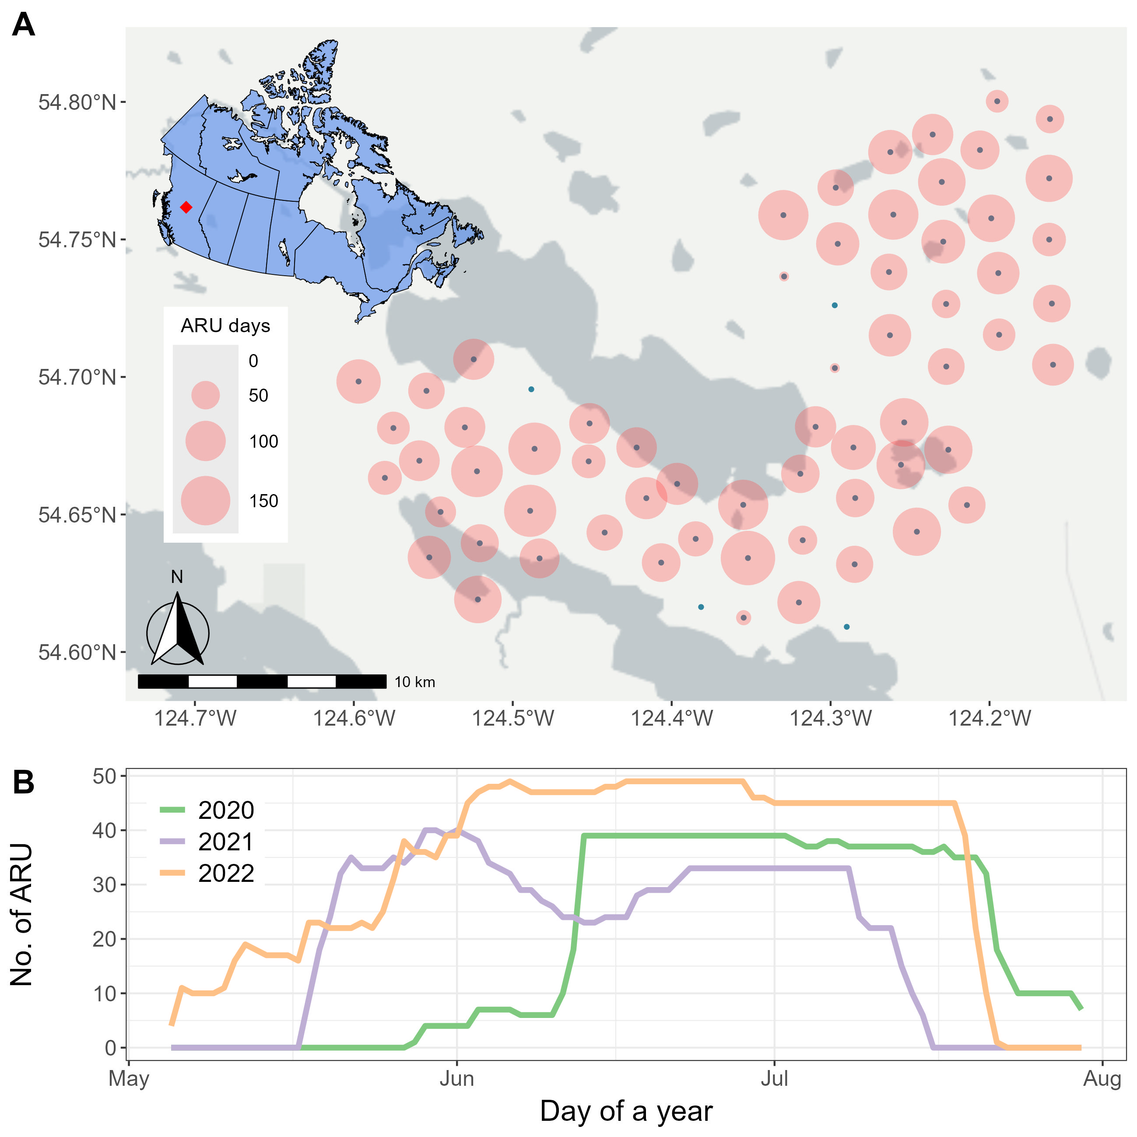

Fig. 1. Spatiotemporal distribution of surveying effort. Number of active ARUs during the surveying seasons across the study sites and across the surveying period.

## Acoustic data processing and target species

Collected acoustic data were analyzed using the BirdNET Analyzer v2.4 model (cite with GitHub repository), utilizing the parameters listed in Table 1. The entire dataset, comprising 1.5 terabytes of audio, required approximately 72 consecutive hours of processing. The overall species list was generated in four steps: (1) BirdNET detections were initially filtered using a confidence threshold of 0.8. For each detected category, five recording segments with the highest confidence scores were manually reviewed. Categories with at least one confirmed vocalization were retained, resulting in 136 categories. (2) Non-bird categories, such as Car Engine, Red Squirrel, Wood Frog, and Slender Meadow Katydid, were removed, reducing the list to 129 categories. (3) Species not listed in the British Columbia Breeding Bird Atlas (<https://www.birdatlas.bc.ca/>), which documents species recorded in the Prince George area since 2008, were excluded, leaving 123 species. (4) Species detected at fewer than two sites or on fewer than two days in June (main breeding season) were excluded, resulting in a final list of 122 species (Supplementary Table A). The overall species list included a diverse range of taxa such as raptors, waterfowl, warblers, sparrows, flycatchers, woodpeckers, owls, and other families.

Target species were selected from the overall species list if they are “breeding, dawn chorus, passerines”. We defined such criteria to avoid biased detection given our recording schedule were set during breeding season dawn chorus. For each species, we defined species-specific BirdNET thresholds to retain reliable BirdNET detections following the methods recommended by Tseng et al. (2025). Stratified sampling was used to select 360 recording segments per species, with 20 segments sampled from each 0.5 confidence interval class (ranging from 0.1 to 1.0). Each segment was manually reviewed via listening or spectrogram analysis to classify detections as true or false positives. A threshold achieving a precision of 0.95, indicating that 95% of remaining detections were true positives, was then identified for each species (see Tseng et al. 2025 for detailed workflow of species-specific thresholds). Some species (e.g., Bohemian Waxwing, Brown Creeper, Mountain Chickadee, and White-crowned Sparrow) were not able to achieve a precision of 95% even with highest possible threshold. Thus, they were dropped from the list. Our target species list ended up including 40 passerines (Table 2).

Table 1. BirdNET algorithms arguments, with default value and the values used in this study. The empty cell in the used value column indicates customized directory.

| Argument | Default value | Used value |
| --- | --- | --- |
| i | none | -- |
| o | none | -- |
| lat | -1 | same as default |
| lon | -1 | same as default |
| week | -1 | same as default |
| slist | none | same as default |
| sensitivity | 1.0 | same as default |
| min_conf | 0.1 | same as default |
| overlap | 0 | same as default |
| rtype | table | r |
| threads | 1 | 4 |
| batchsize | 1 | 4 |
| locale | en | same as default |
| sf_thresh | 0.03 | same as default |
| classifier | none | same as default |
| fmin | 0 | same as default |
| fmax | 15000 | same as default |
| output_file | none | -- |
| skip_existing_results | FALSE | TRUE |

Table 2. The 40 breeding, dawn chorus, passerines selected as our target species. For each species, the table includes the total number of detections by BirdNET and the number of sites where the species was detected. The values were calculated after applying the species-specific thresholds (that achieve 95% precision) and dropped sites that don’t have more than 15 ARU days.

| Common name | Scientific name | Threshold (95%) | No. detections | No. sites |
| --- | --- | --- | --- | --- |
| Swainson's Thrush | *Catharus ustulatus* | 0.10 | 327234 | 59 |
| Hammond's Flycatcher | *Empidonax hammondii* | 0.10 | 140580 | 59 |
| Yellow-rumped Warbler | *Setophaga coronata* | 0.10 | 110942 | 59 |
| Warbling Vireo | *Vireo gilvus* | 0.10 | 86199 | 59 |
| Golden-crowned Kinglet | *Regulus satrapa* | 0.10 | 84229 | 59 |
| Magnolia Warbler | *Setophaga magnolia* | 0.10 | 74066 | 59 |
| Dark-eyed Junco | *Junco hyemalis* | 0.10 | 48329 | 59 |
| Western Tanager | *Piranga ludoviciana* | 0.10 | 39421 | 59 |
| American Robin | *Turdus migratorius* | 0.10 | 37644 | 59 |
| MacGillivray's Warbler | *Geothlypis tolmiei* | 0.10 | 30276 | 59 |
| Orange-crowned Warbler | *Leiothlypis celata* | 0.10 | 11907 | 59 |
| Pine Siskin | *Spinus pinus* | 0.10 | 6399 | 59 |
| Northern Waterthrush | *Parkesia noveboracensis* | 0.10 | 145743 | 58 |
| American Redstart | *Setophaga ruticilla* | 0.10 | 74866 | 58 |
| White-throated Sparrow | *Zonotrichia albicollis* | 0.10 | 42408 | 58 |
| Pacific Wren | *Troglodytes pacificus* | 0.10 | 60245 | 57 |
| Red-breasted Nuthatch | *Sitta canadensis* | 0.21 | 15373 | 57 |
| Tennessee Warbler | *Leiothlypis peregrina* | 0.10 | 36095 | 56 |
| Ruby-crowned Kinglet | *Corthylio calendula* | 0.10 | 13718 | 56 |
| Least Flycatcher | *Empidonax minimus* | 0.16 | 36919 | 55 |
| Chipping Sparrow | *Spizella passerina* | 0.10 | 5162 | 54 |
| Cedar Waxwing | *Bombycilla cedrorum* | 0.36 | 1994 | 53 |
| Olive-sided Flycatcher | *Contopus cooperi* | 0.31 | 9201 | 52 |
| Common Raven | *Corvus corax* | 0.10 | 4668 | 52 |
| Varied Thrush | *Ixoreus naevius* | 0.61 | 6693 | 51 |
| Townsend's Warbler | *Setophaga townsendi* | 0.24 | 3039 | 51 |
| Boreal Chickadee | *Poecile hudsonicus* | 0.20 | 2918 | 51 |
| Western Wood-Pewee | *Contopus sordidulus* | 0.10 | 10992 | 50 |
| Dusky Flycatcher | *Empidonax oberholseri* | 0.26 | 3495 | 49 |
| Alder Flycatcher | *Empidonax alnorum* | 0.10 | 21031 | 48 |
| Common Yellowthroat | *Geothlypis trichas* | 0.10 | 4153 | 46 |
| Western Flycatcher | *Empidonax difficilis* | 0.41 | 1306 | 37 |
| Hermit Thrush | *Catharus guttatus* | 0.79 | 3301 | 36 |
| Wilson's Warbler | *Cardellina pusilla* | 0.46 | 603 | 35 |
| Black-capped Chickadee | *Poecile atricapillus* | 0.26 | 606 | 32 |
| American Crow | *Corvus brachyrhynchos* | 0.10 | 1477 | 30 |
| Song Sparrow | *Melospiza melodia* | 0.10 | 3390 | 23 |
| Red-winged Blackbird | *Agelaius phoeniceus* | 0.10 | 204 | 23 |
| Yellow Warbler | *Setophaga petechia* | 0.40 | 394 | 21 |
| Blackpoll Warbler | *Setophaga striata* | 0.85 | 51 | 10 |

## Response variable: asymptotic richness detected by ARU

Based on a dataset with 40 species and 59 sites, we calculated the number of ARU days that each of the species were detected and the total ARU days (Fig. 2). Simply comparing the observed richness of each site (i.e., sum of the coloured cells for each column in Fig. 2) would not be a fair comparison as each sites has different observer effort (i.e., ARU days). Thus, we chose asymptotic richness to represent the diversity of sites (Chao 2014), to standardize the different in surveying effort between sites.

To calculate the asymptotic richness, we used iNEXT (iNterpolation and EXTrapolation) R package (cite), which focuses on calculating the Hill numbers to reflect diversity. Specifically, we the iNEXT::*iNEXT()* function, with incidence data, to compute asymptotic richness estimates and the associated bootstrap standard error.

Fig. 2. Number of days that each species was detected in each site by ARU. Species in the lower part of the graph represents generalists, such as American Robin, Dark-eyed Junco, and Golden-crowned Kinglet, that were detected in most of the sites. While species on the top part, such as Yellow Warbler and Red-winged blackbird, only get detected in part of the sites, potentially showing preference of habitat.

## Predictor variables: habitat feature measured by Lidar

The Lidar data was collected with a point density of XYZ during 2015 leave off season. We used area-based approach to rasterize the point clouds, with a spatial resolution of 10m. During the modelling stage, we aggregated the covariates within a 100-meter radius circle, to reflect the habitat that a bird is using when getting detected in an ARU site. Conversely, we used the original 10m resolution covariates during the prediction stage to keep the high-resolution advantage of LiDAR. We then selected the canopy and multi-layer metrics as potential predictor variables (Table 3), given these LiDAR metrics were shown to be most relevant to bird distribution modelling (Bakx et al., 2019).

## Model selection and modal inference

We used an information-theoretic approach for model selection and inference, which is particularly useful for likelihood-based models. Instead of interpreting a single best-fit model, we fitted models using all possible linear combinations of the LiDAR covariates, evaluated the AIC, and performed model averaging to assess variable importance and derive averaged coefficients for prediction. Specifically, we fitted a full model using linear combination of all possible LiDAR covariates.

We then used MuMIn R package, specifically the MuMIn::dredge() function, to generate models with combinations of fixed effect from the global model.

to identify the best models. We then evaluated variable importance and obtained a model-averaged estimate for inference.

# Result

## Sites with XYZ are related to higher asymptotic richness

* Separate the curves according to the site class? Or canopy hight? Find someway to visualize the curves
* Show the Hill_table, maybe adding top 3 variables? Or only show the values would be enough

## XYZ is dominant among LiDAR habitat features

* A figure or table to show the variable selection result and model average

## Map of songbird diversity

# Discussion

* Assumption of independent of each site
* Expanded the analysis of multi species, but lost the information of other species given that BirdNET have species-specific performance
* Only use Richness to represent diversity?

# Conclusion

# Literature cited

# Supplementary

Table A. The full list of 122 species detected by ARUs at the study site. For each species, the table includes the total number of detections by BirdNET and the number of sites where the species was detected. The values were calculated before applying species-specific threshold, and before dropping any unused sites in the analysis. The species represent a diverse range of taxa, including raptors, waterfowl, warblers, sparrows, flycatchers, woodpeckers, owls, and other families.

| **Family** | **Scientific name** | **Common name** | **No. detections** | **No. sites** |
| --- | --- | --- | --- | --- |
| Accipitridae  (Hawks, Eagles, and Kites) | *Astur atricapillus* | American Goshawk | 4713 | 54 |
| *Buteo jamaicensis* | Red-tailed Hawk | 296 | 50 |
| *Buteo platypterus* | Broad-winged Hawk | 3302 | 57 |
| *Haliaeetus leucocephalus* | Bald Eagle | 398 | 30 |
| *Accipiter striatus* | Sharp-shinned Hawk | 116 | 38 |
| Pandionidae  (Osprey) | *Pandion haliaetus* | Osprey | 238 | 39 |
| Anatida  (Ducks, Geese, and Waterfowl) | *Anas platyrhynchos* | Mallard | 478 | 40 |
| *Branta canadensis* | Canada Goose | 788 | 39 |
| *Mergus merganser* | Common Merganser | 866 | 32 |
| *Bucephala clangula* | Common Goldeneye | 82 | 21 |
| *Anas crecca* | Green-winged Teal | 124 | 25 |
| *Lophodytes cucullatus* | Hooded Merganser | 75 | 13 |
| *Bucephala islandica* | Barrow's Goldeneye | 19 | 7 |
| *Cygnus buccinator* | Trumpeter Swan | 97 | 18 |
| *Spatula discors* | Blue-winged Teal | 24 | 7 |
| *Mareca americana* | American Wigeon | 23 | 4 |
| *Aythya collaris* | Ring-necked Duck | 144 | 14 |
| Trochilidae  (Hummingbirds) | *Selasphorus rufus* | Rufous Hummingbird | 177 | 24 |
| Caprimulgidae (Nightjars and Allies) | *Chordeiles minor* | Common Nighthawk | 469 | 45 |
| Laridae  (Gulls, Terns, and Skimmers) | *Chroicocephalus philadelphia* | Bonaparte's Gull | 31 | 6 |
| Scolopacidae  (Sandpipers and Allies) | *Actitis macularius* | Spotted Sandpiper | 297 | 33 |
| *Gallinago delicata* | Wilson's Snipe | 11401 | 37 |
| *Tringa solitaria* | Solitary Sandpiper | 94 | 23 |
| *Tringa melanoleuca* | Greater Yellowlegs | 994 | 48 |
| Alcedinidae  (Kingfishers) | *Megaceryle alcyon* | Belted Kingfisher | 462 | 51 |
| Falconidae  (Falcons and Caracaras) | *Falco sparverius* | American Kestrel | 143 | 42 |
| *Falco columbarius* | Merlin | 528 | 32 |
| Phasianidae  (Pheasants, Grouse, and Allies) | *Canachites canadensis* | Spruce Grouse | 15906 | 58 |
| *Bonasa umbellus* | Ruffed Grouse | 1000 | 49 |
| *Lagopus lagopus* | Willow Ptarmigan | 62 | 23 |
| Gaviidae  (Loons) | *Gavia immer* | Common Loon | 5530 | 57 |
| Gruidae  (Cranes) | *Antigone canadensis* | Sandhill Crane | 535 | 35 |
| Rallidae  (Rails, Gallinules, and Coots) | *Porzana carolina* | Sora | 3448 | 17 |
| Bombycillidae  (Waxwings) | *Bombycilla cedrorum* | Cedar Waxwing | 5771 | 59 |
| *Bombycilla garrulus* | Bohemian Waxwing | 151 | 40 |
| Cardinalidae  (Cardinals and Allies) | *Piranga ludoviciana* | Western Tanager | 39616 | 61 |
| *Pheucticus ludovicianus* | Rose-breasted Grosbeak | 3278 | 59 |
| Certhiidae  (Treecreepers) | *Certhia americana* | Brown Creeper | 15142 | 61 |
| Cinclidae  (Dippers) | *Cinclus mexicanus* | American Dipper | 1364 | 27 |
| Corvidae  (Crows, Jays, and Magpies) | *Perisoreus canadensis* | Canada Jay | 634 | 55 |
| *Corvus corax* | Common Raven | 4672 | 54 |
| *Corvus brachyrhynchos* | American Crow | 1477 | 30 |
| Fringillidae  (Finches, Euphonias, and Allies) | *Pinicola enucleator* | Pine Grosbeak | 1139 | 61 |
| *Spinus pinus* | Pine Siskin | 6400 | 60 |
| *Loxia leucoptera* | White-winged Crossbill | 6125 | 60 |
| *Coccothraustes vespertinus* | Evening Grosbeak | 552 | 58 |
| *Haemorhous purpureus* | Purple Finch | 10420 | 62 |
| *Leucosticte tephrocotis* | Gray-crowned Rosy-Finch | 1210 | 51 |
| *Haemorhous mexicanus* | House Finch | 4431 | 59 |
| *Loxia curvirostra* | Red Crossbill | 165 | 45 |
| Hirundinidae  (Swallows) | *Tachycineta thalassina* | Violet-green Swallow | 485 | 39 |
| *Tachycineta bicolor* | Tree Swallow | 1094 | 27 |
| Icteridae  (Troupials and Allies) | *Agelaius phoeniceus* | Red-winged Blackbird | 204 | 23 |
| *Molothrus ater* | Brown-headed Cowbird | 87 | 28 |
| *Euphagus carolinus* | Rusty Blackbird | 1395 | 36 |
| Motacillidae  (Wagtails and Pipits) | *Anthus rubescens* | American Pipit | 4368 | 58 |
| Paridae  (Tits, Chickadees, and Titmice) | *Poecile hudsonicus* | Boreal Chickadee | 4430 | 57 |
| *Poecile gambeli* | Mountain Chickadee | 12994 | 61 |
| *Poecile atricapillus* | Black-capped Chickadee | 1615 | 54 |
| Parulidae  (New World Warblers) | *Setophaga magnolia* | Magnolia Warbler | 74084 | 62 |
| *Setophaga coronata* | Yellow-rumped Warbler | 111092 | 62 |
| *Setophaga townsendi* | Townsend's Warbler | 7361 | 61 |
| *Setophaga striata* | Blackpoll Warbler | 4619 | 61 |
| *Geothlypis tolmiei* | MacGillivray's Warbler | 30304 | 61 |
| *Leiothlypis peregrina* | Tennessee Warbler | 36766 | 58 |
| *Setophaga ruticilla* | American Redstart | 74872 | 59 |
| *Seiurus aurocapilla* | Ovenbird | 5286 | 59 |
| *Cardellina pusilla* | Wilson's Warbler | 4738 | 60 |
| *Leiothlypis celata* | Orange-crowned Warbler | 11951 | 60 |
| *Parkesia noveboracensis* | Northern Waterthrush | 146613 | 60 |
| *Setophaga petechia* | Yellow Warbler | 3407 | 42 |
| *Geothlypis trichas* | Common Yellowthroat | 4153 | 46 |
| Passerellidae  (New World Sparrows) | *Spizella passerina* | Chipping Sparrow | 5162 | 54 |
| *Zonotrichia albicollis* | White-throated Sparrow | 42421 | 60 |
| *Zonotrichia leucophrys* | White-crowned Sparrow | 69534 | 62 |
| *Junco hyemalis* | Dark-eyed Junco | 48344 | 62 |
| *Passerella iliaca* | Fox Sparrow | 2861 | 60 |
| *Melospiza lincolnii* | Lincoln's Sparrow | 19790 | 59 |
| *Melospiza melodia* | Song Sparrow | 3390 | 23 |
| *Spizella pallida* | Clay-colored Sparrow | 228 | 39 |
| *Melospiza georgiana* | Swamp Sparrow | 1846 | 56 |
| *Zonotrichia atricapilla* | Golden-crowned Sparrow | 140 | 35 |
| *Pooecetes gramineus* | Vesper Sparrow | 456 | 32 |
| Regulidae  (Kinglets) | *Regulus satrapa* | Golden-crowned Kinglet | 84683 | 61 |
| *Corthylio calendula* | Ruby-crowned Kinglet | 13918 | 59 |
| Sittidae  (Nuthatches) | *Sitta canadensis* | Red-breasted Nuthatch | 23207 | 61 |
| Troglodytidae  (Wrens) | *Troglodytes pacificus* | Pacific Wren | 60989 | 59 |
| Turdidae  (Thrushes and Allies) | *Catharus ustulatus* | Swainson's Thrush | 327431 | 62 |
| *Ixoreus naevius* | Varied Thrush | 32529 | 61 |
| *Catharus guttatus* | Hermit Thrush | 52026 | 61 |
| *Turdus migratorius* | American Robin | 37737 | 62 |
| *Myadestes townsendi* | Townsend's Solitaire | 787 | 55 |
| *Sialia currucoides* | Mountain Bluebird | 1238 | 54 |
| Tyrannidae  (Tyrant Flycatchers) | *Empidonax difficilis* | Western Flycatcher | 12474 | 62 |
| *Empidonax hammondii* | Hammond's Flycatcher | 141949 | 62 |
| *Empidonax minimus* | Least Flycatcher | 44654 | 58 |
| *Empidonax oberholseri* | Dusky Flycatcher | 9356 | 58 |
| *Contopus cooperi* | Olive-sided Flycatcher | 17061 | 61 |
| *Empidonax flaviventris* | Yellow-bellied Flycatcher | 5815 | 61 |
| *Empidonax alnorum* | Alder Flycatcher | 21412 | 49 |
| *Tyrannus tyrannus* | Eastern Kingbird | 48 | 26 |
| *Contopus sordidulus* | Western Wood-Pewee | 10992 | 50 |
| Vireonidae  (Vireos, Shrike-Babblers, and Erpornis) | *Vireo gilvus* | Warbling Vireo | 87002 | 62 |
| *Vireo cassinii* | Cassin's Vireo | 6188 | 55 |
| *Vireo olivaceus* | Red-eyed Vireo | 600 | 35 |
| Ardeidae  (Herons, Egrets, and Bitterns) | *Botaurus lentiginosus* | American Bittern | 359 | 34 |
| Picidae  (Woodpeckers) | *Sphyrapicus varius* | Yellow-bellied Sapsucker | 5261 | 57 |
| *Sphyrapicus nuchalis* | Red-naped Sapsucker | 5182 | 57 |
| *Picoides arcticus* | Black-backed Woodpecker | 2928 | 60 |
| *Picoides dorsalis* | American Three-toed Woodpecker | 6417 | 62 |
| *Dryobates villosus* | Hairy Woodpecker | 1589 | 54 |
| *Dryocopus pileatus* | Pileated Woodpecker | 1910 | 56 |
| *Dryobates pubescens* | Downy Woodpecker | 331 | 49 |
| *Colaptes auratus* | Northern Flicker | 950 | 43 |
| Podicipedidae  (Grebes) | *Podiceps grisegena* | Red-necked Grebe | 26 | 8 |
| Strigidae  (Owls) | *Strix varia* | Barred Owl | 498 | 43 |
| *Bubo virginianus* | Great Horned Owl | 4902 | 57 |
| *Asio otus* | Long-eared Owl | 294 | 40 |
| *Strix nebulosa* | Great Gray Owl | 419 | 36 |
| *Aegolius acadicus* | Northern Saw-whet Owl | 2223 | 54 |
| *Glaucidium gnoma* | Northern Pygmy-Owl | 876 | 48 |
| *Aegolius funereus* | Boreal Owl | 5826 | 44 |