Quantifying seasonal and habitat-related bird vocal activity using passive acoustic monitoring with GAMs and occupancy models

Abstract
Vocalizations are a primary cue for detecting many bird species; however, species-specific spatiotemporal patterns in vocal activity can bias survey results, particularly when community monitoring programs rely on a single, standardized protocol across multiple species. Effective species-specific survey protocol requires an understanding of fine resolution spatiotemporal patterns in vocal activity. In this study, we used three years of data collected by passive acoustic monitoring (PAM), combined with BirdNET automated detections, to quantify seasonal and habitat-related vocal activity in Olive-sided Flycatcher (Contopus cooperi). Generalized additive models revealed a pronounced peak in detections in mid-June, followed by a smaller secondary peak in mid-July, with modest interannual variation in peak timing and magnitude. Occupancy modelling suggested that Olive-sided Flycatchers were less likely to occupy stands with dense upper-canopy (i.e., canopy cover >10 m), and that the probability of detecting Olive-sided Flycatchers when they occupied a site was reduced in areas with dense lower-canopy (i.e., canopy cover 1–3 m). These findings identify optimal periods (mid-June and mid-July) and habitats (open areas with sparse canopy cover) for conducting Olive-sided Flycatcher surveys. Overall, our study demonstrates that PAM can effectively capture species-specific spatiotemporal patterns in vocal activity, providing data-driven insights to refine survey design, improve detection, and support informed conservation decisions.

Introduction
Bird vocalizations play a central role in inter- and intra-sexual communication, facilitating territory defense, mate attraction, and social interactions. This prevalence of acoustic signalling enables the detection of many species during audio-based surveys (Dawson and Efford 2009). Because vocal activity varies across both seasons and habitat types, the probability of observing a species is closely tied to the underlying spatiotemporal patterns of their vocal activity. These patterns can differ substantially among species: some begin breeding and vocalizing early in the year, while others peak later in the season (Singer et al. 2025). Some species prefer open forests, whereas others prefer mature forest habitats (Billerman et al. 2025). Consequently, understanding when and where species vocalize is fundamental for effective species-specific survey protocols that allow accurate monitoring of populations over long-term and large spatial scales.
North America benefits from several long-term, large-scale bird monitoring initiatives that combine the efforts of professional biologists and community scientists. Structured programs such as the Breeding Bird Survey (https://www.birdscanada.org/bird-science/breeding-bird-survey) and Christmas Bird Count (https://www.birdscanada.org/bird-science/christmas-bird-count) follow standardized protocols that define survey windows, routes, and sampling effort, ensuring consistency and comparability across years. In parallel, flexible platforms like eBird (https://ebird.org) and FeederWatch (www.feederwatch.org) allow participants to record birds opportunistically across diverse locations and times, generating extensive datasets. Together, these initiatives have transformed our understanding of bird distributions and population trends, providing broad temporal and geographic coverage of observations.
Although these monitoring programs provide essential long-term and large-scale information, their survey windows and protocols are typically standardized across broad regions, aiming at detecting a wide breadth of species rather specific target species. Conventionally, these designs are informed by expert knowledge and logistical constraints, and do not always align with species-specific peaks in vocal activity (Singer et al. 2025). Mismatches between survey timing and species-specific vocal activity patterns can introduce bias into trend estimates (Massimino et al. 2021). Even when survey protocols cannot be modified, integrating independent, data-driven information on when and where species are most vocally active can greatly improve the interpretation of existing datasets by clarifying periods of high and low probability of observing a species and identifying potential sources of bias (Best 1981).
Recent advances in passive acoustic monitoring (PAM), combined with automated identification tools such as BirdNET (Kahl et al. 2021), make it possible to quantify vocal activity at fine resolutions across large scales. Continuous or semi-continuous acoustic recordings provide objective measures of the seasonal timing of when species vocalize, as well as the habitat-related variation in vocal activity, which were logistically infeasible to document through traditional field surveys (Shonfield and Bayne 2017). These data-driven activity profiles can refine survey timing, inform modelling approaches, and reveal behavioural patterns not possible through conventional methods.
In this study, we use three years of PAM data from the John Prince Research Forest in central British Columbia, Canada, processed with BirdNET, to quantify the spatiotemporal vocal activity patterns of Olive-sided Flycatcher (Contopus cooperi), a late-breeding species categorized as Special Concern in Canada. Our objectives were: (1) to characterize Olive-sided Flycatcher seasonal vocal activity and identify species-specific peak periods, and (2) to determine the habitat features associated with Olive-sided Flycatcher vocal activity, revealing spatial patterns of occupancy. By outlining a workflow that integrates PAM detections with modelling, this study provides an approach that can be applied to other species to define data-driven spatiotemporal activity patterns. Such information has the potential to refine survey design, improve interpretation of conventional monitoring datasets, and help identify sources of analysis bias.

Methods

Olive-sided Flycatcher
The Olive-sided Flycatcher (Contopus cooperi) is a long-distance migratory songbird currently listed as Least Concern by the IUCN (BirdLife International 2025). However, it is designated as Special Concern by the Committee on the Status of Endangered Wildlife in Canada (Environment and Climate Change Canada 2019) given the significant population declines across its range in recent decades (Billerman et al. 2025). Olive-sided Flycatchers breed in coniferous and mixed forests across western and boreal North America, typically near forest edges with tall trees or snags for perching, adjacent to open areas containing standing trees and snags. Optimal breeding habitat is generally considered to be late-successional forest with relatively open canopy structure (0–39% canopy cover; Verner 1980).
Male Olive-sided Flycatchers produce loud, far-carrying vocalizations, most notably the characteristic “quick-three-beers” song (Audio 1). Vocal activity varies across the breeding cycle, as documented in a study from Alaska (Wright 1997): males sing frequently upon arrival on the breeding grounds and prior to pairing, reduce singing during nest-building, and increase vocal activity again during incubation. Singing is uncommon during the nestling stage, when males are primarily engaged in parental care. As a result, the probability of observing Olive-sided Flycatcher based on song was highest prior to pairing (94%), declined following pair formation (34%), increased during incubation (53%), and was lowest after hatching (12%; Wright 1997). Only one single brood raised per season.

Study area
The study was conducted in the John Prince Research Forest, covering approximately 16,000 ha, located in central British Columbia, Canada (54°27'N, 124°10'W; 700 m a.s.l.) within the dry sub-boreal spruce biogeoclimatic zone. Acoustic data were collected using 66 autonomous recording units (ARUs; AudioMoth; Hill et al. 2018), each deployed at least 2 km apart to minimize spatial autocorrelation. Acoustic data were collected from 2020 to 2022, during May to July, between 4am and 7am. Recordings were scheduled for 1-minute recording followed by 4 minutes of inactivity, resulting in 12 recordings per hour and 36 recordings per day. In total, 67,301 one-minute recordings were obtained across the three years at the 66 sites. All recordings were standardized to a 48 kHz sampling rate and stored as mono Pulse Code Modulation (PCM) WAV files.

Audio processing
Collected acoustic data were analyzed using the BirdNET Analyzer v2.4 model (https://github.com/BirdNET-Team/BirdNET-Analyzer), implemented via the Python module running in a local terminal. To retain more true positive detections in the initial analysis stage, we set the parameter min_conf, which filters out results below a specified confidence threshold, to 0.1. Processing the entire dataset, which comprised 1.5 terabytes of audio, required approximately 72 consecutive hours.
A BirdNET species-specific threshold of 0.35 was applied for Olive-sided Flycatcher detections, which was previously determined for our study area to ensure a precision of 95% (Tseng et al. 2025). Tseng et al. (2025) provides a detailed framework on how these species-specific thresholds were defined. At sites with at least one Olive-sided Flycatcher detection, the number of active ARU days ranged from 1 to 54 per year, with a mean of 6.84 ± 10.89 days per ARU per year (Fig. 1).

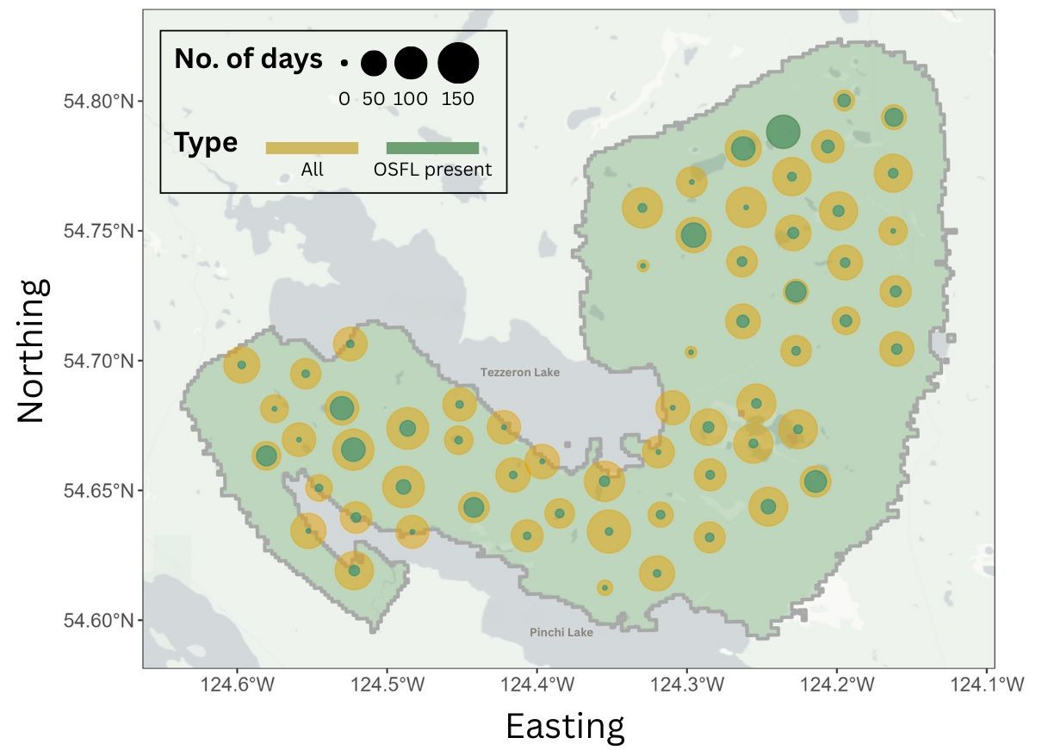
Fig. 1. Site map illustrating survey effort across years, where dot size represents total ARU deployment days (yellow) and days with Olive-sided Flycatcher detections (green). Northeastern sites showed particularly high detection frequency, with Olive-sided Flycatcher detected on most of the recording days.

Modelling temporal pattern – GAM analysis
To characterize seasonal vocal activity of Olive-sided Flycatcher, we first refined the dataset by retaining only site–year combinations with at least two consecutive days of Olive-sided Flycatcher detections. This filter excluded sites with very few or sporadic detections, as single-day detections may represent opportunistic vocalizations or transient individuals rather than meaningful patterns of local activity. Using this criterion, we identified 9, 10, and 13 sites in 2020, 2021, and 2022, respectively, which had consistent flycatcher detections. The majority of these sites had detections concentrated in June and July (Fig. 2).
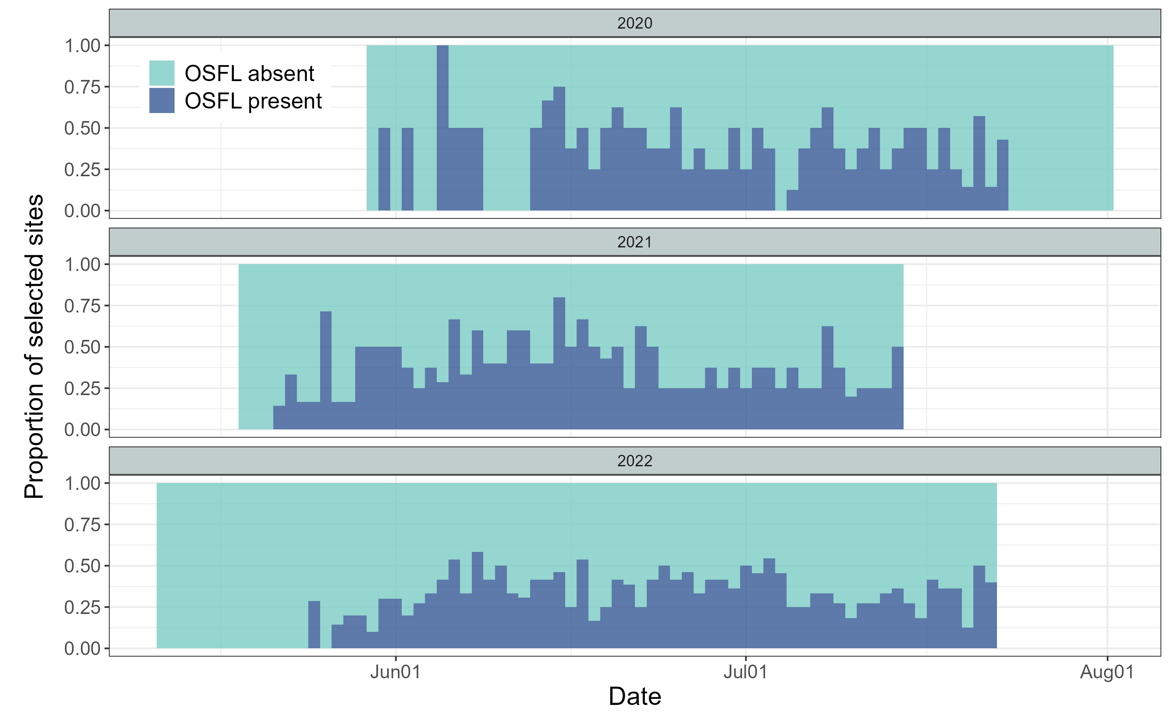
Fig. 2. Seasonal activity of qualified ARUs, defined as ARUs with at least two consecutive days of Olive-sided Flycatcher detections within a site-year. This included 9, 10, and 13 qualified ARUs in 2020, 2021, and 2022, respectively. Qualified ARUs with at least one Olive-sided Flycatcher detection that day are shown in dark blue, and those without detections are shown in light blue.

We used Generalized Additive Models (GAMs) due to their flexibility in capturing nonlinear and cyclic temporal patterns. For all candidate models, the response variable was the daily number of Olive-sided Flycatcher detections (i.e., the total detections across all 36 one-minute recordings per day). Julian day was included as a cyclic smooth term to represent seasonal activity patterns, and site and year were included to account for spatial and interannual variation. We constructed a suite of models of increasing complexity (Table 1; see also Fig. S1 for model ecological meaning and formula).
Table 1 Candidate generalized additive models (GAMs) of daily Olive-sided Flycatcher detections, showing model names and their corresponding model definitions.
Model | Definition
model 0 (m0) | Null model. A constant detection rate with a random site intercept.
model 1 (m1) | A single seasonal curve with a random site intercept.
model 2 (m2) | A single seasonal curve with random site and year intercepts (no interaction).
model 3 (m3) | Year-specific seasonal curves with a random site intercept.
model 4 (m4) | A single seasonal curve with a random site × year intercept.
model 5 (m5) | A single seasonal curve with smooth year-specific deviations and a random site intercept.
model 6 (m6) | Year-specific seasonal curves with a random site × year intercept.

All models were fitted using the gam() function in the mgcv R package (Wood 2001). Maximum likelihood was used to enable valid comparison of Akaike Information Criterion (AIC) values among models with differing fixed-effects structures (Zuur et al. 2009). Models with the lowest AIC values, including those with ΔAIC ≤ 3, were considered supported by the data. These top models were then refitted using restricted maximum likelihood to obtain stable smoothing-parameter estimates and to generate the final inference and visualizations (Zuur et al. 2009).

Modelling spatial pattern – occupancy analysis
We used occupancy modelling to examine the spatial distribution of Olive-sided Flycatchers. To satisfy the closure assumption, that occupancy status remains constant across repeated surveys, we restricted the analysis to 1–30 June, when Olive-sided Flycatchers were considered settled on individual breeding territories at this time of year (Billerman et al. 2025; and Results - Fig. 4). To minimize false positives, we applied the species-specific BirdNET confidence thresholds (see Methods - Audio processing), ensuring 95% precision in identifying Olive-sided Flycatcher vocalizations. To meet the assumption of independence across sampling occasions, we aggregated ARU detections into 5-day intervals to construct the detection history (presence/absence) for Olive-sided Flycatchers (Fig. 3). This window length follows recommendations for continuous-monitoring sensors, including autonomous recording units and camera traps (Chambert et al. 2018; Goldstein et al. 2024).
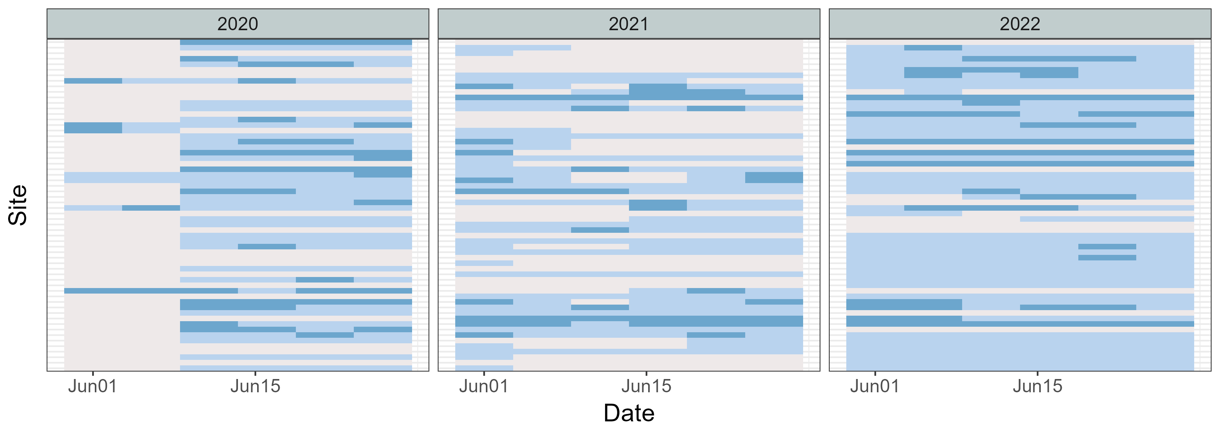
Fig. 3. Detection history for Olive-sided Flycatcher across sites in June of 2020, 2021, and 2022, using a 5-day detection window. Grey cells indicate periods when ARUs were not functioning, light blue cells indicate Olive-sided Flycatcher absence (0), and dark blue cells indicate Olive-sided Flycatcher presence (1). This detection history was used as the input for the occupancy model.
Occupancy models were fitted using the PGOcc() function in the spOccupancy R package (Doser et al. 2022). The models estimate two processes: (1) occupancy probability (ψ) - the probability that a site is truly occupied, and (2) detection probability (p) - the probability of detecting the species given it is present.
For the occupancy component, we included seven LiDAR-derived habitat covariates summarized within a 100-m radius around each site, representing the approximate area a bird may occupy when detected (Pérez-Granados 2025). Covariates were selected based on the documented habitat preferences of Olive-sided Flycatchers, which primarily breed along forest edges and openings and rely on tall, prominent trees or snags as singing and foraging perches, as well as unobstructed airspace for aerial foraging (Billerman et al. 2025). These occupancy covariates were: (1) distance to stream, wetland, or lake edge; (2) distance to polygon stand edge; (3) canopy cover at 1–3 m; (4) canopy cover at 3–10 m; (5) canopy cover >10 m; (6) the proportion of the surrounding polygon with forest age >80 years; and (7) the proportion of deciduous trees with DBH >10 cm.
For the detection component, we included two covariates expected to influence acoustic detectability: (1) Julian day and (2) LiDAR-derived canopy cover at 1–3 m. These covariates were selected because sound transmission and signal attenuation are likely affected by lower-canopy density at the height of the recording units, and because detection probability may vary over the breeding season.
To examine landscape patterns in occupancy and detection probability, we generated spatial predictions using the covariates identified as significant in the occupancy model. Raster layers for these covariates were aggregated to a 15-m analysis resolution and used as inputs to the fitted occupancy model to obtain posterior predictive samples for every grid cell across the study area.

Results

Temporal pattern
We compared candidate GAMs that differed in their treatment of seasonal smoothing, year effects, and site-level random effects (Table 2). Models m4 and m6 had the lowest AICc values and received substantially higher support (wAIC = 0.79 and 0.21, respectively) than all alternative models, indicating that both captured the data structure reasonably well.
In the model with a single seasonal smooth (m4), there was strong evidence of seasonal variation in detections (χ² = 249.6, p < 0.05). Population-level predictions showed a pronounced seasonal pattern, with detections peaking in mid-June, and exhibiting a smaller secondary peak in mid-July (Fig. 4-A1). Site-year random effects contributed substantially to model fit (χ² = 525.9, p < 0.05), with site-years differing widely in baseline detection rates. Some locations showed predicted counts several-fold higher or lower than the population-level mean (Fig. 4-A2). Overall, m4 explained approximately 40% of the deviance (Fig. 4-A3).
The model with year-specific seasonal smooths (m6) produced a similar seasonal pattern but allowed peak timing and magnitude to vary among years. Seasonal effects remained significant across all three years (2020: χ² = 124.5, p < 0.05; 2021: χ² = 83.5, p < 0.05; 2022: χ² = 144.0, p < 0.05). All years exhibited a primary peak in mid-June followed by a secondary peak in mid-July, although the smoothness and height of these peaks differed among years (Fig. 4-B1). Site-year random effects again explained considerable variation (χ² = 519.9, p < 0.001), reflecting persistent differences in baseline detection rates among site-years (Fig. 4-B2). Model m6 explained slightly more deviance (41.4%) than m4 (Fig. 4-B3).
Table 2 AICc-based comparison of candidate GAM models. Models are listed in order of increasing AICc. The two highest-ranked models (bolded) exhibited the strongest empirical support. Full model specifications are provided in the Methods section and illustrated in Fig. S1
Model | DF | AICc | Delta AICc | AICc weight
m4 | 40 | 5017 | 0 | 79%
m6 | 52 | 5020 | 3 | 21%
m5 | 36 | 5082 | 65 | 0%
m3 | 42 | 5085 | 68 | 0%
m2 | 31 | 5089 | 72 | 0%
m1 | 29 | 5103 | 86 | 0%
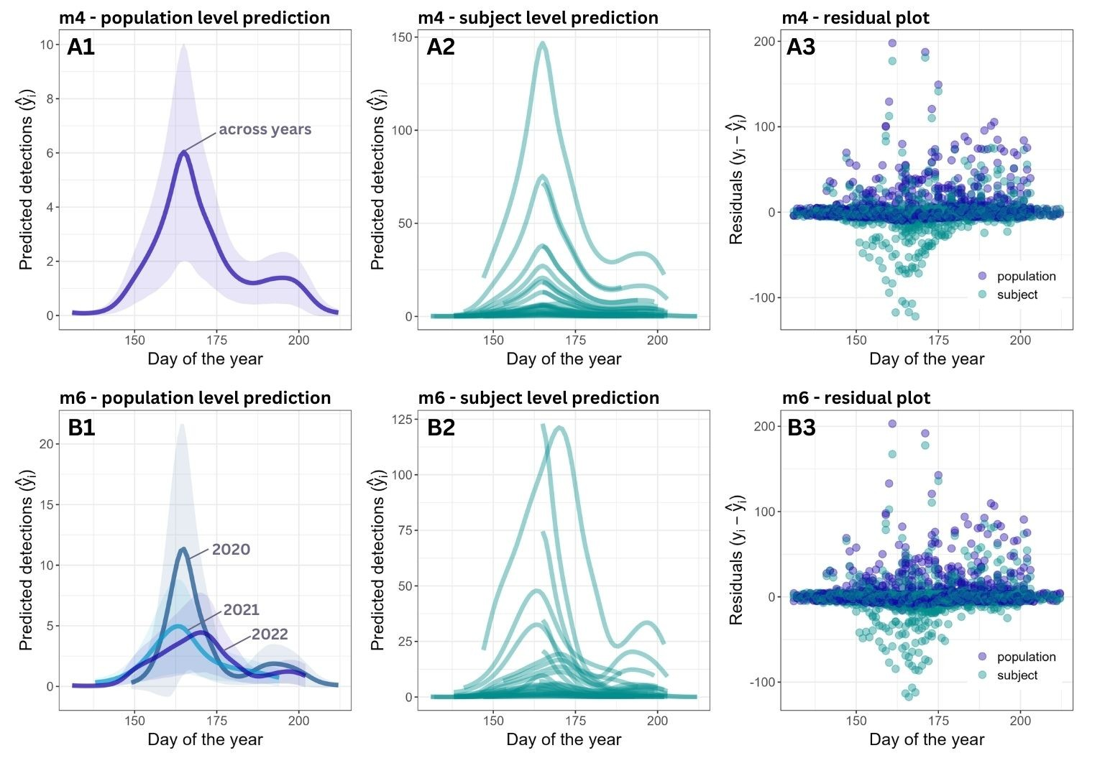
Fig. 4. Model predictions at the (1) population level, (2) site-year (subject) level, and (3) model residuals for (A) model 4 and (B) model 6. Both models showed a bimodal seasonal pattern in Olive-sided Flycatcher vocal activity and substantial variation among site-year combinations.

Spatial pattern
The full model, which included all candidate occupancy and detection covariates, showed improved model fit relative to a null model containing only an intercept for occupancy, as evidenced by a lower WAIC (643.8 vs. 650.1).
Among the occupancy covariates, only canopy cover >10 m had a significant effect on site use (posterior effect size mean: −2.02; 95% credible interval: −3.60 to −0.52), indicating that Olive-sided Flycatcher were less likely to occupy sites with dense upper-canopy cover (Fig. 5A). For detection covariates, canopy cover at 1–3 m had a small but significant negative effect (posterior mean = −0.023, 95% CI: −0.04 to −0.006), suggesting that dense lower-canopy cover slightly reduced the likelihood of detecting singing Olive-sided Flycatchers when the bird is actually occupying the site (Fig. 5B).
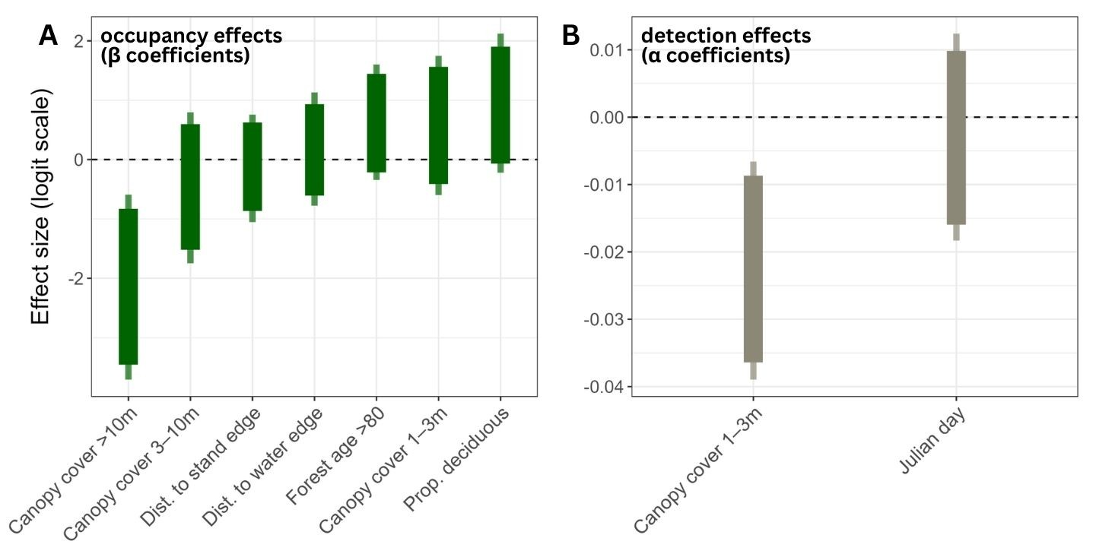
Fig. 5. Posterior effect sizes of covariates on (A) occupancy and (B) detection probabilities for Olive-sided Flycatcher. Thick bars represent 90% credible intervals, and thin bars represent 95% credible intervals. All covariates were standardized prior to modeling.
Landscape-level predictions indicated that occupancy probability was highest in the northwestern of the study area and along the eastern shoreline of Tezzeron Lake, where young forest stands were most common (Fig. 6A). Predicted detection probabilities were below 0.5 throughout most of the study area, with the lowest values occurring in dense shrub habitats, particularly near forest edges where low-height vegetation cover (1–3 m) was greatest (Fig. 6B).

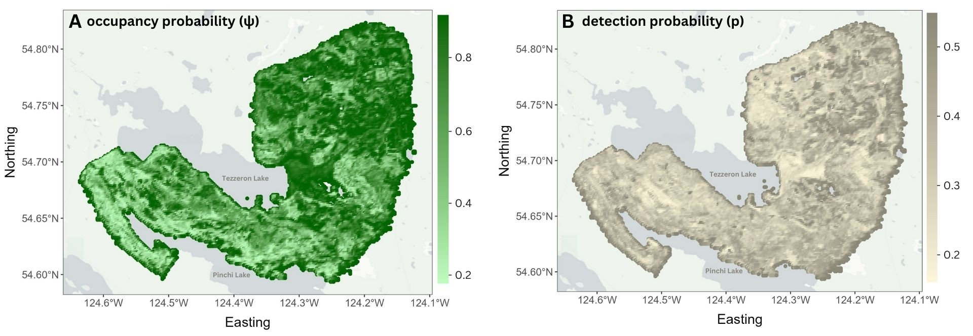
Fig. 6. Spatial predictions from the occupancy model for Olive-sided Flycatcher in the study area. (A) Predicted occupancy probability ($ψ$), showing the likelihood that a site is occupied by Olive-sided Flycatchers. (B) Predicted detection probability ($p$), indicating the probability of detecting Olive-sided Flycatchers at a site if they are present.

Discussion

Temporal vocal activity pattern
Our results revealed a clear seasonal vocal activity pattern in Olive-sided Flycatcher, characterized by a primary peak in mid-June and followed by a smaller secondary peak in mid-July (Fig. 4). This pattern was identified by both the population-level seasonal smooth (m4) and the year-specific smooths (m6). The primary peak in mid-June likely corresponds to territory establishment and mate attraction during female’s arrival, when males sing most intensively to advertise occupancy and secure breeding opportunities (Wright 1997). This timing broadly aligns with previous studies showing high song output early in the breeding season, particularly during territory defense and pair formation (Wright 1997).
The secondary peak in mid-July is most plausibly explained by post-breeding song rather than renesting, given that Olive-sided Flycatchers are considered single-brooded, and elevated singing after successful fledging has been documented in other passerines as a mechanism for territory maintenance, mate guarding, or insurance against late breeding failure (Fig. 6 in Beckett and Ritchison 2010). The temporal spacing between pre-breeding and post-breeding song peaks typically corresponds to the combined duration of incubation and nestling development. In Olive-sided Flycatchers, incubation lasts approximately 14–16 days and the nestling period approximately 16–18 days (Wright 1997), yielding a total of 4–5 weeks. This timing closely aligns with the ~30-day separation between the two vocal activity peaks identified in our model (Fig. 4).
Although the overall seasonal structure was conserved across years, the year-specific smooths in model m6 revealed modest interannual variation in peak timing and magnitude, likely reflecting environmentally driven shifts in breeding phenology. Factors such as warmer spring temperature and earlier snowmelt timing are known to advance arrival dates in long-distance migratory birds (Gordo 2007), such as Olive-sided Flycatchers, and may contribute to the observed variability among years. Multi-year datasets could potentially further identify the relationship between phenology change versus climate.
While this study focused on seasonal vocal dynamics, extending analyses to 24-hour recordings would provide diel activity profiles that reveal how detection probability fluctuates throughout the day. Recent advances in low-cost autonomous recorders, expanded storage capacity, scalable cloud-based processing, and increasingly accurate machine-learning classifiers make continuous, full-season acoustic monitoring increasingly feasible (Singer et al. 2025). Such information can further reduce bias in survey design, especially for species whose singing behaviour is concentrated in narrow dawn or dusk windows.

Spatial vocal activity pattern
Our occupancy models identified forest structure as a key determinant of Olive-sided Flycatcher occupancy and detection probability across the study area. Upper-canopy cover (>10 m) emerged as the strongest predictor of occupancy, with dense overstory substantially reducing the probability of site use (Fig. 5). This finding is consistent with previous studies showing that Olive-sided Flycatchers preferentially breed in open or early-successional forests, where reduced canopy cover facilitates aerial foraging and provides exposed perches for singing and hunting (Billerman et al. 2025). Spatial predictions further supported this pattern, with higher occupancy probabilities concentrated in areas dominated by younger forest stands, particularly in the northwestern portion of the study area (Fig. 6). Together, these results reinforce the importance of canopy openness and forest age structure in shaping Olive-sided Flycatcher breeding habitat at local and landscape scales.
At a broader scale, however, the apparent association between Olive-sided Flycatchers and disturbed or edge habitats should not be interpreted as evidence that increasing forest harvest necessarily benefits the species. Although anthropogenic forest openings may resemble natural post-fire habitats structurally, accumulating evidence suggests that reproductive success is often lower in harvested landscapes, likely due to increased nest predation and altered predator communities (Robertson and Hutto 2007). As a result, such habitats may function as ecological traps, attracting individuals without supporting long-term population viability (Robertson and Hutto 2007). This distinction between habitat use (i.e., occupancy) and habitat quality may help reconcile our spatial results with long-term population declines documented across much of the species’ range (BirdLife International 2025). In heavily logged areas of the study region, suitable structural conditions for occupancy may exist, yet these sites may not contribute positively to population growth.
Detection probability was generally low across the landscape, with predicted values rarely exceeding 0.5, highlighting the importance of accounting for imperfect detection when surveying this species (Fig. 6). Several factors likely contribute to this pattern. First, Olive-sided Flycatcher’s daily singing activity is variable, with peak song rates occurring before dawn and declining rapidly through the morning (Wright 1997). Although our recording schedule were set during early morning hours (4 – 7am), reduced vocal activity later in the recording window may have lowered detectability. In addition, large and well-spaced territories (often 10–20 ha; Altman 1997) inherently result in low local densities, decreasing the detection probability even at occupied sites. Finally, our results indicate that dense lower-canopy vegetation (1–3 m) slightly but significantly reduced detection probability (Fig. 5), likely due to acoustic attenuation or obstruction within shrub layers. These findings suggest that low detection probability in general reflect a combination of species ecology and habitat structure rather than true absence, underscoring the value of occupancy modelling for interpreting survey data on Olive-sided Flycatchers.

Conclusion
This study demonstrates that passive acoustic monitoring (PAM), combined with generalized additive modelling and occupancy modelling, can effectively characterize species-specific temporospatial patterns in Olive-sided Flycatcher vocal activity. Aligning surveys with the mid-June peak, and focusing efforts in young or open forest stands, is likely to increase both detection probability and monitoring efficiency. The modest interannual variation observed in seasonal activity underscores the value of multi-year datasets for capturing environmentally driven shifts in vocal behaviour. More broadly, our findings highlight how integrating full-season acoustic data with modelling approaches can generate species-specific spatiotemporal activity profiles, offering an evidence-based foundation to potentially refine survey protocols, reduce detectability-driven bias, and improve population assessments.

References
Altman, Bob. 1997. Olive-Sided Flycatcher in Western North America: Status Review. US Fish and Wildlife Service, Oregon State Office.
Beckett, Matthew D., and Gary Ritchison. 2010. “Effects of Breeding Stage and Behavioral Context on Singing Behavior of Male Indigo Buntings.” The Wilson Journal of Ornithology 122 (4): 655–65. https://doi.org/10.1676/09-204.1.
Best, Louis B. 1981. “Seasonal Changes in Detection of Individual Bird Species.” Studies in Avian Biology 6: 252–61.
Billerman, S. M., B. K. Keeney, G. M. Kirwan, F. Medrano, N. D. Sly, and M. G. Smith. 2025. Birds of the World. Cornell Laboratory of Ornithology. https://doi.org/10.2173/bow.
BirdLife International. 2025. “IUCN Red List of Threatened Species: Contopus Cooperi.” IUCN Red List of Threatened Species, February 4. https://www.iucnredlist.org/en.
Chambert, Thierry, J. Hardin Waddle, David A. W. Miller, Susan C. Walls, and James D. Nichols. 2018. “A New Framework for Analysing Automated Acoustic Species Detection Data: Occupancy Estimation and Optimization of Recordings Post-Processing.” Methods in Ecology and Evolution 9 (3): 560–70. https://doi.org/10.1111/2041-210X.12910.
Dawson, Deanna K., and Murray G. Efford. 2009. “Bird Population Density Estimated from Acoustic Signals.” Journal of Applied Ecology 46 (6): 1201–9. https://doi.org/10.1111/j.1365-2664.2009.01731.x.
Doser, Jeffrey W., Andrew O. Finley, Marc Kéry, and Elise F. Zipkin. 2022. “spOccupancy: An R Package for Single-Species, Multi-Species, and Integrated Spatial Occupancy Models.” Methods in Ecology and Evolution 13 (8): 1670–78. https://doi.org/10.1111/2041-210X.13897.
Environment and Climate Change Canada. 2019. “Olive-Sided Flycatcher (Contopus Cooperi): COSEWIC Assessment and Status Report 2018.” Program descriptions;research. February 25. https://www.canada.ca/en/environment-climate-change/services/species-risk-public-registry/cosewic-assessments-status-reports/olive-sided-flycatcher-2018.html.
Goldstein, Benjamin R., Alex J. Jensen, Roland Kays, et al. 2024. “Guidelines for Estimating Occupancy from Autocorrelated Camera Trap Detections.” Methods in Ecology and Evolution 15 (7): 1177–91. https://doi.org/10.1111/2041-210X.14359.
Gordo, Oscar. 2007. “Why Are Bird Migration Dates Shifting? A Review of Weather and Climate Effects on Avian Migratory Phenology.” Climate Research 35 (1/2): 37–58.
Hill, Andrew P., Peter Prince, Evelyn Piña Covarrubias, C. Patrick Doncaster, Jake L. Snaddon, and Alex Rogers. 2018. “AudioMoth: Evaluation of a Smart Open Acoustic Device for Monitoring Biodiversity and the Environment.” Methods in Ecology and Evolution 9 (5): 1199–211. https://doi.org/10.1111/2041-210X.12955.
Kahl, Stefan, Connor M. Wood, Maximilian Eibl, and Holger Klinck. 2021. “BirdNET: A Deep Learning Solution for Avian Diversity Monitoring.” Ecological Informatics 61 (March): 101236. https://doi.org/10.1016/j.ecoinf.2021.101236.
Massimino, Dario, Sarah J. Harris, and Simon Gillings. 2021. “Phenological Mismatch between Breeding Birds and Their Surveyors and Implications for Estimating Population Trends.” Journal of Ornithology 162 (1): 143–54. https://doi.org/10.1007/s10336-020-01821-5.
Pérez-Granados, Cristian. 2025. “Birdnet Confidence Scores Decrease with Bird Distance from the Recorder: Revisiting Pérez-Granados (2023).” Ardeola 72 (2): 149–59. https://doi.org/10.13157/arla.72.2.2025.fo1.
Robertson, Bruce A., and Richard L. Hutto. 2007. “Is Selectively Harvested Forest an Ecological Trap for Olive-Sided Flycatchers?” The Condor: Ornithological Applications 109 (1): 109–21. https://doi.org/10.1093/condor/109.1.109.
Shonfield, Julia, and Erin Bayne. 2017. “Avian Conservation and Ecology: Autonomous Recording Units in Avian Ecological Research: Current Use and Future Applications.” Avian Conservation and Ecology 12 (1). https://doi.org/10.5751/ACE-00974-120114.
Singer, David, Johannes Kamp, Hermann Hondong, Andreas Schuldt, and Jonas Hagge. 2025. “Diel and Seasonal Vocal Activity Patterns Revealed by Passive Acoustic Monitoring Suggest Expert Recommendations for Breeding Bird Surveys Need Adjustment.” Journal of Ornithology, ahead of print, July 9. https://doi.org/10.1007/s10336-025-02307-y.
Tseng, Sunny, Dexter P. Hodder, and Ken A. Otter. 2025. “Setting BirdNET Confidence Thresholds: Species-Specific vs. Universal Approaches.” Journal of Ornithology 166 (4): 1123–35. https://doi.org/10.1007/s10336-025-02260-w.
Verner, Jared. 1980. “Bird Communities of Mixed-Conifer Forests of the Sierra Nevada.” (Salt Lake City, Utah).
Wood, Simon N. 2001. “Mgcv: GAMs and Generalized Ridge Regression for R.” R News.
Wright, John M. 1997. Preliminary Study of Olive-Sided Flycatchers, July 1994-April 1997. Final Research Report SE-3-3, 4, and 5. Alaska Department of Fish and Game Division of Wildlife Conservation.
Zuur, Alain F., Elena N. Ieno, Neil Walker, Anatoly A. Saveliev, and Graham M. Smith. 2009. Mixed Effects Models and Extensions in Ecology with R. Statistics for Biology and Health. Springer. https://doi.org/10.1007/978-0-387-87458-6.

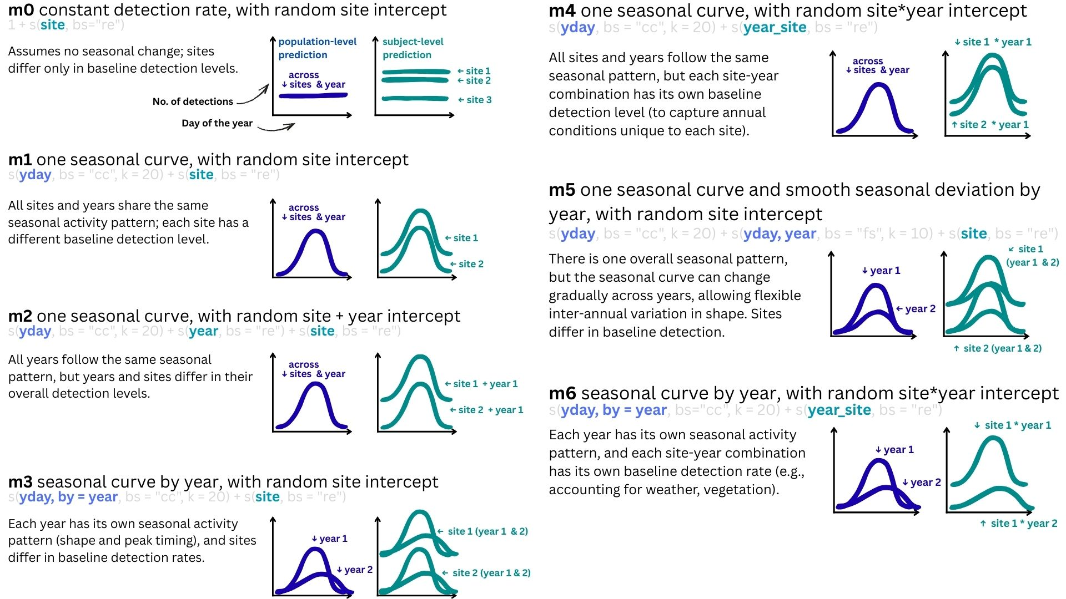
Fig. S1 Specifications of the candidate GAM models, from the null model to the most complex form. All models included Julian day as a cyclic smooth to capture seasonal detection patterns and random effects to account for variation among sites and years. For each model, we provide the model definition, corresponding R code, ecological interpretation, and illustrative predictions: population-level predictions are shown as dark blue curves, and site-year (subject-level) predictions as light blue curves.

