Methods

Target species and study area
The target species was the Olive-sided Flycatcher (OSFL; Contopus cooperi), a long-distance migratory songbird of conservation concern. The species is currently listed as Near Threatened by the IUCN (cite) and designated as Threatened in Canada by COSEWIC (cite). Olive-sided Flycatchers breed in coniferous and mixed forests across western and boreal North America, where males defend large territories and deliver frequent, far-carrying vocalizations, most notably the characteristic “quick-three-beers” song.
The study was conducted in the John Prince Research Forest, covering approximately 16,000 ha, located in central British Columbia, Canada (54°27'N, 124°10'W; 700 m a.s.l.) within the dry sub-boreal spruce biogeoclimatic zone. Acoustic data were collected using 66 AudioMoth (cite), each deployed at least 2 km apart to minimize spatial autocorrelation. Acoustic data were collected during the breeding seasons from 2020 to 2022 (May–July), between 4am and 7am. Recordings were scheduled for 1-minute recording intervals followed by 4 minutes of inactivity, resulting in 12 recordings per hour and 36 recordings per day. In total, 67,301 one-minute recordings were obtained. All recordings were standardized to a 48 kHz sampling rate and stored as mono Pulse Code Modulation (PCM) WAV files.

Audio processing
Collected acoustic data were analyzed using the BirdNET Analyzer v2.4 model (cite GitHub repository), implemented via the Python module running in a local terminal. To retain as many true positive detections as possible in the initial analysis stage, we set the parameter min_conf, which filters out results below a specified confidence threshold, to 0.1. Processing the entire dataset, which comprised 1.5 terabytes of audio, required approximately 72 consecutive hours.
A BirdNET species-specific threshold of 0.35 was applied for OSFL detections to ensure a precision of 0.95 (about 95% of the detections were true detections). This value was defined by Tseng et al. (2025), where species-specific thresholds were calculated for common species using the same dataset. Refer to Tseng et al. (2025) for a detailed framework on how these species-specific thresholds were defined. Daily OSFL detections were summarized for each site throughout the survey period. At sites with at least one detection, the number of active days varied from 1 to 54, with a mean of 6.84 ± 10.89 days (Fig. 1).
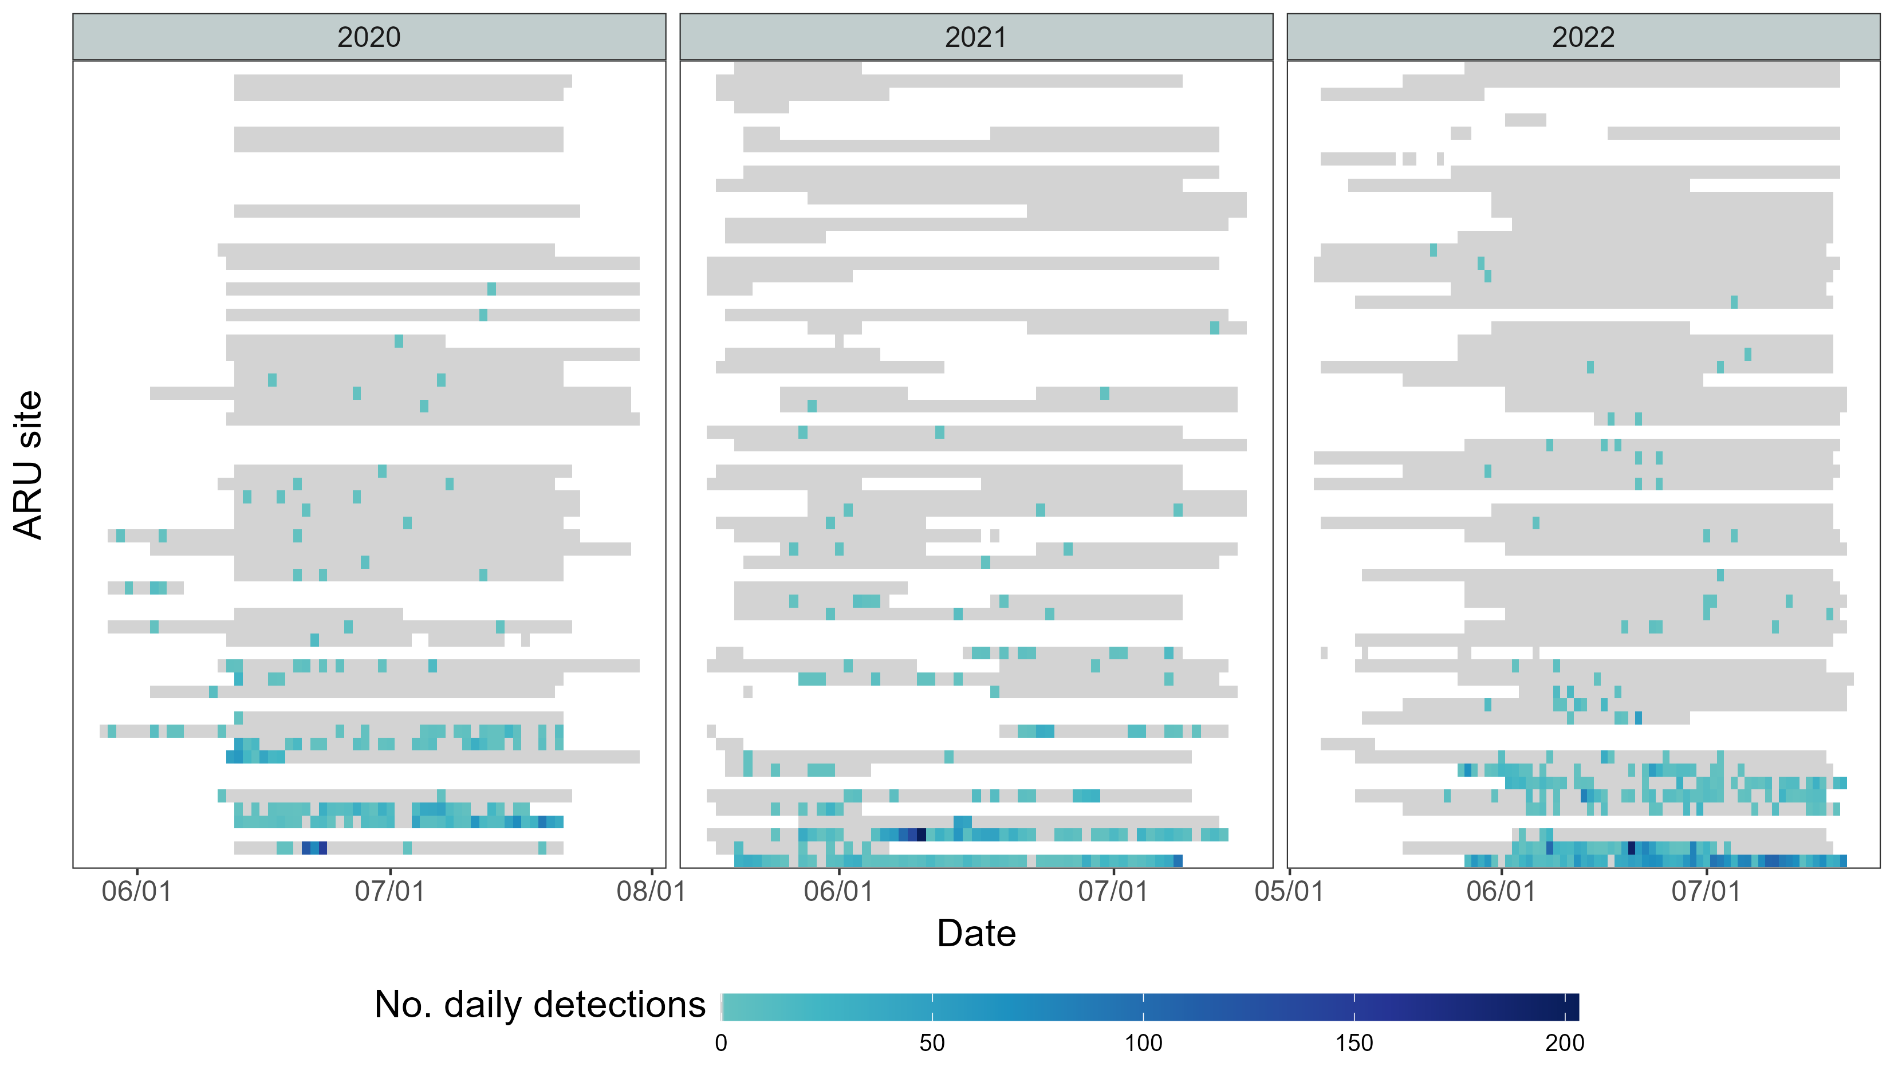
Fig. 1. Daily detections of Olive-sided Flycatcher (OSFL) across sites. Sites are ranked by total OSFL detections, from lowest (top) to highest (bottom). Grid cells with a color gradient indicate days with OSFL detections, while grey cells represent days when the ARU was active but no OSFL detections. Variation in ARU activity periods at each site (grey and colored areas together) reflects logistical constraints and field challenges, including battery depletion, firmware issues, and wildlife disturbances.

Modelling for temporal pattern – GAM modelling
To characterize the seasonal vocal activity of OSFL, we first refined the dataset by retaining only ARUs (site-year combinations) with at least two consecutive days of OSFL detections (hereafter “qualified ARUs”). This criterion excluded ARUs with very few or sporadic detections (Fig. 1), as single-day detections may reflect opportunistic vocalizations or transient individuals rather than meaningful patterns of local activity. There were 9, 10, and 13 qualified ARUs in 2020, 2021, and 2022, respectively. These qualified ARUs showed a higher proportion of active detections near the middle of the breeding season (Fig. 2).
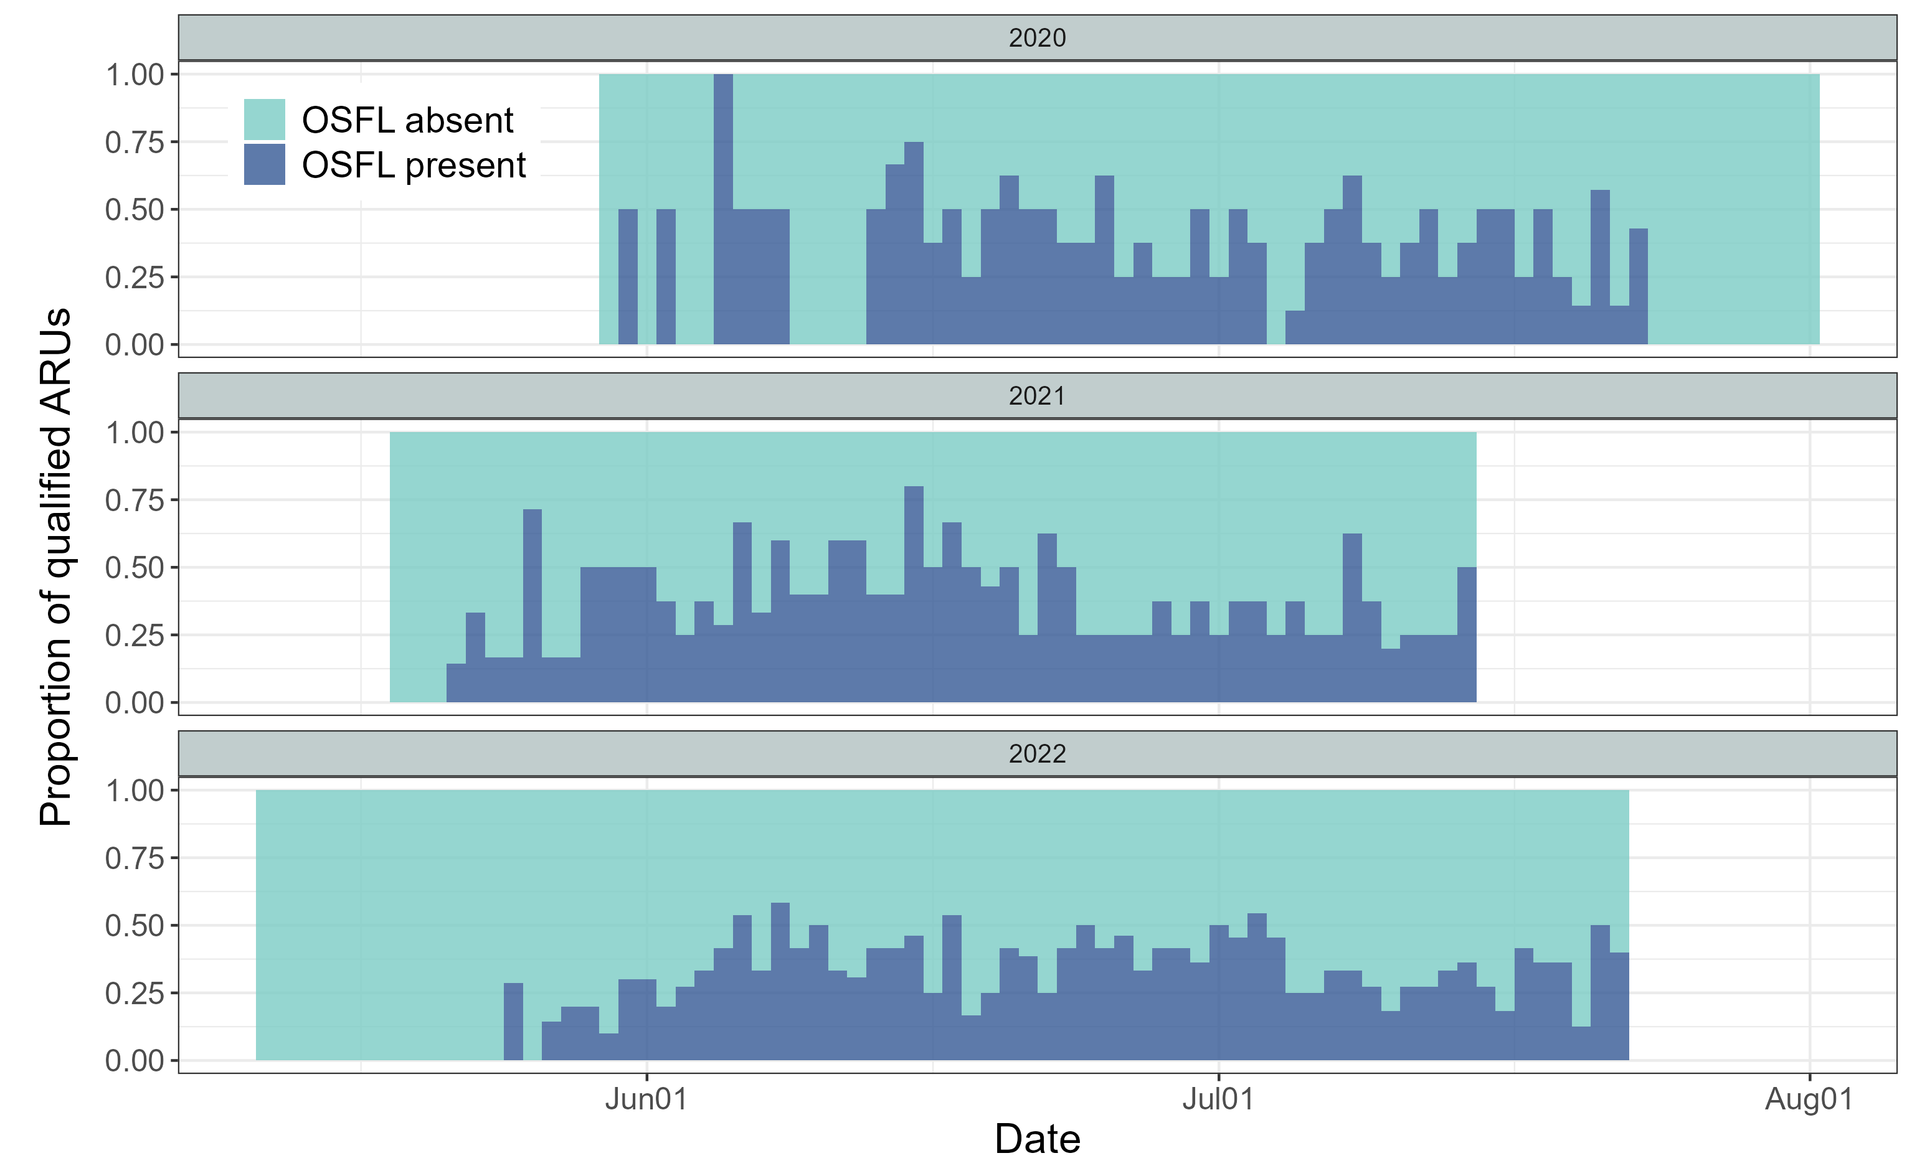
Fig. 2. Seasonal activity of qualified ARUs, defined as ARUs with at least two consecutive days of Olive-sided Flycatcher (OSFL) detections within a site-year. This included 9, 10, and 13 qualified ARUs in 2020, 2021, and 2022, respectively. Qualified ARUs with at least one OSFL detection that day are shown in dark blue, and those without detections are shown in light blue.
We used Generalized Additive Models (GAMs) to model OSFL vocal activity because GAMs flexibly accommodate nonlinear and cyclic temporal patterns, and allow inclusion of random effects to account for hierarchical structure and repeated measurements. All candidate models included Julian day as a cyclic smooth term to represent the seasonal detection pattern, and random effects to account for variation among sites and years. Using data from the qualified ARUs, we constructed a set of models with increasing complexity to evaluate whether seasonal patterns were shared across years or varied annually (Fig. S1). The models were defined as follows:
- Model 0 (m0): Null model; constant detection rate, with random site intercept.
- Model 1 (m1): One seasonal curve with random site intercept.
- Model 2 (m2): One seasonal curve with random site + year intercepts.
- Model 3 (m3): Seasonal curve by year with random site intercept.
- Model 4 (m4): One seasonal curve with random site × year intercept.
- Model 5 (m5): One seasonal curve with smooth year-specific deviations and random site intercept.
- Model 6 (m6): Seasonal curve by year with random site × year intercept.

To identify the most supported model, all candidate models were first fitted using maximum likelihood (ML), allowing valid comparison of Akaike Information Criterion (AIC) values across models differing in fixed effects (cite). The model with the lowest AIC was considered best supported by the data. The top-performing model was then refitted using restricted maximum likelihood (REML) to obtain stable smoothing parameter estimates and to generate the final inference and visualizations (cite).

Modelling for spatial pattern – occupancy modelling
We used occupancy modelling to examine the spatial distribution of OSFL using acoustic monitoring data. To satisfy the closure assumption, that occupancy status remains constant across repeated surveys, we restricted the analysis to June 1–30, the period when OSFL were actively singing and most likely present at breeding sites (see Results section Fig. 4). To reduce temporal autocorrelation and generate independent detection replicates, we aggregated ARU detections into 5-day intervals. Aggregation windows of 2–7 days are commonly used in ARU-based occupancy studies (cite), and a 5-day interval balances the need for repeated sampling with obtaining sufficient detections for analysis. To minimize false positives, we applied species-specific BirdNET confidence thresholds (see Methods – Audio processing), ensuring high precision in identifying OSFL vocalizations. Presence/absence was then assigned for each site and 5-day interval to produce the detection matrix used in the occupancy model (Fig. 3).
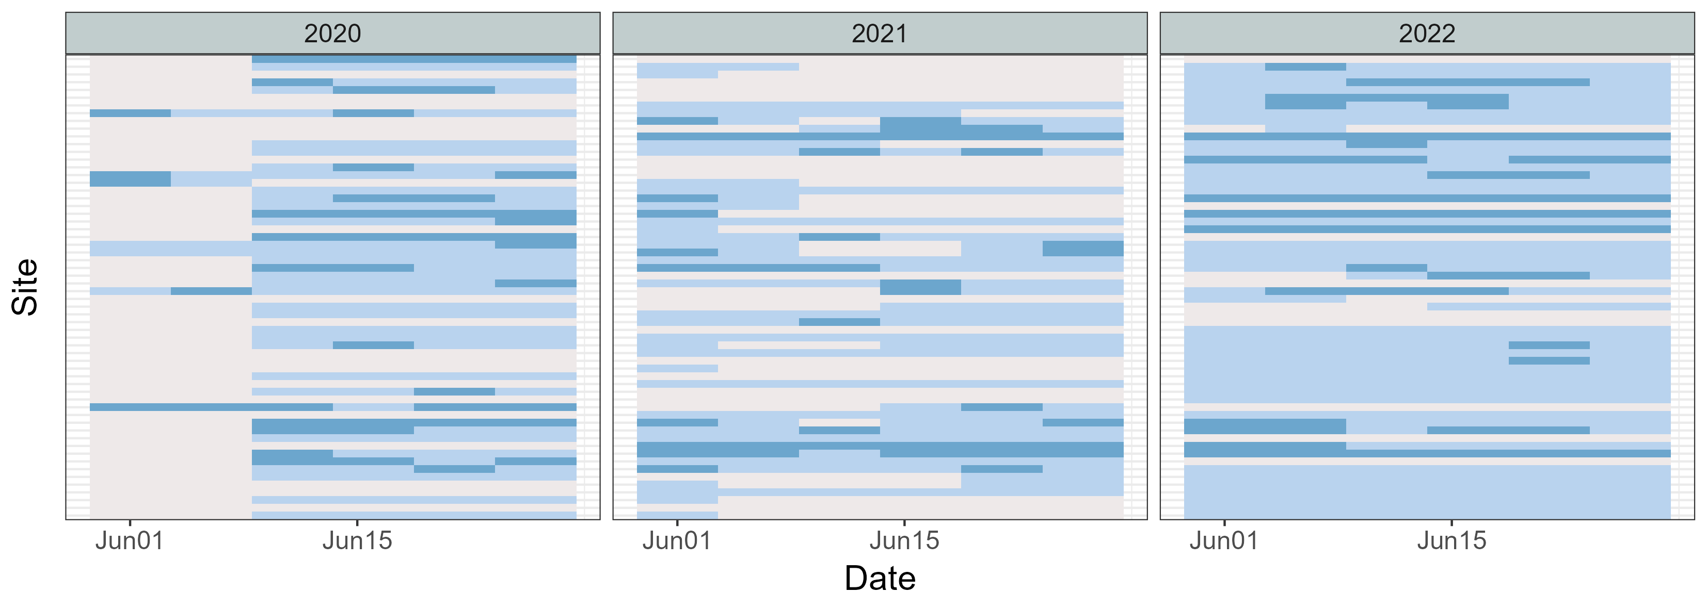
Fig. 3 Occupancy matrix
Occupancy models estimate two processes: (1) the probability that a site is occupied (occupancy probability), and (2) the probability of detecting the species given occupancy (detection probability). For the occupancy covariates, we used LiDAR-derived habitat variables summarized within a 100-m radius around each ARU site, representing the approximate area a bird may occupy when detected (Pérez-Granados 2025). We selected seven candidate covariates expected to influence OSFL occurrence, including:
- Topography: distance to stream, wetland, lake edge, and polygon stand edge;
- Canopy structure: average canopy closure at 1–3 m, 3–10 m, and >10 m;
- Vegetation composition: proportion of the surrounding polygon with forest age >80 years, and proportion of deciduous trees with DBH >10 cm.
For the detection model, we included Julian day and canopy closure at 1–3 m, as both variables are likely to influence the probability of detecting OSFL vocalizations.
Need a paragraph about occupancy modelling using R package spOccupancy, the background of it, and its citation. Model fit was evaluated using WAIC.

To examine landscape-level patterns in occupancy and detection probability, we generated spatial predictions using the covariates identified as significant in the occupancy model. Raster layers for these covariates were aggregated to the analysis resolution of 15m and used as inputs to the fitted occupancy model to obtain posterior predictive samples for every grid cell across the study area.

Results

Temporal pattern
We compared candidate GAMs that differed in their treatment of seasonal smoothing, year effects, and site-level random effects (Table 1). Models m4 and m6 had the lowest AICc values and received substantially higher support (wAIC = 0.79 and 0.21, respectively) than all alternative models, indicating that both captured the data structure reasonably well.
In the model with a single seasonal smooth (m4), there was strong evidence of seasonal variation in detections (χ² = 249.6, p < 0.001). Population-level predictions showed a pronounced seasonal pattern, that detections increased sharply in early spring, peaked in mid-June, and exhibited a smaller secondary peak in mid-July (Fig. 4-A1). Site-year random effects contributed substantially to model fit (χ² = 525.9, p < 0.001), with site-years differing widely in baseline detection rates. Some locations showed predicted counts several-fold higher or lower than the population-level mean (Fig. 4-A2). Overall, m4 explained approximately 40% of the deviance (Fig. 4-A3).
The model with year-specific seasonal smooths (m6) produced a similar seasonal pattern but allowed peak timing and magnitude to vary among years. Seasonal effects remained significant across all three years (2020: χ² = 124.5, p = 0.024; 2021: χ² = 83.5, p < 0.001; 2022: χ² = 144.0, p < 0.001). All years exhibited a primary peak in mid-June followed by a secondary peak in mid-July, although the smoothness and height of these peaks differed among years (Fig. 4-B1). Site-year random effects again explained considerable variation (χ² = 519.9, p < 0.001), reflecting persistent differences in baseline detection rates among site-years (Fig. 4-B2). Model m6 explained slightly more deviance (41.4%) than m4 (Fig. 4-B3), although the improvement was modest.

Table 1 AICc-based comparison of candidate GAM models. Models are listed in order of increasing AICc. The two highest-ranked models (bolded) exhibited the strongest empirical support. Full model specifications are provided in the Methods section and illustrated in Fig. S1.
Model | DF | AICc | Delta AICc | AICc weight
m4 | 40 | 5017 | 0 | 79%
m6 | 52 | 5020 | 3 | 21%
m5 | 36 | 5082 | 65 | 0%
m3 | 42 | 5085 | 68 | 0%
m2 | 31 | 5089 | 72 | 0%
m1 | 29 | 5103 | 86 | 0%
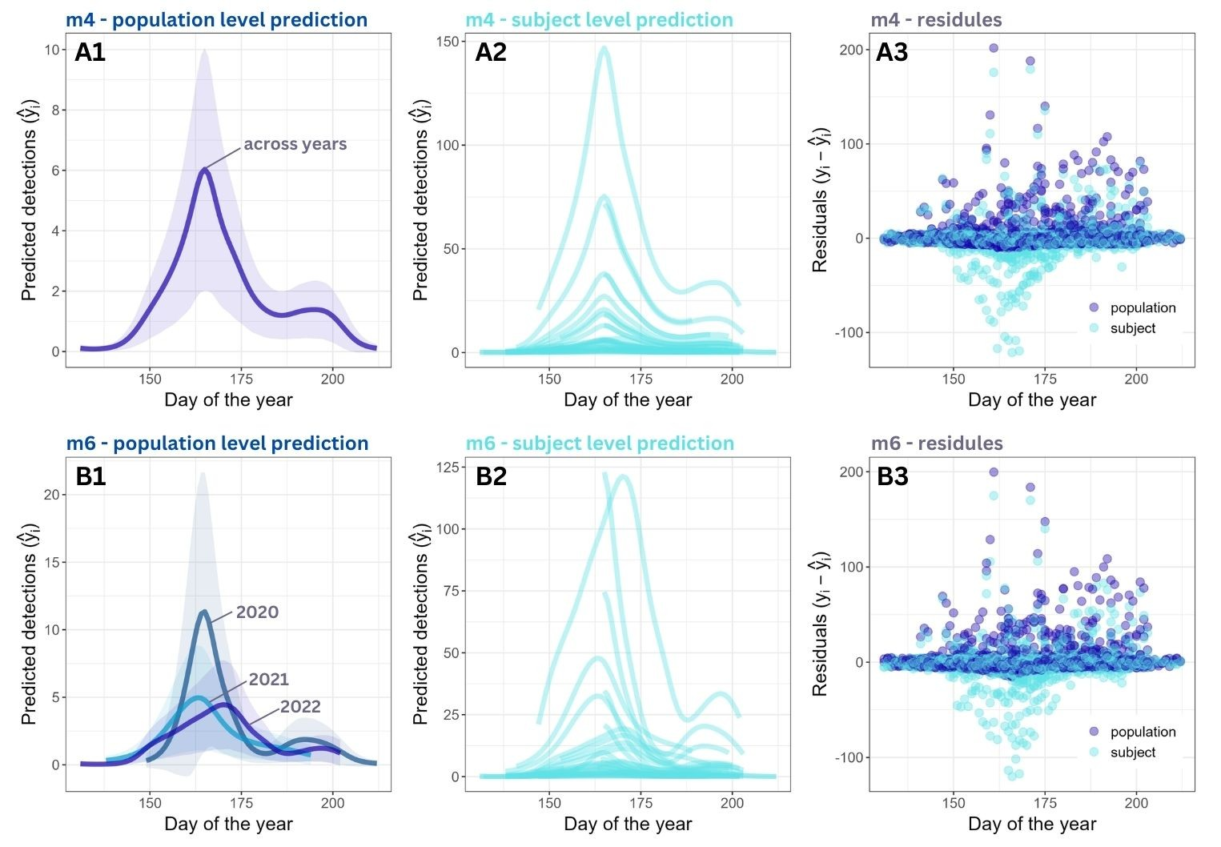
Fig. 4 Model predictions at the (1) population level, (2) site-year (subject) level, and (3) model residuals for (A) model 4 and (B) model 6. Both models showed a bimodal seasonal pattern in OSFL vocal activity and substantial variation among site-year combinations.

Spatial pattern
The full model, which included all candidate occupancy and detection covariates, had a lower WAIC (WAIC = 643.17) than the null model containing only an intercept for occupancy (WAIC = 648.58), indicating improved fit when habitat and detection covariates were included.
Among the occupancy covariates, canopy closure above 10 m had the strongest effect on site use, with a posterior effect size mean of −2.02 (95% credible interval: −3.60 to −0.52), indicating that OSFL were less likely to occupy sites with dense high-canopy cover (Fig. 5A). Other occupancy covariates, including lower canopy closure between 3-10m and above 10m, distance to wetland edges, and forest age, had weaker effects, with 95% credible intervals overlapping zero (Fig. 5A). For detection covariates, canopy closure at 1–3 m had a small but significant negative effect (posterior mean = −0.023, 95% CI: −0.040 to −0.006), suggesting that denser low-canopy cover slightly reduced the likelihood of detecting singing OSFL during a survey (Fig. 5B). While Julian day showed no clear effect on the OSFL detectability during the survey period (Fig. 5B).
Landscape-level predictions revealed distinct spatial patterns in occupancy and detection (Fig. 6). Occupancy probability was highest in young forest stands with lower canopy closure at >10 m, particularly in the northwest of the study area and along the eastern shoreline of Tezzeron Lake (Fig. 6A). In contrast, detection probability exhibited much lower values across the forest (Fig. 6B). Most of the area showed predicted detection probability below 0.5, with the lowest detection probabilities occurring in dense shrub habitats where low-height canopy closure (1–3 m) was greatest.
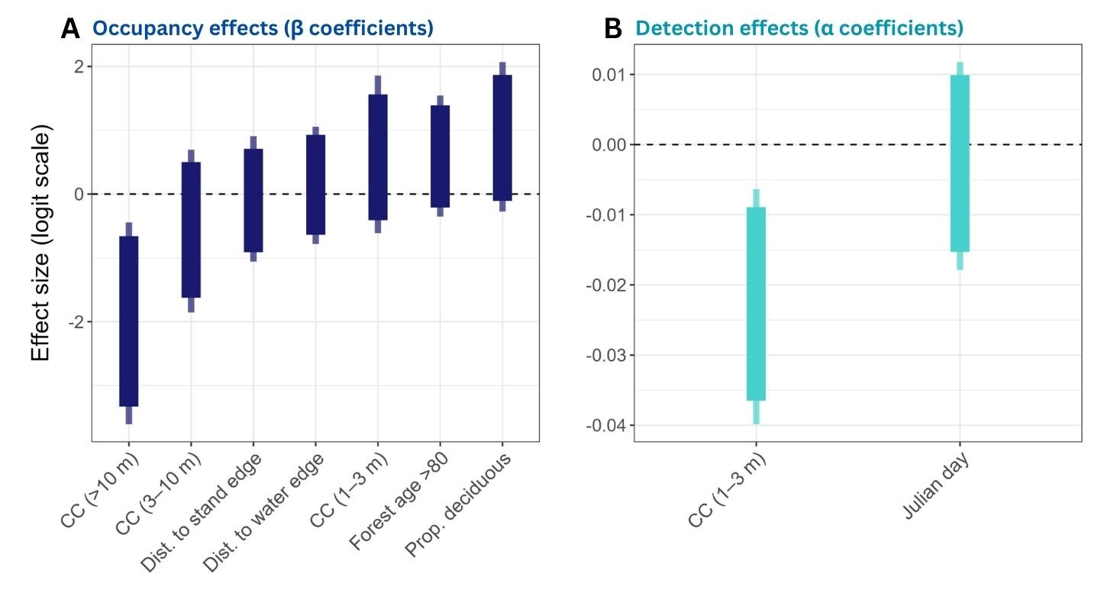
Fig. 5 Posterior effect sizes of covariates on (A) occupancy and (B) detection probabilities for OSFL. Thick bars represent 90% credible intervals, and thin bars represent 95% credible intervals. All covariates were standardized prior to modeling.
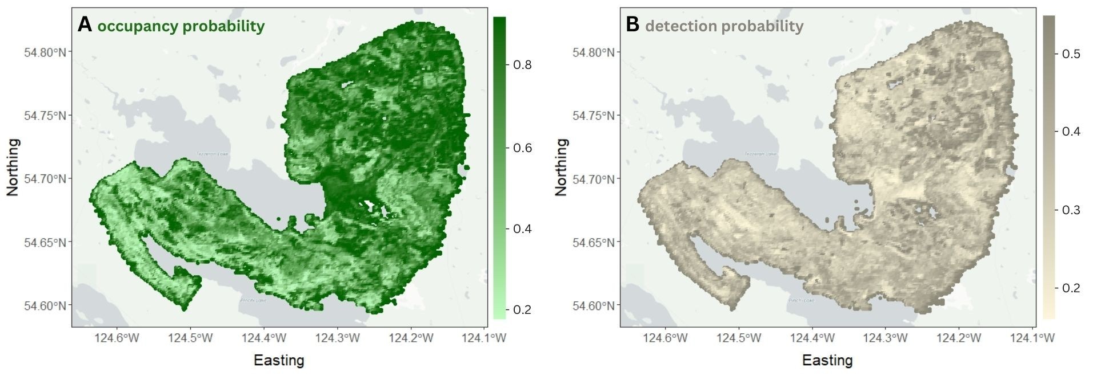
Fig. 6 Spatial predictions from the occupancy model for OSFL in the study area. (A) Predicted occupancy probability ($ψ$), showing the likelihood that a site is occupied. (B) Predicted detection probability ($p$), indicating the probability of detecting the species at a site if it is present. Areas with insufficient data are shown in light grey.

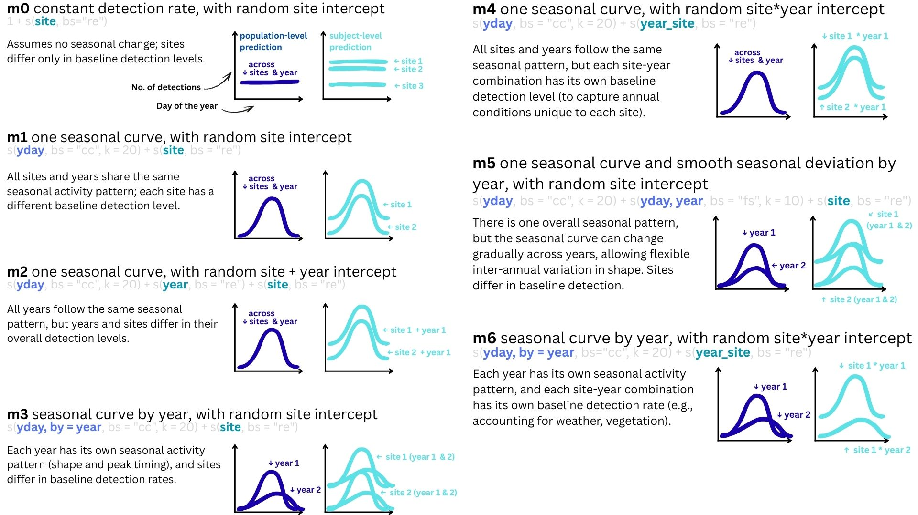

Fig. S1 Specifications of the candidate GAM models, from the null model to the most complex form. All models included Julian day as a cyclic smooth to capture seasonal detection patterns and random effects to account for variation among sites and years. For each model, we provide the model definition, corresponding R code, ecological interpretation, and illustrative predictions: population-level predictions are shown as dark blue curves, and site-year (subject-level) predictions as light blue curves.

