Autonomous recording units can identify spatiotemporal bird activity patterns for better survey protocols

Abstract
During breeding season, most birds show a daily period of high singing activity, which is known as “dawn chorus” (cite). It is widely known that various environmental factors influence the dawn chorus start time, such as ambient temperature, precipitation, cloud cover, lunar phase, and existence of other species (cite). The rapid development of autonomous recording units and machine learning algorithms had notably reduced the difficulty in monitoring dawn chorus. Studies had been done to investigate the relationships between environmental factors and the dawn chorus start time; however, bird species in North American have received little attention (cite). In this study, the relationships between dawn chorus start time and ambient temperature, precipitation, cloud cover, lunar phase, and site biodiversity will be investigated for Olive-sided Flycatcher (Contopus cooperi), whose status is under special concern in Canada (cite). This research will inform the effects of environmental factors on the dawn chorus start time of Olive-sided Flycatcher, not only providing a baseline information for the species but also setting up a standard framework for future dawn chorus studies.
Find the monthly pattern of Olive-sided Flycatcher vocal density by cumulative detections
Determine the factors that related to the start time of dawn chorus from OSFL

Target journal: Methods in Ecology and Evolution (workflows):
Workflows are descriptions of novel and broadly useful assemblages of (usually) existing software or informatic tools into useful pipelines for analysis of complex, Big datasets of demonstrable importance to ecology and evolutionary biology. Workflows may also describe empirical or experimental procedures that are used to generate Big datasets, including (but not limited to) eDNA and ‘omic, metabarcodes, and varKodes, and products of continental- or larger-scale remotely-sensed observations. Workflows should have a maximum of 7000–8000 words (including tables/figure captions, statements and references list) and be formatted according to the Manuscript Specifications below. Submissions of Workflows should be accompanied by the Workflow Checklist uploaded as a file for editors only. Please see here for detailed information on what we will consider as Workflow submission, as well as the downloadable Workflow Checklist

Related papers:
A global assessment of BirdNET performance: differences among continents, biomes, and species
Using data from camera traps and autonomous recording units to evaluate and improve species-habitat inferences
Diel and seasonal vocal activity patterns revealed by passive acoustic monitoring suggest expert recommendations for breeding bird surveys need adjustment
Phenological mismatch between breeding birds and their surveyors and implications for estimating population trends

Potential source to compare the OSFL trends:
Idea – get the Canada wide trends from these three sources and make an comparison?
Trend from eBird data across Canada, and BC (cumulative change 2012 - 2022): https://science.ebird.org/en/status-and-trends/species/olsfly/trends-map?week=1
Trend from various resources in Canada, produced by Nature Counts (annual trend 1970 - 2022): https://naturecounts.ca/nc/socb-epoc/species.jsp?sp=olsfly#status-and-trends
Trends from breeding birds survey across Canada, and BC: https://bbsbayes.github.io/bbsBayes2/articles/bbsBayes2.html

Something else:
BBS protocol: https://www.canada.ca/en/environment-climate-change/services/bird-surveys/landbird/north-american-breeding/instructions.html#toc1

Introduction
Paragraph 1 – Motivation and method context
Passive acoustic monitoring (PAM) has emerged as a powerful tool for studying vocal wildlife, providing continuous, high-resolution data on species’ activity across both temporal and spatial scales (cite). By capturing fine-scale diel and seasonal patterns of vocal activity, PAM allows researchers to quantify singing times and durations, which can reveal gaps in traditional survey protocols that have historically relied on expert knowledge or limited observation windows (cite). On the other hand, by incorporating with habitat modelling, PAM allows researchers to identify key habitat spatially for observations (cite). Such data-driven insights can directly inform survey design in spatiotemporal scales, improving the accuracy and efficiency in monitoring programs.
Paragraph 2 – Limitations of existing monitoring programs
Current bird monitoring programs rely on structured surveys such as the North American Breeding Bird Survey or Christmas Bird Count, which ask observers to sample specific locations at fixed times of the year. In contrast, citizen science platforms like eBird and iNaturalist rely on opportunistic observations that vary in timing, effort, and observer experience. While these approaches provide valuable broad-scale information, they often lack the temporal precision and standardized effort required to capture short-term or fine-scale vocal activity patterns, limiting their utility for optimizing survey protocols or understanding breeding phenology.
Paragraph 3 – Species context and monitoring discrepancies
The Olive-sided Flycatcher (Contopus cooperi) is a species of conservation concern in British Columbia, Canada, listed as Threatened due to widespread population declines. Despite its distinctive song and general detectability, different monitoring programs sometimes produce conflicting results depending on survey approach. For example, broad-scale citizen science datasets suggest relatively stable detection rates across Canada (cite), whereas structured surveys such as the North American Breeding Bird Survey indicate continued long-term declines (cite). These discrepancies highlight the need for high-resolution, standardized acoustic monitoring to better understand fine-scale temporal and spatial patterns of OSFL activity.
Paragraph 4 – Gaps in knowledge
Understanding when and where OSFL are most vocally active is critical for improving monitoring accuracy and interpreting survey data. While previous studies have examined broad-scale population trends, few have leveraged continuous acoustic recordings or combined them with habitat structure data to disentangle ecological drivers of site use from variation in detectability. Integrating PAM with remote sensing data such as LiDAR allows researchers to link temporal vocal activity with spatial habitat features, providing insights into both breeding phenology and habitat associations that were previously unattainable.
Paragraph 5 – Study aims
In this study, we use three years of AudioMoth recordings from the John Prince Research Forest in central British Columbia, processed with BirdNET, and combined with LiDAR-derived habitat covariates to address two main objectives. First, we characterize seasonal vocal activity of OSFL using generalized additive models to identify peaks, interannual variation, and potential phenological stages. Second, we evaluate spatial patterns of site occupancy using occupancy modelling that accounts for imperfect detection, linking vocal activity to habitat structure. By integrating temporal and spatial data, this research aims to improve survey protocol design, refine estimates of habitat use, and inform conservation strategies for a species of high conservation concern.

Methods

Target species and study area
The target species was the Olive-sided Flycatcher (OSFL; Contopus cooperi), a long-distance migratory songbird of conservation concern. The species is currently listed as Near Threatened by the IUCN (cite) and designated as Threatened in Canada by COSEWIC (cite). Olive-sided Flycatchers breed in coniferous and mixed forests across western and boreal North America, where males defend large territories and deliver frequent, far-carrying vocalizations, most notably the characteristic “quick-three-beers” song (Audio 1).
The study was conducted in the John Prince Research Forest, covering approximately 16,000 ha, located in central British Columbia, Canada (54°27'N, 124°10'W; 700 m a.s.l.) within the dry sub-boreal spruce biogeoclimatic zone. Acoustic data were collected using 66 AudioMoth (cite), each deployed at least 2 km apart to minimize spatial autocorrelation. Acoustic data were collected during the breeding seasons from 2020 to 2022 (May–July), between 4am and 7am. Recordings were scheduled for 1-minute recording intervals followed by 4 minutes of inactivity, resulting in 12 recordings per hour and 36 recordings per day. In total, 67,301 one-minute recordings were obtained. All recordings were standardized to a 48 kHz sampling rate and stored as mono Pulse Code Modulation (PCM) WAV files.

Audio processing
Collected acoustic data were analyzed using the BirdNET Analyzer v2.4 model (cite GitHub repository), implemented via the Python module running in a local terminal. To retain as many true positive detections as possible in the initial analysis stage, we set the parameter min_conf, which filters out results below a specified confidence threshold, to 0.1. Processing the entire dataset, which comprised 1.5 terabytes of audio, required approximately 72 consecutive hours.
A BirdNET species-specific threshold of 0.35 was applied for OSFL detections to ensure a precision of 0.95 (about 95% of the detections were true detections). This value was defined by Tseng et al. (2025), where species-specific thresholds were calculated for common species using the same dataset. Refer to Tseng et al. (2025) for a detailed framework on how these species-specific thresholds were defined. At sites with at least one OSFL detection, the number of active ARU days ranged from 1 to 54 per year, with a mean of 6.84 ± 10.89 days per ARU per year (Fig. 1).
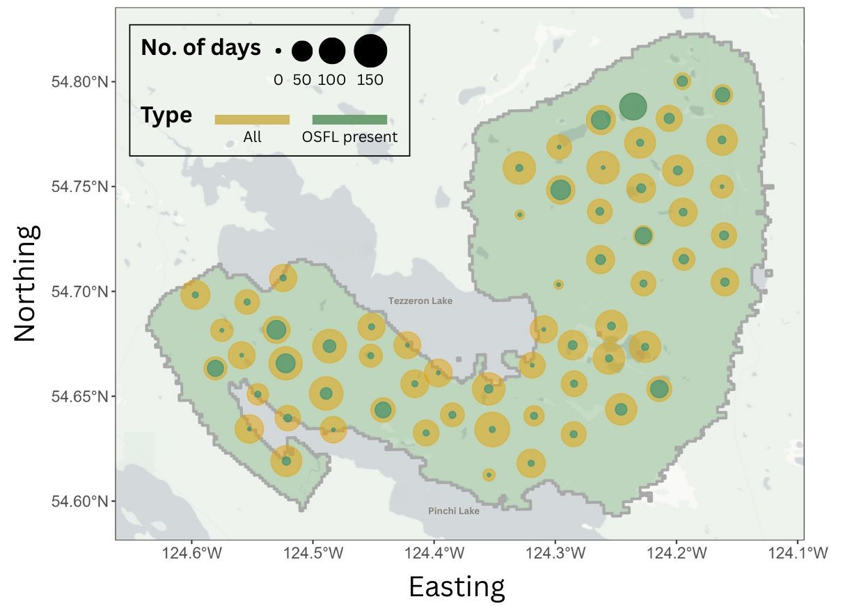
Fig. 1. Site map illustrating survey effort across years, where dot size represents total ARU deployment days (yellow) and days with OSFL detections (green). Northeastern sites showed particularly high detection frequency, with OSFL detected on most recording days.

Modelling temporal pattern – GAM analysis
To characterize seasonal vocal activity of OSFL, we first refined the dataset by retaining only site–year combinations with at least two consecutive days of OSFL detections (hereafter, “selected sites”). This filter excluded sites with very few or sporadic detections (Fig. 1), as single-day detections may represent opportunistic vocalizations or transient individuals rather than meaningful patterns of local activity. Using this criterion, we identified 9, 10, and 13 selected sites in 2020, 2021, and 2022, respectively. A larger proportion of selected sites had detections during June and July (Fig. 2).
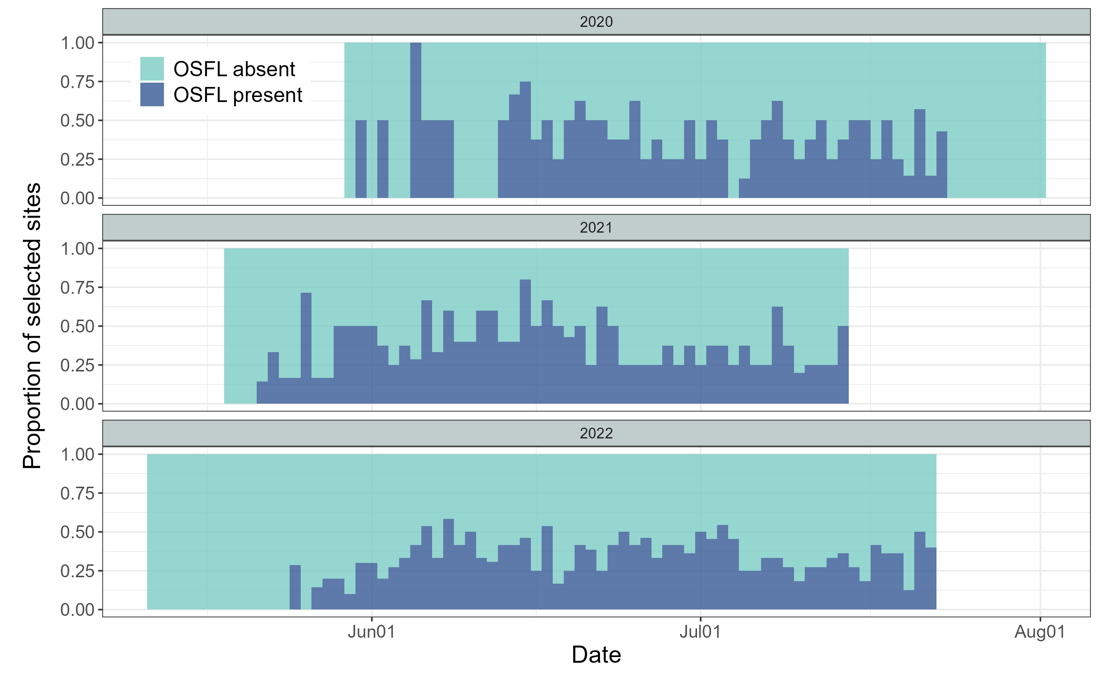
Fig. 2. Seasonal activity of qualified ARUs, defined as ARUs with at least two consecutive days of Olive-sided Flycatcher (OSFL) detections within a site-year. This included 9, 10, and 13 qualified ARUs in 2020, 2021, and 2022, respectively. Qualified ARUs with at least one OSFL detection that day are shown in dark blue, and those without detections are shown in light blue.
We used Generalized Additive Models (GAMs) given their flexibility in capturing nonlinear and cyclic temporal patterns. For all candidate models, the response variable was the daily number of OSFL detections (i.e., the total detections across all 36 one-minute recordings per day). Julian day was included as a cyclic smooth term to represent seasonal activity patterns, and site and year were included to account for spatial and interannual variation. We constructed a suite of models of increasing complexity (see also Fig. S1):
- Model 0 (m0): Null model. A constant detection rate with a random site intercept.
- Model 1 (m1): A single seasonal curve with a random site intercept.
- Model 2 (m2): A single seasonal curve with random site and year intercepts.
- Model 3 (m3): Year-specific seasonal curves with a random site intercept.
- Model 4 (m4): A single seasonal curve with a random site × year intercept.
- Model 5 (m5): A single seasonal curve with smooth year-specific deviations and a random site intercept.
- Model 6 (m6): Year-specific seasonal curves with a random site × year intercept.
All models were fitted using the gam() function in the mgcv R package (cite). Maximum likelihood (ML) was used to enable valid comparison of Akaike Information Criterion (AIC) values across models with differing fixed-effects structures (cite). The model with the lowest AIC value was considered best supported by the data. This top model was then refitted using restricted maximum likelihood (REML) to obtain stable smoothing-parameter estimates and to generate the final inference and visualizations (cite).

Modelling spatial pattern – occupancy analysis
We used occupancy modelling to examine the spatial distribution of OSFL using acoustic monitoring data. To satisfy the closure assumption, that occupancy status remains constant across repeated surveys, we restricted the analysis to 1–30 June, when OSFL were actively singing and most likely present at breeding territories (see Results, Fig. 4). To reduce temporal autocorrelation and produce independent detection replicates, we aggregated ARU detections into 5-day intervals. Aggregation windows of 2–7 days are common in ARU-based occupancy studies (cite). To minimize false positives, we applied the species-specific BirdNET confidence thresholds (see Methods - Audio processing), ensuring 95% precision in identifying OSFL vocalizations. Presence/absence was then assigned for each site and 5-day interval to generate the detection matrix used as the input for occupancy modelling (Fig. 3).
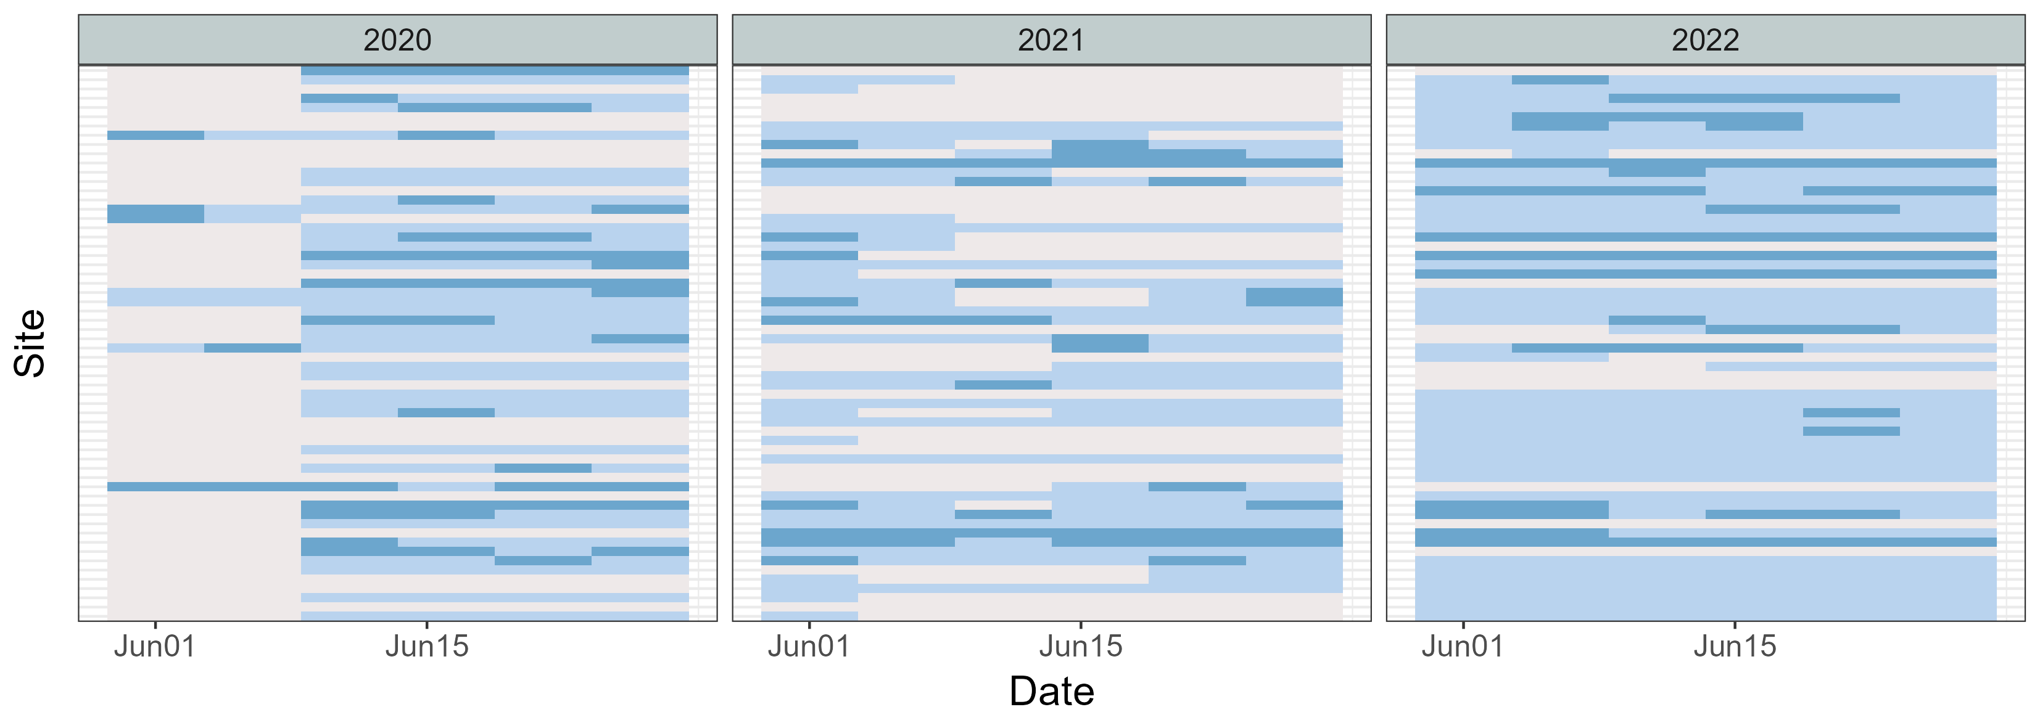
Fig. 3. Detection–nondetection matrix for Olive-sided Flycatcher (OSFL) across all sites in June of 2020, 2021, and 2022, using a 5-day detection window. Grey cells indicate periods when ARUs were not functioning, light blue cells indicate OSFL absence (0), and dark blue cells indicate OSFL presence (1). This matrix was used as the input for the occupancy model.
Occupancy models estimate two processes: (1) occupancy probability (ψ), the probability that a site is truly occupied, and (2) detection probability (p), the probability of detecting the species given it is present. For the occupancy component, we included seven LiDAR-derived habitat variables summarized within a 100-m radius around each site, representing the approximate area a bird may occupy when detected (Pérez-Granados 2025). These covariates were: (1) distance to stream, wetland, or lake edge; (2) distance to polygon stand edge; (3) canopy closure at 1–3 m; (4) canopy closure at 3–10 m; (5) canopy closure >10 m; (6) the proportion of the surrounding polygon with forest age >80 years; and (7) the proportion of deciduous trees with DBH >10 cm. For the detection component, we included two covariates: (1) Julian day and (2) canopy closure at 1–3 m, representing understory vegetation density. Occupancy models were fitted using the PGOcc() function in the spOccupancy R package (cite).
To examine landscape-level patterns in occupancy and detection probability, we generated spatial predictions using the covariates identified as significant in the occupancy model. Raster layers for these covariates were aggregated to a 15-m analysis resolution and used as inputs to the fitted occupancy model to obtain posterior predictive samples for every grid cell across the study area.

Results

Temporal pattern
We compared candidate GAMs that differed in their treatment of seasonal smoothing, year effects, and site-level random effects (Table 1). Models m4 and m6 had the lowest AICc values and received substantially higher support (wAIC = 0.79 and 0.21, respectively) than all alternative models, indicating that both captured the data structure reasonably well.
In the model with a single seasonal smooth (m4), there was strong evidence of seasonal variation in detections (χ² = 249.6, p < 0.001). Population-level predictions showed a pronounced seasonal pattern, that detections increased sharply in early spring, peaked in mid-June, and exhibited a smaller secondary peak in mid-July (Fig. 4-A1). Site-year random effects contributed substantially to model fit (χ² = 525.9, p < 0.001), with site-years differing widely in baseline detection rates. Some locations showed predicted counts several-fold higher or lower than the population-level mean (Fig. 4-A2). Overall, m4 explained approximately 40% of the deviance (Fig. 4-A3).
The model with year-specific seasonal smooths (m6) produced a similar seasonal pattern but allowed peak timing and magnitude to vary among years. Seasonal effects remained significant across all three years (2020: χ² = 124.5, p = 0.024; 2021: χ² = 83.5, p < 0.001; 2022: χ² = 144.0, p < 0.001). All years exhibited a primary peak in mid-June followed by a secondary peak in mid-July, although the smoothness and height of these peaks differed among years (Fig. 4-B1). Site-year random effects again explained considerable variation (χ² = 519.9, p < 0.001), reflecting persistent differences in baseline detection rates among site-years (Fig. 4-B2). Model m6 explained slightly more deviance (41.4%) than m4 (Fig. 4-B3), although the improvement was modest.

Table 1 AICc-based comparison of candidate GAM models. Models are listed in order of increasing AICc. The two highest-ranked models (bolded) exhibited the strongest empirical support. Full model specifications are provided in the Methods section and illustrated in Fig. S1.
Model | DF | AICc | Delta AICc | AICc weight
m4 | 40 | 5017 | 0 | 79%
m6 | 52 | 5020 | 3 | 21%
m5 | 36 | 5082 | 65 | 0%
m3 | 42 | 5085 | 68 | 0%
m2 | 31 | 5089 | 72 | 0%
m1 | 29 | 5103 | 86 | 0%
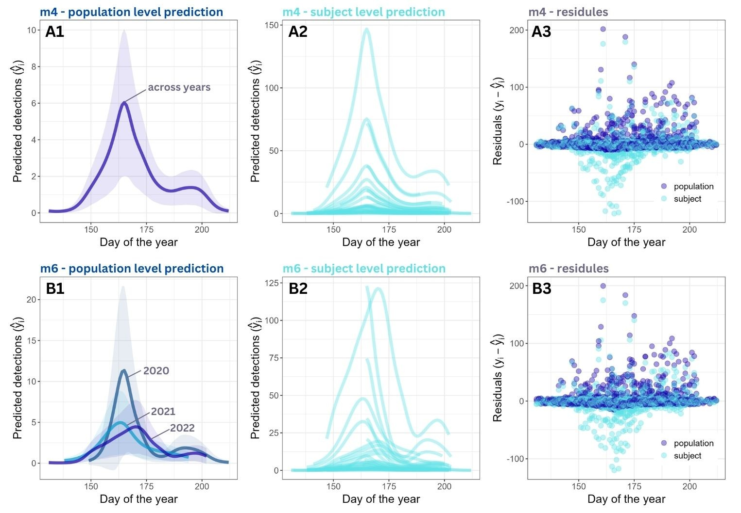
Fig. 4. Model predictions at the (1) population level, (2) site-year (subject) level, and (3) model residuals for (A) model 4 and (B) model 6. Both models showed a bimodal seasonal pattern in OSFL vocal activity and substantial variation among site-year combinations.

Spatial pattern
The full model, which included all candidate occupancy and detection covariates, had a lower WAIC (WAIC = 643.78) than the null model containing only an intercept for occupancy (WAIC = 650.07), indicating improved fit when habitat and detection covariates were included.
Among the occupancy covariates, canopy closure above 10 m had the strongest effect on site use, with a posterior effect size mean of −2.02 (95% credible interval: −3.60 to −0.52), indicating that OSFL were less likely to occupy sites with dense high-canopy cover (Fig. 5A). Other occupancy covariates, including lower canopy closure between 3-10m and above 10m, distance to wetland edges, and forest age, had weaker effects, with 95% credible intervals overlapping zero (Fig. 5A). For detection covariates, canopy closure at 1–3 m had a small but significant negative effect (posterior mean = −0.023, 95% CI: −0.040 to −0.006), suggesting that denser low-canopy cover slightly reduced the likelihood of detecting singing OSFL during a survey (Fig. 5B). While Julian day showed no clear effect on the OSFL detectability during the survey period (Fig. 5B).
Landscape-level predictions revealed distinct spatial patterns in occupancy and detection (Fig. 6). Occupancy probability was highest in young forest stands with lower canopy closure at >10 m, particularly in the northwest of the study area and along the eastern shoreline of Tezzeron Lake (Fig. 6A). In contrast, detection probability exhibited much lower values across the forest (Fig. 6B). Most of the area showed predicted detection probability below 0.5, with the lowest detection probabilities occurring in dense shrub habitats where low-height canopy closure (1–3 m) was greatest.
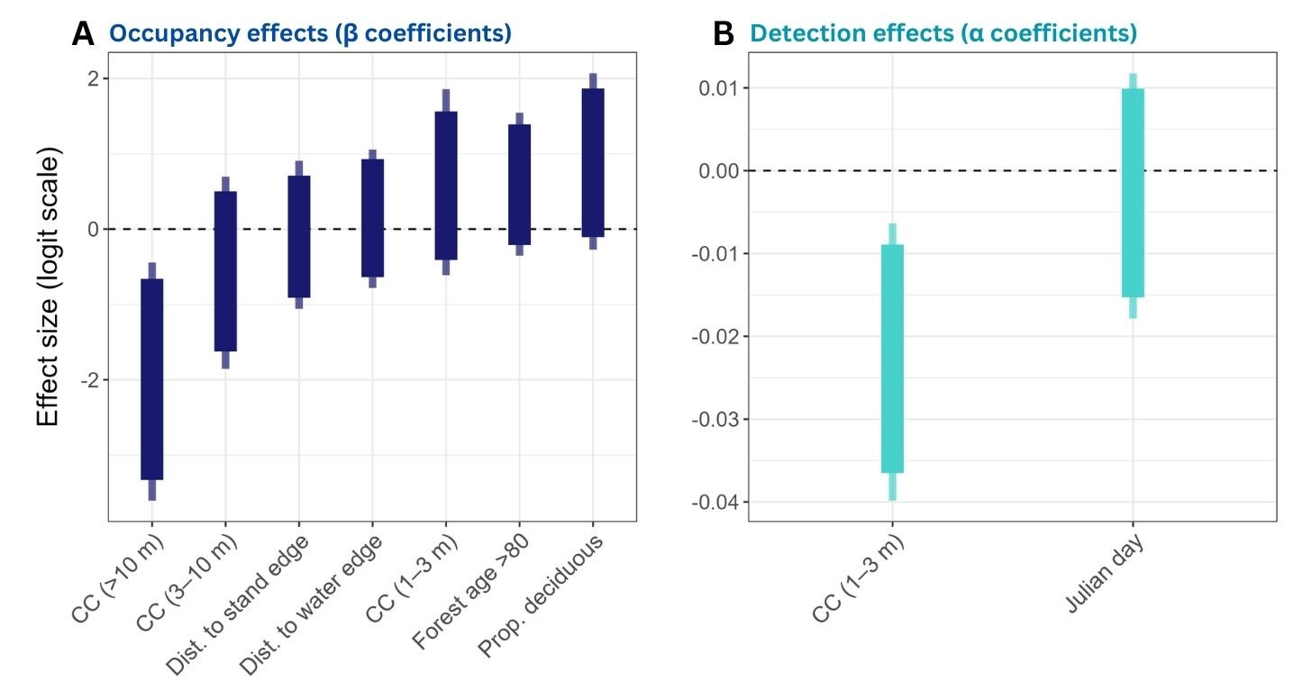
Fig. 5. Posterior effect sizes of covariates on (A) occupancy and (B) detection probabilities for OSFL. Thick bars represent 90% credible intervals, and thin bars represent 95% credible intervals. All covariates were standardized prior to modeling.
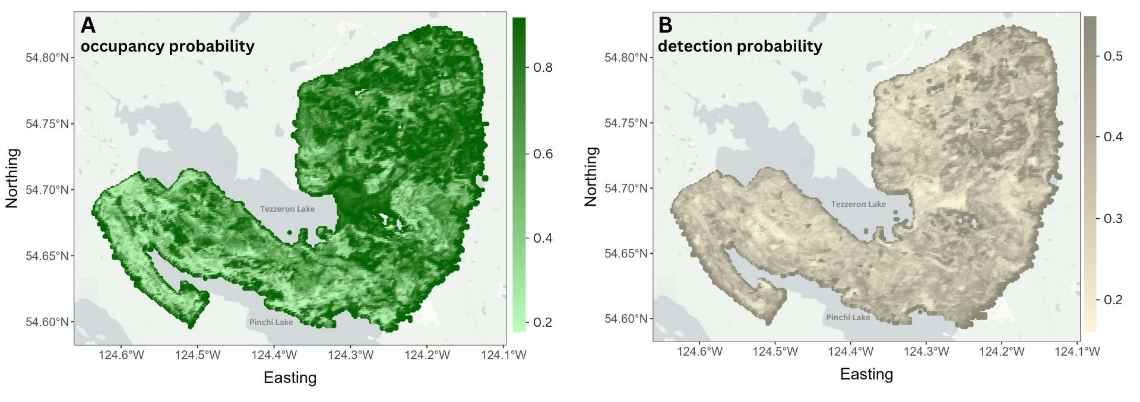
Fig. 6. Spatial predictions from the occupancy model for OSFL in the study area. (A) Predicted occupancy probability ($ψ$), showing the likelihood that a site is occupied. (B) Predicted detection probability ($p$), indicating the probability of detecting the species at a site if it is present.

Discussion

For temporal pattern
Our study revealed clear and consistent seasonal patterns in Olive-sided Flycatcher (OSFL) vocal activity during the breeding season. Both the single-smooth model (m4) and the year-specific smooth model (m6) identified a primary peak in detections in mid-June, followed by a smaller secondary peak in mid-July (Fig. 4). This bimodal pattern may indicate elevated post-breeding singing activity following reproductive success (Fig. 7), a behaviour documented in other warbler species (cite). Future research could investigate this phenomenon more explicitly using the fine-scale temporal information obtained from passive acoustic monitoring. From a survey-design perspective, targeting the mid-June peak is likely to maximize detection probability, while the secondary peak in mid-July provides additional opportunities for late-season monitoring.
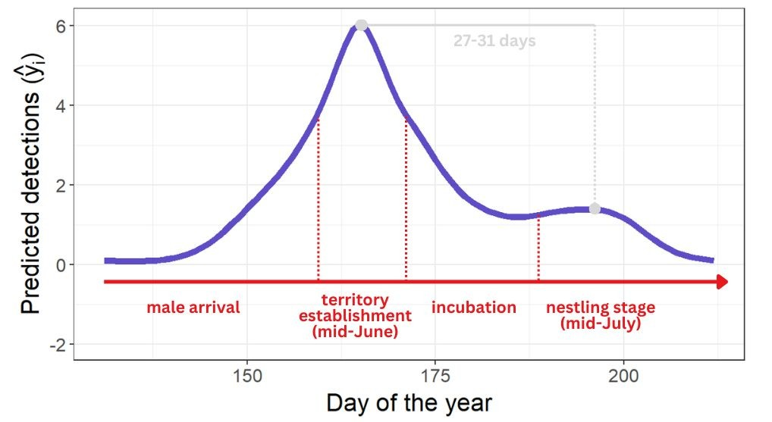
Fig. 7. Detailed view of Fig. 4A1, highlighting the potential breeding phenology stages of Olive-sided Flycatchers (OSFL) that align with the seasonal vocal activity curve derived from passive acoustic monitoring.

Although the overall seasonal pattern was broadly similar across years, m6 revealed modest interannual differences in the magnitude, timing, and smoothness of the peaks (Fig. 4). Allowing seasonal curves derived from passive acoustic monitoring to vary by year provides valuable insight into between-year variation. For example, environmental conditions such as spring temperature can influence the timing of breeding phenology in migratory birds (cite), potentially contributing to the observed variation. These findings underscore the importance of repeated sampling across multiple breeding seasons for accurately estimating temporal trends and informing conservation decisions for this species of conservation concern.

For spatial pattern
The inclusion of habitat and detection covariates substantially improved model performance relative to the null model, underscoring the importance of accounting for both ecological and observational processes when estimating OSFL occupancy. Among habitat covariates, canopy closure emerged as the dominant driver of occupancy. Dense high-canopy closure (>10 m) strongly reduced the probability of site use, consistent with previous observations that OSFL prefer younger or more open forest stands where sparser overstory cover may enhance foraging opportunities and availability of singing perches (cite). Landscape-level predictions mirrored these patterns, with the highest occupancy probabilities occurring in young stands and areas with low tall-canopy cover, particularly in the northwest and along the Tezzeron Lake shoreline. Detection probabilities, in contrast, were generally low across the landscape and were influenced mainly by understory structure. Higher low-canopy closure (1–3 m) slightly reduced detectability, likely due to sound attenuation or acoustic obstruction in dense shrub layers.

Workflows for defining temporal and spatial patterns using passive acoustic monitoring
Workflow:
- (Audio data processing) Run BirdNET for the target species (Make sure that the data has site, year, month, day info, species, and confidence value)
- (Audio data processing) Apply species-specific threshold (filter by threshold)
- Apply zero-filling based on effort data.
- (Modelling) Select sites that is more than few days of target species detection (filter by site)
- (Modelling) Identify the effort to include inactivity time and location – zero filling
(Modelling) Use GAM modelling to identify the modelling pattern

Workflow
- Run BirdNET for the target species (Make sure that the data has site, year, month, day info, species, and confidence value)
- Apply species-specific threshold (filter by threshold)
- Filter the time that is within stable population status (filter by time)
- Identify the effort to include inactivity time and location – zero filling
- Use Occupancy modelling to identify the modelling pattern

References

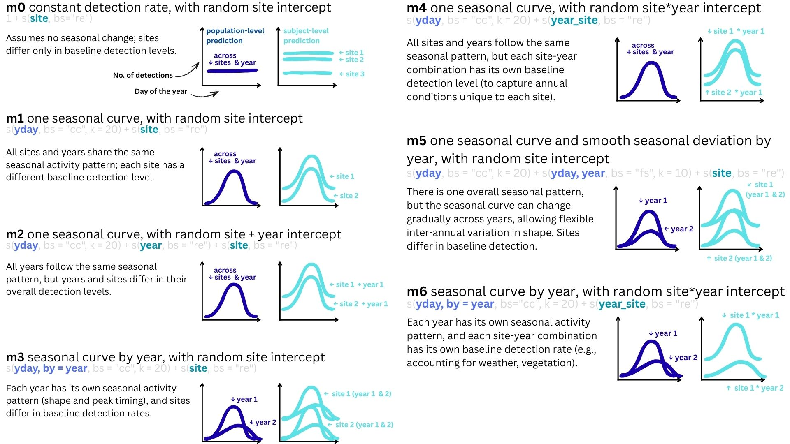

Fig. S1 Specifications of the candidate GAM models, from the null model to the most complex form. All models included Julian day as a cyclic smooth to capture seasonal detection patterns and random effects to account for variation among sites and years. For each model, we provide the model definition, corresponding R code, ecological interpretation, and illustrative predictions: population-level predictions are shown as dark blue curves, and site-year (subject-level) predictions as light blue curves.

