Integrating passive acoustic monitoring and modelling to quantify seasonal and habitat-driven vocal activity of Olive-sided Flycatchers

Abstract
Bird vocalizations are a primary cue for detecting many species; however, species-specific spatiotemporal variation in singing behaviour can bias survey results, particularly when community monitoring programs rely on a single, standardized protocol across multiple species. We used three years of passive acoustic monitoring (PAM) in the John Prince Research Forest, British Columbia, combined with BirdNET automated detections, to quantify seasonal and habitat-related patterns in Olive-sided Flycatcher (Contopus cooperi) vocal activity. Generalized additive models revealed a pronounced peak in detections in mid-June, followed by a smaller secondary peak in mid-July, with modest interannual variation in timing and magnitude. Occupancy modelling showed that dense high-canopy stands reduced site use, while dense low-canopy vegetation slightly lowered detectability. These findings identify optimal periods and habitats for OSFL surveys. Overall, our study demonstrates that PAM can effectively capture species-specific temporal and spatial activity patterns, providing data-driven insights to refine survey design, improve detection, and support informed conservation decisions.

Introduction
Bird vocalizations play a central role in communication, territory defence, mate attraction, and social interactions, making acoustic cues the primary means that many species are detected during surveys (Dawson and Efford 2009). Because vocal activity varies across seasons, and habitat types, the probability of detecting a species is closely tied to the underlying spatiotemporal patterns of vocal behaviour. These patterns can differ substantially among species: some vocalize intensely during narrow dawn windows, whereas others sing at lower levels throughout the day; some begin breeding and vocalizing early in the year, while others peak later in the season (Singer et al. 2025). Consequently, understanding when and where species vocalize is fundamental for designing effective survey strategies and accurately monitoring populations over long-term and large spatial scales.
North America benefits from several long-term, large-scale bird monitoring initiatives that combine the efforts of professional biologists and community scientists. Structured programs such as the Breeding Bird Survey (https://www.birdscanada.org/bird-science/breeding-bird-survey) and Christmas Bird Count (https://www.birdscanada.org/bird-science/christmas-bird-count) follow standardized protocols that define survey windows, routes, and sampling effort, ensuring consistency and comparability across years. In parallel, flexible platforms like eBird (https://ebird.org) and FeederWatch (www.feederwatch.org) allow participants to record birds opportunistically across diverse locations and times, generating extensive datasets. Together, these initiatives have transformed our understanding of bird distributions and population trends, providing broad temporal and geographic coverage of observations.
Although these monitoring programs provide essential long-term and broad-scale information, their survey windows and protocols are typically standardized across species and regions. Because these designs are informed by expert knowledge, convention, and logistical constraints, they do not always align with species-specific peaks in vocal activity (Singer et al. 2025). However, vocal activity is a primary driver of probability of detection, and mismatches between survey timing and true activity patterns can introduce bias into trend estimates (Massimino et al. 2021). Even when survey protocols cannot be modified, integrating independent, data-driven information on when and where species are most vocally active can greatly improve the interpretation of existing datasets by clarifying periods of high and low probability of detection and identifying potential sources of bias (Best 1981).
Recent advances in passive acoustic monitoring (PAM), combined with automated identification tools such as BirdNET (Kahl et al. 2021), make it possible to quantify vocal activity at fine spatiotemporal resolutions across large scale. Continuous or semi-continuous acoustic recordings provide objective, high-frequency measures of when species vocalize, capturing seasonal shifts, and habitat-specific variation that would be logistically infeasible to document through traditional field surveys (Shonfield and Bayne 2017). These data-driven activity profiles can refine survey timing, inform modelling approaches, and reveal behavioural patterns not detectable through conventional monitoring.
In this study, we use three years of PAM data from the John Prince Research Forest in central British Columbia, processed with BirdNET, to quantify the spatiotemporal vocal activity patterns of Olive-sided Flycatcher (OSFL), a late-breeding species categorized as Special Concern in Canada. Our objectives were: (1) to characterize OSFL seasonal vocal activity and identify species-specific peak periods, and (2) to determine the habitat features associated with OSFL vocal activity to reveal spatial patterns of occupancy. By outlining a workflow that integrates PAM-derived detections with habitat modelling, this study provides an approach that can be applied to other species to define data-driven spatiotemporal activity patterns. Such information has the potential to refine survey design, improve interpretation of conventional monitoring datasets, and help identify sources of detectability bias.

Methods

Target species and study area
The target species was the Olive-sided Flycatcher (Contopus cooperi; OSFL), a long-distance migratory songbird. It is currently listed as Least Concern by the IUCN (BirdLife International 2025) but was designated as Special Concern by the Committee on the Status of Endangered Wildlife in Canada (Environment and Climate Change Canada 2019). Olive-sided Flycatchers breed in coniferous and mixed forests across western and boreal North America, typically near forest edges with tall trees or snags for perching, adjacent to open areas containing standing trees and snags. Males defend large territories and produce frequent, far-carrying vocalizations, most notably the characteristic “quick-three-beers” song (Audio 1).
The study was conducted in the John Prince Research Forest, covering approximately 16,000 ha, located in central British Columbia, Canada (54°27'N, 124°10'W; 700 m a.s.l.) within the dry sub-boreal spruce biogeoclimatic zone. Acoustic data were collected using 66 AudioMoth (Hill et al. 2018), each deployed at least 2 km apart to minimize spatial autocorrelation. Acoustic data were collected during the breeding seasons from 2020 to 2022 (May–July), between 4am and 7am. Recordings were scheduled for 1-minute recording intervals followed by 4 minutes of inactivity, resulting in 12 recordings per hour and 36 recordings per day. In total, 67,301 one-minute recordings were obtained. All recordings were standardized to a 48 kHz sampling rate and stored as mono Pulse Code Modulation (PCM) WAV files.

Audio processing
Collected acoustic data were analyzed using the BirdNET Analyzer v2.4 model (https://github.com/BirdNET-Team/BirdNET-Analyzer), implemented via the Python module running in a local terminal. To retain more true positive detections in the initial analysis stage, we set the parameter min_conf, which filters out results below a specified confidence threshold, to 0.1. Processing the entire dataset, which comprised 1.5 terabytes of audio, required approximately 72 consecutive hours.
A BirdNET species-specific threshold of 0.35 was applied for OSFL detections to ensure a precision of 0.95 (i.e., about 95% of the detections were true detections). This value was defined by Tseng et al. (2025), where species-specific thresholds were calculated for common species using the same dataset. Refer to Tseng et al. (2025)for a detailed framework on how these species-specific thresholds were defined. At sites with at least one OSFL detection, the number of active ARU days ranged from 1 to 54 per year, with a mean of 6.84 ± 10.89 days per ARU per year (Fig. 1).
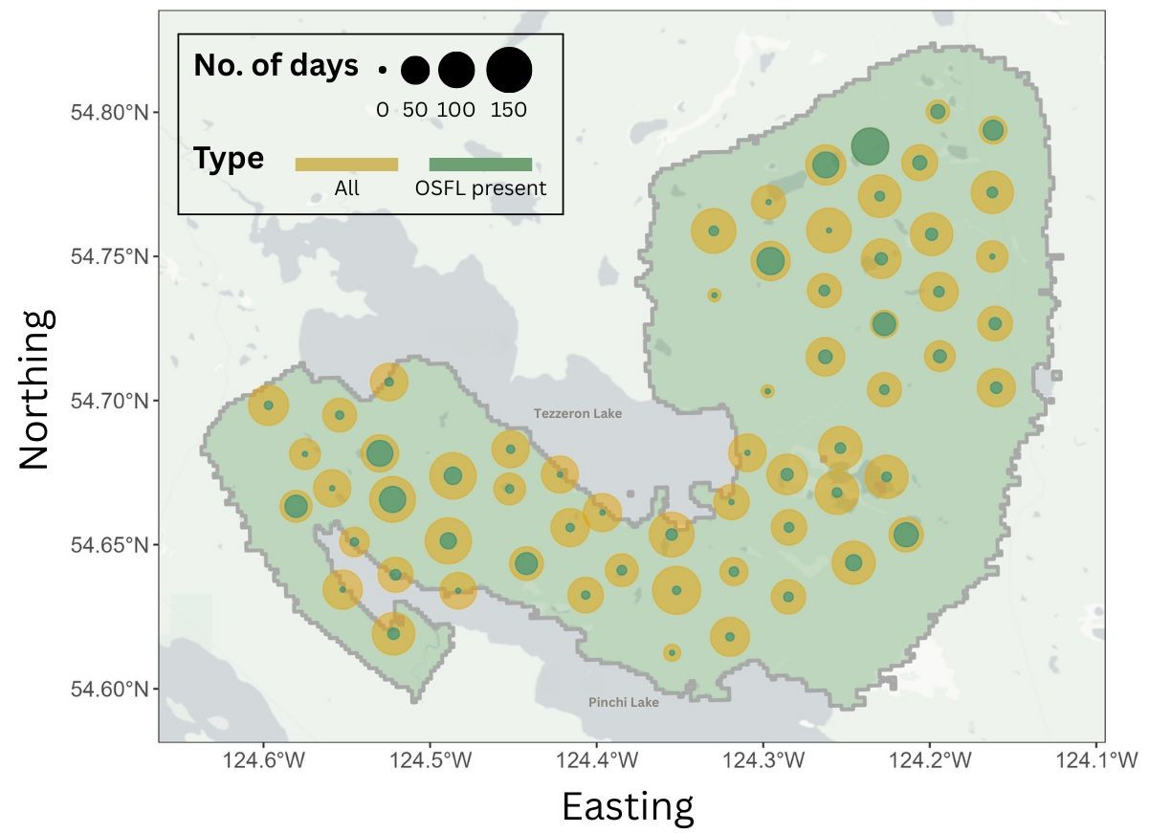
Fig. 1. Site map illustrating survey effort across years, where dot size represents total ARU deployment days (yellow) and days with Olive-sided Flycatcher (OSFL) detections (green). Northeastern sites showed particularly high detection frequency, with OSFL detected on most of the recording days.

Modelling temporal pattern – GAM analysis
To characterize seasonal vocal activity of OSFL, we first refined the dataset by retaining only site–year combinations with at least two consecutive days of OSFL detections (hereafter, “selected sites”). This filter excluded sites with very few or sporadic detections, as single-day detections may represent opportunistic vocalizations or transient individuals rather than meaningful patterns of local activity. Using this criterion, we identified 9, 10, and 13 selected sites in 2020, 2021, and 2022, respectively. A larger proportion of selected sites had detections during June and July (Fig. 2).
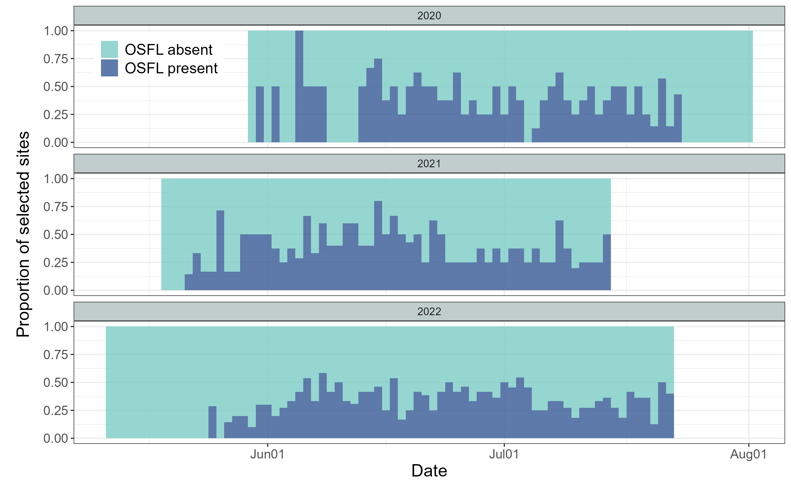
Fig. 2. Seasonal activity of qualified ARUs, defined as ARUs with at least two consecutive days of Olive-sided Flycatcher (OSFL) detections within a site-year. This included 9, 10, and 13 qualified ARUs in 2020, 2021, and 2022, respectively. Qualified ARUs with at least one OSFL detection that day are shown in dark blue, and those without detections are shown in light blue.
We used Generalized Additive Models (GAMs) given their flexibility in capturing nonlinear and cyclic temporal patterns. For all candidate models, the response variable was the daily number of OSFL detections (i.e., the total detections across all 36 one-minute recordings per day). Julian day was included as a cyclic smooth term to represent seasonal activity patterns, and site and year were included to account for spatial and interannual variation. We constructed a suite of models of increasing complexity (see also Fig. S1 for model ecological meaning and formula):
- model 0 (m0): Null model. A constant detection rate with a random site intercept.
- model 1 (m1): A single seasonal curve with a random site intercept.
- model 2 (m2): A single seasonal curve with random site and year intercepts.
- model 3 (m3): Year-specific seasonal curves with a random site intercept.
- model 4 (m4): A single seasonal curve with a random site × year intercept.
- model 5 (m5): A single seasonal curve with smooth year-specific deviations and a random site intercept.
- model 6 (m6): Year-specific seasonal curves with a random site × year intercept.
All models were fitted using the gam() function in the mgcv R package (Wood 2001). Maximum likelihood (ML) was used to enable valid comparison of Akaike Information Criterion (AIC) values across models with differing fixed-effects structures (Zuur et al. 2009). The model with the lowest AIC value was considered best supported by the data. This top model was then refitted using restricted maximum likelihood (REML) to obtain stable smoothing-parameter estimates and to generate the final inference and visualizations (Zuur et al. 2009).

Modelling spatial pattern – occupancy analysis
We used occupancy modelling to examine the spatial distribution of OSFL using acoustic monitoring data. To satisfy the closure assumption, that occupancy status remains constant across repeated surveys, we restricted the analysis to 1–30 June, when OSFL were actively singing and the occupancy status is stable at breeding territories (see Results - Fig. 4). To minimize false positives, we applied the species-specific BirdNET confidence thresholds (see Methods - Audio processing), ensuring 95% precision in identifying OSFL vocalizations. To meet the assumption of independence across sampling occasions, we aggregated ARU detections into 5-day intervals to construct the detection history (presence/absence) for OSFL (Fig. 3). This window length follows recommendations for continuous-monitoring sensors, including autonomous recording units and camera (Chambert et al. 2018; Goldstein et al. 2024).
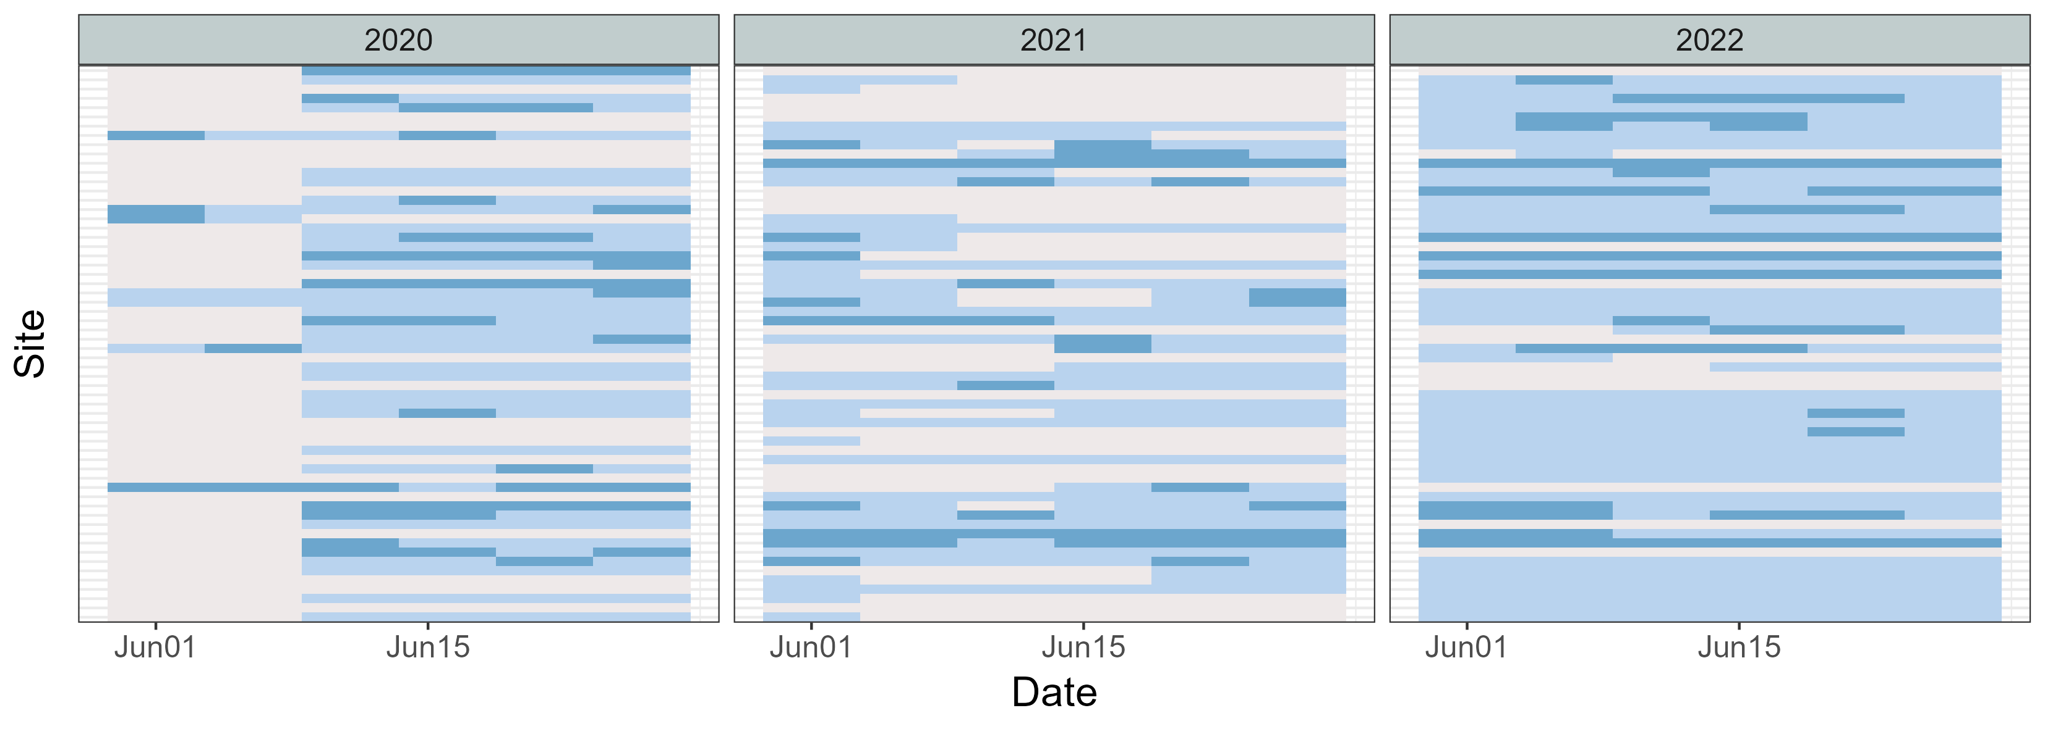
Fig. 3. Detection history for Olive-sided Flycatcher (OSFL) across sites in June of 2020, 2021, and 2022, using a 5-day detection window. Grey cells indicate periods when ARUs were not functioning, light blue cells indicate OSFL absence (0), and dark blue cells indicate OSFL presence (1). This detection history was used as the input for the occupancy model.
Occupancy models estimate two processes: (1) occupancy probability (ψ), the probability that a site is truly occupied, and (2) detection probability (p), the probability of detecting the species given it is present. For the occupancy component, we included seven LiDAR-derived habitat variables summarized within a 100-m radius around each site, representing the approximate area a bird may occupy when detected (Pérez-Granados 2025). These covariates were: (1) distance to stream, wetland, or lake edge; (2) distance to polygon stand edge; (3) canopy closure at 1–3 m; (4) canopy closure at 3–10 m; (5) canopy closure >10 m; (6) the proportion of the surrounding polygon with forest age >80 years; and (7) the proportion of deciduous trees with DBH >10 cm. For the detection component, we included two covariates: (1) Julian day and (2) canopy closure at 1–3 m, representing understory vegetation density. Occupancy models were fitted using the PGOcc() function in the spOccupancy R package (Doser et al. 2022).
To examine landscape-level patterns in occupancy and detection probability, we generated spatial predictions using the covariates identified as significant in the occupancy model. Raster layers for these covariates were aggregated to a 15-m analysis resolution and used as inputs to the fitted occupancy model to obtain posterior predictive samples for every grid cell across the study area.

Results

Temporal pattern
We compared candidate GAMs that differed in their treatment of seasonal smoothing, year effects, and site-level random effects (Table 1). Models m4 and m6 had the lowest AICc values and received substantially higher support (wAIC = 0.79 and 0.21, respectively) than all alternative models, indicating that both captured the data structure reasonably well.
In the model with a single seasonal smooth (m4), there was strong evidence of seasonal variation in detections (χ² = 249.6, p < 0.001). Population-level predictions showed a pronounced seasonal pattern, that detections increased sharply in early spring, peaked in mid-June, and exhibited a smaller secondary peak in mid-July (Fig. 4-A1). Site-year random effects contributed substantially to model fit (χ² = 525.9, p < 0.001), with site-years differing widely in baseline detection rates. Some locations showed predicted counts several-fold higher or lower than the population-level mean (Fig. 4-A2). Overall, m4 explained approximately 40% of the deviance (Fig. 4-A3).
The model with year-specific seasonal smooths (m6) produced a similar seasonal pattern but allowed peak timing and magnitude to vary among years. Seasonal effects remained significant across all three years (2020: χ² = 124.5, p = 0.024; 2021: χ² = 83.5, p < 0.001; 2022: χ² = 144.0, p < 0.001). All years exhibited a primary peak in mid-June followed by a secondary peak in mid-July, although the smoothness and height of these peaks differed among years (Fig. 4-B1). Site-year random effects again explained considerable variation (χ² = 519.9, p < 0.001), reflecting persistent differences in baseline detection rates among site-years (Fig. 4-B2). Model m6 explained slightly more deviance (41.4%) than m4 (Fig. 4-B3), although the improvement was modest.

Table 1 AICc-based comparison of candidate GAM models. Models are listed in order of increasing AICc. The two highest-ranked models (bolded) exhibited the strongest empirical support. Full model specifications are provided in the Methods section and illustrated in Fig. S1.
Model | DF | AICc | Delta AICc | AICc weight
m4 | 40 | 5017 | 0 | 79%
m6 | 52 | 5020 | 3 | 21%
m5 | 36 | 5082 | 65 | 0%
m3 | 42 | 5085 | 68 | 0%
m2 | 31 | 5089 | 72 | 0%
m1 | 29 | 5103 | 86 | 0%
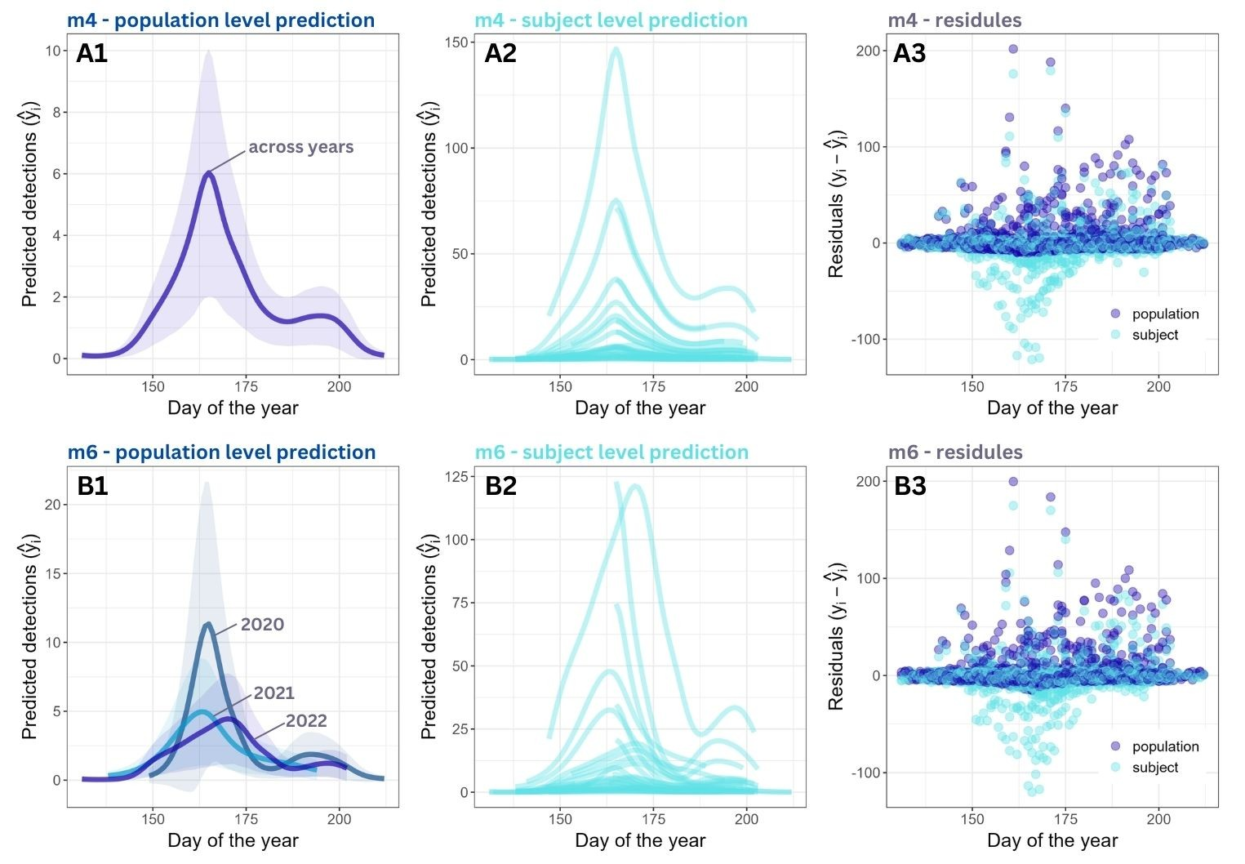
Fig. 4. Model predictions at the (1) population level, (2) site-year (subject) level, and (3) model residuals for (A) model 4 and (B) model 6. Both models showed a bimodal seasonal pattern in OSFL vocal activity and substantial variation among site-year combinations.

Spatial pattern
The full model, which included all candidate occupancy and detection covariates, had a lower WAIC (WAIC = 643.78) than the null model containing only an intercept for occupancy (WAIC = 650.07), indicating improved fit when habitat and detection covariates were included.
Among the occupancy covariates, canopy closure above 10 m had the strongest effect on site use, with a posterior effect size mean of −2.02 (95% credible interval: −3.60 to −0.52), indicating that OSFL were less likely to occupy sites with dense high-canopy cover (Fig. 5A). Other occupancy covariates, including lower canopy closure between 3-10m and above 10m, distance to wetland edges, and forest age, had weaker effects, with 95% credible intervals overlapping zero (Fig. 5A). For detection covariates, canopy closure at 1–3 m had a small but significant negative effect (posterior mean = −0.023, 95% CI: −0.040 to −0.006), suggesting that denser low-canopy cover slightly reduced the likelihood of detecting singing OSFL during a survey (Fig. 5B). While Julian day showed no clear effect on the OSFL detectability during the survey period (Fig. 5B).
Landscape-level predictions revealed distinct spatial patterns in occupancy and detection. Occupancy probability was highest in young forest stands with lower canopy closure at >10 m, particularly in the northwest of the study area and along the eastern shoreline of Tezzeron Lake (Fig. 6A). In contrast, detection probability exhibited much lower values across the forest (Fig. 6B). Most of the area showed predicted detection probability below 0.5, with the lowest detection probabilities occurring in dense shrub habitats where low-height canopy closure (1–3 m) was greatest.
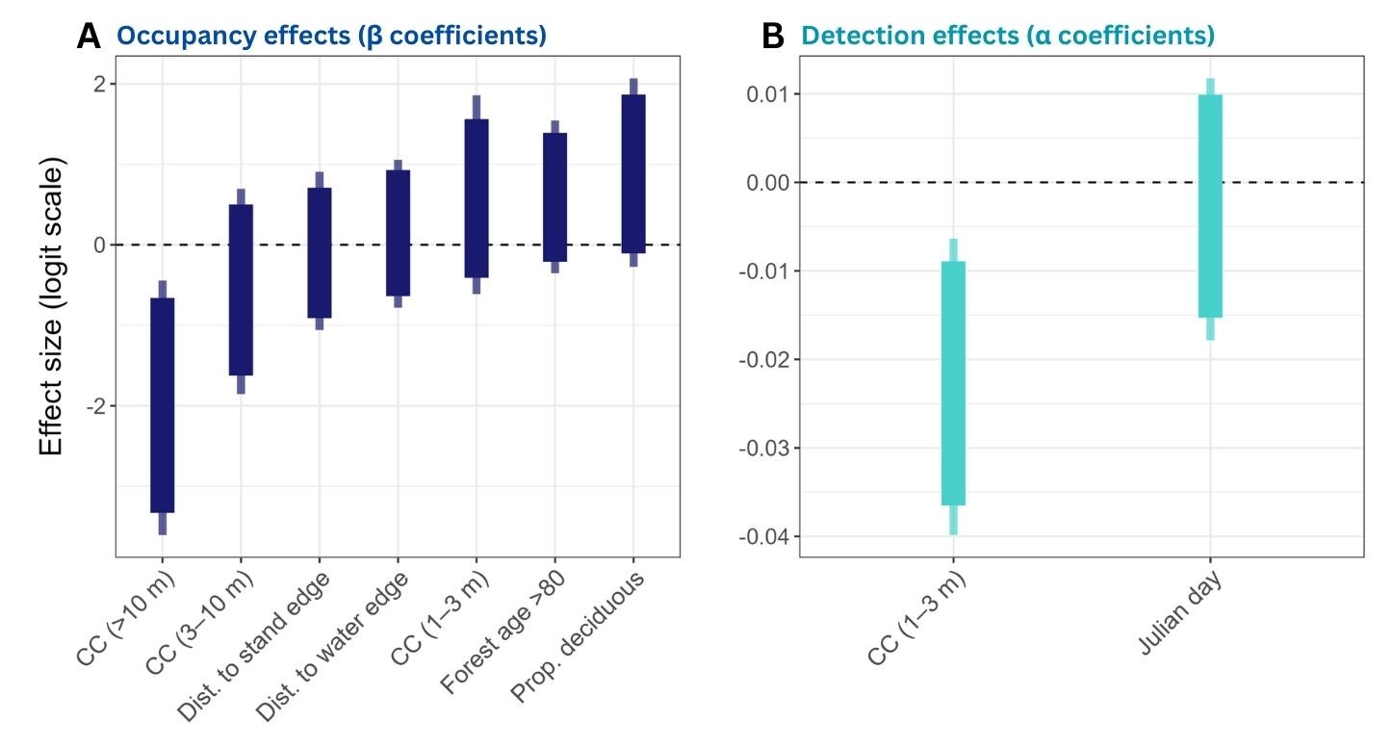
Fig. 5. Posterior effect sizes of covariates on (A) occupancy and (B) detection probabilities for Olive-sided Flycatcher. Thick bars represent 90% credible intervals, and thin bars represent 95% credible intervals. All covariates were standardized prior to modeling.
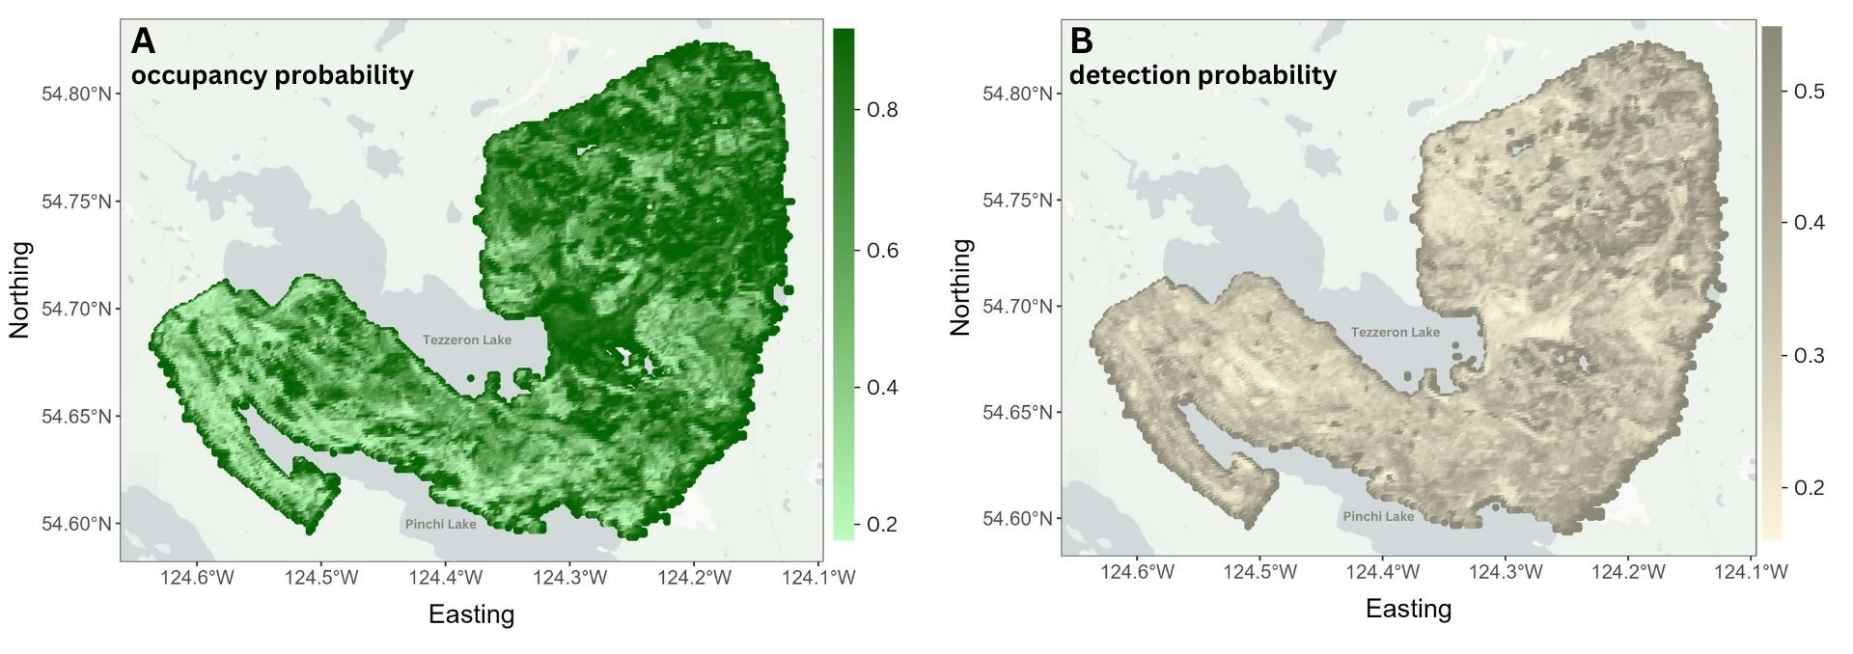
Fig. 6. Spatial predictions from the occupancy model for Olive-sided Flycatcher in the study area. (A) Predicted occupancy probability ($ψ$), showing the likelihood that a site is occupied by OSFL. (B) Predicted detection probability ($p$), indicating the probability of detecting OSFL at a site if it is present.

Discussion

For temporal pattern
Our study revealed clear and consistent seasonal patterns in Olive-sided Flycatcher (OSFL) vocal activity during the breeding season. Both the single-smooth model (m4) and the year-specific smooth model (m6) identified a primary peak in detections in mid-June, followed by a smaller secondary peak in mid-July (Fig. 4). The timing of this second peaks align with (or not align with…) – Need to read more about the phenology from previous studies. Here is the paragraph from Birds of the World. Seems like not aligning with what we found.
Phenology: Pattern of vocalizations varies throughout breeding cycle (Wright 1997a). Males sing upon arrival on breeding grounds, and they sing regularly until they attract females. Singing decreases during courtship and nest-building. During egg-laying and incubation, males sing more frequently again; rarely sing during nestling stage when busy caring for young. Probability of detection by song is 94% before arrival of female and paired status; 34% after arrival of female and pairing (Wright 1997a); 53% during incubation; 12% once young have hatched. In central Alaska, probability of detection by song at least once during 3-min Breeding Bird Survey stop was 76% during first week of Jun, 53-58% in mid-Jun, 66% in late Jun, and 43% in first week of Jul (Wright 1997a). Some singing still occurs while dependent fledglings remain with adults on territory (BA).
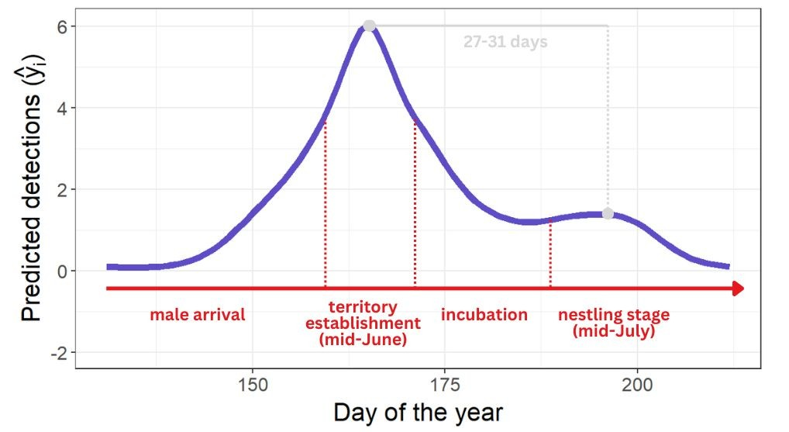
Fig. 7. Detailed view of Fig. 4A1, highlighting the potential breeding phenology stages of Olive-sided Flycatchers that align with the seasonal vocal activity curve derived from passive acoustic monitoring.

Although the overall seasonal pattern was broadly similar across years, m6 revealed modest interannual differences in the magnitude, timing, and smoothness of the peaks (Fig. 4). Allowing seasonal curves derived from passive acoustic monitoring to vary by year provides valuable insight into between-year variation. For example, environmental conditions such as spring temperature can influence the timing of breeding phenology in migratory birds, potentially contributing to the observed variation. These findings underscore the importance of repeated sampling across multiple breeding seasons for accurately estimating temporal trends and informing conservation decisions for this species of conservation concern.
While this study focused on seasonal vocal dynamics, extending analyses to 24-hour recordings would provide diel activity profiles that reveal how detection probability fluctuates throughout the day. Recent advances in low-cost autonomous recorders, expanded storage capacity, scalable cloud-based processing, and increasingly accurate machine-learning classifiers make continuous, full-season acoustic monitoring increasingly feasible. Such information can further reduce bias in survey design, especially for species whose singing behaviour is concentrated in narrow dawn or dusk windows.

For spatial pattern
The inclusion of habitat and detection covariates substantially improved model performance relative to the null model, underscoring the importance of accounting for both ecological and observational processes when estimating OSFL occupancy. Among habitat covariates, canopy closure emerged as the dominant driver of occupancy. Dense high-canopy closure (>10 m) strongly reduced the probability of site use, consistent with previous observations that OSFL prefer younger or more open forest stands where sparser overstory cover may enhance foraging opportunities and availability of singing perches. Landscape-level predictions mirrored these patterns, with the highest occupancy probabilities occurring in young stands and areas with low tall-canopy cover, particularly in the northwest and along the Tezzeron Lake shoreline. Detection probabilities, in contrast, were generally low across the landscape and were influenced mainly by understory structure. Higher low-canopy closure (1–3 m) slightly reduced detectability, likely due to sound attenuation or acoustic obstruction in dense shrub layers.

Conclusion
This study demonstrates that passive acoustic monitoring can effectively characterize species-specific temporal and spatial patterns in Olive-sided Flycatcher vocal activity. Aligning surveys with the mid-June peak, and focusing efforts in young or open forest stands, is likely to increase both detection probability and monitoring efficiency. The modest interannual variation observed in seasonal activity underscores the value of multi-year datasets for capturing environmentally driven shifts in vocal behaviour. More broadly, our findings highlight how integrating full-season acoustic data with modelling approaches can generate species-specific spatiotemporal activity profiles, offering an evidence-based foundation to potentially refine survey protocols, reduce detectability-driven bias, and improve population assessments.

References
Best, Louis B. 1981. “Seasonal Changes in Detection of Individual Bird Species.” Studies in Avian Biology 6: 252–61.
BirdLife International. 2025. “IUCN Red List of Threatened Species: Contopus Cooperi.” IUCN Red List of Threatened Species, February 4. https://www.iucnredlist.org/en.
Chambert, Thierry, J. Hardin Waddle, David A. W. Miller, Susan C. Walls, and James D. Nichols. 2018. “A New Framework for Analysing Automated Acoustic Species Detection Data: Occupancy Estimation and Optimization of Recordings Post-Processing.” Methods in Ecology and Evolution 9 (3): 560–70. https://doi.org/10.1111/2041-210X.12910.
Dawson, Deanna K., and Murray G. Efford. 2009. “Bird Population Density Estimated from Acoustic Signals.” Journal of Applied Ecology 46 (6): 1201–9. https://doi.org/10.1111/j.1365-2664.2009.01731.x.
Doser, Jeffrey W., Andrew O. Finley, Marc Kéry, and Elise F. Zipkin. 2022. “spOccupancy: An R Package for Single-Species, Multi-Species, and Integrated Spatial Occupancy Models.” Methods in Ecology and Evolution 13 (8): 1670–78. https://doi.org/10.1111/2041-210X.13897.
Environment and Climate Change Canada. 2019. “Olive-Sided Flycatcher (Contopus Cooperi): COSEWIC Assessment and Status Report 2018.” Program descriptions;research. February 25. https://www.canada.ca/en/environment-climate-change/services/species-risk-public-registry/cosewic-assessments-status-reports/olive-sided-flycatcher-2018.html.
Goldstein, Benjamin R., Alex J. Jensen, Roland Kays, et al. 2024. “Guidelines for Estimating Occupancy from Autocorrelated Camera Trap Detections.” Methods in Ecology and Evolution 15 (7): 1177–91. https://doi.org/10.1111/2041-210X.14359.
Hill, Andrew P., Peter Prince, Evelyn Piña Covarrubias, C. Patrick Doncaster, Jake L. Snaddon, and Alex Rogers. 2018. “AudioMoth: Evaluation of a Smart Open Acoustic Device for Monitoring Biodiversity and the Environment.” Methods in Ecology and Evolution 9 (5): 1199–211. https://doi.org/10.1111/2041-210X.12955.
Kahl, Stefan, Connor M. Wood, Maximilian Eibl, and Holger Klinck. 2021. “BirdNET: A Deep Learning Solution for Avian Diversity Monitoring.” Ecological Informatics 61 (March): 101236. https://doi.org/10.1016/j.ecoinf.2021.101236.
Massimino, Dario, Sarah J. Harris, and Simon Gillings. 2021. “Phenological Mismatch between Breeding Birds and Their Surveyors and Implications for Estimating Population Trends.” Journal of Ornithology 162 (1): 143–54. https://doi.org/10.1007/s10336-020-01821-5.
Pérez-Granados, Cristian. 2025. “Birdnet Confidence Scores Decrease with Bird Distance from the Recorder: Revisiting Pérez-Granados (2023).” Ardeola 72 (2): 149–59. https://doi.org/10.13157/arla.72.2.2025.fo1.
Shonfield, Julia, and Erin Bayne. 2017. “Avian Conservation and Ecology: Autonomous Recording Units in Avian Ecological Research: Current Use and Future Applications.” Avian Conservation and Ecology 12 (1). https://doi.org/10.5751/ACE-00974-120114.
Singer, David, Johannes Kamp, Hermann Hondong, Andreas Schuldt, and Jonas Hagge. 2025. “Diel and Seasonal Vocal Activity Patterns Revealed by Passive Acoustic Monitoring Suggest Expert Recommendations for Breeding Bird Surveys Need Adjustment.” Journal of Ornithology, ahead of print, July 9. https://doi.org/10.1007/s10336-025-02307-y.
Tseng, Sunny, Dexter P. Hodder, and Ken A. Otter. 2025. “Setting BirdNET Confidence Thresholds: Species-Specific vs. Universal Approaches.” Journal of Ornithology 166 (4): 1123–35. https://doi.org/10.1007/s10336-025-02260-w.
Wood, Simon N. 2001. “Mgcv: GAMs and Generalized Ridge Regression for R.” R News.
Zuur, Alain F., Elena N. Ieno, Neil Walker, Anatoly A. Saveliev, and Graham M. Smith. 2009. Mixed Effects Models and Extensions in Ecology with R. Statistics for Biology and Health. Springer. https://doi.org/10.1007/978-0-387-87458-6.

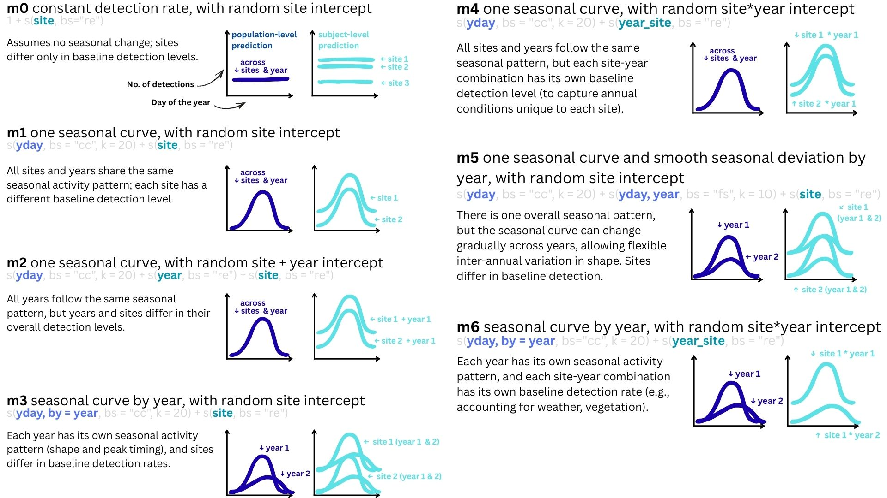

Fig. S1 Specifications of the candidate GAM models, from the null model to the most complex form. All models included Julian day as a cyclic smooth to capture seasonal detection patterns and random effects to account for variation among sites and years. For each model, we provide the model definition, corresponding R code, ecological interpretation, and illustrative predictions: population-level predictions are shown as dark blue curves, and site-year (subject-level) predictions as light blue curves.

