**Audio monitoring for temporal pattern of migratory birds: using Olive-sided Flycatcher as an example**

# Outline

During breeding season, most birds show a daily period of high singing activity, which is known as “dawn chorus” (cite). It is widely known that various environmental factors influence the dawn chorus start time, such as ambient temperature, precipitation, cloud cover, lunar phase, and existence of other species (cite). The rapid development of autonomous recording units and machine learning algorithms had notably reduced the difficulty in monitoring dawn chorus. Studies had been done to investigate the relationships between environmental factors and the dawn chorus start time; however, bird species in North American have received little attention (cite). In this study, the relationships between dawn chorus start time and ambient temperature, precipitation, cloud cover, lunar phase, and site biodiversity will be investigated for Olive-sided Flycatcher (*Contopus cooperi*), whose status is under special concern in Canada (cite). This research will inform the effects of environmental factors on the dawn chorus start time of Olive-sided Flycatcher, not only providing a baseline information for the species but also setting up a standard framework for future dawn chorus studies.

# Objectives

* Find the monthly pattern of Olive-sided Flycatcher vocal density by cumulative detections
* Determine the factors that related to the start time of dawn chorus from OSFL

Related papers:

* A global assessment of BirdNET performance: differences among continents, biomes, and species
* Using data from camera traps and autonomous recording units to evaluate and improve species-habitat inferences
* Diel and seasonal vocal activity patterns revealed by passive acoustic monitoring suggest expert recommendations for breeding bird surveys need adjustment
* Phenological mismatch between breeding birds and their surveyors and implications for estimating population trends

Potential source to compare the OSFL trends:

Idea – get the Canada wide trends from these three sources and make an comparison?

* Trend from eBird data across Canada, and BC: <https://science.ebird.org/en/status-and-trends/species/olsfly/trends-map?week=1>
* Trend from various resources in Canada, produced by Nature Counts: <https://naturecounts.ca/nc/socb-epoc/species.jsp?sp=olsfly#status-and-trends>
* Trends from breeding birds survey across Canada, and BC: <https://bbsbayes.github.io/bbsBayes2/articles/bbsBayes2.html>

Something else:

BBS protocol: <https://www.canada.ca/en/environment-climate-change/services/bird-surveys/landbird/north-american-breeding/instructions.html#toc1>

# Method and materials

## Study area

The audio data was collected in John Prince Research Forest (54° 27'N, 124° 10'W, 700 m a.s.l) in 2020 breeding season. A total of 41 recorders (AudioMoth; Open Acoustic Devices, 2020) were evenly distributed across the region (fig. of a map). Adjacent recorders were placed at least 2 km apart to ensue independent sampling. All recorders were under an identical recording schedule, repeating daily from four am to seven am, one minute on, followed by four minutes off. Recorders were deployed in the field beginning on X April 2021 (mean deployment date X April 2021; range X April 2021 – X May 2021; X±Y recorded/recorder). This resulted in 67,301 one-minute recordings collected. All recordings were formatted into a 48 kHz sampling rate and the mono pulse code modulation WAV.

## Audio data

Process through BirdNET, filter the detections by the developed threshold, based on previous publication.

Each site with at least one detection of OSFL has varied days of OSFL presence, ranging from 1 to 54 days, mean days is 6.84 +- 10.89 days (Fig.).

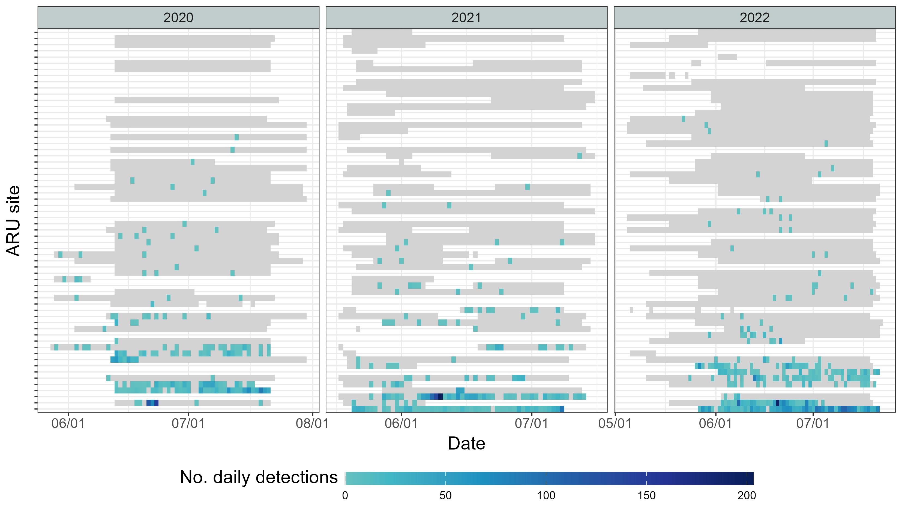

Fig. XYZ the occupancy of OSFL in sites and date. Sites were ranked by number of total OSFL detections from low (top) to high (bottom).

## Weather and environmental covariates

From ECCC Historical data,

***Modelling for temporal pattern***

Generalized additive model with polynomial terms. Try to see whether the temporal variation change due to the weather.

Qualified ARU site - at least 2 consecutive days of detection” as evidence of recurring presence during that period. This filtering was done to only use sites with at least two consective days of detection OSFL. This results in 9, 10, and 13 sites in 2020, 2021, and 2022, respectively. All the modelling and exploratory were done using data from these sites in according years. The seasonal activity can be captured roughly by the proportion of these qualified ARUs that with OSFL detections (Fig.XYZ).

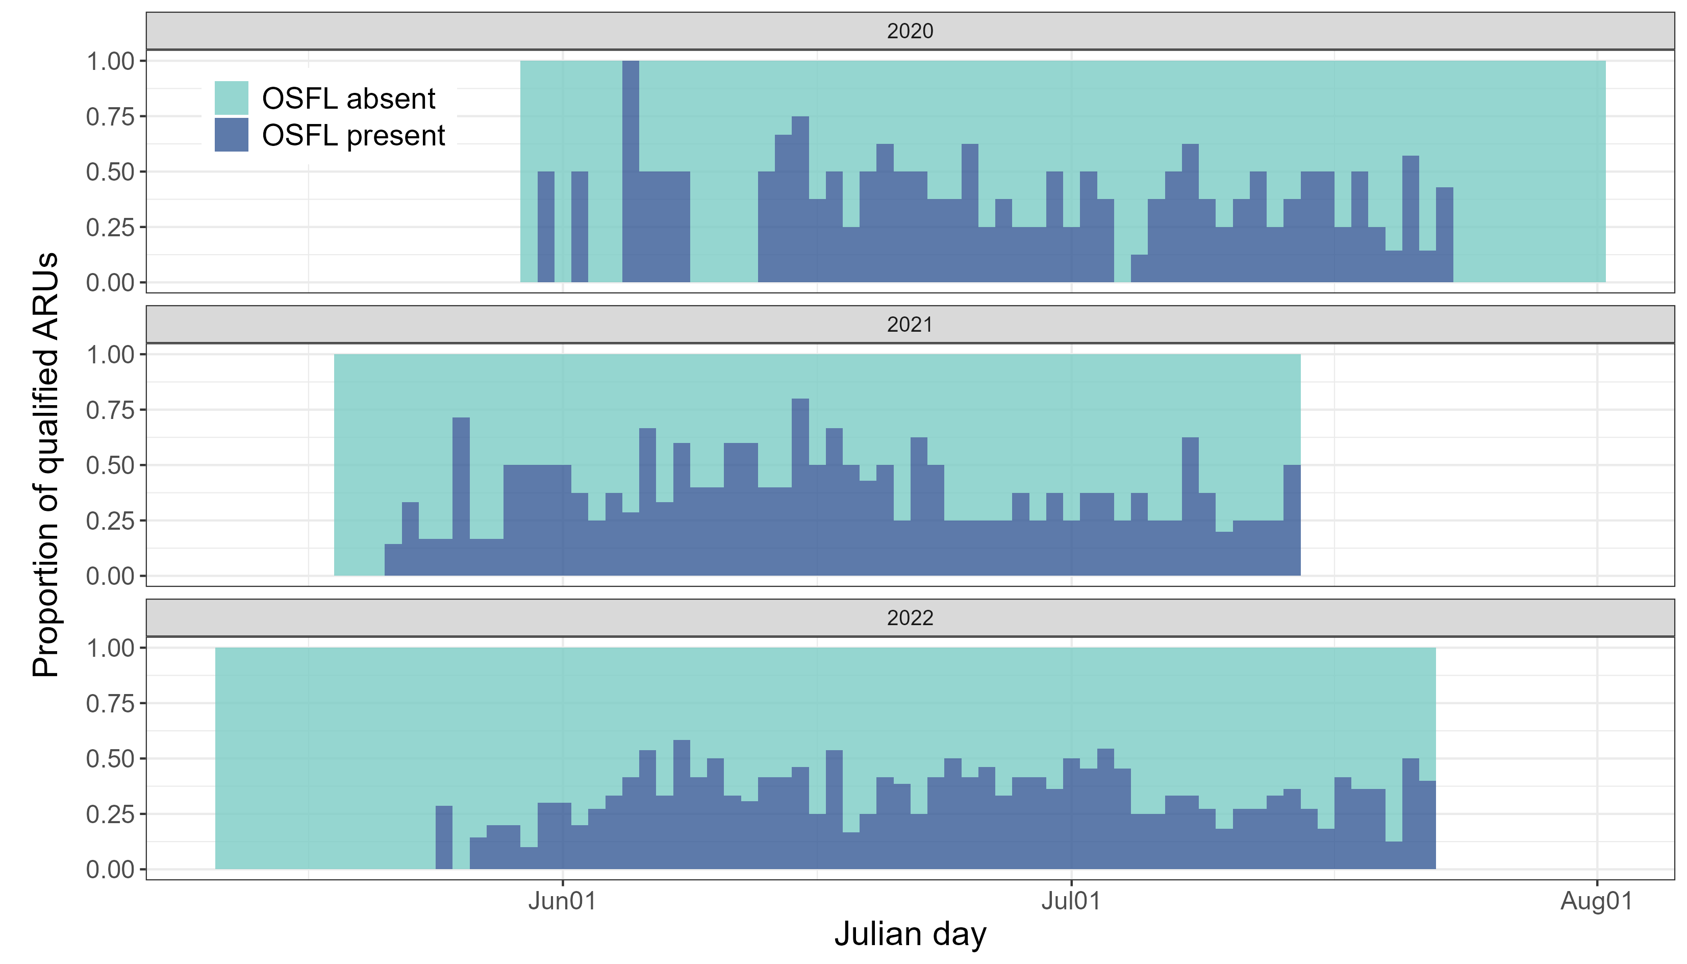

Fig.XYZ The activity of qualified ARUs.

“Model the number of detections as a negative binomial count process.  
The expected number of detections changes smoothly over the day of year,  
with a separate seasonal pattern for each year,  
while accounting for random differences in baseline detection rates across sites.

***Modelling for spatial pattern***

Occupancy modelling with LiDAR covariates. Try to identify whether the spatial variation change due to the environmental variation.

Use data from all sites (no filtering out low detection data), but need to use the result from the temporal pattern to identify the breeding season (?), or use temporal covariate to account for the temporal variation.Use grouping to get the detection matrix.

# Results

## Temporal pattern

## Spatial pattern