Assignment – 1 Northwind Database

* Create Database:

CREATE DATABASE northwind

* Create Table:

1. Supplier Table

CREATE TABLE tblSuppliers

(

SupplierID int IDENTITY(1,1) PRIMARY KEY,

CompanyName VARCHAR(40) UNIQUE NOT NULL,

ContactName VARCHAR(30) NOT NULL,

ContactTitle VARCHAR(30),

City VARCHAR(30) NOT NULL

)

1. Category Table

CREATE TABLE tblCategories

(

CategoryID int IDENTITY(1,1) PRIMARY KEY,

CategoryName VARCHAR(15) UNIQUE NOT NULL,

CategoryDescription VARCHAR(250)

)

1. Product Table

CREATE TABLE tblProducts

(

ProductID INT IDENTITY(1,1) PRIMARY KEY,

ProductName VARCHAR(40) UNIQUE NOT NULL,

SupplierID INT,

CategoryID INT,

QuantityPerUnit VARCHAR(20),

UnitPrice DECIMAL(10,4),

UnitsInStock SMALLINT,

UnitsOnOrder SMALLINT,

ReorderLevel SMALLINT,

Discontinued bit,

FOREIGN KEY (SupplierID) REFERENCES tblSuppliers(SupplierID)

ON DELETE NO ACTION ON UPDATE NO ACTION,

FOREIGN KEY (CategoryID) REFERENCES tblCategories(CategoryID)

ON DELETE NO ACTION ON UPDATE NO ACTION

)

Q1) Write a query to get a Product list (id, name, unit price) where current products cost less than $20.

==>

SELECT ProductId, ProductName, UnitPrice

FROM tblProducts

WHERE ( UnitPrice < 20 AND Discontinued = 0 )

Output:

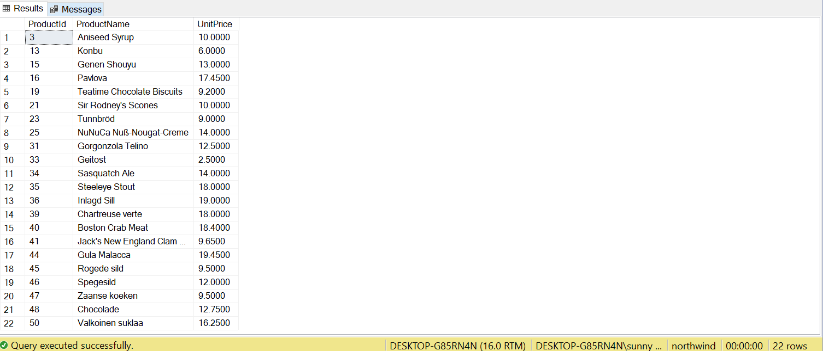

Q2) Write a query to get Product list (id, name, unit price) where products cost between

$15 and $25.

==>

SELECT ProductId, ProductName, UnitPrice

FROM tblProducts

WHERE UnitPrice BETWEEN 15 AND 25

Output:

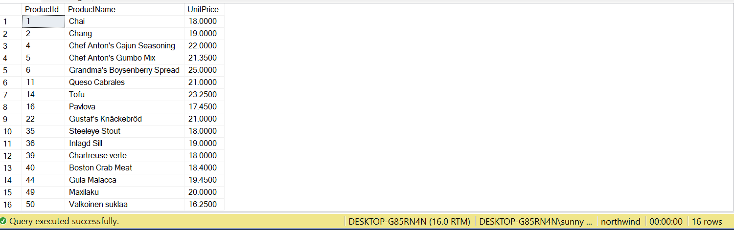

Q3) Write a query to get Product list (name, unit price) of above average price.

==>

SELECT ProductName, UnitPrice

FROM tblProducts

WHERE UnitPrice > (

SELECT AVG(UnitPrice) FROM tblProducts

)

Output:

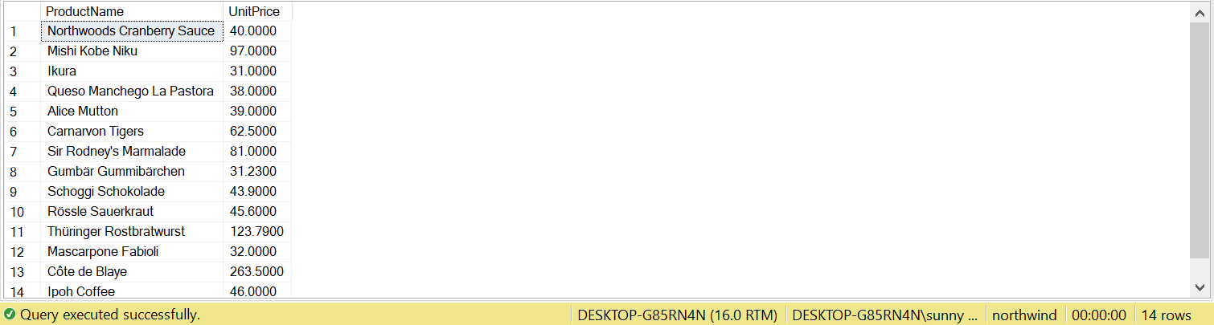

Q4) Write a query to get Product list (name, unit price) of ten most expensive products.

==>

SELECT TOP 10 ProductName, UnitPrice

FROM tblProducts

ORDER BY UnitPrice DESC

Output:

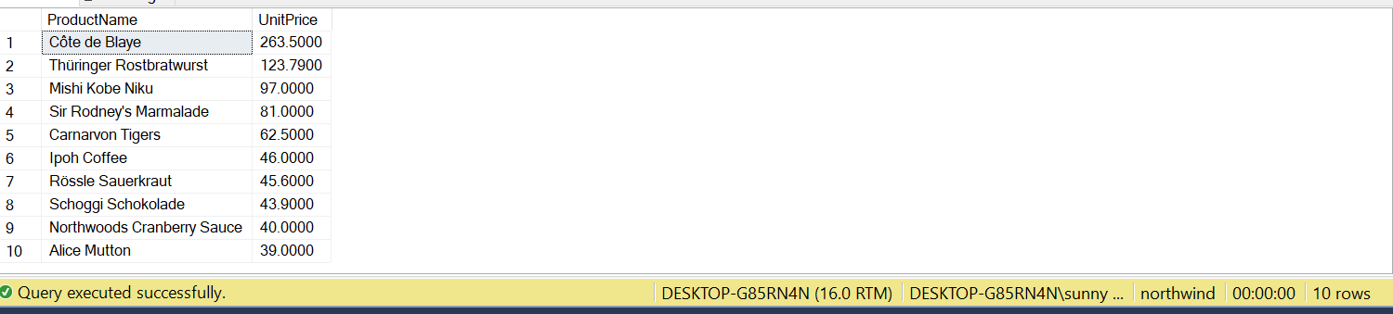

Q5) Write a query to count current and discontinued products.

==>

SELECT CASE WHEN Discontinued=0 THEN 'Current' ELSE 'Discontinued' END AS [Product Type],

COUNT(ProductId) [Product Count]

FROM tblProducts

GROUP BY Discontinued

Output:

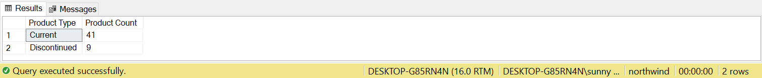

Q6) Write a query to get Product list (name, units on order, units in stock) of stock is less

than the quantity on order.

==>

SELECT ProductName, UnitsOnOrder, UnitsInStock

FROM tblProducts

WHERE ( UnitsInStock < UnitsOnOrder ) AND Discontinued=0

Output:

