**Assignment – 3**

* Create Database:

CREATE DATABASE emp_dept_db

* Create Table

1) Department Table

CREATE TABLE tblDepartment

(

dept_id INT IDENTITY(500, 1) PRIMARY KEY,

dept_name VARCHAR(30) NOT NULL

)

ALTER TABLE tblDepartment

ADD CONSTRAINT UQ_tblDepartment_dept_name UNIQUE (dept_name)

2) Employee Table

CREATE TABLE tblEmployee

(

emp_id INT IDENTITY(100, 1) PRIMARY KEY,

dept_id INT,

mngr_id INT,

emp_name VARCHAR(30) NOT NULL,

salary DECIMAL(10, 2) CONSTRAINT CHK_tblEmployee_salary CHECK(salary > 2000),

FOREIGN KEY(dept_id) REFERENCES tblDepartment(dept_id)

)

Queries

Q1) Write a SQL query to find Employees who have the biggest salary in their Department.

==>

SELECT emp.emp_id, emp.emp_name "Employee Name", emp.salary "Salary", dept.dept_name "Department Name"

FROM tblEmployee emp JOIN tblDepartment dept

ON emp.dept_id = dept.dept_id

WHERE emp.salary IN (SELECT MAX(salary) FROM tblEmployee GROUP BY dept_id)

Output:

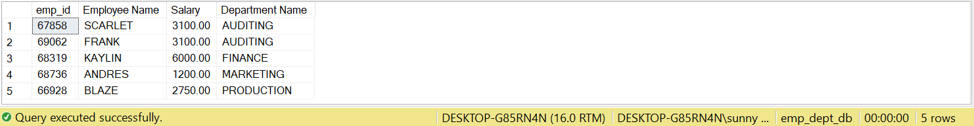

Q2) Write a SQL query to find Departments that have less than 3 people in it.

==>

SELECT emp.dept_id, COUNT(emp.dept_id) "Total Employee", dept.dept_name “Department Name”

FROM tblEmployee emp JOIN tblDepartment dept

ON emp.dept_id = dept.dept_id

GROUP BY emp.dept_id, dept.dept_name

HAVING COUNT(emp.dept_id) < 3

Output:

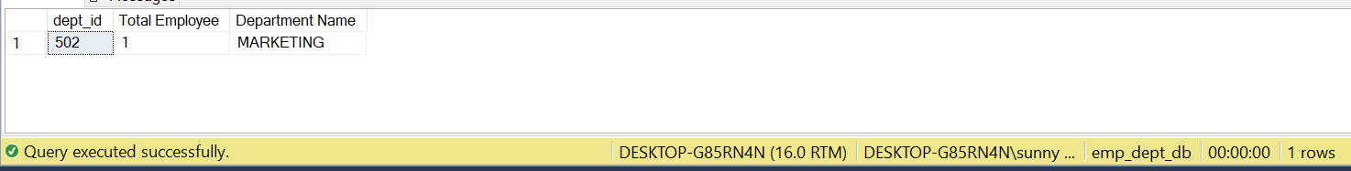

Q3) Write a SQL query to find All Department along with the number of people there.

==>

SELECT emp.dept_id, dept.dept_name "Department Name", COUNT(emp.dept_id) "Total Employee"

FROM tblEmployee emp JOIN tblDepartment dept

ON emp.dept_id = dept.dept_id

GROUP BY emp.dept_id, dept.dept_name

Output:

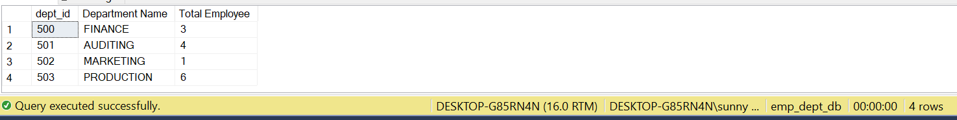

Q4) Write a SQL query to find All Department along with the total salary there.

==>

SELECT emp.dept_id, dept.dept_name "Department Name", SUM(emp.salary) "Total Salary"

FROM tblEmployee emp JOIN tblDepartment dept

ON emp.dept_id = dept.dept_id

GROUP BY emp.dept_id, dept.dept_name

Output:

