**Assignment – 4**

* **Check constraint on order details table**

ALTER TABLE tblOrderDetails

ADD CONSTRAINT CHK_tblOrderDetails_Unit_Price CHECK( unit_price > 0)

ALTER TABLE tblOrderDetails

ADD CONSTRAINT CHK_tblOrderDetails_Quantity CHECK( quantity > 0)

ALTER TABLE tblOrderDetails

ADD CONSTRAINT DF_tblOrderDetails_Discount DEFAULT 0 FOR discount

Q1) Average Freight. Check before update and insert.

==>

CREATE PROCEDURE usp_Orders_AverageFreight

AS

BEGIN

RETURN ( SELECT AVG(freight) FROM tblOrders )

END

Output:

EXEC sp_help usp_Orders_AverageFreight

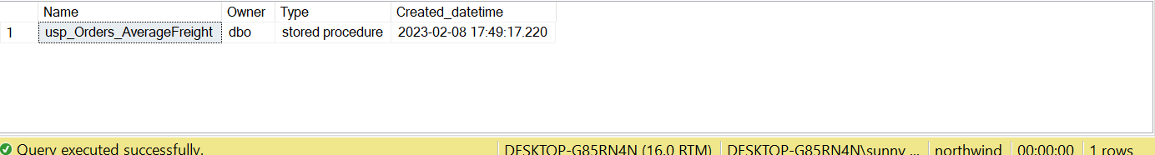

Q2) Write a SQL query to Create Stored procedure in the Northwind database to retrieve Employee Sales by Country.

==>

CREATE PROCEDURE usp_Employee_EmployeeSalesByCountry

AS

BEGIN

SELECT emp.employee_id, emp.first_name + ' ' + emp.last_name "Employee Name", ord.ship_country "Country", COUNT(ord.order_id) "Total Order",

ROUND(SUM(od.quantity * od.unit_price - ( od.quantity * od.unit_price * od.discount)), 2) "Total Sale"

FROM dbo.tblEmployees emp JOIN dbo.tblOrders ord

ON emp.employee_id = ord.employee_id

JOIN dbo.tblOrderDetails od

ON ord.order_id = od.order_id

GROUP BY emp.employee_id, emp.first_name + ' ' + emp.last_name, ord.ship_country

END

Output:

EXEC sp_help usp_Employee_EmployeeSalesByCountry



EXEC usp_Employee_EmployeeSalesByCountry

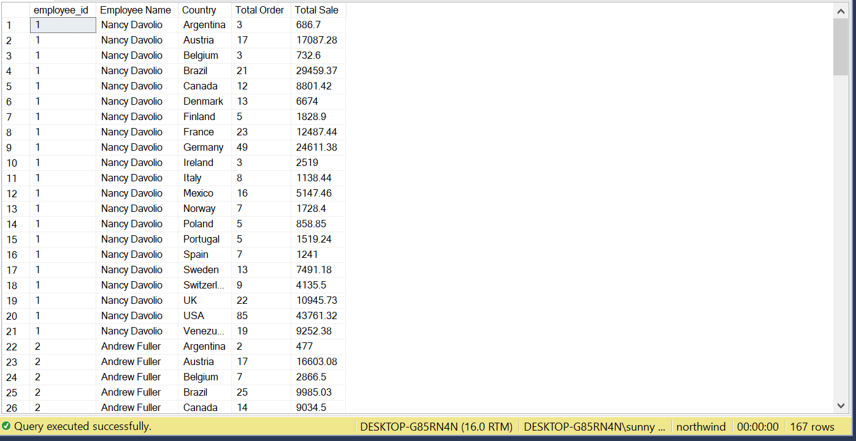

Q3) write a SQL query to Create Stored procedure in the Northwind database to retrieve Sales by Year.

==>

CREATE PROCEDURE usp_Order_SalesByYear( @Year SMALLINT )

AS

BEGIN

IF @YEAR NOT IN ( SELECT YEAR(tblOrders.order_date) FROM tblOrders GROUP BY YEAR(tblOrders.order_date))

BEGIN

RAISERROR(N'No transaction found for given year: %d',16, 1, @Year)

RETURN

END

SELECT YEAR( ord.order_date ) "Year", COUNT(ord.order_id) "Total Order",

ROUND(SUM(od.quantity * od.unit_price - ( od.quantity * od.unit_price * od.discount)), 2) "Total Sale"

FROM tblOrders ord JOIN tblOrderDetails od

ON ord.order_id = od.order_id

WHERE YEAR(ORD.order_date) = @Year

GROUP BY YEAR(ord.order_date)

END

Output:

EXEC sp_help usp_Order_SalesByYear

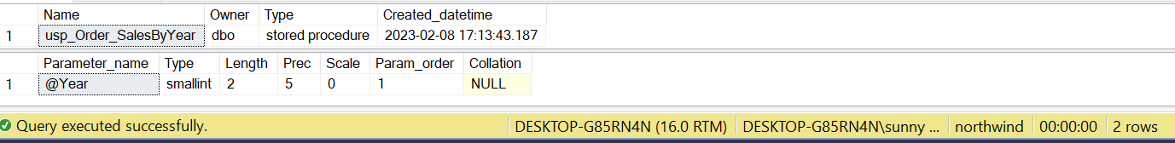

EXEC usp_Order_SalesByYear 1997

EXEC usp_Order_SalesByYear 1998

EXEC usp_Order_SalesByYear 1996

EXEC usp_Order_SalesByYear 2001

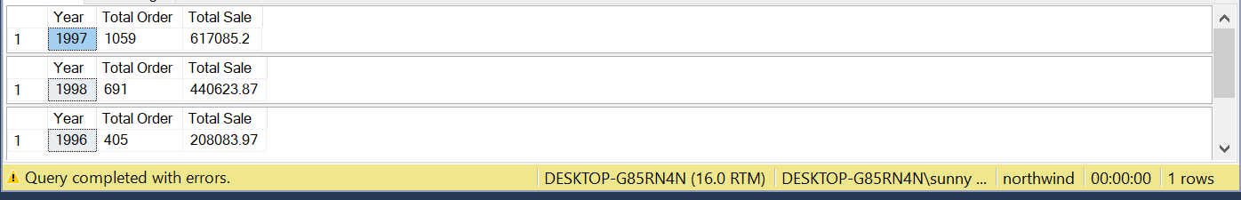

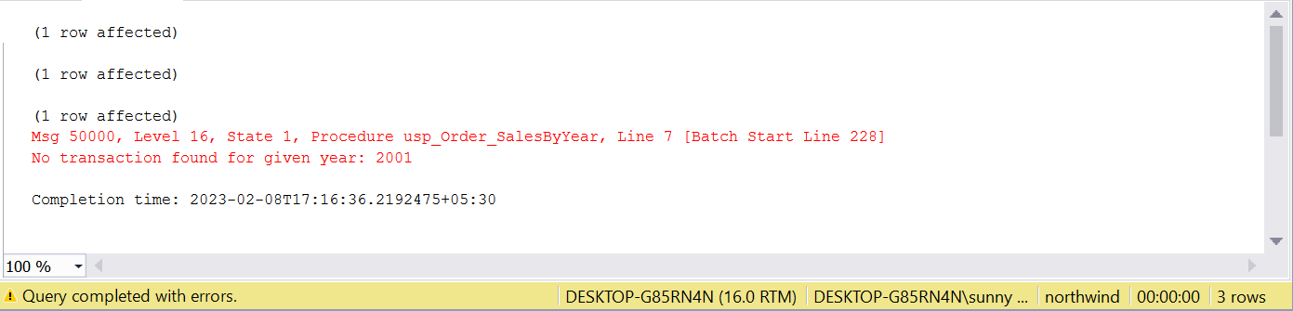

Q4) Write a SQL query to Create Stored procedure in the Northwind database to retrieve Sales By Category.

==>

CREATE PROCEDURE usp_Category_SalesByCategory( @Category VARCHAR(20) = NULL)

AS

BEGIN

IF @Category IS NULL

BEGIN

SELECT category.CategoryID, category.CategoryName,

ROUND(SUM(od.quantity * od.unit_price - ( od.quantity * od.unit_price * od.discount)), 2) "Total Sale"

FROM tblOrderDetails od JOIN tblProducts product

ON od.product_id = product.ProductID

JOIN tblCategories category

ON category.CategoryID = product.CategoryID

GROUP BY category.CategoryID, category.CategoryName

END

ELSE

BEGIN

SELECT category.CategoryID, category.CategoryName,

ROUND(SUM(od.quantity * od.unit_price - ( od.quantity * od.unit_price * od.discount)), 2) "Total Sale"

FROM tblOrderDetails od JOIN tblProducts product

ON od.product_id = product.ProductID

JOIN tblCategories category

ON category.CategoryID = product.CategoryID

WHERE category.CategoryName LIKE '%'+@Category+'%'

GROUP BY category.CategoryID, category.CategoryName

END

END

Output:

EXEC sp_help usp_Category_SalesByCategory

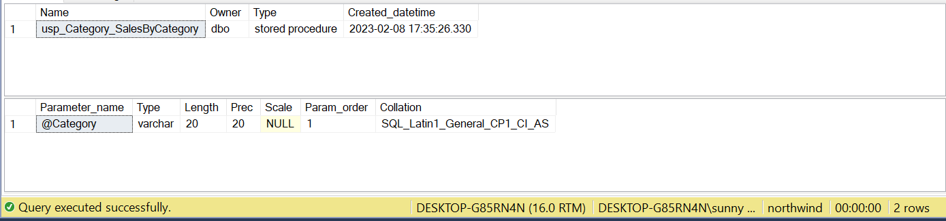

EXEC usp_Category_SalesByCategory

EXEC usp_Category_SalesByCategory 'Produce'

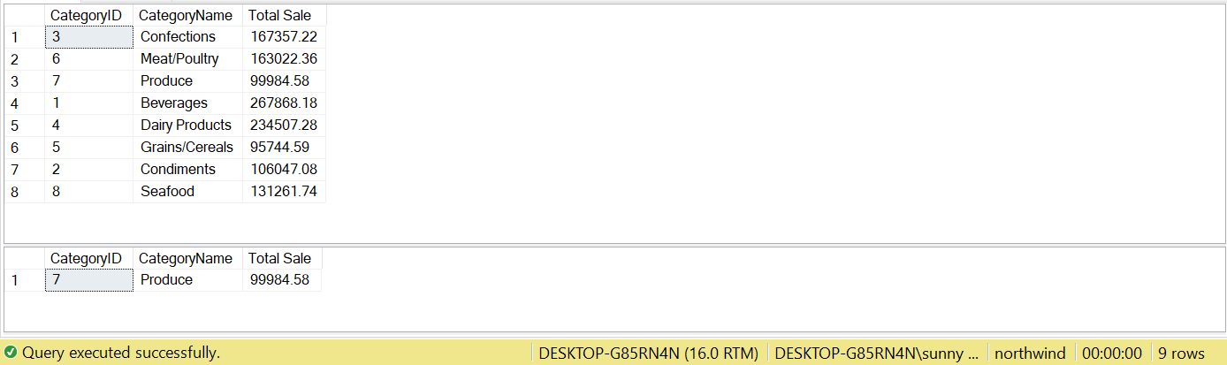

Q5) Write a SQL query to Create Stored procedure in the Northwind database to retrieve Ten Most Expensive Products.

==>

CREATE PROCEDURE usp_Products_TopProductsByPrice ( @NumOfRecord INT = 10)

AS

BEGIN

SELECT TOP (@NumOfRecord) *

FROM dbo.tblProducts

ORDER BY UnitPrice DESC

END

Output:

EXEC sp_help usp_Products_TopProductsByPrice

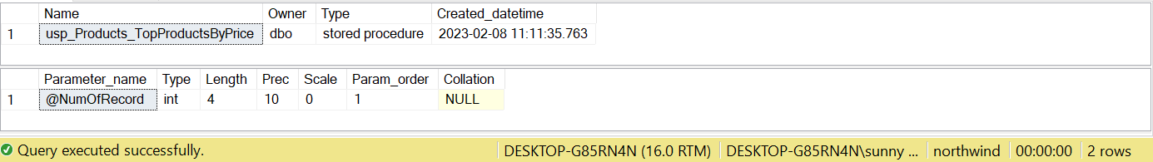

EXEC usp_Products_TopProductsByPrice

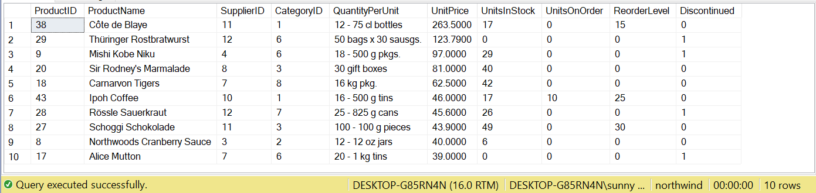

Q6) Write a SQL query to Create Stored procedure in the Northwind database to insert Customer Order Details.

==>

CREATE PROCEDURE usp_OrderDetails_Insert( @OrderID SMALLINT,

@ProductID INT,

@UnitPrice REAL,

@Quantity SMALLINT,

@Discount REAL = 0

)

AS

BEGIN

IF EXISTS(SELECT order_id FROM tblOrderDetails WHERE order_id = @OrderID AND product_id = @ProductID)

BEGIN

RAISERROR(N'Given ORDER ID: %d and product ID: %d already exists', 16, 1, @OrderID, @ProductID)

RETURN

END

INSERT INTO dbo.tblOrderDetails

VALUES (@OrderID, @ProductID, @UnitPrice, @Quantity, @Discount)

END

**Output:**

**EXEC sp_helptext usp_OrderDetails_Insert**

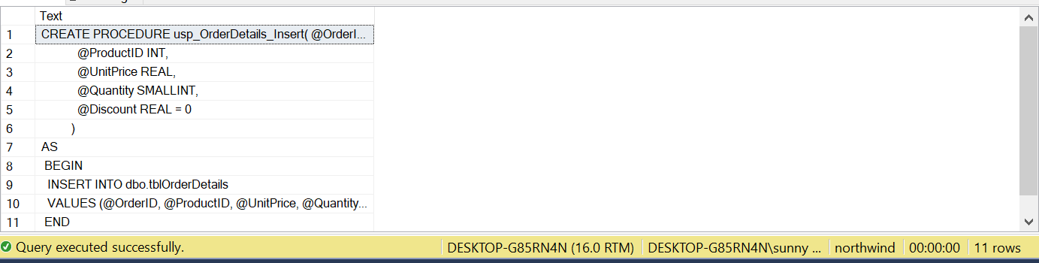

Inserting Record in Order Details

EXEC usp_OrderDetails_Insert 10268, 10, 20, 30, 0.18

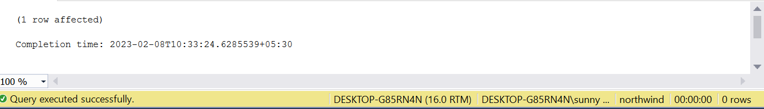

Q7) Write a SQL query to Create Stored procedure in the Northwind database to update Customer Order Details.

==>

CREATE PROCEDURE usp_OrderDetails_Update(

@OrderID SMALLINT,

@ProductID INT,

@UnitPrice REAL = NULL,

@Quantity SMALLINT = NULL,

@Discount REAL = NULL

)

AS

BEGIN

IF NOT EXISTS(SELECT order_id FROM tblOrderDetails WHERE order_id = @OrderID AND product_id = @ProductID)

BEGIN

RAISERROR(N'Given ORDER ID: %d and product ID: %d does not exists', 16, 1, @OrderID, @ProductID)

RETURN

END

IF @UnitPrice IS NULL AND @Quantity IS NULL AND @Discount IS NULL

BEGIN

RAISERROR('Nothing to update', 16, 1);

RETURN

END

DECLARE @oldPrice REAL, @oldQuantity SMALLINT, @oldDiscount REAL

SELECT @oldPrice = unit_price, @oldQuantity = quantity, @oldDiscount = discount

FROM dbo.tblOrderDetails

WHERE order_id = @OrderID AND product_id = @ProductID

IF (@UnitPrice IS NULL)

BEGIN

SET @UnitPrice = @oldPrice

END

IF (@Quantity IS NULL)

BEGIN

SET @Quantity = @oldQuantity

END

IF (@Discount IS NULL)

BEGIN

SET @Discount = @oldDiscount

END

UPDATE dbo.tblOrderDetails

SET unit_price = @UnitPrice, quantity = @Quantity, discount = @Discount

WHERE order_id = @OrderID AND product_id = @ProductID

END

Output:

EXEC sp_help usp_OrderDetails_Update

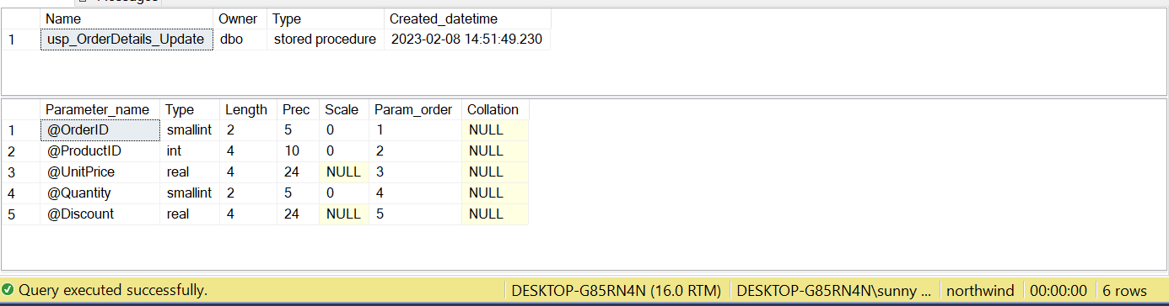

EXEC usp_OrderDetails_Update 10248, 11, 14, 12, 0.13

