CS650100 Geometric Modeling

113062589 洪聖祥

1. Non-manifold Component Direction

1. isNonManifoldVert

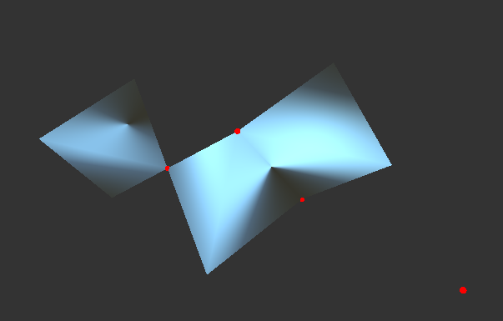

1. isNonManifoldEdge

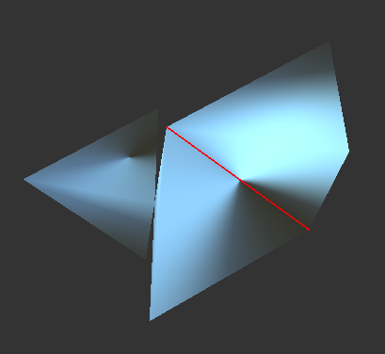

3. findHoles

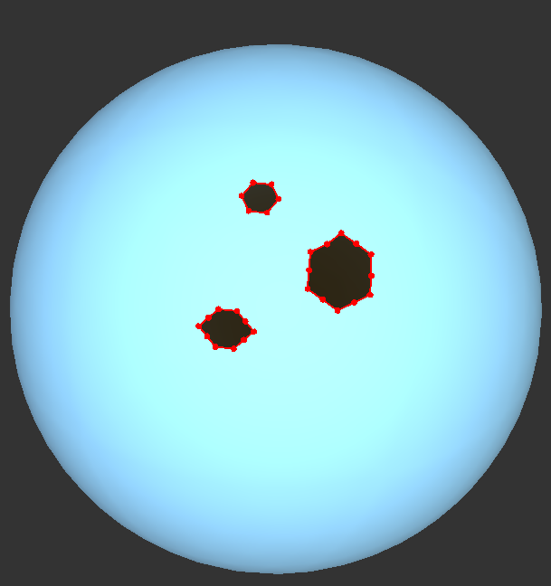

4. The following challenges arise when dealing with non-manifold surfaces

* Ambiguity in topology: non-manifold surfaces have vertices shared by more than on disconnected fan of triangle or faces shared by more than two faces. Therefore, algorithms relying surface neighborhoods can fail or behave unexpectedly.
* Traversal breaks: Many mesh operations need to walk around a vertex or along adjacent faces. Non-manifold surfaces break the traversal of the mesh since there are some non-connected fan of triangles.

2. Topological Evaluation

(2)

|  |  |  |  |  |
| --- | --- | --- | --- | --- |
| PLY | V-E+F | Handles | Total valence deficit | Total angle deficit |
| Sphere | 2 | 0 | 12 | 12.5664 |
| Icosahedron | 2 | 0 | 12 | 12.5664 |
| Bunny1 | 2 | 0 | 12 | 12.5664 |
| Hand | 2 | 0 | 12 | 12.5664 |
| Torus | 0 | 1 | 0 | -3.76588e-13 |
| Dragon | 0 | 1 | 12 | 12.5664 |
| Feline | -2 | 2 | -12 | -12.5664 |
| Happy | -10 | 6 | -60 | -62.8319 |
| Heptoroid | -42 | 22 | -252 | -263.894 |

(3)

For a **closed orientable 2-manifold**:

* Euler characteristic is also related to the number of **handles** g
* Total Valence deficit (:

For Valence deficit per vertex v:

For total valence deficit (:

Since 3F = 2E for triangles

* Total angle deficit (:

For angle deficit per vertex v:

For total angle deficit:

Since for triangles.

(4)

Usually, irregular vertices exist on high curvature area or near the holes of the hole (if exists).

Therefore, vertices near the hole usually have a total interior angle much less than and vertices near high curvature are usually have a total interior angle of much more than .

There are two hypotheses:

1. Vertices near the hole usually have a total interior angle much less than . Therefore, I expect large positive valence and angle deficits near holes.

2. Vertices on high curvature areas will often have sum of interior angles > , so I expect angle deficit will be negative

* + For vertices near a hole, the valence deficit is large since there are less incident edges. From the below color mapping also proves my hypotheses.

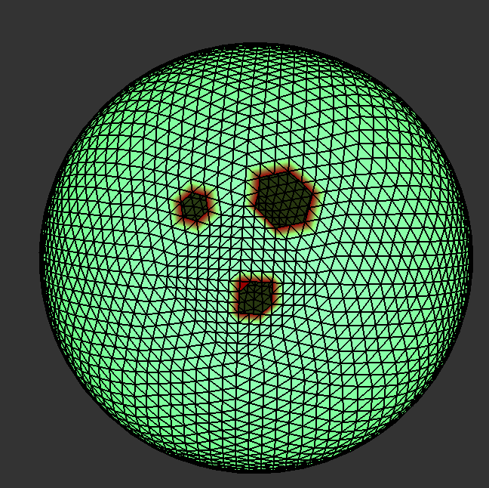 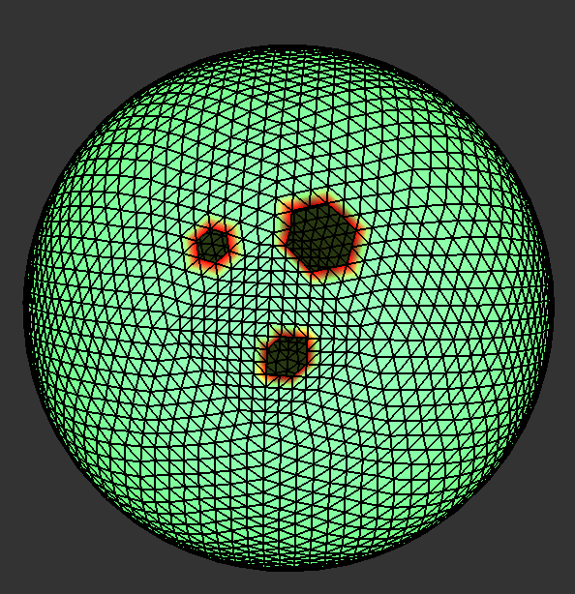

Valence deficit viz Angle deficit viz

* + For vertices on high curvature areas, angle deficit will be negative. From the below color mapping also proves my hypotheses.

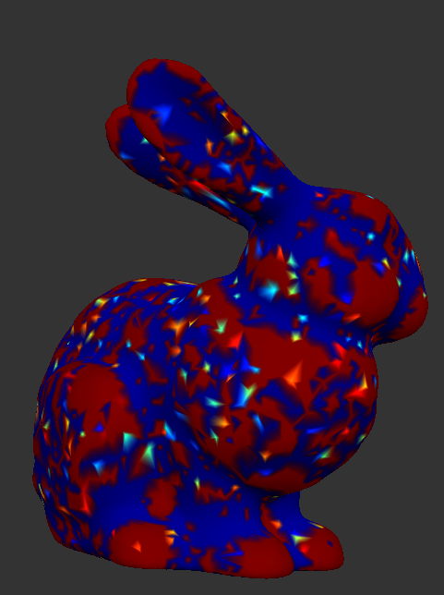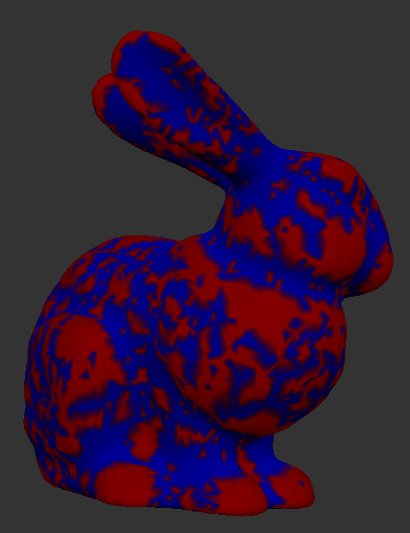

Angle deficit viz Gaussian curvature viz

3. Geometric Evaluation

(4) Vertex Area / Gaussian curvature / mean curvature / max principal curvature / min principal curvature / principal direction

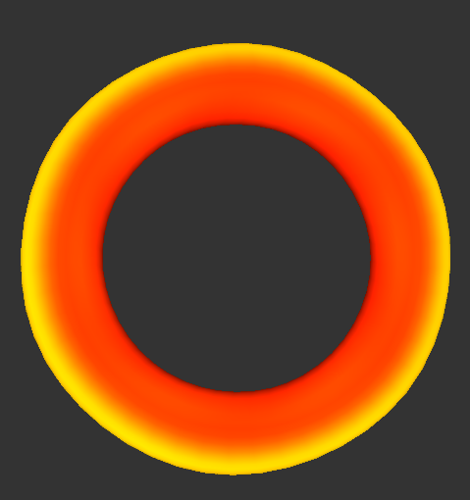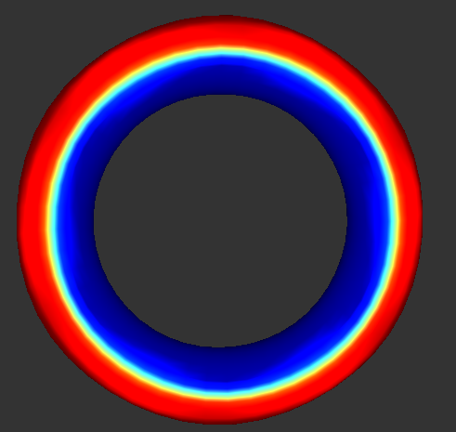

Vertex Area Gaussian Curvature

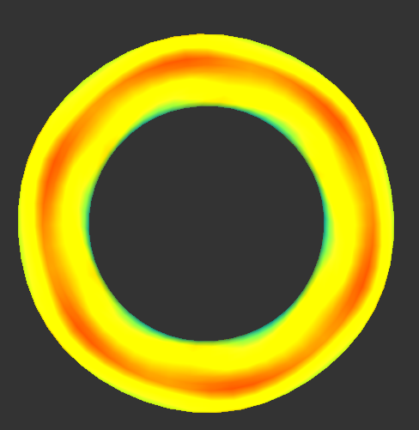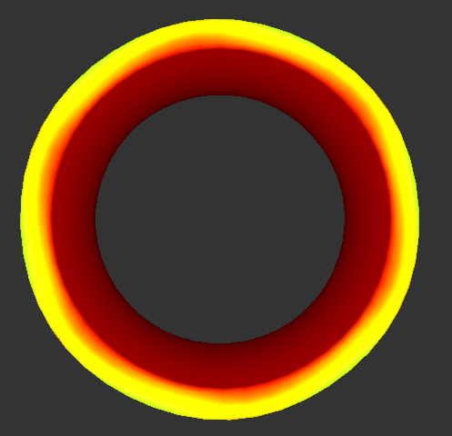

Mean Curvature Max Principal Curvature

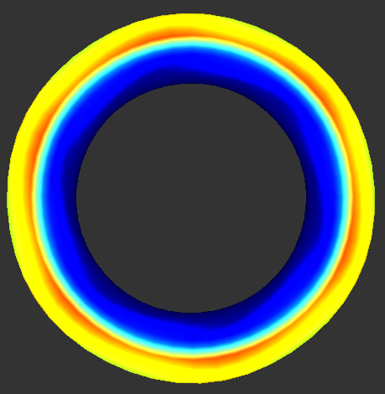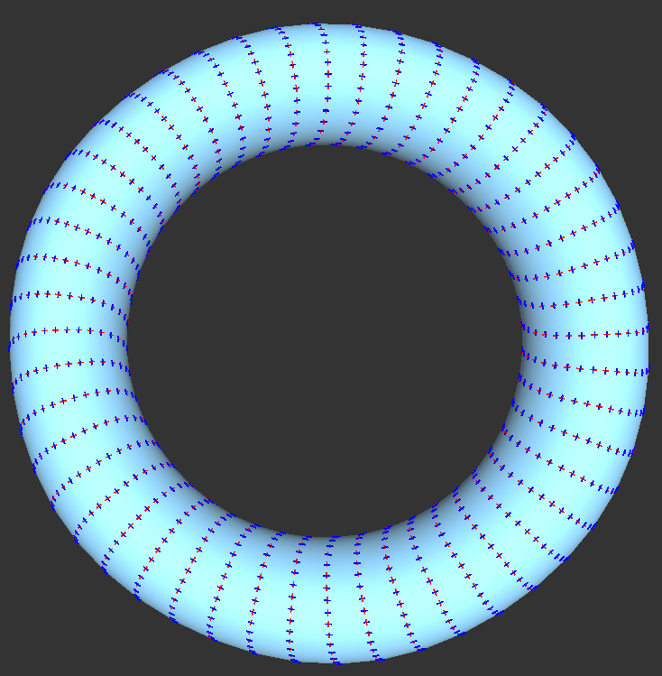

Min Principal Curvature Principal Direction

(5)

* Volume of bunny1.ply / bunny2.ply / bunny3.ply
  + bunny1.ply: -0.468656
  + bunny2.ply: -0.474289
  + bunny3.ply: -0.463707
* bunny3.ply is more regular. From the visualization of bunny1.ply, bunny2.ply and bunny3.ply. We can observe that the valence deficit color visualization valence > 6 is red and valence < 6 is blue and valence value near 6 is green. For a regular mesh, we expect that the vertex valence deficit value is near 6 (green). Therefore, from the below visualization, bunny3.ply is more regular.

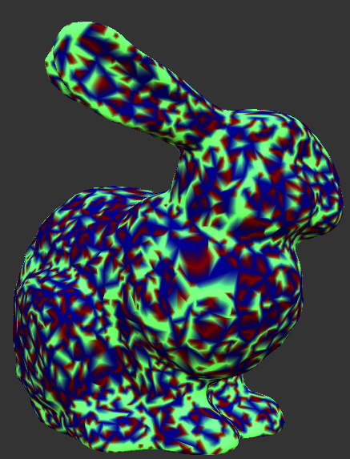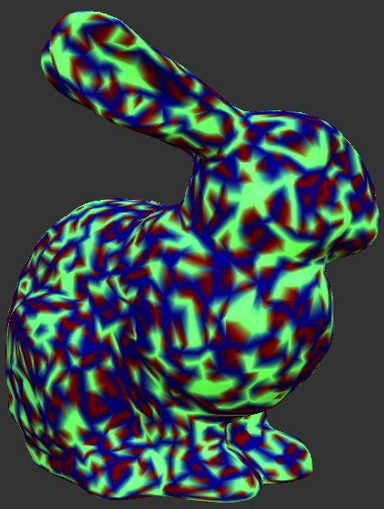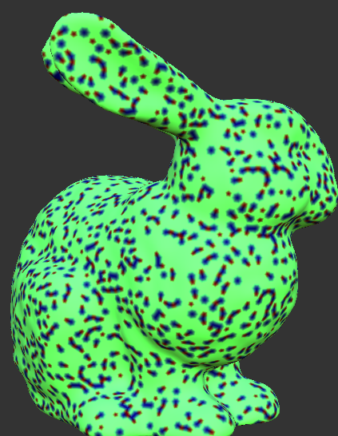

bunny1.ply bunny2.ply bunny3.ply

* + I prefer bunny3.ply since the surface is smoother and more regular. Also, from the above valence deficit visualization, vertices are more regular. (I think bunny3.ply has applied mesh subdivision so the surface is smoother)