Hyydra工具

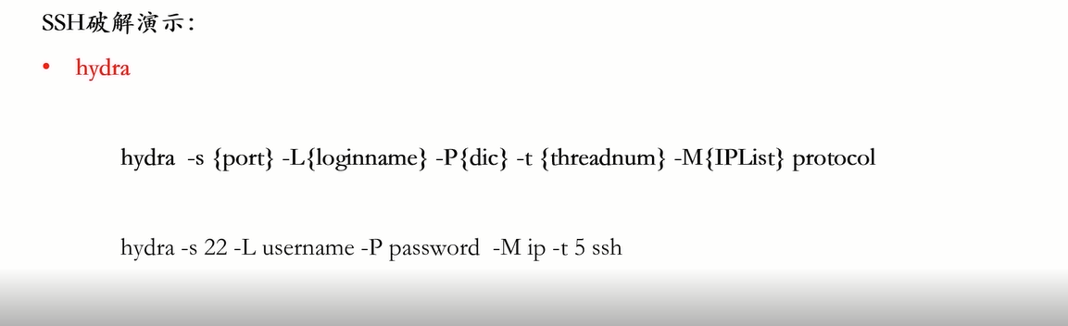

**hydra –s {port} –L{loginname} –P{dic} –t {threadnum} –M{IPList} protocol**

**hydra –s {端口} –L{用户名} –P{密码} –t {线程} –M{IP清单} 协议**

实例：

**hydra -s 3389 -L /root/Desktop/username.txt -P /root/Desktop/password.txt -t 5 192.168.29.128 rdp**

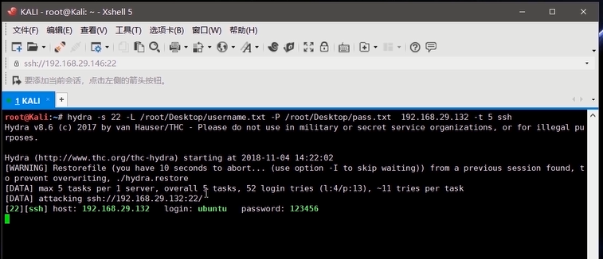

Xhydra图形化界面

