Name : Sakshi Batham

Roll No : 18031046

Class : BCA 3rd year

Batch : 7

Date of exam : 5/05/21

Section name : JAVA

1)Write a program to display reverse of a digit no. using array.

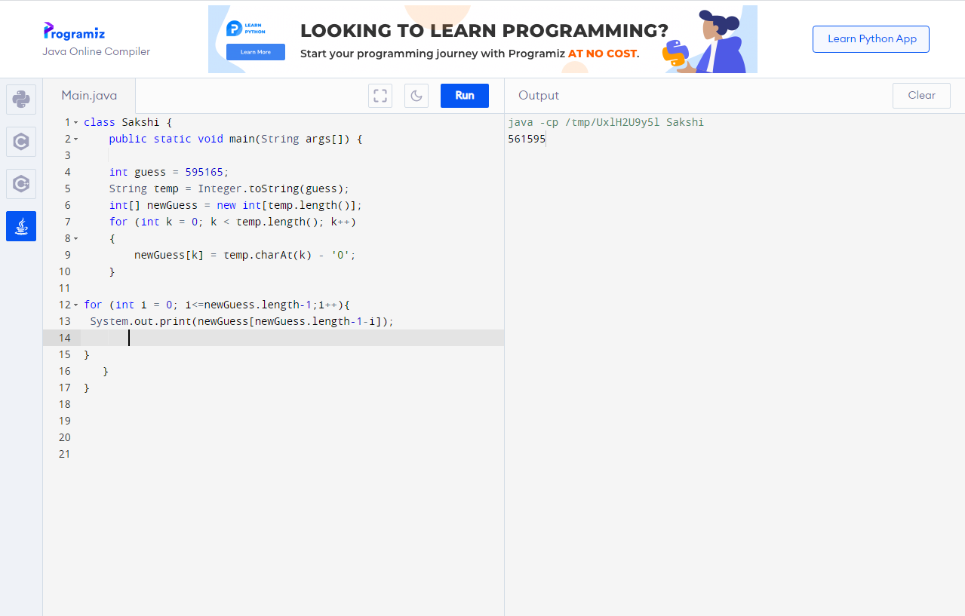

2)Write a program to convert the given no of days into month & days using classes,objects and method

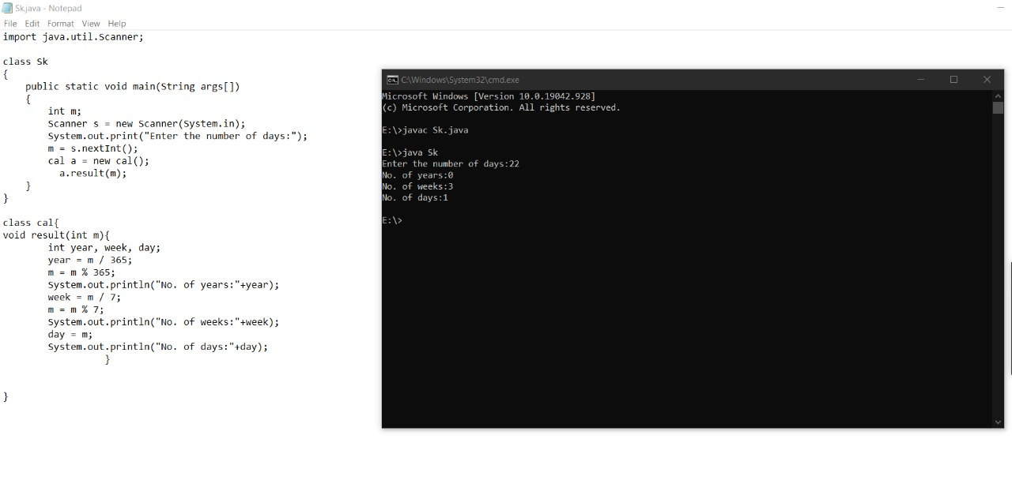

Name : Sakshi Batham

Roll No : 18031046

Class : BCA 3rd year

Batch : 7

Date of exam : 5/05/21

Section name : python

1)Write a program to demonstrate various operation on LIST

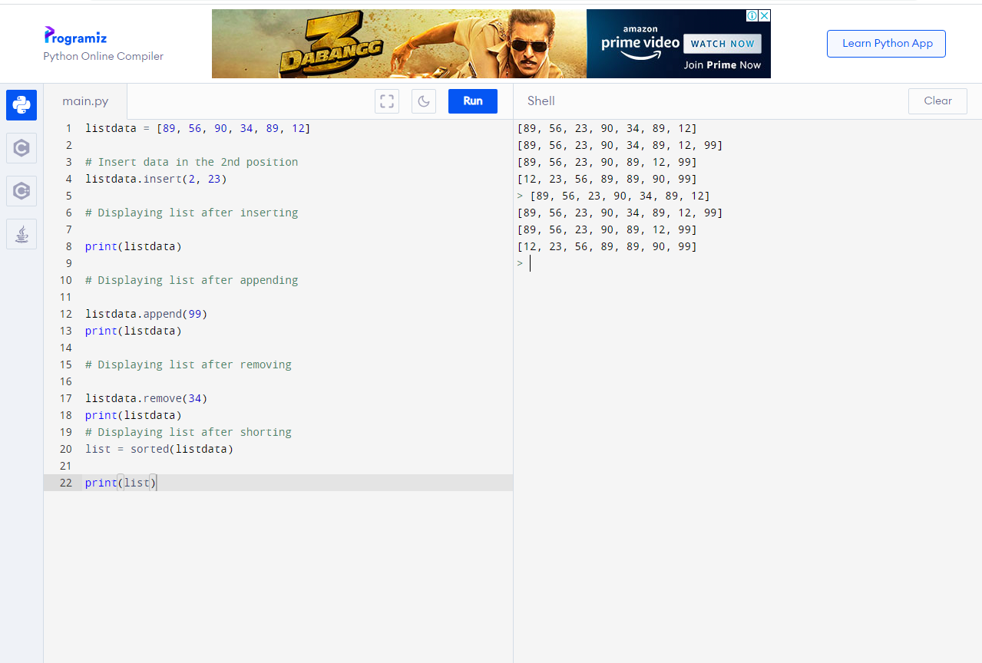

2)Write a program to check whether entered number is a pallindrom or not

