**BHOPAL SCHOOL OF SOCIAL SCIENCES**



**DEPARTMENT OF COMPUTER APPLICATION**

**TOPIC: NUTRI CARE**

**SUBMITTED BY:**

**SHON JOSEPH**

**ROBIN GEORGE**

**TABLE OF CONTENTS**

Page No.

1. Synopsis 06
2. Introduction 09
3. About the Organization 12
4. System Analysis 13
   1. Existing System
   2. Proposed System
   3. Software Requirement Specification (SRS)
   4. Feasibility Analysis
   5. Data Flow Diagram (DFD) (or system chart)
5. System Design 30
   1. Input Design
   2. Output Design
   3. Table Design
6. System Testing & Implementation 38
7. Security Technologies & Policies 38
8. Maintenance 42
9. Conclusion 43
   1. Scope for future Enhancements
10. Bibliography 44
11. Appendix 45
    1. Screen Shots
    2. Coding

**SYNOPSIS**

1. **SYNOPSIS**

**INTRODUCTION**

The project brings the entire manual process of work of an asha worker online. The main purpose of this project is to simplify the process of handling each event by providing a web interface for admin, worker and parents, doctors. The admin module consist of register each worker and allot each worker to different locations and view the overall work of worker. The worker module consist of register parent have child less than 5 years old, providing baby food, alert vaccination details, date of vaccination, manage the health of both mother and child, add details of diseases etc. The parent module consist view the view the vaccination details, view the details about the nutrition foods, diseases so and so.

MAIN MODULES OF THE SYSTEM

**Admin**

* Registration Module
* View Vaccination Details
* View Food Details
* View Disease Details
* View Details of parent and child
* View Tips

**Worker**

* Add Mothers
* Add Vaccination Details
* Alert Vaccination Dates to parents
* Add Food Details
* Add Disease Details
* Add Health Care Details
* Distribute Food
* Add Basic Tips To care child

**Mothers**

* View Vaccination Details
* View Food Details
* View Disease Details
* View Health Care Tips
* Distribution Food Details
* View tips

**Doctors**

* View Mother and child details
* Add Health Tips

**INTRODUCTION**

2. **INTRODUCTION**

**GOALS & OBJECTIVES:**

The project brings the entire manual process of work of an asha worker online. The main purpose of this project is to simplify the process of handling each event by providing a web interface for admin, worker and parents, doctors. The admin module consist of register each worker and allot each worker to different locations and view the overall work of worker. The worker module consist of register parent have child less than 5 years old, providing baby food, alert vaccination details, date of vaccination, manage the health of both mother and child, add details of diseases etc. The parent module consist view the view the vaccination details, view the details about the nutrition foods, diseases so and so.

**SCOPE OF THE PROJECT**

Scope of the website depends upon the following things:

* It satisfy the user requirement
* Be easy to understand by the user and operator
* Be easy to operate
* Have a good user interface
* Be expandable

**3. ABOUT THE ORGANIZATION**

**Syntax Soft** is an aggressive catalysts helping customers to leverage technology to accelerate adaptation. Our focus is singular and clear: offer business benefits to the customer to deliver an unbeatable edge over competition. That's the bottom line we like to put on top of everything else. All our passion, all our values, our strengths, skills and efforts orbit around this positioning. The idea of offering endless value to the customer is the very differentiating principle Syntax was founded on. Building up from the direction our foundation gave us, our guaranteed, unwavering quality of delivery was built up by sheer determination, expertise and commitment.

Having started in 1998 with a one-man team and a single client, Syntax today has a manpower base of over 150 that is expected to double within the year and a list of clients that reads like a Who's Who list of companies spread across geographies. Syntax has now attained the position of an emergent powerhouse in Technology consulting, product development and Outsourcing services. This amazing growth has resulted from the tremendous confidence Syntax has evoked in everyone alike - Management, Employees, Investors, Partners, Alliances and, of-course, our Clients. On the ground, Syntax is a people company. The company's backbone is its strong management team that keeps focused on the magic of the initial vision. In addition, the expertise and energy of the founders has filtered down to the entire team making it one complete dynamic entity with strong commitment and focus. Syntax fundamentally aims to build strong relationships. Our deliverables are strong technology solutions that make a difference to the profitability of our clients' businesses. Our fundamental values can be defined by our Vision, Mission and Philosophy.

**Vision**

To be one of the top IT Consulting Companies in India and abroad.

**Mission**

To leverage Technology & Human Capital for Optimum Productivity.

**Philosophy**

To create an opportunity & to provide a platform where everybody can grow & contribute towards making India a 'Super Power' & the World a better place to live in.

**Syntax Soft-Tech India Pvt. Ltd, Marine Drive, cochin-31**

**SYSTEM ANALYSIS**

**4. SYSTEM ANALYSIS**

System analysis works with users to identify goals and build systems to achieve them. System analysis is an important phase of any system development process. The system is studied to the minute details and analysed. Analysis is a detailed study of various operations performed by a system and their relationship within and outside the system. During analysis data are collected on the available files, decision points and transaction handles by the present system, Interviews, on-site observation and questionnaire are the main tools used for system analysis.

The system analysts play the role of an interrogator and dwells deep in the working of the present system. System analyst makes investigation and possible changes to the existing system. At the conclusion of the system analysis there is a system description and set if requirement for a new system. If there is no existing system, the analysis defines the requirements. Decide, which follows, purpose a new system that meets its needs. This new system may be built a fresh or by changing the existing system. Developments begin by defining a model of new system and convert this model to a working system. Finally, the data models are converted to a database and a processed to user procedures and computer programmers.

**4.1 EXISTING SYSTEM**

In the existing system normally there is no way to alert mothers about vaccination details or food details E.g.: pulse polio vaccination. It is very important for child up to 5years.Also about the food details for children and pregnant. The new Panchayat programs, health centre programs and Government schemes are unavailable to public. The Asha worker not bother about new born child’s and mothers.

**Disadvantages of Current System**

1. Asha worker can’t manage efficiently each pregnant women and child. Some of The information may not get all public.

2. There are many benefits from the Government of Kerala for women and children. But most of them do not know the benefits, and they do not get it. For example Pregnancy Aid Scheme financial benefit of INR 6000 to pregnant women, but the public doesn’t know how to apply, how it sanctioned.

3. Each month health centre conduct program like mothers meeting, most of people don’t know about it. Panchayat programs like Gramasabha meeting may be forget.

4. Asha worker can’t continuous look each pregnant women’s in their place, some of the pregnant women are working, and they are not in home at working time. Then there may have communication gap between Asha worker and pregnant women and mothers.

* 1. **PROPOSED SYSTEM**

The Ninocare consist of four users, Government, Panchayat, Asha worker and Mother/pregnant women.. In this application, Government can view all reports of Panchayat. The Government (Admin) add Panchayat and publish all schemes (e.g.: Maternity Benefit Programme) of government through this application and Asha workers and Users can view these schemes through this website.Panchayat are managed by admin and can view report by district wise. Panchayat add all programs conduct by panchayat and Asha worker and Users can view all these programs. Asha worker informs relevant user’s availability of food, vaccination conducting details and program conducting details. Users and Asha worker can access these website at anywhere .Additionally this website give other information , which vaccinations you may or may not need during your pregnancy and acts as a child’s healthcare provider if your child is up to date with all recommended vaccines.

**Advantages of the proposed system**

1. To eliminate wastage of time and energy: babycare will be able to save a lot of paper and time.

2. To bring system into real life: It would be dire need of all Asha workers having multiple pregnant women and child as its easy and shortcut method to inform details and guide them.

3. Each child get vaccines at correct time, then we can avoid vaccine diseases, make a healthy generation etc.

4. Easy to use: By the help of free babycare users can access the vaccination details, food details, program details. Asha worker can inform users with update details at any time.

**4.3 SOFTWARE REQUIREMENT SPECIFICATION**

The software for the development of the proposed system is as follows. The software for the development has been selected based on several factors such as:-

* Support
* Cost effectiveness
* Development speed
* Ability to rubout application in the least time
* Stability

Operating System : Windows

Front end : Html, JavaScript, CSS

Scripting language : PYTHON

Back end : My SQL

**LANGUAGE:**

**PYTHON**

Python is an interpreted, high-level, general-purpose programming language created by Guido Van Rossum and first released in 1991, Python's design philosophy emphasizes code readability with its notable use of significant whitespace. Its language constructs and object-oriented approach aim to help programmers write clear, logical code for small and large-scale projects.

Python is dynamically typed and garbage-collected. It supports multiple programming paradigms, including structured (particularly, procedural), object-oriented, and functional programming. Python is often described as a "batteries included" language due to its comprehensive standard library.

Python was conceived in the late 1980s as a successor to the ABC language. Python 2.0, released in 2000, introduced features like list comprehensions and a garbage collection system capable of collecting reference cycles. Python 3.0, released in 2008, was a major revision of the language that is not completely backward-compatible, and much Python 2 code does not run unmodified on Python 3.

**PYTHON’s Strengths**

In comparison to these products, PYTHON has much strength, including the following

* Easy to code
* Free and open source
* Object-oriented programming
* GUI programming support
* High level language
* Extensible feature
* Portability
* Integration
* Interpretation
* Standard library
* Dynamical

**Easy to code**

Python is high level programming language. Python is very easy to learn language as compared to other language like c, c#, java script, java etc. It is very easy to code in python language and anybody can learn python basic in few hours or days. It is also developer-friendly language.

**Free and Open Source**

Python language is freely available at official website. Since, it is open-source, this means that source code is also available to the public. So you can download it as, use it as well as share it.

**Object-Oriented Language:**

One of the key features of python is Object-Oriented programming. Python supports object oriented language and concepts of classes, objects encapsulation etc.

**GUI Programming Support:**

Graphical Users interfaces can be made using a module such as PyQt5, PyQt4, wxPython or Tk in python.PyQt5 is the most popular option for creating graphical apps with Python.

**High-Level Language:**

Python is a high-level language. When we write programs in python, we do not need to remember the system architecture, nor do we need to manage the memory.

**Extensible feature:**

Python is an Extensible language. We can write our some python code into c or c++ language and also we can compile that code in c/c++ language.

**Python is Portable language:**

Python language is also a portable language. For example, if we have python code for windows and if we want to run this code on other platform such as Linux, Unix and Mac then we do not need to change it, we can run this code on any platform.

**Python is Integrated language**

Python is also an Integrated language because we can easily integrated python with other language like c, c++ etc.

**Interpreted Language**

Python is an Interpreted Language. because python code is executed line by line at a time. like other language c, c++, java etc there is no need to compile python code this makes it easier to debug our code.The source code of python is converted into an immediate form called bytecode.

**Large Standard Library**

Python has a large standard library which provides rich set of module and functions so you do not have to write your own code for every single thing.There are many libraries present in python for such as regular expressions, unit-testing, web browsers etc.

**Dynamically Typed Language**

Python is dynamically-typed language. That means the type (for example- int, double, long etc) for a variable is decided at run time not in advance.because of this feature we don’t need to specify the type of variable.

**MySQL**

MySQL’s main competitors are PostgreSQL, Microsoft SQL Server, and Oracle. MySQL has much strength, including the following:

* High performance
* Low cost
* Ease of configuration and learning
* Portability

**Performance**

MySQL is undeniably fast. In 2002, Week published a benchmark comparing five databases powering a web application. The best result was a tie between MySQL and the much more expensive Oracle.

**Low Cost**

MySQL is available at no cost under an open source license or at low cost under a commercial license. You need a license if you want to redistribute MySQL as part of an application and do not want to license your application under an Open Source license. If you do not intend to distribute your application—typical for most web applications, or are working on free or open source Software, you do not need to buy a license.

**Ease of Use**

Most modern databases use SQL. If you have used another RDBMS, you should have no trouble adapting to this one. MySQL is also easier to set up than many similar products.

**Portability**

MySQL can be used on many different UNIX systems as well as under Microsoft Windows.

**Queries**

The most common operation in SQL databases is the query, which is performed with the declarative SELECT keyword. SELECT retrieves data from a specified table, or multiple related tables, in a database. While often grouped with Data Manipulation Language (DML) statements, the standard SELECT query is considered separate from SQL DML, as it has no persistent effects on the data stored in a database. Note that there are some platform-specific variations of SELECT that can persist their effects in a database, such as the SELECT INTO syntax that exists in some databases.

SQL queries allow the user to specify a description of the desired result set, but it is left to the devices of the database management system (DBMS) to plan, optimize, and perform the physical operations necessary to produce that result set in as efficient a manner as possible. An SQL query includes a list of columns to be included in the final result immediately following the SELECT keyword. An asterisk ("*”) can also be used as a "wildcard" indicator to specify that all available columns of a table (or multiple tables) are to be returned. SELECT is the most complex statement in SQL, with several optional keywords and clauses, including: The FROM clause which indicates the source table or tables from which the data is to be retrieved. The FROM clause can include optional JOIN clauses to join related tables to one another based on user-specified criteria.

Microsoft SQL Server is a relational database server, developed by Microsoft: it is a software product whose primary function is to store and retrieve data as requested by other software applications, be it those on the same computer or those running on another computer across a network. There are at least a dozen different workloads ranging from small applications that store and retrieve data on the same computer, to millions of users and computers that access huge amounts of data from the internet at the same time.

Microsoft SQL Server is a relational database management system developed by Microsoft. As a database, whose primary function is to store and retrieve data as requested by other software applications, be it those on the same computer or those running on another computer across a network (including the Internet). There are at least a dozen different editions of Microsoft SQL Server aimed at different audiences and for different workloads (ranging from small applications that store and retrieve data on the same computer, to millions of users and computers that access huge amounts of data from the Internet at the same time).

SQL Server 2008 (formerly codenamed "Katmai") was released on August 6, 2008 and aims to make data management self-tuning, self-organizing, and self-maintaining with the development of SQL Server Always On technologies, to provide near-zero downtime. SQL Server 2008 also includes support for structured and semi-structured data, including digital media formats for pictures, audio, video and other multimedia data. In current versions, such multimedia data can be stored as BLOBs (binary large objects), but they are generic bit streams. Intrinsic awareness of multimedia data will allow specialized functions to be performed on them.

SQL Server includes better compression features, which also helps in improving scalability. It enhanced the indexing algorithms and introduced the notion of filtered indexes. It also includes Resource Governor that allows reserving resources for certain users or workflows. It also includes capabilities for transparent encryption of data (TDE) as well as compression of backups. SQL Server 2008 supports the ADO.NET Entity Framework and the reporting tools, replication, and data definition will be built around the Entity Data Model. SQL Server Reporting Services will gain charting capabilities from the integration of the data visualization products from Dundas Data Visualization, Inc., which was acquired by Microsoft.

**PLATFORM:**

WINDOWS 10

**Windows 10** is a series of [personal computer](https://en.wikipedia.org/wiki/Personal_computer) [operating systems](https://en.wikipedia.org/wiki/Operating_system) produced by [Microsoft](https://en.wikipedia.org/wiki/Microsoft) as part of its [Windows NT](https://en.wikipedia.org/wiki/Windows_NT) family of operating systems. It is the successor to [Windows 8.1](https://en.wikipedia.org/wiki/Windows_8.1), and was [released to manufacturing](https://en.wikipedia.org/wiki/Software_release_cycle#RTM) on July 15, 2015, and broadly released for retail sale on July 29, 2015. Windows 10 receives new [builds](https://en.wikipedia.org/wiki/Software_build) on an ongoing basis, which are available at no additional cost to users, in addition to additional test builds of Windows 10 which are available to [Windows Insiders](https://en.wikipedia.org/wiki/Windows_Insider). Devices in enterprise environments can receive these updates at a slower pace, or use long-term support milestones that only receive critical updates, such as security patches, over their ten-year lifespan of extended support.

One of Windows 10's most notable features is support for [universal apps](https://en.wikipedia.org/wiki/Universal_app), an expansion of the [Metro-style apps](https://en.wikipedia.org/wiki/Metro-style_app) first introduced in [Windows 8](https://en.wikipedia.org/wiki/Windows_8). Universal apps can be designed to run across multiple Microsoft product families with nearly identical code‍—‌including [PCs](https://en.wikipedia.org/wiki/Personal_computer), [tablets](https://en.wikipedia.org/wiki/Tablet_computer), [smartphones](https://en.wikipedia.org/wiki/Smartphone), [embedded systems](https://en.wikipedia.org/wiki/Embedded_system), [Xbox One](https://en.wikipedia.org/wiki/Xbox_One), [Surface Hub](https://en.wikipedia.org/wiki/Surface_Hub) and [Mixed Reality](https://en.wikipedia.org/wiki/Windows_Mixed_Reality). The Windows user interface was revised to handle transitions between a mouse-oriented interface and a [touchscreen](https://en.wikipedia.org/wiki/Touchscreen)-optimized interface based on available input devices‍—‌particularly on [2-in-1 PCs](https://en.wikipedia.org/wiki/2-in-1_PC), both interfaces include an updated [Start menu](https://en.wikipedia.org/wiki/Start_menu) which incorporates elements of [Windows 7](https://en.wikipedia.org/wiki/Windows_7)'s traditional Start menu with the tiles of [Windows 8](https://en.wikipedia.org/wiki/Windows_8). Windows 10 also introduced the [Microsoft Edge](https://en.wikipedia.org/wiki/Microsoft_Edge) [web browser](https://en.wikipedia.org/wiki/Web_browser), a [virtual desktop](https://en.wikipedia.org/wiki/Virtual_desktop) system, a window and desktop management feature called [Task View](https://en.wikipedia.org/wiki/Task_View), support for [fingerprint](https://en.wikipedia.org/wiki/Fingerprint_recognition) and [face recognition](https://en.wikipedia.org/wiki/Face_recognition) login, new security features for enterprise environments, and [DirectX 12](https://en.wikipedia.org/wiki/DirectX_12).

Windows 10 received mostly positive reviews upon its original release in July 2015. Critics praised Microsoft's decision to provide a desktop-oriented interface in line with previous versions of Windows, contrasting the tablet-oriented approach of 8, although Windows 10's touch-oriented user interface mode was criticized for containing regressions upon the touch-oriented interface of Windows 8. Critics also praised the improvements to Windows 10's bundled software over Windows 8.1, [Xbox Live](https://en.wikipedia.org/wiki/Xbox_Live) integration, as well as the functionality and capabilities of the [Cortana](https://en.wikipedia.org/wiki/Cortana) personal assistant and the replacement of [Internet Explorer](https://en.wikipedia.org/wiki/Internet_Explorer) with Edge. However, media outlets have been critical of changes to operating system behaviors, including mandatory [update](https://en.wikipedia.org/wiki/Windows_Update) installation, [privacy](https://en.wikipedia.org/wiki/Digital_privacy) concerns over data collection performed by the OS for Microsoft and its partners and the [adware](https://en.wikipedia.org/wiki/Adware)-like tactics used to promote the operating system on its release.

**4.4 FESIBILITY ANALISIS**

**FEASIBILITY STUDY**

After the scope has been identified, the next step is to determine whether the project is feasible or not. The objective includes technical, social and economic feasibility of the proposed system. The proposed system must be evaluated from technical viewpoint first. If the compatible technical and social system can be devised, then they must be tested for economic feasibility.

**TECHNICAL FEASIBILITY**

The assessment of technical feasibility must be based on an outline design of system requirements in terms of input, output, files, programs, procedures and staff. This can be quantified in terms of volume of data, trends, frequency of updating, etc. Having identified an outline system, the investigator must go on suggesting the type of equipment required, methods of developing the system, and method of running the system. With regard to processing facilities, the feasibility study will need to consider the possibility of using a bureau or if in-house equipment is available, the nature of the hardware to be used for data collection, storage, output and processing. On the system development side, the feasibility study must consider the various ways of acquiring the system. These include the purchase of package, the use of consultancy organization or software house to design the system and write the programs.

**SOCIAL FEASIBILITY**

The assessment of social feasibility will be along with technical feasibility. Each of the alternative technical solutions, which emerge, must be evaluated. The various people affected by the system (Both directly and indirectly) must be taken in to account positively. The various social costs must also be evaluated. These will include the cost of education and training, communication, consultation etc.

**ECONOMIC FEASIBILITY**

Justification for any capital is that it will increase profit, reduce expenditure or improve the quality-increased profit. Proposed or developing system must be justified by cost benefit criteria that effort is concentrated on projects, which will give the best, return at the earliest opportunity. The cost benefit analysis is often used as a basis for assessing economic feasibility. The factor involve in this analysis are :

* Cost of operation of the existing and proposed system.
* Cost of development of the proposed system.
* Value of the benefits of the proposed system.

**4.5 DATA FLOW DIAGRAM**

A data flow diagram (DFD) or bubble chart is a graphical tool for structure analysis. DFD models a system by using external entities from which data flows to a process, which transforms the data and creates output data flows which go to other processes or external entities or files. Data in files may also flow to processes as inputs. DFDs can be hierarchically organized, which helps in partitioning and analysing large systems. As a first step, one dataflow diagram can depict an entire system which gives the overview. It is called as context diagram of level 0 DFD. The context diagram can be further expanded.

The DFD also known as bubble chart. It is a simple graphical formalism that can be used to represent a system in terms of the input data to the system, various processing carried out on these data and the output data generated by the system. The main reason why this DFD technique is so popular is probably because of the fact that DFD is a very simple formalism- it is simple to understand and use. A DFD model uses a very limited number of primitive symbols to represent the functions performed by a system and the data flow among these systems. Starting with a set of high level functions that a system performance of DFD model in hierarchically it represents various sub functions. The Data Flow Diagramming technique also follows a simple set of intuitive concepts and rules.

Data flow diagram (DFD) is used to show how data flows through the system and the processes that transform the input data into output. Data flow diagrams are a way of expressing system requirements in a graphical manner. DFD represents one of the most ingenious tools used for structured analys

**BASIC DFD SYMBOLS**

**Function Symbol:**

A function is represented using a circle. This symbol is called a process or a bubble. Bubbles are annotated with the names of corresponding functions.

**External Entity Symbol:**

An external entity such as a user, project manager etc. is represented by a rectangle. The external entities are essentially those physical entities external to the application system, which interact with the system by inputting data to the system or by consuming the data produced by the system. In addition to the human users the external entity symbols can be used to represent external hardware and software such as application software.

**Data Flow Symbol:**

A directed arc or an arrow is used as a Data Flow Symbol. This represents the data flow occurring between two processes or between an external entity and a process; in direction of the Data Flow Arrow. Data flow Symbols are annotated with corresponding data names.

**Data Store Symbol**

A Data Store represents a logical file; it is represented using two parallel lines. A logical file can represent either Data Store Symbol, which can represent either data structure or a physical file on disk. Each data store is connected to a process by means of a Data Flow Symbol. The direction of the Data

Flow Arrow shows whether data is being read from or written into a Data Store. An arrow flowing in or out of a data store implicitly represents the entire area of the Data Store and hence arrows connecting to a data store need not be annotated with the names of the corresponding data items.

**LEVEL-0 DFD**

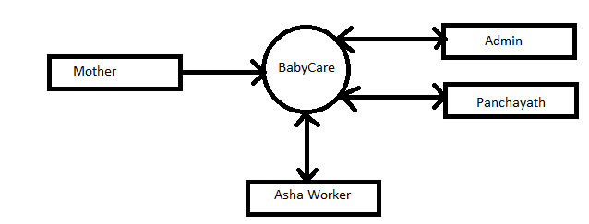

**LEVEL-1 DFD OF ADMIN**

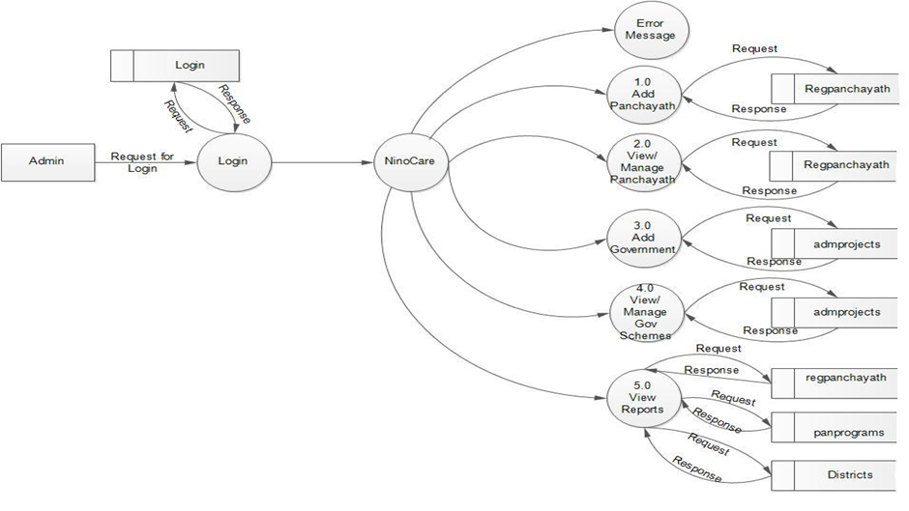

## 

## LEVEL 1 DFD OF PANCHAYATH

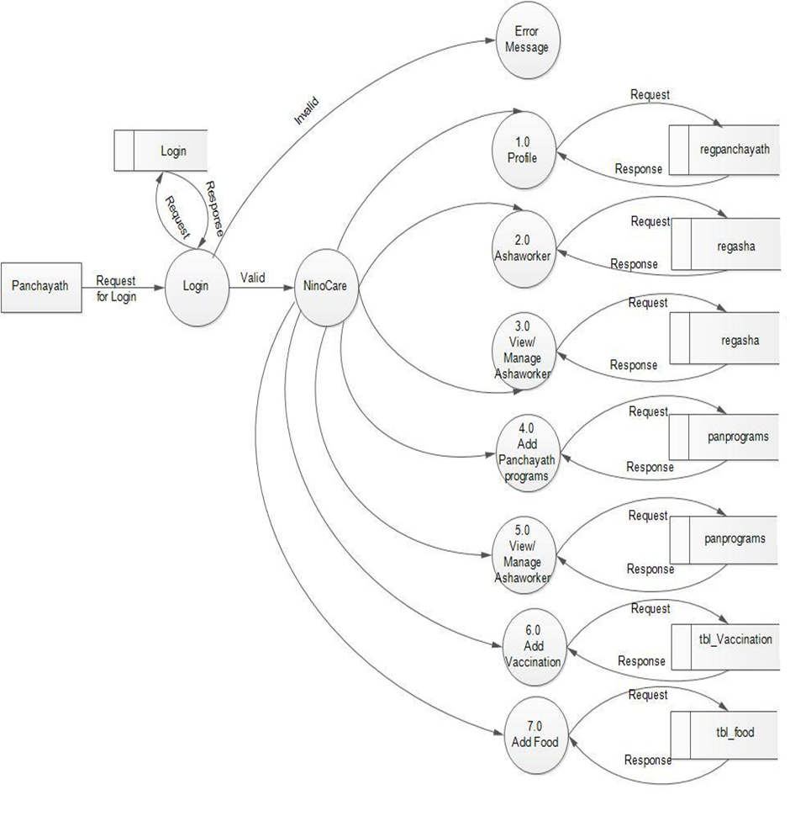

**LEVEL-1 DFD OF ASHA WORKER**

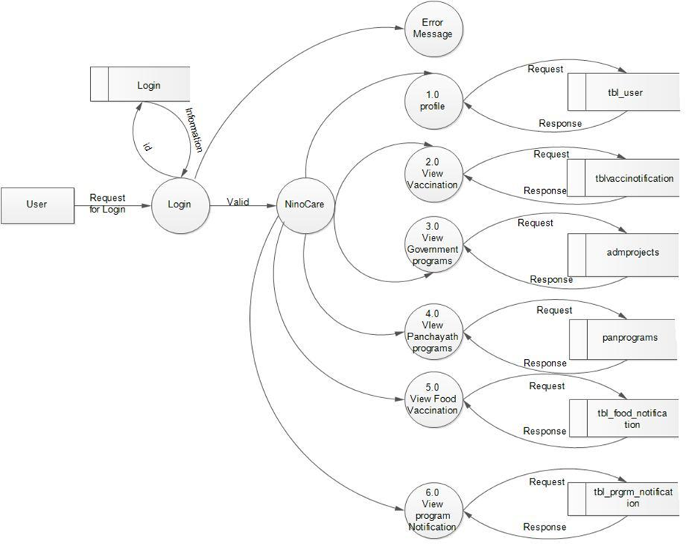

**ER Diagram**

**SYSTEM DESIGN**

**5. SYSTEM DESIGN**

The most creative and challenging phase of the system development is system design, is a solution to how to approach to the creation of the proposed system. It refers to the technical specification that will be applied. It provides the understanding and procedural details necessary for implementing the system recommended in the feasibility study. Design goes through the logical and physical stages of development. At an early stage in designing a new system, the system analyst must have a clear understanding of the objectives, which the design is aiming to fulfill. The first step is to determine how the output is to be produced and in what format. Second input data and master files (database) have to be designed to meet the requirements of the proposed output. The operational (processing) phases are handled through program construction and testing.

The system design includes:-

5.1 Input design

5.2 Output design

5.3 Database design

**5.1 INPUT DESIGN**

Input design is the primary step in the system design, to design the input with the predefined guidelines. The objective of the layout is easy to follow and does not include operator errors.

Input design is the process of converting user oriented input to the computer based output. Input data are collected and organized into group of similar data. The goal of designing input data is to make data entry easy, logical and error free as possible in input design and the administrator checks the entered data valid or not.

**5.2 OUTPUT DESIGN**

Output design has been an ongoing activity. The output is the most Important and direct source of information to the user. Efficient intelligible output design should improve the system’s relationship with the user and helps in decision making. Designing output requires understanding user’s output requirements; the system produces an output, which varying according to user requirements.

**5.3 TABLE DESIGN**

* **Table Name: reg_panchayath**

|  |  |  |
| --- | --- | --- |
| **FIELD NAME** | **DATA TYPE** | **DESCRIPTION** |
| PID | bigint(50) | ID for panchayath (primary key) |
| Did | bigint(50) | District id of panchayath |
| PName | varchar(100) | Name of panchayath |
| PAddress | varchar(100) | Address of panchayath |
| PArea | varchar(50) | ID for the users |
| President | varchar(50) | Address of the organization |
| EmpNos | bigint(50) | Name of the organization |
| Wards | varchar(100) | Number of wards |
| Houses | varchar(50) | Number of houses |
| Email | varchar(50) | Email of panchayath |

* **Table Name: reg_asha**

|  |  |  |
| --- | --- | --- |
| **FIELD NAME** | **DATA TYPE** | **DESCRIPTION** |
| AID | bigint(50) | ID of asha worker (primary key) |
| PID | varchar(100) | Panchayath id of asha worker |
| Name | varchar(100) | Ashaworker’s name |
| DOB | date | DOB of asha worker |
| Gender | varchar(100) | Gender of asha worker |
| Address | varchar(100) | Address of asha worker |
| WardNo | varchar(100) | Ward number of asha worker |
| Qualification | varchar(100) | Ash worker’s qualification |

* **Table Name: district**

|  |  |  |
| --- | --- | --- |
| **FIELD NAME** | **DATA TYPE** | **DESCRIPTION** |
| Did | bigint(50) | ID of district of kerala (primary key) |
| Dname | varchar(100) | District name |

* **Table Name: Login**

|  |  |  |
| --- | --- | --- |
| **FIELD NAME** | **DATA TYPE** | **DESCRIPTION** |
| Did | bigint(50) | ID of district of kerala (primary key) |
| Dname | varchar(100) | District name |

* **Table Name: tbl_user**

|  |  |  |
| --- | --- | --- |
| **FIELD NAME** | **DATA TYPE** | **DESCRIPTION** |
| Uid | bigint(50) | ID of user (primary key) |
| Aid | bigint(50) | Ashaworker id of user |
| Hnumber | varchar(100) | House number of user |
| Name | varchar(100) | Name of user |
| Dob | date | DOB of user |
| carring_month | date | Last menses date |
| Address | varchar(100) | Address of user |
| Phone | varchar(100) | Phone number of user |
| Email | varchar(100) | Email of user |
| Photo | longblob | Profile photo of user |
| Date | varchar(100) | Registered date |

* **Table Name: panprograms**

|  |  |  |
| --- | --- | --- |
| **FIELD NAME** | **DATA TYPE** | **DESCRIPTION** |
| ProgID | bigint(50) | ID of panchayath program (primary key) |
| PID | varchar(100) | ID of panchayath |
| ProgName | varchar(1000) | Panchayath program name |
| PanProLoc | varchar(1000) | Panchayath program location |
| PanProDate | date | Panchayath program date |
| Progtime | time | Panchayath program time |

* **Table Name: admprojects**

|  |  |  |
| --- | --- | --- |
| **FIELD NAME** | **DATA TYPE** | **DESCRIPTION** |
| pro_id | bigint(50) | ID of government scheme (primary key) |
| pro_name | varchar(100) | Government scheme name |
| pro_user | varchar(100) | User of government scheme |
| pro_det | varchar(100) | Government schemem details |
| pro_date | date | Government scheme date |

* **Table Name: tbl_childregister**

|  |  |  |
| --- | --- | --- |
| **FIELD NAME** | **DATA TYPE** | **DESCRIPTION** |
| cid | bigint(50) | ID of child (primary key) |
| Aid | bigint(50) | Asha worker id |
| Hnumber | varchar(100) | House number of user |
| Mid | bigint(50) | ID of mother |
| Name | varchar(100) | Name of child |
| Gender | varchar(100) | Gender of child |
| Dob | varchar(100) | DOB of child |
| Date | varchar(100) | Registered date |

* **Table Name: tbl_food**

|  |  |  |
| --- | --- | --- |
| **FIELD NAME** | **DATA TYPE** | **DESCRIPTION** |
| Fid | bigint(50) | ID of food (primary key) |
| Pid | bigint(50) | Panchayath id |
| FoodName | varchar(100) | Food name |
| FoodUserType | varchar(100) | Food usertype |
| FoodPeriod | varchar(100) | Time to eat |

* **Table Name: tbl_food_notification**

|  |  |  |
| --- | --- | --- |
| **FIELD NAME** | **DATA TYPE** | **DESCRIPTION** |
| Foodid | bigint(50) | ID of food notification (primary key) |
| Aid | bigint(50) | Asha worker id |
| Usertype | varchar(100) | User of food, mother or child |
| Foodname | varchar(100) | Food name |
| Descript | varchar(100) | Description of food |
| Date | varchar(100) | Date of food delivered |

* **Table Name: tbl_program_notification**

|  |  |  |
| --- | --- | --- |
| **FIELD NAME** | **DATA TYPE** | **DESCRIPTION** |
| Progid | bigint(50) | ID of program notification (primary key) |
| Aid | bigint(50) | Asha worker id |
| Progname | varchar(100) | Program name |
| Pdate | varchar(100) | Program date |
| Plocation | varchar(100) | Program location |
| Ptime | varchar(100) | Program time |
| Description | varchar(100) | Program description |

* **Table Name: tbl_vacci_notification**

|  |  |  |
| --- | --- | --- |
| **FIELD NAME** | **DATA TYPE** | **DESCRIPTION** |
| not_id | bigint(50) | ID of vaccination notification (primary key) |
| Vid | varchar(100) | Vaccination id |
| Aid | bigint(50) | Asha worker id |
| Date | varchar(100) | Date of vaccination |
| Location | varchar(100) | Location |
| Time | varchar(100) | Vaccinaton date |

**TESTING**

**6. SYSTEM TESTING**

System testing is the stage of implementation highly aimed at ensuring that the system works accurately and efficiently before the live operation commences. Testing is vital to the success of the system. The primary objective of testing is to derive a set of tests that has the highest like hood for uncovering defects in then software. The system test in implementation should conform that all is correct and an opportunity to show the users that the system works as expected. It accounts the largest percentage of technical effort in the software development process. Testing phase in the development cycle validates the code against the functional specification.

The performance of the system is measured in this phase. Testing is a set activity that can be planned and conducted systematically. Testing begins at the module level and works towards the integration of entire computers based systems. Nothing is complete without testing, as it is vital success of the system.

The different types of testing are as follows:

**Whitebox** **Testing**

White box testing (also known as Clear box testing, Open box testing, Glass box testing, Transparent box testing, Code-Based testing or Structural testing) is a testing technique that takes into account the internal mechanism of a system. In order to perform white box testing on an application, the tester needs to possess knowledge of the internal working of the code, white box testing is often used for verification.

**Black box Testing**

Black box testing is a testing technique that ignores the internal mechanism of the system and focuses on the output generated against any input and execution of the system. It is also called functional testing. Black box testing is often used for validation.

**Unit Testing**

Unit testing is the testing of an individual unit or group of related units. It falls under the class of white box testing. It is often done by the programmer to test that the unit he/she has implemented is producing expected output against given input.

**Integration Testing**

Integration testing is testing in which a group of components are combined to produce output. Also, the interaction between software and hardware is tested in integration testing if software and hardware components have any relation. It may fall under both white box testing and black box testing.

**Functional Testing**

Functional testing is the testing to ensure that the specified functionality required in the system requirements works. It falls under the class of black box testing.

**System Testing**

System testing is the testing to ensure that by putting the software in different environments (e.g., Operating Systems) it still works. System testing is done with full system implementation and environment. It falls under the class of black box testing.

**Performance Testing**

Performance testing is the testing to assess the speed and effectiveness of the system and to make sure it is generating results within a specified time as in performance requirements. It falls under the class of black box testing.

**Usability Testing**

Usability testing is performed to the perspective of the client, to evaluate how the GUI is user-friendly? How easily can the client learn? After learning how to use, how proficiently can the client perform? How pleasing is it to use its design? This falls under the class of black box testing.

**Acceptance Testing**

Acceptance testing is often done by the customer to ensure that the delivered product meets the requirements and works as the customer expected. It falls under the class of black box testing.

**Regression Testing**

Regression testing is the testing after modification of a system, component, or a group of related units to ensure that the modification is working correctly and is not damaging or imposing other modules to produce unexpected results. It falls under the class of black box testing.

**Beta Testing**

Beta testing is the testing which is done by end users, a team outside development, or publicly releasing full pre-version of the product which is known as beta version. The aim of beta testing is to cover unexpected errors. It falls under the class of black box testing.

**Validation Testing**

Data validations are done to see whether the corresponding entries made in the tables are correct. Proper validations checks are done in case of insertion and updating of tables.validaton testing is the process of evaluating software at the end of software development process to ensure compliance with software requirements.

**7. SECURITY TECHNOLOGIES AND POLICIES**

Verification is the process to make sure the product satisfies the conditions imposed at the start of the development phase. In other words, to make sure the product behaves the way we want it to.

Two types of Validations are present, that are

* Client side validation
* Server side validation

**Client side validation**

Client side validation is something that will happen on users' browser. The validation will occur before the data gets posted back to server. It is a good idea to have client side validation as the user gets to know what needs to be changed immediately, i.e., no trips to servers are made. JavaScript is most widely used to perform client side validation.

**Server Side Validation**

Server side validation occurs at server. The benefit of having server side validation is that if the user somehow bypasses the client side validation (accidentally or deliberately), then we can catch the problem on the server side. So having server side validation provides more security and ensures that no invalid data gets processed by the application. Server side validation is done by writing our custom logic for validating all the input.

**8. MAINTENANCE**

We maintain system via admin by updating all the necessary data as on time. Also ensuring the correctness of the data . This is also maintained by the developers on the securities and data hiding and also the update of the website and its accessories.

**9. CONCLUSION**

We have developed this website for the ease of people. We have provided better and user friendly websites, which is easily operable and secure. We contribute to the society in the field of health with our website.

* 1. **SCOPE FOR FUTURE ENHANCEMENT**

Our plans for future

**10. BIBLIOGRAPHY**

**[**1] Jeeva Jose 2018 HANDS ON PYTHON

**[**2] Zed A. Shaw (3rd Edition) Head-First Python

[3] Mathew McDonald HTML5 ‘the missing manual’.

[4] [Ramez Elmasri](https://www.amazon.in/Ramez-Elmasri/e/B000APV0OK/ref=dp_byline_cont_ebooks_1)  &  [Shamkant B. Navathe](https://www.amazon.in/s/ref=dp_byline_sr_ebooks_2?ie=UTF8&field-author=Shamkant+B.+Navathe&text=Shamkant+B.+Navathe&sort=relevancerank&search-alias=digital-text) fundamentals of database system.

[5] Sumitha Arora MySql database.

[6] Wl3schools.com

[7] l3layouts.com

[8] developer.morzila.org

[9] Greeksforgreeks.org

# [10] **Holovaty**, Adrian, **Kaplan-Moss**, Jacob The Definitive Guide to Django.

**11. APPENDIX**

**LOGIN**

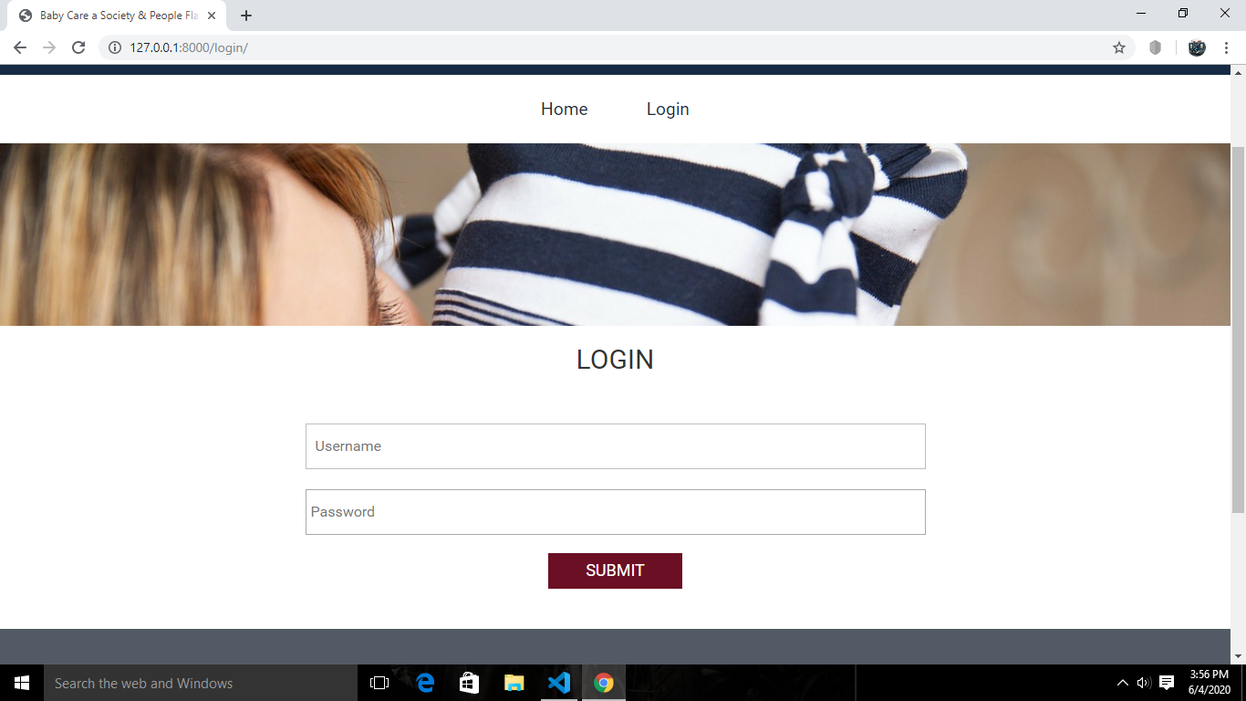

**REGISTRATION**

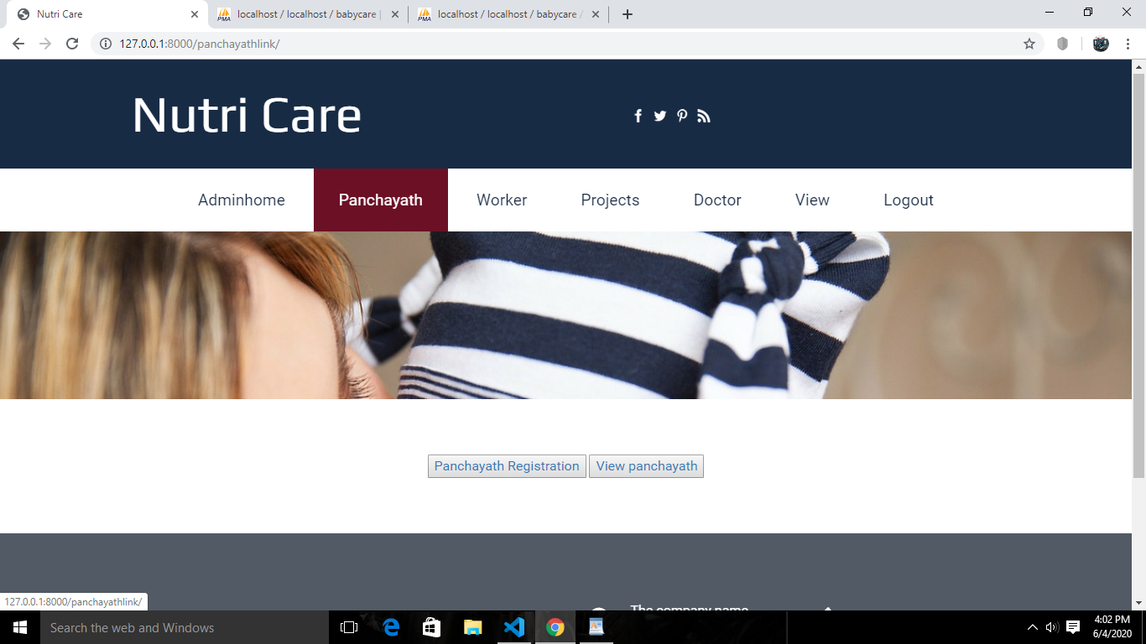

**PANCHAYATH FORM**

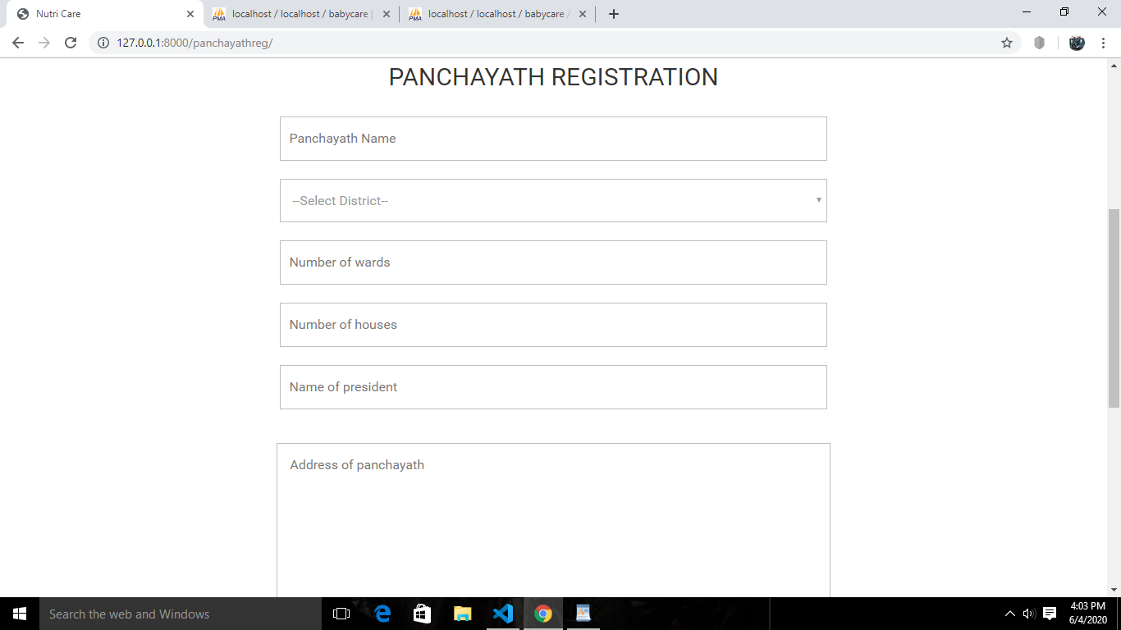

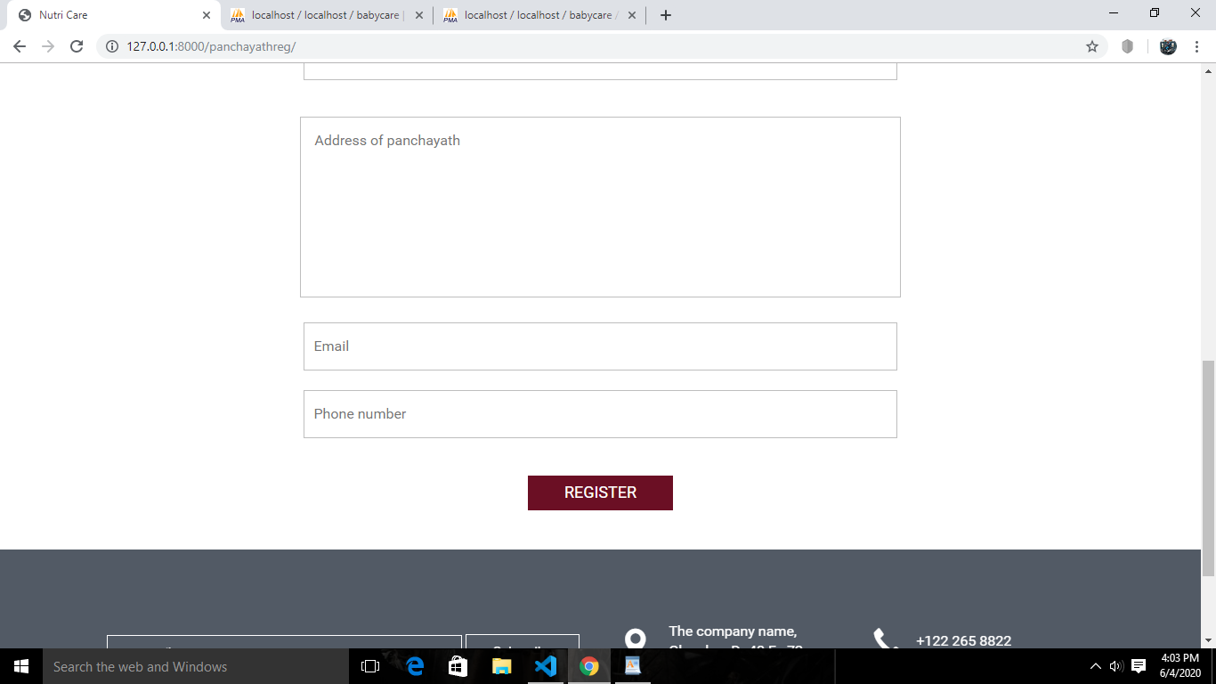

**WORKER REGISTRATION**

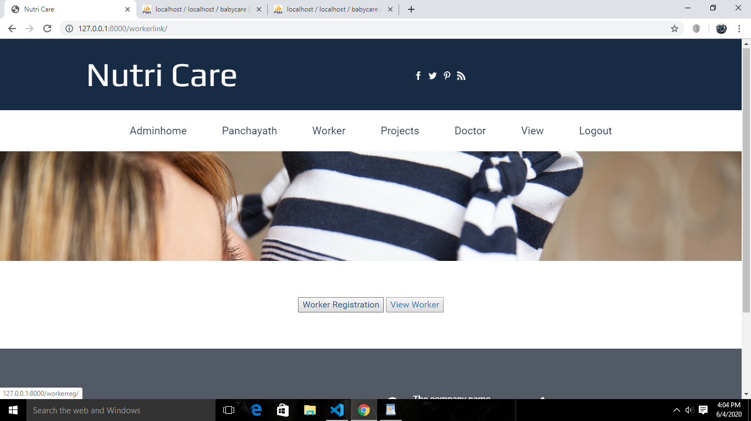

**ADDING PROJECT**

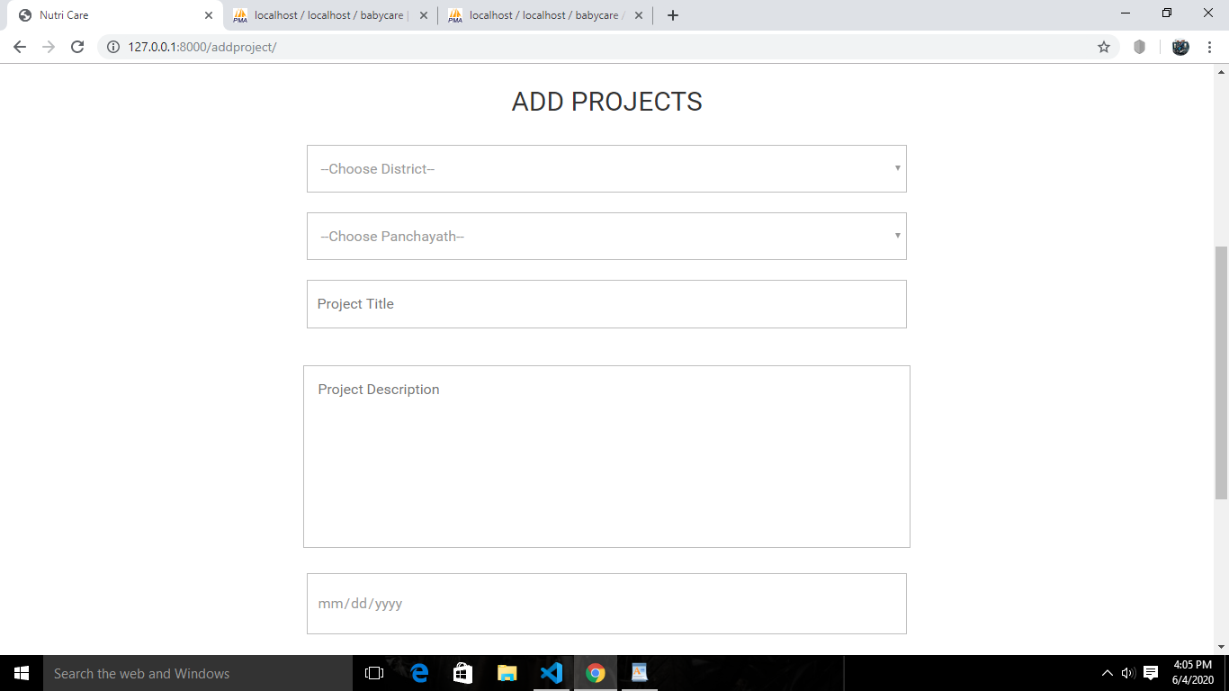

**ADDING DOCTOR**

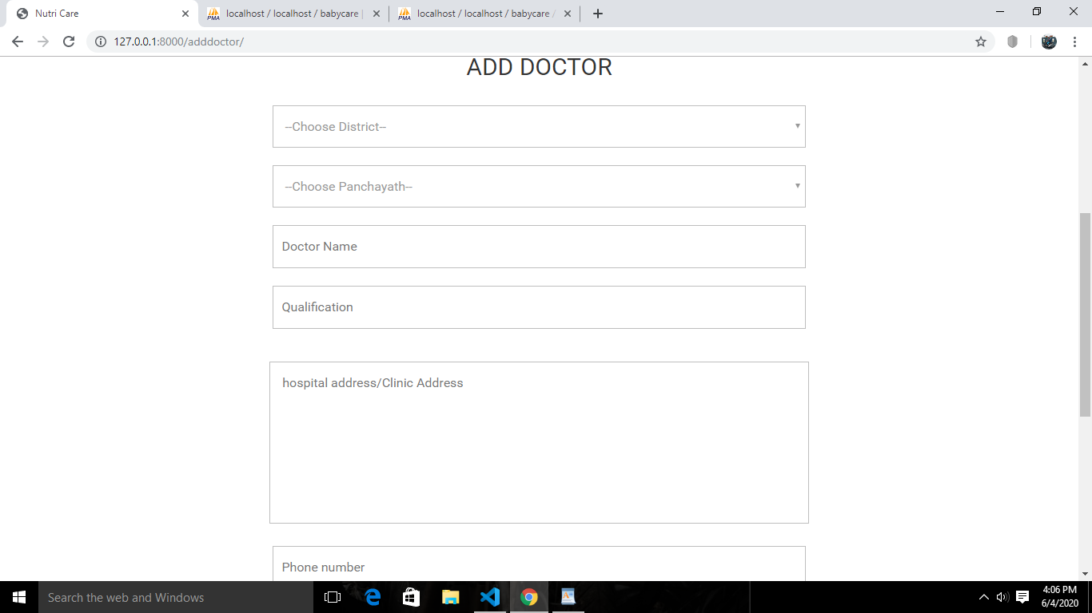

**ADDING VACINATION**

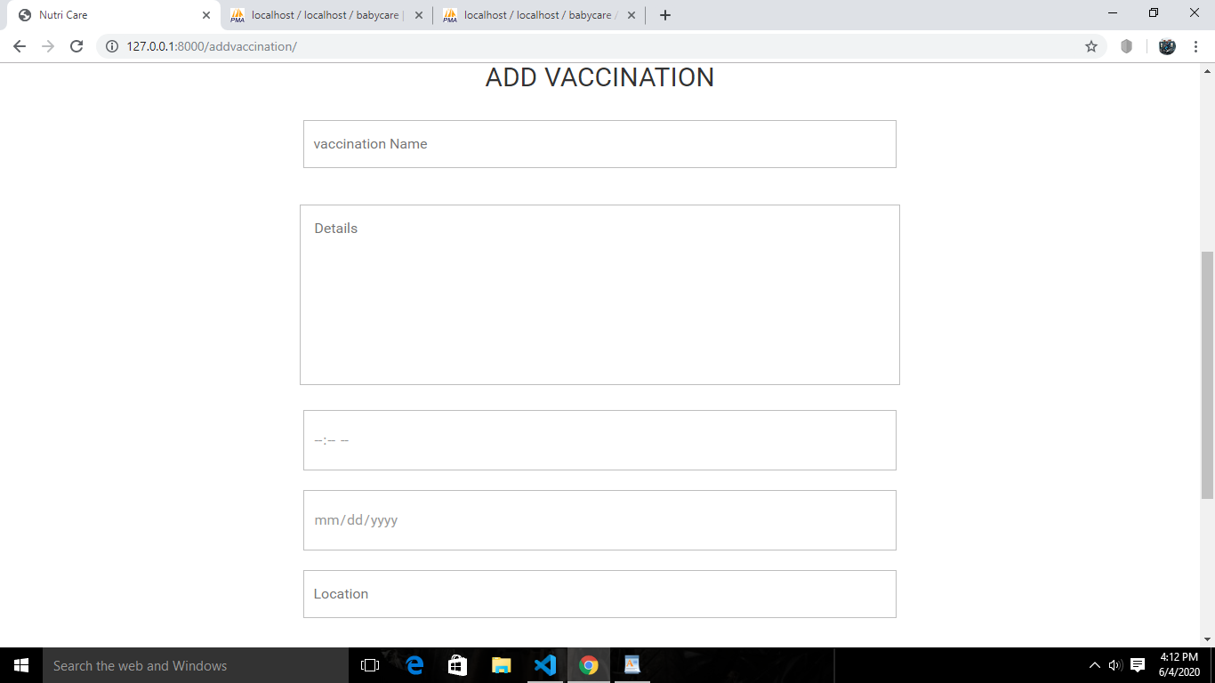

**ADDING FOOD**



**ADDING HEALTH TIPS**

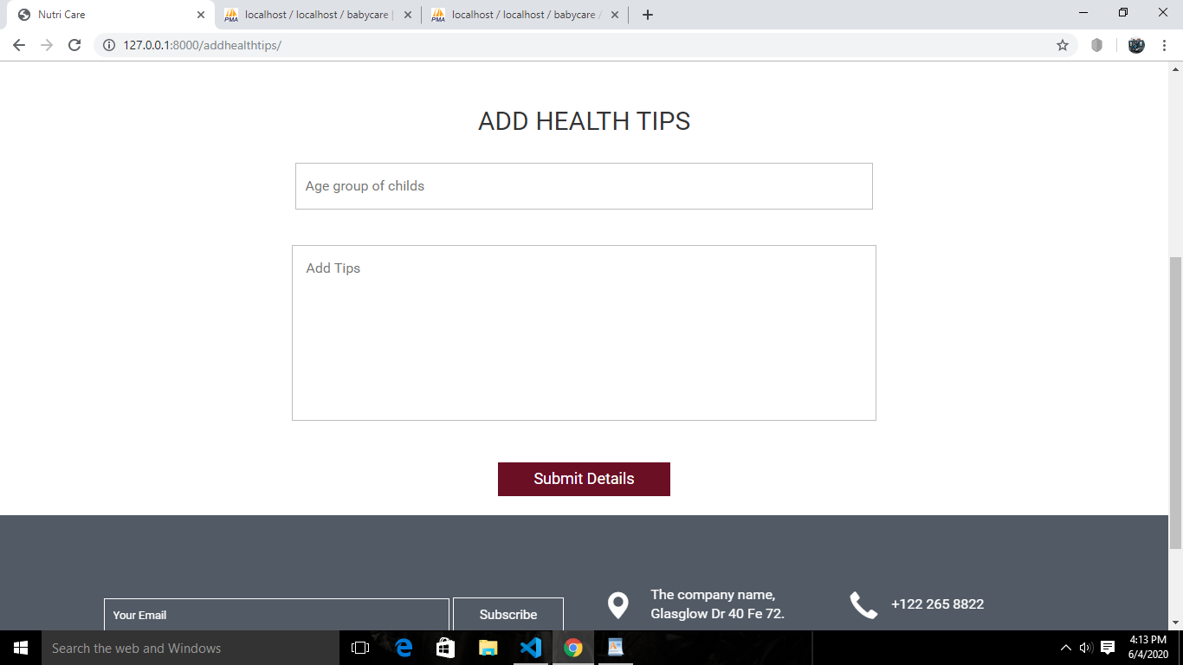

**ADDING DISEASES DETAILS**

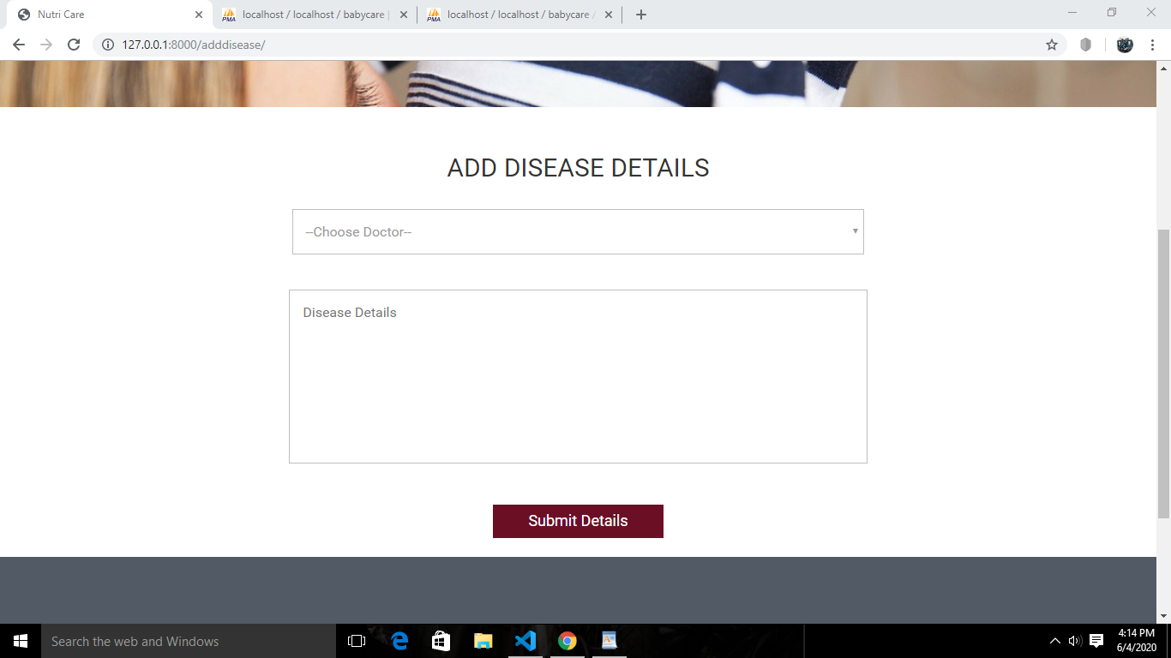

**DELIVERY FORM**



**NOTIFICATIONS**

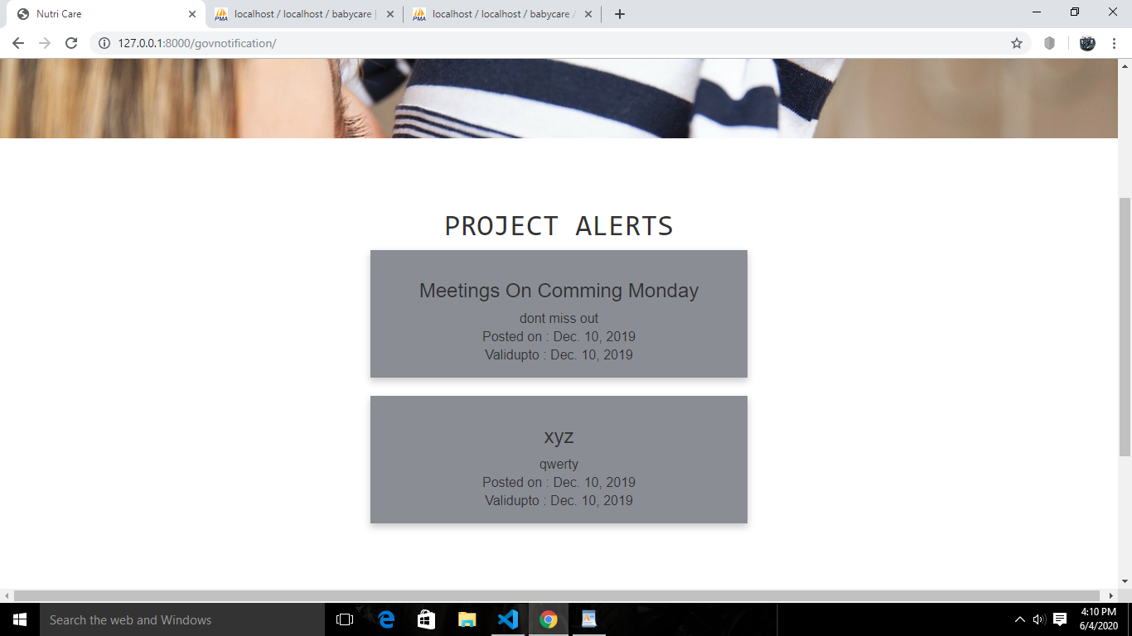

**DETAILS**

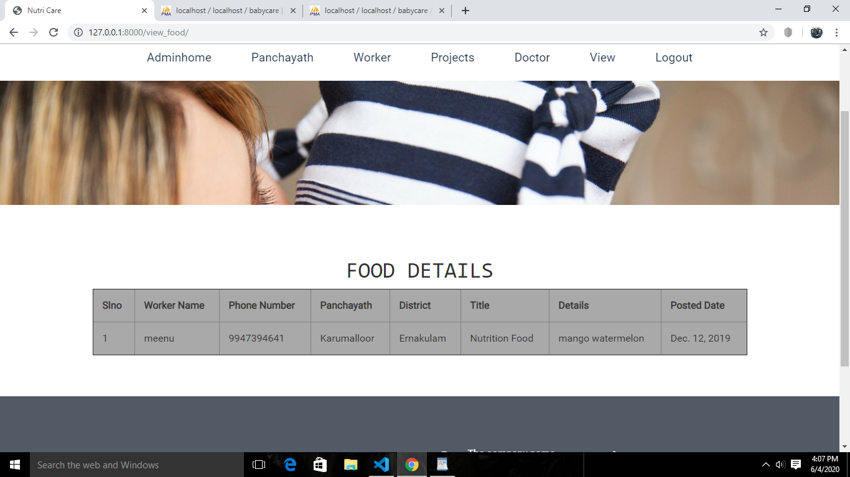

**CODING**

**<!--A Design by W3layouts**

**Author: W3layout**

**Author URL:** [**http://w3layouts.com**](http://w3layouts.com)

**License: Creative Commons Attribution 3.0 Unported**

**License URL:** [**http://creativecommons.org/licenses/by/3.0/**](http://creativecommons.org/licenses/by/3.0/)

**-->**

**{% extends 'Doctor_Header_Footer.html' %}**

**{% block mother123 %}**

**{% load static %}**

**<!--script-for-menu-->**

**<!--banner-starts-->**

**<div class="banner-1">**

**</div>**

**<!--banner-end-->**

**<!--contact-->**

**<style>**

**table {**

**width: 78%;**

**background-color:darkgray;**

**padding: 10px;**

**}**

**th, td {**

**padding: 15px;**

**text-align: left;**

**}**

**button {background-color: #f44336;}**

**</style>**

**<center><div class="Registeration">**

**<br><br><br>**

**<h1 style="font-family: monospace">MOTHER DETAILS LIST</h1>**

**<table border="1">**

**<th>Slno</th>**

**<th>Mother Name</th>**

**<th>Age</th>**

**<th>Address</th>**

**<th>District</th>**

**<th>Panchayath</th>**

**<th>Ward Number</th>**

**<th>Pregnent status</th>**

**<th>Month Count</th>**

**<th>Delivery Date</th>**

**<th>Phone Number</th>**

**{%for d in data%}**

**<tr>**

**<td>{{d.0}}</td>**

**<td>{{d.2}}</td>**

**<td>{{d.3}}</td>**

**<td>{{d.4}}</td>**

**<td>{{d.5}}</td>**

**<td>{{d.6}}</td>**

**<td>{{d.7}}</td>**

**<td>{{d.8}}</td>**

**<td>{{d.9}}</td>**

**<td>{{d.10}}</td>**

**<td>{{d.11}}</td>**

**</tr>**

**{% endfor %}**

**</table>**

**</div>**

**</center>**

**<br><br><br>**

**{% endblock %}**

**REPORTS**

