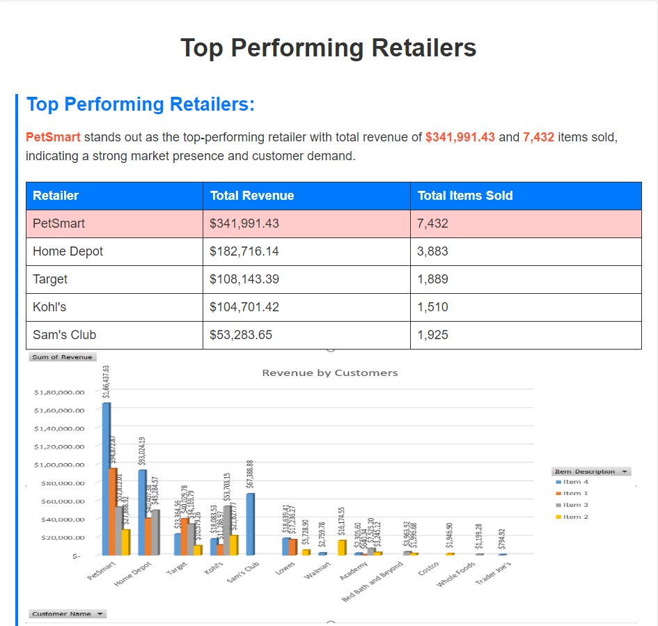

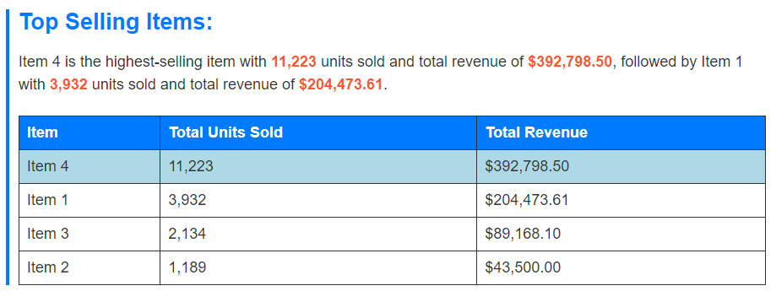

## Retailer and Item Performance:

PetSmart and Home Depot demonstrate balanced performance across items, indicating a diverse product range and customer base.

Kohl's relies heavily on Item 3 for revenue, while Target and Home Depot show more balanced revenue distribution across items.

Lowes has a lower total revenue compared to other major retailers, suggesting potential areas for improvement or focus.

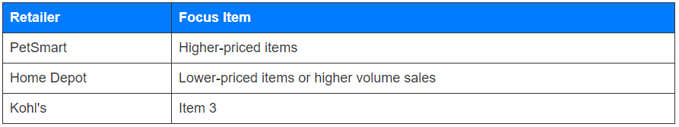

**Summary of Insights:**

**Focus on Top-Selling Items**

Retailers should prioritize their top-selling items to maximize revenue.

**PetSmart's Strategy**

PetSmart should emphasize higher-priced items, which contribute significantly to its total revenue.

**Home Depot's Strategy**

Home Depot should focus on either offering lower-priced items or increasing volume sales to boost revenue.

**Kohl's Focus**

Kohl's should continue to promote and prioritize sales of Item 3, as it contributes significantly to their total revenue.

**Overall Strategy**

Retailers can benefit from diversifying their product range and focusing on items that drive the most revenue.