1. navigate and list all contents of the the /tmp

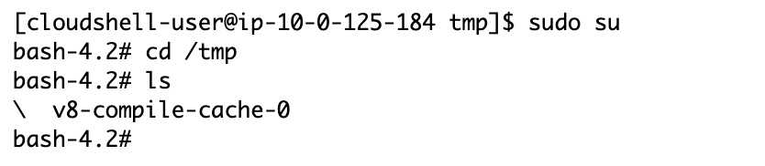

2) create a file (test.sh) in /tmp directory of an ec2 server

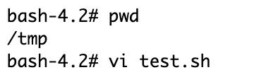

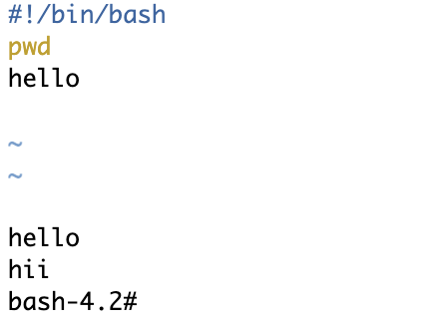

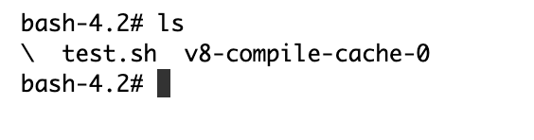

3) copy all content from /var/log to a folder mylogs under /tmp

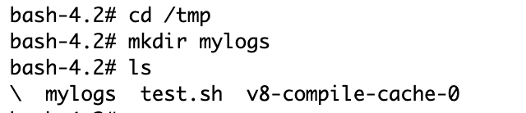

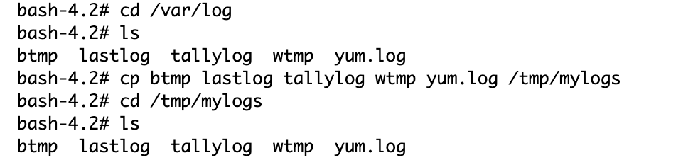

4) print the current date , current directory

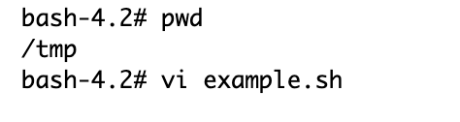

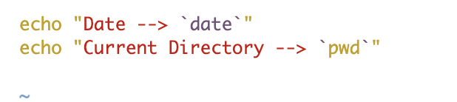

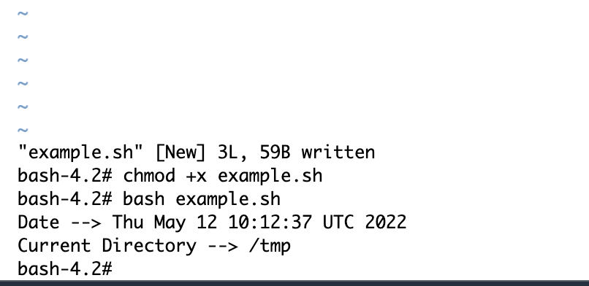

5)write some content to the file test.sh using vi

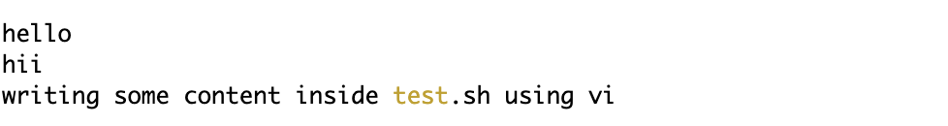

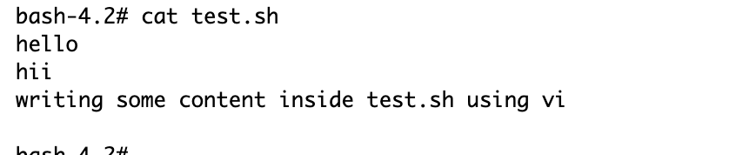

6)write some content to the file test.sh using echo command



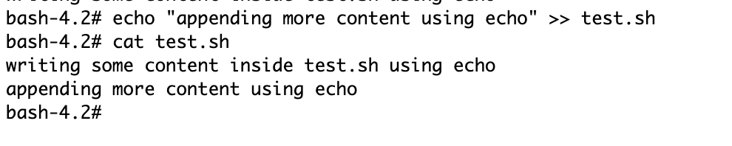

7) find and search for the word "Hello" in the file test.sh

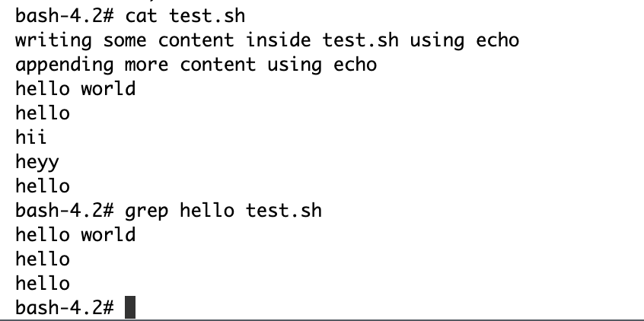

8) write a small shell script to get the first and last name of the user as input and display the full name by combining both first and last name

