**1) that prints the user input string**

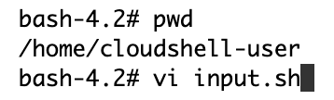

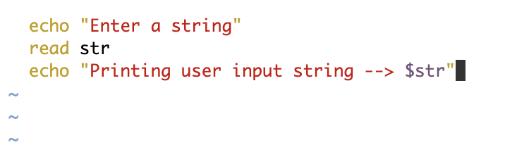

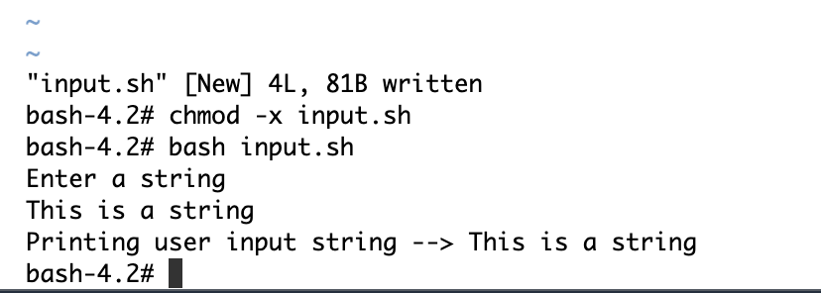

**2) create a directory /tmp/task1 using the script using appropriate flags to create directory if not present and ignore if present**

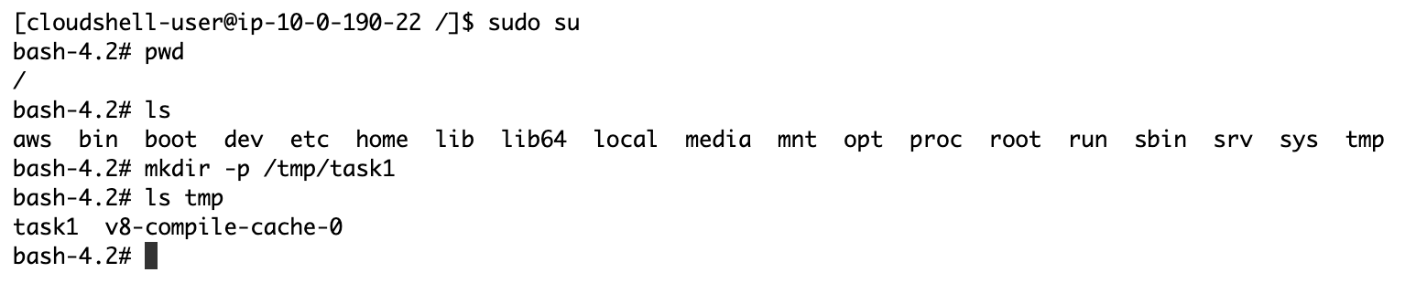

**3) create and append ( not overwrite) the user inputs to the input.txt file under /tmp/task1 (at least 10 such inputs)**

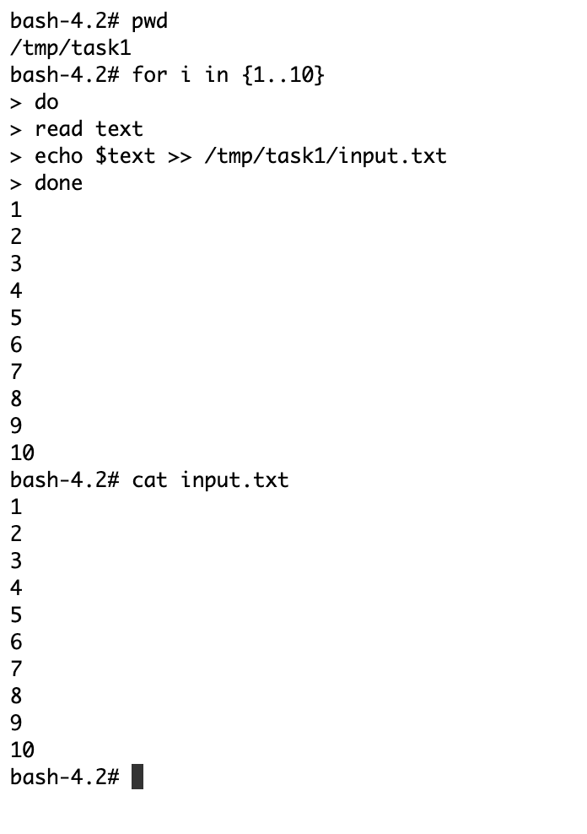

**4) Display the path and the contents of the folder /tmp/task1**

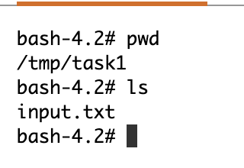

**5) Now get numbers as user inputs and print the number along with it's square values to the file ( eg Num: 5 , SqValue=35 )**

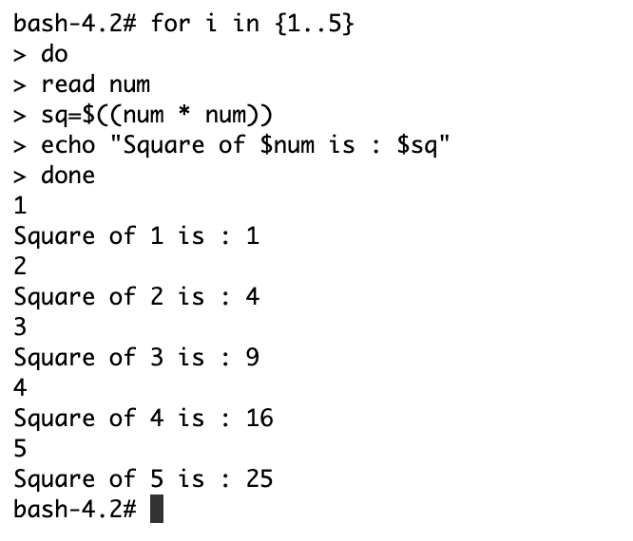

**6) search the file input.txt and find if the word Hello exists and if it does print "Hello exists" and print "Oops. Not found" if it doesn't**

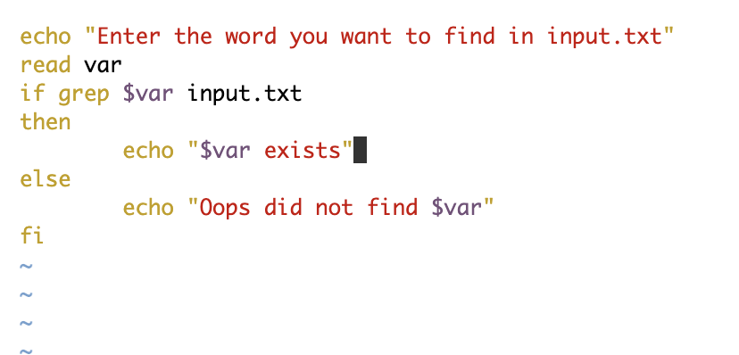

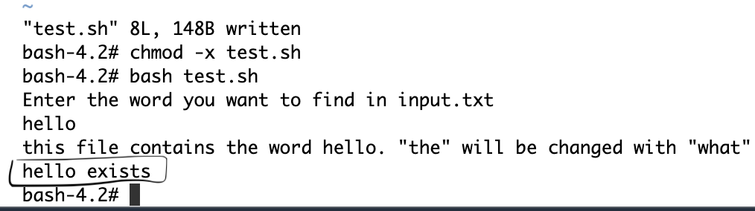

**Input.txt file contents:-**

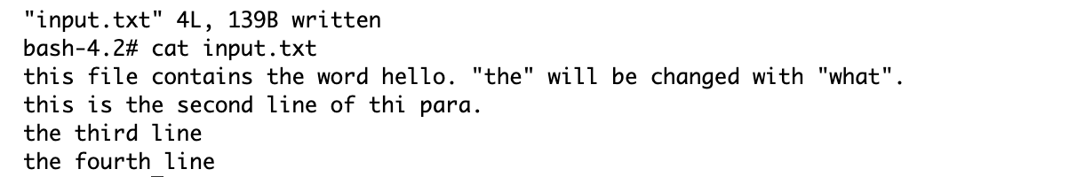

**7) find and replace all occourences of the word "the" with "what" in the file. (single command)**

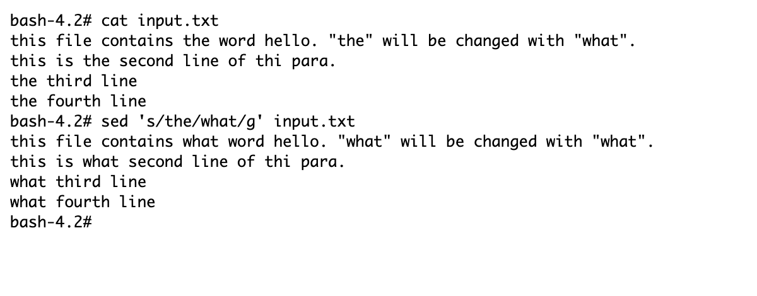

**8) use for loop and try to print the 1st word of every line**

