Create a shell script to create a file (input.txt)

Get 10 inputs from different users(sentences) and check if the file exists in the given path, if it does then write those inputs to the file....if not, then print.. Oops..can't write to file.

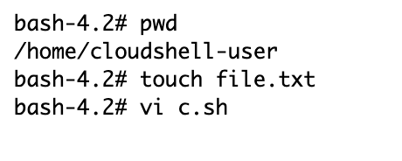

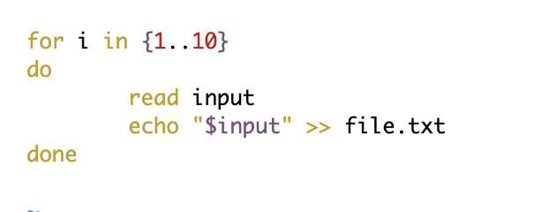

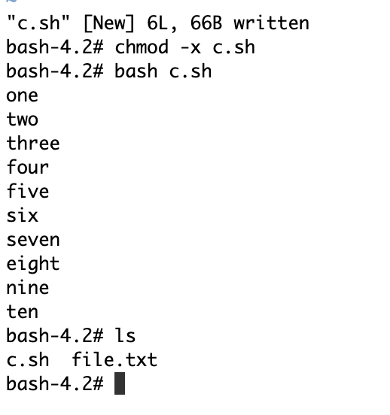

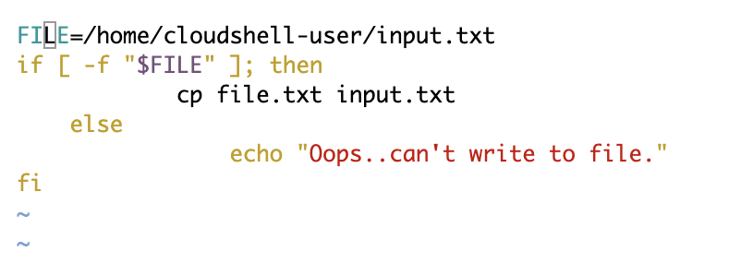

(When input.txt does not exist)

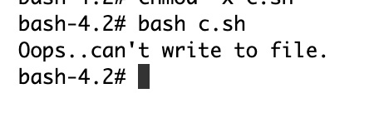

(When input.txt exists)

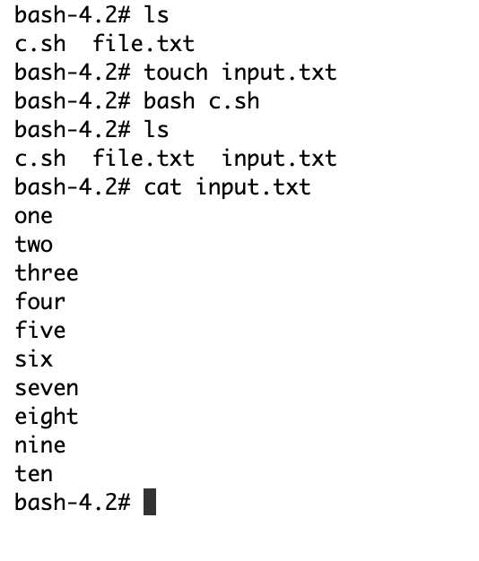

Create another shell script with a function where a user passes a param(word) to the script and the script loops through the sentences in the file(input.txt) and check if the sentence contains the word, if yes.... append the sentence to another file **Hi.txt**.. if it doesn't exist, append to the file **bye.txt.**

