Create an IAM user with keys.

Install aws cli version to your system

Create a credentials file and add keys to your local ( using profiles)

Assign S3 full permissions to your user

(done)

list all buckets in your account

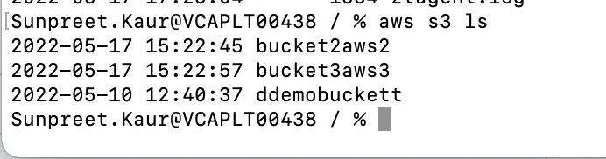

List all ec2 instances in your account

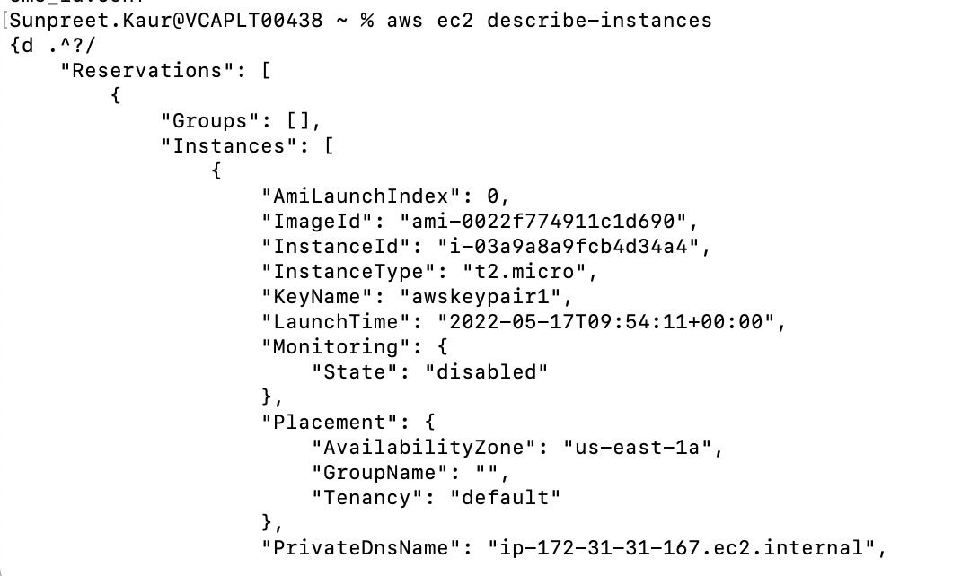

Copy all files from /tmp in your local to any s3bucket

