1套



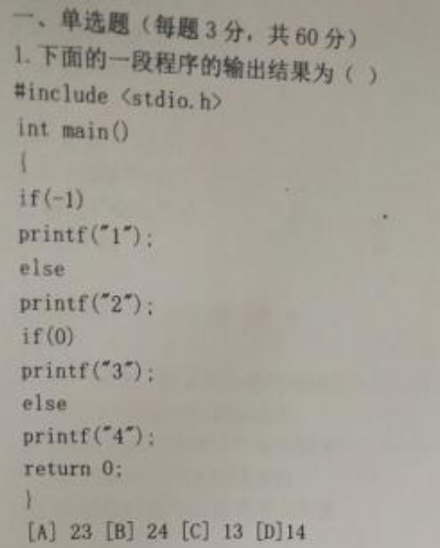

B D

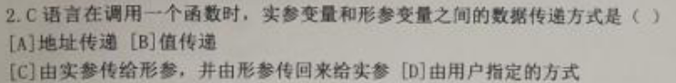

D B



B

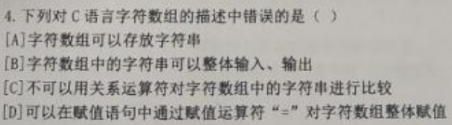

C D



D B

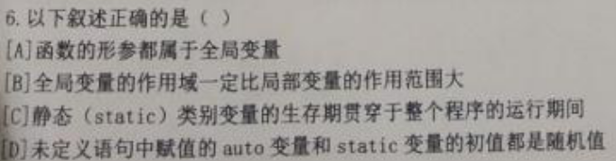

C

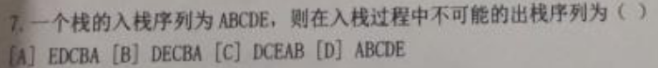

C

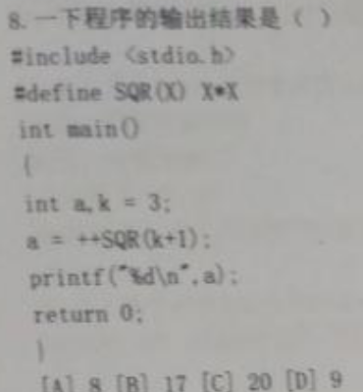

D

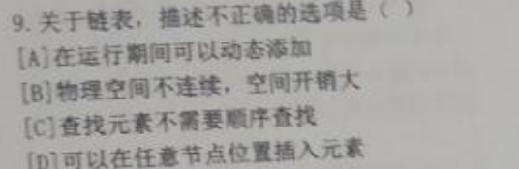

C

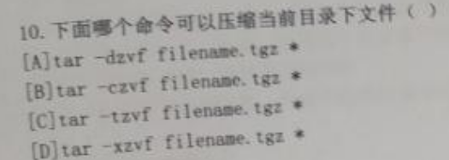

B

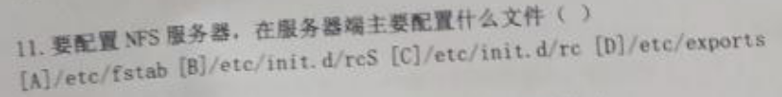



A

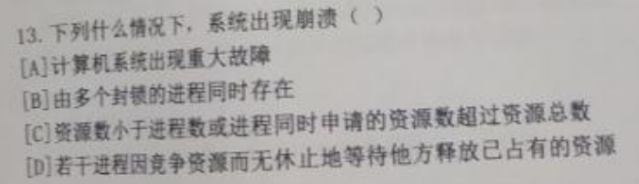

D

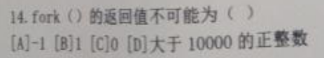

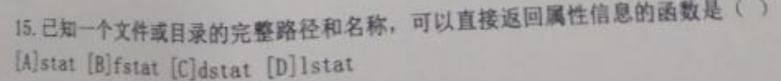

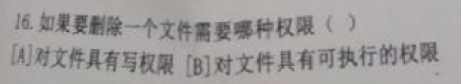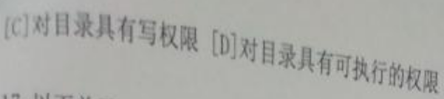

A

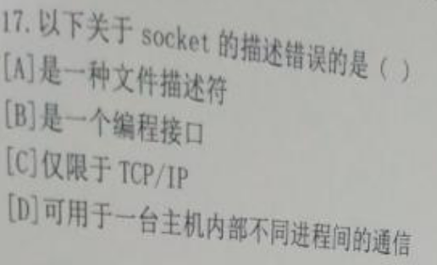

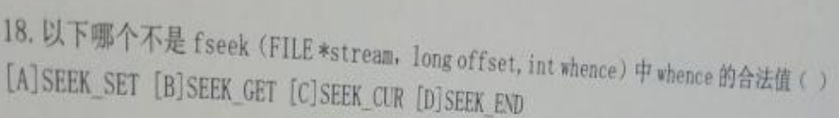

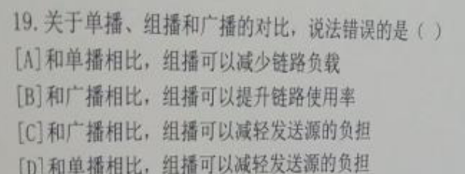

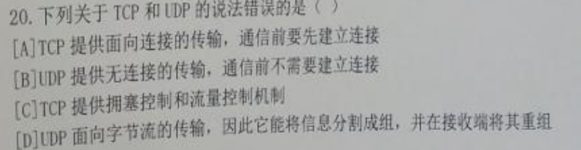

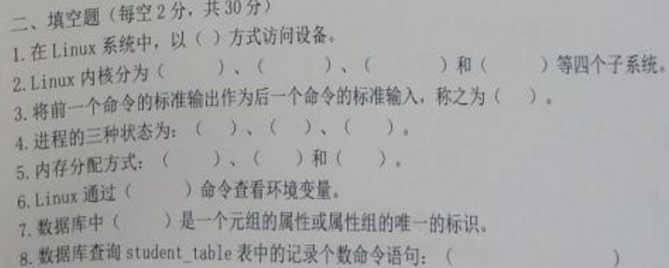

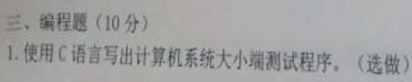

#include <stdio.h>

#include <string.h>

int main(int argc, char const \*argv[])

{

int a=0x12345678;

char \*p=(char \*)&a;

if(\*p==0x78)

printf("LSB\n");

else if(\*p==0x12)

printf("MSB\n");

return 0;

}

