网络模式

**请求-应答模式(Request-Reply)：**

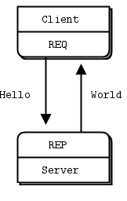

**范例：**

* [Hello World server in C++](http://zguide.zeromq.org/cpp:hwserver)
* [Hello World client in C++](http://zguide.zeromq.org/cpp:hwclient)
* [Hello World server in C#](http://zguide.zeromq.org/cs:hwserver)
* [Hello World client in C#](http://zguide.zeromq.org/cs:hwclient)
* [Hello World server in Python](http://zguide.zeromq.org/py:hwserver)
* [Hello World client in Python](http://zguide.zeromq.org/py:hwclient)

**发布-订阅模式(Publish-Subscribe)：**

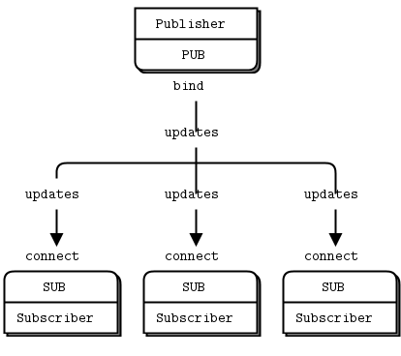

**范例：**

* [Weather update server in C++](http://zguide.zeromq.org/cpp:wuserver)
* [Weather update client in C++](http://zguide.zeromq.org/cpp:wuclient)
* [Weather update server in C#](http://zguide.zeromq.org/cs:wuserver)
* [Weather update client in C#](http://zguide.zeromq.org/cs:wuclient)
* [Weather update server in Python](http://zguide.zeromq.org/py:wuserver)
* [Weather update client in Python](http://zguide.zeromq.org/py:wuclient)

**并行管道模式(Parallel Pipeline)：**

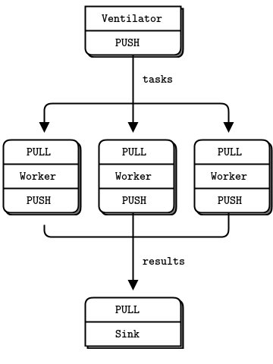

**范例：**

* [Parallel task ventilator in C++](http://zguide.zeromq.org/cpp:taskvent)
* [Parallel task worker in C++](http://zguide.zeromq.org/cpp:taskwork)
* [Parallel task sink in C++](http://zguide.zeromq.org/cpp:tasksink)
* [Parallel task ventilator in C#](http://zguide.zeromq.org/cs:taskvent)
* [Parallel task worker in C#](http://zguide.zeromq.org/cs:taskwork)
* [Parallel task sink in C#](http://zguide.zeromq.org/cs:tasksink)
* [Parallel task ventilator in Python](http://zguide.zeromq.org/py:taskvent)
* [Parallel task worker in Python](http://zguide.zeromq.org/py:taskwork)
* [Parallel task sink in Python](http://zguide.zeromq.org/py:tasksink)

**参考：**

* [ØMQ - The Guide](http://zguide.zeromq.org/page:all)
* [The Examples](https://github.com/booksbyus/zguide/tree/master/examples)