Documentation Battery Voltage Current Sensor

This board can be installed in the main power path of a high voltage battery storage. It can measure the voltage and current. The power supply is provided by the high voltage source.

* Umax : 750VDC (isolated up to 1000VDC)
* Imax : +- 50A
* No external power needed
* Absolut safe isolation concept, all data are sent via WiFi
* 100mm x 100mm board size

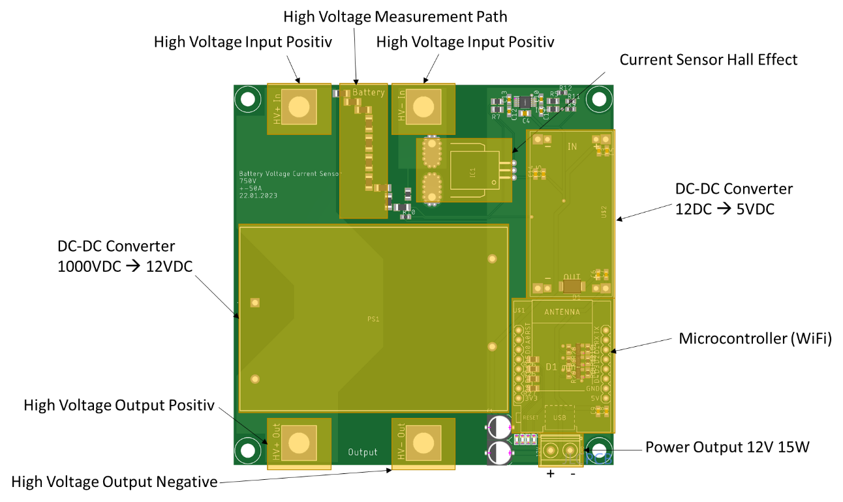

Basic connection diagram:

