Bat In + |  | Bat In - |  | Bat Out + |  | Bat Out - |  | Steuersignale |  | Erdung |  | Erdung
PV Feld 1 In  + |  | PV Feld 2 In  + |  | PV Feld 1 Out + |  | PV Feld 1 Out + |  | PV Feld 2 Out + |  | 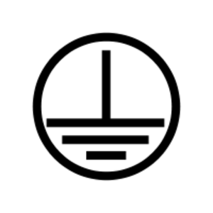
PV Feld 1 In  - |  | PV Feld 2 In  - |  | PV Feld 1 Out - |  | PV Feld 1 Out - |  | PV Feld 2 Out -
Bat In + |  | Bat In - |  | Bat Out + |  | Bat Out - |  | Steuersignale |  | Erdung |  | Erdung
PV Feld 1 In  + |  | PV Feld 2 In  + |  | PV Feld 1 Out + |  | PV Feld 1 Out + |  | PV Feld 2 Out +
PV Feld 1 In  - |  | PV Feld 2 In  - |  | PV Feld 1 Out - |  | PV Feld 1 Out - |  | PV Feld 2 Out -
LAN |  | CAN 1 |  | CAN 0 |  | LAN |  | CAN 1 |  | CAN 0 |  | Steuersignale
12V Out |  | 12V Out |  | 12V Out |  | 12V Out |  | AC In 230V |  | AC In 230V |  | Bat 1 +
Q1 |  | Q1 |  | Q2 |  | Q2 |  | Q3 |  | Q3 |  | Bat 1 -
Q4 |  | Q4 |  | Q5 |  | Q5 |  | Bat 2 + |  | Bat 2 - |  | Bat 3 +
Bat 3 - |  | Bat 4 + |  | Bat 4 - |  | Bat 5 + |  | Bat 5 - |  | Bat 6 + |  | Bat 6 -
Bat 7 + |  | Bat 7 - |  | Bat 8 + |  | Bat 8 - |  | Bat 9 + |  | Bat 9 - |  | Bat 10 +
Bat 10 - |  | Bat 11 + |  | Bat 11 - |  | Bat 12 + |  | Bat 12 - |  | Internet |  | CAN
LAN WR |  | LAN Bat |  | U + |  | U - |  | Bat G + |  | Bat G - |  | I In
I Out |  | Solar 1 + |  | Solar 1 - |  | Solar 2 + |  | Solar 2 - |  | Solar 1 + |  | Solar 1 -
Solar 2 + |  | Solar 2 - |  | Bat G + |  | Bat G - |  | U + |  | U - |  | Batterie +
Batterie – |  | Batterie + |  | Batterie – |  | Bat AP |  | Bat AP |  | Str Box |  | Str Box

