

Q1:

Software Requirements Specification

for

<FOOD ORDERING SYSTEM>

Version 1.0 approved

Prepared by

<TRẦN HOÀNG PHÚC>

<FPT University Đà Nẵng>

<9-10-2024>

Q2:

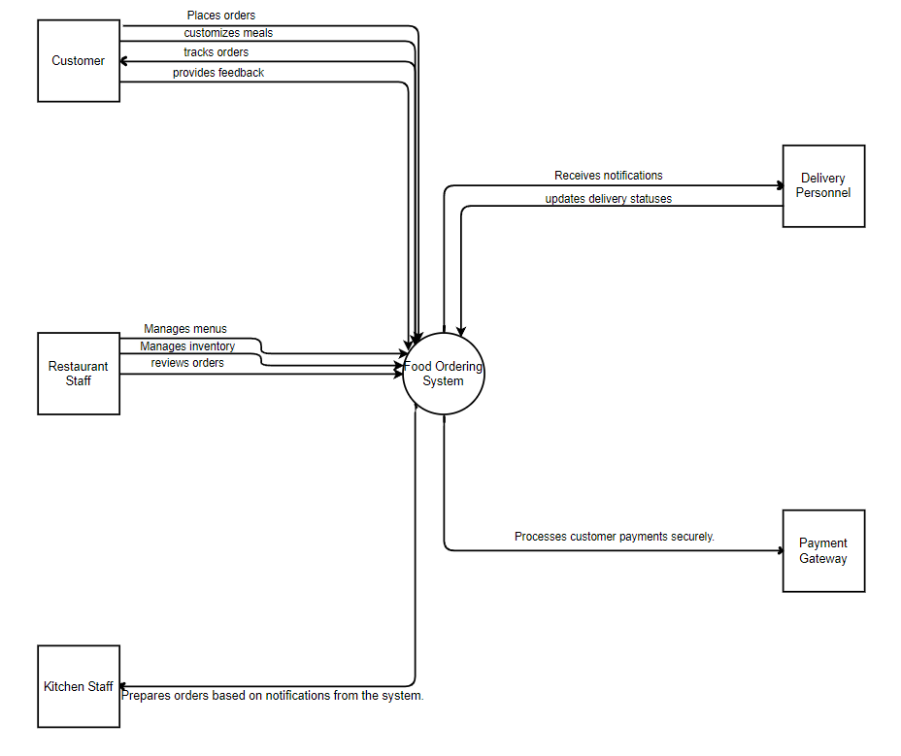Notes:

1. Draw the correct syntax to describe the context diagram (0.4 point)
2. Draw external entities (0.6 point)
3. Draw the data flows described in this exam paper (1.5 points)

>

Q3:

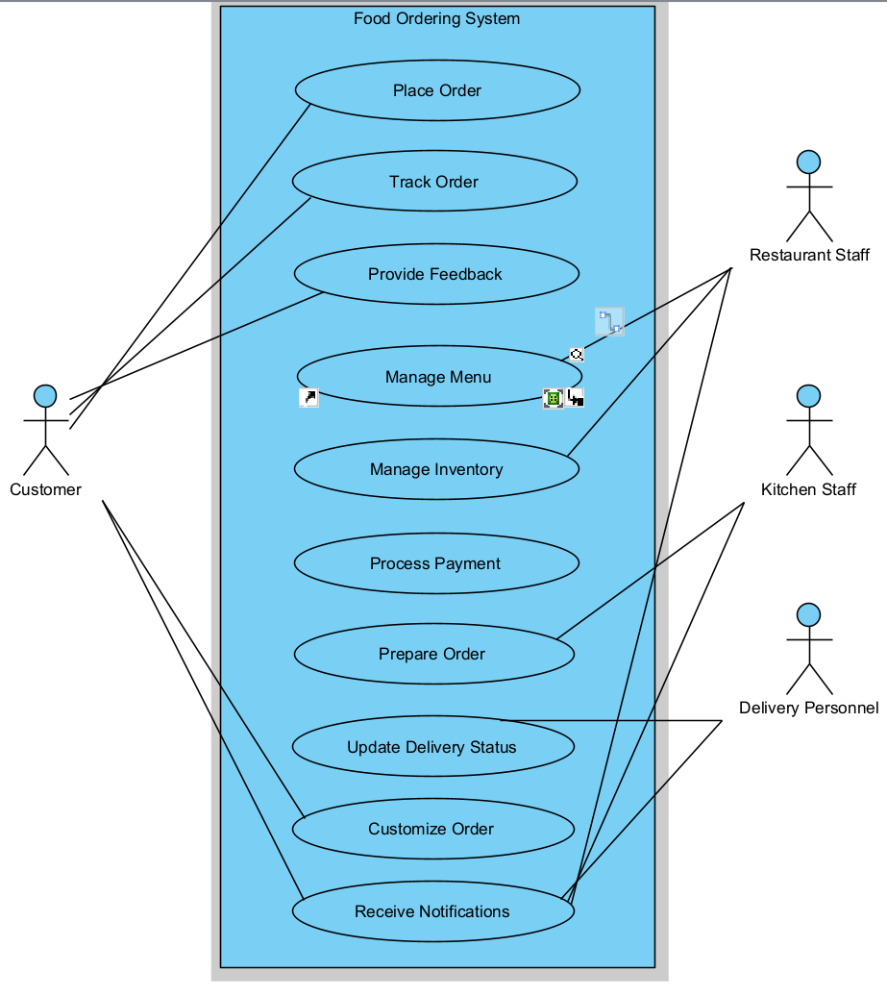Notes:

1. Draw the correct syntax to describe the use case diagram (0.4 point)
2. Draw actors and brief descriptions (0.9 point)
3. Draw use cases and brief descriptions (2.7 points)

>

|  |  |  |
| --- | --- | --- |
| **#** | **Actor** | **Description** |
| 01 | Customer | Places orders, customizes orders, tracks orders, provides feedback, and receives notifications. |
| 02 | Restaurant Staff | Manages menu, manages inventory, processes orders, and receives notifications. |
| 03 | Delivery Personnel | Updates delivery status and receives notifications. |
| 04 | Kitchen Staff | Prepares orders based on notifications from the system and updates order status. |
| 05 | Payment Gateway | Processes customer payments securely (special actor not show in the diagrams) |

|  |  |  |  |
| --- | --- | --- | --- |
| **#** | **Use Case** | **Actors** | **Description** |
| UC-01 | Place Order | Customers | Allows customers to select items and submit an order. |
| UC-02 | Customize Order | Customers | Enables customers to modify their orders according to preferences or dietary requirements. |
| UC-03 | Track Order | Customers | Enables customers to monitor the status of their order in real-time. |
| UC-04 | Provide Feedback | Customers | Allows customers to give feedback on their order and experience. |
| UC-05 | Manage Menu | Restaurant Staff | Enables restaurant staff to update menu items and prices. |
| UC-06 | Manage Inventory | Restaurant Staff | Allows restaurant staff to track and update inventory levels. |
| UC-07 | Process Payment | Payment Gateway | Handles secure transaction processing for orders. |
| UC-08 | Prepare Order | Kitchen Staff | Notifies kitchen staff of new orders and allows them to update order status during preparation. |
| UC-09 | Update Delivery Status | Delivery Personnel | Allows delivery personnel to provide real-time updates on order delivery. |
| UC-10 | Receive Notifications | Customer, Restaurant Staff, Kitchen Staff, Delivery Personnel | Sends relevant notifications to all actors |

Q4:

**Business rule:**

1. All customer orders must be processed through the Food Ordering System before being sent to the kitchen staff for preparation.
2. Restaurant staff must update both the menu and inventory information in the system to ensure accurate order processing and customization options.
3. Kitchen staff must update the order status in the system as they progress through preparation stages.
4. Customers can customize their orders within the options provided by the restaurant's menu and inventory.
5. Delivery personnel must update delivery statuses in real-time for orders assigned to them by the system.

Notes:

1. Describe 4 business rules (1.0 point)
2. For each incorrect business rule, 0.25 points will be deducted

>

|  |  |  |
| --- | --- | --- |
| ID | Rule Definition | Use cases |
| BR-01 | All customer orders must be processed through the Food Ordering System before being sent to the kitchen staff for preparation. | UC-01, UC-02, UC-03 |
| BR-02 | Restaurant staff must update both the menu and inventory information in the system to ensure accurate order processing and customization options. | UC-05,UC-06 |
| BR-03 | Kitchen staff must update the order status in the system as they progress through preparation stages. | UC-08 |
| BR-04 | Customers can customize their orders within the options provided by the restaurant's menu and inventory. | UC-02 |
| BR-05 | Delivery personnel must update delivery statuses in real-time for orders assigned to them by the system. | UC-09 |

**Q5:**

< Student must replace this line

Notes:

1. Draw the correct syntax to describe the state transition diagram (0.3 point)
2. Draw states and brief descriptions (0.9 point)
3. Draw transitions (0.8 points)

>

<Student must replace this line, answer Q5 by drawing 1 state transition diagram that reflect this exam paper and copy and then paste the image of that state transition diagram here >

< Student must replace this line, **briefly describe** the states of the diagram by fill the content to below table>

|  |  |  |
| --- | --- | --- |
| **#** | **State** | **Description** |
| 01 | Accepted | The Requester submitted a completed chemical request and the system accepted it for processing. |
| 02 |  |  |
| 03 |  |  |