B2B

Compile and Run
B2B consist of just one java file. After compiled, it takes in 2 parameters: the file path to the XML report files and the path to the folder that you want the HTML report to appear in.

The HTML report is named after the millisecond the program was ran (ex 1417211671214.html).

After generating the report, the program outputs the full path to the html file.

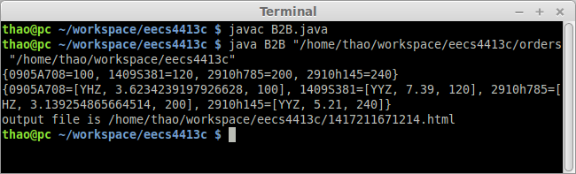

File appear on disk
The above example wants the HTML in the same folder as the project source.

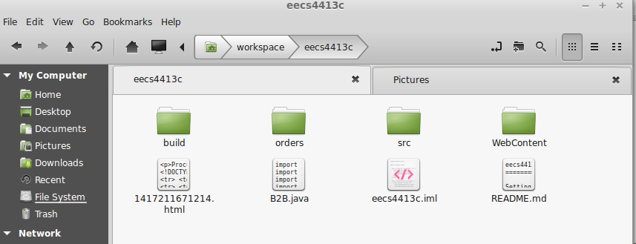

HTML Report
An example of howthe report looks like:

