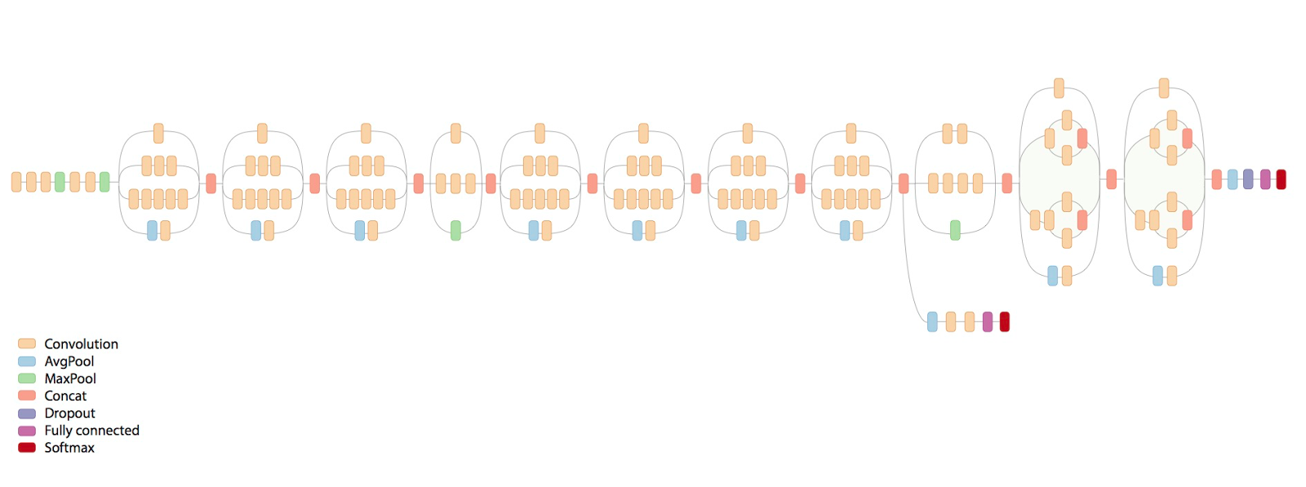

Figure 3: The original Inception V3 network structure