Callum McNeilage – n10482652

Rui, Jayvahn, Mike, Daniel

IFB103 – Assessment 3

# Item 1:

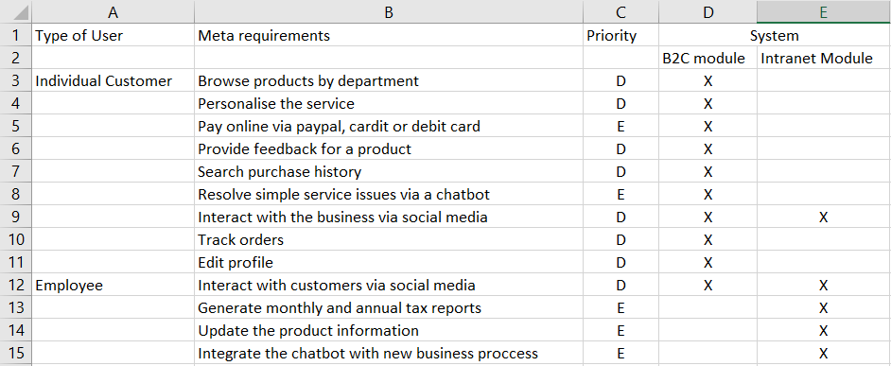

# Item 2a:

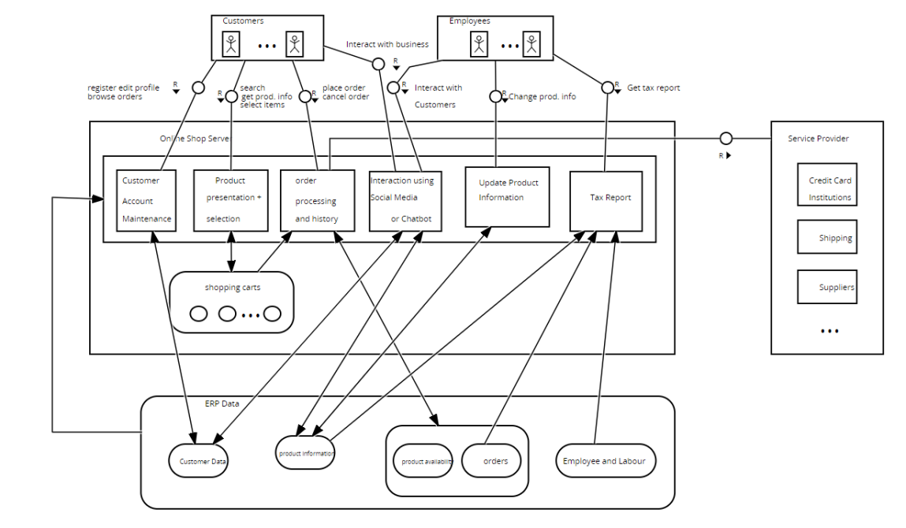

# Item 2b:

It is important for designers to draw FMC Diagrams because they provide a graphical description of a software-intensive system by depicting the compositional structure of any system that processes information. FMC diagrams allow designers to visualize didactic models to help reduce the cost and risk in the design and handling of complex systems. FMC also provides a universal notation which is easy to learn and apply, which is built off existing standards, to allow for coherent communication with stakeholders.

# Item 3a:

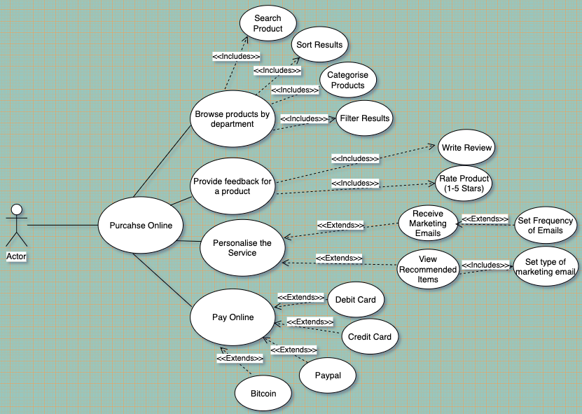

# Item 3b:

Use Case Diagrams allow designers to illustrate activities that are performed by certain types of users of a system (human or not). They do this by describing a goal the user would like to achieve and how the system will support the users achieving that goal. Each Use Case is made up of a set of possible sequences of interactions between systems and users within an environment and related to a particular goal, and contains all system activities that have significance to the users of the system.

# Item 4a:

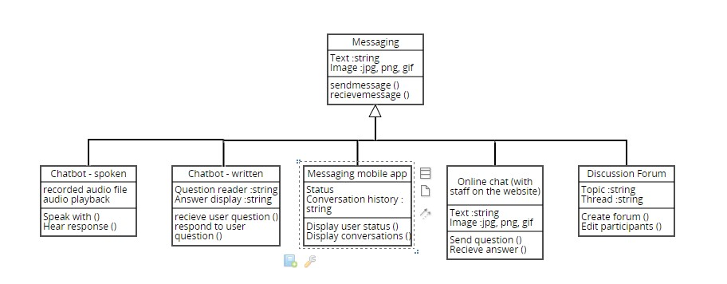

# Item 4b:

Class diagrams are important across many stages of system design. It can help you to understand the requirements and components of your problem domain in the analysis stage which can then be refined later to show specific parts of the system. These specifics often translate into actual software classes and objects. Class diagrams then become a description of exactly how a system works, the relationship between components and how they components are implemented.

# Item 5b:

Activity Diagrams are used by designers to see the process of using a system from the perspective of the user, including how a system works in real scenarios. They are used for modelling how events in a single use case relate to one another and how a collection of use cases work together to represent business workflows or behaviours of using a system from the user’s point of view.

# Item 6: Amazon.com.au

Over the last decade, amazon.com.au has become a giant of the online retail sector. But with this massive market presence, there comes a large economic impact on its consumer base. According to Business Insider, a senior economist at Westpac, Matthew Hassan, has stated that “on an economy-wide level [in Australia], many of the effects are likely to be marginal and come through gradually over several years” (Scutt, 2017). However, the likely further downside on margins may lead the Reserve Bank to keep interest rates on hold for longer than expected (Scutt, 2017). In addition, local big-name retailers, such as Coles and Woolworths, have begun focusing on their online presence by offering free same-day delivery when customers spend $150 and $300 respectively (Chau, 2018). The main reason for Amazon’s success is use of automation in as much of the process as possible. An Institute of Local Self-Reliance report calculated Amazon to have eliminated 149,000 more jobs than it created, through the use of the widespread introduction of robots for collecting items, delivery drones and even the roll-out of its cashier-free physical stores (Opray, 2017).

However, Amazon is still yet to crack the Australian market, with an after-tax loss of $8.9 million in 2017 (Chau, 2018). As such, many retailers are not expecting much of a fight with a Commonwealth Bank survey finding that of more than 600 retailers, only 41% thought Amazon would be a threat to their business (Opray, 2017). The National Union of Workers has highlighted Amazon’s record of poor labour practices, including electronic monitoring of workers and harassment (Opray, 2017). There is also the issue of multinational tax avoidance which is common among e-commerce enterprises.

Yet, after all this there are still positive effects for Australian consumers. The community relationship of small businesses may see their popularity spike as they continue to provide personal interactive experiences (Opray, 2017). In addition, small companies with unique offerings could benefit by selling products through Amazon (Opray, 2017).

## References

Chau, business reporter D. (2018, December 26). Amazon on track to dominate Australian retail within seven years, despite a shaky start [Text]. Retrieved May 27, 2019, from ABC News website: https://www.abc.net.au/news/2018-12-26/amazon-dominate-retail-within-years-slow-start/10667884

Opray, M. (2017, September 26). The giant is coming: the true cost of Amazon to retailers and workers. *The Guardian*. Retrieved from https://www.theguardian.com/australia-news/2017/sep/27/the-giant-is-coming-the-true-cost-of-amazon-to-retailers-and-workers

Scutt, D. (2017, December 5). Here’s what Amazon’s arrival could mean for the Australian economy. Retrieved May 27, 2019, from Business Insider Australia website: https://www.businessinsider.com.au/amazon-australia-economic-impact-2017-11