Bryan

Technical Reference Manual

DRAFT

Document Number:
Word: eDOCS # 2901180 Bryan – Technical Reference
PDF: eDOCS # 2901181 Bryan – Technical Reference
File No:
17-005074/001 Hydrologic Modelling Procedures
Revision 1

Date: June 2025
Project: Hydrology Uplift Project

Document authors/ approvals table
Author | Position | Date | Signature
Graigan Panosot | Hydrologist | 13/03/2025
Richard Sharpe | Principal Engineer - Hydrology | 05/06/2025

Revision history
Revision | Date | Description | Reviewer | Approver
1 | 06/06/2025 | Draft for TRP Review | Samantha Watt | Michael Hughes

Executive summary
Sunwater manages a portfolio of 20 referrable dams. While these dams provide an essential service to regional Queensland, they also pose a risk to communities in downstream floodplains should water be released in an uncontrollable manner. For this reason, Sunwater is required to investigate the flood hydrology of catchments draining into these dams and the potential lake levels and outflows that may occur during floods.
Sunwater has defined a set of minimum and recommended requirements for hydrology assessments for Sunwater dams, outlined in Sunwater’s Design Hydrology Specification (DS PRO 030).
Sunwater has developed a Python-based wrapper, called Bryan, that implements the preferred design hydrology approach including stochastic sampling, generation of design storm files, and analysis of results. Bryan functions consistently across both URBS and RORB models but does not currently have functionality for other platforms.
This Technical Reference outlines the technical basis of the methods and algorithms that are included within Bryan.

Table of Contents
Document authors/ approvals table 2
Revision history 2
Executive summary 3
1. Introduction 7
2. Monte Carlo sampling approach 7
2.1. Rainfall 7
2.2. Storm method 8
2.3. Main burst temporal pattern 9
2.4. Pre-burst depth 9
2.5. Pre-burst temporal pattern 10
2.6. Rainfall losses 10
2.7. Antecedent storage 11
3. Ensemble approach 11
4. Design storm development 12
4.1. Rainfall depths 12
4.1.1. Frequent to rare rainfall (up to 1 in 2,000 AEP) 12
4.1.2. Extreme rainfall (1 in 2,000 AEP to PMP) 12
4.2. Spatial pattern 13
4.3. Catchment focal points 13
4.4. Main burst filtering 14
4.5. Pre-burst filtering 14
4.6. Climate change adjustments 17
4.6.1. Rainfall depth and intensity 17
4.6.2. Losses 18
4.6.3. Temporal pattern shift 18
5. Hydrologic modelling 18
5.1. URBS wrapper 18
5.2. RORB wrapper 19
5.3. Baseflow 20
5.4. Level pool routing 20
5.5. Output file management 21
6. Monte Carlo result analyses 22
6.1. Central estimate 22
6.2. Uncertainty estimates 22
6.3. Critical durations 23
6.4. Representative events 24
7. Output files 24
7.1. General 24
7.2. Monte Carlo method 24
7.3. Ensemble method 25
8. Version control 25
9. Ancillary scripts 26
9.1. IFD tables 26
9.2. Critical storm durations 26
9.3. Plotting tool 26
9.4. AEP interpolation/extrapolation 26
9.5. Representative events 27
9.6. Downstream storm files 27
9.7. Others 27
10. References 28

List of Figures
Figure 1: Overview of processes. 7
Figure 2: Overview of the pre-burst filter process 15
Figure 3: The sub-burst component of the pre-burst filter. 16
Figure 4: The supra-burst component of the pre-burst filter. Error! Bookmark not defined.
Figure 5: Example plot of raw percentiles and smooth uncertainty bounds for a specific storm duration. 23
Figure 6: Example plot of developing the final uncertainty bounds for an envelope of the critical durations. 23
Figure 7: Plot of candidate events for a representative event 27

List of Tables
Table 1: Pre-burst duration scaling factors for uniform pre-burst patterns (sensitivity analysis only) 10
Table 2: Standardised loss factors (Hill et al., 2015) 11
Table 3: Adopted global warming levels 17
Table 4: Rate of change (α) and climate change uplift factors by burst duration. 17

- Introduction
Bryan is a Python-based platform that has been developed to implement Sunwater’s design flood hydrology specification (DS PRO 030) (Sunwater, 2025a). Bryan’s core functionality is to implement the Monte Carlo event-based approach for simulating dam hydrology. The Monte Carlo approach approximates natural variability in a broad range of parameters, with rainfall depths, temporal patterns, losses and antecedent lake levels sampled stochastically. A stratified sampling approach is used when sampling rainfall depths, and the AEP for a given peak flow or lake level is assigned based on the Total Probability Theorem. The Monte Carlo approach also allows uncertainty in the design flood estimates to be quantified. An overview of the processes is shown in Figure 1.
The theoretical framework is based on Australian Rainfall and Runoff (Ball et al., 2019), hereafter referred to as ARR. Given that the purpose of the flood analyses is to inform dam safety, extreme flooding is an important aspect and methods dealing with extreme storms are developed using the following methods published by the Bureau of Meteorology:
GSDM – the generalised storm duration method (Bureau of Meteorology, 2003); and
GTSMR – the revised generalised tropical storm method (Walland et al., 2003).
There are instances where the guidelines in ARR are insufficient, and novel methods have had to be developed. Novel methods are discussed in this document and include the pre-burst temporal patterns, temporal pattern filtering, and very rare spatial pattern smoothing.
Bryan is a wrapper that prepares the inputs for external hydrologic modelling software and undertakes subsequent statistical analyses. Development and calibration of a hydrologic model must be undertaken before it can be applied in Bryan. Bryan is compatible with both URBS and RORB models.

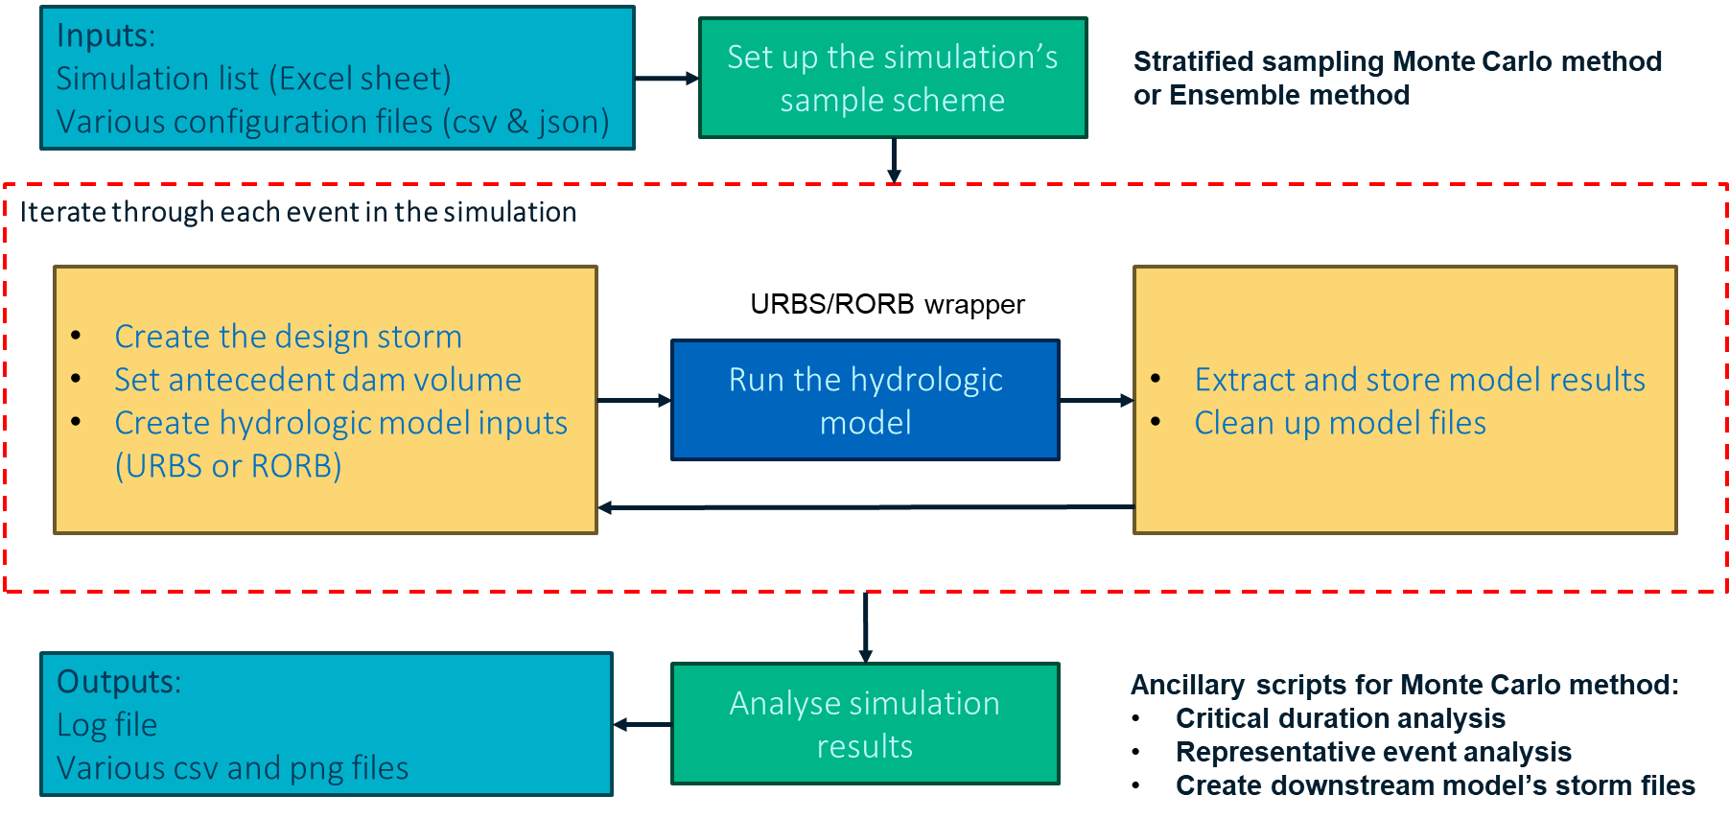
Figure 1: Overview of processes.

- Monte Carlo sampling approach
  - Rainfall
The primary variable of an individual storm event is the rainfall depth for a given annual exceedance probability (AEP) of the storm burst. A stratified sampling method was adopted for the rainfall depth as described in Chapter 4.3.3.3 of Book 4 in ARR. This approach was adopted as it enables computation of the central estimate in a more efficient manner. A stochastic sample of the standard normal variate is used, which is the inverse of the normal cumulative distribution with mean of zero and standard deviation of one and is expressed mathematically as:
$Z_{std}=F^{-1}\left(1- \frac{1}{AEP}\right)$ (1a)
$AEP=\frac{1}{1-F\left(Z_{std}\right)}$ (1b)
Where:
Z_{std} = the standard normal variate
AEP = the annual exceedance probability, in the form of 1 in X
F = the standard normal cumulative distribution
F⁻¹ = the inverse of the standard normal cumulative distribution
The standard normal cumulative distribution and its inverse are calculated using the ndtr and ndtri functions in the SciPy package for Python. The stratified sampling approach is as follows:
The standardised normal probability domain is uniformly partitioned into M intervals between the lower- and upper-bound AEPs that are specified for the analysis. The user should specify these bounds beyond the AEP of interest for the study. For example, if a 50% AEP estimate is required, the lower bound should be more frequent than 50% AEP and provide the rainfall depths for the lower bound in the Bryan configuration.
Within each interval, variates are sampled N times. The following three methods are available in Bryan (user-specified):
- Random variates are sampled from a normal distribution truncated at the bounds of the interval. This is the preferred method.
Random samples of $Z_{std}$ within the bounds of the interval from a uniform distribution.
- Stratified, non-stochastic, equidistant samples of $Z_{std}$ across the interval.
The rainfall depth for a sampled $Z_{std}$ is then interpolated from the rainfall intensity-frequency-duration (IFD) curves (refer to section 4.1). Note that sampling is done on a single burst duration and the analysis is repeated on other durations. The critical burst duration is identified separately (see Section 9.2).
  - Storm method
ARR distinguishes between rare, very rare, and extreme storm classes and provides distinct recommendations for modelling each class. This creates a potential for discontinuity at the transition points between classes, and ARR advises that inconsistency may arise and smoothing may be required. Bryan applies the following set of rules to determine which storm method to apply:
For frequent to rare events (up to 1 in 100 AEP), Bryan applies a deterministic rubric to select either ‘ARR point’ or ‘ARR areal’ storm method.
- If the focal catchment area is less than 75 km², then the ‘ARR point’ method is applied
- If the focal catchment area is 75 km² or greater, and the main burst duration less than 12 hours, then the ‘ARR point’ method is applied.
- If the focal catchment area is 75 km² or greater, and the main burst duration is 12 hours or longer, then the ‘ARR areal’ method is applied.
For very rare events (beyond 1 in 100 AEP up to 1 in 2,000 AEP or as defined by the user), Bryan randomly selects between rare and extreme methods with equal probability. This effectively smooths the output frequency curves between the rare and extreme range.
For extreme events (exceeding the 1 in 2000 AEP or as defined by the user), Probable Maximum Precipitation (PMP) storm methods are selected based on the burst duration:
- For design bursts up to 9-hour durations, Bryan applies the GSDM method.
- For design bursts of 18-hour duration or longer, Bryan applies the GTSMR method.
- For intermediate storm durations (i.e. 12-hour), Bryan randomly selects between the GSDM and GTSMR methods with equal probability.
The selection of storm method determines which set of temporal patterns is sampled (section 2.3) and which spatial patterns are applied (section 4.2). Note that the changeover bounds can be customised by the user using the keys aep_changeover and gdsm_gtsmr_changeover in the storm config file.
  - Main burst temporal pattern
The term ‘main burst temporal pattern’ is used here to distinguish from the pre-burst temporal pattern. Bryan requires the following four temporal pattern datasets as input (10 patterns per dataset):
ARR point temporal patterns (ARR Book 2 Chapter 5.5)
ARR areal temporal patterns (ARR Book 2 Chapter 5.6)
GSDM temporal patterns – derived from Jordan et al. (2015)
GTSMR temporal patterns
Bryan ingests the csv files of temporal patterns downloaded from the ARR datahub. For the GSDM and GTSMR, the same temporal pattern file format used by URBS (*.pat files) are used. For ARR areal patterns, an in-built routine selects the subset of temporal pattern applicable to the catchment size. For ARR point patterns, an in-built routine determines whether to use frequent, intermediate, or rare patterns. Sampling is done using a random number generator with discrete uniform probability distribution. Bryan uses the sampled storm method (section 2.2) to determine which dataset to sample from.
  - Pre-burst depth
Bryan calculates pre-burst depth by sampling a value for the ratio of pre-burst depth to main burst depth (hereafter referred to as pre-burst proportion) and multiplying by the main burst depth. If climate adjustment is applied to the main burst depth, then the same adjustment factor is applied to the pre-burst depth.
Bryan samples the pre-burst proportion from an empirical distribution. This would typically be extracted from ARR DataHub (Babister et al, 2016), although Bryan provides the option to input a custom distribution in CSV format.
ARR DataHub pre-burst proportions are provided by main burst duration, storm AEP, and percentiles. Bryan applies the following rules in order:
ARR DataHub provides distributions of pre-burst proportion s for some standard durations between 1 and 72 hours. If the pre-burst proportion distribution is not defined for the main burst duration, then:
- If the main burst duration is less than 1 hour, adopt the 1-hour distribution.
- If the main burst duration is greater than 72 hours, adopt the 72-hour distribution.
- If the main burst duration is 4.5 hours, adopt the average of the 3-hour and 6-hour distributions.
- If the main burst duration is 9 hours, adopt the average of the 6-hour and 12-hour distributions.
- Otherwise, adopt the distribution of the nearest duration to the main burst duration.
ARR DataHub provides pre-burst proportion distributions up to the 1% AEP:
- If the storm AEP exceeds 1%, then adopt the 1% AEP distribution.
- Otherwise, interpolate between the distributions of the nearest standard AEP in the standard normal domain.
ARR DataHub provides pre-burst proportions for the 10th, 25th, 50th, 75th and 90th percentiles.
- Bryan samples a value by applying a cubic spline interpolation (with the minimum pre-burst proportion set at zero).
- Bryan does not extrapolate beyond the range provided. Instead, samples outside of the range are set to the pre-burst proportion at the boundary of the range.
Bespoke tables of pre-burst proportions can be provided by the user (csv file format), which is useful if the user wants to provide smaller proportions for longer storm durations (informed by analysing pre-bursts in data from nearby gauges).
  - Pre-burst temporal pattern
There is an option to either include or exclude excess pre-burst rainfall. If including pre-burst rainfall, a temporal pattern will need to be provided. ARR provides limited guidance on pre-burst temporal patterns for Queensland. Therefore, a novel approach was developed to generate a dataset of pre-burst temporal patterns from gauged data, as detailed in the Design Hydrology Specification (DS PRO 030). The dataset is grouped by main burst duration and contains up to 20 pre-burst temporal patterns for each group.
Pre-burst temporal patterns are sampled by main burst duration and pre-burst proportion only. The three pre-burst temporal patterns in the database with the closest pre-burst proportion are identified and one is randomly selected with equal probability.
The input pre-burst temporal patterns have 1 hour time steps. When sampled, the patterns are aggregated or disaggregated to match the time step of the main burst temporal patterns. If disaggregating, a uniform disaggregation is assumed.
This sampling method assumes independence between pre-burst temporal pattern and main burst temporal pattern. It also assumes independence between the AEP of the main burst depth and the pre-burst temporal pattern.
There is also an option to use a uniform pre-burst temporal pattern. This method is included for sensitivity testing purposes only and uses a simple assumption on pre-burst durations. Pre-burst durations are set by scaling the main burst durations according to the table below. No pre-burst temporal pattern filtering is undertaken when using uniform patterns.
Table 1: Pre-burst duration scaling factors for uniform pre-burst patterns (sensitivity analysis only)
Main burst duration (hours) | Pre-burst duration scaling
1 | 4.0
6 | 3.0
9 | 2.75
12 | 2.5
18 | 2.25
24 | 2.0
36 | 1.75
48 | 1.5
72 | 1.25
96 | 1.125
120 | 1.0

  - Rainfall losses
The theoretical basis for applying a distribution of loss values standardised by the catchment median loss was described by Nathan et al (2003). Bryan adopts the standardised distribution of initial and continuing losses, developed by Hill et al (2015) and reproduced in Chapter 3 of Book 5 in ARR, for stochastic sampling of losses. This requires user specification of the median initial and continuing losses for the catchment model. The empirical distributions shown in Table 2 are then independently sampled for each storm event using cubic interpolation. Bryan provides the option to switch off stochastic continuing loss sampling and instead apply constant continuing loss. A constant continuing loss is currently preferred due to uncertainties in potential for joint probability of initial and continuing losses.
Table 2: Standardised loss factors (Hill et al., 2015)
Percentile | 0 | 10 | 20 | 30 | 40 | 50 | 60 | 70 | 80 | 90 | 100
Standardised IL_{s} | 3.19 | 2.26 | 1.71 | 1.40 | 1.20 | 1.00 | 0.85 | 0.68 | 0.53 | 0.39 | 0.14
Standardised CL | 3.85 | 2.48 | 1.88 | 1.50 | 1.24 | 1.00 | 0.79 | 0.61 | 0.48 | 0.35 | 0.15
Bryan also allows users to vary the continuing loss (CL) down to a smaller value as bursts become more extreme beyond an AEP of 1% consistent with ARR Book 8, Chapter 4. The reduced CL is provided for the PMP burst and linearly reduced between the 1% AEP and the AEP of the PMP using a standard normal variate scale for the AEP axis and log scale for the CL axis.
  - Antecedent storage
The antecedent storage (AS) can be treated as a fixed volume specified by the user and applied across all events in the simulation or varying across events by sampling from a user-specified distribution. The distributions are specified as relationships between the standard normal variate (which is sampled for each event) and antecedent storage. A single distribution can be applied, or several distributions can be stacked to create a stratified distribution with each layer operating within a specified range in the standard normal variate domain. The following distributions are supported:
A uniform volume can be applied that is used across all events in the simulation.
An empirical curve can be imported from a csv file consisting of a column for the standard normal variate and a column for the AS.
A sigmoid curve can be applied as per equation.

$$\begin{aligned}\log\left(AS\right)= \frac{\log\left(V_{c}\right)}{H+e^{-k(z-z_{0})}}+log⁡(V_{f})\#\left(6\right)\end{aligned}$$
Where:
$AS$ is the antecedent storage
$V_{c}$ is the ceiling volume for the curve
$V_{f}$ is the floor volume for the curve
$H$ is a height scaling parameter
$k$ is the slope of the curve
$z_{0}$ is the middle of the curve along the standard normal variate axis
$z$ is the standard normal variate
There may be cases where the antecedent storage is correlated with rainfall magnitude. Correlations can be applied either as a single correlation across the full range of rainfall magnitude or specific correlations applied to specific ranges of rainfall magnitude (standard normal variate). If a correlation is specified, the method presented in Section 4.3.2.4 of Book 4 in ARR (Nathan & Weinmann, 2019) is used to generate a correlated set of standard normal variates for the AS.
- Ensemble approach
Bryan has the functionality to apply the ensemble approach described in ARR Book 4 Chapter 3.2.3. This is a more deterministic method that is quicker than the Monte Carlo method. It can been used for simulating the Probable Maximum Flood (PMF), comparison to previous studies that adopted an Ensemble approach, as well as sensitivity testing during model development.
The ensemble approach simulates rainfall depths at standard AEPs, with an ensemble of temporal patterns for the main burst. Other inputs are selected as follows:
Storm method: users should specify in the configuration file which storm method should be applied in the changeover zone leading into more extreme storms: ARR or GSDM/GTSMR. There is an option to use both the ARR and GSDM/GTSMR patterns (total of 20) in the changeover zone, which is currently used as the standard approach.
The user must specify whether to use GTSMR or GSDM (from Jordan et al. 2005) patterns in the storm duration range between 6 hours and 24 hours.
Pre-burst depth: the median pre-burst proportion is applied.
If excess pre-burst is included in the simulation (optional), pre-burst temporal patterns are needed. Bryan applies a user-specified median pre-burst temporal pattern for each main burst duration. The median patterns are calculated in a pre-processing script as follows:
Each temporal pattern in an ensemble of patterns is converted to a cumulative temporal pattern.
The cumulative patterns are normalised by the pre-burst depth.
The time axis in the normalised patterns are set relative to the start of the main burst (i.e. negative times that finish at time zero).
For the set of normalised patterns in each ensemble, the median is computed at each time interval.
The median patterns are converted back to interval patterns.
Rainfall losses: the median initial and continuing losses specified by the user are applied
Antecedent storage: users must specify the antecedent storage
- Design storm development
  - Rainfall depths
    - Frequent to rare rainfall (up to 1 in 2,000 AEP)
Tables of average point rainfall IFD data must be provided for each sub-catchment, up to the 1 in 2,000 AEP. IFD grids have been extracted from the Bureau’s Design Rainfall Data System (2016) across all Sunwater catchments and compiled into a single file. An ancillary script (IFD tables) is used to query this IFD file and generate the IFD tables required by Bryan (refer to section 9.1). Note that the order in which the sub-catchment IFD data are listed is critical, as Bryan writes the sub-catchment spatial patterns to the storm files in the same order:
For an URBS-based model, the sub-catchment IFD data must be listed in the same order as the URBS catchment data file.
For a RORB-based model, the sub-catchment IFD data must be in the same order as the RORB calculation order.
Bryan applies generalised areal reduction factors (ARF) to the IFD dataset up to the 1 in 2,000 AEP, using the procedures detailed in ARR 2019 Book 2 Chapter 4.3.1, which are not repeated here. Bryan reads the long duration ARF region from the input ARR DataHub file. The ARFs are calculated as a function of the focal catchment area and applied to every sub-catchment.
For rainfall up to the 1 in 2,000 AEP, Bryan will apply a cubic spline to interpolate depths in the log-normal domain.
    - Extreme rainfall (1 in 2,000 AEP to PMP)
Bryan requires the following probable maximum precipitation (PMP) inputs:
A PMP depth-duration curve for the catchment
Spatial scaling factors for GTSMR and GSDM methods for each sub-catchment
AEP of the PMP
Rainfall depths rarer than the 1 in 2,000 AEP are estimated with an interpolated curve with the start of the curve fitted to the areal-reduced 1 in 2,000 AEP rainfall depth and the end point of the curve at the PMP. Three interpolation methods are provided:
Siriwardena and Weinmann (1998). This procedure is detailed in ARR 2019 Book 8 Chapter 3.5.2 and uses a parabolic curve in log-log scale.
Hill et al (2000) is a variation of the above, using log-normal scale.
GEV method uses the inverse cumulative distribution function for a generalised extreme value distribution and was developed to deal with vertex perplexity encountered using the parabolic methods (Sharpe, 2024).
  - Spatial pattern
For events assigned ‘ARR point’ or ‘ARR areal’ storm methods (section 2.2), Bryan adopts the spatial patterns derived from the design rainfall grid in accordance with ARR Book 2 Chapter 6.3.2.
For events assigned ‘GSDM’ or ‘GTSMR’ storm methods, Bryan provides two methods for deriving spatial patterns:
The ‘interpolate_depths’ method involves the following steps:
Calculate the areally-reduced 1 in 1,000 and 1 in 2,000 AEP rainfall depths for each sub-catchment.
Calculate the PMP depths for each sub-catchment by applying the spatial scaling factors to the catchment PMP.
Fit extreme rainfall interpolation curves to each sub-catchment.
This is the default method and implicitly smooths the transition between rare rainfall spatial patterns and PMP spatial patterns. However, errors may result in cases where some sub-catchments have small PMP spatial scaling factors, resulting in some sub-catchment PMP depths that are not substantially larger than the 1 in 2000 AEP rainfall depths, primarily for sub-catchments overlying outer GSDM ellipses. In such instances, it may not be possible to satisfactorily fit an extreme rainfall interpolation curve.
The ‘interpolate_weights’ method was developed to deal with the issue noted in the ‘interpolate_depths’ method and involves the following steps:
Fit the extreme rainfall interpolation curve to the catchment average rainfall depths.
Compute the weighting for the 1% AEP event in each catchment ($w_{i,1\%}$) by dividing the sub-catchment depth by the catchment average depth.
If the design storm AEP is between 1% and 1 in 2000, spatial factors are calculated as a linear combination of the 1% AEP spatial factors and the PMP spatial factors, weighted by the distance from the 1% and the 1 in 2000 AEPs in the standard normal domain as shown in Equation 2.

$w_{i}\left(Z\right)= w_{i, 1\%}\left(1- \frac{Z-Z_{1\%}}{Z_{0.05\%}-Z_{1\%}}\right)+w_{i, pmp }\left( \frac{Z-Z_{1\%}}{Z_{0.05\%}-Z_{1\%}}\right)$ (2)
Where:
$w_{i}(Z)$ = spatial factor for sub-area $i$ as a function of the standard normal variate
$Z$ = standard normal variate of the AEP (between 1% and the 1 in 2000 AEP)
$w_{i,1\%}$ = spatial factor for sub-area $i$ for the 1% AEP
$w_{i,pmp}$ = spatial factor for sub-area $i$ for the PMP (GSDM or GTSMR)
The rainfall depth in each sub-catchment is then computed as the product of $w_{i}(Z)$ and the catchment average depth.
If the design storm AEP is equal to or rarer than 1 in 2,000 AEP, the PMP spatial factors are applied.
  - Catchment focal points
Users should note that the analysis performed by Bryan are specific to a particular focal location in the catchment – to perform analysis at multiple locations with the same URBS/RORB model requires multiple sets of inputs. This is because some inputs are dependent on the spatial properties within the catchment, particularly the focal sub-catchment file.
The focal sub-catchment file is a CSV formatted file containing two columns:
Name: lists the name of the sub-catchment.
Area: lists the corresponding area in km² of the sub-catchment if it is upstream of the focal point, and zero otherwise.
Bryan uses the sub-catchment area to calculate the area-weighted catchment average rainfall. This is required for main-burst and pre-burst filtering procedures. Bryan also calculates the focal catchment area from the sum of the ‘Area’ column. The focal catchment area is used for calculating the areal reduction factor and selecting areal temporal patterns.
Other inputs that need to be updated for analysing a different focal area are:
PMP depth-duration curve, spatial factors, and AEP of the PMP
ARR DataHub file should be extracted for each focal catchment
For validation runs, different Global Warming Levels may need to be specified for each focal area for consistency with different gauge periods.
  - Main burst filtering
A potential issue arising from scaling design temporal patterns to sampled design rainfall depths is that of embedded burst, where sub-periods within the main burst exceed the corresponding design depths for the AEP being examined (Scorah et at, 2016). This is commonly resolved by embedded burst filtering, whereby the temporal pattern is adjusted such that the embedded burst is removed. In Bryan, embedded burst filtering is optional and may be excluded from the analysis at the user’s discretion.
The algorithm developed for filtering the main burst temporal pattern is broadly based on Scorah et al (2016). Note that it is entirely separate from the pre-burst filtering algorithm (section 4.5). The algorithm preserves the duration and the total rainfall depth of the main burst as a requisite. It next prioritises the relative variation in rainfall depth over the temporal pattern hyetograph above other criterion such as minimising intensity reduction, or minimising changes to the cumulative mass curve.
The main burst filtering algorithm applies the following logic:
Analyse sub-periods of the main burst, starting with the shortest duration defined in the input IFD dataset, and progressively increasing to the next shortest defined duration. Durations not defined in the input IFD dataset (i.e. not included in the IFD table provided to Bryan) are not assessed. Note that this means that short-duration IFD data should be provided to Bryan – even if only long-duration design bursts are required in the assessment – to allow embedded burst filtering.
For the selected duration, embedded bursts are checked. Sub-periods with the maximum rainfall depth are identified and compared against the catchment average design depth for the design AEP. A tolerance of 10% is applied, to avoid overly flattening the temporal patterns.
If an embedded burst is detected, the rain depth within the sub-period is scaled down such that the embedded burst exceeds the design depth by no more than 10%. The remainder of the main burst is scaled up a commensurate amount to preserve the total depths.
Multiple passes are undertaken in case the temporal pattern has multiple peaks.
Bryan outputs the filtered and unfiltered hyetographs of the main bursts for events that are filtered to enable checks on the filtering to be undertaken. Filtering is generally only required for a small fraction of the events.
  - Pre-burst filtering
In some instances, the approach of sampling a pre-burst temporal pattern and scaling to a sampled pre-burst depth (as described in section 2.5) can lead to the following issues:
The rainfall depth in a period of the storm with duration equal to or greater than the main burst may have a corresponding AEP that is rarer than the main burst. In most cases, this period straddles the end portion of the pre-burst rainfall and the beginning of the main burst.
The peak discharge from the hydrologic model may erroneously correspond with a period of the pre-burst rainfall, and not the main burst. This can occur when the most intense period of the pre-burst is greater than the most intense period of the main burst.
To address the above issues, a novel filtering algorithm is used to modify the pre-burst temporal pattern with the following criteria:
Criterion 2 (supra-bursts):
For all periods of the storm longer than the main burst duration, the AEP correlating to the rainfall depth must not exceed the AEP of the main burst.
Criterion 1 (sub-bursts):
For all periods within the pre-burst that are shorter than the main burst duration, the pre-burst depth must not exceed 90% of the maximum depth of an equivalent duration within the main burst.

Note that embedded bursts as defined in section 4.4 are not explicitly filtered. However, the main burst is filtered for embedded bursts first (if the option of filtering embedded bursts is on). Therefore, the pre-burst will also be filtered due to criterion 1. The pre-burst filter analyses the combined pre-burst and main burst period (complete storm), with the condition that the main burst temporal pattern cannot be altered. The filtering comprises two functions: a sub-burst and supra-burst filter. The supra-burst filter does not check criterion 1. Therefore, it is necessary to re-run the sub-burst filter function. An overview of the filter procedure is shown in Figure 2, and the sub- and supra-burst filter processes are shown in Figure 3 and Error! Reference source not found..

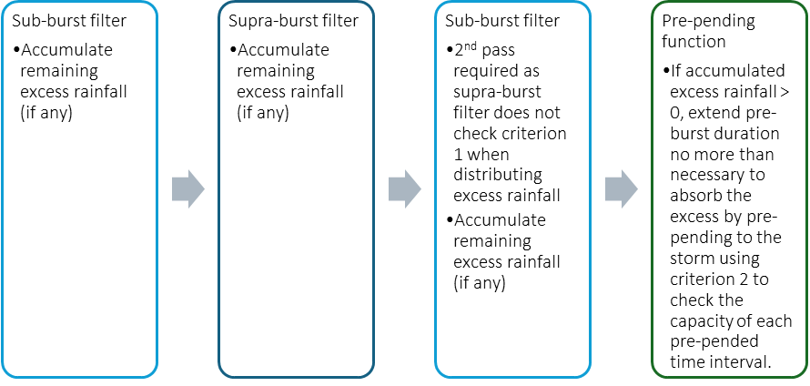
Figure 2: Overview of the pre-burst filter process

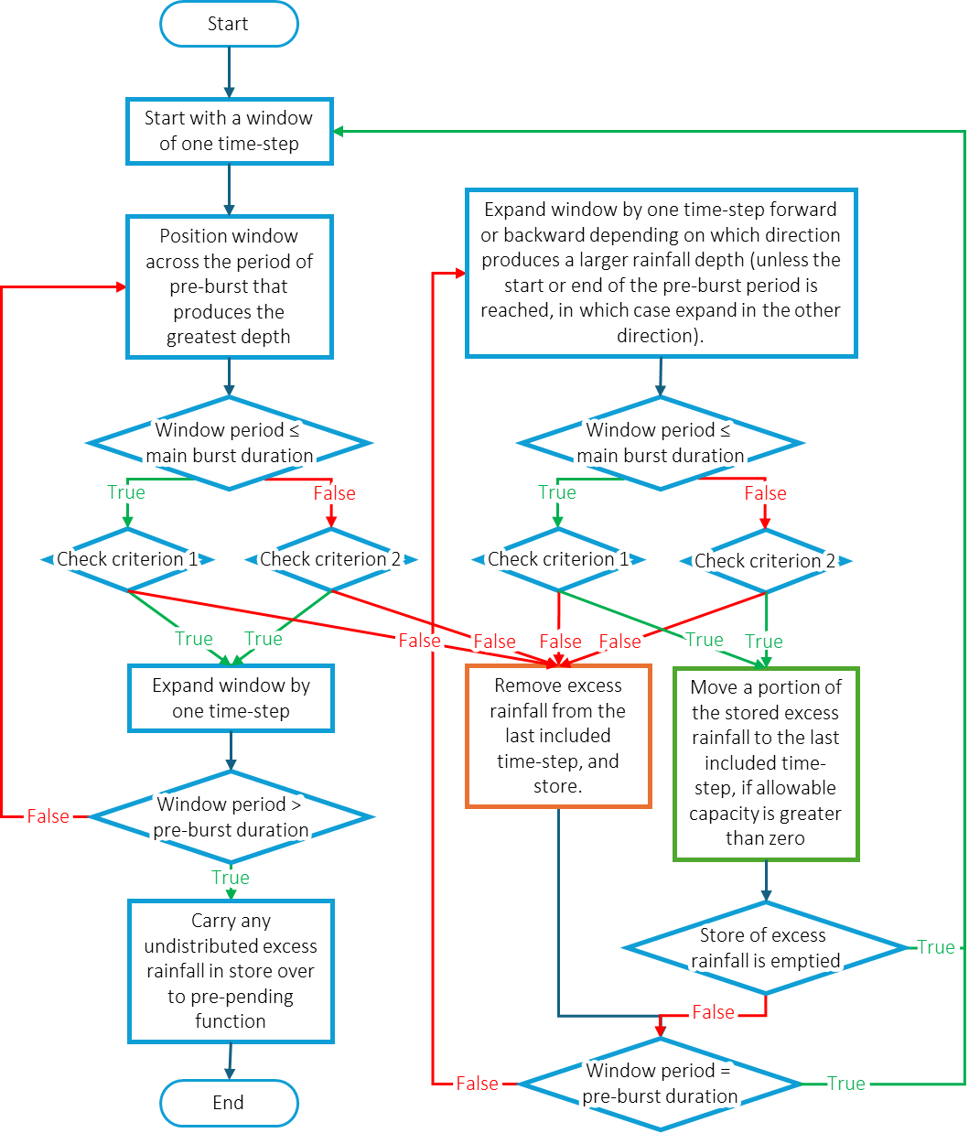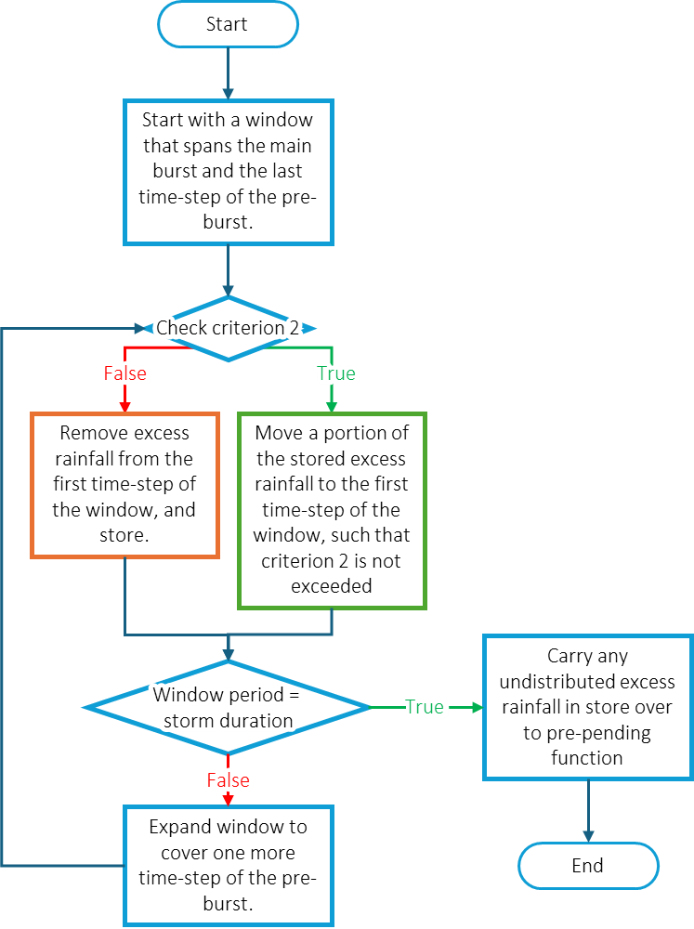
Criterion 2 (supra-bursts):
For all periods of the storm longer than the main burst duration, the AEP correlating to the rainfall depth must not exceed the AEP of the main burst.
Criterion 1 (sub-bursts):
For all periods within the pre-burst that are shorter than the main burst duration, the pre-burst depth must not exceed 90% of the maximum depth of an equivalent duration within the main burst.
Figure 3: The sub-burst component of the pre-burst filter. Figure 4: The supra-burst component of the pre-burst filter.

  - Climate change adjustments
Bryan implements the rainfall intensity and loss adjustments recommended in Chapter 6 of Book 1 in ARR v4.2 (Wasko et al., 2024). Estimation of climate change impact requires the user to specify a global warming level (GWL). Sunwater’s Climate Change Assessment Procedure for Flood Hydrology in Dam Safety (DS PRO 029) (Sunwater, 2025b) adopts the following global warming levels (GWL) for near-, medium- and long-term climate horizons shown in Table 3. Note that pre-industrial GWLs are the temperature rise since the 1850-1900 baseline. The hydrologic GWLs account for the 0.3°C warming between the pre-industrial baseline and 1961-1990 period, which is the hydrologic baseline for the BOM 2016 IFD.
Table 3: Adopted global warming levels
Climate horizon | Period | Pre-industrial GWL | Hydrologic GWL
Hydrologic baseline | 1961-1990 | 0.3°C | 0.0°C
Near term | 2021-2040 | 1.6°C | 1.3°C
Medium term | 2041-2060 | 2.0°C | 1.7°C
Long term | 2081-2100 | 3.0°C | 2.7°C
    - Rainfall depth and intensity
Bryan adopts the median rate of change (α) derived in Wasko et al. (2024) to uplift event rainfall using the compounded rate of change per °C of warming formula shown in equation 3a.
$I_{p}=I ×{\left(1+ \frac{α}{100}\right)}^{ΔT}$ (3a)
Where:
I_{p} = the projected design rainfall depth
I = the historical design rainfall depth
α = the rate of change (percent per degree warming)
ΔT = the global temperature rise in degrees Celsius (i.e. global warming level)
The rate of change (α) is a function of storm duration (d, in hours) and varies between 8%-15% per degree Celsius. Bryan calculates the rate of change using equations 3b-3c, which evaluates to the rates shown in Table 4 for standard durations.
$α=\left\{\begin{aligned}15, & d≤1 \\ f\left(d\right), & 1 <d<24 \\ 8, & d≥24\end{aligned}\right.$ (3b)
$f(d) =exp⁡(0.01177526 × {\ln\left(d\right)}^{2}-0.235206 × ln\left(d\right)+2.70886)$ (3c)
Table 4: Rate of change (α) and climate change uplift factors by burst duration.
Duration | Rate of change (%/°C) | Uplift factor
 |  | Near term  (2021-2040) | Medium term  (2041-2060) | Long term  (2081-2100)
1 hour or less | 15.0 | 1.20 | 1.27 | 1.46
1.5 hour | 13.7 | 1.18 | 1.24 | 1.41
2 hour | 12.8 | 1.17 | 1.23 | 1.38
3 hour | 11.8 | 1.16 | 1.21 | 1.35
4.5 hour | 10.8 | 1.14 | 1.19 | 1.32
6 hour | 10.2 | 1.13 | 1.18 | 1.30
9 hour | 9.5 | 1.13 | 1.17 | 1.28
12 hour | 9.0 | 1.12 | 1.16 | 1.26
18 hour | 8.4 | 1.11 | 1.15 | 1.24
24 hour or more | 8.0 | 1.11 | 1.14 | 1.23
Note that values in Table 4 is:
inversely correlated with duration (i.e. uplift is greater for shorter durations)
invariant with storm frequency (i.e. the same uplift applies up to and including the PMP)
invariant with location (i.e. the same uplift applies to all catchments in Australia)
Bryan treats pre-burst rainfall depth by applying the same climate change uplift factor as for the main burst. However, for the main-burst and pre-burst temporal pattern filters, the uplift factor varies with duration. This means that embedded intensities may be uplifted by more than the main burst.
    - Losses
Climate change impact on rainfall losses is also calculated using the compounded rate of change per °C of global warming (equation 3a). The rate of change applied in Bryan are dependent on the natural resource management cluster that the catchment is located in and were obtained from Wasko et al. (2024), which were based on Ho et al. (2023).
    - Temporal pattern shift
ARR discusses the potential for temporal patterns to become more front-loaded and peakier in future climate horizons. However, the evidence and influence of this shifting pattern is limited. Therefore, modelling of this shift need only be undertaken to test the sensitivity of design flood estimates.
The research uses a parameter termed, D50, which is the percentage of time within a storm burst at which 50% of the rainfall has fallen. The shift in the temporal pattern in a warming climate is then characterised as a percentage change in D50 per °C of warming from the baseline climate based on the Köppen−Geiger Climate Classification for the catchment (Visser, 2023). ARR provides little guidance on how to implement this shift in D50. Therefore, a method has been developed and implemented within Bryan.
The various temporal patterns available from the ARR datahub and the GTSMR and GSDM methods have been analysed to determine the D50 for all patterns and average D50 for all sets of patterns. The three most front-loaded storms in each set of patterns were then identified, and the weighting required to be applied to these three patterns to shift the average D50 in each set of temporal patterns was determined. For example, the three most front-loaded patterns in the ARR areal patterns for a catchment area of 500 km² are patterns 6, 1, and 5 (of 1 to 10). The weighting required to be applied to these three patterns in a probability weighted sampling scheme to shift the D50 forward by 1% is 0.116 and the weighting for the remaining seven patterns is 0.093 (a weighting of 0.1 for each pattern would yield equal probability). The weightings for all sets of patterns and for D50 shifts of 1% to 5% have been computed and are an input into the Bryan configuration. The user needs to specify the Köppen−Geiger Climate Classification, then Bryan will look up the weighting based on the temporal pattern source, applied GWL, and storm duration. The weighting is then used for probability-weighted sampling of the temporal pattern.
Again, given the uncertainty in how temporal patterns may shift with a warming climate, and that the influence of the impacts are expected to be minor even in the most extreme warming case simulated, incorporation of temporal pattern shift within design estimates is not expected to be warranted in most cases and only tested for sensitivity.
- Hydrologic modelling
  - URBS wrapper
Bryan runs URBS by using a batch file to call the URBS32 console application. Bryan has been developed and tested with URBS 2019 version 6.67.
Bryan specifies the URBS routing parameters α, m and β in the command line interface using the numeric mode (refer to URBS manual Chapter 8.1.1). The initial and continuing losses are written into the storm file.
Bryan implements the antecedent storage by setting an environmental variable initial_lake_level with each run that is referenced in the dam route line in the catchment definition file (.VEC). If baseflow is required, Bryan makes a copy of the .VEC file with _baseflow appended to the file name and appends the baseflow parameters (section 5.3) to the print statement locations specified by the user. This process is repeated for each simulation because the BC parameter varies with rainfall AEP.
Bryan performs the following actions when a batch of simulations is initialised:
Create sub-folders for the storm files and the model outputs.
Copy the .DAT file to the output sub-folder
For each event, Bryan does the following:
If simulating baseflow, copy the .VEC file and append baseflow parameters to user-specified print statements
Write the initial lake level to an environment variable in the batch file used to run URBS
Write a storm file to the storm sub-folder
Write and execute the batch file
Extract peak values from the .p output file and store these in the mcdf file produced by Bryan.
Extract inflow and outflow hydrographs from the .q output file and store these in the result files produced by Bryan
Extract dam level hydrographs from the .h output file and store this in the result files produced by Bryan.
When the focal point is at a gauge rather than at the dam, the inflow location is changed from the dam to the label of the print statement that outputs the gauge flow results.
  - RORB wrapper
Bryan runs RORB using RORB_CMD, a console application of RORBwin. At the time of writing, the latest version of RORB_CMD is based on RORBwin version 6.31. (The current version of RORBwin is version 6.52).
RORB_CMD can be executed from a batch file, with a path to the .PAR file as a single argument. A template .PAR file must be provided by the user. The .PAR file specifies the catchment (.CATG) and storm (.STM) files for RORB, as well as the routing parameters and losses. The template .PAR file is used to set the routing parameters for Bryan. Note that the .PAR for RORB_CMD is distinct from a .PAR file for RORBwin. Refer to the RORB_CMD documentation for full details of the required format.
Bryan performs the following actions when a batch of simulations is initialised:
Create an output sub-folder for the simulation
Copy the .CATG file to the output sub-folder
Read in the template .PAR file
Create a batch file in the output sub-folder for executing RORB_CMD
For each event, Bryan does the following:
Write a storm file to the output sub-folder
Edit the .CATG file with the reservoir drawdown level
Overwrite the .PAR file in the output sub-folder, updating the storm file name and the initial and continuing losses for each event.
Execute the batch file
Parse the output file to extract hydrograph time series and peak values, which are stored in the result files produced by Bryan.
Similarly to URBS, the location of the inflow is changed from the dam to the gauge location for a simulation that is focussed on a gauge; i.e. the results at the gauge are stored and analysed using the Total Probability Theorem rather than the dam inflow.
  - Baseflow
While the term baseflow is used here, interflow is a better term for the type of flow discussed in this section. The baseflow term is used for consistency with the URBS manual. Baseflow was modelled using the functionality in URBS (Carroll, 2016), which uses equation 4.
$$\begin{aligned}{Qb}_{i}= B0+BR \left({Qb}_{i-1}-B0\right)+BC{\left(Qr\right)}^{BM}\#\left(4\right)\end{aligned}$$
Where:
$Qb_{i}$ is baseflow rate at time step $i$.
$B0$, $BR$ and $BM$ are constants representing:
  - minimum persistent baseflow from deep groundwater stores,
  - daily baseflow recession factor, and
  - baseflow exponent applied to runoff, respectively
$BC$ is a baseflow coefficient applied to runoff.
$BC$ is a function of Baseflow Volume Index which varies with storm AEP as discussed in Chapter 4 of Book 5 in ARR (Hill et al., 2019) and is computed using equations 5a to 5c. $BFVF_{10}$ is read from the ARR DataHub file while $F$ and $BR$ are specified by the user in the model config file.
$$\begin{aligned}BC = \left(1-BR\right)BFVF\#\left(5a\right)\end{aligned}$$
$$\begin{aligned}BFVF= {F × BFVF}_{10} × {10}^{r}\#\left(5b\right)\end{aligned}$$
$$\begin{aligned}r= -0.02079z^{2}-0.1375z+0.2079\#\left(5c\right)\end{aligned}$$
Where:
$BFVF$ is the baseflow volume factor
$BFVF_{10}$ is the baseflow volume factor of the 10% AEP event sourced from ARR DataHub
$F$ is a scaling factor applied to $BFVF_{10}$ determined through model calibration
$r$ is a scaling factor applied to $BFVF_{10}$ to account for adjustments related to the AEP of the event
$z$ is the standard normal variate of the storm AEP
Equation 5c was developed by fitting a regression to the baseflow volume factors listed in Table 5.4.1 in Chapter 4 of Book 5 in ARR (Hill et al., 2019).
  - Level pool routing
A level pool routing module was added to Bryan to enable the baseflow model discussed in Section 5.3 to be applied to the RORB simulations, and the consideration of antecedent storage conditions in excess of the full supply volume. There are two components to the module that can be run individually or in tandem:
Baseflow component: The outputs from a Monte Carlo simulation which was run without baseflow can be post-processed to have baseflow added to the dam inflows and gauge locations. New result files for inflow are created that include baseflow. Note that this component does not implement the dam routing unless the dam routing component of the module is also invoked (see below).
Dam routing component: Dam inflow result files from prior Monte Carlo simulations (or results post-processed to include baseflow) are routed through the dam and new lake level and outflow result files are generated.
After the above components are undertaken, the Monte Carlo analyses discussed in Section 6 can be run on the new set of results.

  - Output file management
A single Monte Carlo simulation includes thousands of events with each event producing a set of output files from the hydrologic model. To keep file management efficient, Bryan provides an option to delete the individual event files produced by URBS/RORB after extracting the requisite information from them. For the storm files, the first ten files in a simulation are always retained for checking purposes.
- Monte Carlo result analyses
  - Central estimate
The peak inflow, lake level, and outflow are computed for each event during the Monte Carlo simulation and stored in the mcdf file. After the suite of model runs are complete, this mcdf file is imported and used to compute the AEP of each event in the simulation using the Total Probability Theorem (TPT) as discussed in Section 4.3.3 of Book 4 in ARR (Nathan & Weinmann, 2019). This method estimates the probability of a given quantile by summing the conditional probabilities that the quantile ($Q$) is exceeded in each rainfall interval ($R_{i}$) as shown in equation 7,
$$\begin{aligned}p\left(Q>q\right)=\sum_{i=0}^{M+1}{p\left[Q>q|R_{i}\right]p\left[R_{i}\right]}\#\left(7a\right)\end{aligned}$$
Where:
$p(Q>q)$ is the probability that $Q$ is exceeded.
$p\left[Q>q|R_{i}\right]$ is the probability that $Q$ is exceeded within interval $R_{i}$. For example, if $Q$ is exceeded 195 times out of 200 samples in interval $R_{1}$, then $p\left[Q>q|R_{1}\right]$ will be 0.975.
$p\left[R_{i}\right]$ is the probability that rainfall occurs within the interval $R_{i}$. The width of the interval is used. For example, if interval $R_{1}$ spans an AEP of 1 in 2 ($p$ = 0.5) to 1 in 5 ($p$ = 0.8) then $R_{1}$ = 0.3.
$p\left[Q>q|R_{i}\right]p\left[R_{i}\right]$ is the conditional probability that $Q$ is exceeded for interval $R_{i}$. Following on from the above example, $p\left[Q>q|R_{1}\right]p\left[R_{1}\right]$ = 0.975 x 0.3 = 0.2925.
The sampled domain spans $R_{1}$ to $R_{M}$. To cover the full probability space, the unsampled domains bounding on the more frequent side ($R_{0}$) and on the rarer side ($R_{M+1}$) also need to be accounted for. This is done using geometric means and assumptions for the probabilities in the unsampled intervals as shown in equation 7b and 7c, where $p\left[R_{0}^{b}\right]$ is the probability at the more frequent bound of the sampled space (e.g. 0.5 following on from the example above).
$$\begin{aligned}p\left[Q>q|R_{0}\right]=\sqrt{\left(p\left[R_{0}^{b}\right]p\left[Q>q|R_{1}\right]\right)×p\left[Q>q|R_{1}\right]}\#\left(7b\right)\end{aligned}$$
$$\begin{aligned}p\left[Q>q|R_{M+1}\right]=\sqrt{p\left[Q>q|R_{M}\right]×1}\#\left(7c\right)\end{aligned}$$
The upper- and lower-bound AEPs of the sampled domain should span a range greater than the AEPs of interest to minimise the influence of the assumptions in equations 7b and 7c on the probability estimates. Also, the number of intervals and the number of samples within each interval should be sufficiently large to ensure there is adequate sampling over the range of interest and for the number of stochastically sampled parameters.
Convergence testing should be completed to confirm the adopted number of intervals and samples is sufficient for the probability space being considered.
  - Uncertainty estimates
One of the advantages of undertaking Monte Carlo analyses is that the method enables uncertainty to be quantified. Quantifying uncertainty from a stratified sampling method, like that used for the rainfall sampling, is more complex than random sampling because samples are forced to be taken within each stratification interval. Nevertheless, an indication of uncertainty has been computed using the following method implemented on the peak inflow, lake level, and outflow for a Monte Carlo simulation:
Raw percentiles: The quantiles for the 5th and 95th percentiles in each of the stratification intervals are computed and listed against the corresponding centre of the interval in standard normal variate scale.
Smoothed percentiles: The raw percentiles are smoothed by fitting 6th degree polynomials to log transforms of the percentiles. A standard set of AEPs is created and percentiles for each AEP estimated from the polynomial models.
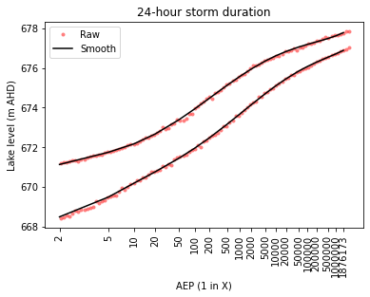
Figure 5: Example plot of raw percentiles and smooth uncertainty bounds for a specific storm duration.
The above provides an indication of uncertainty for a given storm duration. The script used to undertake the critical storm duration (Section 9.2) implements the following procedure to create uncertainty bounds for the final estimates:
Initial percentiles: For each AEP in the standard set of AEPs, the percentiles for the critical duration are extracted.
Final percentiles: The initial percentiles are checked and adjusted as needed to ensure they are monotonically increasing as the standard normal variate increases. This adjustment is done by making a percentile match the prior percentile if it is lower than the prior percentile. A 5th degree polynomial is fitted to the log transforms of the percentiles. These polynomials are used to generate the uncertainty limits that are adopted and plotted on frequency plots.
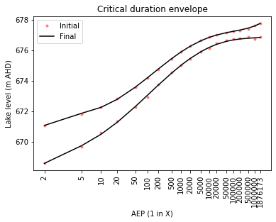
Figure 6: Example plot of developing the final uncertainty bounds for an envelope of the critical durations.
  - Critical durations
Each Monte Carlo simulation is undertaken for a specified storm duration. The results for each storm duration are then compared to identify the critical storm duration for each quantile. This analysis is done using a post-processing script (see Section 9.2).
  - Representative events
Once the design flood estimates for the critical durations have been determined, flood events that are representative of lake levels of interest are needed for subsequent modelling downstream of the dam. Again, a post-processing script is used to identify representative events (see Section 9.5).
- Output files
  - General
The following files are created for both the Monte Carlo and Ensemble methods:
Simulation list log: Each time a simulation is run the start time, end time, computer, and other information is appended to a log file that tracks the simulations that have been run. The filename of this file matches the filename of the simulation list filename (Excel file) with a _log.csv suffix.
Simulation log: Each time a simulation is run all output to the terminal is also written to a log file that is stored in a location and with a name specified by the user in the simulation list file. This is a text file that potentially includes thousands of lines as information for each event in the Monte Carlo simulation is written to the file. Much of the input data is also written to this file, which makes it useful for checking that the intended inputs have been imported correctly.
Hydrograph files: Hydrographs of dam inflows, lake levels (for URBS), and outflows are written to file for each event in the simulation using csv file format (one file includes results from all events for a single Monte Carlo / Ensemble simulation). The files are stored in a folder called urbs_results or rorb_results in the parent folder of the results folder that is used for storing the Bryan results.
  - Monte Carlo method
The following files are generated for a Monte Carlo simulation (for a single duration):
Database file (mcdf): This is the main result file generated by Bryan. It is in csv file format and includes a row for each event in the simulation. All sampling information is included in this file such as the sampled standard normal variate for the rainfall and AS, and the sampled percentile for the loss scaling and preburst proportion. Other relevant information like the main burst initial loss, sampled AS, and peak inflow, lake level, and outflow are stored. This file is the primary input for the Monte Carlo analysis discussed in Section 6, which adds the computed AEP for each event to this file.
A csv file of hyetographs is created for the main burst. These files only include storms for which embedded bursts were filtered in the main burst. A separate csv file is created for the unfiltered (_hyeto_original.csv) and filtered (_hyeto_filtered.csv) hyetographs. This enables checking of the embedded burst filtering algorithm.
The Monte Carlo analysis produces several files including:
A csv file of the central estimate of the quantile for the lake (or gauge) inflow, lake level, and outflow for a standard set of AEPs.
A csv file listing the 5th and 95th percentiles of peak inflows, lake levels, and outflows within each of the intervals from the stratified rainfall sampling.
A csv file of the above that has been smoothed by fitting a polynomial, in standard normal variate - log space, and extracting the percentiles at standard AEPs.
Images of frequency curves showing the results of the TPT analysis for the dam inflow, lake level, and outflow.

  - Ensemble method
The following files are generated for the ensemble method:
An output database storing the details of each event in the ensemble simulation, e.g. AEP, storm duration, temporal pattern, etc. This file also stores the peak dam inflow, lake level and outflow for each event. Or, for simulations that are focussed on a gauge, the peak flows at the gauge are stored.
A csv file of the median (rank 6) dam inflow, lake level, and outflow for each AEP and storm duration.
A csv file of the dam inflow, lake level, and outflow for the critical duration for each AEP.
A box plot for each AEP summarising the spread of dam inflows, lake levels, and outflows for each storm duration.
- Version control
Version control for Byran is managed using Tortoise SVN with the repository on a Sunwater server. Because the hydrologic modelling is also version controlled in the same repository using Tortoise SVN, version numbers can rise relatively rapidly during the model build process. Release versions are tagged at completion of design runs using the year-month-dam-version notation. The latest release version is:
2025-05-Tinaroo-1538: used for the Tinaroo Falls Dam design flood hydrology.
There is also a development version. At the time of writing, the development version includes additional features such as inclusion of a baseflow model and a dam routing module (see Section 5.4) needed for a subsequent study that uses RORB for the hydrologic modelling – since RORB does not natively support baseflow or initial lake levels higher than spillway level.

- Ancillary scripts
  - IFD tables
This Python script was developed to produce IFD tables for input to Bryan. In preparing this tool, the 2016 Design Rainfall Grids produced by the Bureau of Meteorology were downloaded across all Sunwater catchments. The design rainfall grids are available in ASCII format with GDA94 coordinate reference system (EPSG: 4283) and a resolution of 0.025 × 0.025 decimal degrees. These were downloaded and combined into a single NetCDF file, which forms an input to the script. The script requires a shapefile of sub-catchment boundaries as input in the same coordinate reference system as the rainfall grids. The following steps are undertaken to extract design rainfall values for each sub-catchment:
The design rainfall grids are down-sampled to 0.005 × 0.005 decimal degrees using bilinear interpolation. The increase in grid resolution improves the representation of the sub-catchment boundaries in the next step.
The sub-catchment boundary shapefile is converted to a raster with the same resolution and alignment as the rainfall grids. This raster is outputted for checking.
The design rainfall value for each sub-catchment is calculated as the mean of the rainfall grid cells within the sub-catchment using the zonal_stats function in the Xarray-spatial package.
Note that some very small sub-catchments may not be represented when the boundaries are converted to a raster. In such instances, the sub-catchment centroid is used to sample a design rainfall value.
  - Critical storm durations
For the Monte Carlo simulations, the critical duration analyses are undertaken using a separate script in the Bryan util folder: CrticalDurationAnalysis.py. This script is pointed at a Monte Carlo simulation. It opens the csv files that list the quantiles for the standard set of AEPs for each storm duration and seeks the critical durations. A csv file listing the quantiles for each duration, the maximum quantile, and the critical duration is created. This script also estimates and outputs the final uncertainty bounds as described in Section 6.2. The outputs are given the same name as the input files, but with the storm duration key in the filename set to 00h. Images plotting the quantiles are also created.
  - Plotting tool
Frequency plots of quantiles can be created using a plotting tool in the util folder: PlotFrequencyCurves.py. A spreadsheet is used to manage the plot inputs and includes sheets for:
FFA sheet: A list of the flood frequency distributions (e.g. a Log-Pearson III distribution) extracted from RMC Bestfit to make available to the plotting tool.
URBS sheet: A list of Bryan simulations to make available to the plotting tool.
Plots sheet: A list of plots to create with pointers to which simulations and FFA outputs to include and additional details, for example: the type of result to plot (inflow, level, or outflow), the filename, the plot title, etc.
  - AEP interpolation/extrapolation
Two scripts in the util folder are used for interpolating/extrapolating the AEP of given levels. The DesignFloodInterpolation.py script opens the csv file created by the critical storm duration analysis and interpolates the AEP of flood levels provided by the user. There are two methods:
Method 1 linearly interpolates between the standard quantiles using a log-normal scale and
Method 2 fits a polynomial to the standard quantiles. This is used for estimating the AEP of specific flood loads (using method 1).
The AEPofPMF.py script opens the mcdf file for a specific Monte Carlo simulation and storm duration and fits a polynomial to the AEP estimates across all events in the simulation using a log-normal scale. This polynomial is used to estimate the AEP of the PMF given the PMF level.
  - Representative events
The GetRepresentativeEvents.py script in the util folder is used to identify representative events. The script reads a spreadsheet that lists the target lake levels and rainfall AEPs, then identifies the events in the Monte Carlo simulation that are the closest match. The target lake level can be inserted as an AEP or an elevation in m AHD. If the target lake level is inserted as an elevation, the target rainfall AEP must also be listed. The script creates a spreadsheet of the 10 best matches for each target event and a plot of the candidate events. This information is then inspected to select the representative events.
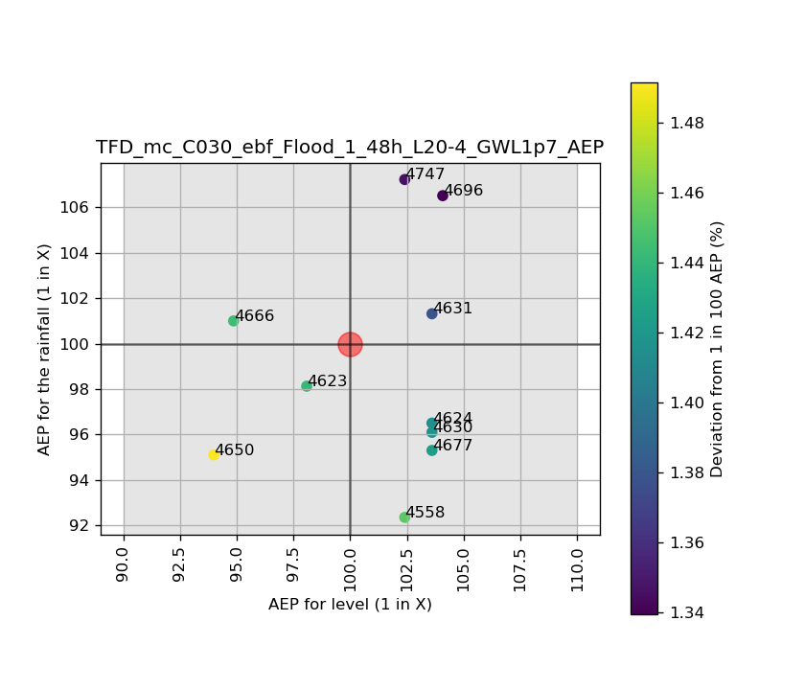
Figure 7: Plot of candidate events for a representative event
  - Downstream storm files
Representative events need to be simulated downstream of the dam for the consequence assessment. Coincident rainfall distributions downstream of the dam are determined through a joint probability analysis (JPA). The DownstreamStormGenerator.py script in the parent folder of Bryan is used to generate URBS model inputs (storm file and dam outflow) for the selected representative events in the downstream URBS model or downstream catchment within a combined model.
The script reads a spreadsheet and several config files that provide information from the JPA and the upstream representative event (such as the upstream rainfall AEP, rainfall losses after adjustment for climate change, and the temporal pattern). Inputs include IFD tables for downstream regions, coincident rainfall AEPs, and any scaling of rainfall losses (relative to upstream) identified during calibration.
  - Others
Other tools used are as follows:
A set of scripts used to undertake the antecedent storage analyses.
A reporting tool used to generate tables for sensitivity analyses.
A tool used to analyse and extract data from AWAP data.
Scripts and spreadsheets used for the joint probability analysis for concurrent downstream flooding.

- References
Ball, J., Babister, M., Nathan, R., Weeks, W., Weinmann, E., Retallick, M., Testoni, I., (Eds.). (2019). Australian Rainfall and Runoff: A Guide to Flood Estimation, Commonwealth of Australia (Geoscience Australia), Version 4.2.
Bureau of Meteorology (2003). The Estimation of Probable Maximum Precipitation in Australia: Generalised Short-Duration Method. Commonwealth Bureau of Meteorology.
Bureau of Meteorology (2016). Design Rainfall Data System (2016). http://www.bom.gov.au/water/designRainfalls/revised-ifd.
Carroll, D. G. (2016). URBS: A Rainfall runoff routing model for flood forecasting and design. User Manual Version 6.00.
Hill, P.I., Nathan, R.J., Rahman, A., Lee, B.C., Crowe, P. and Weinmann, P.E. (2000), Estimation of extreme design rainfalls for South Australia using the CRC-FORGE method. In: Proceedings of 3rd international hydrology and water resources symposium interactive hydrology, Engineers Australia, Perth, Western Australia, 1: 558-563, 20-23 Nov 2000
Hill, P., Graszkiewicz, Z., Loveridge, M., Nathan, R., & Scorah, M. (2015). Analysis of loss values for Australian rural catchments to underpin ARR guidance. In 36th Hydrology and Water Resources Symposium: The art and science of water. Engineers Australia. https://search.informit.org/doi/10.3316/informit.814786697128639
Hill, P., Brown, R., Nathan, R., Graszkiewicz, Z. (2019). Baseflow models. In J. Ball, M. Babister, R. Nathan, W. Weeks, E. Weinmann, M. Retallick, I. Testoni (Eds.), Chapter 4 of Book 5 Australian Rainfall and Runoff: A Guide to Flood Estimation, Commonwealth of Australia (Geoscience Australia), Version 4.2.
Ho, M., Wasko, C., O'Shea, D., Nathan, R., Vogel, E., & Sharma, A. (2023). Changes in flood-associated rainfall losses under climate change. Journal of Hydrology, 625, 129950. https://doi.org/10.1016/j.jhydrol.2023.129950.
Jordan, P., Nathan, R., Mittiga, L., & Taylor, B. (2005). Growth curves and temporal patterns of short duration design storms for extreme events. Australasian Journal of Water Resources, 9(1), 69–80. https://doi.org/10.1080/13241583.2005.11465265
Nathan, R., Weinmann, E., & Hill, P. (2003). Use of Monte Carlo Simulation to Estimate the Expected Probability of Large to Extreme Floods. In 28th International Hydrology and Water Resources Symposium: About Water; Symposium Proceedings. Institution of Engineers, Australia. https://search.informit.org/doi/10.3316/informit.350910043129567
Nathan, R., & Weinmann, E. (2019). Treatment of joint probability. In J. Ball, M. Babister, R. Nathan, W. Weeks, E. Weinmann, M. Retallick, I. Testoni (Eds.), Chapter 4 of Book 4 Australian Rainfall and Runoff: A Guide to Flood Estimation, Commonwealth of Australia (Geoscience Australia), Version 4.2.
Scorah, M., Hill, P., Lang, S., & Nathan, R. (2016). Addressing embedded bursts in design storms for flood hydrology. Hydrology & Water Resources Symposium, Engineers Australia. https://search.informit.org/doi/10.3316/informit.690051901801776.
Siriwardena, L. & Weinmann, P.E. (1998). A technique to interpolate frequency curves between frequent events and probable maximum events. CRCCH Research Report 98/9, Cooperative Research Centre for Catchment Hydrology, December 1998.
Sharpe, R.G. (2024). Dealing with vertex perplexity in parabolic interpolation of design rainfall. ANCOLD conference, November 2024
Sunwater (2025a). Design Flood Hydrology Technical Specification. DS PRO 029, eDMS 2882803.v1.
Sunwater (2025b). Climate Change Assessment Procedure for Flood Hydrology in Dam Safety
Walland, D. J., Meighen, J., Xuereb, K. C., Beesley, C. A., & Hoang, T. M. T. (2003). Revision of the generalised tropical storm method for estimating probable maximum precipitation. Commonwealth Bureau of Meteorology.
Wasko, C., Westra, S., Nathan, R., Jakob, D., Nielson, C., Evans, J., Rodgers, S., Ho, M., Babister, M., Dowdy, A., & Sharples, W. (2024) Climate change considerations. In J. Ball, M. Babister, R. Nathan, W. Weeks, E. Weinmann, M. Retallick, I. Testoni (Eds.), Chapter 6 of Book 1 Australian Rainfall and Runoff: A Guide to Flood Estimation, Commonwealth of Australia (Geoscience Australia), Version 4.2.

