Resolution
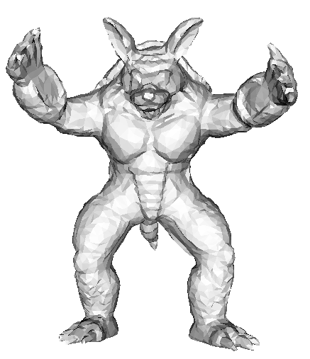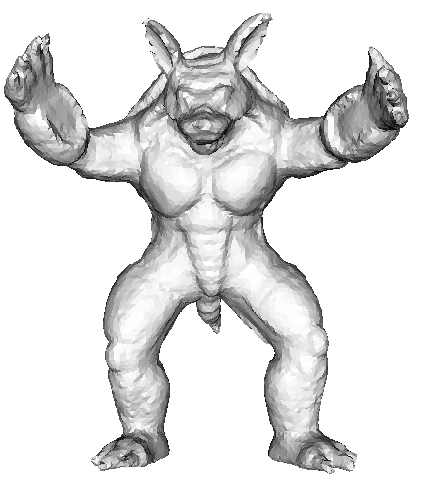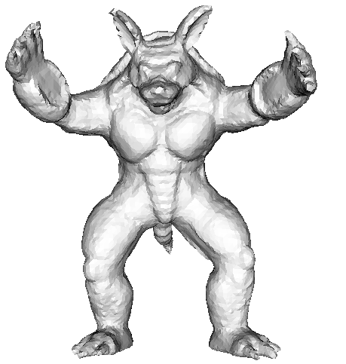
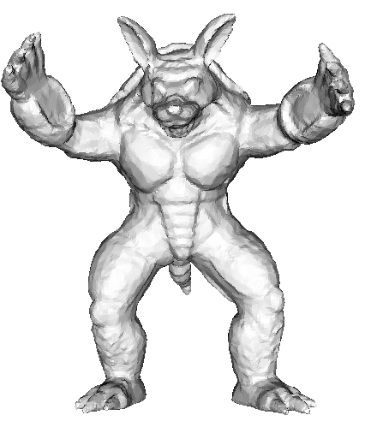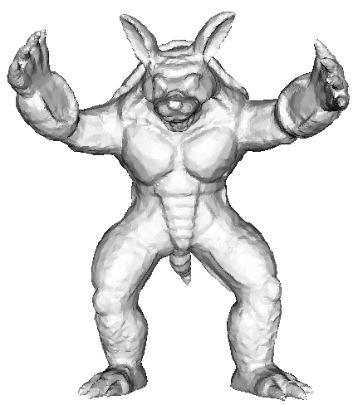
Original mesh (5002 vertices) Deform to fit_ iteration 1 Deform to fit_ iteration 2
Comparisons with different resolutions. The top row is the low resolution, and the bottom row is the dense resolution.

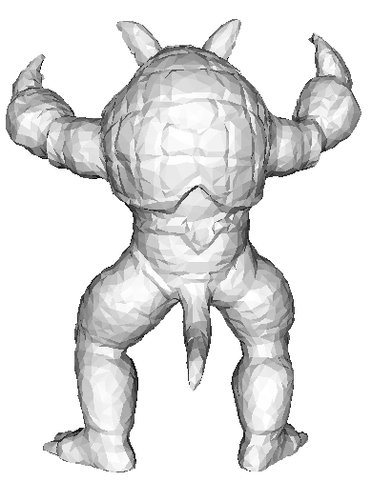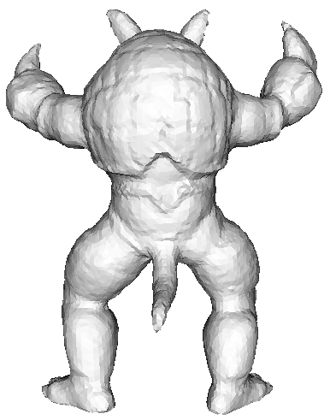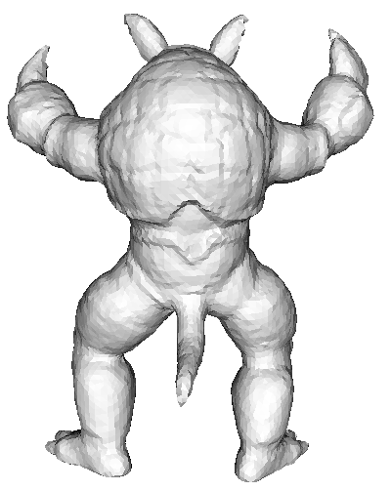
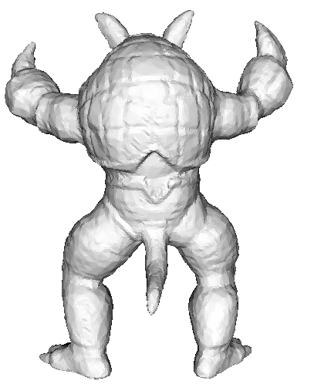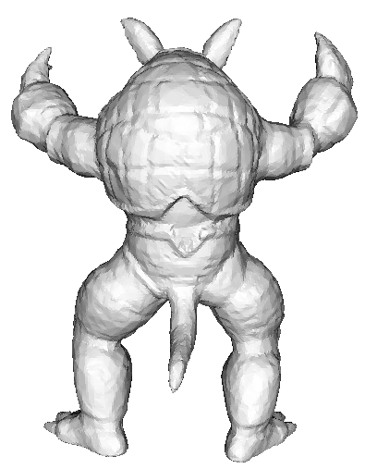
Original mesh (5002 vertices) Deform to fit_ iteration 1 Deform to fit_ iteration 2
Comparisons with different resolutions. The top row is the low resolution, and the bottom row is the dense resolution.
Note: the angle bounds are in [30, 90] for all the results.

 | Max distance | Mean distance
Low resolution iteration 1(13168 vertices) | 0.005699(0.017363) | 0.000214(0.000557)
Dense resolution iteration 1(48138 vertices) | 0.003887(0.008714) | 0.000076(0.000257)
Low resolution iteration 2(13168 vertices) | 0.005024(0.013026) | 0.000198(0.000506)
Dense resolution iteration 2(48138 vertices) | 0.003401(0.005668) | 0.000070(0.000242)
The two directions Hausdorff distances (compared with the dialog line of boxing box).
0.005699: the Hausdorff distance from the result to the original mesh
(0.017363): the Hausdorff distance from the original mesh to the result

Conclusions:
1. The Hausdorff distance from the original mesh to the mesh is much larger than that from the result to the original mesh. This may be due to that we just project the non-obtuse mesh to the original mesh. Two directions projection would improve the results.
2. The results of dense resolution are desirable, but with much expensive time cost.

