Simplification
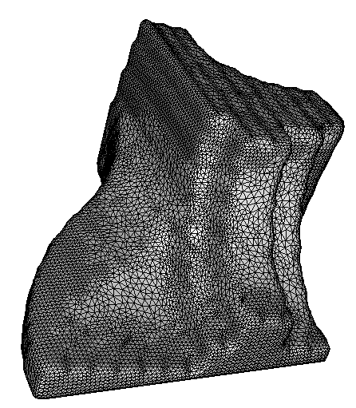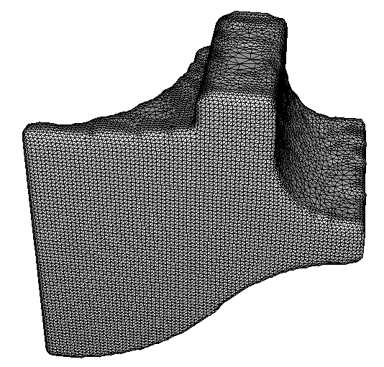
Simplification on the original non-obtuse mesh

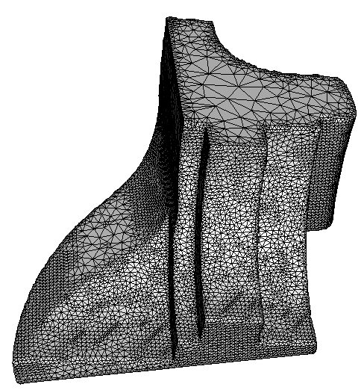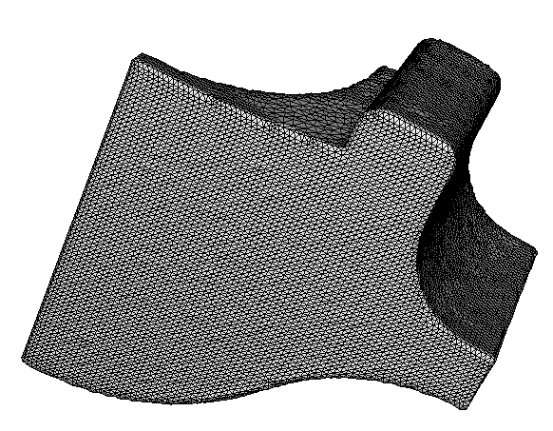
Simplification on the result with triangle stencil

Note: The constraints on the bottom plane are so rigid that the points cannot move.

